Supplementary Information

Bio-inspired proton-conformation-coupled hydrogen-bond network reconfiguration for adaptive optical anisotropy

Yayong Sun^{1,3}, Jiachen Lu¹, Yanqiang Li²*, Wei Zeng¹, Chong-An Chen¹, Congcong Jin¹, Hyungjin Lim¹, Sooyeon Lee¹, Hanjung Kim¹, Jian Zhang³*, Tianhua Zhou³*, and Kang Min Ok¹*

¹Department of Chemistry, Sogang University, Seoul 04107, Republic of Korea
²Quantum Science Center of Guangdong-Hong Kong-Macao Greater Bay Area, Shenzhen 518045, P. R. China
³State Key Laboratory of Structural Chemistry, Fujian Institute of Research on the Structure of Matter, Chinese Academy of Sciences, Fuzhou, Fujian, 350002, P. R. China.

*Yanqiang Li, *Jian Zhang, *Tianhua Zhou, *Kang Min Ok
Email: leeyq11@163.com; zhj@fjirsm.ac.cn; thzhou@fjirsm.ac.cn; kmok@sogang.ac.kr

S1. Materials and general information 3
S2. Crystal structure determinations 3
S3. Birefringence measurements 4
S4. Computational details 4
S5. Semi-empirical formula to evaluate the birefringence 5
S6. Chemical characterization, stability tests, birefringence, and theoretical calculations 6
S7. References 66

S1. Materials and general information
All chemicals were commercially available and used without further purification, except for N,N´-bis(2-phosphonomethyl)-1,4,5,8-naphthalenediimide (PMNDI). 1,4,5,8-naphthalenetetracarboxylic dianhydride (NDI, 96%, Aladdin), aminomethylphosphonic acid (99%, Rhawn), imidazole (99%, Thermo Scientific), and hydrochloric acid (HCl, 35 %, Dae Jung) were used as received. Crystals of HOFBC-1 were synthesized according to the previously reported procedure¹. Powder X-ray diffraction (PXRD) data were collected using a Rigaku MiniFlex 600 diffractometer with Cu/Kα radiation (λ = 1.54406 Å) over the 2θ range of 5−45° at a scanning rate of 10° min⁻¹ at the Advanced Bio−Interface Core Research Facility at SogangUniversity. Ultraviolet-visible (UV-vis) diffuse reflectance spectra were recorded on a PerkinElmer Lambda 1050 spectrophotometer over the range of 200−800 nm with a resolution of 1 nm at room temperature. Elemental analyses of C, N, and H were performed using a Vario MICRO elemental analyzer. Fourier-transform infrared (FT-IR) spectra were recorded in the range of 4000−400 cm⁻¹ using a Thermo Scientific Nicolet iS50 FTIR spectrometer. Thermogravimetric analysis (TGA) was carried out using a SCINCO TGA-N 1000 thermal analyzer. Powder samples were loaded into alumina crucibles and heated to 800 ºC at a rate of 10 ºC min⁻¹ under flowing nitrogen. Scanning electron microscopy (SEM) and elemental mapping were performed using a field-emission scanning electron microscope (JSM-7100F).

S2. Crystal structure determinations
Single crystals of ABC-1−5 were selected directly from the mother liquid without further treatment, transferred into oil, and mounted on loops for single-crystal X-ray diffraction data collection. Single-crystal X-ray diffraction data for ABC-1, ABC-3, ABC-4, and ABC-5 were collected at RT using a Bruker D8 QUEST diffractometer with Mo Kα radiation (λ = 0.71073 Å). Crystallographic data for ABC-2 were collected using a Hybrid Pixel Array detector equipped with graphite-monochromated Ga Kα radiation (λ = 1.3405 Å). Absorption corrections were applied using a multi-scan method. The structures were solved by direct methods and refined by full-matrix least-squares on F² using SHELXTL-2015² within Olex2³. Non-hydrogen atoms were refined anisotropically, and all hydrogen atoms were located at geometrically calculated positions. Crystallographic data and details of the structure refinements are summarized in the Supplementary Information (Tables S1).

S3. Birefringence measurements
The birefringence of ABC-1, ABC-2, ABC-3, and ABC-4 was measured at 546 nm using a ZEISS Axiolab 5 polarizing microscope equipped with a Berek compensator. The birefringence was calculated according to the following equation:
R = |n_{e} − n_{o}| × d = Δn × d Equation (1)
where R is the optical path difference, Δn is the birefringence, and d is the thickness of the measured crystal. n_{o} and n_{e} represent the ordinary and extraordinary refractive indices, respectively.

S4. Computational details
First-principles calculations of birefringence were performed using CASTEP⁴, a plane-wave pseudopotential package⁵, within the framework of density functional theory (DFT)⁶. The exchange-correlation energy was described using the generalized gradient approximation (GGA) with the Perdew-Burke-Ernzerhof (PBE) functional, as implemented in the CASTEP code.⁷ Norm-conserving pseudopotentials were employed to model ion-electron interactions for each atomic species with the following valence-electron configurations⁸: H 1s¹; C 2s²2p²; N 2s²2p³; O 2s²2p⁴; P 3s²3p³. A plane-wave cutoff energy of 830 eV was used for ABC-1, ABC-2, ABC-3 and ABC-4. Monkhorst-Pack scheme k-point meshes with a spacing smaller than 0.03 Å⁻¹ in the Brillouin zone were adopted for all calculations⁹.
Ab initio molecular calculations were carried out using Gaussian 16¹⁰. Geometry optimizations of P1, P2, and P3 were performed at the aug-cc-pVDZ level, and the optimized structures were subsequently used to evaluate their polarizabilities and polarizability anisotropy. Wavefunction analyses were conducted using Multiwfn 3.8 (dev)¹¹, and isosurface maps were generated with VMD¹².
The anisotropy of the polarizability tensor was defined from the static polarizability tensor according to Equation (2)¹³. Detailed static polarizabilities and polarizability anisotropies for different groups are summarized in Table S4. Here, the commonly used atomic unit (a.u.) was adopted for polarizability anisotropy.
$\text{δ} \text{=} \sqrt{\text{[(}{\text{α}}_{\text{xx}}{\text{α}}_{\text{yy}}{\text{)}}^{\text{2}}\text{+(}{\text{α}}_{\text{xx}}{\text{α}}_{\text{zz}}{\text{)}}^{\text{2}}\text{+(}{\text{α}}_{\text{yy}}{\text{α}}_{\text{zz}}{\text{)}}^{\text{2}}\text{+6}\text{(}{\text{α}}_{\text{xy}}^{\text{2}}\text{+}{\text{α}}_{\text{xz}}^{\text{2}}\text{+}{\text{α}}_{\text{yz}}^{\text{2}}\text{)}\text{]} \text{/} \text{2}}$ Equation (2)
where α represents the static polarizability tensor and δ denotes the anisotropy of the polarizability tensor.
In Figure 3h, the lengths of the three central bidirectional arrows represent the total polarizabilities along the X, Y, and Z directions (α_{x}, α_{y}, and α_{z}, respectively), as defined by Equations (3)−(5), where α_{xy} = α_{yz}, α_{xz} = α_{zx}, and α_{xz} = α_{zx}.
α_{x} = α_{xx} + α_{xy} + α_{xz} Equation (3)
α_{y} = α_{yx} + α_{yy} + α_{yz} Equation (4)
α_{z} = α_{zx} + α_{zy} + α_{zz} Equation (5)

S5. Semi-empirical formula for evaluating birefringence
To evaluate the birefringence of compounds ABC-1 to ABC-5, we introduce a semi-empirical formula to estimate the macroscopic birefringence generated by aromatic π-conjugated units:
$\text{Δ}\text{n}\text{ = A}\text{ρ}\text{(}\text{cos}{{\text{θ}\text{)}}^{\text{2}}}{\text{ (}\text{δ} \text{+} \text{λ}\text{e}}^{\text{-}\text{k}\text{d}}\text{)} \text{+} \text{B}$ Equation (6)
The birefringence is governed by the cooperative interplay between molecular anisotropy and intermolecular coupling. Here, ρ represents the packing density of the π-conjugated units, $\text{θ}$ is the dihedral angle between adjacent π-conjugated units, and $\text{(}\text{cos}{{\text{θ}\text{)}}^{\text{2}}}$ describes the planarity of the representative conformation. The polarizability anisotropy, δ, corresponds to the intrinsic microscopic anisotropy of the π-conjugated unit, whereas λ${\text{e}}^{\text{-}\text{kd}}$ describes the contribution from intermolecular electronic coupling, with d representing π···π stacking distance. The coefficient A reflects macroscopic amplification (A ≈ 0.96), λ (9.5 × 10⁵) and k (11.45) describe the strength and decay of π···π coupling, and B represents the intrinsic baseline anisotropy (B ≈ 0.21). Owing to parameter coupling in the exponential term, the effective π···π interaction range is determined by the experimentally observed stacking distances, which fall within 3.4−3.7 Å. When d is 0 Å, the coupling interaction between π-conjugated units is absent and λ is set to 0.

S6. Chemical characterization, stability tests, birefringence measurements, and theoretical calculations
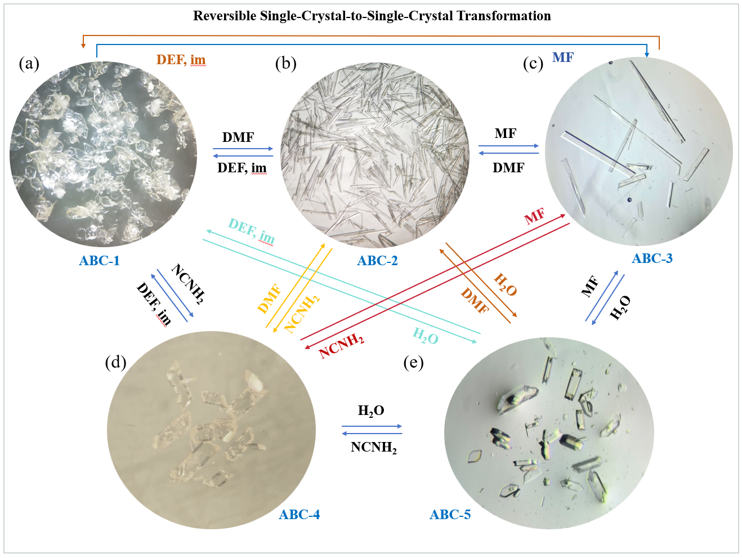
Figure S1. Reversible single-crystal-to-single-crystal transformations of ABC-1 (a), ABC-2 (b), ABC-3 (c), ABC-4 (d), and ABC-5 (e).

Table S1. Crystal data and structure refinement parameters for ABC-1－ABC-5.
Compound | ABC-1 | ABC-2 | ABC-3 | ABC-4 | ABC-5
Empirical formula | C₁₁H₁₀N₃O₅P | C₁₀H₁₃N₂O₅P | C₈H₉N₂O₅P | C₁₇H₁₇N₅O₁₀P₂ | C₁₆H₁₄N₂O₁₁P₂
Formula weight | 295 | 272.19 | 244.14 | 513.29 | 472.23
Temperature/K | 294 | 298 | 295 | 294 | 295
Crystal system | monoclinic | triclinic | triclinic | triclinic | monoclinic
Space group | P2₁/n | P-1 | P-1 | P-1 | P2₁/c
a/Å | 9.0258(3) | 4.7632(2) | 4.6371(4) | 8.5601(3) | 8.4004(3)
b/Å | 9.8458(3) | 7.8486(3) | 7.4493(6) | 8.7126(3) | 11.4656(4)
c/Å | 13.6802(4) | 16.4221(7) | 14.5081(12) | 14.2352(5) | 18.4447(5)
α/° | 90 | 100.767(3) | 88.434(4) | 96.8570(10) | 90
β/° | 94.5840(10) | 98.052(3) | 82.786(4) | 95.9470(10) | 100.6270(10)
γ/° | 90 | 93.767(3) | 77.489(4) | 110.1350(10) | 90
V/Å³ | 1211.82(7) | 594.51(4) | 485.38(7) | 977.66(6) | 1746.04(10)
Z | 4 | 2 | 2 | 2 | 4
ρ_{calc}g/cm³ | 1.618 | 1.521 | 1.670 | 1.744 | 1.796
μ/mm⁻¹ | 0.252 | 1.455 | 0.292 | 0.296 | 0.323
F(000) | 608.0 | 284.0 | 252.0 | 528.0 | 968.0
R_{int} | 0.0712 | 0.0594 | 0.1524 | 0.0558 | 0.1086
Data/restraints/parameters | 3005/0/182 | 2235/0/167 | 1725/1/162 | 4902/1/313 | 4332/1/291
S | 1.116 | 1.046 | 1.149 | 1.028 | 1.140
R₁, wR₂ [I>=2σ (I)]ª | R₁ = 0.0505,  wR₂ = 0.1111 | R₁ = 0.0500,  wR₂ = 0.1338 | R₁ = 0.0869,  wR₂ = 0.1410 | R₁ = 0.0478,  wR₂ = 00.1349 | R₁ = 0.0683,  wR₂ = 0.1646
R₁, wR₂ [all data]^{b} | R₁ = 0.0711,  wR₂ =0.1291 | R₁ = 0.0561,  wR₂ = 0.1401 | R₁ = 0.1478,  wR₂ = 0.1663 | R₁ = 0.0562,  wR₂ = 00.1436 | R₁ = 0.1147,  wR₂ = 0.1920
ªR₁ = Σ(|F_{o}|-|F_{c}|)/Σ|F_{o}|; ^{b}wR₂ = {Σ[w(F_{o}²-F_{c}²)²]/Σ[w(F_{o}²)²]}^{1/2}.

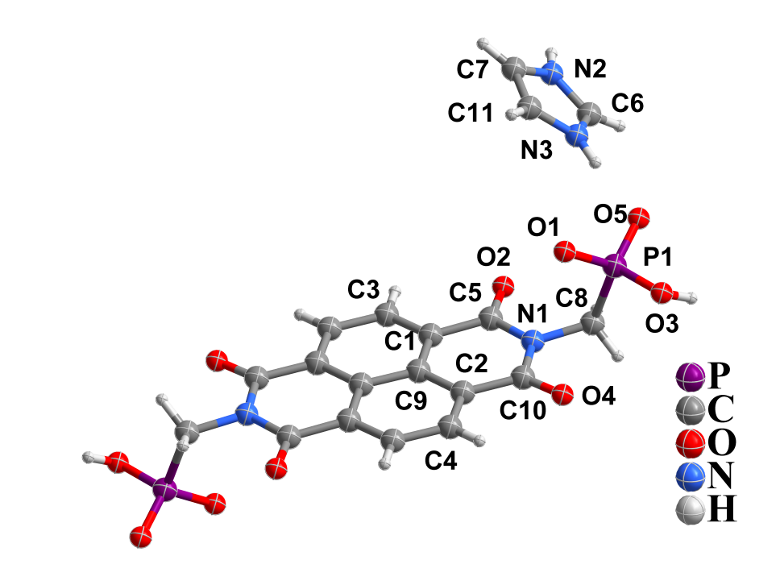
Figure S2. Asymmetric unit of ABC-1.

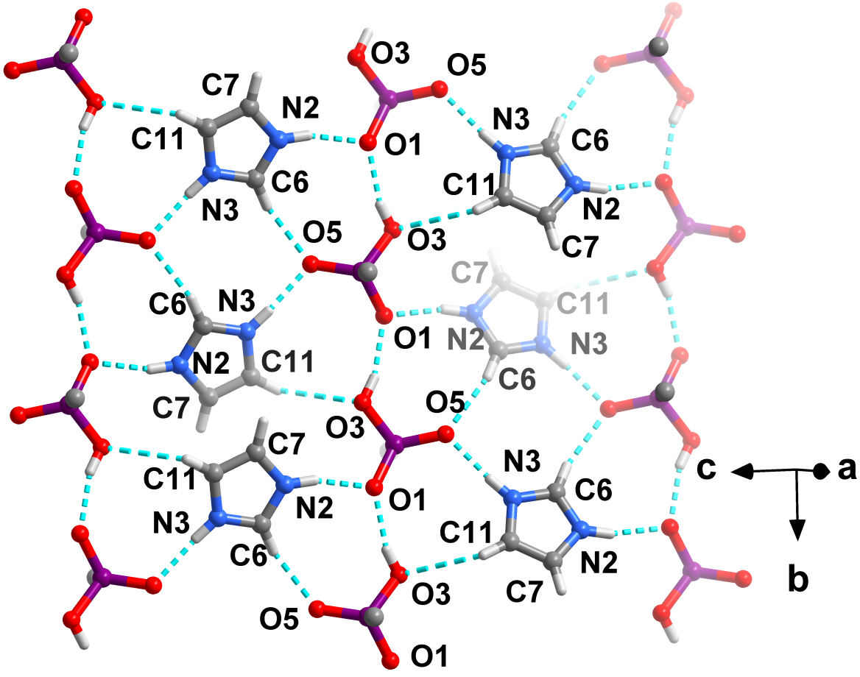
Figure S3. Hydrogen-bonded layer in ABC-1 formed by phosphonate groups and protonated imidazole cations.

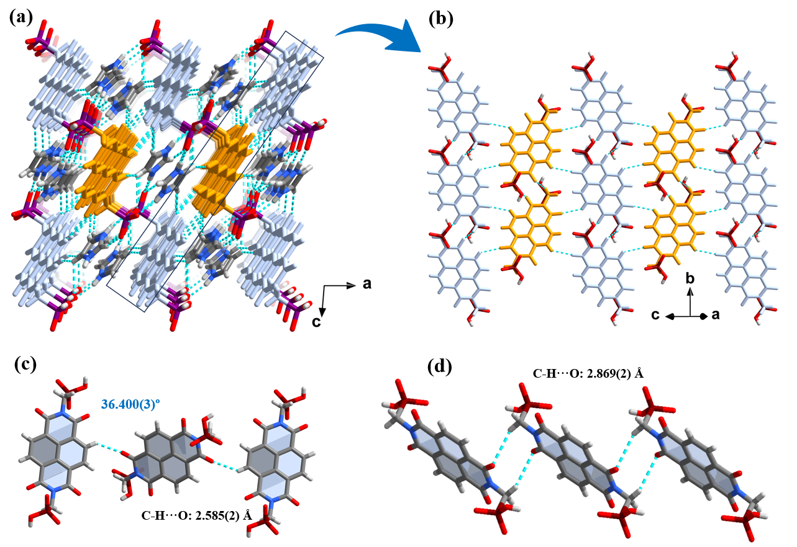
Figure S4. (a) Layer-by-layer three-dimensional hydrogen-bonded supramolecular structure of ABC-1, constructed from hydrogen-bonded and aromatic layers. (b) Intermolecular interactions between adjacent π-conjugated units in the aromatic layer. (c) Dihedral angles between adjacent π-conjugated units with different arrangements. (d) Head-to-head arrangement.

Table S2. Hydrogen-bond lengths (Å) and angles (°) in ABC-1, ABC-2, ABC-3, and ABC-4.
D-H···A | d(D-H)/Å | d(H···A)/Å | d(D···A)/Å | D-H···A/°
ABC-1
N3-H3B···O5 | 0.860(2) | 1.812(1) | 2.670(2) | 175.4(1)
N2-H2···O1 | 0.860(2) | 1.878(1) | 2.726(2) | 161.3(1)
C6-H6···O5 | 0.930(2) | 2.150(1) | 3.056(2) | 164.6(1)
C11-H11···O3 | 0.930(2) | 2.780(2) | 3.413(3) | 126.3(1)
C7-H7···O2 | 0.930(2) | 2.810(2) | 3.680(3) | 156.3(1)
C11-H11···O3 | 0.930(2) | 2.780(2) | 3.413(3) | 126.3(1)
O3-H3···O1 | 0.820(1) | 1.825(1) | 2.618(2) | 162.2(0)
C8-H8B···O4 | 0.970(2) | 2.869(2) | 3.675(3) | 141.2(1)
C4-H4···O2 | 0.930(2) | 2.585(2) | 3.326(3) | 137.0(1)
ABC-2
N2-H2A···O2 | 0.890(2) | 1.845(2) | 2.726(2) | 169.8(1)
N2-H2B···O2 | 0.890(2) | 1.930(2) | 2.780(3) | 159.0(1)
N2-H2B···O1 | 0.890(2) | 2.486(2) | 2.991(3) | 116.5(1)
C10-H10A···O1 | 0.960(3) | 2.618(2) | 3.190(4) | 118.5(2)
C9-H9B···O4 | 0.960(4) | 2.816(1) | 3.352(3) | 116.1(2)
C9-H9C···O4 | 0.960(4) | 2.935(2) | 3.797(4) | 150.0(2)
C10-H10C···O4 | 0.960(3) | 2.771(2) | 3.647(3) | 152.1(2)
O4-H4···O5 | 0.820(1) | 1.747(1) | 2.536(2) | 160.9(1)
C5-H5···O3 | 0.930(2) | 2.439(2) | 3.190(3) | 137.8(1)
C7-H7···O3 | 0.930(2) | 2.999(1) | 3.464(3) | 112.6(1)
C6-H6A···O5 | 0.970(2) | 2.541(2) | 3.317(3) | 137.0(1)
C6-H6A···O3 | 0.970(2) | 2.634(2) | 3.354(2) | 131.2(1)
ABC-3
N2-H2A···O1 | 0.917(6) | 1.917(6) | 2.825(7) | 169.9(6)
N2-H2B···O1 | 1.046(1) | 1.789(1) | 2.824(7) | 169.4(1)
N2-H2C···O1 | 0.901(8) | 2.226(7) | 2.960(8) | 138.2(6)
N2-H2D···O1 | 0.859(9) | 2.170(9) | 3.022(8) | 171.0(7)
N2-H2D···O2 | 0.859(9) | 2.532(7) | 3.041(7) | 118.8(6)
O3-H3···O2 | 0.820(2) | 1.754(2) | 2.551(3) | 163.3(2)
C5-H5···O4 | 0.930(3) | 2.445(3) | 3.359(4) | 167.6(2)
C7-H7···O3 | 0.930(2) | 2.581(2) | 3.497(3) | 168.2(2)
N2-H2A···O5 | 0.890(2) | 2.162(2) | 2.882(3) | 137.5(2)
ABC-4
N1-H1A···O7 | 0.860(2) | 1.607(2) | 2.431(2) | 159.3(1)
N3-H3B···O8 | 0.860(2) | 2.135(2) | 2.990(2) | 172.2(1)
N2-H2B···O4 | 0.860(2) | 2.122(2) | 2.924(3) | 155.0(1)
O5-H5···O10 | 0.878(3) | 1.681(3) | 2.553(2) | 171.6(1)
N3-H3C···O2 | 0.860(2) | 2.159(2) | 2.829(3) | 134.6(1)
N1-H1B···O9 | 0.860(2) | 2.219(2) | 3.010(3) | 152.8(1)
N2-H2A···O9 | 0.860(2) | 2.175(2) | 2.970(3) | 153.5(1)

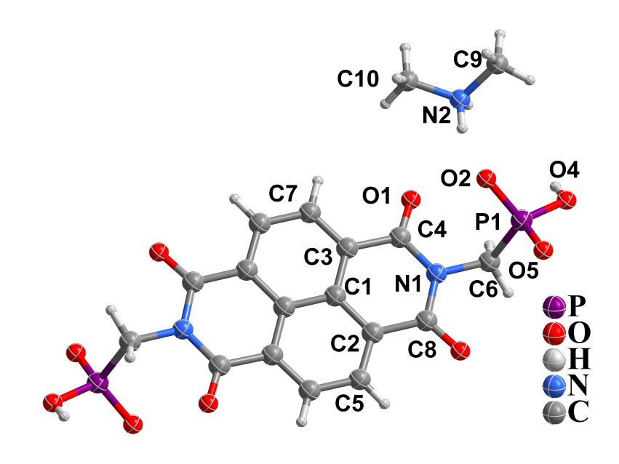
Figure S5. Asymmetric unit of ABC-2.

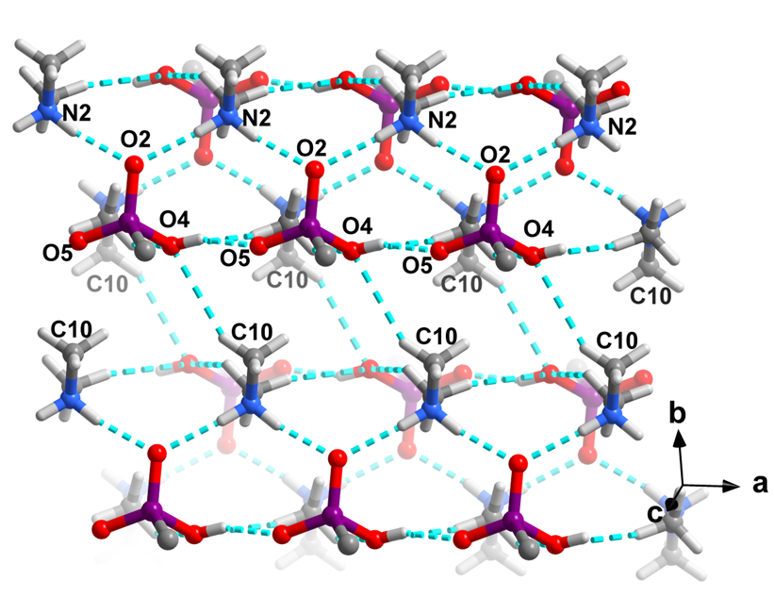
Figure S6. Hydrogen-bonded layer in ABC-2 formed by phosphonate groups and protonated dimethylammonium cations.

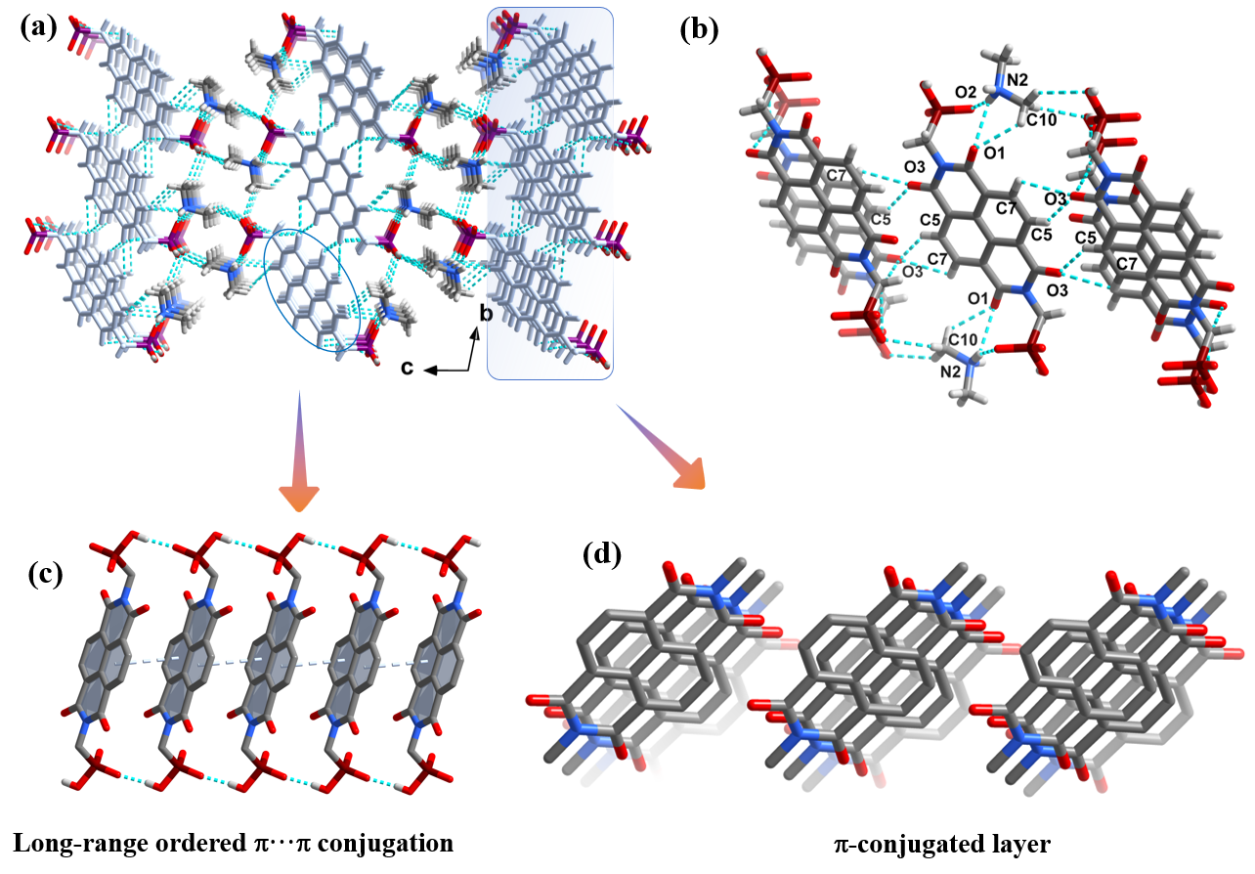
Figure S7. (a) Layer-by-layer three-dimensional hydrogen-bonded supramolecular structure of ABC-2, constructed from hydrogen-bonded and aromatic layers. (b) Side-by-side arrangement of adjacent π-conjugated units along the b axis. (c) Long-range ordered π···π interactions with a face-to-face arrangement along the a axis. (d) Perfectly aligned π-conjugated units.

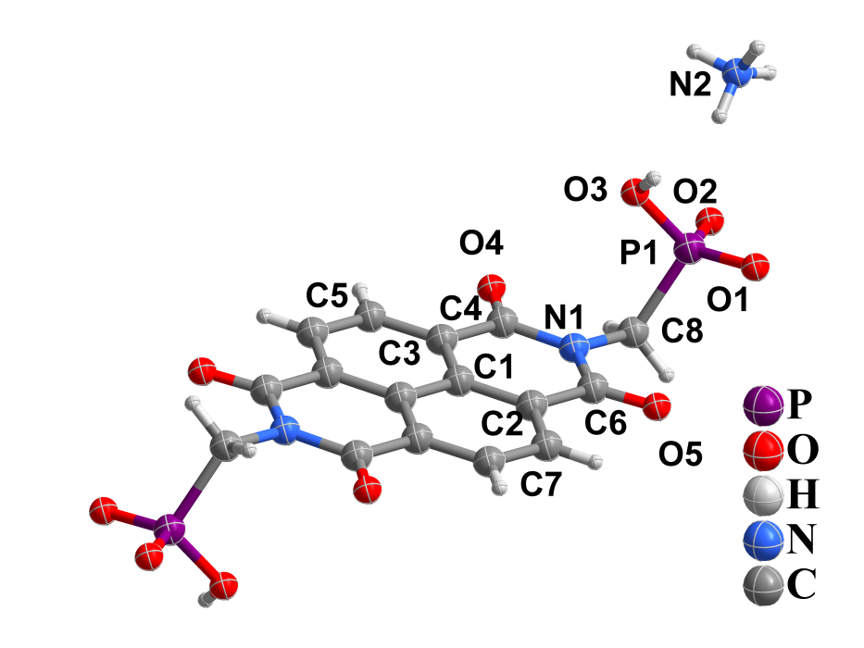
Figure S8. Asymmetric unit of ABC-3.

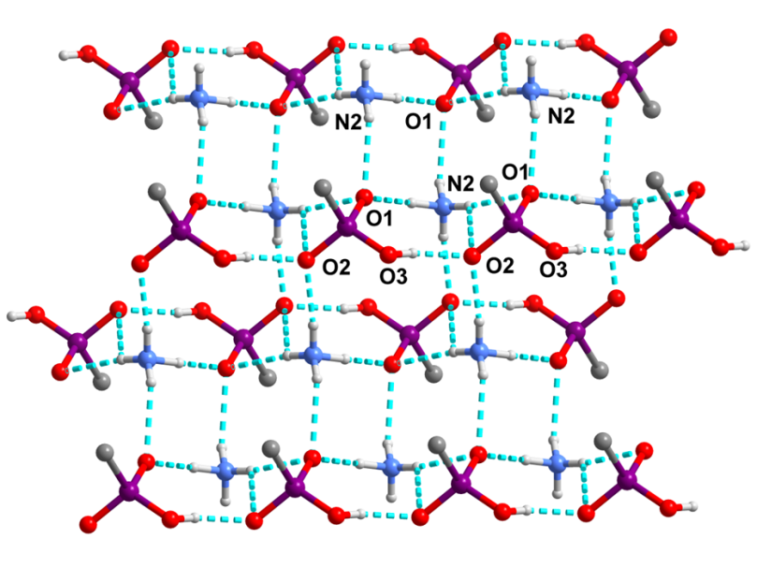
Figure S9. Hydrogen-bonded layer in ABC-3 formed by phosphonate groups and ammonium cations.

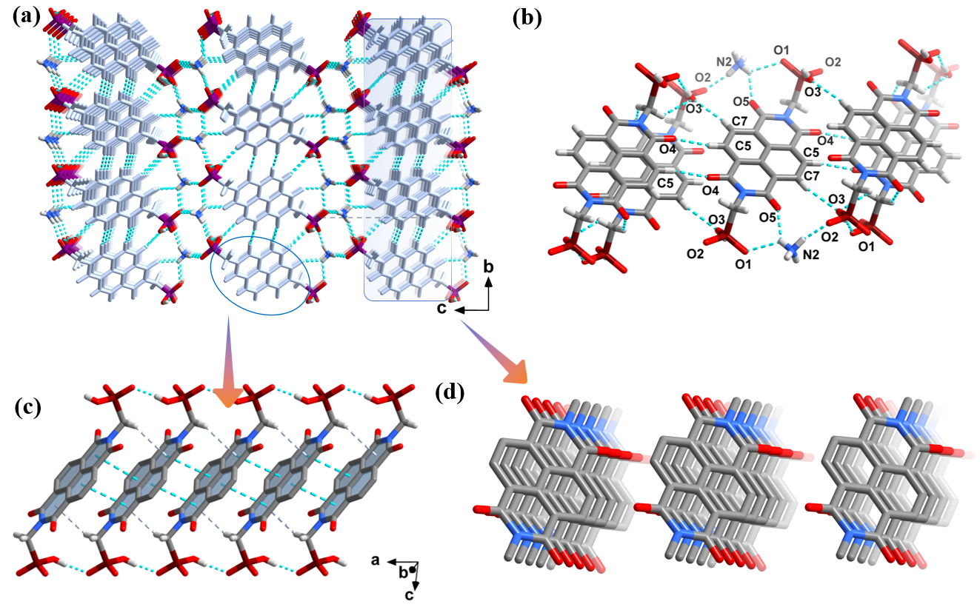
Figure S10. (a) Layer-by-layer three-dimensional hydrogen-bonded supramolecular structure of ABC-3, constructed from hydrogen-bonded and aromatic layers. (b) Side-by-side arrangement of adjacent π-conjugated units along the b axis. (c) Long-range ordered π···π interactions with a face-to-face arrangement along the a axis. (d) Perfectly aligned and densely packed π-conjugated units.

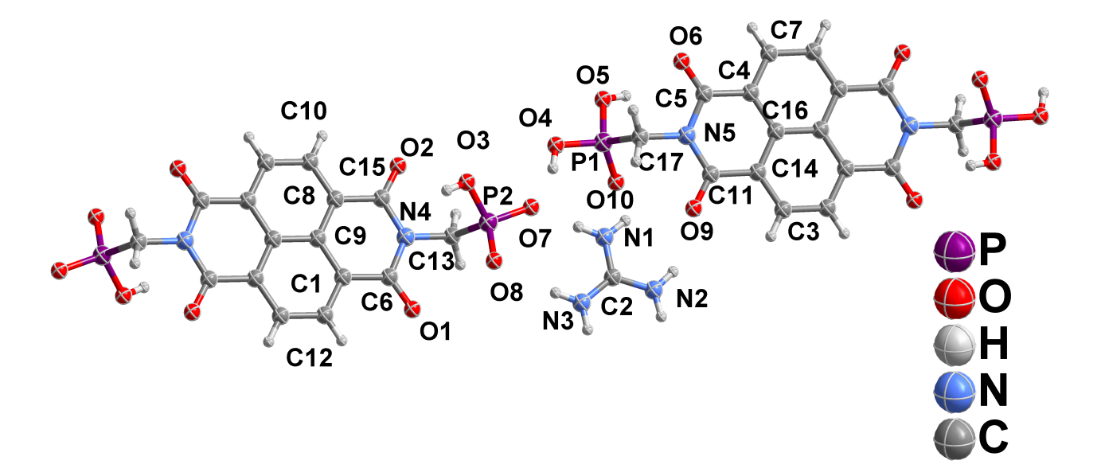

Figure S11. Asymmetric unit of ABC-4.

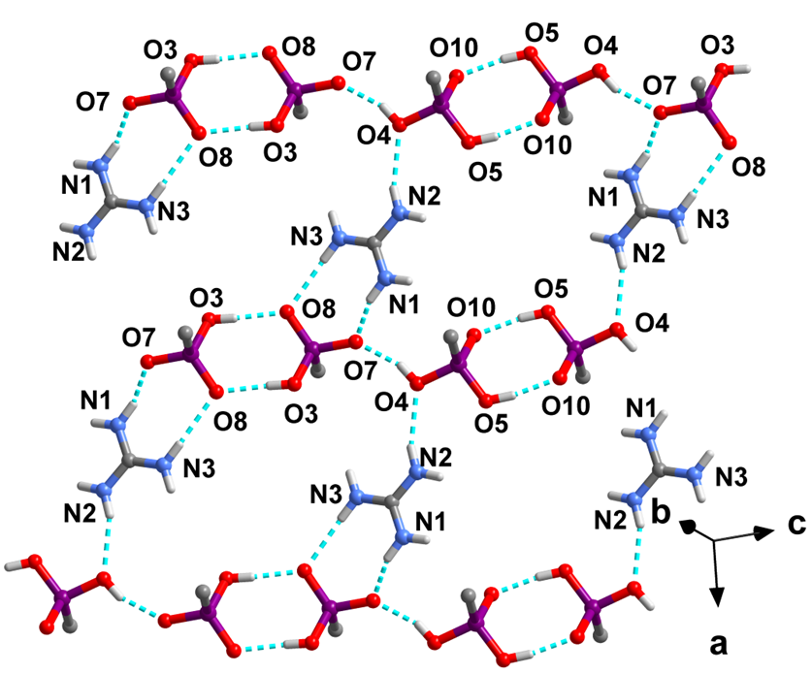
Figure S12. Hydrogen-bonded layer in ABC-4 formed by phosphonate groups and protonated guanidinium cations.

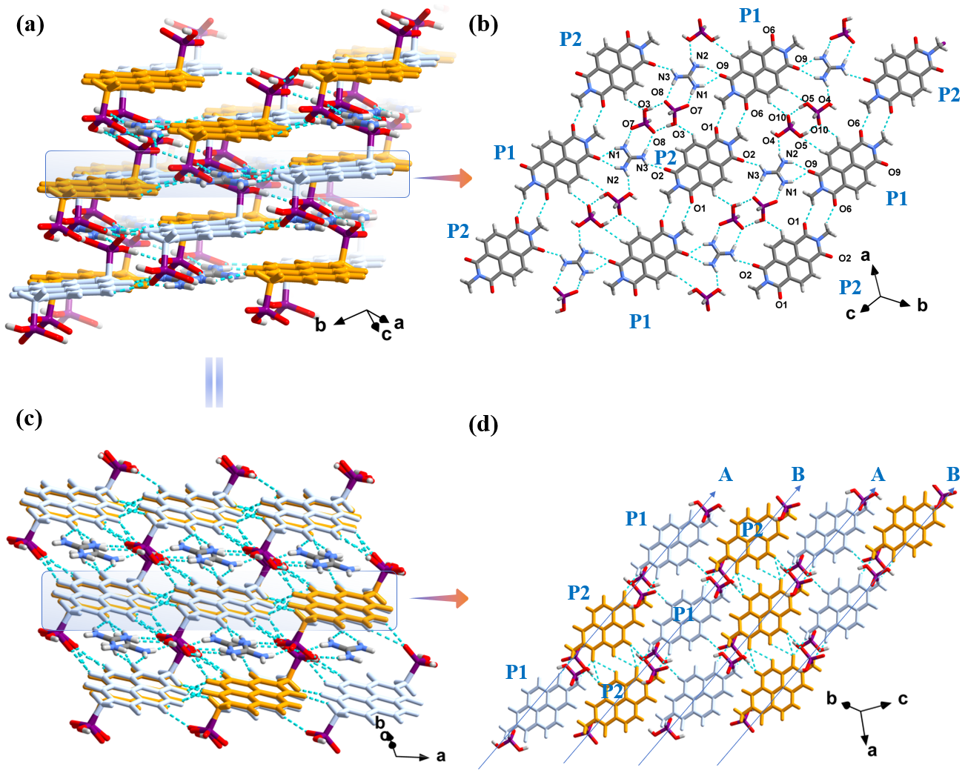
Figure S13. (a,c) Layer-by-layer three-dimensional hydrogen-bonded supramolecular structure of ABC-4, constructed from hydrogen-bonded and aromatic layers. (b) Hydrogen-bonding interactions in ABC-4 between phosphonate groups, protonated guanidinium cations, and π-conjugated NDI units. (d) Hydrogen-bonding interactions between adjacent π-conjugated NDI units in the aromatic layer.

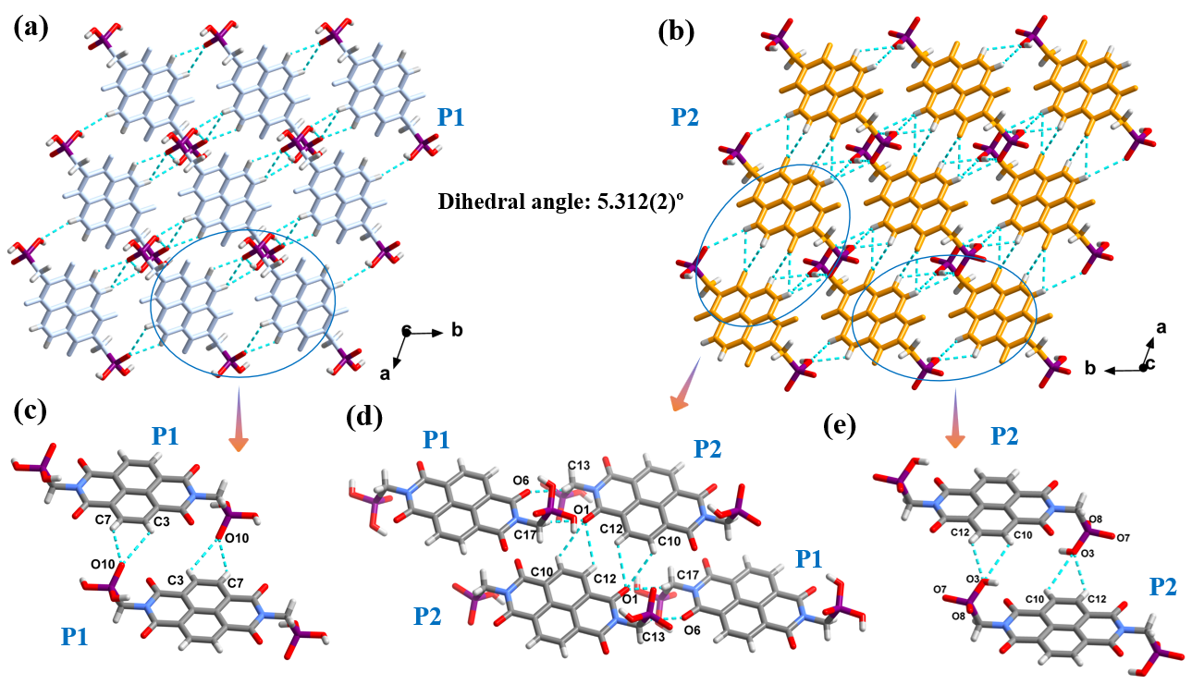
Figure S14. (a) Hydrogen-bonding interactions and arrangement modes between adjacent π-conjugated units of P1 along the c axis in ABC-4. (b) Hydrogen-bonding interactions and arrangement modes between adjacent π-conjugated units of P2 along the c axis. (c) Hydrogen-bonding interactions within the organic building unit P1. (d) Hydrogen-bonding interactions between the organic building units P1 and P2. (e) Hydrogen-bonding interactions within the organic building unit P2.

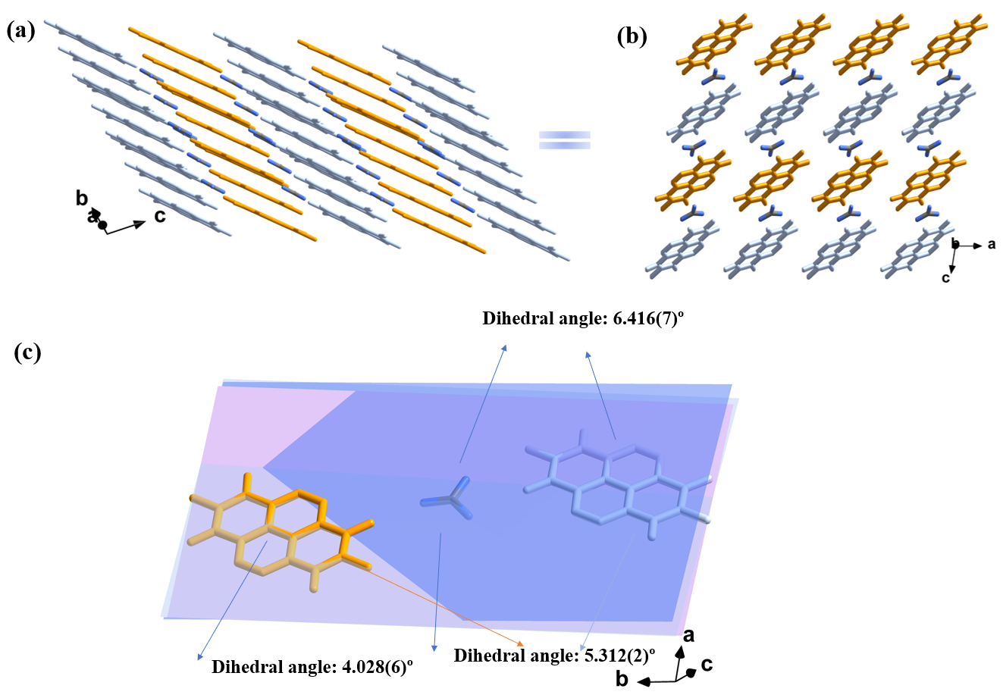Figure S15. (a,b) Parallel and uniform arrangement of π-conjugated NDI units; (c) π-conjugated guanidinium cations exhibiting a reduced dihedral angle from 40.28(6)° to 6.416(7)° in ABC-4.
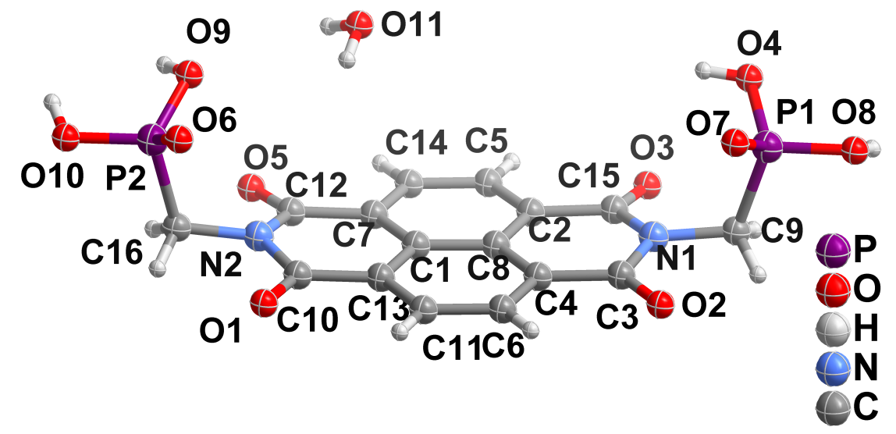
Figure S16. Asymmetric unit of ABC-5.

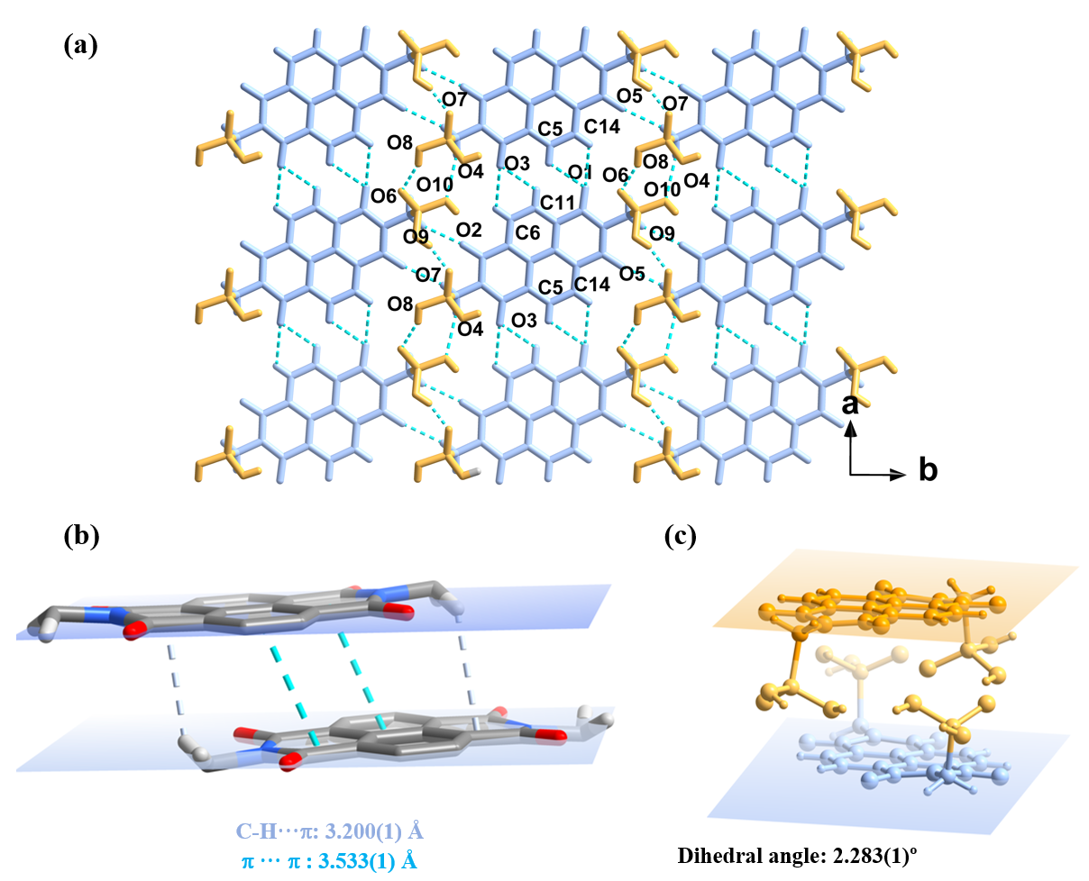
Figure S17. (a) Perfectly aligned stacking of π-conjugated NDI units through head-to-head and side-by-side arrangements. (b) Aromatic interactions between adjacent π-conjugated NDI units. (c) Dihedral angles between adjacent π-conjugated NDI units.

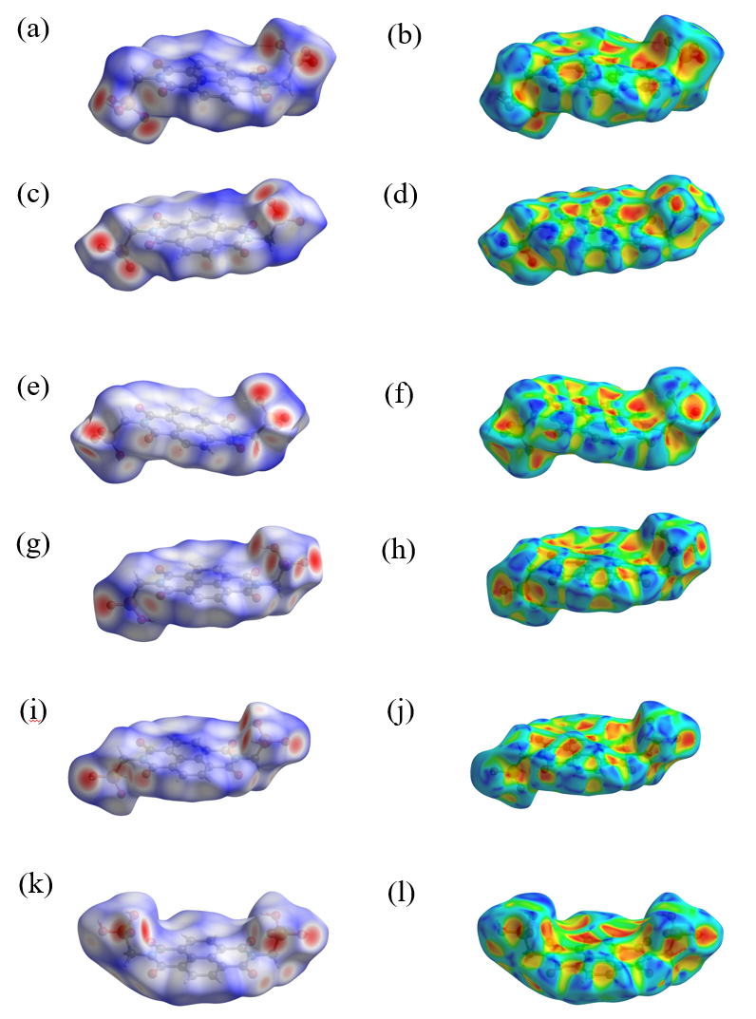

Figure S18. Hirshfeld surfaces of ABC-1–ABC-5. $d_{\text{norm}}$ surfaces: ABC-1 (a), ABC-2 (c), ABC-3 (e), ABC-4 (g and h; deprotonated and protonated phosphonate groups), and ABC-5 (k). Shape index surfaces: ABC-1 (b), ABC-2 (d), ABC-3 (f), ABC-4 (i and j), and ABC-5 (l).

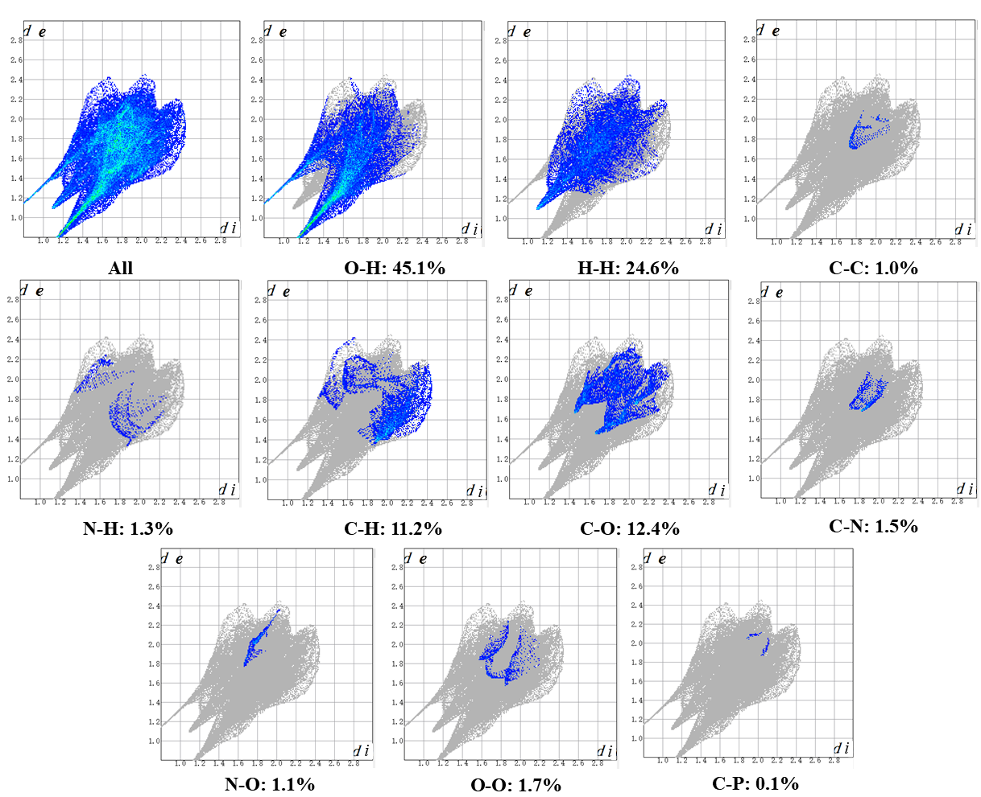
Figure S19. Two-dimensional fingerprint plots showing overall and atom-type-specific interactions in the crystal packing of ABC-1.

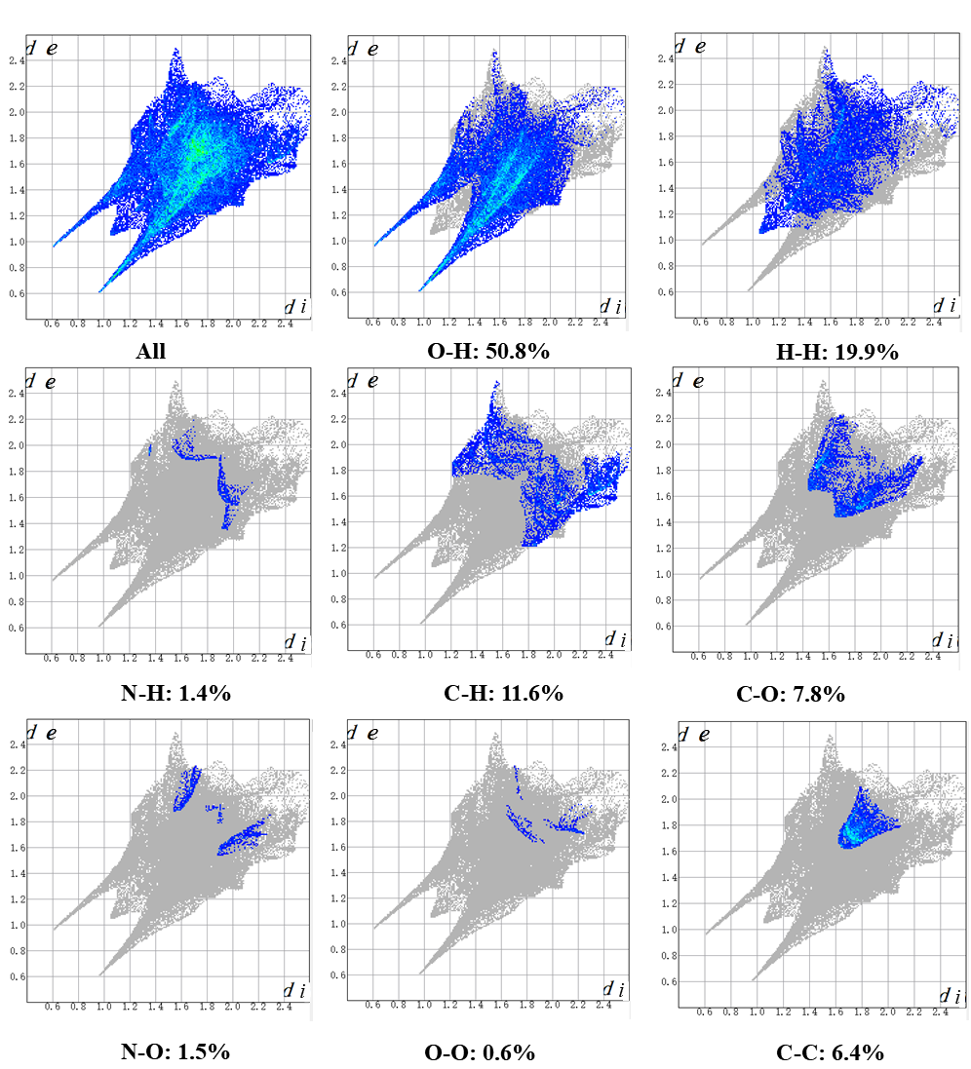
Figure S20. Two-dimensional fingerprint plots showing overall and atom-type-specific interactions in the crystal packing of ABC-2.

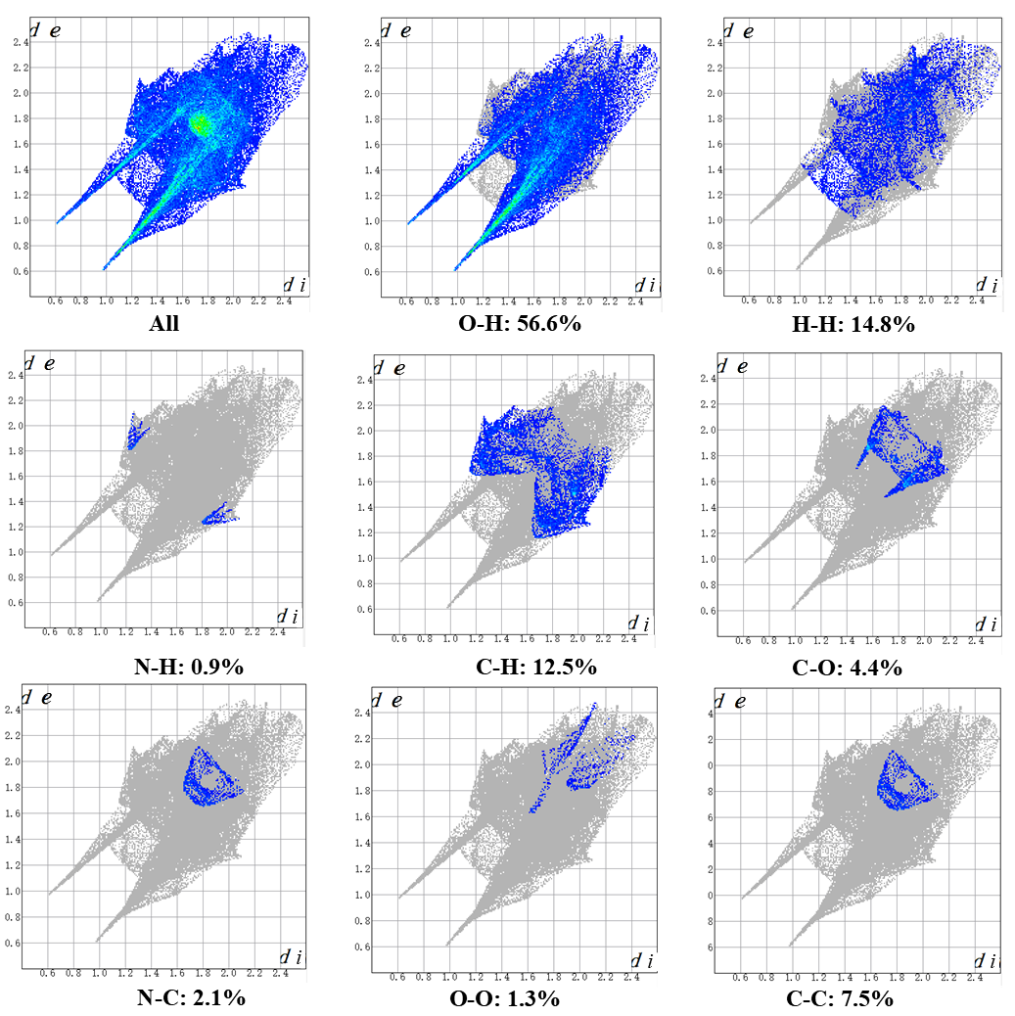
Figure S21. Two-dimensional fingerprint plots showing overall and atom-type-specific interactions in the crystal packing of ABC-3.

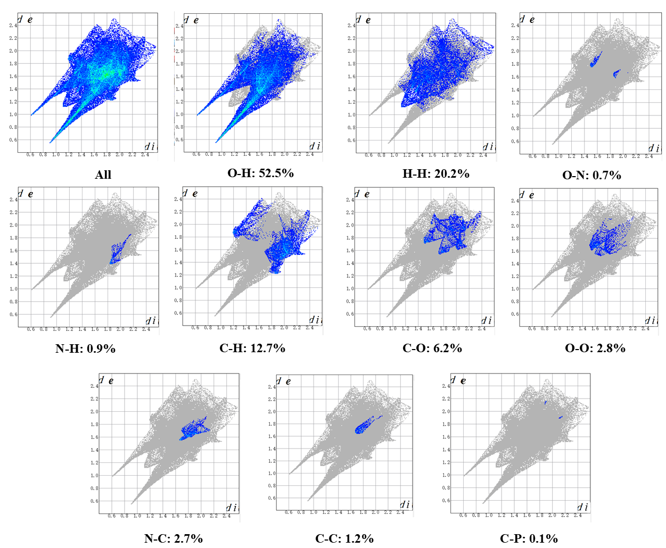
Figure S22. Two-dimensional fingerprint plots showing overall and atom-type-specific interactions in the crystal packing of the P1 organic building block in ABC-4.

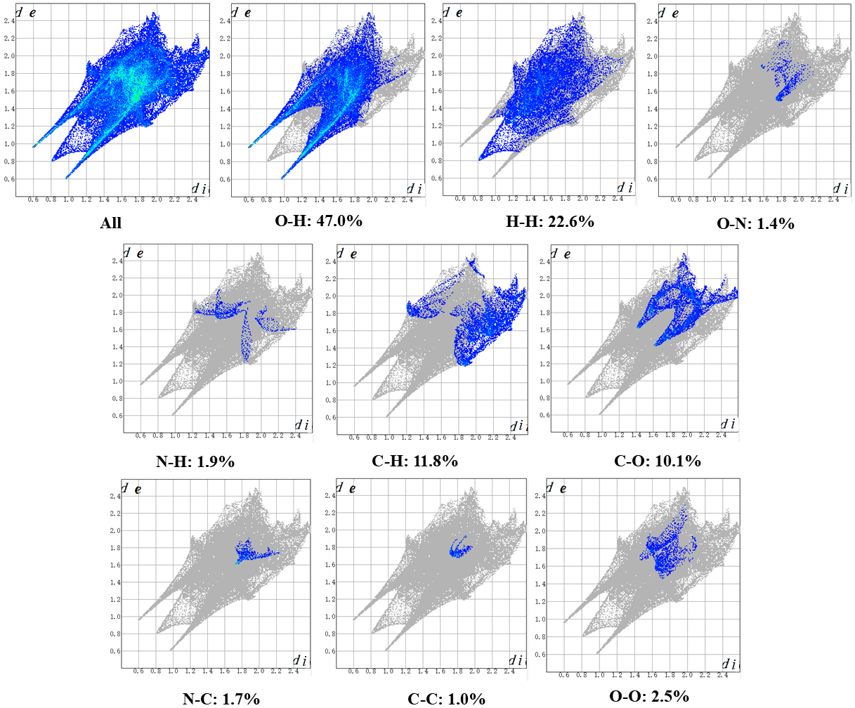
Figure S23. Two-dimensional fingerprint plots showing overall and atom-type-specific interactions in the crystal packing of the P2 organic building block in ABC-4.

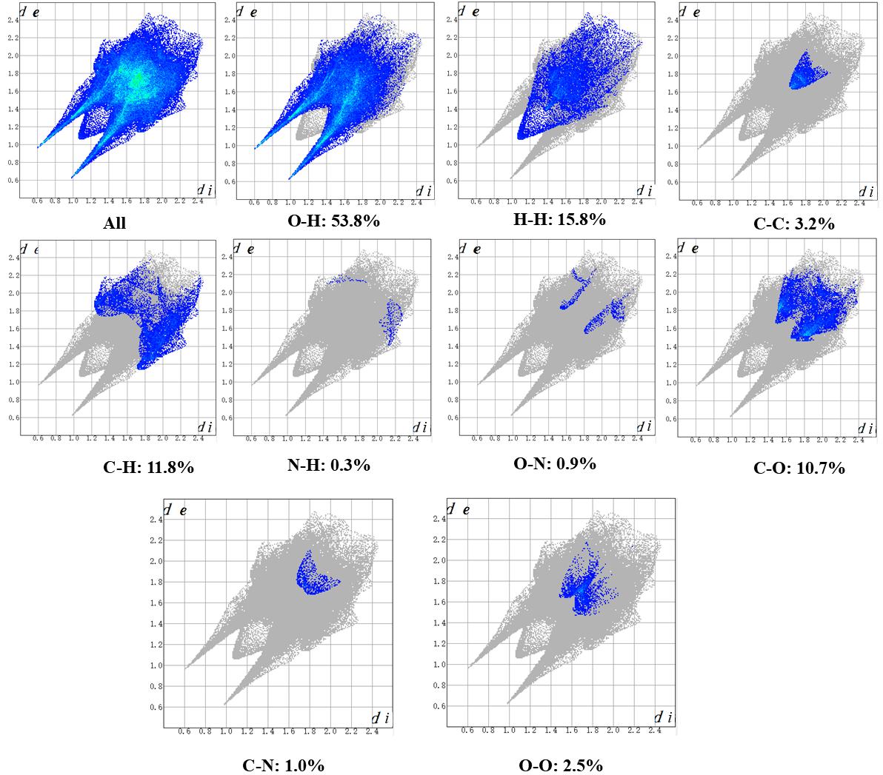
Figure S24. Two-dimensional fingerprint plots showing overall and atom-type-specific interactions in ABC-5.
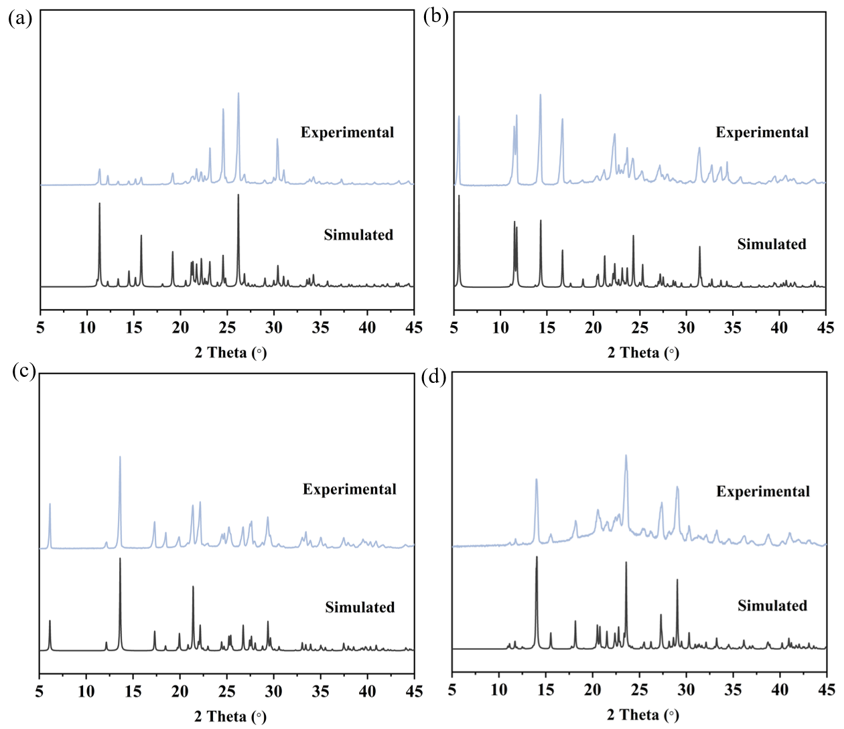

Figure S25. Powder X-ray diffraction patterns of ABC-1 (a), ABC-2 (b), ABC-3 (c), and ABC-4 (d).
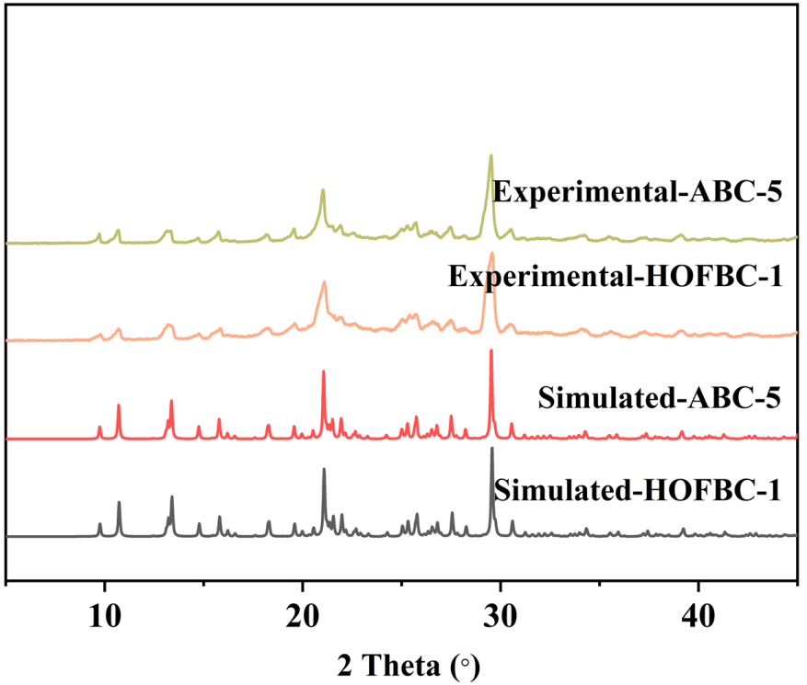
Figure S26. Powder X-ray diffraction patterns of ABC-5 and HOFBC-1.

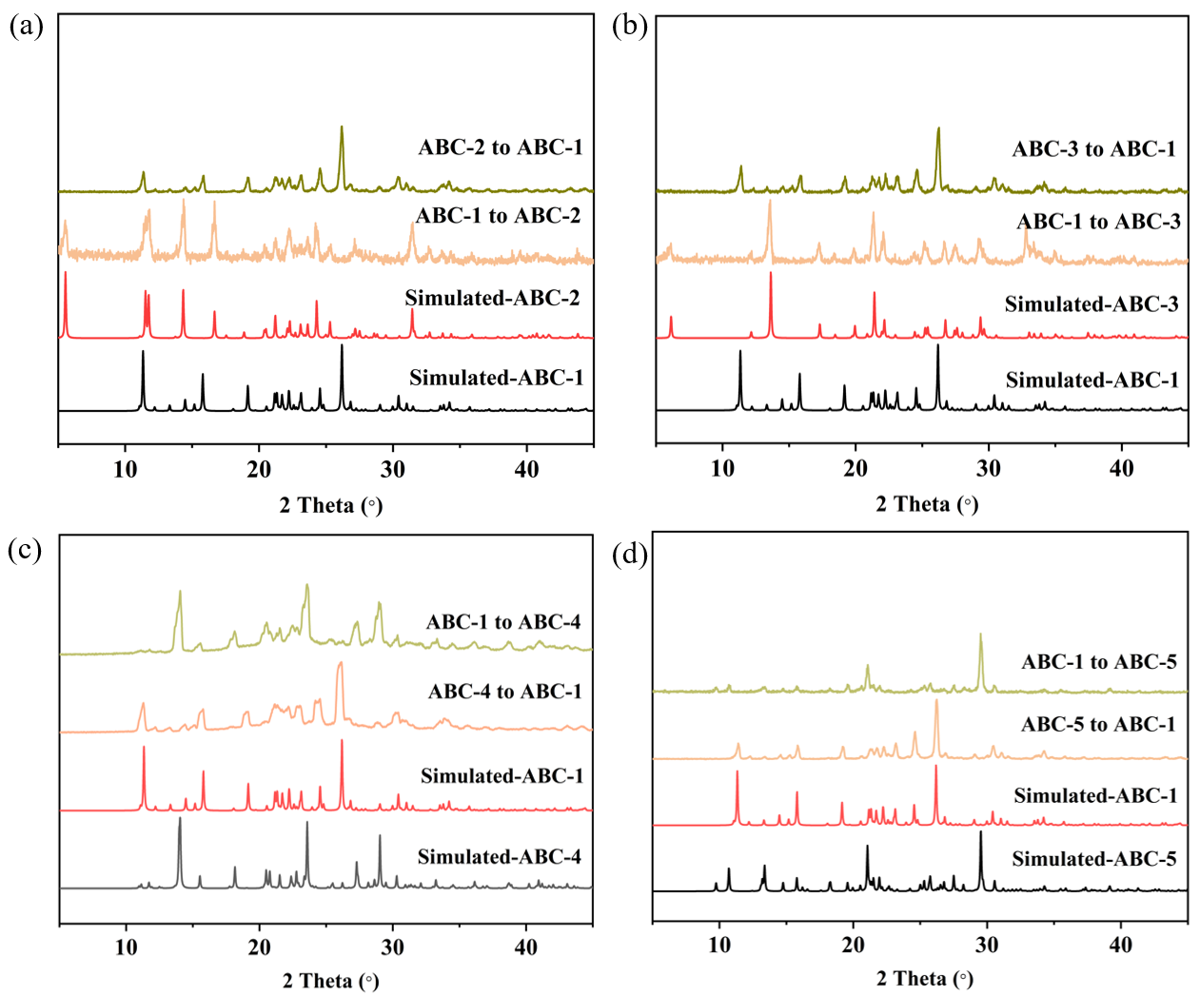
Figure S27. Powder X-ray diffraction patterns showing structural transformations between ABC-1 and ABC-2 (a), ABC-3 (b), ABC-4 (c), and ABC-5 (d), respectively.
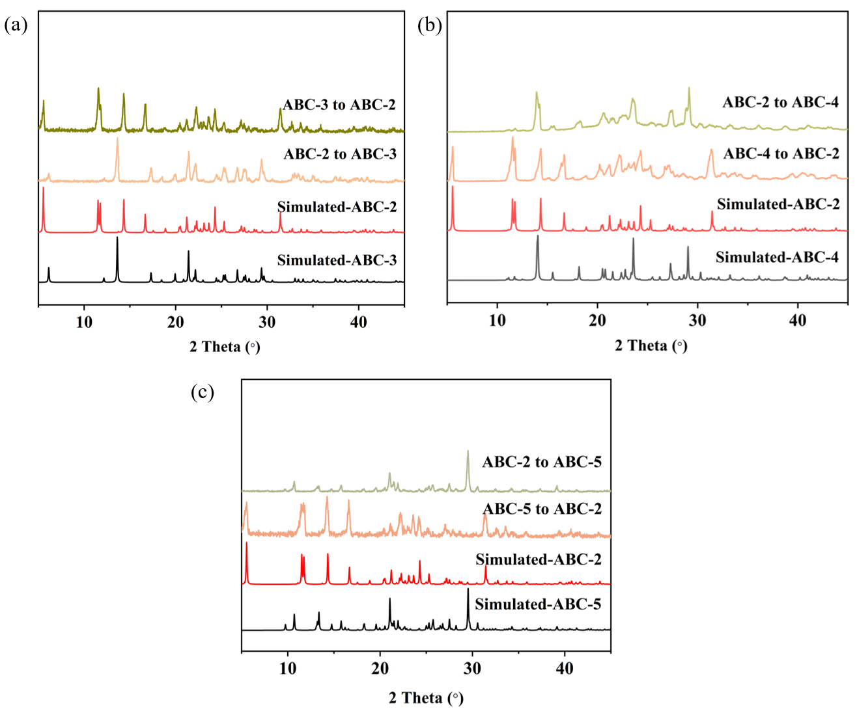
Figure S28. Powder X-ray diffraction patterns showing structural transformations between ABC-2 and ABC-3 (a), ABC-4 (b), and ABC-5 (c), respectively.

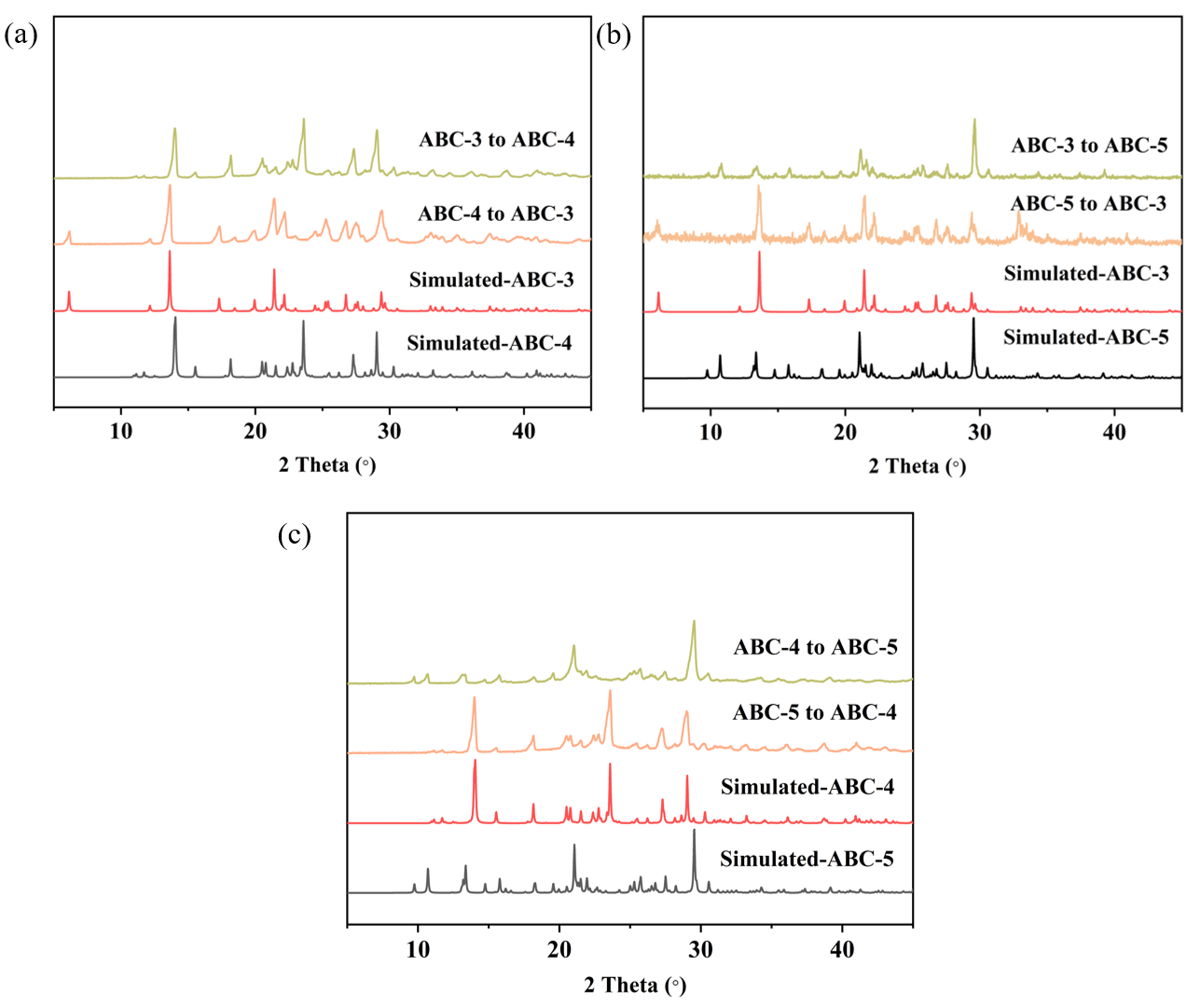
Figure S29. Powder X-ray diffraction patterns showing structural transformations between ABC-3 and ABC-4 (a) and ABC-5 (b), respectively; (c) PXRD patterns showing the structural transformation between ABC-4 and ABC-5.

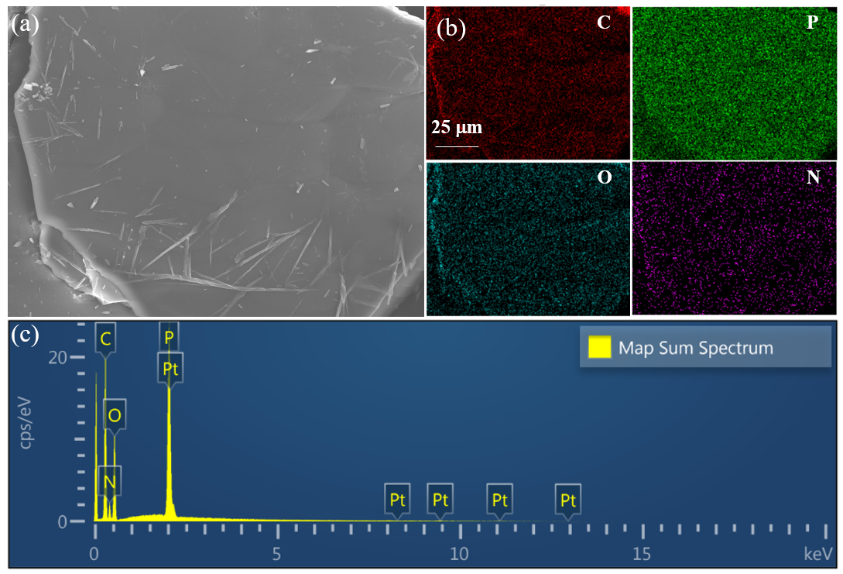
Figure S30. SEM image (a), SEM mapping (b), and energy-dispersive X-ray spectroscopy results (c) of ABC-1.

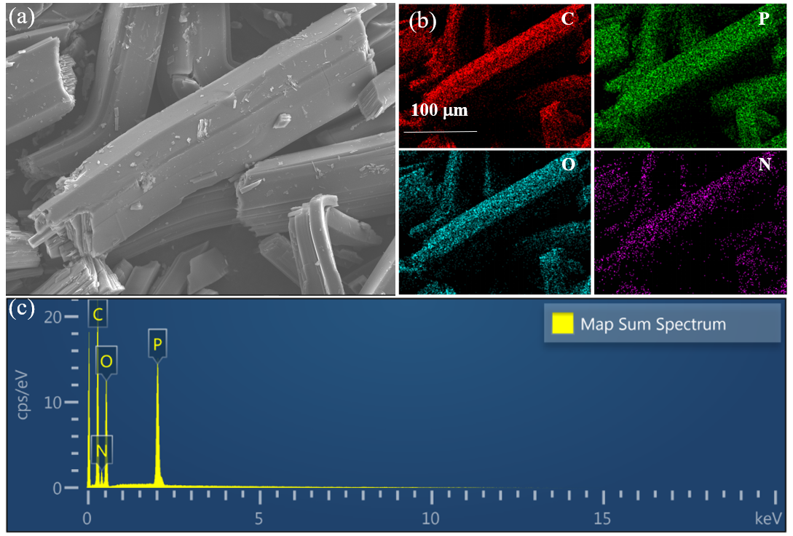
Figure S31. SEM image (a), SEM mapping (b), and energy-dispersive X-ray spectroscopy results (c) of ABC-2.

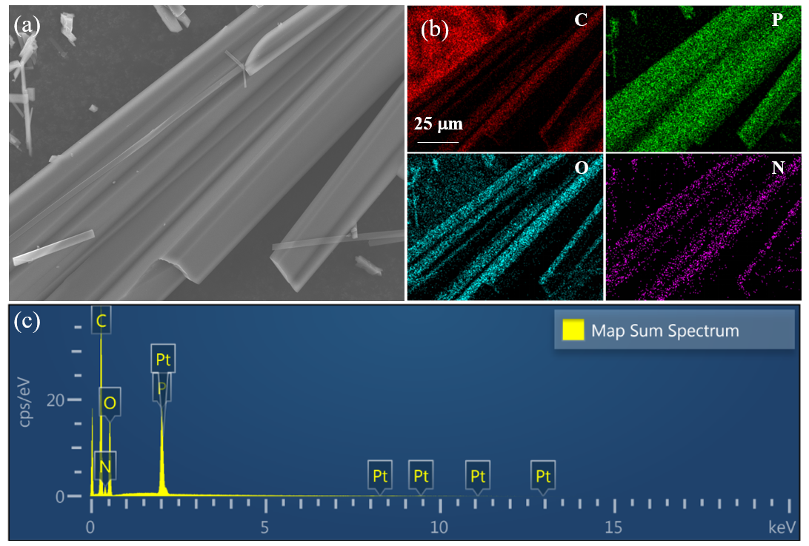
Figure S32. SEM image (a), SEM mapping (b), and energy-dispersive X-ray spectroscopy results (c) of ABC-3.

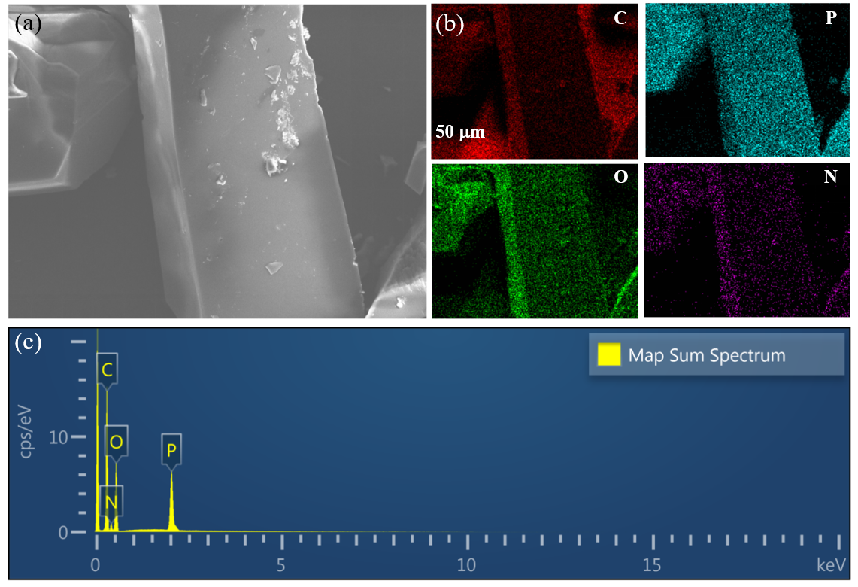
Figure S33. SEM image (a), SEM mapping (b), and energy-dispersive X-ray spectroscopy results (c) of ABC-4.

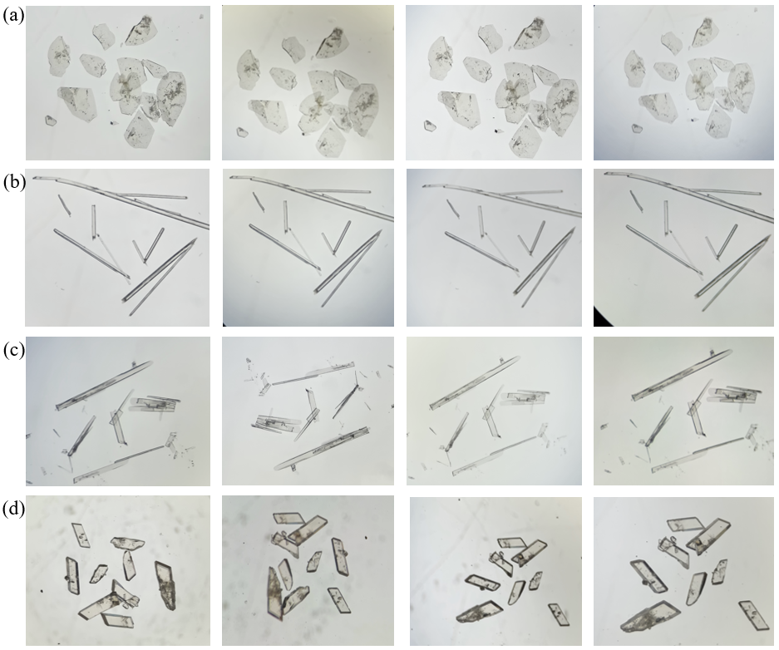

Figure S34. Photographs of ABC-1 (a), ABC-2 (b), ABC-3 (c), and ABC-4 (d) crystals exposed to air for different durations; from left to right: original crystals, 1 day, 7 days, and 14 days.

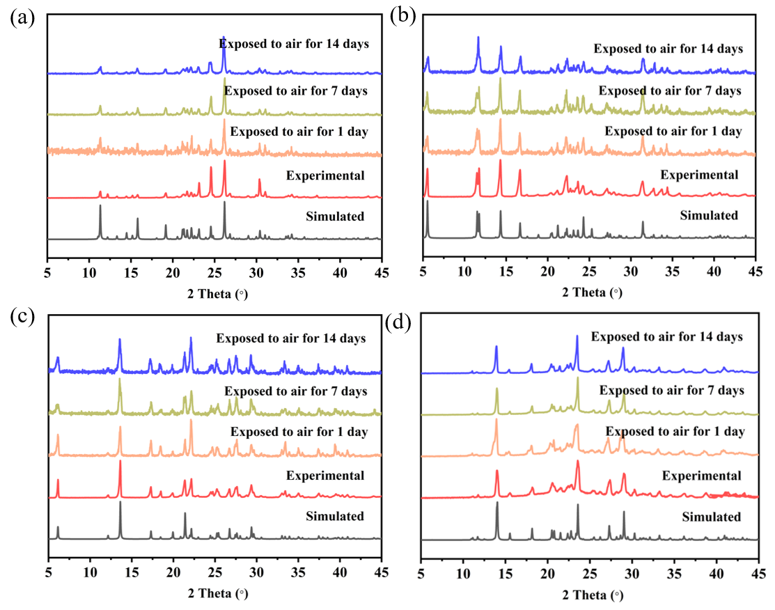
Figure S35. Powder X-ray diffraction patterns of ABC-1 (a), ABC-2 (b), ABC-3 (c), and ABC-4 (d) after exposure to air for different durations; from left to right: original crystals, 1 day, 7 days, and 14 days.

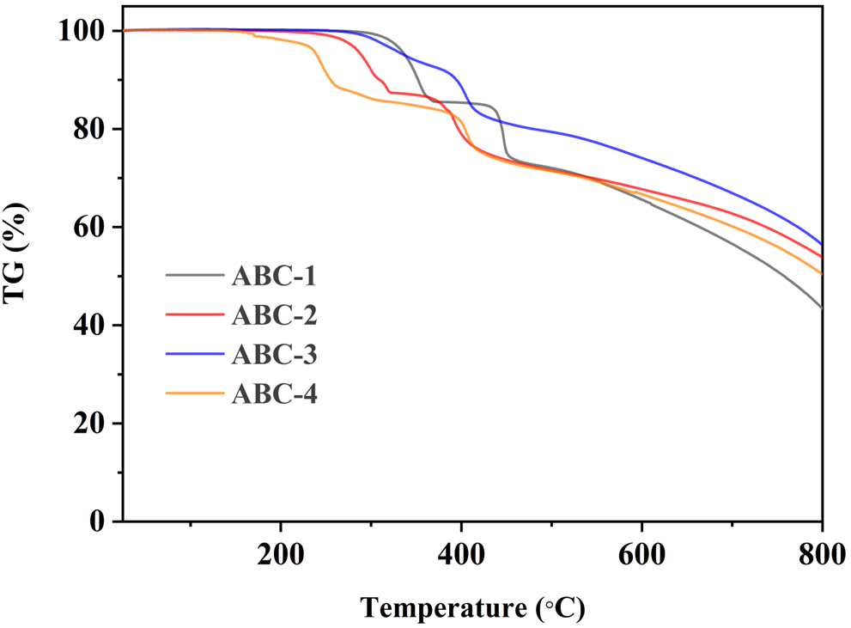
Figure S36. Thermogravimetric analysis curves of ABC-1–ABC-4.
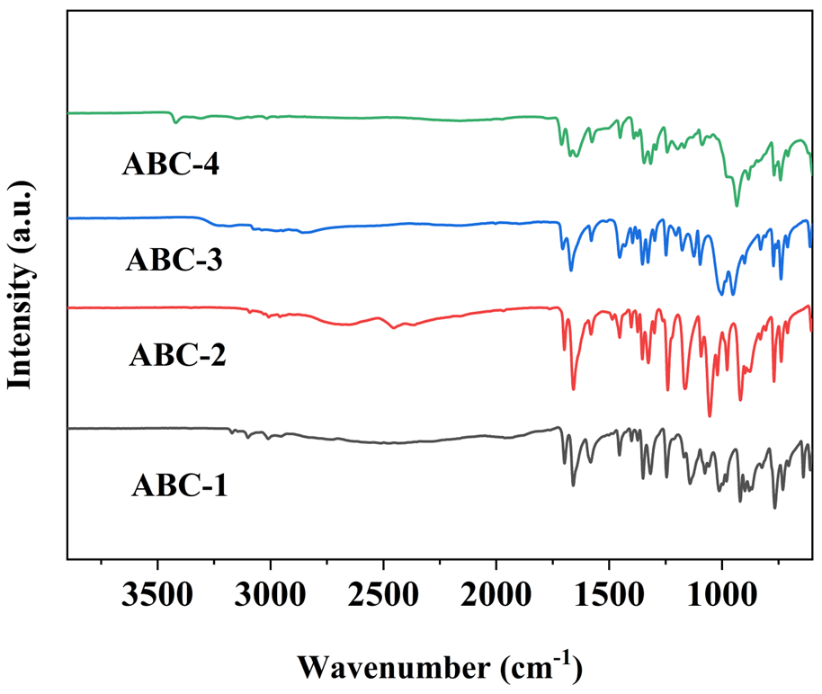
Figure S37. Infrared spectra of ABC-1–ABC-4.

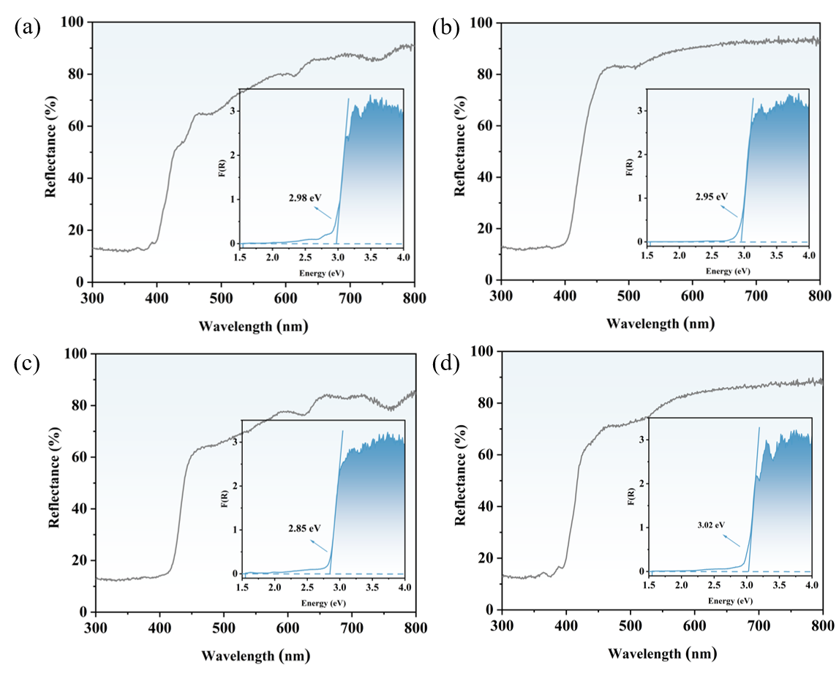
Figure S38. Diffuse reflectance spectra and experimentally determined band gaps of ABC-1 (a), ABC-2 (b), ABC-3 (c), and ABC-4 (d).

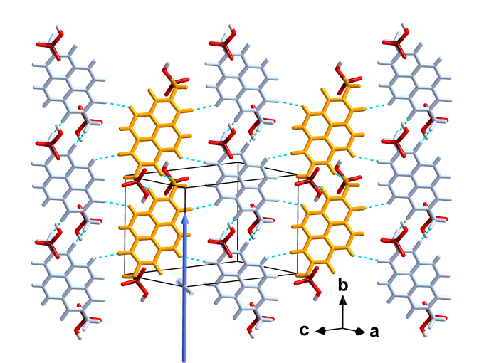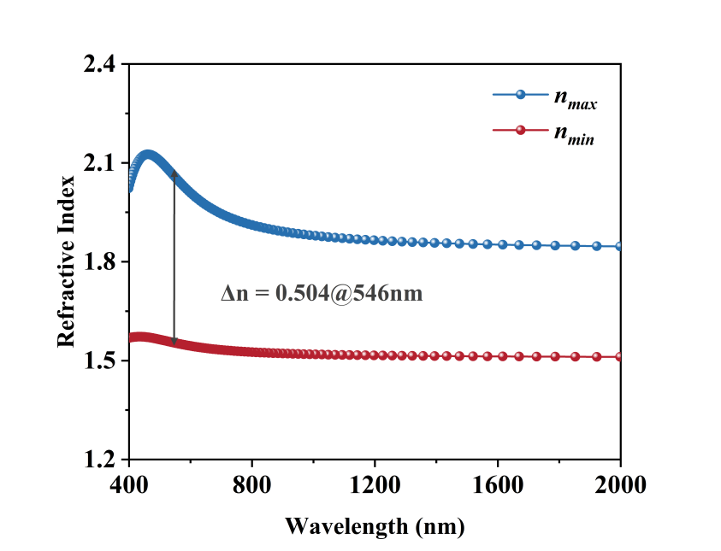
n_{max}
n_{min}
Figure S39. Calculated refractive index of ABC-1.

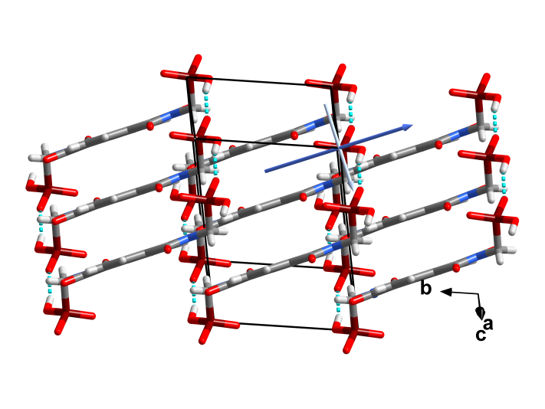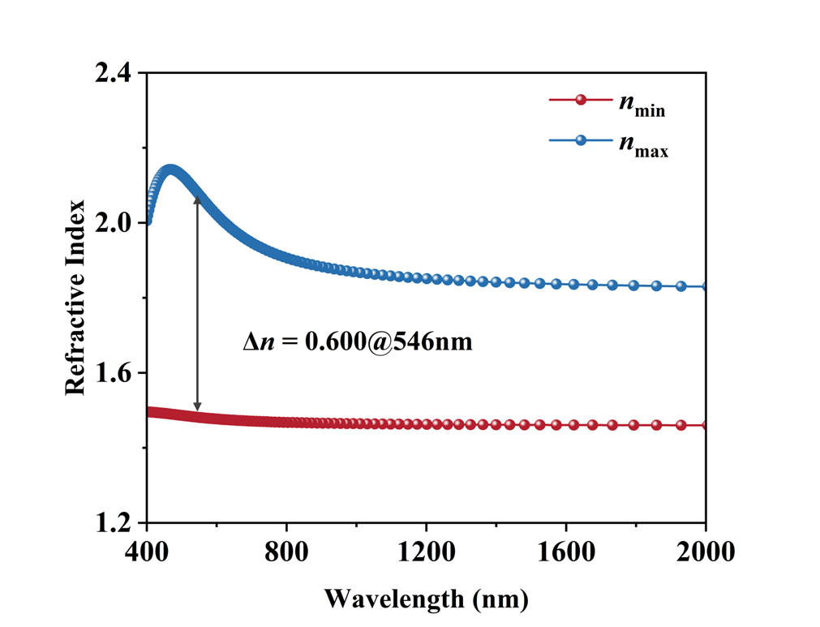
n_{max}
n_{min}
Figure S40. (a) Calculated refractive index of ABC-2. (b) Directions perpendicular and parallel to the π-conjugated unit.

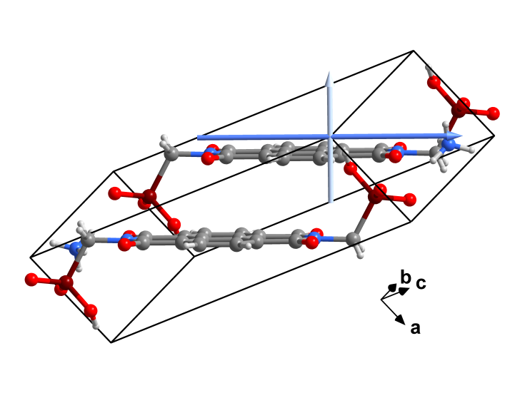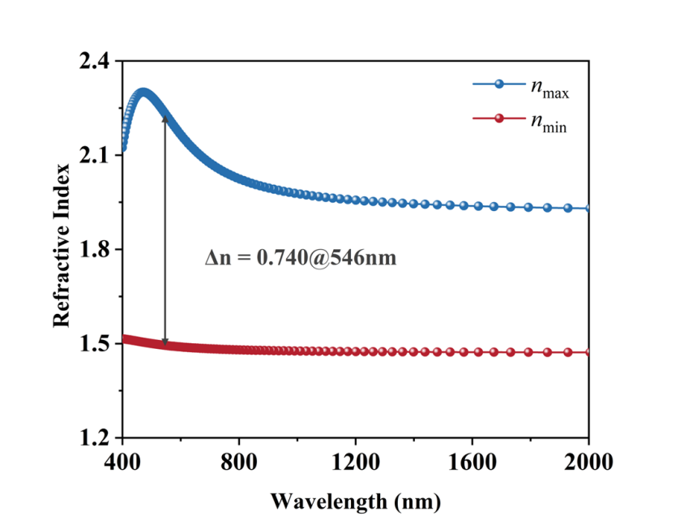
n_{min}
n_{max}
Figure S41. (a) Calculated refractive index of ABC-3. (b) Directions perpendicular and parallel to the π-conjugated unit.

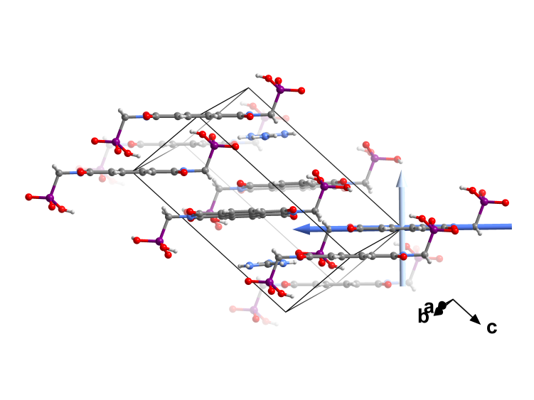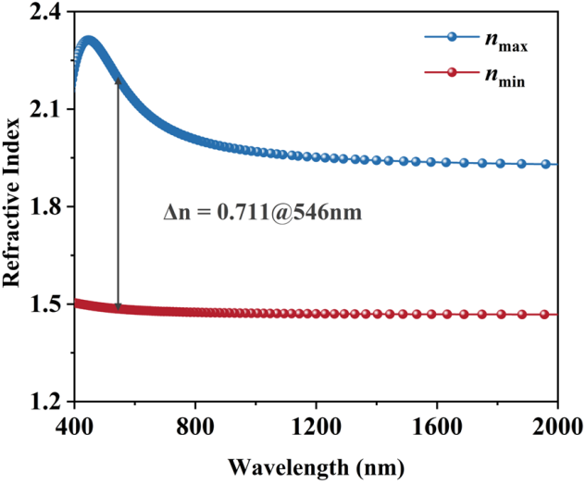
n_{min}
n_{max}
(a)
(b)
Figure S42. (a) Calculated refractive index of ABC-4. (b) Directions perpendicular and parallel to the π-conjugated unit.

Table S4. Static polarizability tensors and corresponding polarizability anisotropies (a.u.) of the P1, P2, and P3 functional modules.

Groups | Static polarizability (α) |  |  |  |  |  | δ
Groups | xx | xy | yy | xz | yz | zz | δ
P1 | 461.4 | -5.2 | 310.0 | -27.0 | -3.8 | 179.6 | 248.9
P2 | 503.3 | -6.8 | 332.6 | -26.5 | -3.4 | 202.3 | 265.8
P3 | 459.9 | 0 | 308.3 | 0 | 21.3 | 182.1 | 243.7

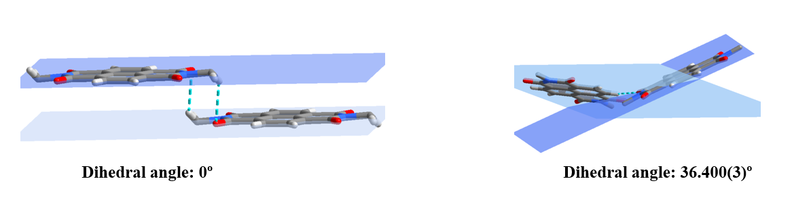
Figure S43. Dihedral angle between adjacent π-conjugated NDI units in ABC-1.

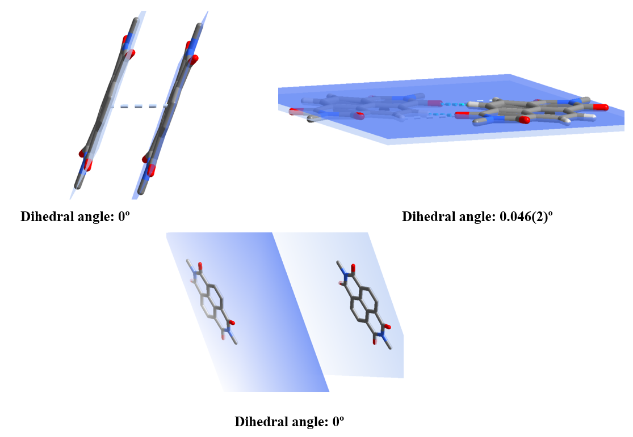
Figure S44. Dihedral angle between adjacent π-conjugated NDI units in ABC-2.

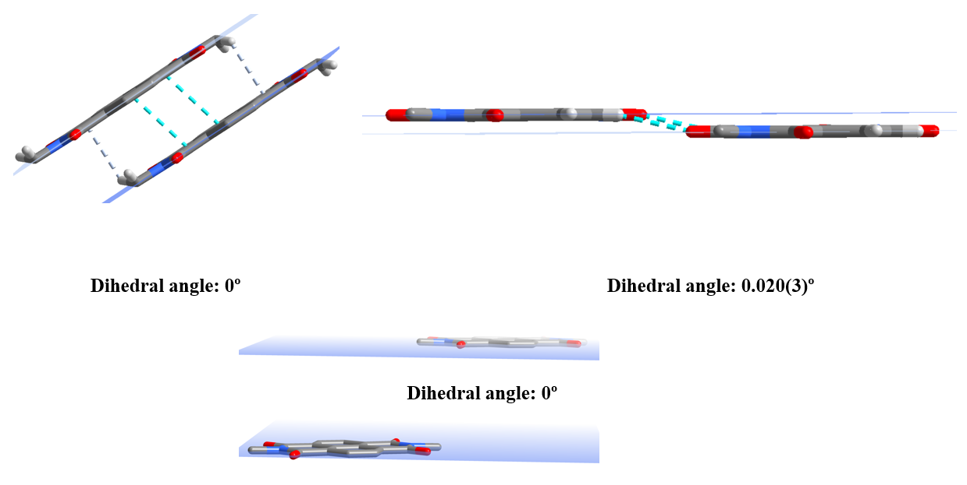
Figure S45. Dihedral angle between adjacent π-conjugated NDI units in ABC-3.

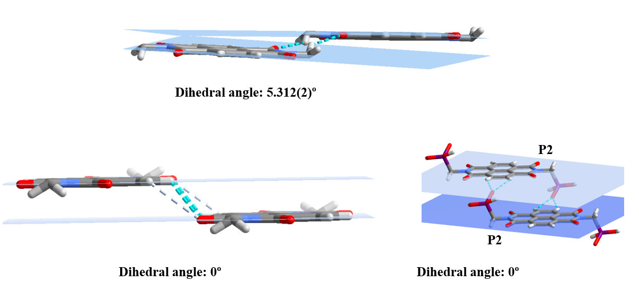
Figure S46. Dihedral angle between adjacent π-conjugated NDI units in ABC-4.

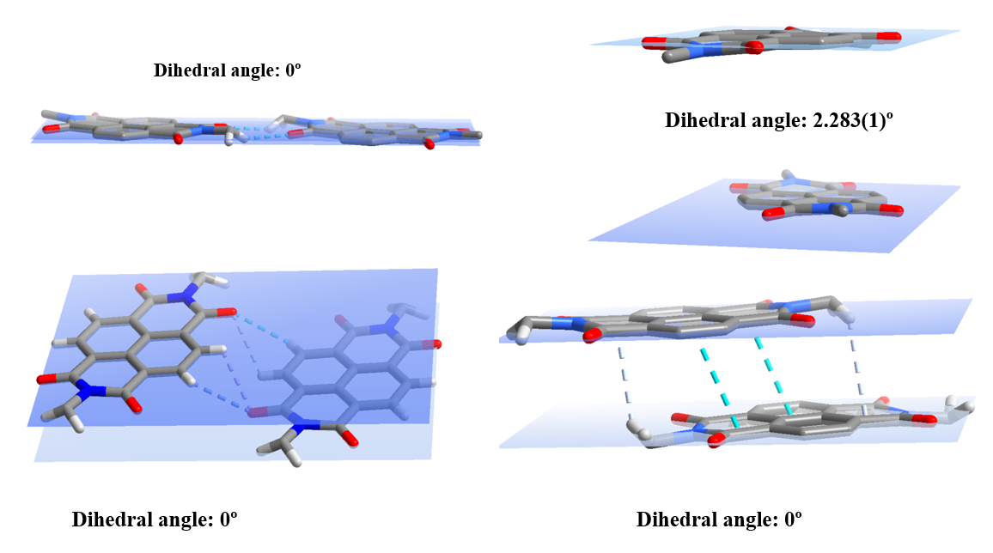
Figure S47. Dihedral angle between adjacent π-conjugated NDI units in ABC-5.

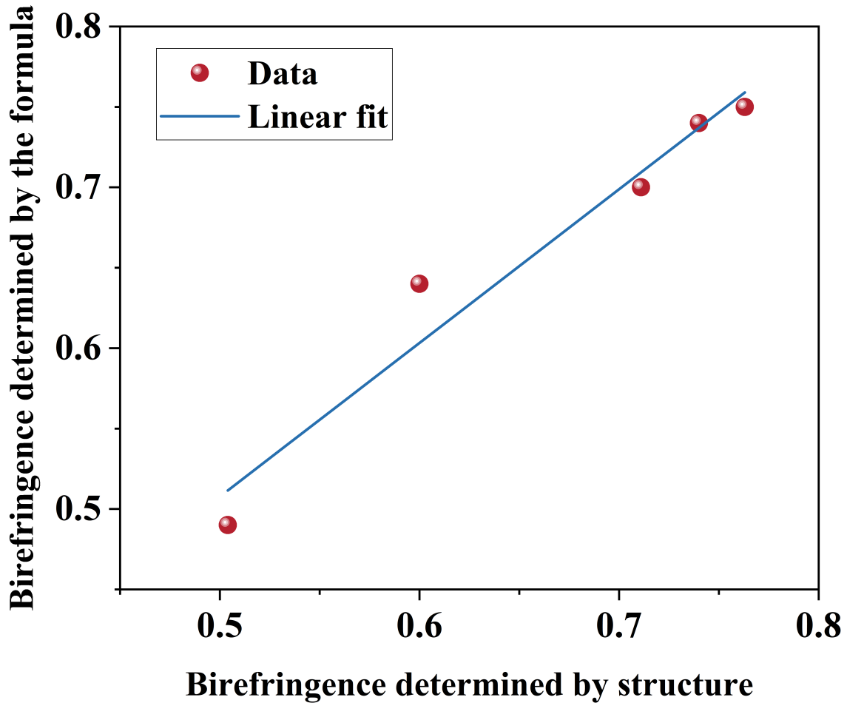
Figure S48. Comparison of birefringence values calculated from crystal structures and those predicted by Equation 6 (S5) for ABC-1–ABC-5.

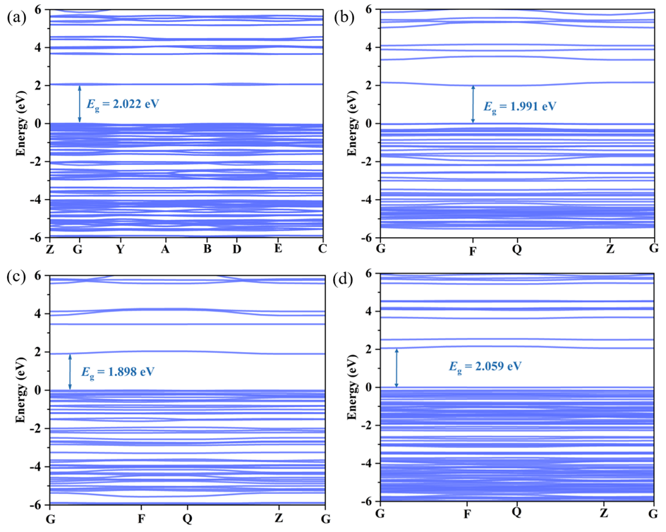
Figure S49. Calculated band gaps of ABC-1 (a), ABC-2 (b), ABC-3 (c), and ABC-4 (d).

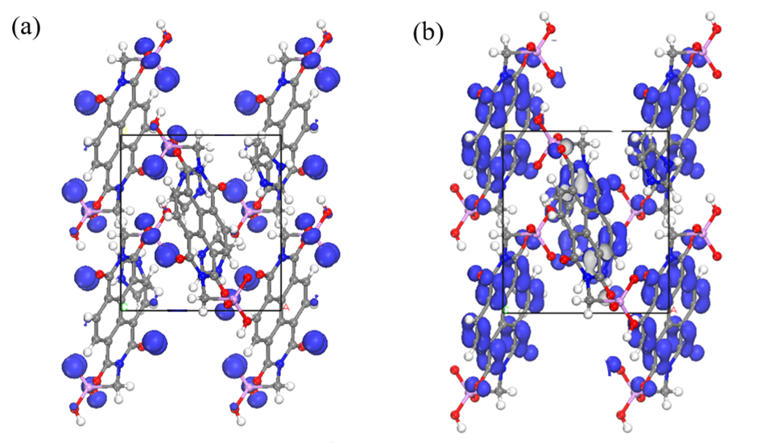
Figure S50. HOMO and LUMO maps of ABC-1.

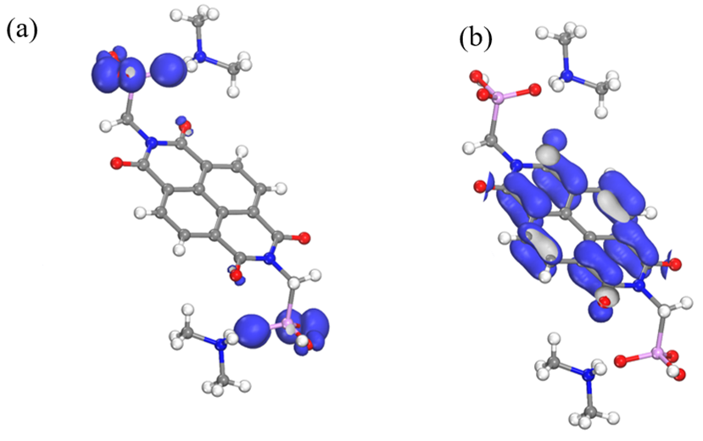
Figure S51. HOMO and LUMO maps of ABC-2.

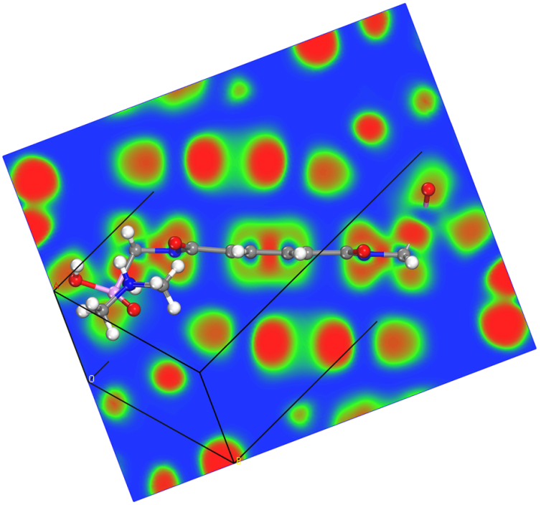
Figure S52. Two-dimensional electron localization function maps perpendicular to the π-conjugated NDI unit in ABC-2.

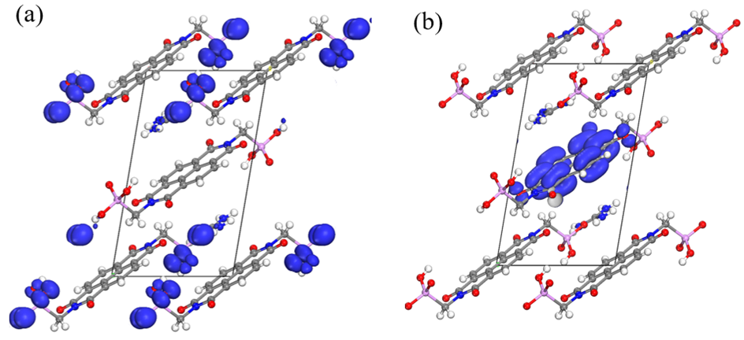
Figure S53. HOMO and LUMO maps of ABC-4.

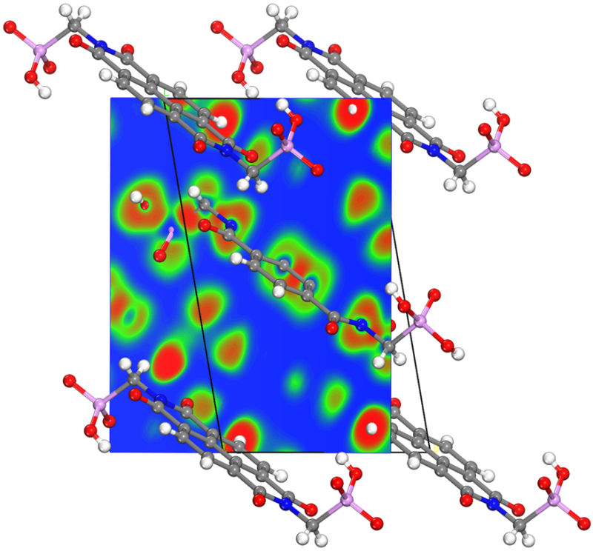
Figure S54. Two-dimensional electron localization function maps perpendicular to the π-conjugated NDI units in ABC-4.

Table S3. Comparison of birefringence in phosphate- and phosphonate-based crystals.
No. | Crystal | Space group | Birefringence | Wavelength(nm) | Bad gap (eV) | Ref
1 | HOFBC-1 (ABC-5) | P2₁/c | 0.763(cal) | 546 | 2.93 | 1
2 | ABC-3 | P-1 | 0.740(cal) | 546 | 2.85 | This work
3 | ABC-4 | P-1 | 0.711(cal) | 546 | 2.99 | This work
4 | Sn₂PO₄I | Cmcm | 0.664(exp) | 546 | 1.65 | 14
5 | C₆N₇(NH₂)₃·H₃PO₄ | R3c | 0.609(cal) | 1064 | 3.77 | 15
6 | ABC-2 | P-1 | 0.600(cal) | 546 | 2.94 | This work
7 | ABC-1 | P2₁/n | 0.504(cal) | 546 | 2.98 | This work
8 | Hg^{I}₂Hg^{II}(Te₂O₄)₂(HPO₄)₂ | P-1 | 0.444(cal) | 546 | 3.32 | 16
9 | Sn₂PO₄Br | Cmcm | 0.336(exp) | 546 | 1.97 | 14
10 | (3CP)(H₂PO₄) | Pbca | 0.284(cal) | 546 | 4.24 | 17
11 | NaPO₂(NH)₃(CO)₂ | P21/c | 0.280(exp) | 550 | 6.5 | 18
12 | (C₅H₆ON)⁺(H₂PO₄)⁻ | P2₁2₁2₁ | 0.25(cal) | 1064 | 4.69 | 19
13 | K(GeHPO₃)₂ Br | P-3m1 | 0.247(exp) | 546 | 3.7 | 20
14 | (C₄H₆N₃)⁺(H₂PO₃)⁻ | P2₁ | 0.225(cal) | 589.3 | 3.27 | 21
15 | (3AP)(H₂PO₄) | Fdd2 | 0.209(cal) | 546 | 4.24 | 17
16 | (C₂N₄OH₇)H₂PO₃ | Cc | 0.19(cal) | 589.3 | 4.96 | 22
17 | Hg₂(HTe₂O₅)(PO₄) | P-1 | 0.168(exp) | 546 | 3.58 | 23
18 | (C₃H₅N₂)(H₂PO₄) | Pna2₁ | 0.15(exp) | 546 | 5.41 | 24
19 | Te₃O₃(PO₄)₂ | P2₁/c | 0.158(cal) | 1064 | 4.28 | 25
20 | [(C₄H₆N₃)(H₂PO₄)] | P2₁2₁2₁ | 0.145(cal) | 546 | 2.315 | 26
21 | [CN₄H₇]H₂PO₂ | P2₁2₁2 | 0.144(cal) | 532 | 5.33 | 27
22 | [CN₄H₇]HPO₂(OH) | Pna2₁ | 0.144(cal) | 532 | 5.05 | 27
23 | CityU-10 | Aea2 | 0.133(exp) | 550 | - | 28
24 | Sr₃Y[PO₄][CO₃]₃ | R3m | 0.121(cal) | 532 | 6.85 | 29
25 | [NH₂(CH₂COOH)₂]H₂PO₂ | Ama2 | 0.120(cal) | 546 | 5.20 | 30
26 | (C₄H₇N₂)(H₂PO₄) | P2₁/n | 0.120(exp) | 546 | 5.21 | 24
27 | Y(HPO₄)(NO₃)(H₂O)·2H₂O | Pbcm | 0.09(exp) | 546.1 | 3.87 | 31
28 | (NH₄)₃B₁₁PO₁₉F₃ | R3 | 0.088(cal) | 1064 | 6.78 | 32
29 | K[PO₂(NHCONH₂)₂] | Fdd2 | 0.088(cal) | 532 | 5.50 | 33
30 | [C(NH₂)₃]₂PO₃(OH) | Pbca | 0.086(cal) | 546 | 6.29 | 34
31 | [C(NH₂)₃]₆(PO₄)₂·3H₂O | Cc | 0.077(cal) | 546 | 4.87 | 35
32 | Cs₃[(BOP)₂(B₃O₇)₃] | R3 | 0.075(cal) | 532 | 5.79 | 36
33 | LiHgPO₄ | P4̅2₁m | 0.068(cal) | 1064 | 4.03 | 37
34 | (C₂H₁₀N₂)[Zn₂(HPO₄)₂Cl₂] | P-1 | 0.066(exp) | 546 | 5.043 | 38
35 | [C(NH₂)₃]₄P₂O₇·H₂O | P2₁ | 0.065(exp) | 546 | 6.693 | 39
36 | Ag(Te₂O₃)(PO₄) | Pna2₁ | 0.062(cal) | 546 | 1.01 | 40
37 | GeHPO₃ | Pna2₁ | 0.062(exp) | 546 | 5.2 | 20
38 | [C(NH₂)₃]₃PO₄·2H₂O | Pna2₁ | 0.053(cal) | 546.1 | 4.2 | 41
39 | [NH₂(CH₂COOH)₂]H₂PO₃ | P2₁/n | 0.038(exp) | 546 | 5.16 | 30
40 | (C(NH₂)₃)₂Zn(HPO₃)₂ | Fdd2 | 0.03(cal) | 1064 | 6.18 | 42
41 | (NH₄)₂PO₃F | Pna2₁ | 0.027(cal) | 1064 | 7.59 | 43

S7. References
1 Sun, Y. et al. Giant Birefringence Induced by Intermolecular Aromatic Interactions in Hydrogen-Bonded Organic Frameworks. Adv. Mater. 37, e09171 (2025).
2 Sheldrick, G. M. A short history of SHELX. Acta Crystallogr. A 64, 112-122 (2008).
3 Dolomanov, O. V., Bourhis, L. J., Gildea, R. J., Howard, J. A. K. & Puschmann, H. OLEX2: a complete structure solution, refinement and analysis program. J. Appl. Crystallogr. 42, 339-341 (2009).
4 Stewart J. Clark, M. D. S., Chris J. Pickard, Phil J. Hasnip, Matt I. J. Probert, Keith Refson and Mike C. Payne. First principles methods using CASTEP. Z. Kristallogr. 220, 567-570 (2005).
5 Payne, M. C., Teter, M. P., Allan, D. C., Arias, T. A. & Joannopoulos, J. D. Iterative minimization techniques forab initiototal-energy calculations: molecular dynamics and conjugate gradients. Rev. Mod. Phys. 64, 1045-1097 (1992).
6 Kohn, W. Nobel Lecture: Electronic structure of matter-wave functions and density functionals. Rev. Mod. Phys. 71, 1253 (1999).
7 John P. Perdew, K. B., Matthias Ernzerhof. Generalized Gradient Approximation Made Simple. Phys. Rev. Lett. 77, 3865 (1996).
8 Rappe, A. M., Rabe, K. M., Kaxiras, E. & Joannopoulos, J. D. Optimized pseudopotentials. Phys. Rev. B 41, 1227-1230 (1990).
9 Monkhorst, H. J. & Pack, J. D. Special points for Brillouin-zone integrations. Phys. Rev. B 13, 5188-5192 (1976).
10 Frisch, M. J. T., G. W.; Schlegel, H. B.; Scuseria, G. E.; Robb, M. A.; Cheeseman, J. R.; Scalmani, G.; Barone, V.; Mennucci, B.; Petersson, G. A.; Nakatsuji, H.; Caricato, M.; Li, X.; Hratchian, H. P.; Izmaylov, A. F.; Bloino, J.; Zheng, G.; Sonnenberg, J. L.; Hada, M.; Ehara, M.; Toyota, K.; Fukuda, R.; Hasegawa, J.; Ishida, M.; Nakajima, T.; Honda, Y.; Kitao, O.; Nakai, H.; Vreven, T.; Montgomery, J. A., Jr.; Peralta, J. E.; Ogliaro, F.; Bearpark, M.; Heyd, J. J.; Brothers, E.; Kudin, K. N.; Staroverov, V. N.; Kobayashi, R.; Normand, J.; Raghavachari, K.; Rendell, A.; Burant, J. C.; Iyengar, S. S.; Tomasi, J.; Cossi, M.; Rega, N.; Millam, J. M.; Klene, M.; Knox, J. E.; Cross, J. B.; Bakken, V.; Adamo, C.; Jaramillo, J.; Gomperts, R.; Stratmann, R. E.; Yazyev, O.; Austin, A. J.; Cammi, R.; Pomelli, C.; Ochterski, J. W.; Martin, R. L.; Morokuma, K.; Zakrzewski, V. G.; Voth, G. A.; Salvador, P.; Dannenberg, J. J.; Dapprich, S.; Daniels, A. D.; Farkas, Ö.; Foresman, J. B.; Ortiz, J. V.; Cioslowski, J.; Fox, D. J. . Gaussian 09. Gaussian, Inc., Wallingford CT (2009).
11 Lu, T. & Chen, F. W. Multiwfn: A multifunctional wavefunction analyzer. J. Comput. Chem. 33, 580-59 (2012).
12 Humphrey, W., Dalke, A. & Schulten, K. VMD: Visual molecular dynamics. J. Mol. Graph. 14, 33-38 (1996).
13 Alparone, A. Linear and nonlinear optical properties of nucleic acid bases. Chemical Physics 410, 90-98 (2013).
14 Guo, J., Tudi, A., Han, S., Yang, Z. & Pan, S. Sn₂PO₄I: An Excellent Birefringent Material with Giant Optical Anisotropy in Non π-Conjugated Phosphate. Angew. Chem. Int. Ed. 60, 24901-24904 (2021).
15 Wei, R., Huang, H., Yang, D., Wang, Y. & Zhang, B. C₆N₇(NH₂)₃·H₃PO₄: Strong Second Harmonic Generation and Giant Birefringence Benefiting from Amino Substitution Strategy. Adv. Opt. Mater. 12, 240181 (2024).
16 Li, P. F., Hu, C. L., Mao, J. G. & Kong, F. A Giant Optically Anisotropic Phosphate Driven by Mixed Valence Mercury Units. Laser Photonics Rev. 19, 2401488 (2025).
17 Xu, M.-B. et al. Designing promising ultraviolet (UV) birefringent crystals with different hydrogen-bonded phosphate frameworks. Inorg. Chem. Front. 11, 4307-4317 (2024).
18 Zhou, Y., Zhang, X., Hong, M., Luo, J. & Zhao, S. Achieving effective balance between bandgap and birefringence by confining π-conjugation in an optically anisotropic crystal. Sci. Bull. 67, 2276-227 (2022).
19 Lu, J. et al. Discovery of NLO Semiorganic (C₅H₆ON)⁺(H₂PO₄)⁻: Dipole Moment Modulation and Superior Synergy in Solar-Blind UV Region. J. Am. Chem. Soc. 143, 3647-3654 (2021).
20 Tian, Y. et al. Ge-Enhanced UV Nonlinear Optical Properties in Layered Germanous Phosphites through Functional Group Sequential Construction. Angew. Chem. Int. Ed. 63, e202409093 (2024).
21 Zhang, Z.-P. et al. Driving Nonlinear Optical Activity with Dipolar 2-Aminopyrimidinium Cations in (C₄H₆N₃)⁺(H₂PO₃)⁻. Chem Mater 34, 1976-1984 (2022).
22 Guangsheng Xu, X. B., Zhihua Yang, Jian Han, and Shilie Pan. π-Conjugated Cations in Phosphates: A Pathway to Solar-Blind UV Nonlinear Optical Crystals with Phase-Matching. Angew. Chem. Int. Ed. 64, e202510363 (2025).
23 Li, P.-F., Hu, C.-L., Zhang, B., Mao, J.-G. & Kong, F. Hg₂(HTe₂O₅)(PO₄): a novel phosphate crystal with enhanced birefringence enabled by the synergistic modification of multiple functional groups. Inorg. Chem. Front. 12, 4712-4719 (2025).
24 Xia, Q. et al. Large optical anisotropy in noncentrosymmetric phosphate with pseudo 2D intercalated layer. Inorg. Chem. Front. 11, 8813-8823 (2024).
25 Dong, W. et al. Te₃O₃(PO₄)₂: a phosphate crystal with large birefringence activated by the highly distorted [TeO5] group and antiparallel [PO₄] pseudo-layer. J. Mater. Chem. C 8, 9585-9592 (2020).
26 Arif, M. et al. Optimizing optical anisotropy in low-dimensional structures via intralayer hydrogen bonding modulation and anionic substitution. Mater. Horiz. 12, 3538-3545 (2025).
27 Zhang, W. et al. Highly Polarizable Phosphorus-Centered Tetrahedra and π-Conjugated Carbon-Centered Triangular Moieties Inducing Large Anisotropy and Short-Wavelength Phase-Matching. Adv. Opt. Mater. 13, 2403372, (2025).
28 Xue, M. et al. A Metal-Free Helical Covalent Inorganic Polymer: Preparation, Crystal Structure and Optical Properties. Angew. Chem. Int. Ed. 63, e202315338, (2024).
29 Xiong, L., Wu, L. M. & Chen, L. A General Principle for DUV NLO Materials: π-Conjugated Confinement Enlarges Band Gap. Angew. Chem. Int. Ed. 60, 25063-25067 (2021).
30 Duan, L. et al. Hydrogen-Bond-Modulated Alignment of Iminodiacetic Acid Cations for Achieving Ultraviolet Second Harmonic Generation. Adv. Opt. Mater. 14, e03629 (2026).
31 Heo, Y., Li, Y., Kim, J., Joo, S. H. & Ok, K. M. Y(HPO₄)(NO₃)(H₂O)·2H₂O: A Solvent-Responsive Inorganic Layered Material with Reversible Phase Transitions and Optically Active Proton Conductivity. Chem. Mater. 37, 4910-4916 (2025).
32 Cheng, B. et al. (NH₄)₃B₁₁PO₁₉F₃: a deep-UV nonlinear optical crystal with unique [B₅PO10F]∞ layers. Natl. Sci. Rev. 9, nwac110 (2022).
33 Chen, F., Mo, F., Chen, H., Lin, M.-J. & Chen, Y. KPO₂(NHCONH₂)₂: A Promising Deep-Ultraviolet Nonlinear Optical Phosphate Containing Polar [PO₂(NHCONH₂)₂]⁻ Tetrahedra. Chem. Mater. 36, 2985-2992 (2024).
34 Zhou, H., Cheng, M., Yang, Z. & Pan, S. [C(NH₂)₃]₂PO₃(OH): A Deep-Ultraviolet Birefringent Crystal Enabled by Synergy of π-Conjugated Cations and Heteroleptic Tetrahedra. ACS Appl. Opt. Mater. 4, 200-205 (2025).
35 Wu, C. et al. UV Solar-Blind-Region Phase-Matchable Optical Nonlinearity and Anisotropy in a π-Conjugated Cation-Containing Phosphate. Angew. Chem. Int. Ed. 60, 14806-14810 (2021).
36 Liu, H. et al. Cs₃[(BOP)₂(B₃O₇)₃]: A Deep-Ultraviolet Nonlinear Optical Crystal Designed by Optimizing Matching of Cation and Anion Groups. J. Am. Chem. Soc. 145, 12691-12700 (2023).
37 Wu, B.-L., Hu, C.-L., Mao, F.-F., Tang, R.-L. & Mao, J.-G. Highly Polarizable Hg²⁺ Induced a Strong Second Harmonic Generation Signal and Large Birefringence in LiHgPO₄. J. Am. Chem. Soc. 141, 10188-10192 (2019).
38 Fang, Z., Pan, Y.-M., Han, P., Yang, B.-P. & Duan, M.-H. (C₂H₁₀N₂)[Zn₂(HPO₄)₂Cl₂]: substitution-activated new short-wave ultraviolet phosphate with pivotal dual-property enhancement. J. Mater. Chem. C 12, 17482-17489 (2024).
39 Wu, L. et al. Enhanced Tripling-Performance in [C(NH₂)₃]₄P₂O₇·H₂O as UV Nonlinear Optical Material Due to π-Conjugated Cation and Hydrogen Bonding Intervention. Chinese Journal of Structural Chemistry. 41, 100904 (2026).
40 Chen, W. et al. Ag(Te₂O₃)(PO₄): Linear and Nonlinear Optical Properties of a Noncentrosymmetric Phosphotellurite with P-O-Te Connection. Inorg. Chem. 64, 24321-24328 (2025).
41 Wen, X. et al. [C(NH₂)₃]₃PO₄·2H₂O: A new metal-free ultraviolet nonlinear optical phosphate with large birefringence and second-harmonic generation response. Sci. China Mater. 64, 2008-2016 (2021).
42 Zhang, J., Zhang, X., Wang, Y., Wu, K. & Zhang, B. Phosphites: A Nonlinear Optical Materials System with a Wide Band Gap and Moderate Second-Harmonic Generation Effect. Inorg. Chem. 61, 18622-18628 (2022).
43 Zhang, B. et al. Expanding Frontiers of Ultraviolet Nonlinear Optical Materials with Fluorophosphates. Chem. Mater. 30, 5397-5403 (2018).

