STING Beyond Immunity: Tumour-Intrinsic Roles in Breast Cancer Progression and Metastasis
Authors: Vaibhavi Joshi¹, Kate Beecher¹, Pascal HG Duijf², Andrew Stacey^{1,3}, Sam Druskovich^{1,3}, Sarah Reed¹, Peter T Simpson^{1,4}, Sunil R Lakhani^{1,3}, Amy E McCart Reed^{1,*}
Author Affiliations:
¹Frazer Institute, Faculty of Health, Medicine and Behavioural Sciences, The University of Queensland, Australia
²Centre for Cancer Biology, Clinical and Health Sciences, Adelaide University & SA Pathology, Australia
³Pathology Queensland, Royal Brisbane and Women’s Hospital, Australia
⁴School of Biomedical Sciences, Faculty of Health, Medicine and Behavioural Sciences, The University of Queensland, Australia

*Corresponding author:
Amy E McCart Reed, Frazer Institute, Faculty of Health, Medicine and Behavioural Sciences, The University of Queensland, Brisbane 4029, Australia. Email: amy.reed@uq.edu.au
Running title: STING Beyond Immunity in Breast Cancer
Keywords: STING, breast cancer, brain metastasis, tumour intrinsic, biomarker
Conflict of interest statement: The authors declare no potential conflicts of interest.

Supplementary Figures and Tables

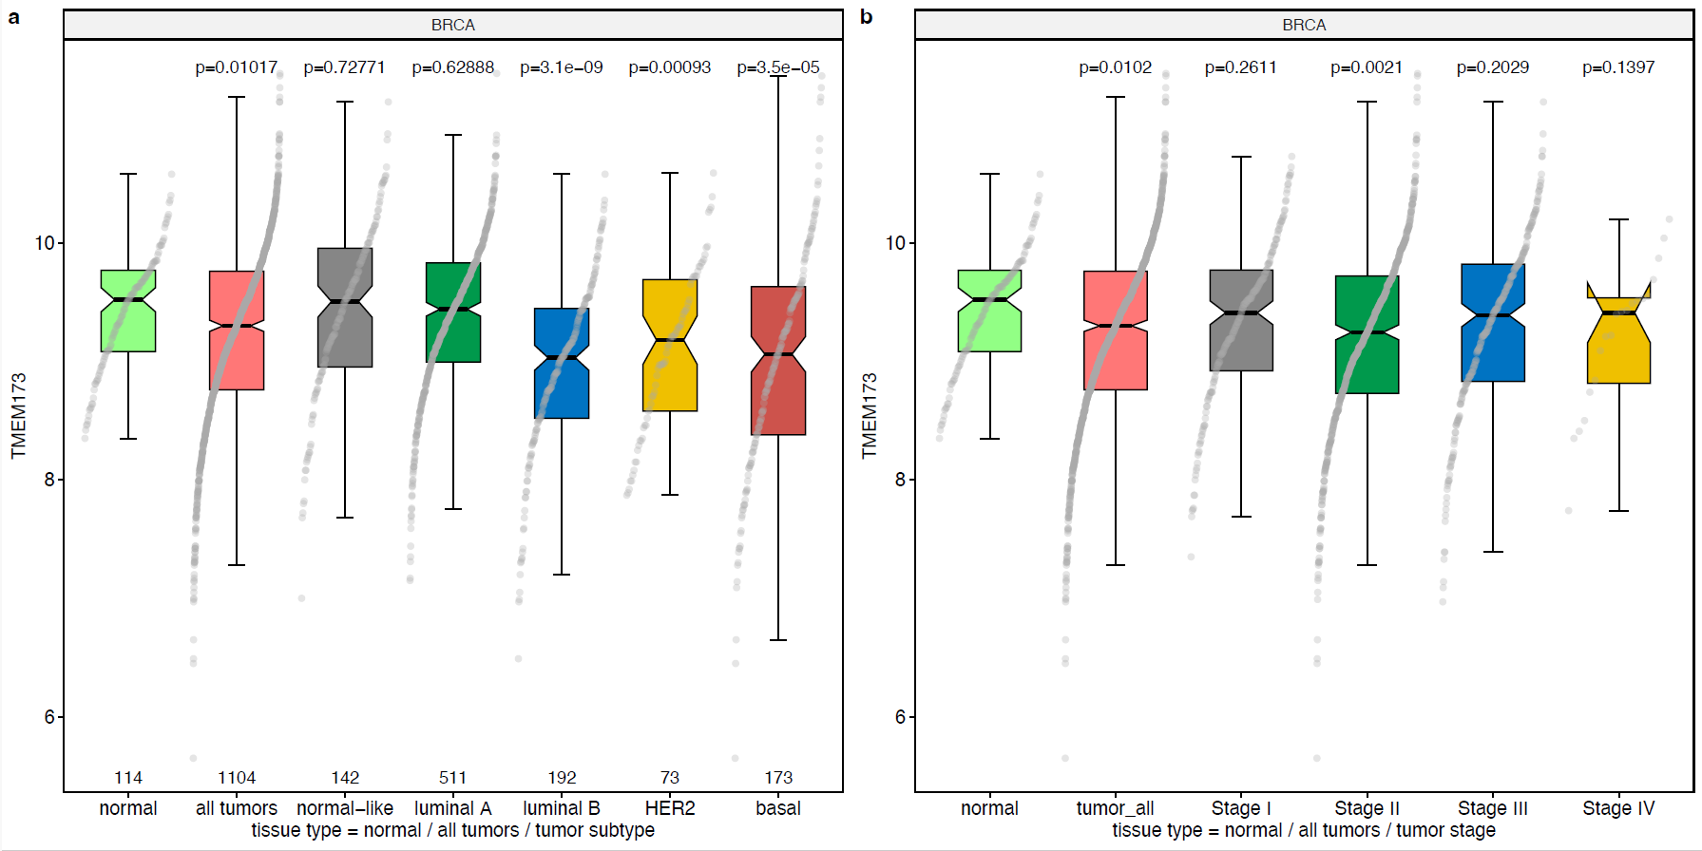
Figure S1. TMEM173 (STING) expression in normal breast and breast cancer tissues across subtypes and stages. (a, b) Boxplots of TMEM173 mRNA expression levels in adjacent normal and breast cancer tissues in the invasive breast cancer (BRCA) dataset from The Cancer Genome Atlas (TCGA), including all breast cancer samples combined, as well as per PAM50 subtype (a) and stage (b). Boxplots show medians, interquartile ranges and all individual data points. P values: Mann-Whitney U tests compared to the normal breast tissue group.

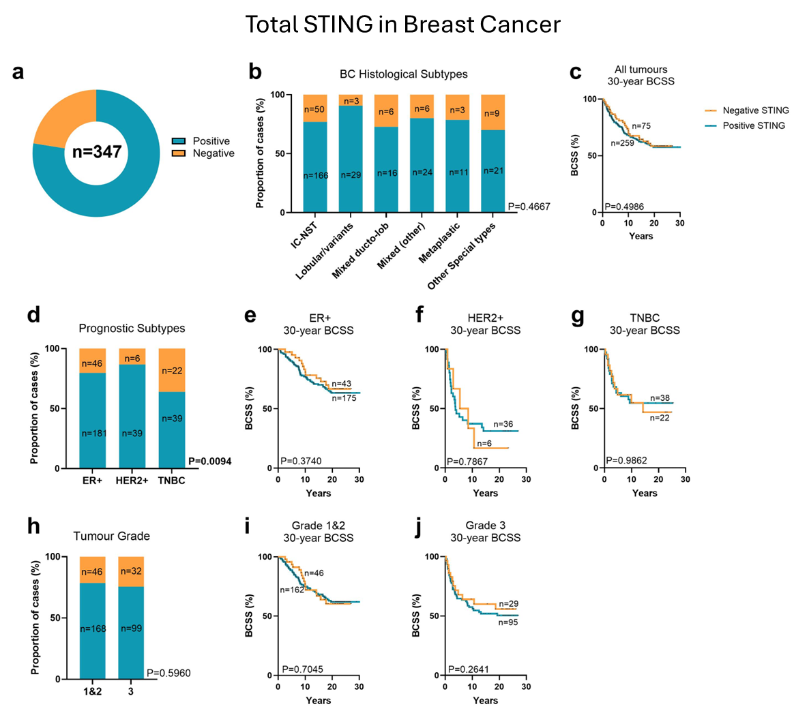
Figure S2. STING expression in breast tumours in the QFU cohort. (a) Breakdown of STING expression with 77% of the breast tumours in the QFU cohort stained positive for STING (n = 269 of 347). (b) Chi-square analysis of the proportion of breast cancer histological subtypes with negative, or positive STING expression. (c) Kaplan–Meier (KM) analysis of STING expression and 30-year BCSS. (d) Chi-square analysis of the proportion of breast cancer prognostic subtypes (ER+, HER2+, and TNBC) with negative or positive STING expression. (e-f) Kaplan–Meier (KM) analysis of STING expression and 30-year BCSS across ER (e), HER2 (f) and TNBC (g). (h) Chi-square analysis of the proportion of breast cancer cases with positive and negative STING expression compared across tumour grades. (i-j) Kaplan–Meier (KM) analysis of STING expression and 30-year BCSS across Grade 1 and 2 (i), and Grade 3 (j).
BC, breast cancer; BCSS, breast cancer specific survival; ER+, oestrogen receptor; HER2+, human epidermal growth factor receptor 2; IC-NST, invasive carcinoma of no special type; TNBC, triple negative breast cancer.
Figure S3. pSTING expression and lymphocytic infiltration and tumour infiltrating lymphocytes in the QFU cohort. (a) Chi-square analysis of lymphocytic infiltration (LI) in all tumours as well as ER+ only, HER2+ only, and TNBC only. (b) Chi-square analysis of tumour infiltrating lymphocytes (TILS) in all tumours as well as HER2+ only, and TNBC only.
BC, breast cancer; ER+, oestrogen receptor; HER2+, human epidermal growth factor receptor 2; LI, lymphocytic infiltration; TILs, tumour infiltrating lymphocytes; TNBC, triple negative breast cancer.
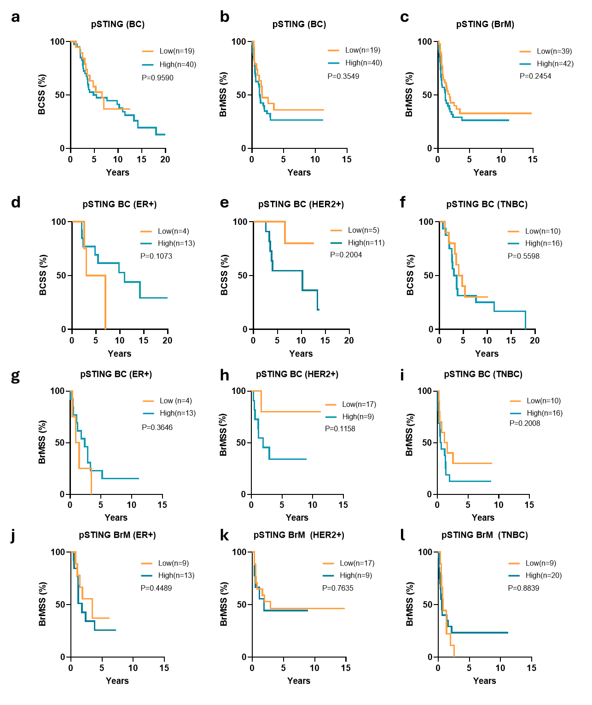

Figure S4. Survival analysis of pSTING expression in BC and BrM. (a) KM analysis of pSTING expression and BCSS in BC tumours. KM analysis of pSTING expression and BrMSS in (b) BC tumours and (c) BrM tumours. KM analysis of pSTING expression and BrMSS in BrM tumours. KM analysis of pSTING expression and BCSS in BC cases compared across hormone receptor subtypes- (d) ER+; (e) HER2+; (f) TNBC. KM analysis of STING expression and BrMSS in BC cases compared across hormone receptor subtypes- (g) ER+; (h) HER2+; (i) TNBC. KM analysis of pSTING expression and BrMSS in BrM cases compared across hormone receptor subtypes- (j) ER+; (k) HER2+; (l) TNBC.
BCSS, Breast cancer specific survival; BrMSS, Brain metastasis specific survival; KM, Kaplan Meier; ER+, oestrogen receptor; HER2+, Human epidermal growth factor receptor 2; TNBC, triple negative breast cancer

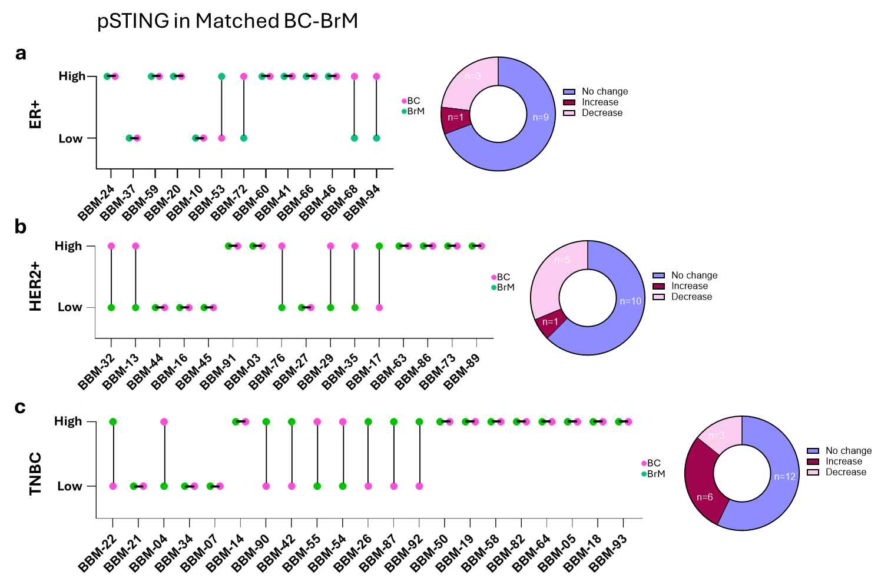
Figure S5. pSTING status across matched BC-BrM cases. Matched case by case analysis of pSTING expression status in primary breast cancer matched with corresponding brain metastases in (a) ER+, (b) HER2+, and (c) TNBC cases.
ER+, oestrogen receptor; HER2+, Human epidermal growth factor receptor 2; TNBC, triple negative breast cancer

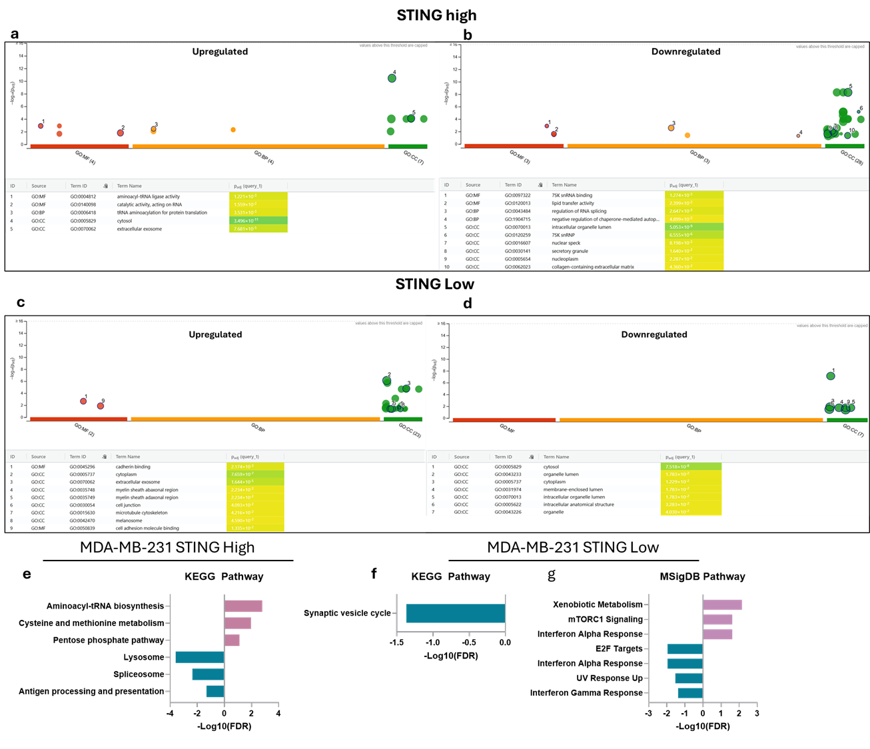
Figure S6. Functional enrichment analysis of STING-associated differentially expressed proteins relative to control.
Gene Ontology (GO) biological process enrichment analysis of (a) upregulated and (b) downregulated proteins in STING-high cells compared with control.
GO biological process enrichment analysis of (c) upregulated and (d) downregulated proteins in STING-low cells compared with control.
KEGG pathway enrichment analysis of differentially expressed proteins in (e) STING-high and (f) STING-low cells relative to control.
(g) MSigDB Hallmark pathway enrichment analysis of differentially expressed proteins in STING-low cells compared with control. Pathways with FDR < 0.05 are shown.
Table S1. General linear model analysis for time to neurosurgery
Dependent Variable: Time to Neurosurgery
Source | Type III Sum of Squares | df | Mean Square | F | Sig.
Corrected Model | 155.363ª | 5 | 31.073 | 2.289 | 0.059
Intercept | 718.722 | 1 | 718.722 | 52.939 | 0.000
pSTING expression (Low vs High) | 47.658 | 1 | 47.658 | 3.510 | 0.067
Breast cancer subtypes | 57.932 | 2 | 28.966 | 2.134 | 0.128
STING x Subtype interaction | 14.062 | 2 | 7.031 | 0.518 | 0.599
Error | 719.550 | 53 | 13.576
Total | 1862.757 | 59
R Squared = .178 (Adjusted R Squared = .100) | 874.913 | 58
a. R Squared = .178 (Adjusted R Squared = .100)

Table S2.1 Significant Gene Ontology Terms MDA-MB-231 STING High vs STING Low (Upregulated)
ID | Term_name | Source | Adjusted  p_value | Intersections
1 | Structural constituent of ribosome | GO:MF | 1.01E-24 | RPL10A,RPL12,RPL13A,RPL14,RPL15,RPL18,RPL21,RPL23A,RPL24,RPL27,RPL27A,RPL3,RPL32,RPL35,RPL36,RPL4,RPL6,RPL7,RPL7A,RPLP1,RPS13,RPS15A,RPS16,RPS2,RPS24,RPS3A,RPS4X,RPS8
2 | RNA binding | GO:MF | 2.77E-15 | AARS1,ALYREF,BTF3,CDC5L,CORO1A,DDX20,FBL,MKI67,NOP2,PUS7,RANGAP1,RPL10A,RPL12,RPL13A,RPL14,RPL15,RPL18,RPL21,RPL23A,RPL24,RPL27,RPL27A,RPL3,RPL32,RPL35,RPL36,RPL4,RPL6,RPL7,RPL7A,RPS13,RPS15A,RPS16,RPS2,RPS24,RPS3A,RPS4X,RPS8,SARS1,SPATS2L,STAU1,SUPT16H,TAF15,TOP1
3 | Cadherin binding | GO:MF | 0.000243507 | EFHD2,PDLIM5,RANGAP1,RPL14,RPL15,RPL23A,RPL24,RPL6,RPL7A,RPS2
4 | Aminoacyl-tRNA ligase activity | GO:MF | 0.011612634 | AARS1,AARSD1,SARS1,WARS1
5 | Ser-tRNA(Ala) deacylase activity | GO:MF | 0.025058823 | AARS1,AARSD1
6 | Cytoplasmic translation | GO:BP | 1.71E-41 | AARS1,MTOR,RPL10A,RPL12,RPL13A,RPL14,RPL15,RPL18,RPL21,RPL23A,RPL24,RPL27,RPL27A,RPL3,RPL32,RPL35,RPL36,RPL4,RPL6,RPL7,RPL7A,RPLP1,RPS13,RPS15A,RPS16,RPS2,RPS24,RPS3A,RPS4X,RPS8,SARS1
7 | Ribosome biogenesis | GO:BP | 1.86E-10 | FBL,NOP2,RPL14,RPL24,RPL27,RPL35,RPL7,RPL7A,RPS13,RPS15A,RPS16,RPS24,RPS3A,RPS4X,RPS8
8 | Cellular component biogenesis | GO:BP | 0.013929686 | AP2S1,BOLA2,CORO1A,DDX20,FBL,GBP1,GOLPH3,HAT1,INPPL1,ISG15,MACROH2A1,MTOR,NAPA,NOP2,OGFOD1,PDLIM5,RPL13A,RPL14,RPL24,RPL27,RPL35,RPL7,RPL7A,RPS13,RPS15A,RPS16,RPS24,RPS3A,RPS4X,RPS8,RRM2,SUPT16H,TUBB,WARS1
9 | tRNA aminoacylation for protein translation | GO:BP | 0.020530705 | AARS1,AARSD1,SARS1,WARS1
10 | Cytosolic ribosome | GO:CC | 1.77E-43 | RPL10A,RPL12,RPL13A,RPL14,RPL15,RPL18,RPL21,RPL23A,RPL24,RPL27,RPL27A,RPL3,RPL32,RPL35,RPL36,RPL4,RPL6,RPL7,RPL7A,RPLP1,RPS13,RPS15A,RPS16,RPS2,RPS24,RPS3A,RPS4X,RPS8
11 | Focal adhesion | GO:CC | 8.99E-13 | RPL10A,RPL12,RPL13A,RPL18,RPL27,RPL3,RPL4,RPL6,RPL7,RPL7A,RPLP1,RPS13,RPS16,RPS2,RPS3A,RPS4X,RPS8,ZNF185
12 | Synapse | GO:CC | 7.25671E-05 | AP2S1,CALB2,CORO1A,NAPA,PDLIM5,RPL10A,RPL12,RPL13A,RPL14,RPL15,RPL24,RPL27,RPL27A,RPL36,RPL6,RPL7,RPL7A,RPS13,RPS16,STAU1
13 | Nucleoplasm | GO:CC | 0.000359948 | ALYREF,CDC5L,CNDP2,DDX20,FBL,HAT1,IMUP,INPPL1,INTS7,ISG15,MACROH2A1,MKI67,MTOR,NOP2,OGFOD1,PPIL3,RANGAP1,RPL27,RPL27A,RPL4,RPS13,RPS15A,RPS16,RPaS2,RPS24,RPS3A,RPS4X,RPS8,RRM2,SPATS2L,SUPT16H,TAF15,TOP1
14 | Rough endoplasmic reticulum | GO:CC | 0.000589542 | RPL18,RPL27,RPL4,RPL6,STAU1
15 | Postsynaptic density | GO:CC | 0.042846 | PDLIM5,RPL10A,RPL12,RPL14,RPL6,RPL7,RPS13

Table S2.2 Significant Gene Ontology Terms MDA-MB-231 STING High vs STING Low (Downregulated)
ID | Term_name | Source | Adjusted_p_value | Intersections
1 | RNA binding | GO:MF | 5.8218E-06 | NAT10,ZC3H14,SIN3A,PUS1,PTPN1,HLA-A,PDCD4,FXR1,GRWD1,TST,SERPINH1,S100A4,ASS1,CCAR2,HNRNPC,RBM12,RALY,H1-5,CAVIN1,PPP1R8,CALR,FSCN1,LSM4,HMGB3,SNRPB,SAFB,SNRPD2,SNRPD3,CSTB,SRRT,LSM3,CELF1,KHSRP,TARDBP,HNRNPK,FAM120A,SND1
2 | Protein binding | GO:MF | 0.005683587 | POLR2L,DIP2B,NAT10,CCNK,GATAD2B,UNC119B,ZC3H14,DCLK1,NEU1,SEC16A,PIP4K2C,POMP,SIN3A,AGR2,PDHB,CTSZ,PTPN1,LGMN,CTSB,HLA-A,PDCD4,ESYT1,PSAP,ITGB1,CTPS2,CAT,FXR1,PIR,GRWD1,CSPG4,SDHA,ANKFY1,NAE1,SERPINH1,ATL3,S100A4,TCEAL4,ASS1,LGALS3BP,CALU,CCAR2,TMPO,ACSS2,TXNDC5,HNRNPC,RBM12,RALY,ENY2,SUMF2,H1-5,ICAM1,CAVIN1,PPP1R8,GNS,CALR,PARD6B,FSCN1,CD59,CNPY3,LSM4,VAPA,HMGB3,RAB21,SH3GLB1,SNRPB,EHD2,AIP,SAFB,SNRPD2,SNRPD3,GALE,CSTB,NDUFA8,SRRT,LSM3,ASPSCR1,CELF1,ATP6V1B2,KHSRP,TPM3,TARDBP,HNRNPK,DPYSL2,IDH3A,FAM120A,SND1
3 | Protein-containing complex binding | GO:MF | 0.030683018 | GATAD2B,SIN3A,CTSB,HLA-A,ITGB1,FXR1,SERPINH1,HNRNPC,H1-5,ICAM1,CALR,FSCN1,SNRPB,NDUFA8,SRRT,TPM3,SND1
4 | 7-methylguanosine cap hypermethylation | GO:BP | 0.009576964 | SNRPB,SNRPD2,SNRPD3
5 | RNA catabolic process | GO:BP | 0.020178128 | ZC3H14,FXR1,HNRNPC,PPP1R8,LSM4,CELF1,KHSRP,TARDBP,SND1
6 | Tricarboxylic acid cycle | GO:BP | 0.034085064 | PDHB,SDHA,ACO2,IDH3A
7 | Intracellular organelle lumen | GO:CC | 4.88E-11 | POLR2L,NAT10,CCNK,GATAD2B,ZC3H14,NEU1,PIP4K2C,POMP,SIN3A,CTSA,PDHB,PUS1,CTSZ,PTPN1,MIX23,LGMN,CTSB,PSAP,IRF2BP2,COLGALT1,CAT,FXR1,PIR,GRWD1,CSPG4,SDHA,TST,SERPINH1,CFDP1,S100A4,ASS1,LGALS3BP,CALU,CCAR2,ACSS2,TXNDC5,HNRNPC,RBM12,ENY2,SUMF2,H1-5,CAVIN1,PPP1R8,GNS,CALR,CNPY3,LSM4,SH3GLB1,ACO2,SNRPB,AIP,SAFB,SNRPD2,SNRPD3,CSTB,NDUFA8,SRRT,LSM3,ASPSCR1,CELF1,KHSRP,TARDBP,HNRNPK,IDH3A
8 | Catalytic step 2 spliceosome | GO:CC | 2.81465E-05 | HNRNPC,RALY,SNRPB,SNRPD2,SNRPD3,LSM3,HNRNPK
9 | Pigment granule | GO:CC | 0.032242176 | CTSB,ITGB1,CALU,ATP6V1B2,SND1
10 | Oxidoreductase complex | GO:CC | 0.046511852 | PDHB,CAT,SDHA,NDUFA8,IDH3A

Table S3. KEGG and MSigDB pathways enriched in MDA-MB-231 STING high vs STING Low cells
KEGG Pathways_STING High vs STING Low
 | Term | Overlap | P-value | Adjusted P-value | Odds Ratio | Combined Score | Genes
Upregulated | Ribosome | 28/158 | 2.53E-40 | 2.15E-38 | 90.71358 | 8270.667 | RPL4;RPL3;RPL32;RPLP1;RPL12;RPL10A;RPL6;RPL7;RPS4X;RPL7A;RPS16;RPS15A;RPL36;RPL14;RPL35;RPL15;RPS2;RPL18;RPS13;RPL21;RPS8;RPL13A;RPS3A;RPL23A;RPL27A;RPL24;RPL27;RPS24
Upregulated | Coronavirus disease | 29/232 | 3.92E-37 | 1.67E-35 | 61.24845 | 5134.398 | RPL4;RPL3;RPL32;RPLP1;RPL12;RPL10A;RPL6;RPL7;RPS4X;RPL7A;RPS16;RPS15A;RPL36;RPL14;RPL35;RPL15;RPS2;RPL18;RPS13;RPL21;RPS8;RPL13A;RPS3A;ISG15;RPL23A;RPL27A;RPL24;RPL27;RPS24
Downregulated | Lysosome | 7/128 | 2.58E-06 | 3.28E-04 | 13.00601 | 167.346 | CTSA;CTSZ;NEU1;PSAP;GNS;CTSB;LGMN
Downregulated | Spliceosome | 7/150 | 7.38E-06 | 4.69E-04 | 10.99285 | 129.8958 | HNRNPK;SNRPD2;SNRPD3;HNRNPC;LSM4;LSM3;SNRPB
Downregulated | Citrate cycle (TCA cycle) | 4/30 | 1.19E-05 | 5.04E-04 | 33.60778 | 381.0575 | PDHB;ACO2;SDHA;IDH3A
Downregulated | Glyoxylate and dicarboxylate metabolism | 3/30 | 3.84E-04 | 0.012194 | 24.00725 | 188.8104 | ACSS2;CAT;ACO2
Downregulated | Antigen processing and presentation | 4/78 | 5.21E-04 | 0.013227 | 11.77963 | 89.05652 | HLA-A;CALR;CTSB;LGMN
MSigDB Pathways_STING High vs STING Low
 | Term | Overlap | P-value | Adjusted P-value | Odds Ratio | Combined Score | Genes
Upregulated | Myc Targets V1 | 5/200 | 9.31E-04 | 0.023278 | 7.227106 | 50.43885 | FBL;RPL14;RPS2;RPL18;RPL6
Upregulated | Interferon Alpha Response | 3/97 | 0.005802 | 0.072521 | 8.790337 | 45.26676 | ISG15;IFIT3;WARS1
Downregulated | Adipogenesis | 7/200 | 4.73E-05 | 0.001845 | 8.124352 | 80.90987 | TST;CAVIN1;CAT;PDCD4;ESYT1;ACO2;IDH3A
Downregulated | Estrogen Response Late | 5/200 | 0.002662 | 0.020767 | 5.615385 | 33.29101 | GALE;TST;AGR2;PDCD4;ASS1
Downregulated | Myc Targets V1 | 5/200 | 0.002662 | 0.020767 | 5.615385 | 33.29101 | SNRPD2;FAM120A;SNRPD3;HNRNPC;TARDBP
Downregulated | Epithelial Mesenchymal Transition | 5/200 | 0.002662 | 0.020767 | 5.615385 | 33.29101 | ITGB1;SERPINH1;CALU;CD59;COLGALT1
Downregulated | Oxidative Phosphorylation | 5/200 | 0.002662 | 0.020767 | 5.615385 | 33.29101 | NDUFA8;PDHB;ACO2;SDHA;IDH3A

