STING Beyond Immunity: Tumour-Intrinsic Roles in Breast Cancer Progression and Metastasis
Authors: Vaibhavi Joshi¹, Kate Beecher¹, Pascal HG Duijf², Andrew Stacey^{1,3}, Sam Druskovich^{1,3}, Sarah Reed¹, Peter T Simpson^{1,4}, Sunil R Lakhani^{1,3}, Amy E McCart Reed^{1,*}
Author Affiliations:
¹Frazer Institute, Faculty of Health, Medicine and Behavioural Sciences, The University of Queensland, Australia
²Centre for Cancer Biology, Clinical and Health Sciences, Adelaide University & SA Pathology, Australia
³Pathology Queensland, Royal Brisbane and Women’s Hospital, Australia
⁴School of Biomedical Sciences, Faculty of Health, Medicine and Behavioural Sciences, The University of Queensland, Australia

*Corresponding author:
Amy E McCart Reed, Frazer Institute, Faculty of Health, Medicine and Behavioural Sciences, The University of Queensland, Brisbane 4029, Australia. Email: amy.reed@uq.edu.au
Running title: STING Beyond Immunity in Breast Cancer
Keywords: STING, breast cancer, brain metastasis, tumour intrinsic, biomarker
Conflict of interest statement: The authors declare no potential conflicts of interest.

Western Blot Supplementary file
Unedited blots for STING (target, ~42 kDa) and Vinculin (housekeeping/loading control, ~124 kDa). Membranes were cut horizontally at the 70 kDa marker to allow simultaneous detection of both proteins. STING was detected on the lower membrane section (45–70 kDa) and Vinculin on the upper section (70–210 kDa. Primary antibodies: anti-STING [1:1000; Cell Signaling Technology, clone D2P2F; #13647], anti-Vinculin [1:1000; Sigma-Aldrich; #V9131]. Detection: [ECL/fluorescent].

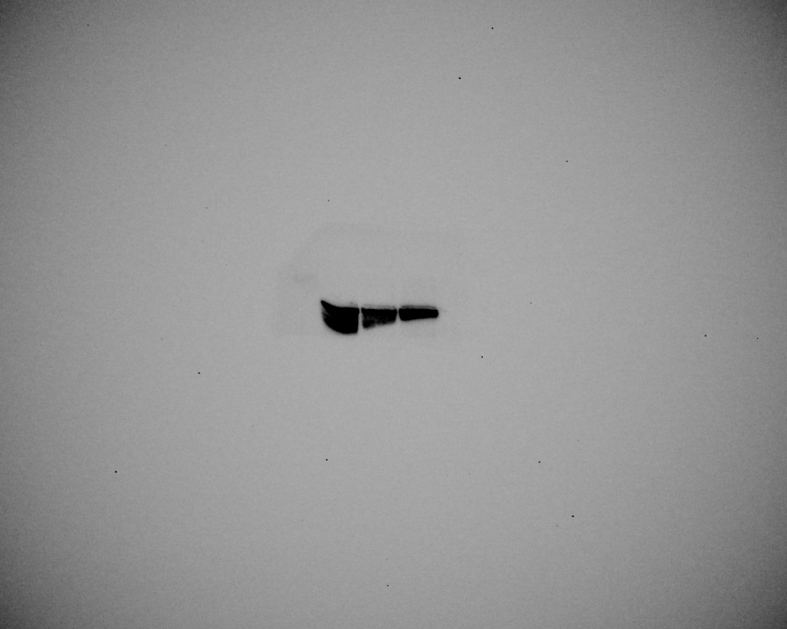

1: MDA-MB-231 Control
2: MDA-MB-231 shSTING (STING-low)
3: MDA-MB-231 STING high
1
2
3
Vinculin
STING

