Supplementary Information

A Topography-Vegetation-Hydrology Nexus Governs the Rapid Expansion of Alpine Snow Algae Blooms

Nozomu Takeuchi¹, Hiroyuki Oguma², Reiko Ide², Ryotaro Okamoto², Masato Ono³, Atsushi Kume⁴, Wataru Shimada⁵, Kazuma Aoki⁵

1 Center for Environmental Remote Sensing, Chiba University, Chiba 263-8522, Japan.
2 Biodiversity Division, National Institute of Environmental Research, Ibaraki 305-8506, Japan.
3 Center for Ecological Research, Kyoto University, Shiga, Japan.
4 Faculty of Agriculture, Kyushu University, Fukuoka 812-8581, Japan
5 Department of Natural and Environmental Sciences, Faculty of Science, University of Toyama, Toyama 930-8555, Japan

Correspondence to: Nozomu Takeuchi (ntakeuch@faculty.chiba-u.jp)

This PDF file includes:
Supplementary Table S1
Supplementary Figures S1–S6

Table S1: Cell concentrations of two morphological taxa of pigmented algal cells in the surface snow collected in the Murodo-daira on 17 Jun 2023. Site locations were shown in Supplementary Figure S1.

Site | Sanguina sp | Chloromonas sp. | Total algal cell
 | cells/mL | cells/mL | cells/mL
S1 | 6969 | 0 | 69,474
S2 | 371,120 | 4,294 | 371,120
S3 | 195,891 | 2,952 | 198,843
S4 | 169,594 | 1,073 | 170,667
S5 | 37,971 | 268 | 38,239
S6 | 106,935 | 671 | 107,606
S7 | 82,221 | 537 | 82,757
S8 | 132,347 | 1,395 | 133,747
S9 | 100,897 | 859 | 101,756
S10 | 69,448 | 859 | 70,306
Mean | 133,590 | 1,291 | 134,881
Standard deviation | 96,256 | 1,328 | 97,511

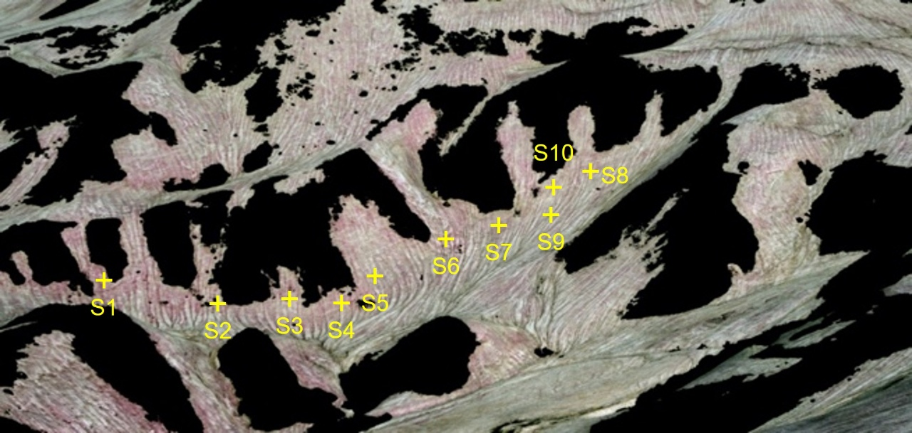

Figure S1. A photograph of the study site on June 17, 2023, showing field sampling locations.
Yellow crosses indicate the ten sites (S1–S10) where snow samples were collected to quantify algal cell concentrations. Specific algal cell concentrations for each site are presented in Supplementary Table S1. The photograph was optimized for a qualitative overview of red snow distribution.

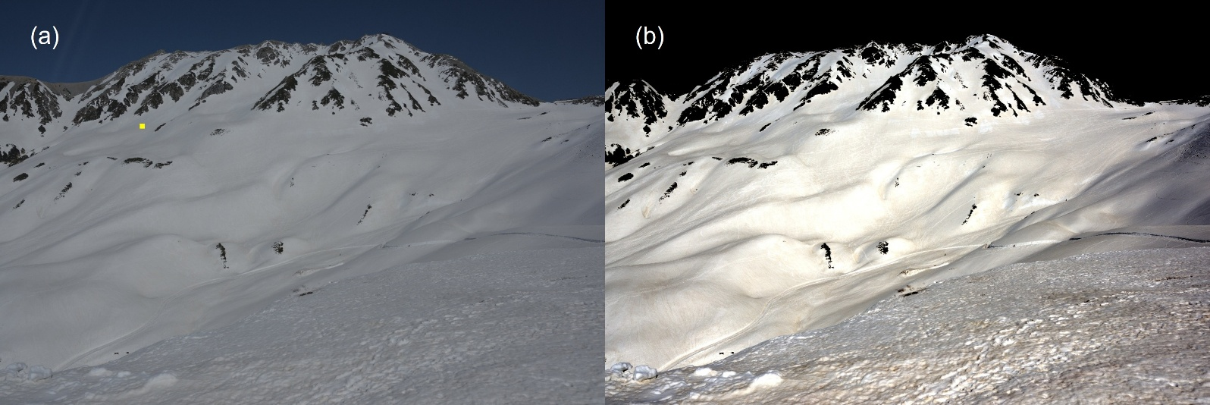
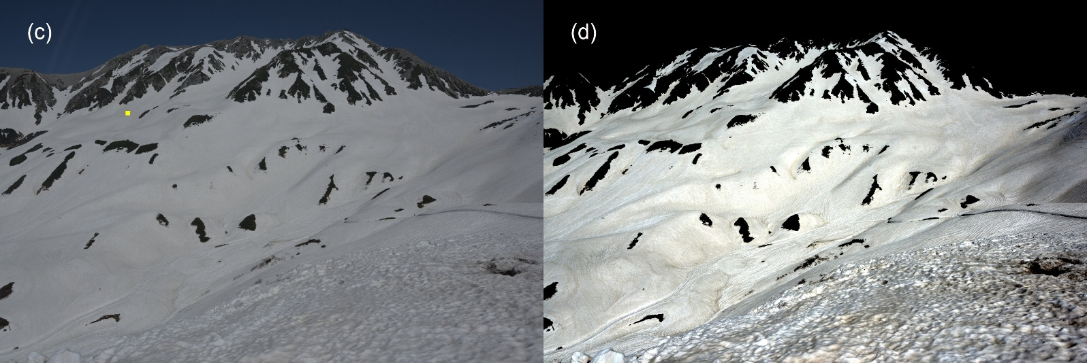
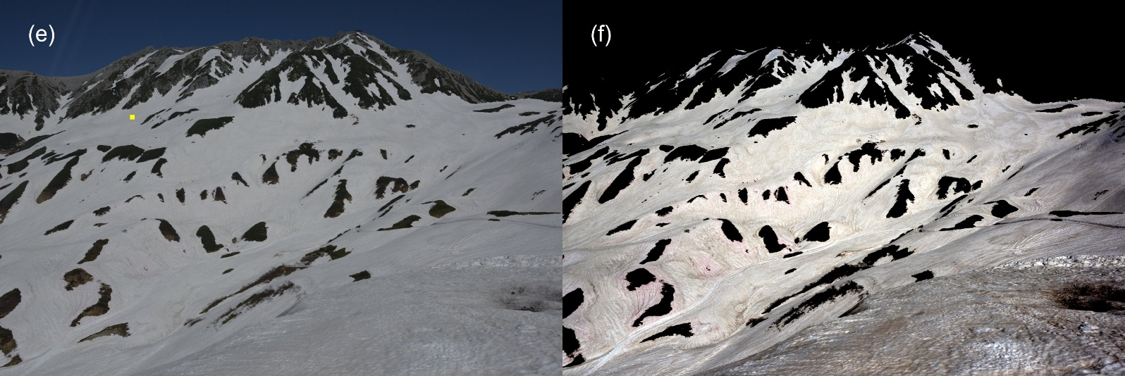
Figure S2. Comparative true-color images before and after the visualization protocol for 2023. The images in the left column (a, c, e, g, i, k) show the initial, low-contrast appearance of the snow surface, with non-snow areas masked in black. The yellow square indicated in panels (a, c, e, g, i, k) represents the high-elevation reference area used for the white balance and intensity normalization protocol across all images. These original 14-bit data minimize pixel clipping but make it difficult to visually identify subtle impurities. The images in the right column (b, d, f, h, j, l) illustrate the corresponding results after applying the reference-based linear scaling and mapping protocol described in the Methods. This transformation, anchoring a high-elevation pristine snow patch to a target intensity of 180, significantly enhances the visual contrast of red snow algal blooms (retaining red pigments) and mineral dust (yellow/brown), revealing their detailed spatiotemporal evolution. The dates for each pair are (a, b) May 4; (c, d) May 17; (e, f) May 31; (g, h) June 7; (i, j) June 17; and (k, l) June 25.

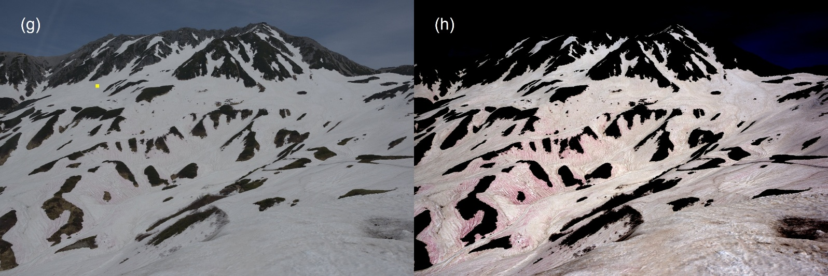
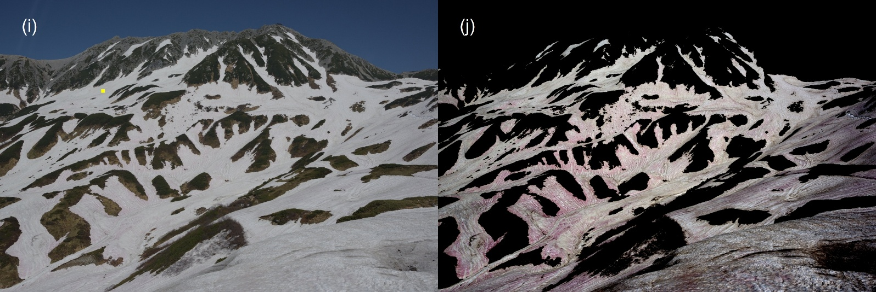
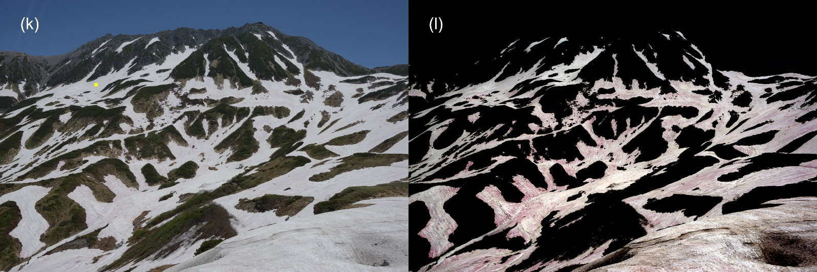
Figure S2 Continued.

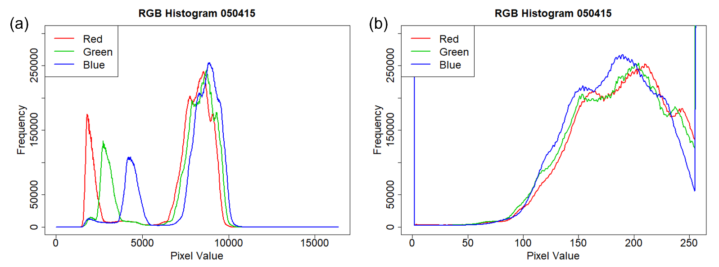
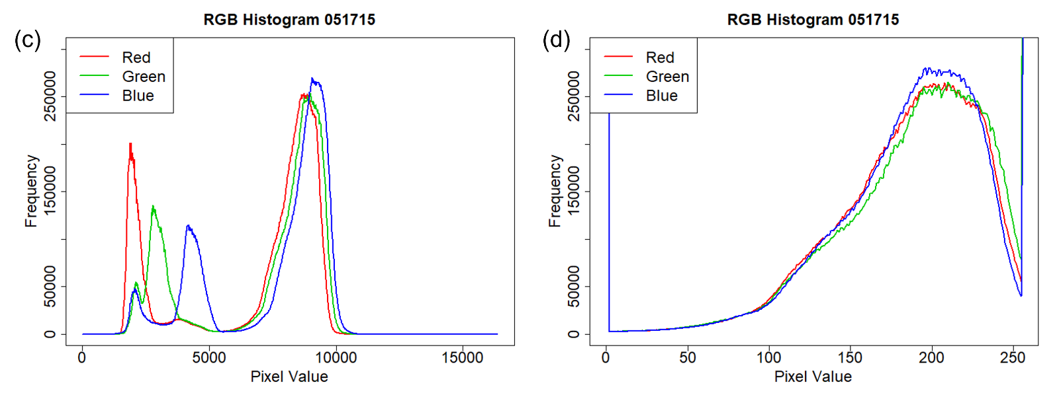
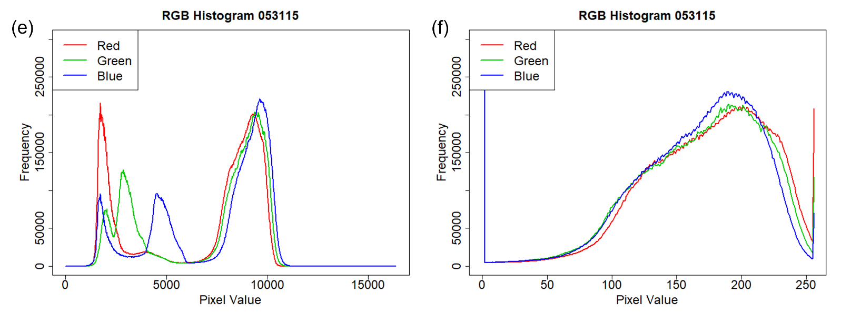
Figure S3. RGB histograms of the images before and after the visualization protocol.
The histograms correspond to the images shown in Figure S3. The left panels (a, c, e, g, i, k) show the 14-bit RAW histogram (0–16,384 levels). The primary peaks representing the snowpack are concentrated within a narrow range (approximately 7,000–10,000), resulting in the low-contrast appearance of the original image. Small peaks at lower intensities represent non-snow areas. The rights panels (b, d, f, h, j, l) show the 8-bit histogram (0–255 levels) after linear scaling. By mapping the reference snow mode value to 180 and applying the linear transformation, the pixel distribution is stretched across the available dynamic range. This process effectively amplifies the radiometric differences between pristine snow, red snow, and mineral dust, facilitating the qualitative identification of algal bloom spatial patterns. The dates for each pair are (a, b) May 4; (c, d) May 17; (e, f) May 31; (g, h) June 7; (i, j) June 17; and (k, l) June 25.

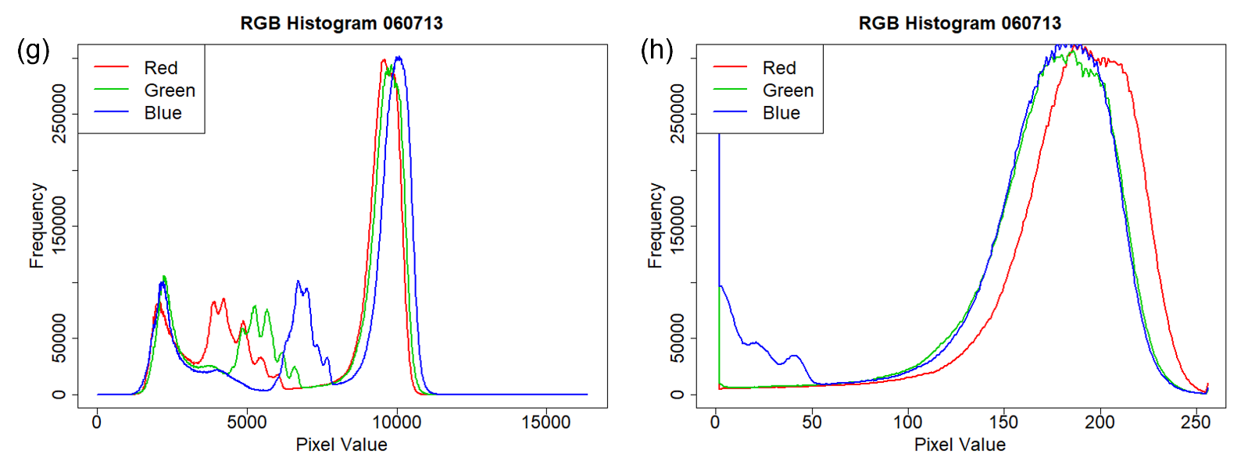
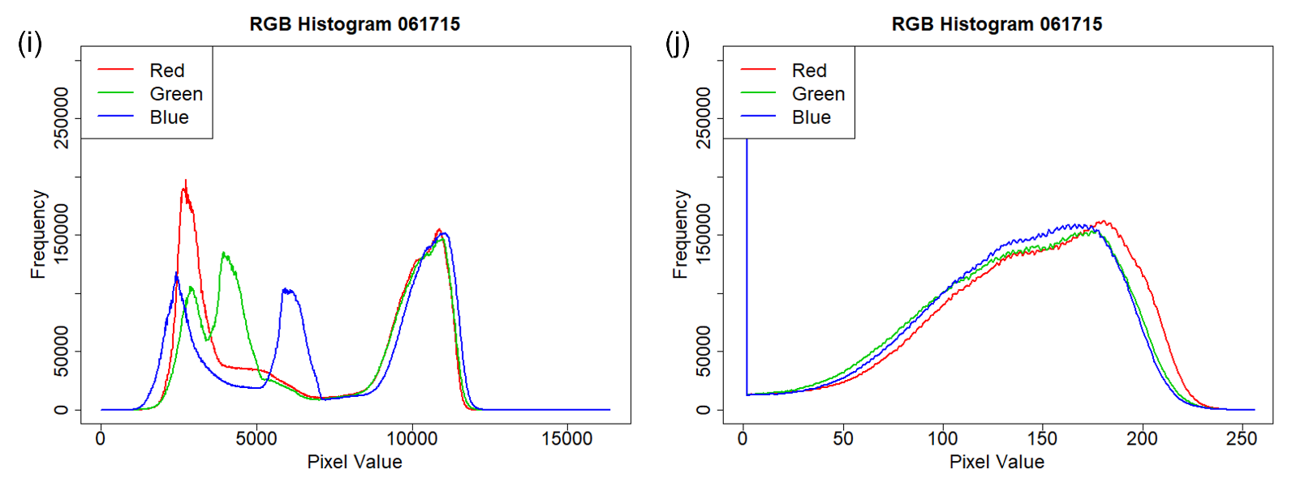
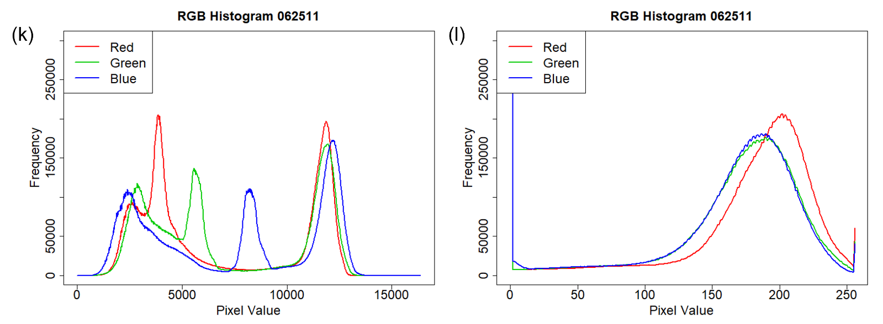
Figure S3. continued

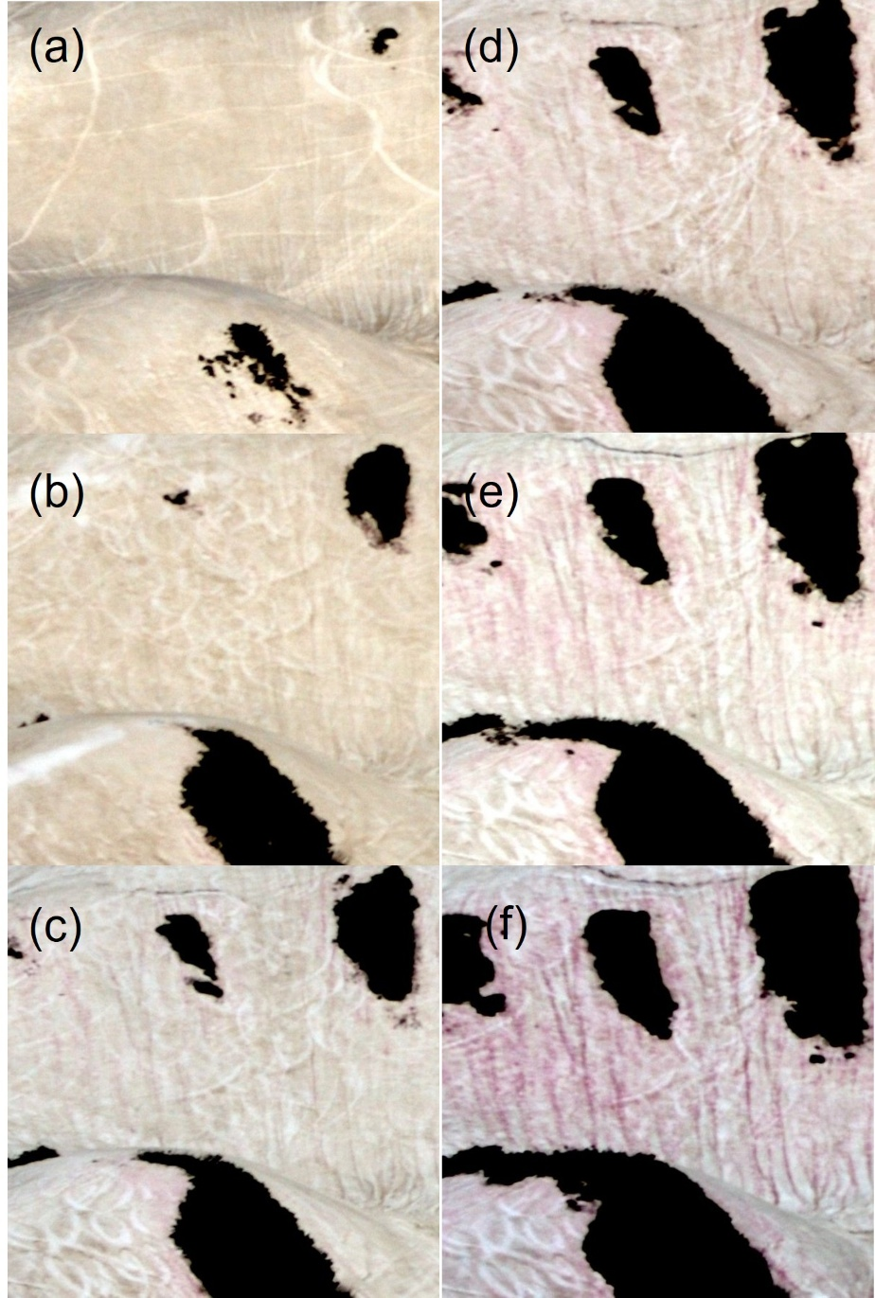
Figure S4. Time-series magnification of the snow surface illustrating the lateral redistribution and concentration of red snow algae.
Panels (a–f) provide a detailed view of the same hillslope area over the study period, showing the progression of algal bloom development. (a–c) In the early melting stage, algal pigments and particulate matter are relatively diffuse across the snow surface. (d–f) The white linear features visible in the images are ski tracks (skier’s spoor); however, their spatial orientation remains distinct from the natural meltwater drainage patterns. As snowmelt progresses, liquid water channels (rills) become more pronounced, and algal cells are increasingly concentrated within these hydrological pathways. The formation of distinct vertical red stripes demonstrates that the spatial heterogeneity of the bloom is primarily driven by the lateral transport of cells mediated by meltwater hydrology, rather than uniform in-situ growth. Dates for each panel correspond to those in Figure S3: (a) May 4, (b) May 17, (c) May 31, (d) June 7, (e) June 17, and (f) June 25.

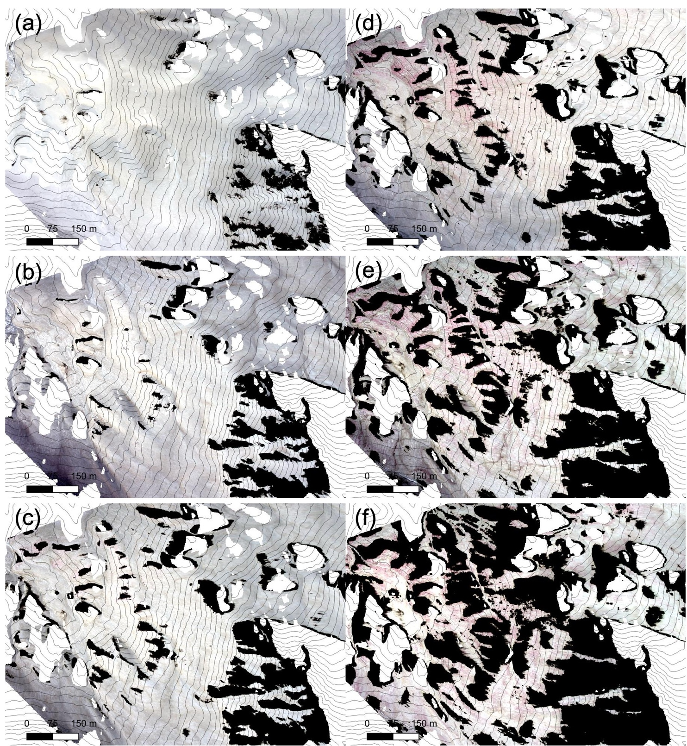
Figure S5. Enhanced true-color orthomosaics derived from 14-bit raw camera images.
Panels (a) to (f) display orthomosaics showing the progression of snow algae blooms, corresponding to the six selected dates in Figure S2. The dense black areas within each panel represent regions of exposed rock or saturated meltwater, indicative of complete snowmelt. True residual snow cover appears white, while areas with high concentrations of carotenoid-rich snow algae (red snow) are visible as distinct reddish-pink patches, mostly concentrated around the retreating snow margins and persistent hydrological rills. Black contour lines show the topography, with a scale bar in each panel. These images visually demonstrate the landscape-scale progression from near-complete snow cover to extensive melt and biological colonization over the six-day period. Dates for each panel correspond to those in Figure S3: (a) May 4, (b) May 17, (c) May 31, (d) June 7, (e) June 17, and (f) June 25.

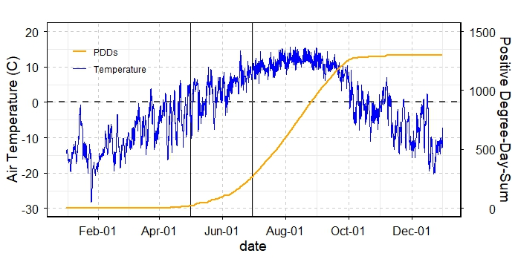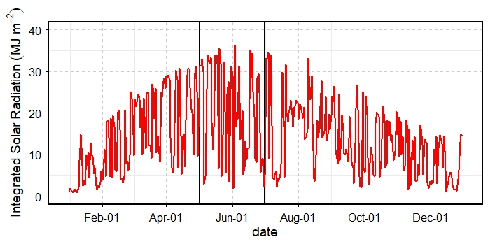
(a)
(b)

Figure S6. Meteorological conditions and snowmelt potential at Murodo-daira (2,450 m a.s.l.) in 2023.
(a) Seasonal variations in air temperature (blue line) and the cumulative Positive Degree-Day Sum (PDDS, orange line). The PDDS, an indicator of cumulative snowmelt, began to increase rapidly in late April, coinciding with the onset of the seasonal snowmelt period. (b) Daily integrated solar radiation (red line). The vertical black lines in both panels indicate the primary study period (May to June), during which intense solar radiation and rising temperatures triggered the redistribution of liquid water and the subsequent development of red snow algal blooms.

