TABLES/FIGURES
Figure 1. Study Flowchart
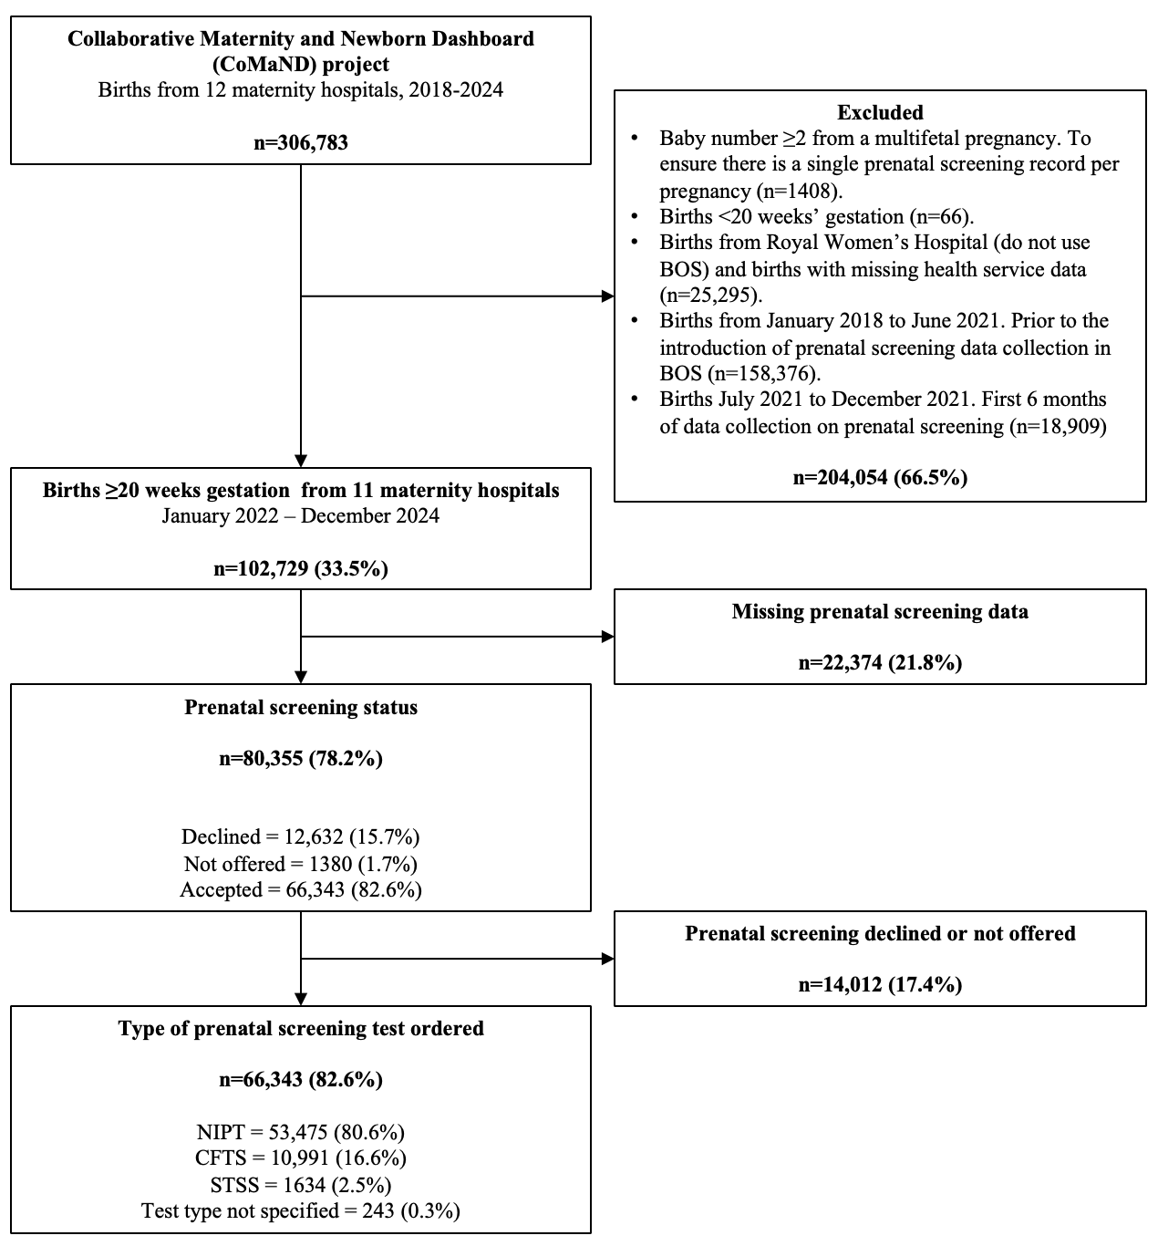

CFTS, combined first trimester screening; BOS, birthing outcome system™️; STSS, second trimester serum screening; NIPT, non-invasive prenatal testing.
Table 1. Maternal sociodemographic and clinical characteristics associated with prenatal aneuploidy screening status.
Characteristic | Declined screening |  | Not offered screening |  | Accepted screening |  | aRRR (95% CI)
 | n | (row %) | n | (row %) | n | (row %) | Declined  vs. accepted |  | Not offered vs. accepted
All participants | 12632 | (15.7) | 1380 | (1.7) | 66343 | (82.6)
Maternal age (years)
< 25 | 2588 | (31.5) | 344 | (4.2) | 5277 | (64.3) | 3.86 | (3.75-3.96) | 4.30 | (4.06-4.56)
25-29 | 3209 | (19.6) | 324 | (2.0) | 12850 | (78.4) | 1.83 | (1.79-1.87) | 1.74 | (1.66-1.84)
30-34 | 4045 | (13.0) | 395 | (1.3) | 26669 | (85.7) | Ref |  | Ref
35-39 | 2033 | (11.0) | 227 | (1.2) | 16216 | (87.8) | 0.66 | (0.64-0.68) | 0.78 | (0.73-0.82)
≥ 40 | 476 | (11.9) | 65 | (1.6) | 3462 | (86.5) | 0.51 | (0.48-0.53) | 0.77 | (0.70-0.84)
Missing | 281 | (12.9) | 25 | (1.2) | 1869 | (85.9)
BMI categories
<18 | 154 | (18.9) | 16 | (2.0) | 644 | (79.1) | 1.11 | (1.02-1.20) | 1.20 | (1.01-1.44)
18-24 | 4463 | (12.9) | 408 | (1.2) | 29801 | (86.0) | Ref |  | Ref
25-29 | 3671 | (15.3) | 425 | (1.8) | 19969 | (83.0) | 1.06 | (1.03-1.07) | 1.47 | (1.40-1.54)
30-34 | 2123 | (18.8) | 230 | (2.0) | 8957 | (79.2) | 1.17 | (1.15-1.20) | 1.60 | (1.51-1.69)
35-39 | 1077 | (12.4) | 120 | (2.4) | 3841 | (76.2) | 1.26 | (1.22-1.30) | 1.77 | (1.65-1.91)
≥ 40 | 926 | (28.5) | 87 | (2.7) | 2237 | (68.8) | 1.62 | (1.55-1.68) | 2.17 | (1.99-2.36)
Missing | 218 | (18.1) | 94 | (7.8) | 894 | (74.1)
Mothers' region of birth
Americas | 110 | (12.2) | 14 | (1.6) | 780 | (86.3) | 1.53 | (1.41-1.66) | 2.36 | (1.97-2.83)
Australia | 5360 | (13.3) | 545 | (1.4) | 34472 | (85.4) | Ref |  | Ref
North Africa and the Middle East | 948 | (32.1) | 79 | (2.7) | 1927 | (65.2) | 1.94 | (1.87-2.01) | 1.96 | (1.80-2.14)
New Zealand | 868 | (41.8) | 94 | (4.5) | 1117 | (53.7) | 2.96 | (2.82-3.10) | 3.24 | (2.97-3.53)
North-East Asia | 100 | (4.0) | 22 | (0.9) | 2368 | (95.1) | 0.58 | (0.53-0.63) | 1.54 | (1.33-1.80)
North-West Europe | 135 | (7.5) | 11 | (0.6) | 1663 | (91.9) | 0.86 | (0.80-0.92) | 0.79 | (0.65-0.97)
Oceania§ | 389 | (50.9) | 47 | (6.1) | 328 | (42.9) | 3.14 | (2.93-3.36) | 3.60 | (3.19-4.06)
South-East Asia | 1056 | (15.5) | 128 | (1.9) | 5633 | (82.6) | 1.50 | (1.45-1.55) | 2.21 | (2.04-2.38)
Southern and Central Asia | 2419 | (14.0) | 300 | (1.7) | 14514 | (84.2) | 1.23 | (1.19-1.25) | 1.85 | (1.76-1.97)
Southern and Eastern Europe | 132 | (10.3) | 13 | (1.0) | 1136 | (88.7) | 0.70 | (0.65-0.75) | 0.76 | (0.62-0.93)
Sub-Saharan Africa | 904 | (40.9) | 83 | (3.8) | 1221 | (55.3) | 3.63 | (3.48-3.80) | 3.97 | (3.63-4.35)
Missing | 852 | (14.7) | 173 | (3.1) | 4414 | (82.3)
Socioeconomic status (IRSAD quintile)
1 (most disadvantaged) | 4044 | (23.3) | 443 | (2.6) | 12870 | (74.2) | Ref |  | Ref
2 | 1672 | (16.8) | 204 | (2.1) | 8076 | (81.2) | 0.76 | (0.74-0.78) | 0.88 | (0.78-0.89)
3 | 4090 | (17.4) | 421 | (1.8) | 18936 | (80.8) | 0.77 | (0.75-0.78) | 0.72 | (0.68-0.76)
4 | 1933 | (10.3) | 208 | (1.1) | 16703 | (88.6) | 0.59 | (0.57-0.60) | 0.56 | (0.52-0.60)
5 (most advantaged) | 883 | (8.3) | 99 | (0.9) | 9720 | (90.8) | 0.59 | (0.57-0.61) | 0.56 | (0.51-0.61)
Missing | 10 | (18.9) | 5 | (9.4) | 38 | (71.7)
Smoking status during pregnancy
No | 11905 | (15.2) | 1257 | (1.6) | 64931 | (83.2) | Ref |  | Ref
Yes | 727 | (32.1) | 123 | (5.4) | 1412 | (62.4) | 1.22 | (1.18-1.27) | 1.86 | (1.72-2.00)
COVID 19 status
Unvaccinated | 2008 | (21.3) | 231 | (2.5) | 7171 | (76.2) | Ref |  | Ref
Vaccinated | 8266 | (14.3) | 990 | (1.5) | 54364 | (84.1) | 0.81 | (0.79-0.82) | 0.76 | (0.72-0.80)
Missing | 1358 | (21.5) | 159 | (2.5) | 4808 | (76.0)
Pertussis status
Unvaccinated | 2153 | (34.4) | 288 | (4.6) | 3816 | (61.0) | Ref |  | Ref
Vaccinated | 9556 | (13.4) | 1030 | (1.4) | 60971 | (85.2) | 0.58 | (0.56-0.59) | 0.54 | (0.51-0.58)
Missing | 923 | (36.3) | 62 | (2.4) | 1556 | (61.2)
Parity‡
0 | 3618 | (10.4) | 532 | (1.5) | 30545 | (88.0) | Ref |  | Ref
1 | 4015 | (13.5) | 423 | (1.4) | 25297 | (85.1) | 1.68 | (1.64-1.71) | 1.17 | (1.11-1.23)
2 | 2593 | (24.5) | 195 | (1.8) | 7788 | (73.6) | 3.43 | (3.34-3.52) | 1.56 | (1.46-1.65)
≥ 3 | 2406 | (45.0) | 230 | (4.3) | 2713 | (50.7) | 7.17 | (6.94-7.39) | 3.93 | (3.68-4.19)
Gestation at first antenatal visit
≤ 12 weeks | 9489 | (15.2) | 744 | (1.2) | 52011 | (83.6) | Ref |  | Ref
> 12 weeks | 3143 | (17.4) | 636 | (3.5) | 14332 | (79.1) | 1.01 | (0.99-1.03) | 2.18 | (2.09-2.28)
Care model
Private in public hospital | 92 | (6.0) | 20 | (1.3) | 1410 | (92.6) | 0.49 | (0.46-0.53) | 0.65 | (0.57-0.76)
All other care models | 12439 | (15.9) | 1334 | (1.7) | 64597 | (82.4) | Ref |  | Ref
Missing | 101 | (21.8) | 26 | (5.6) | 336 | (72.6)

aRRR, adjusted relative risk ratio; BMI, body mass index (kg/m²); CI, confidence interval; IRSAD, Index of Relative Socioeconomic Advantage and Disadvantage.
‡Parity refers to the number of previous pregnancies resulting in a live birth or stillbirth at ≥ 20 weeks' gestation or with a birthweight of ≥ 400 g.
§Oceania excludes women born in Australia or New Zealand.
Row percentages are presented to reflect the distribution of prenatal screening type within each clinical and maternal covariate.
Unadjusted relative risk ratios are presented in Supplementary Tables 3 and 4.

Table 2. Maternal sociodemographic and clinical characteristics associated with non-invasive prenatal testing.
Prenatal screening type | NIPT |  | Other prenatal aneuploidy screening¶ |  | aIRR (95% CI)
 | n | (row %) | n | (row %) | NIPT vs. Other
All participants | 53475 | (80.6) | 12868 | (19.4)
Maternal age (years)
<25 | 3496 | (66.3) | 1781 | (33.8) | 0.81 | (0.78-0.85)
25-29 | 9942 | (77.4) | 2908 | (22.6) | 0.94 | (0.92-0.97)
30-34 | 21677 | (81.3) | 4992 | (18.7) | Ref
35-39 | 13797 | (85.1) | 2419 | (14.9) | 1.07 | (1.05-1.10)
≥ 40 | 2990 | (86.4) | 472 | (13.6) | 1.11 | (1.07-1.16)
Missing | 1573 | (84.2) | 296 | (15.8)
BMI categories
<18 | 501 | (77.8) | 143 | (22.2) | 0.96 | (0.87-1.06)
18-24 | 24575 | (82.5) | 5226 | (17.5) | Ref
25-29 | 16104 | (80.6) | 3865 | (19.4) | 0.99 | (0.97-1.01)
30-34 | 7060 | (78.8) | 1897 | (21.2) | 0.97 | (0.94-1.00)
35-39 | 2919 | (76.0) | 922 | (24.0) | 0.94 | (0.90-0.98)
≥ 40 | 1590 | (71.1) | 647 | (28.9) | 0.88 | (0.84-0.93)
missing | 726 | (81.2) | 168 | (18.8)
Mothers' region of birth
Americas | 662 | (84.9) | 118 | (15.1) | 0.95 | (0.88-1.03)
Australia | 28732 | (83.4) | 5740 | (16.7) | Ref
New Zealand | 767 | (68.7) | 350 | (31.3) | 0.85 | (0.78-0.92)
North Africa and the Middle East | 1327 | (68.9) | 600 | (31.1) | 0.87 | (0.82-0.92)
North-East Asia | 2125 | (89.7) | 243 | (10.3) | 1.01 | (0.96-1.05)
North-West Europe | 1453 | (87.4) | 210 | (12.6) | 0.99 | (0.93-1.05)
Oceania§ | 292 | (58.2) | 137 | (41.8) | 0.73 | (0.63-0.86)
South-East Asia | 4586 | (81.4) | 1047 | (18.6) | 0.96 | (0.93-0.99)
Southern and Central Asia | 10889 | (75.0) | 3625 | (25.0) | 0.88 | (0.86-0.91)
Southern and Eastern Europe | 980 | (86.3) | 156 | (13.7) | 1.03 | (0.96-1.11)
Sub-Saharan Africa | 770 | (63.1) | 451 | (36.9) | 0.77 | (0.71-0.84)
missing | 993 | (83.9) | 191 | (16.1)
Socioeconomic status (IRSAD quintile)
1 (most disadvantaged) | 9696 | (75.3) | 3174 | (24.7) | Ref
2 | 6440 | (79.7) | 1636 | (20.3) | 1.04 | (1.01-1.08)
3 | 14737 | (77.8) | 4199 | (22.2) | 1.03 | (1.00-1.06)
4 | 13936 | (83.4) | 2767 | (16.6) | 1.06 | (1.03-1.10)
5 (most advantaged) | 8640 | (88.9) | 1080 | (11.1) | 1.09 | (1.06-1.13)
Missing | 26 | (68.4) | 12 | (31.6)
Smoking status during pregnancy
No | 52571 | (81.0) | 12360 | (19.0) | Ref
Yes | 904 | (64.0) | 508 | (36.0) | 0.82 | (0.77-0.89)
COVID 19 status
Unvaccinated | 5669 | (79.1) | 1502 | (21.0) | Ref
Vaccinated | 43984 | (80.9) | 10380 | (19.1) | 1.00 | (0.97-1.03)
Missing | 3822 | (79.5) | 986 | (20.5)
Pertussis status
Unvaccinated | 2797 | (73.3) | 1019 | (26.7) | Ref
Vaccinated | 49488 | (81.2) | 11483 | (18.8) | 1.03 | (0.99-1.08)
Missing | 1190 | (76.5) | 366 | (23.5)
Parity‡
0 | 25526 | (83.6) | 5019 | (16.4) | Ref
.1 | 20466 | (80.9) | 4831 | (19.1) | 0.94 | (0.92-0.96)
2 | 5825 | (74.8) | 1963 | (25.2) | 0.86 | (0.84-0.89)
≥ 3 | 1658 | (61.1) | 1055 | (38.9) | 0.73 | (0.69-0.77)
Gestational age at first antenatal visit
≤ 12 weeks | 41819 | (80.4) | 10192 | (19.6) | Ref
> 12 weeks | 11656 | (81.3) | 2676 | (18.7) | 1.00 | (0.97-1.02)
Care model
Private in public hospital | 1236 | (94.5) | 72 | (5.5) | 1.11 | (1.04-1.19)
All other care models | 51954 | (80.3) | 12745 | (19.7) | Ref
Missing | 285 | (84.8) | 51 | (15.2)

aIRR, adjusted incident rate ratio; BMI, Body Mass Index (kg/m²); IRSAD, Index of Relative Socioeconomic Advantage and Disadvantage.
‡Parity refers to the number of previous pregnancies resulting in a live birth or stillbirth at ≥ 20 weeks' gestation or with a birthweight of ≥ 400 g.
§Oceania excludes women born in Australia or New Zealand.
¶Other prenatal aneuploidy screening included combined first trimester screening, second trimester serum screening, and screening type not specified.
Row percentages are presented to reflect the distribution of prenatal screening type within each clinical and maternal covariate.
Unadjusted incident rate ratios are presented in Supplementary Table 5.

