SUPPLEMENTARY MATERIAL

QuTILs: Open-Source Image-Based Infiltrating Immune Cell Detection and Outcomes in Breast Cancer Clinical Trials

Supplementary Table S1: Overall Demographics and Cohort Characteristics

Cohort | 40502 (TNBC) | 40603
Enrolled | 201 | 443
With Images | 99 | 348
Age (20-49) | 28 | 86
Age (>49) | 71 | 262
Race (white) | 78 | 248
Race (non-white) | 21 | 100
Stage
0 | - | 170
I | - | 91
II | - | 49
III | 8 | 30
IV | 86 | -
Missing | 5 | 9
Grade
I | - | 4
II | - | 34
III | - | 268
Missing | - | 42
With RNAseq | 80 | 389
Union (img.,RNA) | 77 | 348

Supplementary Figure S1: QuTILs Accuracy and Performance with CNN11 Benchmark. A, C) Binary validation accuracy for QuTILs (A) and CNN11 (C) based on non-TIL and TIL cell classes and labels. B, D) Multi-category validation accuracy of QuTILs (B) and CNN11 (D) based on TIL, tumor, stromal, and ‘other’ cell classes and labels. E) Various assessments of performance for QuTILs and CNN11. F) Representative cell detections, classifications, and ground truth labels showing some correctly and incorrectly classified cells by QuTILs. Dark blue, red, green and yellow borders correspond to ground truth TIL, tumor, stromal and ‘other’ labels, respectively, while light blue, magenta, green and yellow nucleus and cell segmentation polygons correspond to classified TIL, tumor, stromal and ‘other’ cells, respectively.
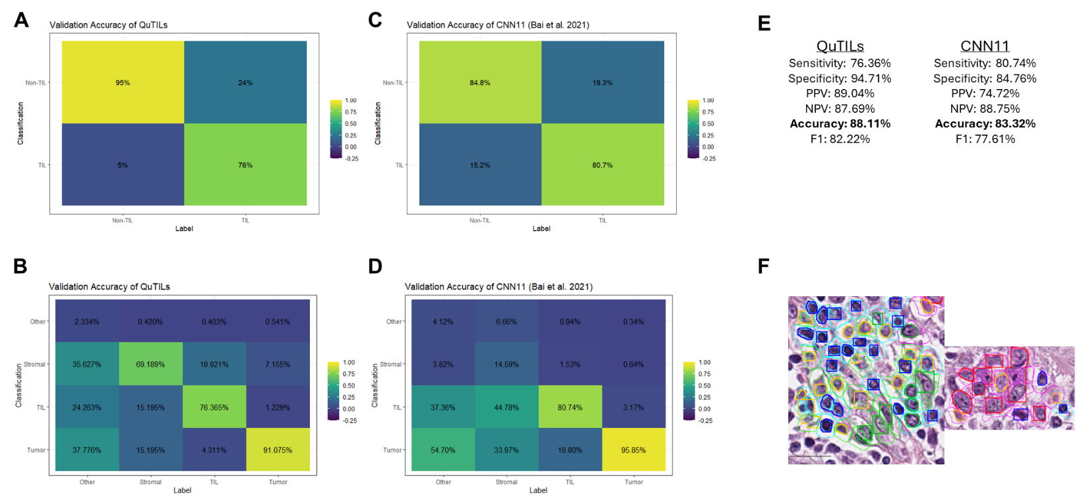

Supplementary Figure S2: TIL Metric Correlations and Demographic and Cohort-based TILs. Box-and-whisker plots with associated t-tests for QuTILs measures and cohort and demographic variables. A) QuTILs total and marginal % TIL estimates between the CALGB 40502 and 40603 cohorts. B) QuTILs estimates by tumor pathologic grade in the CALGB 40603 cohort. C-D) QuTILs estimates by age category in the CALGB 40502 (C) and 40603 (D) cohorts. E-F) QuTILs estimates by race category in the CALGB 40502 (E) and 40603 (F) cohorts. Individual Student’s t-tests were conducted in all cases.

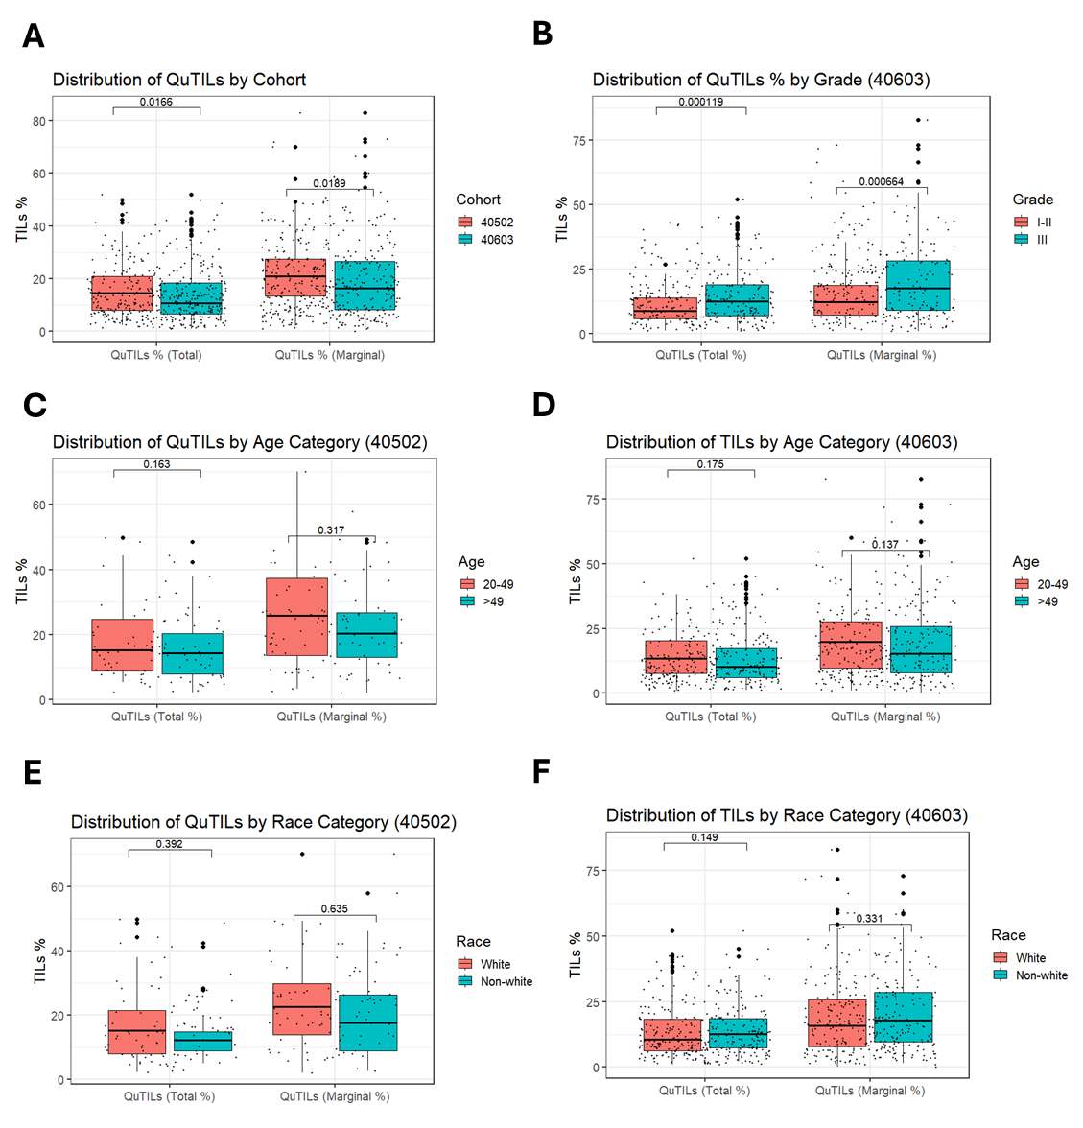
Supplementary Figure S3. Association of RNAseq Immune Deconvolution Subtypes with QuTILs and Patient Outcome. Cox’s proportional hazards model of immune subtypes across deconvolution methods with overall survival in CALGB 40502 (A) and CALGB 40603 (B). Correlation to QuTILs marginal (left) and total (right) TIL estimates are indicated in the adjacent heatmap for each immune subtype.
A B
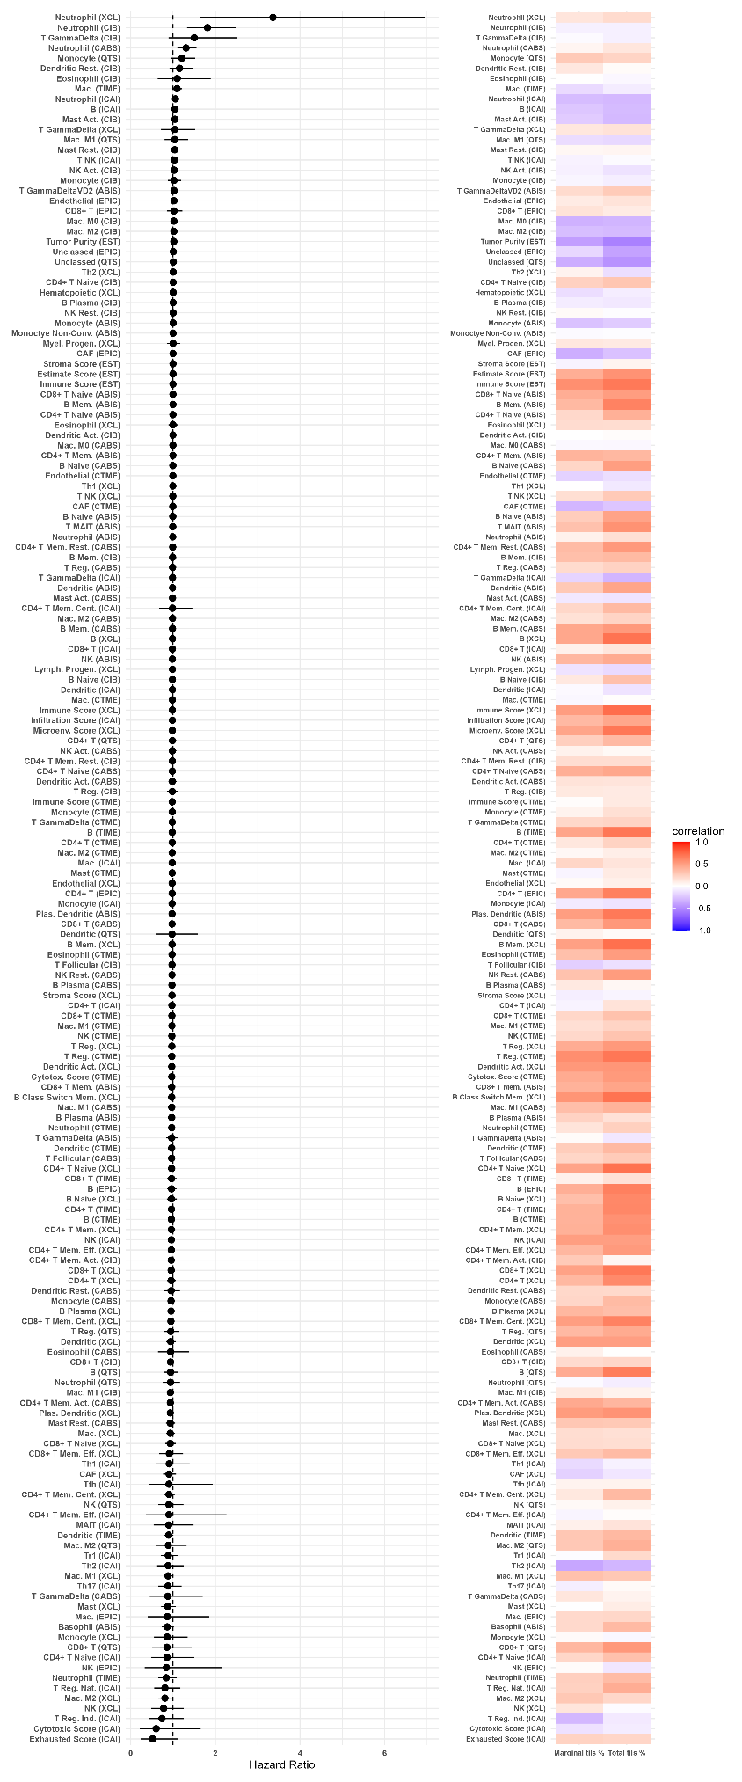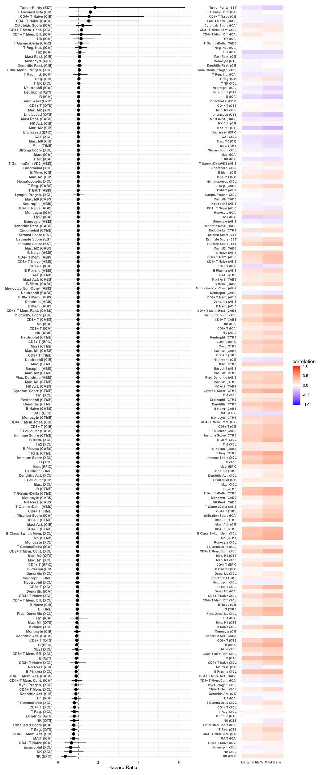
Supplementary Figure S4. Supplemental Sample Tumor Infiltrating Lymphocyte (TIL) Levels Before and Following Chemotherapy in CALGB 40603. Total TIL percent by QuTILs paired by individual patient pre- versus post-neoadjuvant chemotherapy. Samples are presented here based on whether they showed an increase between stages (A, C) or decrease (B, D) for CALGB 40603, with all pre-/post pairs visualized (A-B) or only those with at least 5% change in total TILs (C-D). Wilcoxon Signed-Rank tests were conducted to assess the significance of change within samples between stages for each cohort.

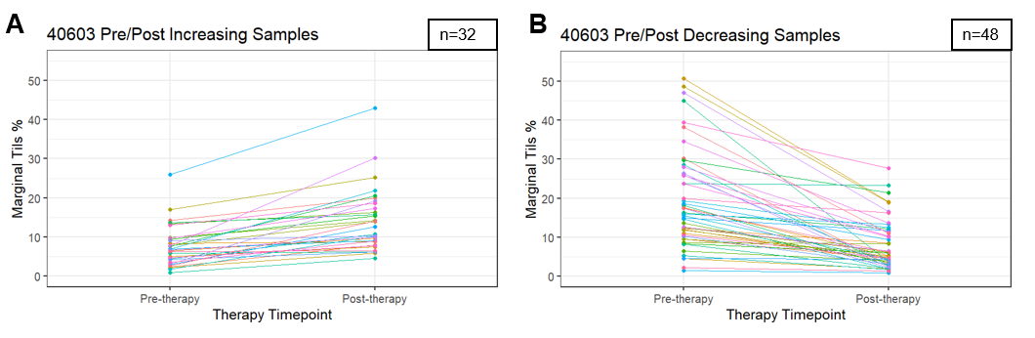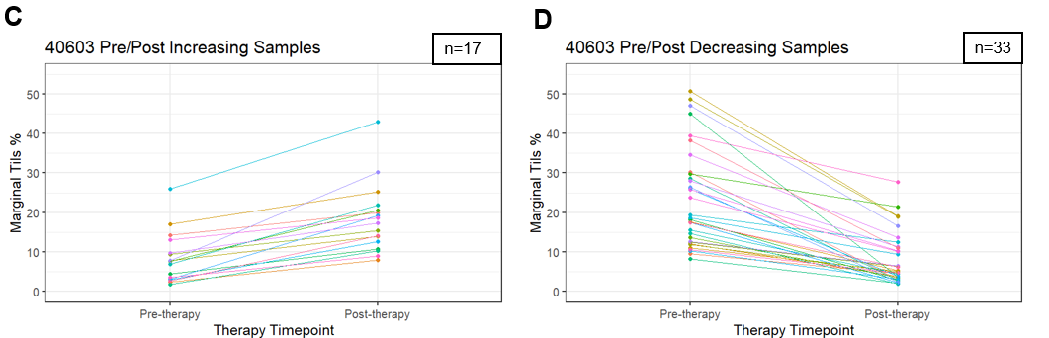
Pre-median=11.44
Post-median=8.82
W=2171
p=0.008
Wilcoxon Signed Rank
(all pre-/post-pairs)
Pre-median=14.46
Post-median=10.22
W=943
p=0.003

