Supplementary information
Measuring and tailoring Li-ion interfacial transport in hybrid solid electrolytes
Ming Liuª, Ernst R. H. van Eck^{b}, Swapna Ganapathy^{a*}, Marnix Wagemaker^{a*}

ª Section Storage of Electrochemical Energy, Radiation Science and Technology, Faculty of Applied Sciences, Delft University of Technology, Mekelweg 15, 2629 JB, Delft, The Netherlands.
E-mail: s.ganapathy@tudelft.nl and m.wagemaker@tudelft.nl

^{b} Institute for Molecules and Materials, Radboud University, Heyendaalseweg 135, 6525 AJ, Nijmegen, The Netherlands.

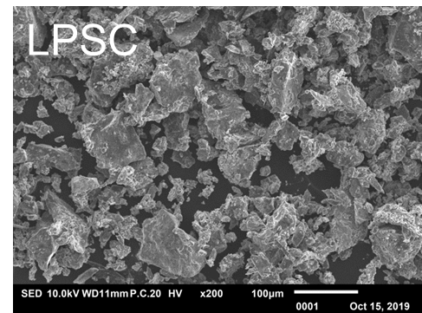
Figure S1| SEM images of micron sized LPSC.

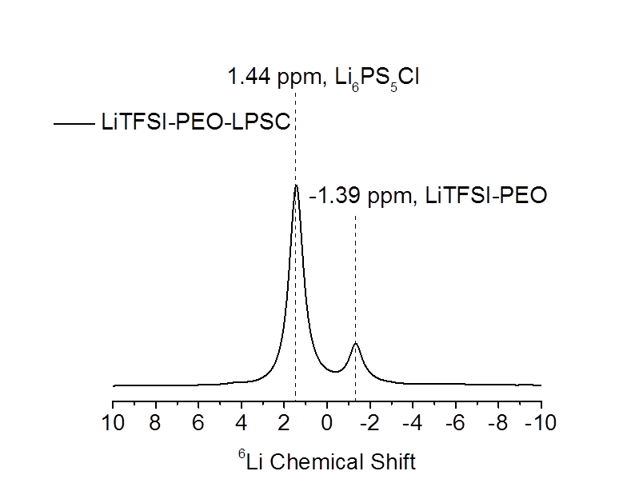
Figure S2| 1D ⁶Li magic angle spinning (MAS) spectra corresponding to the Li₆PS₅Cl -LiTFSI-PEO HSE
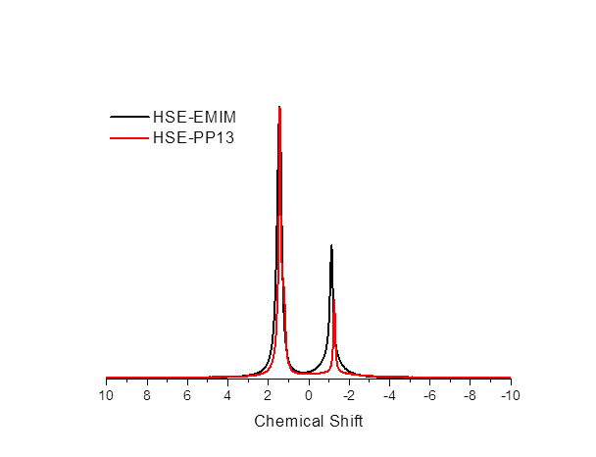

Figure S3| 1D ⁷Li MAS spectra of HSE-EMIM and HSE-PP13.

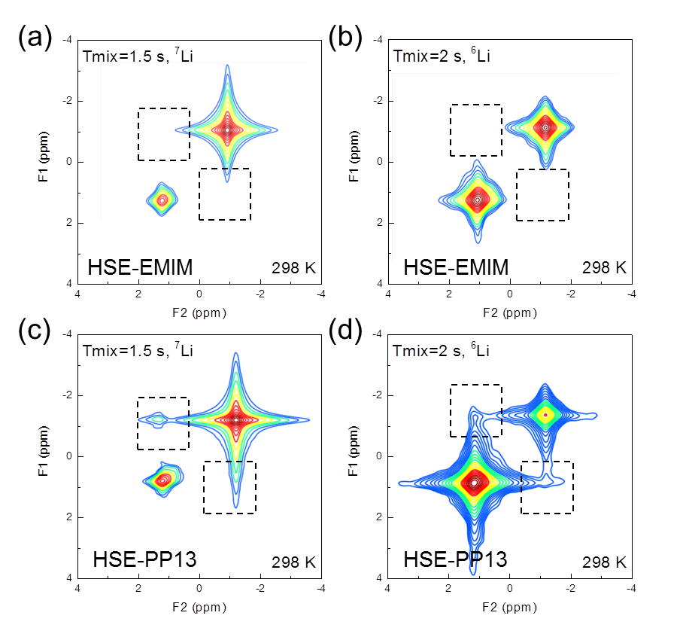
Figure S4| Li⁺ transport characterization in HSE with PP13 TFSI and EMIM TFSI ionic liquids additives. ⁷Li–⁷Li, ⁶Li-⁶Li 2D-EXSY corresponding to the LPSC-LiTFSI-PEO HSE with EMIM TFSI (a, b) and PP13 TFSI (c, d) ionic liquids measured under MAS at a spinning speed of 5 kHz mixing time of 1.5 s and 2 s at 328K.

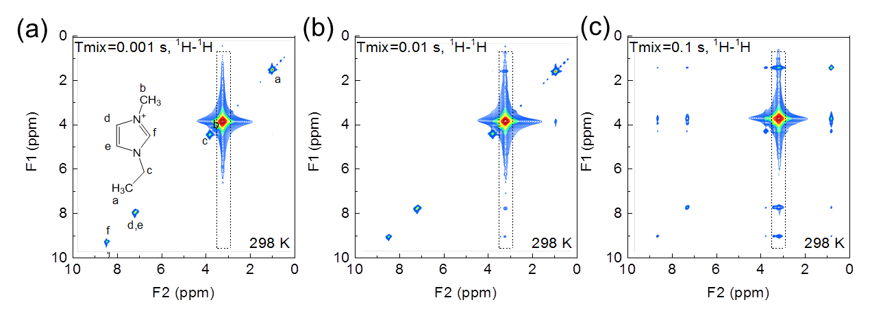
Figure S5| 2D ¹H-¹H NOESY of HSE-EMIM measured under MAS at a spinning speed of 5 kHz at 298 K with mixing time T_{mix} of (a) 0.001, (b) 0.01 and (c) 0.1s.

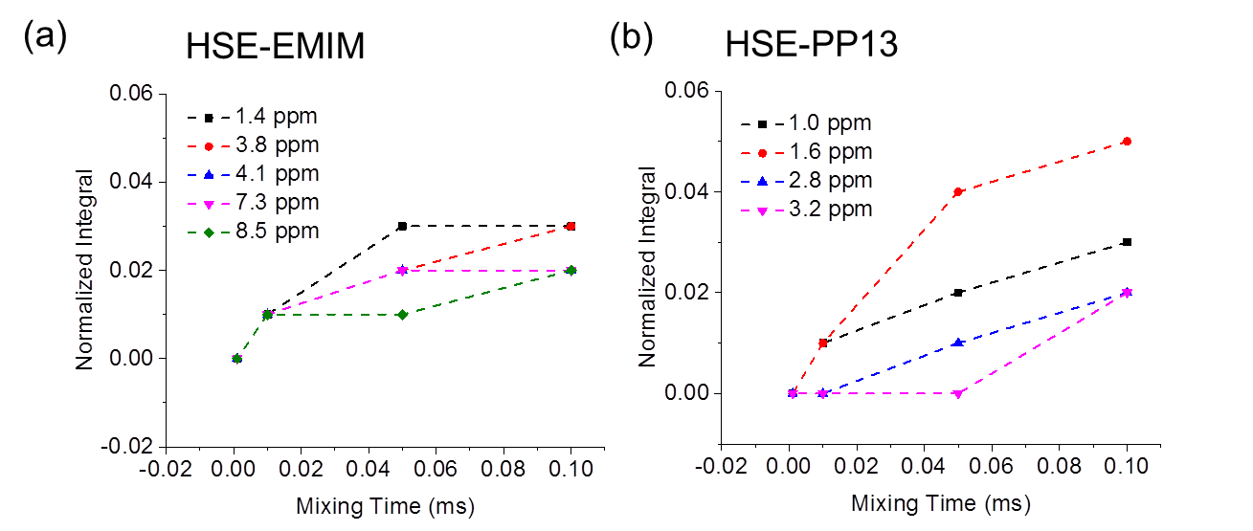
Figure S6| ¹H-¹H Cross peaks intensity buildup of protons in EMIM TFSI (a) and PP13 TFSI (b) correlated to PEO from the 2D ¹H-¹H NOESY spectra of HSE-PP13 and HSE-EMIM given in Figure S5 and Figure 4. All the cross peaks between EMIM TFSI and LiTFSI-PEO appear at nearly at the same mixing time which means that there is no preferred orientation of the EMIM TFSI species with respect to PEO. While a sequence of cross peak evolution with mixing time is observed in HSE-PP13. At the shortest mixing times, ¹H-¹H correlations are first observed between ¹H resonances at positions 1.0 ppm and 1.6 ppm on the piperidene ring of PP13 TFSI and the –OCH₂- protons from PEO. These ring protons are the furthest away from the bulky propyl and methyl groups attached to the N atom on the piperidene ring.

Table S1 Comparison of the recently reported electrochemical performances of solid-state Li–Li symmetric cells for critical current density (CCD), areal capacity, duration time and temperature.

Method | CCD (mA/cm²) | Areal Capacity (mAh/cm²) | Duration time (per cycle) | Temperature | Ref
Polymer in ceramic | 0.5 | 0.5 | 1 h | 55 | 1
RGO PEO-LLZO | 1 | 1 | 1 h | 60 | 2
PEC-LiMNT-FEC | 0.5 | 0.5 | 1 h | 25 | 3
Double layer polymer (PMA-PEO) | 0.1 | 0.1 | 1 h | 65 | 4
PEO-Li₃PS₄ | 0.1 | 0.1 | 1 h | 60 | 5
MOF-PEO-IL | 0.2 | 0.2 | 1 h | 60 | 6
Nano LLZO-PEO | 3 | 3 | 1 h | 60 | 7
Nanowire LLZO-PEO | 0.5 | 0.5 | 1 h | 25 | 8
LLZO-PEO | 0.1 | – | – | 60 | 9
HSE with IL additive | 0.25 | 1 | 4 h | 25 | This work

Refernces

1 Chen, L. et al. PEO/garnet composite electrolytes for solid-state lithium batteries: From "ceramic-in-polymer" to "polymer-in-ceramic". Nano Energy 46, 176-184 (2018).
2 Liu, Y. et al. Transforming from planar to three-dimensional lithium with flowable interphase for solid lithium metal batteries. Science Advances 3, eaao0713 (2017).
3 Chen, L., Li, W., Fan, L. Z., Nan, C. W. & Zhang, Q. Intercalated electrolyte with high transference number for dendrite‐free solid‐state lithium batteries. Adv Func Mater 29, 1901047 (2019).
4 Zhou, W. et al. Double‐layer polymer electrolyte for high‐voltage all‐solid‐state rechargeable batteries. Adv Mater 31, 1805574 (2019).
5 Chen, S. et al. In-situ preparation of poly (ethylene oxide)/Li₃PS₄ hybrid polymer electrolyte with good nanofiller distribution for rechargeable solid-state lithium batteries. J Power Sources 387, 72-80 (2018).
6 Wu, J. F. & Guo, X. Nanostructured Metal–Organic Framework (MOF)‐Derived Solid Electrolytes Realizing Fast Lithium Ion Transportation Kinetics in Solid‐State Batteries. Small 15, 1804413 (2019).
7 Zhang, J. et al. Flexible and ion-conducting membrane electrolytes for solid-state lithium batteries: dispersion of garnet nanoparticles in insulating polyethylene oxide. Nano Energy 28, 447-454 (2016).
8 Fu, K. K. et al. Flexible, solid-state, ion-conducting membrane with 3D garnet nanofiber networks for lithium batteries. Proc Natl Acad Sci 113, 7094-7099 (2016).
9 Zhao, C.-Z. et al. An anion-immobilized composite electrolyte for dendrite-free lithium metal anodes. Proc Natl Acad Sci 114, 11069-11074 (2017).

Supplemental experiment methods
Quantification of interfacial exchange
Quantification of exchange between the LPSC and PEO was performed by fitting the growing off-diagonal signal to a diffusion model where in a solution to Fick’s law for diffusion is determined $\frac{∂m(\vec{r},\vec{t})}{∂t}=\vec{∇}∙\left\{D(\vec{r})m(\vec{r},\vec{t})\right\}$, where $m(\vec{r},\vec{t})$ is the magnetization of Li at position $\vec{r}$ and t and $D$ is the lithium-ion self-diffusion coefficient. By using the mathematical models of Schmidt-Rohr and co-workers for spin diffusion, and by assuming the overall diffusivity to be equal to the effective diffusion coefficient, the rate of demagnetization of lithium ions in the LPSC can be set equal to the initial magnetization minus the rate of magnetization in the PEO. Assuming a cubic shaped LPSC phase embedded in an infinite PEO phase, this leads to the following analytical expression for the rate of demagnetization from the LPSC into PEO as
$$m\left(t_{mix}\right)={\left\{\frac{m_{0}}{2}\sqrt{4Dt_{mix}}\left[ierfc\left(\frac{d}{\sqrt{4Dt_{mix}}}\right)+ierfc\left(\frac{-d}{\sqrt{4Dt_{mix}}}\right)-\frac{2}{\sqrt{π}}\right]\right\}}^{3}$$
where $ierfc\left(x\right)=1/{\sqrt{π}}\exp\left(-x^{2}\right)-x\left[l-erf⁡(x)\right]$ and $d$ is the Li diffusion distance from the LPSC particle to the PEO. Assuming that exchange on average occurs form the centre of a LPSC particle to the most recent PEO chains, having individual particle sizes of 120 nm, this leads to an average diffusion distance of 60 nm.

