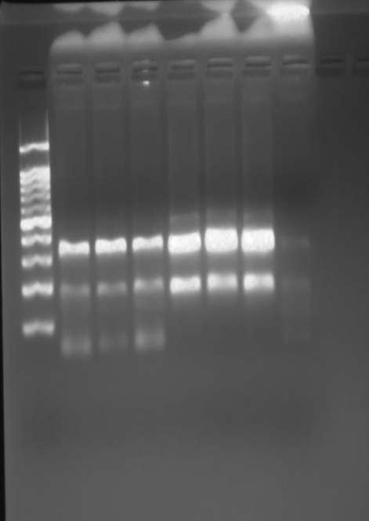
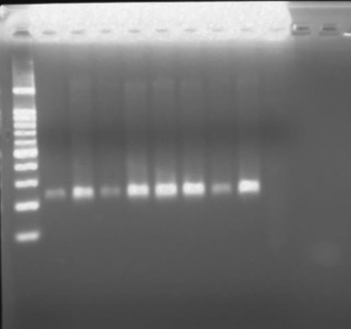
Figure 2: The BioDoc-Transilluminator gel imaging system photographs the results of Agarose gel electrophoresis of the (1) stx1 (180bp) gene and the eaeA (384bp), (2) stx2 (255bp) gene in the Escherichia coli O157:H7strain milk isolated from raw milk, respectively. Lane M = 100bp DNA ladder; PC= positive control; 1, 2, 3…7 positives samples; NC = negative control.

