AMPK–TFE3–SLCO4A1 axis drives xanthosine-mediated NK cell suppression under hypoxia
Chaomin Wang^{1,2,#}, Yu Wu^{3,#}, Na Zhao^{2,#}, Yawen Song^{4,#}, Wenhao Niu^{1,#}, Zhaosong Wang², Jialei Hua², Shuya Zhao², Qianhui Hao², Dong Yang², Zhansheng Jiang², Benfu Zhong^{2,*}, Xiuju Chen^{3,*}, Miao Liu^{2,*}, Changsen Bai^{2,*}

¹Department of Clinical Laboratory, Shanxi Provincial People's Hospital, No. 29 of Shuangtasi Street，Taiyuan，Shanxi，China
²National Clinical Research Center for Cancer, Key Laboratory of Cancer Prevention and Therapy, Tianjin's Clinical Research Center for Cancer, Tianjin Medical University Cancer Institute and Hospital, Tianjin, China
³Tianjin Nankai Hospital, Tianjin Medical University, Tianjin,China
⁴The Third Central Hospital of Tianjin, Tianjin Key Laboratory of Extracorporeal Life Support for Critical Diseases, Artificial Cell Engineering Technology Research Center, Tianjin Institute of Hepatobiliary Disease, 83 Jintang Road, Hedong District, Tianjin, China.
#These authors contributed equally to this work.

* Corresponding authors:
Changsen Bai:
National Clinical Research Center for Cancer, Key Laboratory of Cancer Prevention and Therapy, Tianjin's Clinical Research Center for Cancer, Tianjin Medical University Cancer Institute and Hospital, Tianjin, China.
E-mail: changsenbai@tmu.edu.cn
Miao Liu:
National Clinical Research Center for Cancer, Key Laboratory of Cancer Prevention and Therapy, Tianjin's Clinical Research Center for Cancer, Tianjin Medical University Cancer Institute and Hospital, Tianjin, China.
E-mail: 732793416@qq.com

Xiuju Chen:
Tianjin Nankai Hospital, Tianjin Medical University, Tianjin,China
E-mail: chyjutj@163.com

Benfu Zhong:
National Clinical Research Center for Cancer, Key Laboratory of Cancer Prevention and Therapy, Tianjin's Clinical Research Center for Cancer, Tianjin Medical University Cancer Institute and Hospital, Tianjin, China
E-mail: benfu1314@126.com

Supporting Information (Supplementary Figures S1-S10 and Table S1-S4)
Figure S1 SLCO4A1 Downregulation Significantly Inhibits Cancer Growth Under Hypoxia.
- qPCR analysis of SLCO4A1 mRNA levels in HeLa and MCF-7 cells cultured under normoxia or hypoxia for 24 h.
- Western blot analysis of SLCO4A1 protein expression in HeLa and MCF-7 cells cultured under normoxia or hypoxia for 24 h.
(C) Western blot analysis confirmed successful generation of SLCO4A1 knockdown cell lines.
(D) Cell viability of Scr and shSLCO4A1-1 cells cultured under normoxia and hypoxia was measured at 24, 48, 72, and 96 hours.
(E) Scr and shSLCO4A1-1 cells were cultured under normoxia and hypoxia for 96 hours, and EdU incorporation was assessed by flow cytometry.
(F) Western blot analysis confirmed successful generation of SLCO4A1 knockdown and rescue cell lines.
(G) Scr, shSLCO4A1-1, and shSLCO4A1-1 + SLCO4A1 cells were cultured under hypoxia for 96 hours, and EdU-positive cells were quantified by flow cytometry.
(H) 5 × 10⁶ HeLa/Scr, HeLa/shSLCO4A1, and HeLa/shSLCO4A1/SLCO4A1 cells were subcutaneously injected into nude mice (n=5/group). Quantification of tumor weights at the end of the experiment.
All cultures were supplied with 10% dialyzed serum. Values are presented as means ± SD from three independent experiments. **p < 0.01; ***p < 0.001; ****p < 0.0001 (Student’ s t-test).

Figure S2 SLCO4A1 Is Amplified in Multiple Cancers and Correlates with Poor Patient Prognosis.
- Analysis of SLCO4A1 expression and mutation status in various cancers using the cBioPortal online database.
- Large-scale data analysis of the correlation between SLCO4A1 expression and prognosis in breast cancer patients (data from TCGA Breast Cancer, analyzed by Kaplan-Meier gene expression).
(C) Analysis of the association between SLCO4A1 expression and prognosis in liver cancer patients (https://www.kmplot.com/).

Figure S3 TFE3 Positively Correlates with SLCO4A1 and Regulates Its Expression Through Promoter Association.
(A) Western blot analysis of TFE3 and SLCO4A1 protein expression in tumor cells transiently transfected with FLAG-TFE3 for 48h.
(B–D) Transcriptional correlation in clinical samples. mRNA levels of TFE3 and SLCO4A1 were detected by qPCR in 17 paired liver cancer and adjacent non-tumor tissues (B-C), followed by Pearson correlation analysis (D).
(E–F) Specificity of SLCO4A1 regulation by MiT family members. (E) qPCR validation of TFEB mRNA levels in HeLa and MCF-7 cells 48 h post-transfection with the TFEB plasmid. (F) Western blot analysis showing the impact of 48-h TFEB overexpression on SLCO4A1 protein levels in the indicated cell lines.
(G–H) Effects of mTOR inhibition on TFE3 and SLCO4A1. (G) Immunofluorescence (IF) detection of TFE3 subcellular localization in HeLa cells treated with Torin 1 (250 nM) for 24 hours. (H) qPCR analysis of SLCO4A1 mRNA expression in HeLa cells following Torin 1 treatment.
(I–K) ChIP-qPCR analysis of TFE3 occupancy at the SLCO4A1 promoter. (I) Representative agarose gel images showing ChIP products for negative control, IgG, positive control, and TFE3-binding sites under normoxia and hypoxia. (J–K) Quantitative ChIP-qPCR results showing the relative enrichment of TFE3 at the SLCO4A1 promoter, presented as a fold change relative to the IgG control.
All cultures were supplied with 10% dialyzed serum. Values are presented as means ± SD from three independent experiments. *p < 0.05 (Student’s t-test).

Figure S4 AMPK Activation Facilitates Nuclear Translocation of TFE3 and Upregulates SLCO4A1 Expression.
- KEGG pathway analysis of transcriptome sequencing data from HeLa cells cultured under normoxia and hypoxia for 8 hours, showing pathways enriched under hypoxia compared to normoxia.
- KEGG pathway enrichment and Venn diagram analysis of transcriptome data from HeLa cells cultured for 8 hours under normoxia, hypoxia, or treated with Antimycin A (Ant A) (1 μM), showing AMPK signaling among the top 10 enriched pathways under hypoxia and Antimycin A conditions.
(C-D) TFE3 protein stability assays. HeLa cells were treated with or without the AMPK activator AICAR (1mM) in the presence of cycloheximide (CHX, 20μg/mL) or MG132 (20μM) for the indicated time points. TFE3 expression was analyzed by Western blot to assess its degradation rate and proteasomal involvement.
(E-J) HeLa, MCF-7 and HCC-LM3 cells transiently transfected with TFE3 (FLAG) for 36h and treated with AMPK activator AICAR (1mM) or inhibitor Compound C (25 μM) for 24h. IF confocal microscopy analysis of TFE3 subcellular localization(E-G); Nucleocytoplasmic fractionation and Western blot analysis(H-J).
(K–M) HeLa cells were treated with AntA (1μM) for 8 h. (K) IF detection of TFE3 localization. (L) Western blot analysis of AMPK pathway activation (p-AMPK/AMPK). (M) qPCR analysis of SLCO4A1 mRNA levels.
(N–O) Validation in CAL-62 cells. (N) Western blot detection of TFE3 and AMPK activation in CAL-62 cells under normoxia or hypoxia. (O) qPCR analysis of SLCO4A1 mRNA expression.
All cultures were supplemented with 10% dialyzed fetal bovine serum. Values are presented as means ± SD from three independent experiments. **p < 0.01 (Student’s t-test).

Figure S5 Hypoxia Activates AMPK to Promote Nuclear Translocation of TFE3 and Upregulate SLCO4A1 Expression.
(A) qRT-PCR analysis of MCOLN1 mRNA expression levels in HeLa cells transfected with FLAG-TFE3 for 48 h to validate TFE3 transcriptional activity.
(B) qRT-PCR analysis of MCOLN1 mRNA expression levels in HeLa cells cultured under normoxia or hypoxia (1% O₂) for 24 h.
(C–D) HeLa and MCF-7 cells were transiently transfected with FLAG-TFE3 for 36 h, followed by treatment with or without the AMPK inhibitor Compound C (25 μM) under normoxia or hypoxia for an additional 24 h. Subcellular localization of TFE3 was evaluated by IF staining and confocal microscopy.
(E) Transcriptomic analysis of FLCN mRNA expression levels in HeLa cells cultured under normoxia or hypoxia for 8 h.
All cultures were supplemented with 10% dialyzed fetal bovine serum. Values are presented as means ± SD from three independent experiments. **p < 0.01 (Student’s t-test).

Figure S6 TFE3 Facilitates Membrane Localization of SLCO4A1 Under Hypoxia.
- Representative immunofluorescence images showing SLCO4A1 localization in HeLa cells cultured for 48 hours under normoxia or hypoxia.
(B) Immunofluorescence detection of SLCO4A1 localization in HCC-LM3 and MCF-7 cells cultured for 48 hours under normoxia or hypoxia.
(C) TFE3 is required for hypoxia-induced SLCO4A1 membrane localization. HeLa cells transfected with control shRNA (Scr) or shTFE3-1 were cultured under hypoxia for 48 h, followed by IF staining to assess SLCO4A1 distribution.
(D)Transcriptomic analysis of RAB8A, RAB8B and RAB14 mRNA expression levels in HeLa cells cultured under normoxia or hypoxia for 8 h.
All cultures were supplied with 10% dialyzed serum. Values are presented as means ± SD from three independent experiments.

Figure S7 The Oncogenic Role of TFE3 Under Hypoxia Depends on Its Regulation of SLCO4A1.
- Flow cytometry analysis of EdU-positive cells after culturing Scr, shTFE3, and shTFE3 + SLCO4A1 cell lines under hypoxia for 96 hours.
(B-C) Prognostic analysis of TFE3 and PRKAA1 (AMPKα) expression in breast, liver, and cervical cancer patients using https://www.kmplot.com/, including overall survival (OS) and relapse-free survival (RFS).
All cultures were supplied with 10% dialyzed serum. Values are presented as means ± SD from three independent experiments. **p < 0.01; ***p < 0.001 (one-way ANOVA).
Figure S8 Under Hypoxia, SLCO4A1 Regulates the Uptake and Secretion of Diverse Metabolites.
- B) VIP analysis of intracellular metabolites in HeLa/Scr and HeLa/shSLCO4A1-1 cells under normoxia and hypoxia.
(C-D) VIP analysis of extracellular metabolites in conditioned media from HeLa/Scr and HeLa/shSLCO4A1-1 cells under normoxic and hypoxic conditions.
All cultures were supplied with 10% dialyzed serum.

Figure S9 Xanthine secretion remodels the immune microenvironment.
(A) Schematic workflow of the PBMC functional assay. Peripheral blood mononuclear cells (PBMCs) were isolated from healthy donors via centrifugation and washed twice with 1X PBS. Cells (1 x 10⁶ cells/well) were inoculated in 12-well plates using RPMI-1640 medium supplemented with 10% FBS. Following a 48-h co-incubation with various concentrations of xanthosine (0, 10, 50, 100 μM), cells were stained with fluorescently conjugated antibodies (20 min, room temperature, protected from light) and resuspended for downstream analysis. Supernatants were collected for metabolic profiling.
(B-C) PBMCs from healthy donors were treated with different concentrations of xanthosine for 48 h, and the proportion of B, CD8⁺ and CD4⁺ cells were analyzed by flow cytometry.
(D) After 48 h of xanthosine treatment, culture supernatants from PBMCs were collected, and glucose and lactate levels were quantified using cobas 701 system or VITROS 5600 Integrated System.
All cultures were supplied with 10% dialyzed serum. Values are presented as means ± SD from three independent experiments. *p < 0.05 (Student’ s t-test)

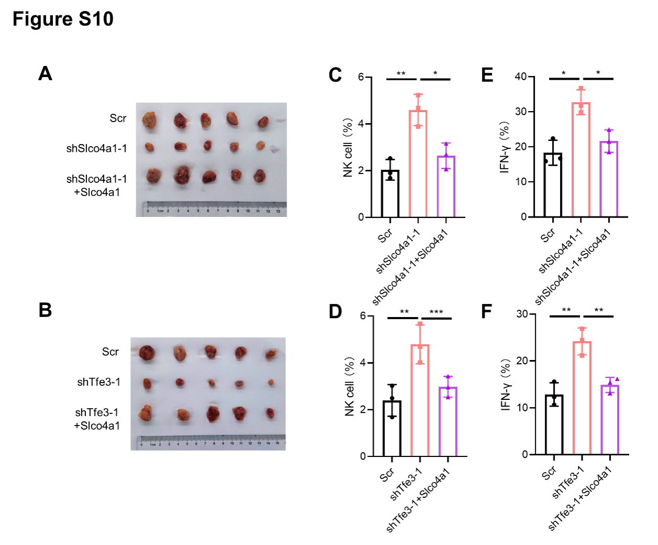
Figure S10 Slco4a1-Mediated Xanthosine Export Suppresses NK Cell Function and Promotes Immune Evasion.
(A) Tumor representative images of syngeneic 4T1 breast cancer models in Scr, shSlco4a1, and shSlco4a1+Slco4a1 groups.
(B) Tumor representative images in 4T1 models following Tfe3 depletion with or without Slco4a1 restoration, validating the Tfe3/Slco4a1 regulatory axis.
(C-D) Flow cytometric quantification of the abundance of tumor-infiltrating NK cells in Slco4a1-modulated groups (C) and Tfe3/Slco4a1-modulated groups (D).
(E-F) Flow cytometric analysis of the percentage of IFN-γ NK cells within tumor tissues to assess NK cell activation and effector function. (E) Comparison between Slco4a1-knockdown and restoration groups. (F) Comparison between Tfe3-depletion and SLCO4A1-rescue groups.
Values are presented as means ± SD from three independent experiments. *p < 0.05; **p < 0.01; ***p < 0.001 (Student’ s t-test).
Table S1 shRNAs used in this study
Targets | sequence (5'-3')
SLCO4A1 (human) | #1: GCACTTCAACTTGTCAGAGAA  #2: GCACTTCAACTTGTCAGAGAA
TFE3 (human) | #1: ATTGTTGCTGACATAGAATTA  #2: AGCTTGGAGGAGGGTTGTAAA

Table S2 Antibodies and chemicals used in this study
Antibodies | Application | Reference
SLCO4A1 (human) | WB | Novus Biologicals (NBP2-85772)
SLCO4A1 (human) | IF | Proteintech(26399-1-AP)
Ki67 (human) | IHC | Proteintech (27309-1-AP)
Caspase 3 (human) | IHC | Santa (sc-7272)
TFE3 (human) | WB | Abcam (ab93808)
p-TFE3 (human) | WB | Cell Signaling Technology (23816)
Flag (human) | WB | Proteintech (20543-1-AP)
Flag (human) | IF | Proteintech (20543-1-AP)
AMPKα (human) | WB | Abcam (ab32047)
p-AMPKα-T172 (human) | WB | Cell Signaling Technology (Cat#2535S)
GAPDH (human) | WB | Proteintech (60004-1-Ig)
YY1 (human) | WB | Proteintech (66281-1-Ig)
Histone H3 (human) | WB | Proteintech (17168-1-AP)
HIF1α (human) | WB | Proteintech (20960-1-AP)
NKP46 (mouse) | IF | Proteintech (84416-5-RR)
β-actin (human) | WB | Sigma (A3854)
Antibody-CD45-FITC/CD4-RD1/CD8-CD/CD3-PC5 (mouse) | FCM | Beckman Coulter (731037-CF)
Antibody-CD45-FITC/CD56-RD1/CD19-ECD/CD3-PC5 (mouse) | FCM | Beckman Coulter (2420903-GF)
CD49b (mouse) | FCM | BioLegend (108907)
CD3 (mouse) | FCM | BioLegend (100217)
IFN-γ mouse) | FCM | BioLegend (502527)
AICAR | mM | Selleck (S1802, Selleck)
Compound C | μM | Selleck (S7840)
WB: Western Blot; IF: Immunofluorescence; IHC: Immunohistochemistry; FCM: Flow cytometric analysis.

Table S3 Sequences of primers for qPCR
qPCR primers | sequence (5'-3')
TFE3 (human) | F: CCGTGTTCGTGCTGTTGGA  R: GCTCGTAGAAGCTGTCAGGAT
SLCO4A1 (human) | F: TGGCTTCATCAACACAGTCATCAC  R: AGGCGGCAATGTCGTAGGAG
TFEB (human) | F: GACCGCATCAAGGAGTTG  R: GCTGCTTGTTGGTCATCT
MCOLN1 (human) | F: GTTTGTGGGGTTCATGTGGC  R: GAAGAGGCTGAGCACCATGT

Table S4 Sequences of primers for CHIP assay
Chip primers | sequence (5'-3')
Negative site (SLCO4A1) | F: TTCCACCCTCAGAGCTAGTGT  R: TAGCCTGGGAATCCGGGGAAT
Binding site (SLCO4A1) | F: AGACCGGCGGGCACCTTCA  R: TTCAGCTCCGCCCTTCCGAAA
Positive site  (MCOLN1) | F: AGCCAGGGCAGAGCTCGT  R: GGAACAGCGCGCATGCGTG

