Attachment

Removal of duplicated articles (n = 136)
Identification through 6 database
PubMed, CINAHL, Scopus, ProQuest, Science Direct, Global Index Medicus
(n = 736)
After study limitation to adult and human (n = 571)

Screening

Inclusion

Eligibility

Identification
Additional articles identified from other databases (n = 19)
Total studies (n = 590)
Screened articles (n = 454)
Excluded articles
(n = 432)
Assessment of full-text articles for study eligibility (n = 22)
Excluded full-text articles:
(n = 12)
1 overlapped study
1 unpublicized study
5 articles do not meet the criteria for inclusion
5 does not meet the criteria for exclusion

Included studies in qualitative synthesis (n = 10)
Included studies in qualitative synthesis (meta-analysis) (n = 10)
Figure L1. Diagram systematic study

Non Aggressive
Aggressive
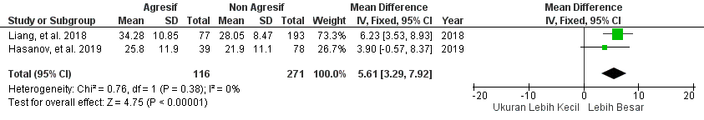

Figure L2. Forest plot of mean difference in adenoma size on aggressiveness
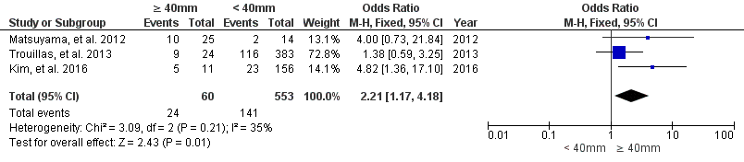
Figure L3. Forest plot between giant adenoma and non-giant adenoma on aggressiveness
Non Aggressive
Aggressive
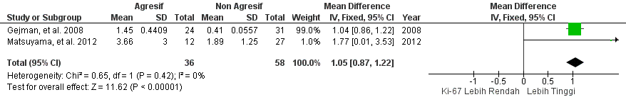
Aggressive
Non Aggressive

Figure L4. Forest plot of Ki-67 mean difference on aggressiveness

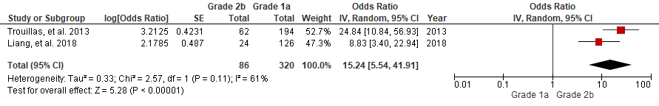

Figure L5. Forest plot of grade 2b and grade 1a on aggressiveness

No Residual
With Residual
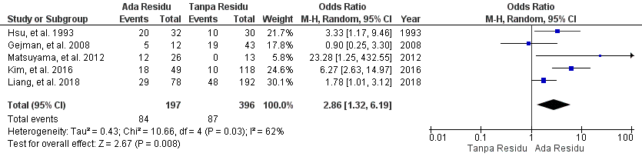
No Residual
With Residual

Figure L6. Forest plot of post-operative residue on aggressiveness

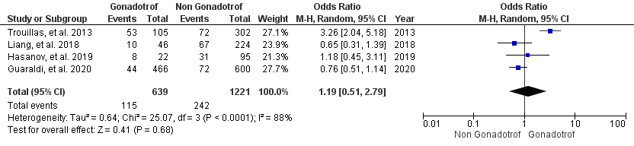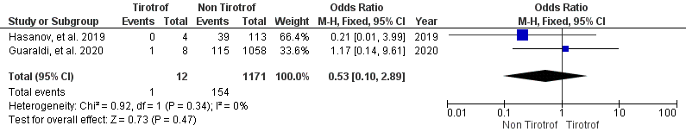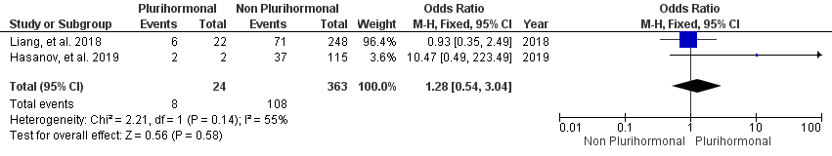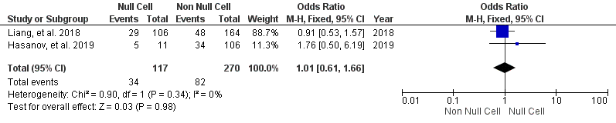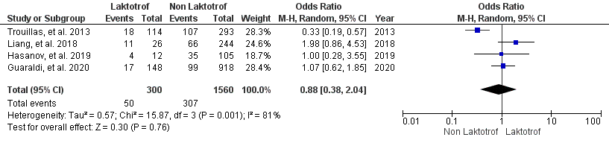
Non Lactotroph
Lactotroph
Thyrotroph
Non Thyrotroph
Non Gonatrotroph
Gonadotroph
Non Lactotroph
Lactotroph
Non Thyrotroph
Thyrotroph
Non Gonatrotroph
Gonadotroph

Figure L7. Forest plot of adenoma types (gonadotroph, thyrotroph, plurihormonal, null cell, and lactotroph)

Table L1. Excluded studies

No | Study, Year | Reasons
1 | Oruckaptan et al³², 2000 | Does not assess the correlation between independent variables and recurrence/progression (Does not meet the inclusion criteria)
2 | Roelfsema et al³³, 2012 | Does not assess the correlation between independent variables and recurrence/progression (Does not meet the inclusion criteria)
3 | Diri et al³⁴, 2013 | Does not assess the correlation between independent variables and recurrence/progression (Does not meet the inclusion criteria)
4 | Chiloiro et al³⁵, 2014 | Only included certain pituitary adenoma subjects (Meet the exclusion criteria)
5 | Waraasawapati et al³⁶, 2014 | Only in the form of poster information and not published
6 | Bodhinayake et al³⁷, 2014 | Only assess 1 independent variable (Meet the exclusion criteria)
7 | Sarkar et al³⁸, 2015 | Does not assess the correlation between independent variables and recurrence/progression (Does not meet the inclusion criteria)
8 | Liang et al³⁹, 2018 | Only included certain pituitary adenoma subjects (Meet the exclusion criteria)
9 | Petry et al⁴⁰, 2019 | Only assess 1 independent variable (Meet the exclusion criteria)
10 | Asioli et al¹⁶, 2019 | Part of Guaraldi et al. study
11 | Pappy et al⁴¹, 2019 | Does not assess the correlation between independent variables and recurrence/progression (Does not meet the inclusion criteria)
12 | Liu et al²⁶, 2020 | Only assess 1 independent variable (Meet the exclusion criteria)

