Supplemental Table S1.
Univariable Linear Regression Analyses of Docking, Console, and Operative Times

Variable | β（95% CI） | p-value
Docking Time | -
BMI | 0.58 (-0.12 to 1.28) | 0.11
Parity | 0.16 (-2.57 to 2.89) | 0.91
*Uterine weight | 0.50 (-0.72 to 1.72) | 0.43
Console Time
BMI | 0.47 (-0.27 to 1.21) | 0.22
Parity | -0.35 (-3.17 to 2.47) | 0.81
*Uterine weight | 1.11 (-0.14 to 2.36) | 0.08
Operative Time
BMI | 2.42 (0.79 to 4.05) | <0.001
Parity | 2.09 (-4.31 to 8.49) | 0.52
*Uterine weight | 5.65 (2.98 to 8.32) | <0.001
β represents the regression coefficient (estimate).
* Uterine weight was entered per 100 g to improve clinical interpretability.

Supplemental Table S2. Variance Inflation Factor (VIF) Summary

Variable | Docking Time VIF | Console Time VIF | Operative Time VIF
BMI | 1.01 | 1.01 | 1.01
Parity | 1.03 | 1.03 | 1.03
Uterine weight | 1.01 | 1.01 | 1.01
The Variance Inflation Factor (VIF) was calculated to assess multicollinearity among predictor variables in the multivariate regression analyses for docking time, console time, and operative time. VIF values greater than 10 are typically indicative of significant multicollinearity. In this study, all VIF values were below 2, indicating no meaningful multicollinearity among the predictors.

Supplementary Figure S1.
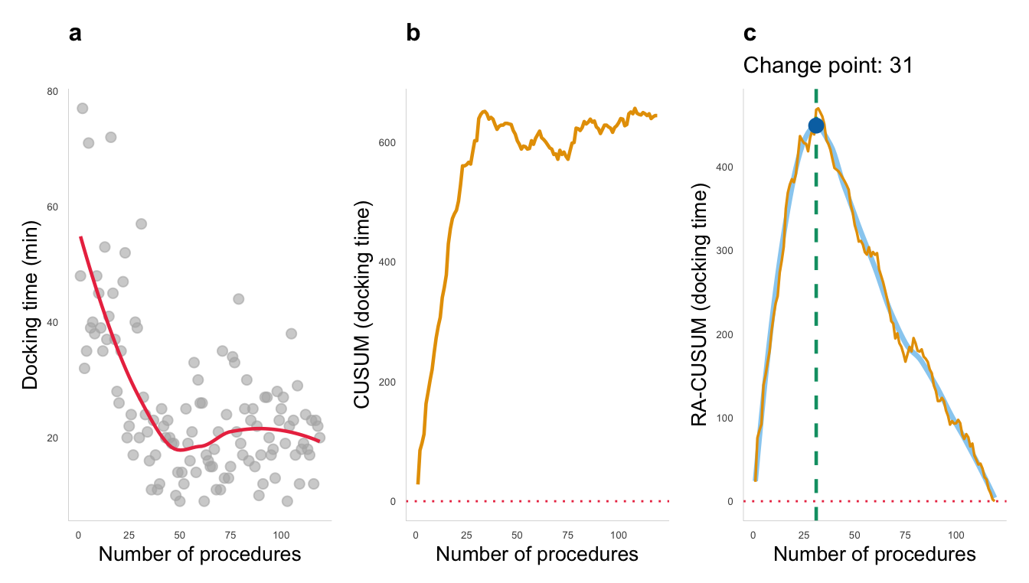
Supplementary Figure S2.
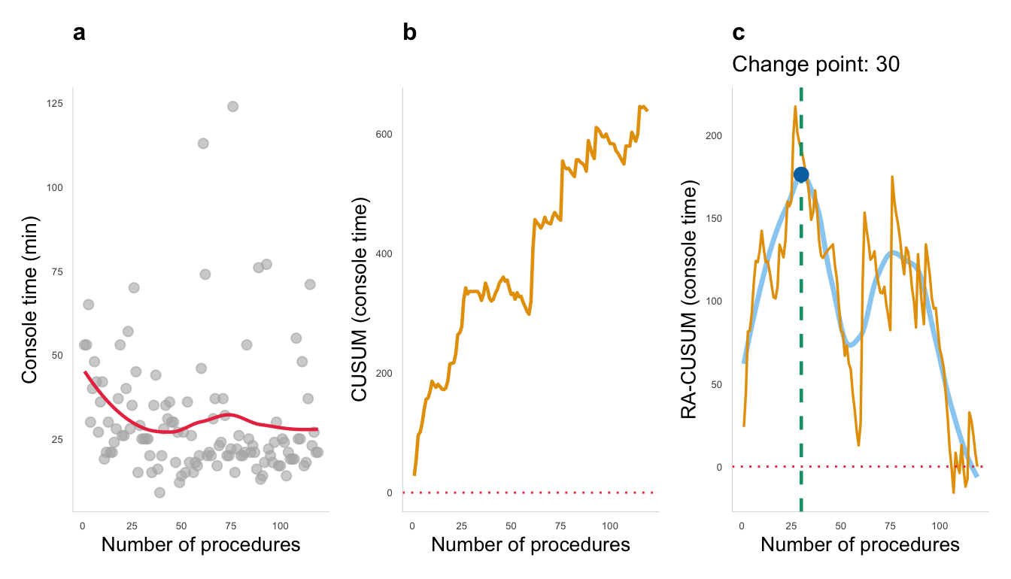

Supplementary Figure S3.
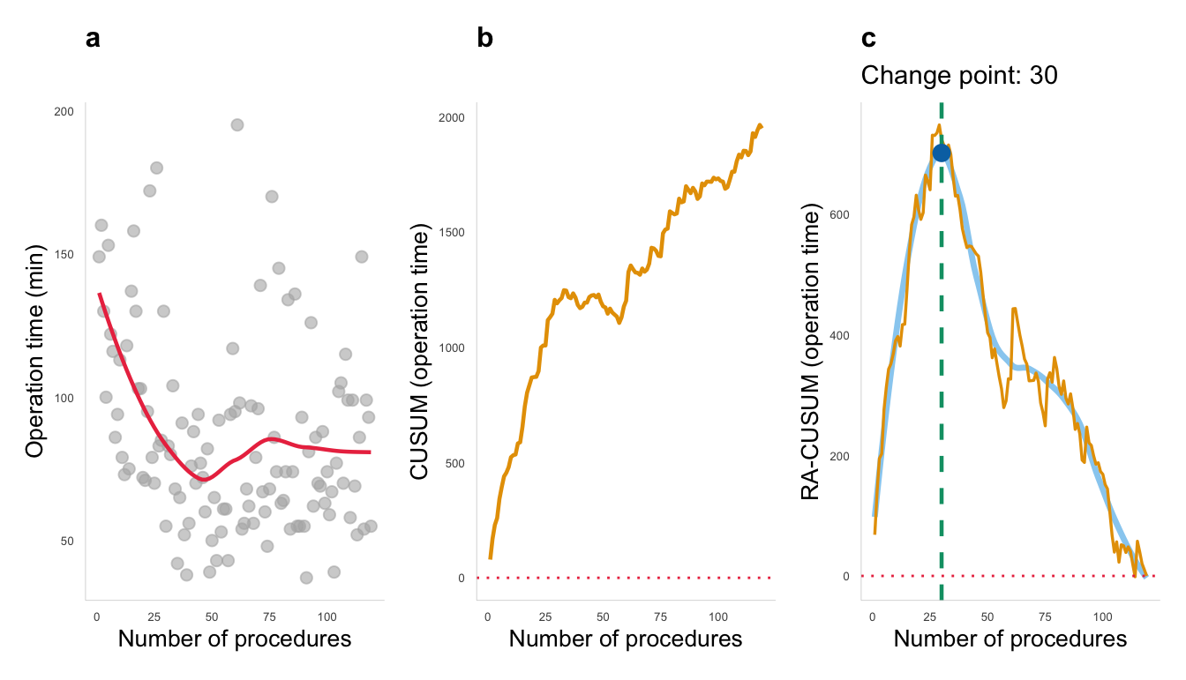

Supplementary Figure Legends
Figure S1.
Sensitivity analyses of the learning curve for docking time, including the three visceral injury cases.
(a) Transition plot.
(b) Conventional CUSUM plot; the y-axis represents cumulative time (minutes).
(c) Risk-adjusted CUSUM plot; the y-axis represents cumulative residuals (observed minus expected docking time, minutes).

Figure S2.
Sensitivity analyses of the learning curve for console time, including the three visceral injury cases.
(a) Transition plot.
(b) Conventional CUSUM plot; the y-axis represents cumulative time (minutes).
(c) Risk-adjusted CUSUM plot; the y-axis represents cumulative residuals (observed minus expected console time, minutes).
Figure S3.
Sensitivity analyses of the learning curve for operative time, including the three visceral injury cases.
(a) Transition plot.
(b) Conventional CUSUM plot; the y-axis represents cumulative time (minutes).
(c) Risk-adjusted CUSUM plot; the y-axis represents cumulative residuals (observed minus expected operative time, minutes).

