Uncropped Western blot images are provided.
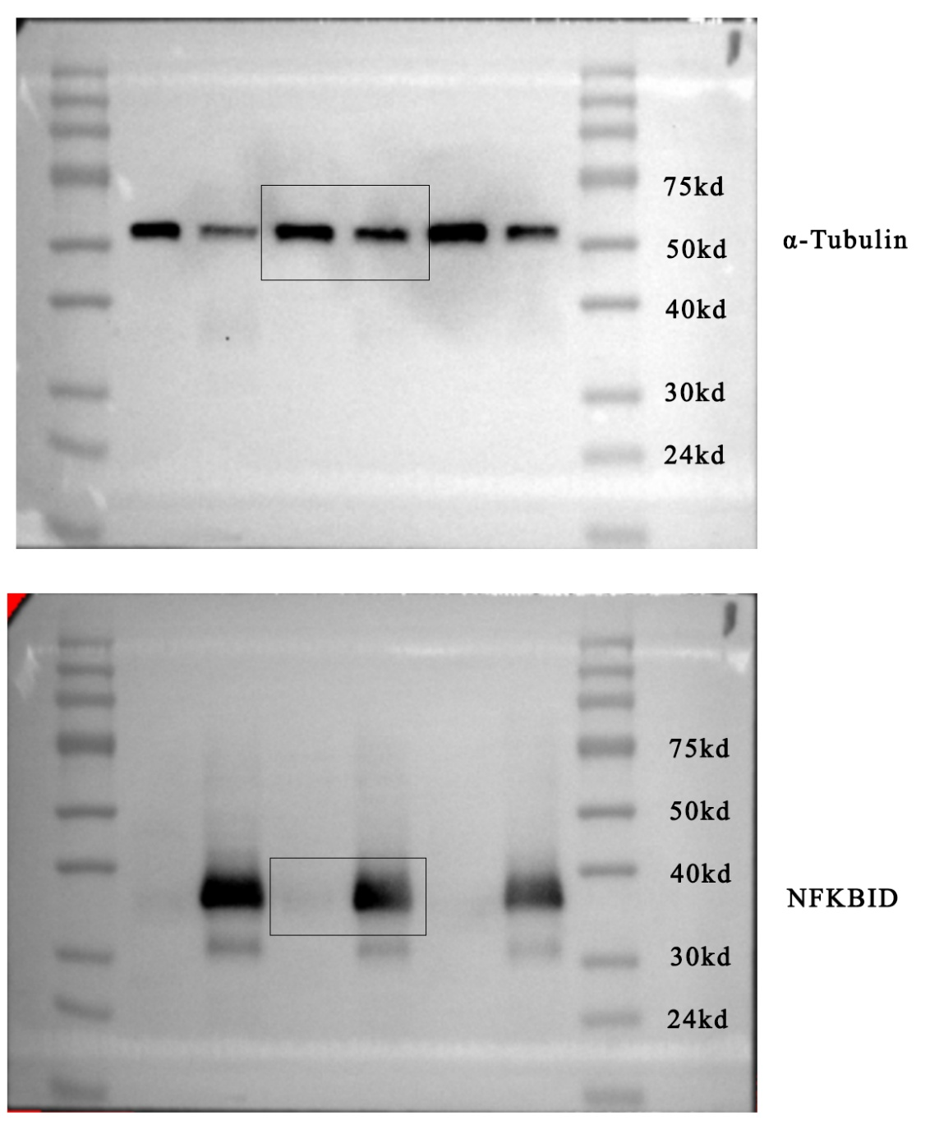
The areas indicated by rectangular boxes correspond to the bands presented in Fig. 7A of the main manuscript.

