Supplementary Information

Tuning amorphous-crystalline heterogeneity enables simultaneous optimization of thermoelectric performance and ductility in silver chalcogenides

Jong Min Park^{a,b,1}, Jeong Min Lee^{c, 1}, Seungki Joª, Soo-Ho Jungª, Linh Ba Vuª, Hyun-Sik Kim^{d}, Hyeon Woo Kim^{e}, Sung Beom Cho^{e}, Xun Shi^{f}, Kwi-Il Park^{b, *}, Weon Ho Shin^{c, *}, Kyung Tae Kim^{a, *}

ªNano Materials Research Division, Korea Institute of Materials Science, 797 Changwon-daero, Seongsan-gu, Changwon, Gyeongnam 51508, Republic of Korea
^{b}Department of Materials Science and Metallurgical Engineering, Kyungpook National University, 80 Daehak-ro, Buk-gu, Daegu 41566, Republic of Korea
^{c}Department of Electronic Materials Engineering, Kwangwoon University, 20 Kwangwoon-Ro, Nowon-Gu, Seoul, 01897, Republic of Korea
^{d}Department of Materials Science and Engineering, University of Seoul, 232 Gongneung-ro, Nowon-gu, Seoul 01811, Republic of Korea
^{e}Department of Materials Science and Engineering, Ajou University, Suwon, Gyeonggi-do 16499, Republic of Korea
^{f}State Key Laboratory of High Performance Ceramics, Shanghai Institute of Ceramics, Chinese Academy of Sciences, Shanghai 200050, China.

¹These authors contributed equally to this work.
*Correspondence: kipark@knu.ac.kr (K.-I. Park), weonho@kw.ac.kr (W. H. Shin) ktkim@kims.re.kr (K. T. Kim)
Supplementary Methods
Calculation of minimum lattice thermal conductivity
The minimum lattice thermal conductivity was estimated using the Cahill–Pohl model. In this model, the minimum thermal conductivity corresponds to the regime where phonon lifetimes are limited to roughly one half of their vibrational period, which can be interpreted as phonon mean free paths on the order of one-half of the phonon wavelength. This model has been demonstrated to describe thermal transport in amorphous solids and strongly disordered crystalline materials, representing a glass-like limit of heat conduction. Accordingly, the calculated minimum lattice thermal conductivity provides a reasonable lower bound for the lattice thermal transport in the present materials. Minimum lattice thermal conductivity is defined as equation below.
$$κ_{min}^{Cahill}=\frac{1}{2.48}k_{B}n^{2/3}(ν_{L}+2ν_{T})$$
where k_{B} is the Boltzmann constant, n is number density of atoms, $ν_{L}$ is longitudinal sound velocity, and $ν_{T}$ is transverse sound velocity. The parameters required for the calculation were obtained by linear interpolation of reported values for crystalline Ag₂S and Ag₂Te ¹.
 | n (atoms m⁻³) | $ν_{L}$ (m s⁻¹) | $ν_{T}$ (m s⁻¹)
Ag₂S | 4.89×10²⁸ | 2596 | 1128
Ag₂Te | 4.34×10²⁸ | 3048 | 1382
Ag₂S_{0.4}Te_{0.6} | 4.56×10²⁸ | 2867.2 | 1280.4

Calculation of weighted mobility and quality factor
The weighted mobility (μ_{w}) was calculated using the single parabolic band (SPB) model, which relates the Seebeck coefficient (S) and electrical conductivity (σ) as follows ²:
$$μ_{w}=\frac{3h^{3}σ}{8πe{(2m_{e}k_{B}T)}^{3/2}}\left[\frac{exp\left[\frac{\left|S\right|}{{k_{B}}/e}-2\right]}{1+exp\left[-5\left(\frac{\left|S\right|}{{k_{B}}/e}-1\right)\right]}+\frac{\frac{3}{π^{2}}\frac{\left|S\right|}{{k_{B}}/e}}{1+exp\left[5\left(\frac{\left|S\right|}{{k_{B}}/e}-1\right)\right]}\right]$$
where k_{B} is the Boltzmann constant, e is the elementary charge, h is the Planck constant, and m_{e} is the electron mass.
Based on the calculated weighted mobility, the thermoelectric quality factor (B) was determined using ²:
$$B={(\frac{k_{B}}{e})}^{2}\frac{8πe{(2m_{e}k_{B}T)}^{3/2}}{3h^{3}}∙\frac{μ_{w}}{κ_{L}}T$$
where κ_{L} is the lattice thermal conductivity and T is the absolute temperature. The quality factor provides a measure of the intrinsic thermoelectric performance by incorporating both carrier transport properties and lattice thermal conductivity.

Finite-element simulation details
Finite-element simulations were performed using COMSOL Multiphysics (version 6.2) to evaluate the coupled temperature and electrical potential distributions of Ag₂S_{0.4}Te_{0.6} ingots. A three-dimensional model with dimensions of 5 × 5 × 10 mm³ was constructed. The simulations were carried out using experimentally measured thermoelectric properties, including electrical conductivity, Seebeck coefficient, and thermal conductivity, which were assigned to each sample to ensure direct comparison under identical conditions. Thermal boundary conditions were applied such that the top surface was maintained at a constant temperature of 288 K, while a uniform heat flux of 1500 Wm⁻² was applied to the bottom surface. All other surfaces were treated as thermally insulated. These conditions were selected to generate a stable temperature gradient while maintaining the operating temperature range relevant for wearable thermoelectric applications. The electrical potential distribution was calculated by solving the coupled heat transfer and thermoelectric equations under steady-state conditions. The resulting temperature difference (ΔT) and electrical potential were extracted for comparison among samples with different amorphous–crystalline fractions.
Table S1. Formation energies of crystalline Ag₂Te and Ag₂S ³⁻⁶.
Formula | Crystal System | Formation Energy (eV/atom)
Ag₂Te | Monoclinic | -0.0952
Ag₂S | Monoclinic | -0.118
Ag₂S | Cubic | -0.0414

Table S2. ZT-bending ductility for AM60 and reported Ag₂S-based materials ⁷⁻¹³.
Formula | ZT | Bending ductility (%)
Ag₂S_{0.4}Te_{0.6} AM60 (This work) | ~0.466 | ~23
Ag₂S_{0.5}Se_{0.5}+0.5mol% Ag₂Te⁷ | ~0.39 | ~32.5
Ag₂₀S₇Te₃⁸ | ~0.3 | ~15
Ag₂S_{0.5}Se_{0.5}⁹ | ~0.26 | ~12
Ag₂S_{0.4}Te_{0.6}¹⁰ | ~0.2 | ~16
Ag_{1.98}S_{1/3}Se_{1/3}Te_{1/3}¹¹ | ~0.28 | ~15
Ag₂S_{0.7}Se_{0.295}I_{0.005}¹² | ~0.26 | ~15
Ag₂S_{0.7}Te_{0.3}¹³ | ~0.3 | ~20

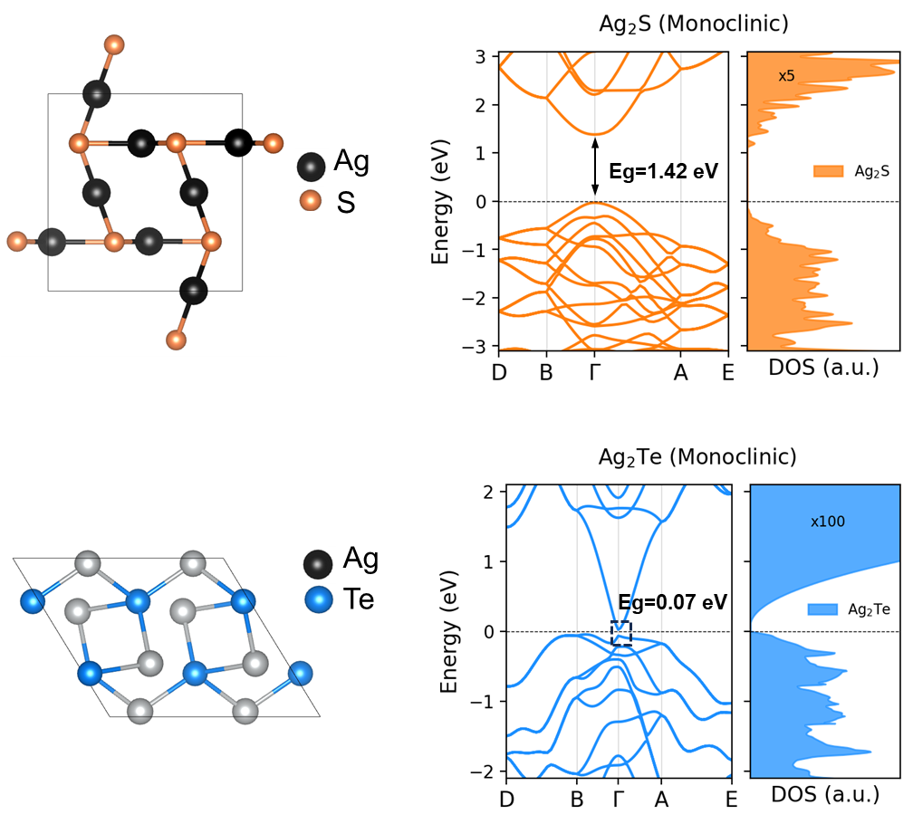
Figure S1. Electronic DOS of monoclinic Ag₂S and Ag₂Te calculated by DFT.

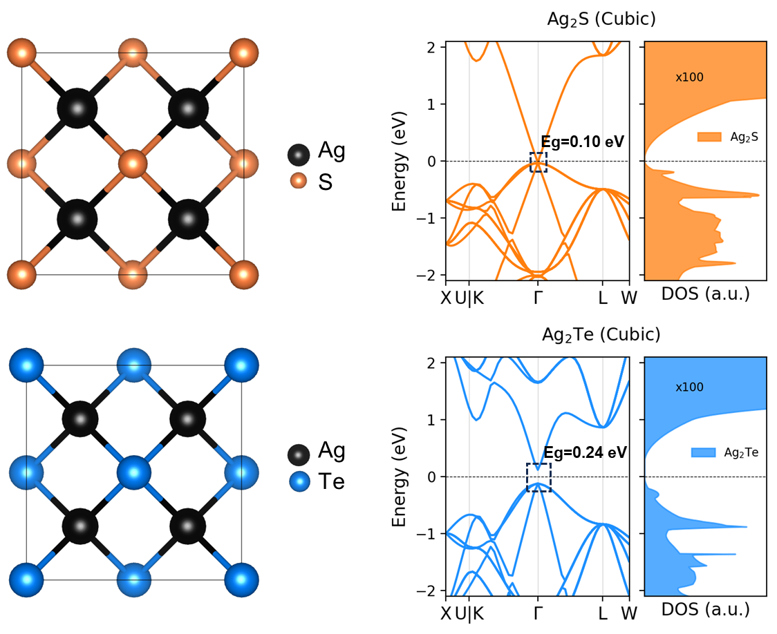
Figure S2. Electronic DOS of cubic Ag₂S and Ag₂Te calculated by DFT.

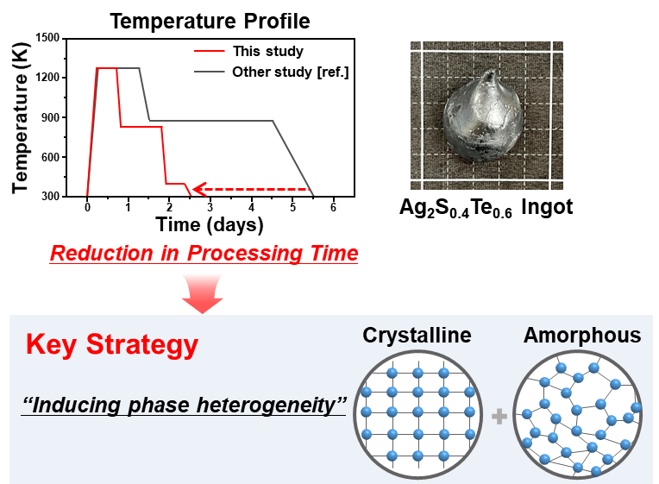
Figure S3. The temperature profile in this study (red line) is designed to induce phase heterogeneity and significantly reduces the processing time compared to the conventional method reported in Ref. 14 (grey line).

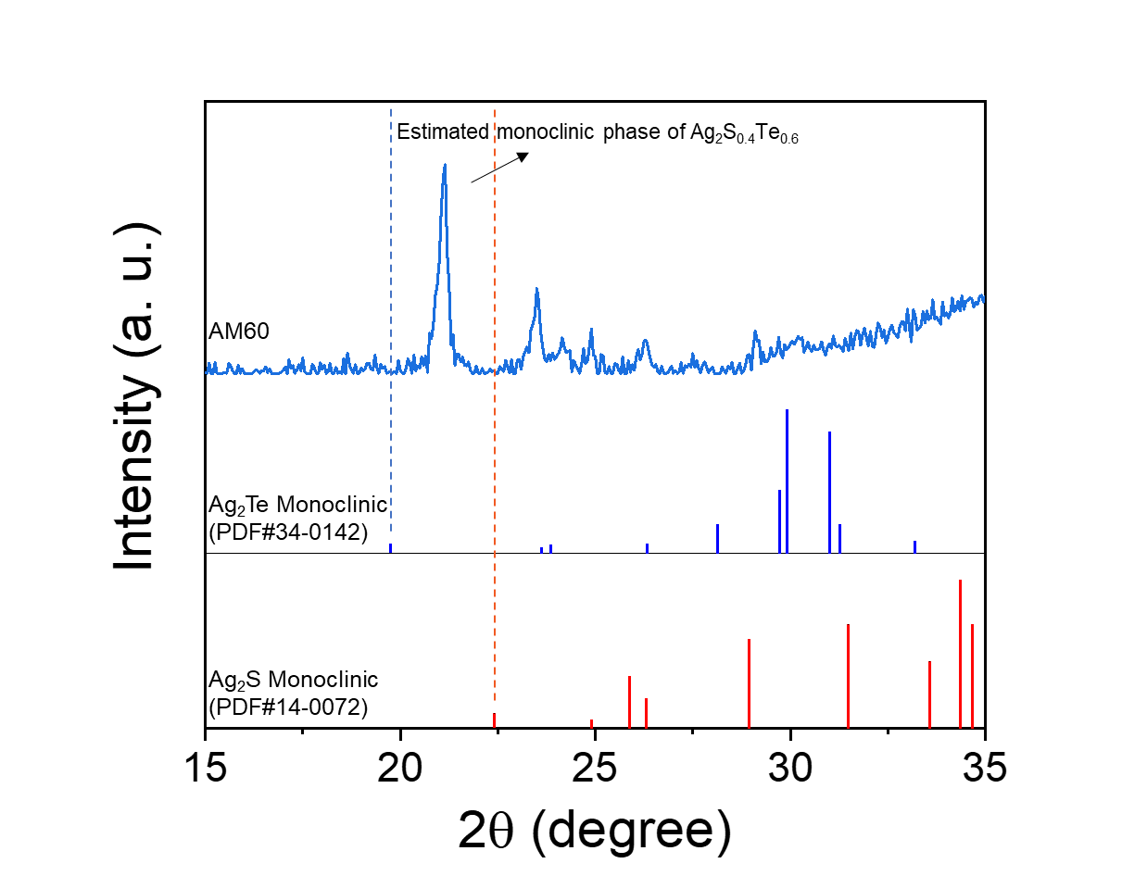
Figure S4. Magnified XRD pattern of AM60 (15–35°) with reference peak positions of monoclinic Ag₂S and Ag₂Te.

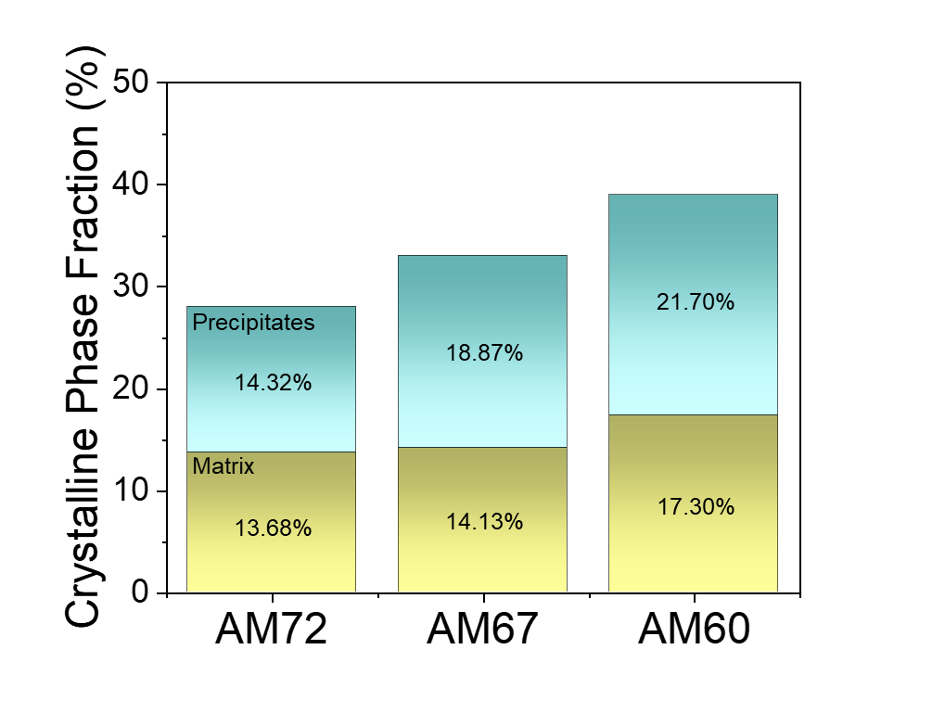
Figure S5. Quantified crystalline phase fraction of matrix and precipitates using peak area integration method.

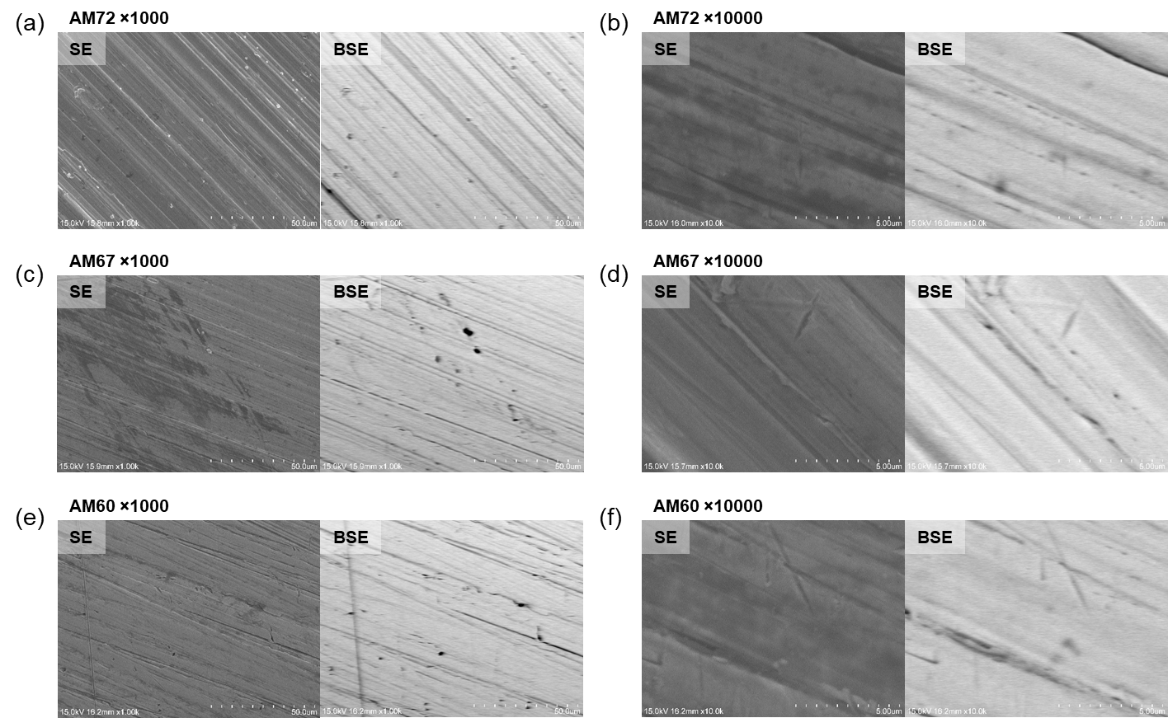
Figure S6. SE and BSE image of the Ag₂S_{0.4}Te_{0.6} ingots at magnification of ×1000 and ×10000. (a, b) AM72, (c, d) AM67, and (e, f) AM60.

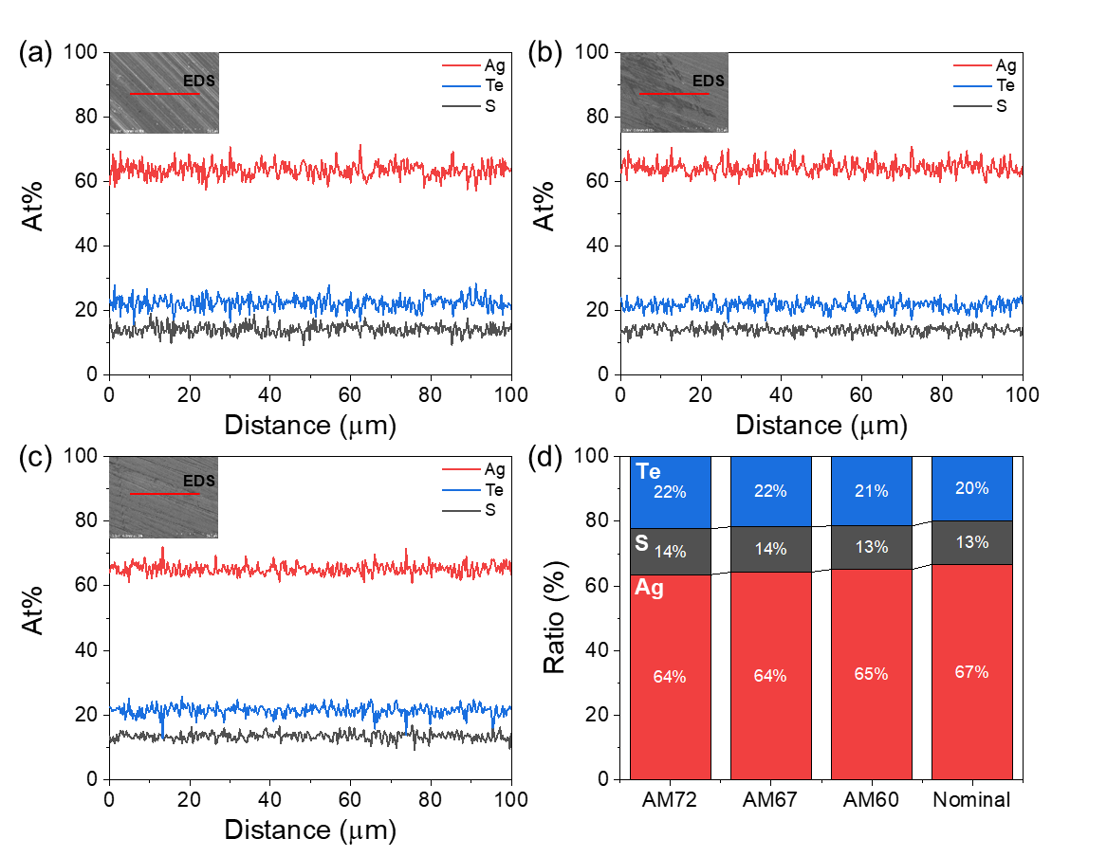
Figure S7. (a–c) SEM images with corresponding line-scan EDS profiles of AM72, AM67, and AM60, respectively, acquired at a magnification of ×1000. (d) Elemental compositions obtained from the line-scan EDS analyses of the three ingots.

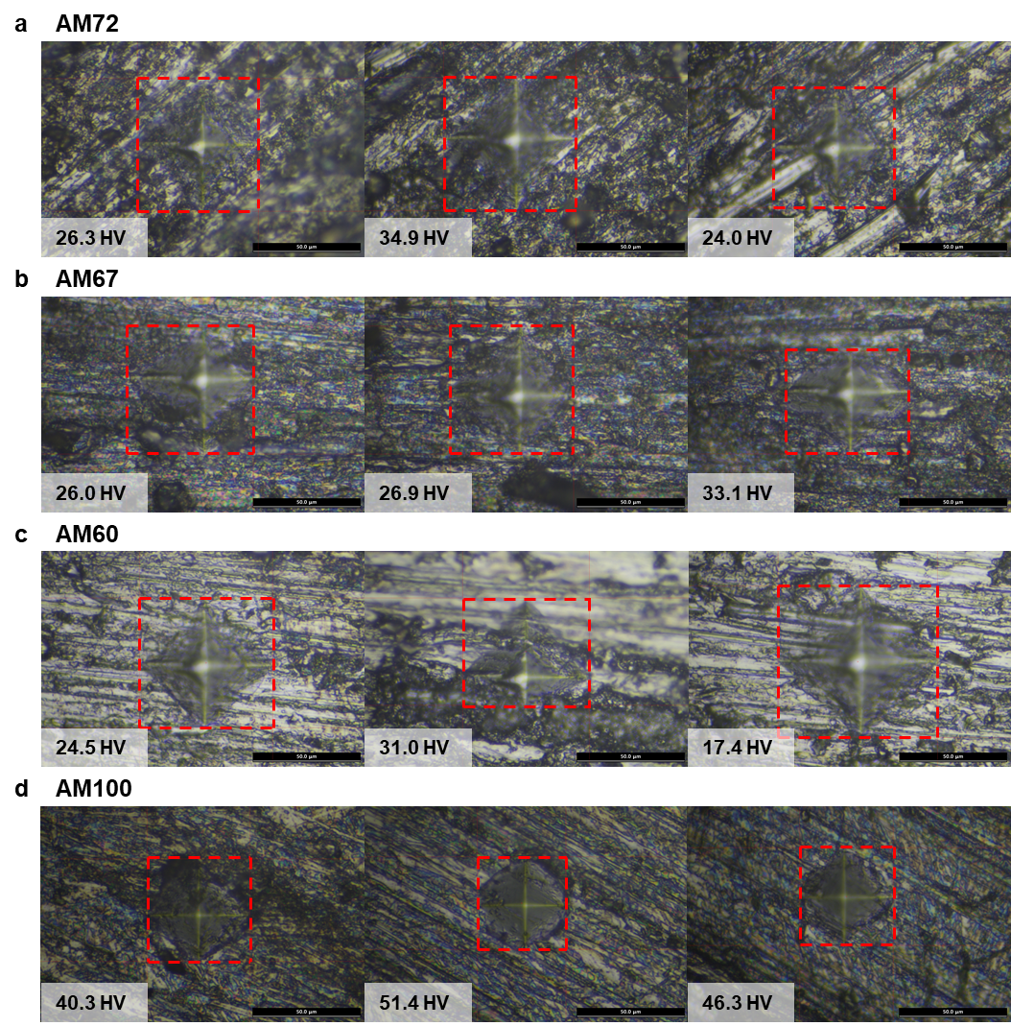
Figure S8. Vickers indentation images at different regions of Ag₂S_{0.4}Te_{0.6} ingots. The dashed boxes indicate indentation areas with corresponding hardness values.

References
1. Xia, Z. et al. Enhancement of thermoelectric properties of Ag₂Te semiconductors through In-doping induced resonant levels and multi-valley degeneracy. J Mater Chem A 13, 12266-12276 (2025).
2. Snyder, G. J. et al. Weighted Mobility. Adv Mater 32, 2001537 (2020)
3. Jain, A. et al. The Materials Project: A materials genome approach to accelerating materials innovation. APL Mater 1, 011002 (2013)
4. Materials Project. Crystal structure of Ag₂S (mp-2018369). https://next-gen.materialsproject.org/materials/mp-2018369 (Accessed March 19, 2026).
5. Materials Project. Crystal structure of Ag₂S (mp-1229090). https://next-gen.materialsproject.org/materials/mp-1229090 (Accessed March 19, 2026).
6. Materials Project. Crystal structure of Ag₂Te (mp-1592). https://next-gen.materialsproject.org/materials/mp-1592 (Accessed March 19, 2026).
7. Wu H, et al. Optimized Thermoelectric Performance and Plasticity of Ductile Semiconductor Ag₂S_{0.5}Se_{0.5} Via Dual‐Phase Engineering. Adv Energy Mater 13, 2302551 (2023).
8. Yang S, et al. Ductile Ag₂₀S₇Te₃ with Excellent Shape-Conformability and High Thermoelectric Performance. Adv Mater 33, e2007681 (2021).
9. Liang J, et al. Flexible thermoelectrics: from silver chalcogenides to full-inorganic devices. Energy Environ Sci 12, 2983-2990 (2019).
10. He S, et al. Semiconductor glass with superior flexibility and high room temperature thermoelectric performance. Sci Adv 6, eaaz8423 (2020).
11. Chen H, et al. High‐Entropy Cubic Pseudo‐Ternary Ag₂(S, Se, Te) Materials With Excellent Ductility and Thermoelectric Performance. Adv Energy Mater 14, 2303473 (2023).
12. Liu J, et al. Enhanced thermoelectric performance in ductile Ag₂S-based materials via doping iodine. Appl Phys Lett 119, 121905 (2021).
13. Peng L, et al. Phase-modulated mechanical and thermoelectric properties of Ag₂S_{1-x}Te_{x} ductile semiconductors. J Materiomics 8, 656-661 (2022).
14. Wang, Y. et al. Reversible room temperature brittle‐plastic transition in Ag₂Te_{0.6}S_{0.4} inorganic thermoelectric semiconductor. Adv Funct Mater 33, 2300189 (2023).

