Supplementary data
Table S1. The definitions of diet component used in the UK biobank study
Diet component | Intake goal | Data field IDs | Amount per serving
Fruit | 3 servings/day | 1309 | 1 piece
Fruit | 3 servings/day | 1319 | 5 pieces
Vegetable | 3 servings/day | 1289 | 3 heaped tablespoons
Vegetable | 3 servings/day | 1299 | 3 heaped tablespoons
(Shell) fish | ≥2 servings/week | 1329 | Once/week
(Shell) fish | ≥2 servings/week | 1339 | Once/week
Red and processed meat | ≤2 servings/week | 1359 | Once/week
Red and processed meat | ≤2 servings/week | 1369 | Once/week
Red and processed meat | ≤2 servings/week | 1379 | Once/week
Red and processed meat | ≤2 servings/week | 1389 | Once/week
Red and processed meat | ≤2 servings/week | 1349 | 1 piece/day
Whole grains | 3 servings/day | 1438, 1448 | 1 slice/day
Whole grains | 3 servings/day | 1458, 1468 | 1 bowl/day
Sugar-sweetened beverages | Don not drink | 6155 | Only 0 servings were possible here
Low-fat dairy | Intake | 1418 | Intake of semi-skimmed, skimmed, and soya milk was possible here

Table S2. HR (95% CI) for incidence based on PhenoAge acceleration
 | PhenoAge acceleration (quartiles)
 | Quartile 1 | Quartile 2 | Quartile 3 | Quartile 4 | P for trend
Hypothyroidism
Model 1 | Ref. | 1.17 (1.10, 1.26) | 1.39 (1.30, 1.49) | 1.85 (1.73, 1.97) | < 0.001
Model 2 | Ref. | 1.11 (1.04, 1.19) | 1.26 (1.18, 1.35) | 1.55 (1.45, 1.66) | < 0.001
Model 3 | Ref. | 1.11 (1.03, 1.18) | 1.25 (1.16, 1.33) | 1.49 (1.39, 1.59) | < 0.001
Hyperthyroidism
Model 1 | Ref. | 1.17 (1.08, 1.28) | 1.42 (1.31, 1.53) | 2.56 (2.38, 2.75) | < 0.001
Model 2 | Ref. | 1.09 (1.01, 1.19) | 1.23 (1.13, 1.33) | 1.93 (1.79, 2.09) | < 0.001
Model 3 | Ref. | 1.09 (1.01, 1.19) | 1.23 (1.13, 1.34) | 1.93 (1.79, 2.09) | < 0.001

Model 1: Age (continuous, years), sex (female, male) were adjusted.
Model 2: Age (continuous, years), sex (male and female), ethnicity (white people and others), TDI (low, moderate, high), BMI (<30 kg/m², ≥30 kg/m²), tobacco smoking (never, current or former smokers), alcohol consumption (never, current or former drinkers), physical activity (inactive, low, moderate, high), health diet (yes, no) were adjusted.
Model 3: Age (continuous, years), sex (male and female), ethnicity (white people and others), TDI (low, moderate, high), BMI (<30 kg/m², ≥30 kg/m²), tobacco smoking (never, current or former smokers), alcohol consumption (never, current or former drinkers), physical activity (inactive, low, moderate, high), health diet (yes, no) , and use of thyroid-related medications (yes, no), PM2.5 were adjusted.
P for trend was tested by using ordered integer values.

Table S3. RERI, AP for cumulative interactions between benzene and accelerated biological aging
Benzene | PhenoAge acceleration
 | RERI （95 % CI） | AP （95 % CI）
Hypothyroidism
Quartile 2 | 0.21 (-0.04, 0.46) | 0.13 (-0.02, 0.27)
Quartile 3 | 0.43 (0.18, 0.68) | 0.23 (0.11, 0.35)
Quartile 4 | 0.40 (0.13, 0.66) | 0.19 (0.07, 0.30)
Hyperthyroidism
Quartile 2 | 0.21 (-0.15, 0.56) | 0.09 (-0.06, 0.23)
Quartile 3 | 0.12 (-0.22, 0.46) | 0.05 (-0.10, 0.20)
Quartile 4 | 0.30 (-0.06, 0.67) | 0.10 (-0.02, 0.22)

Table S4. Association between benzene exposure and thyroid dysfunction after multiple imputation of covariates
 | Benzene(continuous) | Benzene(quartiles)
 | HR (95% CI) for a 1 μg/m³ increase | Quartile 1 | Quartile 2 | Quartile 3 | Quartile 4 | P for trend
Hypothyroidism
Model 1 | 1.29 (1.27, 1.32) | Ref. | 1.71 (1.61, 1.82) | 1.87 (1.75, 1.98) | 2.22 (2.09, 2.36) | <0.001
Model 2 | 1.30 (1.28, 1.33) | Ref. | 1.71 (1.61, 1.82) | 1.84 (1.73, 1.96) | 2.16 (2.03, 2.30) | <0.001
Model 3 | 1.31 (1.28, 1.34) | Ref. | 1.73 (1.62, 1.84) | 1.86 (1.75, 1.98) | 2.18 (2.04, 2.33) | <0.001
Hyperthyroidism
Model 1 | 1.51 (1.48, 1.54) | Ref. | 1.70 (1.58, 1.82) | 1.83 (1.70, 1.96) | 3.02 (2.82, 3.24) | <0.001
Model 2 | 1.36 (1.33, 1.39) | Ref. | 1.72 (1.60, 1.85) | 1.75 (1.63, 1.88) | 2.36 (2.20, 2.54) | <0.001
Model 3 | 1.35 (1.32, 1.38) | Ref. | 1.69 (1.57, 1.82) | 1.70 (1.58, 1.83) | 2.26 (2.10, 2.44) | <0.001
The models were adjusted for age (continuous, years), sex (male and female), ethnicity (white people and others), TDI (low, moderate, high), BMI (<30 kg/m², ≥30 kg/m²), tobacco smoking (never, current or former smokers), alcohol consumption (never, current or former drinkers), physical activity (inactive, low, moderate, high), health diet (yes, no) , and use of thyroid-related medications (yes, no), PM2.5. BMI: body mass index; TDI, Townsend deprivation index; PM2.5, particulate matter with diameter < 2.5 μm. P for trend was tested by using ordered integer values.

Table S5. Association of benzene exposure with thyroid dysfunction after excluding participants with less than 2 years of follow-up
 | Benzene(continuous) | Benzene(quartiles)
 | HR (95% CI) for 1 μg/m³ increase | Quartile 1 | Quartile 2 | Quartile 3 | Quartile 4 | P for trend
Hypothyroidism
Model 1 | 1.17 (1.15, 1.19) | Ref. | 1.28 (1.20 1.36) | 1.34 (1.27, 1.43) | 1.57 (1.48, 1.67) | <0.001
Model 2 | 1.16 (1.13, 1.18) | Ref. | 1.27 (1.19, 1.35) | 1.32 (1.24, 1.40) | 1.49 (1.40, 1.59) | <0.001
Model 3 | 1.16 (1.13, 1.19) | Ref. | 1.26 (1.19, 1.34) | 1.31 (1.23, 1.39) | 1.49 (1.40, 1.59) | <0.001
Hyperthyroidism
Model 1 | 1.38 (1.35, 1.41) | Ref. | 1.29 (1.20, 1.38) | 1.32 (1.23, 1.42) | 2.20 (2.06, 2.35) | <0.001
Model 2 | 1.21 (1.18, 1.24) | Ref. | 1.25 (1.16, 1.34) | 1.21 (1.12, 1.30) | 1.62 (1.51, 1.73) | <0.001
Model 3 | 1.20 (1.17, 1.23) | Ref. | 1.23 (1.15, 1.33) | 1.18 (1.10, 1.27) | 1.56 (1.45, 1.68) | <0.001

The models were adjusted for age (continuous, years), sex (male and female), ethnicity (white people and others), TDI (low, moderate, high), BMI (<30 kg/m², ≥30 kg/m²), tobacco smoking (never, current or former smokers), alcohol consumption (never, current or former drinkers), physical activity (inactive, low, moderate, high), health diet (yes, no) , and use of thyroid-related medications (yes, no), PM2.5. BMI: body mass index; TDI, Townsend deprivation index; PM2.5, particulate matter with diameter < 2.5 μm. P for trend was tested by using ordered integer values.

Table S6. Association of benzene exposure with thyroid dysfunction after excluding participants with medication usage
 | Benzene(continuous) | Benzene(quartiles)
 | HR (95% CI) for a 1 μg/m³ increase | Quartile 1 | Quartile 2 | Quartile 3 | Quartile 4 | P for trend
Hypothyroidism
Model 1 | 1.17 (1.15, 1.19) | Ref. | 1.30 (1.22, 1.38) | 1.36 (1.28, 1.44) | 1.59 (1.50, 1.70) | <0.001
Model 2 | 1.16 (1.13, 1.18) | Ref. | 1.29 (1.21, 1.37) | 1.33 (1.25, 1.41) | 1.51 (1.42, 1.61) | <0.001
Model 3 | 1.16 (1.14, 1.19) | Ref. | 1.29 (1.21, 1.38) | 1.33 (1.25, 1.42) | 1.52 (1.42, 1.63) | <0.001
Hyperthyroidism
Model 1 | 1.40 (1.37, 1.43) | Ref. | 1.30 (1.21, 1.40) | 1.35 (1.26, 1.45) | 2.28 (2.14, 2.44) | <0.001
Model 2 | 1.23 (1.20, 1.26) | Ref. | 1.27 (1.18, 1.36) | 1.23 (1.15, 1.32) | 1.67 (1.56, 1.80) | <0.001
Model 3 | 1.22 (1.19, 1.25) | Ref. | 1.25 (1.17, 1.35) | 1.21 (1.12, 1.30) | 1.62 (1.51, 1.74) | <0.001
The models were adjusted for age (continuous, years), sex (male and female), ethnicity (white people and others), TDI (low, moderate, high), BMI (<30 kg/m², ≥30 kg/m²), tobacco smoking (never, current or former smokers), alcohol consumption (never, current or former drinkers), physical activity (inactive, low, moderate, high), health diet (yes, no), PM2.5. BMI: body mass index; TDI, Townsend deprivation index; PM2.5, particulate matter with diameter < 2.5 μm. P for trend was tested by using ordered integer values.

Table S7. Association between benzene exposure and thyroid dysfunction based on inverse probability weighted analysis
 | Benzene(quartiles)
 | Quartile 1 | Quartile 2 | Quartile 3 | Quartile 4 | P for trend
Hypothyroidism
Model 1 | Ref. | 1.23 (1.08, 1.40) | 1.18 (1.04, 1.34) | 1.54 (1.36, 1.74) | <0.001
Model 2 | Ref. | 1.22 (1.08, 1.39) | 1.18 (1.03, 1.34) | 1.54 (1.36, 1.74) | <0.001
Model 3 | Ref. | 1.23 (1.08, 1.39) | 1.19 (1.05, 1.34) | 1.55 (1.38, 1.74) | <0.001
Hyperthyroidism
Model 1 | Ref. | 1.19 (1.05, 1.35) | 1.16 (1.02, 1.32) | 1.59 (1.41, 1.80) | <0.001
Model 2 | Ref. | 1.19 (1.04, 1.35) | 1.16 (1.02, 1.31) | 1.59 (1.40, 1.80) | <0.001
Model 3 | Ref. | 1.19 (1.05, 1.35) | 1.16 (1.03, 1.31) | 1.60 (1.42, 1.80) | <0.001
The models were adjusted for age (continuous, years), sex (male and female), ethnicity (white people and others), TDI (low, moderate, high), BMI (<30 kg/m², ≥30 kg/m²), tobacco smoking (never, current or former smokers), alcohol consumption (never, current or former drinkers), physical activity (inactive, low, moderate, high), health diet (yes, no) , and use of thyroid-related medications (yes, no), PM2.5. BMI: body mass index; TDI, Townsend deprivation index; PM2.5, particulate matter with diameter < 2.5 μm. P for trend was tested by using ordered integer values.

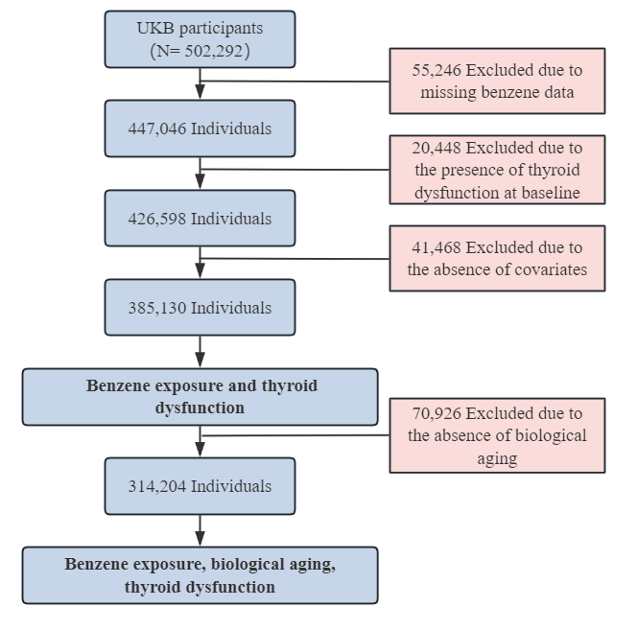
Fig. S1 Flow chart of participants included in the study.
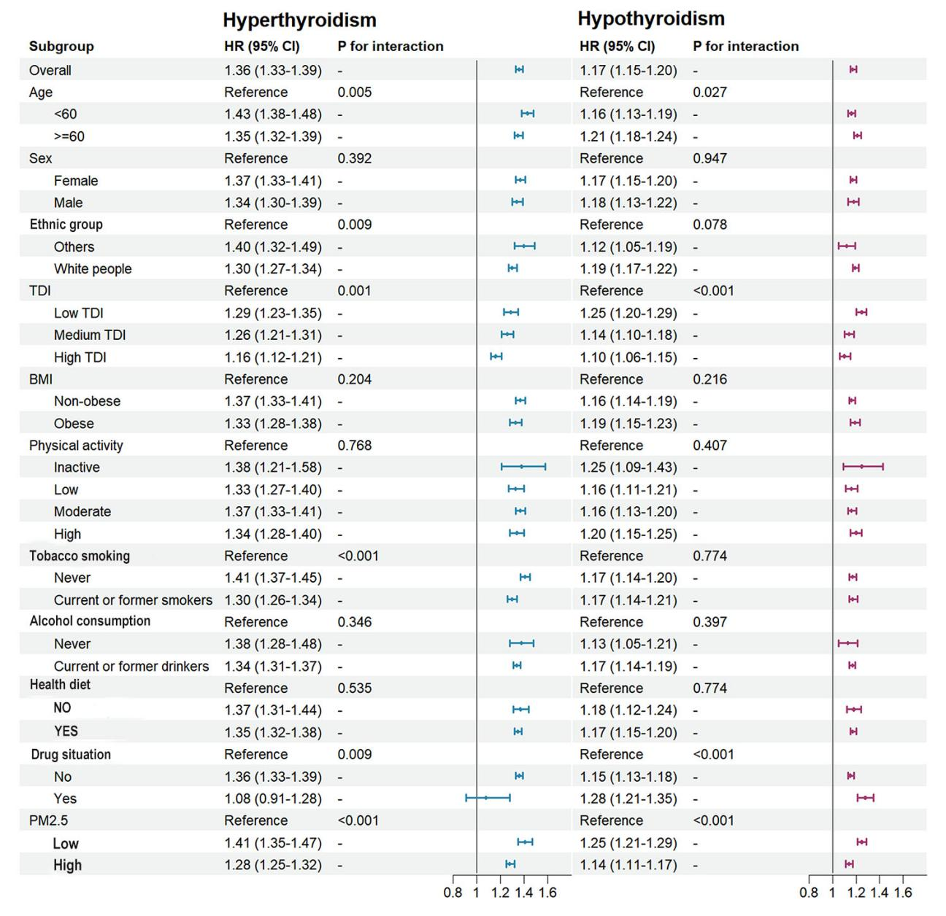
Fig. S2 Subgroup Analysis of the Association Between Environmental Benzene Exposure and Thyroid Dysfunction.

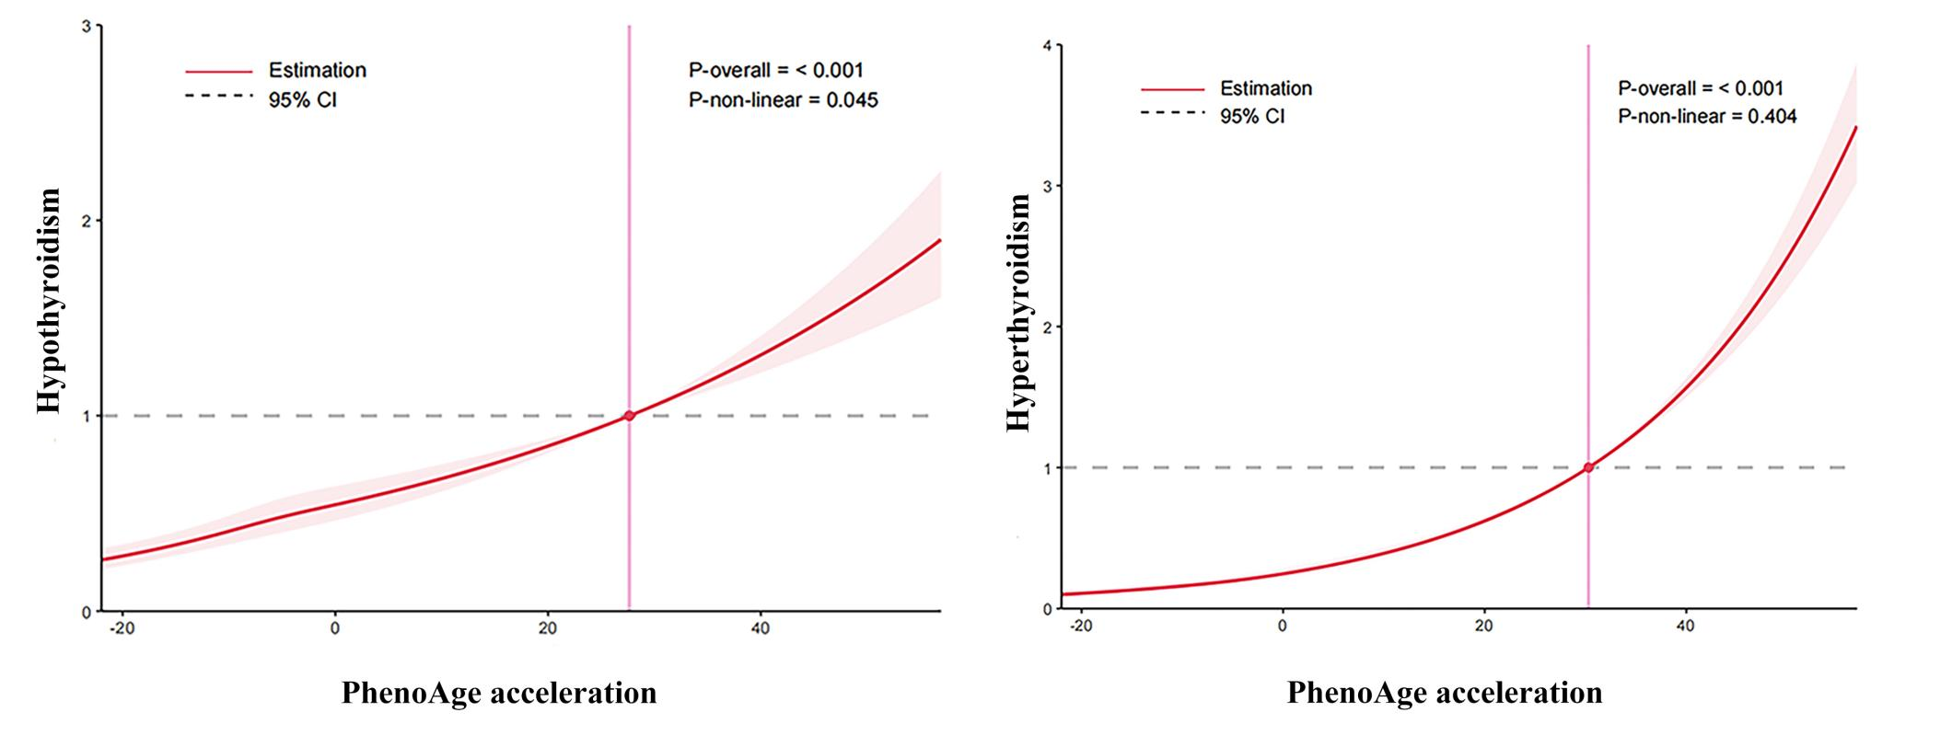
Fig. S3 Exposure-response curves of accelerated biological aging and thyroid dysfunction. Models were adjusted for age (continuous, years), sex (male and female), ethnicity (white people and others), TDI (low, moderate, high), BMI (<30 kg/m², ≥30 kg/m²), tobacco smoking (never, current or former smokers), alcohol consumption (never, current or former drinkers), physical activity (inactive, low, moderate, high), health diet (yes, no) , and use of thyroid-related medications (yes, no), PM2.5. BMI: body mass index; TDI, Townsend deprivation index; PM2.5, particulate matter with diameter < 2.5 μm.

Fig. S4 Exposure-response curves of environmental benzene exposure and accelerated biological aging. Models were adjusted for age (continuous, years), sex (male and female), ethnicity (white people and others), TDI (low, moderate, high), BMI (< 30 kg/m², ≥ 30 kg/m²), tobacco smoking (never, current or former smokers), alcohol consumption (never, current or former drinkers), physical activity (inactive, low, moderate, high), health diet (yes, no) , and use of thyroid-related medications (yes, no), PM2.5. BMI: body mass index; TDI, Townsend deprivation index; PM2.5, particulate matter with diameter < 2.5 μm.

