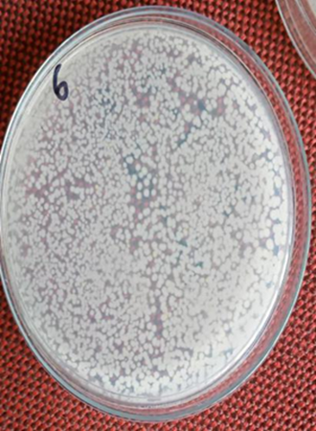  Nutrient Agar  A | 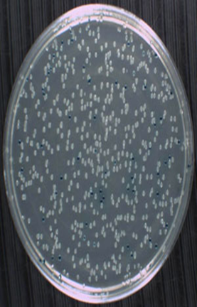  B | 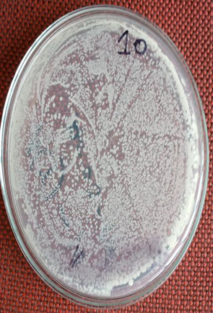  C
A. Raw tap water spread plate culture | B. Raw tube-well water spread plate culture | C. Raw reused plate cleaning water spread plate culture
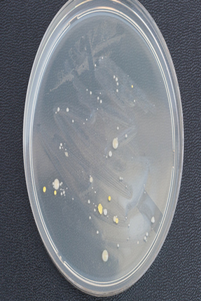  D | 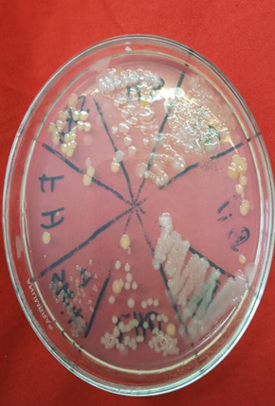  E | 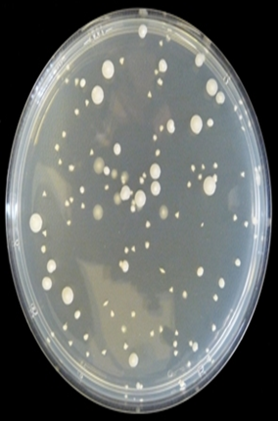  F
D. 10-3 times diluted tap water streak plate culture | E. 10-1 times diluted reused plate cleaning water streak culture | F. 10-3 times diluted tap water spread plate culture
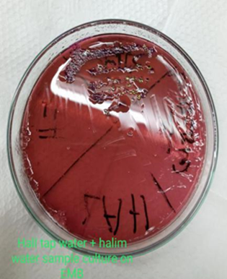  A | 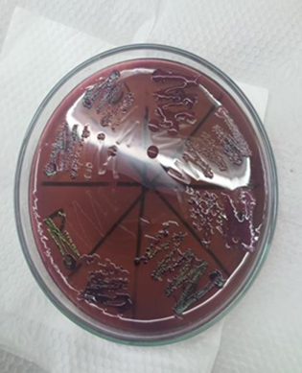  B | 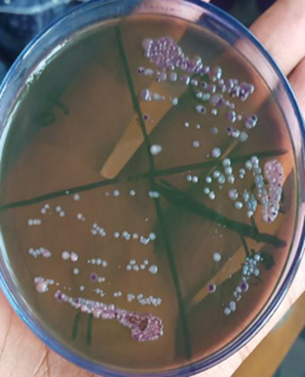  C
A. No E.coli in tap water but E.coli in reused plate cleaning water | B. E.coli in reused plate cleaning water | C. No E.coli in tube-well water
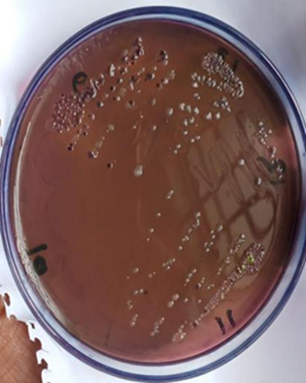  D | 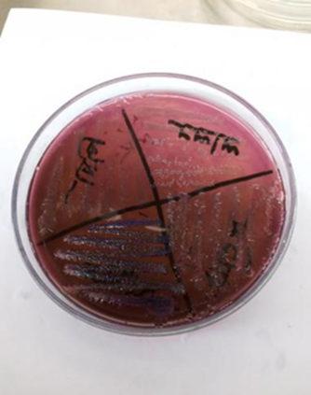  E | F
D. E.coli in reused plate cleaning water | E. No E.coli on nutrient broth reached tubewell water | F. E.coli streak plate culture
Eosin Methylene Blue agar:
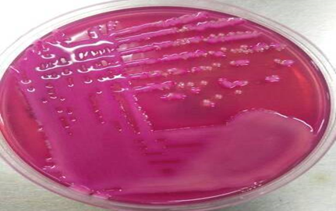  B  A | 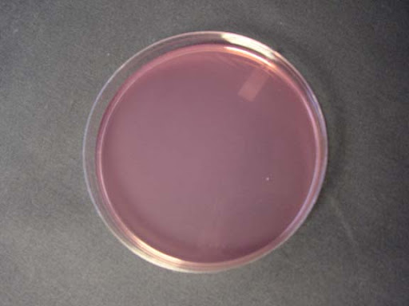 | 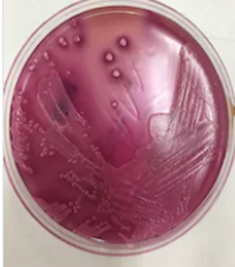  C
A. Staphylococcus growth from dish cleaning water | B. No growth observed from tap or tube-well water | C. E.coli growth from dish cleaning water
Mannitol Salt Agar:
MacConkey Agar:

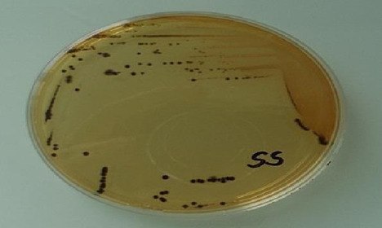  A | 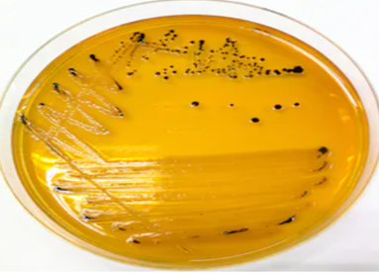  B
A. Salmonella grow from reused plate cleaning water | B. Salmonella grow from reused dish cleaning water
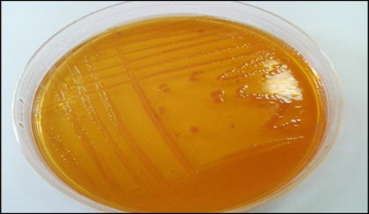  C | 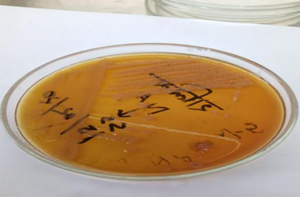  D
C. Shigella grow from reused plate cleaning water | D. Shigella grow from reused dish cleaning water
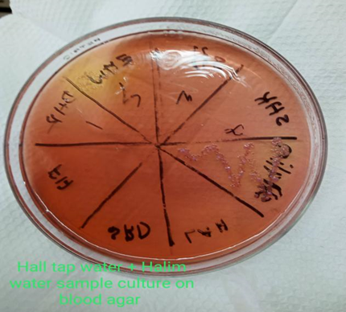  Blood Agar  A | 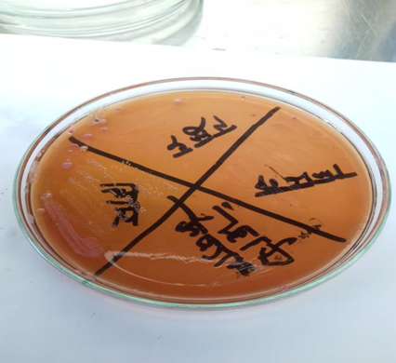  B
Staphylococcus aureus on blood agar from reused plate cleaning water | Klbessila grow from reused plate cleaning water

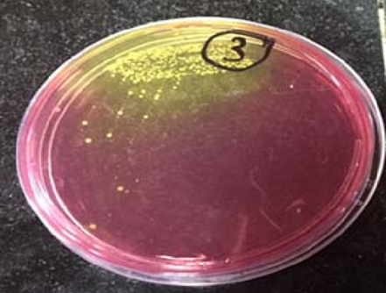  B  A | 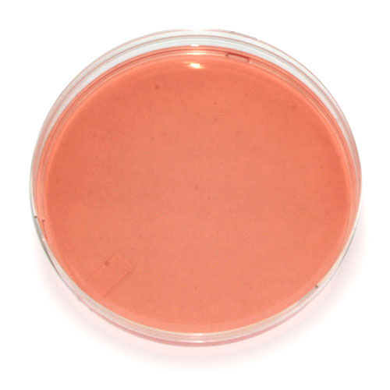 | 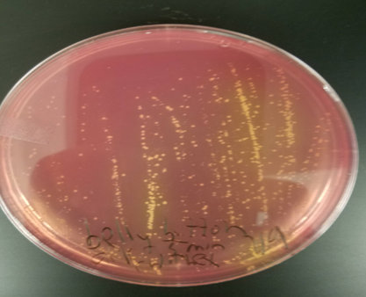  C
A. Staphylococcus aureus from reused plate cleaning water | B. No growth observed from tap and tubewell water | C. Staphylococcus aureus from reused plate cleaning water
Salmonella Shigella media

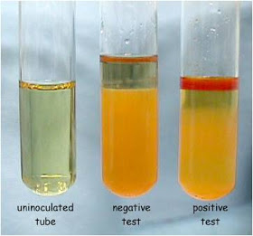  A | 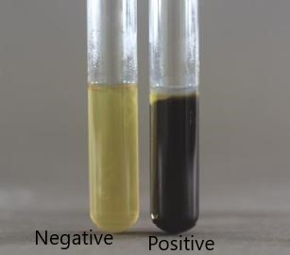  B
A. Indole Test | B. H₂S Test
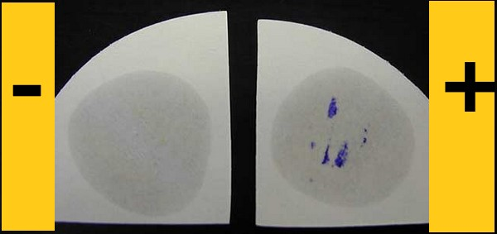  C | 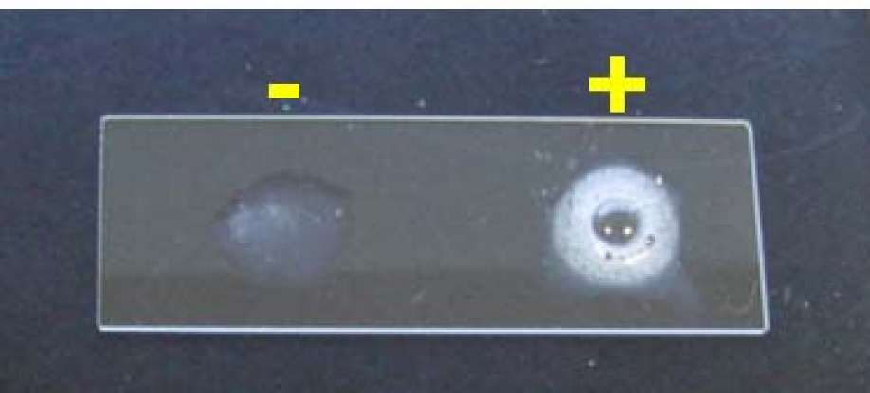  D
C. Oxidase Test | D. Catalase Test
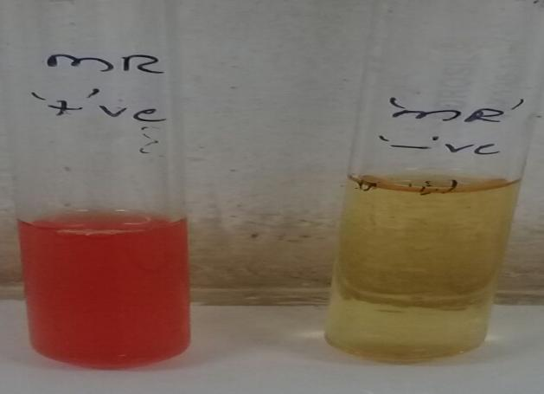 | 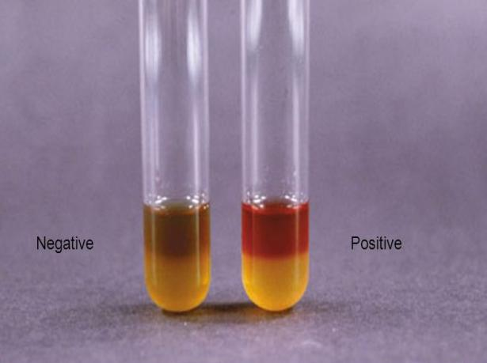  F
E. MR Test | F. VP Test
E

