Appendix
Table 1: Indices used as input for kochia prediction
No. | Abbreviation | Index name | Reference
1 | GNDVI | Green Normalized Difference Vegetation Index | Gitelson et al. (1996)
2 | MRBVI | Modified Red-Blue Vegetation Index | Guo et al. (2020)
3 | MTCI | MERIS Terrestrial Chlorophyll Index | Dash and Curran (2004)
4 | MSR705 | Modified Simple Ratio at 705 nm | Wu et al. (2008)
5 | GSAVI | Green Soil-Adjusted Vegetation Index | Sripada et al. (2005)
6 | GOSAVI | Green Optimized Soil-Adjusted Vegetation Index | Sripada et al. (2005)
7 | OSI | Oil Spill Index | Rajendran et al. (2021)
8 | ExR | Excess Red Index | Meyer et al. (1999)
9 | BRBA | Band Ratio for Built-up Area | Waqar et al. (2012)
10 | MNDWI | Modified Normalized Difference Water Index | Xu (2006)
11 | WRI | Water Ratio Index | Shen and Li (2010)
12 | MuWIR | Modified Universal Water Index for Remote Sensing | Wang et al. (2018)
13 | DSI | Drought Stress Index | Mu et al. (2013)
14 | DSWI3 | Disease-Water Stress Index 3 | Apan et al. (2004)
15 | REDSI | Red-Edge Stress Index | Zheng et al. (2018)
16 | SeLI | Sentinel-2 LAI Green Index | Pasqualotto et al. (2019)
17 | TCI | Triangular Chlorophyll Index | Haboudane et al. (2008)
18 | TCARIOSAVI | Topographically Corrected Atmospherically Rescaled Optimized Soil-Adjusted Vegetation Index | Haboudane et al. (2002)
19 | BLFEI | Built-Up Land Features Extraction Index | Bouhennache et al. (2019)
20 | kNDVI | Kernel Normalized Difference Vegetation Index | Camps-Valls et al. (2021)
21 | GRVI | Green-Red Vegetation Index | Sripada et al. (2005)
22 | GRNDVI | Green-Red Normalized Difference Vegetation Index | Huang (2007)
23 | KVI | Kochia Vegetation Index | This study

Table 2: The overall classification accuracy of the Gradient Boosted Machine (GBM), Random Forest (RF), and Support Vector Machine (SVM) classifiers were evaluated using Leave-One-Year-Out Cross-Validation (LOYO-CV) using Sentinel 2 1m spatial resolution.
Year | GBM | RF | SVM
2020 | 0.980 | 0.982 | 0.986
2021 | 0.984 | 0.989 | 0.995
2022 | 0.987 | 0.992 | 0.962
2023 | 0.974 | 0.981 | 0.979
2024 | 0.959 | 0.973 | 0.867
Mean | 0.977 | 0.983 | 0.958
StdDev | 0.011 | 0.007 | 0.051

Table 3: The overall classification accuracy of the Gradient Boosted Machine (GBM), Random Forest (RF), and Support Vector Machine (SVM) classifiers were evaluated using Leave-One-Location-Out Cross-Validation (LOLO-CV) using Sentinel 2 1m spatial resolution.
Location | GBM | RF | SVM
Bradwell | 0.991 | 0.995 | 0.978
Davison | 0.994 | 0.997 | 0.952
EagleRidge | 0.951 | 0.958 | 0.708
PatienceLake | 0.978 | 0.978 | 0.958
PorterLake | 0.985 | 0.983 | 0.851
Lucklake | 0.970 | 0.983 | 0.967
Mean | 0.978 | 0.982 | 0.902
StdDev | 0.016 | 0.014 | 0.105

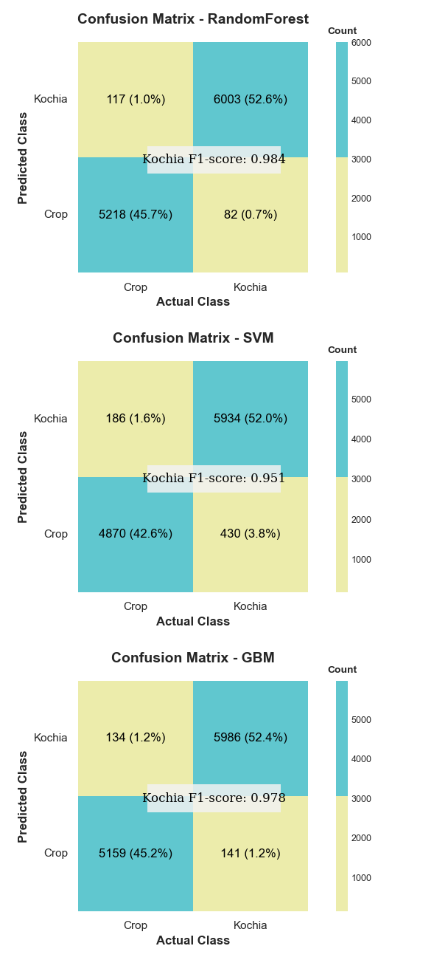
Figure 9. Aggregated confusion matrix plots for each model, combining results from both cross-validation strategies (LOYO-CV and LOLO-CV).

