The GeoCTGAN methodology is a multi-stage pipeline to transform raw, point-level event data and road network (polylines) into a high-fidelity, privacy-preserving synthetic point dataset, comprising:

(1) Geospatial Discretization: The continuous road network was converted into a finite set of discrete spatial units (segments).
(2) DeepWalk Topological Encoding: A deep graph embedding was constructed and learned for each spatial unit or segment using the DeepWalk algorithm ¹, capturing network connectivity based on random walks (15 walks of length 20).
(3) Event Localization and Spatial Feature Engineering: Real events were snapped to the nearest spatial features (segments using a 20-meter tolerance), and all features were then transformed (e.g., cyclic for temporal data, logit for segment position) for modelling.
(4) Cohort-Based Conditional Generative Modelling: A series of CTGAN models was trained on the spatially enriched tabular data, with the data stratified by year and month cohort.
(5) Capacitated Assignment, Reconstruction, and Privacy Gating: The Capacitated k-Nearest Neighbour (CaNN) algorithm was used to assign synthetic events to the network, reconstruct point geometries, and apply privacy filters (k-anonymity and Distance-to-Closest-Record).
The framework utilized two primary geospatial datasets. The Major Crime Indicators (MCI) from the Toronto Police Service Public Safety Data Portal ² was a point-feature dataset containing records of individual crime events, including temporal attributes (e.g., date of occurrence), categorical descriptors (e.g., MCI category, premises type), and spatial coordinates. For this study, 413,858 individual events, comprising 31 columns, were extracted for the period from 2014 to 2024. The original data provider noted that locations were offset to the nearest road intersection to protect privacy, but this did not affect this study, as the primary objective was to construct a spatial feature-aware CTGAN that could faithfully reproduce both the spatial and non-spatial attributes of the real data. Hence, a spatially rich event dataset (i.e., point-wise locations with non-spatial attributes) was more important than precise event locations, which would have been more relevant for risk factor analyses or crime causality investigations. The road network data were downloaded from OpenStreetMap (OSM) using the OSMnx Python library ³ and exported as a vector road network layer for use as input in GeoCTGAN. A topologically connected street network for the City of Toronto was downloaded using place-based queries and simplified to retain navigable road segments. The resulting graph was converted into node and edge GeoDataFrames, preserving standard OSM attributes (e.g., road type, directionality, and segment length). The network was exported to GraphML and GeoPackage formats and subsequently processed into discretized road segments for spatial analysis and modelling.

The GeoCTGAN data generation and evaluation pipelines were run on a Linux server running Ubuntu 22.04.5 LTS, equipped with a dual-socket AMD EPYC 9254 processor (48 cores, 96 threads) and 256 GB RAM. The system included an NVIDIA H100 NVL GPU with 96 GB of dedicated VRAM, operating on NVIDIA driver 580.126.09. The software environment utilized Python 3.10.12 with PyTorch 2.9.0 (built with CUDA 12.8), scikit-learn 1.7.2, NumPy 1.26.4, Pandas 2.3.3, SciPy 1.15.3, and SDV 1.28.0.
1 Geospatial Discretization (Road Network Segmentation)

The first stage involved discretizing the continuous spatial environment defined by the road network. The raw network polylines, which included both LineString and MultiLineString geometries, were flattened into a single collection of simple LineString features. Each LineString was then recursively subdivided using a process that ensured no resulting segment exceeded a predefined maximum length. In our implementation, the hyperparameter (MAX_SEG_LEN_M) was explicitly set to 40 m. This maximum length was computed in a metric Coordinate Reference System (EPSG:32617), and the subdivision was performed through proportional splits along the native geometry. This process transformed the continuous network into a finite library of N road segments, each assigned a unique segment ID (segment_id), which served as the fundamental spatial unit for all subsequent analysis and the basis for the topological encoding. The process resulted in the creation of 964,834 segments within the entire road network.

2 Topological Encoding: DeepWalk Graph Embeddings

2.1 Graph Construction

An undirected, unweighted adjacency graph, $G=(V,E)$, was constructed from the N segments. The set of vertices V (or, nodes) represented the N total segment IDs. An edge $e_{ij}∈E$ existed if and only if the segment i and segment j were spatially adjacent. Adjacency was defined by shared endpoints (vertices). The hyperparameter settings outlined below were selected based on a priori knowledge from established crime literature, and each spatial issue was addressed through the constructed graph components.

The start-point (${coords}_{0}$) and endpoint (${coords}_{1}$) coordinates were extracted for every segment. These endpoint coordinates were then snapped to a grid defined by a tolerance, NODE_SNAP_TOL_M (set to 0.75 m), using a rounding function (snap_key). A dictionary (node_map) mapped these snapped coordinate tuples to unique integer IDs, effectively representing the network's intersections. An adjacency list (adj) was then constructed by iterating through all segments, where if two segments shared a common node_id from the node_map, they were considered adjacent, and an edge was added to the graph.

2.2 Representation Learning via DeepWalk

With the topology formally defined as a graph G, a low-dimensional feature representation was learned for each vertex (segment) using the DeepWalk algorithm ¹. DeepWalk learned latent representations by modelling a stream of truncated random walks. First, a collection of graph traversal sequences was generated using the deepwalk_sequences function, capturing the structural context of each node within the urban road network. This function iterated $N_{walks}$ times over all N nodes. From each node, it initiated a random walk of length $L_{walk}$. At each step, the next node was chosen uniformly at random from the adjacency list of the current node. For this study, the hyperparameters N_WALKS ($N_{walks}$) and WALK_LEN ($L_{walks}$) were set to 15 and 20, respectively. In simple terms, each segment started 15 random walks of length 20 nodes (up to 19 random steps through adjacent segments).

This sequence of walks (e.g., [seg_A, seg_C, seg_F and onwards]) was then used to train a Word2Vec (skip-gram) model, implemented via the gensim library ⁴. The model learned a mapping from each segment_id to a vector in a latent space, optimized to predict a node's context (nearby nodes) within the random walks. Key hyperparameters for this model were: vector_size (EMB_DIM) = 16, window (W2V_WINDOW) = 10, sg = 1 (skip-gram), and epochs (W2V_EPOCHS) = 6. Given 964,834 road segments, with 15 random walks per segment ($N_{w}$ = 15), each of length 20 ($L_{w}$ = 20), and trained over 6 epochs, the model learned the spatial structure of the road network from approximately 290 million token segments (964,834 × 15 × 20 = 289,450,200), corresponding to about 1.74 billion token exposures across all epochs (6 × 290 million). This provided enough structural information to learn how segments were related within the city network.

The representation learning produced an embedding matrix of N x 16, where each road segment i was represented by a 16-dimensional feature vector, $v_{i}= {(gemb}_{o}, … {gemb}_{15})$. This vector replaced simplistic spatial features (such as spatial lags) by encoding the rich, global topological role of each road segment, capturing its relationship to hubs, bridges, and peripheries within the network. Incorporating these embeddings into the model was crucial, as crime events occurring along similar network topologies often exhibit strong spatiotemporal autocorrelation ⁵. Previous studies have also demonstrated that road network topology can influence the movement patterns of both offenders and victims, affecting where (space) and when (time) crimes occur ⁵⁻⁷.

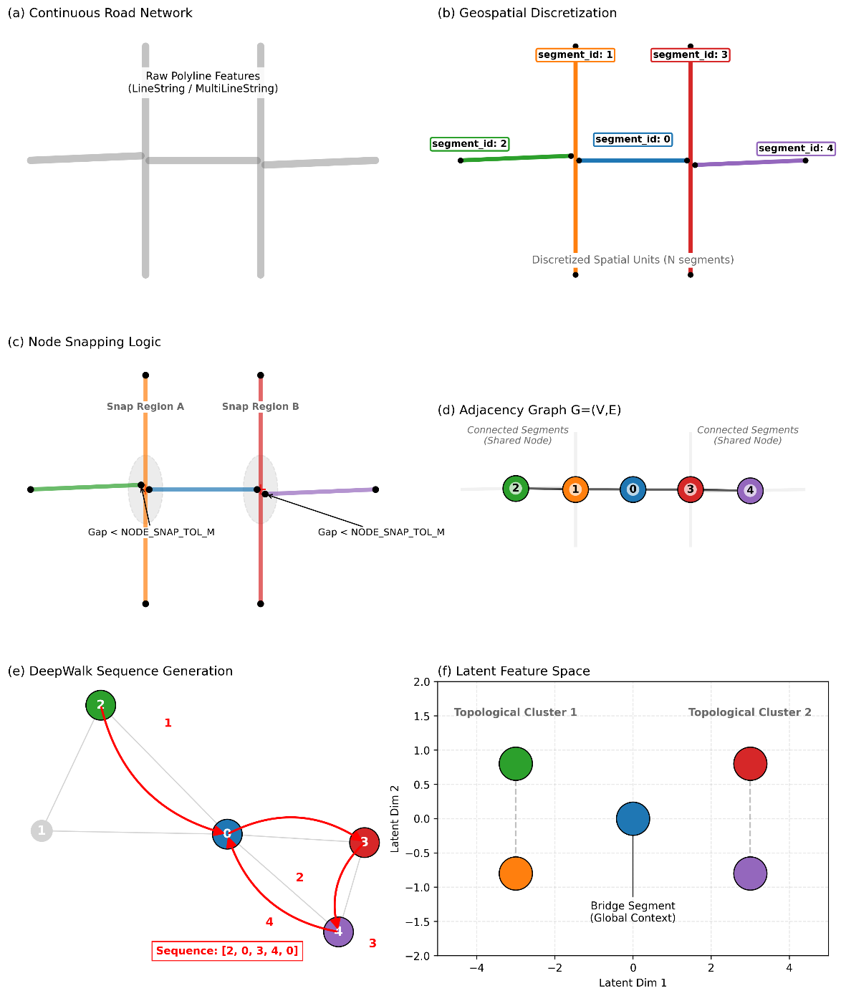
Supplementary Fig. 1 | Geospatial discretization, graph construction, and DeepWalk-based topological embedding steps in GeoCTGAN.
The core stages of the geospatial preprocessing and topological encoding processes, showing (a) continuous road network, (b) discretization into road segments, (c) node snapping using a spatial tolerance, (d) construction of the adjacency graph, (e) DeepWalk random-walk generation and (f) the resulting latent topological feature space.

3 Event Localization and Spatial Feature Engineering

3.1 Map-Matching

Real event points from the cleaned MCI dataset were snapped to their nearest network segment. This was accomplished using the geopandas library (through geopandas.sjoin_nearest) (https://geopandas.org/en/stable/), which searched and found the closest segment for each point. This operation was constrained by a maximum search radius (SNAP_MAX_M), which was set to 20 m. In dense cities like Toronto, typical road spacing is 20-60 m between parallel streets, so a 20 m threshold was used to capture points plausibly on or near the street network without spilling over into adjacent streets. In this process, events with no segment within a 20 m radius or with insufficient geometry to compute seg_pos were dropped, resulting in the exclusion of 3956 events. This left a final dataset of 409,902 events. These events were then split into train (327,921) and test (81,981) datasets using an 80-20 split.

This map-matching process generated two new crucial spatial features for each event, in addition to its assigned segment_id:
(1) Segment position (seg_pos): A continuous numerical value in the range [0,1] (where 0 was near the start of the segment and 1 was near the end of the segment), representing the fractional distance of the event's projected (snapped) location along the length of its assigned segment.
(2) Offset distance (SEG_MAP_DIST_M): The Euclidean distance (in meters) between the event's original coordinates and its snapped location on the line, serving as a measure of snapping quality.

3.2 Feature Transformation

The resulting tabular dataset (containing event attributes, seg_pos, and SEG_MAP_DIST_M) was then prepared for the CTGAN. To prevent leakage, the 80/20 split (stratified by Year-Month) was executed immediately after snapping and before any feature encoding or embedding merge. The 16‑dimensional segment embeddings (${gemb}_{0}$,…,${gemb}_{15}$) were merged onto the train split only. The test split was held out and left unmerged for downstream evaluation. The encodings used to fit CTGAN were computed on the training table and applied accordingly. We maintained two synchronized training tables: (i) a raw table (keeping segment_id, original time fields, and diagnostics for reconstruction and event capacity calculations), and (ii) a modelling table (for CTGAN) that excluded segment_id and contained only encoded or continuous features. We also carried an explicit cohort label to coordinate cohort‑level training and sampling.

The segment_id itself was removed from the modelling table to avoid a high-cardinality segment identifier, and also because the GAN learned to associate event types with the topological embedding ($v_{i}$), making the arbitrary, high-cardinality segment identifier redundant. Furthermore, several features in the dataset exhibited non-Gaussian, bounded, or cyclic properties, which standard GANs may struggle to model effectively. In CTGAN (implemented using the SDV library), continuous variables are passed through Gaussian-mixture-based transforms (rather than being left raw), which necessitated transforming bounded or circular variables into unbounded spaces ⁸. Temporal variables with natural periodicity were encoded via sine-cosine pairs (Hour: $P=24$; Day-of-Week: $P=7$; Month: $P=12$) and the original integer columns were dropped after encoding in the training data ⁹.

The bounded seg_pos was clipped to $\left[ε,1-ε\right]$with $ε={10}^{-6}$and transformed using the logit to yield an unbounded seg_pos_logit. SEG_MAP_DIST_M was stabilized via $log⁡(1+x)$ and stored as SEG_MAP_DIST_M_log1p. These transformations ensured that bounded and right-skewed spatial variables were mapped to numerically stable, approximately unbounded spaces that were better suited for Gaussian-mixture-based preprocessing and adversarial training. The segment position (seg_pos) feature represented the normalized position of an event along a road segment, ranging from 0 to 1. This bounded nature could make it difficult for a CTGAN to model effectively, because GANs generally operate more efficiently when input variables have unbounded or approximately Gaussian-like distributions ⁸. Hence, the logit transformation enabled the generator and discriminator within the GAN to capture continuous variability and gradients during training more effectively. Before applying the logit transformation, all values of seg_pos were clipped slightly away from 0 and 1 (i.e., into $\left[ε,1-ε\right]$with $ε={10}^{-6}$) to prevent division by zero or infinite outputs. This clipping was important because events that snapped precisely to the start or end of a segment (i.e., seg_pos = 0 or 1) would otherwise produce infinite or undefined logit values. These positions are quite common in real-world event coordinates occurring in or near dense urban networks with many intersections. Similarly, the offset distance (SEG_MAP_DIST_M or the map-matching distance between an event and its nearest road segment) tends to be highly right-skewed as most events are snapped very close to the network, while a few lie farther away. To normalize this distribution, a logarithmic transformation was applied. This reduced the influence of extreme distances and improved numerical stability for both model training and evaluation.

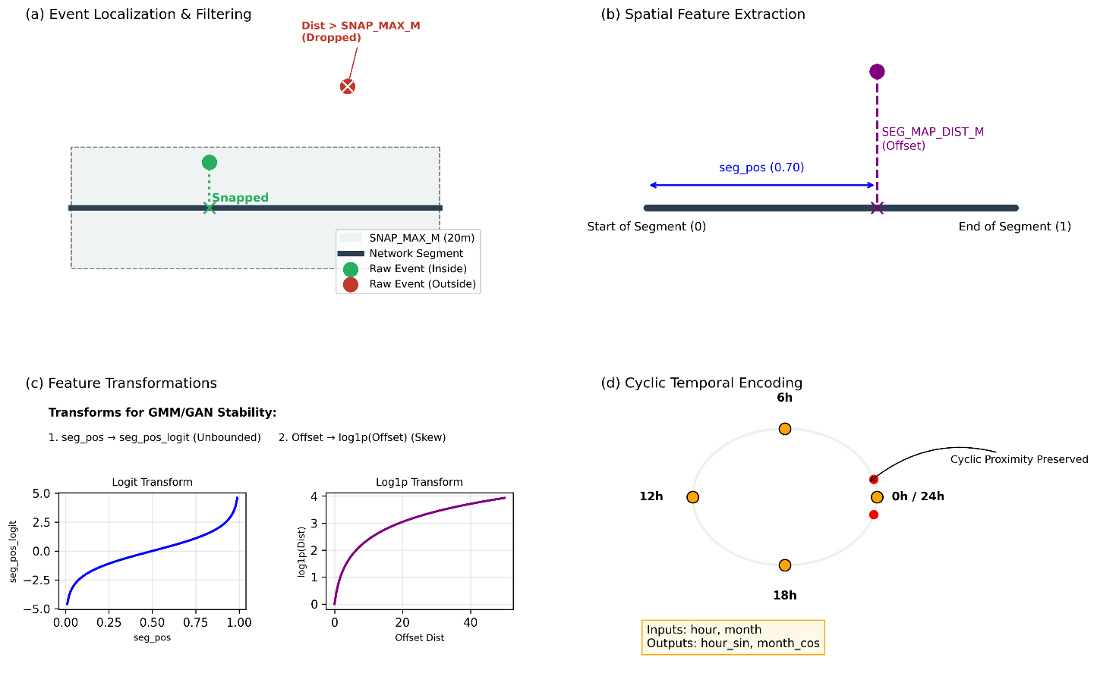

Supplementary Fig. 2 | Event localization, spatial feature extraction, and feature transformations for GeoCTGAN preprocessing.
(a) Event localization and filtering, showing how raw point events were snapped to their nearest road segment within the search tolerance, with out-of-range events discarded, (b) Spatial feature extraction, depicting the computation of the normalized segment position (seg_pos) and the perpendicular offset distance (SEG_MAP_DIST_M), (c) Feature transformations applied to stabilize bounded and skewed variables before CTGAN training, including the logit mapping of seg_pos and log1p transformation of offset distances, (d) Cyclic temporal encoding, demonstrating how periodic time attributes were converted to sine-cosine representations to preserve circular proximity.

4 Cohort-Based Conditional Generative Modelling

4.1 Model Architecture

The core generative model was the Conditional Tabular GAN (CTGAN), implemented via the CTGANSynthesizer class from the SDV library. CTGAN is specifically designed for tabular data, employing a conditional generator and training-by-sampling to handle highly imbalanced categorical data ⁸. A metadata object is created for the training data, in which all transformed continuous features (including the 16 embedding features and the sine-cosine cyclic encodings) were explicitly declared as sdtype='numerical', and all discrete attributes (e.g., MCI categories, premises type, location type) were specified as sdtype='categorical'. This ensured that the reversible data transformers of SDV applied the appropriate GMM-based continuous transforms and one-hot encodings in a leakage-free manner ⁸.
To ensure stable training and mitigate mode collapse, the Wasserstein GAN with Gradient Penalty (WGAN-GP) loss function, available in CTGAN, was employed. We trained for 600 epochs with pac=10, used a batch size that is the largest multiple of pac not exceeding a target of 512 (thus BATCH_SIZE=510 under default settings), and set identical learning rates for the generator and discriminator as ${10}^{-4}$ (generator_lr = discriminator_lr = ${10}^{-4}$). Rounding was enabled (enforce_rounding=True) to preserve integer-like outputs for relevant categorical or integer-value features once the reversible transformer was inverted. The choice of the majority of these hyperparameters was primarily guided by our prior CTGAN hyperparameter tuning study ¹⁰, which identified this configuration as providing a favourable balance between mode coverage, training stability, and fidelity for high-dimensional tabular data.

4.2 Cohort-Based Training

Geospatial event patterns are often non-stationary, exhibiting significant temporal variation. To capture these temporal dynamics, a single monolithic model was not used. The training data was partitioned into discrete cohorts based on the year and month of event occurrence. A separate, independent CTGAN model was then trained for each cohort whose training-split sample size met or exceeded the configured batch-size threshold (i.e., $n≥ 510$under the default PAC-based batching strategy). Cohorts with fewer rows were skipped to ensure stable mini-batch dynamics under the pac setting and to prevent unstable discriminator behaviour during WGAN-GP training.

5 Reconstruction via Capacitated k-NN (CaNN) Assignment

After training, the cohort models were sampled to generate a raw synthetic table containing synthetic tabular attributes (e.g., MCI category, offence, location types) and the 16-dimensional embedding vector, $v_{syn}$. The CaNN algorithm mapped this latent vector back to a real-world segment identifier (segment_id) by comparing the Euclidean distance ($d$) between $v_{syn}$and each real segment's embedding vector $v_{i}$ in the training data. This comparison was conducted in the learned embedding space rather than physical coordinate space, enabling assignment of each synthetic event to the most topologically similar segment under segment-level capacity constraints. Hence, this process preserved the empirical spatial distribution and allowed reconstruction of final event locations.

5.1 Define Segment Capacities

To preserve the spatial distribution of real events in the synthetic dataset, a capacity constraint was defined for each road segment (segment_id). The real, snapped event data were first grouped by temporal cohort (for example, "2023_01"). Within each Year‑Month cohort, the number of events per segment was counted. These counts were further stratified by a selected categorical variable, major crime type (defined by CAPACITY_STRAT_COLS). This stratification created a highly granular segment-level capacity indicator. For instance, a given segment might contain five 'Assault' and two 'Robbery' events in January 2023. Further stratifications can be made if required, for example, by major crime type and then the location type (e.g., commercial and residential).

A custom helper function, make_capacities, was defined to scale these segment-level counts by the sampling factor (SAMPLE_FACTOR, set to 1.0 in this study) and to apply stochastic rounding. This ensured that the synthetic sample size for each cohort-stratum combination matched the real distribution. Furthermore, to strictly enforce these capacities, we implemented a post-hoc marginal enforcement step. If the generative model undersampled or oversampled specific categorical stratifications due to sampling noise, the algorithm relabelled or resampled the synthetic output to strictly align with the target capacity counts prior to spatial assignment. This maintained spatial fidelity and mitigated distributional imbalances during data generation (e.g., mode imbalance, spatial bias, and sample-size drift). All capacity calculations were performed using only the real train split to prevent information leakage.

5.2 Building the k-NN Index

A nearest-neighbour search index was constructed to efficiently identify spatially similar segments in the embedding space. This index was built using scikit-learn's NearestNeighbors implementation (sklearn.neighbors.NearestNeighbors, algorithm='auto') on the 16-dimensional real segment embeddings. The algorithm automatically selected an appropriate search strategy (e.g., KD-Tree) based on data dimensionality and size. The index enabled rapid retrieval of the most relevant segments for any synthetic embedding based on geometric proximity in the learned feature space.

5.3 The CaNN Assignment Algorithm

The segment assignment procedure (assign_segments_capkNN) determined the spatial placement of each synthetic event based on its learned embedding. This was implemented as follows:

(i) Nearest-Neighbour search: Each synthetic embedding searched for its k nearest real segment embeddings using a progressive nearest-neighbour expansion. The search began with K0_NEIGHBORS = 16 and expands to KMAX_NEIGHBORS = 128 only if needed (e.g., when nearby segments have exhausted their capacity). This progressive search ensured that every synthetic record could be matched, even when nearby segments reached capacity limits due to sampling noise, cohort conditioning, and the stochastic assignment of synthetic embeddings to events.

(ii) Softmax probability weighting: Instead of assigning to the single nearest neighbour, which can cause spatial mode collapse, segment selection probabilities ($w_{i})$ were computed using a softmax kernel applied to squared Euclidean distances ¹¹, as defined by the equation below:

$$w_{i}= \frac{\exp{ (-d (v_{syn},}v_{i})^{2}/τ)}{\sum_{j}{\exp{ (-d (v_{syn},}v_{j})^{2}/}τ)}$$

Here,
$w_{i}$ : the normalized probability that a given synthetic event would be assigned to segment i. Larger $w_{i}$ would indicate that the segment i was more likely to receive a synthetic event.
$v_{syn}$ : the 16-dimensional synthetic embedding vector. It encoded the event's latent spatial and contextual properties.
$v_{i}$ : the 16-dimensional real segment embedding vector learned from DeepWalk/Word2Vec. Each vector represented the segment's topological and spatial position in latent space.
$d(v_{syn}, v_{i})$ : the geometric (Euclidean) distance in the embedding space between the synthetic event and segment i. Smaller distances implied higher similarity (and hence higher probability).
​
$τ$ : the temperature parameter, a smaller $τ$ (e.g., 0.25) would heavily favour the nearest segments, while a larger $τ$would spread probability more evenly among the neighbouring segment candidates.

$∑_{j}$ : the normalization term ensuring that all probabilities $w_{i}$ summed to 1 over the k nearest candidate segments found in the neighbour search.

(iii) Capacity-constrained sampling: The softmax probabilities were then masked by the remaining segment capacities, renormalized, and sampled from only those segments with remaining capacity. That is, before choosing where to place the next synthetic event, the algorithm checked which of those nearby segments still had room left (their capacity). It then masked (ignored) the already full segments and excluded them from the selection pool. The probabilities for the remaining available segments were then renormalized (rescaled so that all the chosen ones still add up to 1). Finally, one of the available segments was randomly selected according to these updated probabilities. This step ensured that synthetic events are distributed realistically across the geographic space (here, the road network segments), reducing the likelihood of creating unrealistic local spatial patterns and finally, preserving the balance of the real-world spatial count of events.

(iv) Assignment and update: The selected segment ID (segment_id) was assigned to the synthetic record, and its available capacity was then decreased by 1. This process iterated until all synthetic events were placed, ensuring both capacity preservation and spatial geometric coherence.

5.4 Geometric Point Reconstruction

The final event coordinates were reconstructed by decoding the output features of the GAN. Temporal sine-cosine encodings were first converted back to their angular representations, and the bounded positional feature was recovered using the inverse logit (sigmoid) function to obtain the fractional position along each road segment. The decoded position (seg_pos), assigned segment (segment_id), and lateral offset (SEG_MAP_DIST_M) were then passed to a geometric interpolation function, which placed each synthetic point along the corresponding segment's line geometry with a small, randomized perpendicular offset, yielding realistic reconstructed event locations.

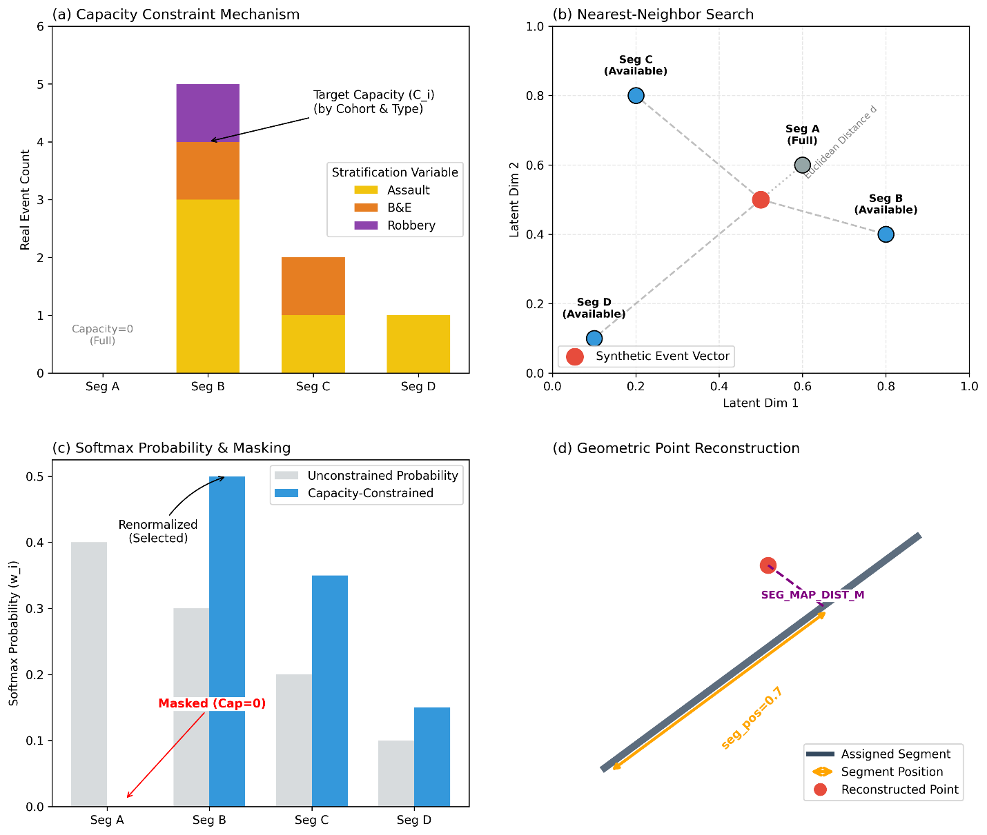

Supplementary Fig. 3 | Capacitated k-NN (CaNN) assignment and geometric reconstruction of synthetic events.
The core components of the CaNN spatial assignment and reconstruction procedure, (a) Capacity constraint mechanism showing how real segment-level counts defined allowable synthetic allocations under major crime-based stratification, (b) Nearest-neighbour search in the learned 16-dimensional embedding space, illustrating how synthetic event vectors were matched to topologically similar segments while excluding full segments, (c) Softmax-based probability weighting and capacity masking, where candidate segments were reweighted and renormalized after removing those that had reached their capacity, (d) Geometric point reconstruction, depicting how the assigned segment, fractional position, and offset distance were combined to place the final synthetic event along the network geometry.

6 Privacy-Preserving Gating

Even before the final stage of applying privacy-preserving filters, the geosynthetic data generated by the GeoCTGAN inherently benefited from several privacy-preserving mechanisms introduced during the generative and embedding processes. First, the CTGAN model operated through distributional learning rather than direct record replication, meaning synthetic samples were generated from learned probability distributions rather than copied from any real record. This process inherently reduced the risk of re-identification ⁸. Second, the segment embedding representation process and GAN conditioning further abstracted sensitive spatial relationships, replacing explicit geographic coordinates with compressed, non-invertible latent vectors. This embedding-space mixing introduced an additional layer of privacy, making it quite challenging to reconstruct real-world locations directly from the model's internal features.

However, for added security, following geosynthetic data generation and reconstruction, the fully synthesized dataset was passed through a two-stage privacy gating process to enforce spatial and proximity-based privacy constraints:

(i) Spatial k-anonymity filter: To prevent re-identification in rare or isolated regions, a synthetic event was retained only if its assigned segment was associated with at least k real events in the training data ^{12,13}. The anonymity threshold (K_ANON) was set to 10, ensuring that no synthetic event originated from a segment with fewer than 10 real samples. A larger value could be applied depending on the required privacy gatekeeping. However, it would also reduce the spatial granularity and fidelity of the synthetic data.

(ii) Distance-to-Closest-Record (DCR) filter: For mitigating the risks of data memorization or near-duplicate generation, the distance from each synthetic event to its nearest real event was calculated in metric space using a KD-tree structure ¹⁴. Events with distances smaller than the minimum privacy buffer (DCR_THRESH_M, set to 5.0 m) were discarded. The DCR filter enforced a minimum spatial separation between real and synthetic events, ensuring no synthetic record was an exact or nearly exact spatial copy of a real record.

7 Evaluation Framework: Comparing utility, fidelity and privacy disclosure risk of the synthetic data

Evaluating the quality of geosynthetic data is a challenging task, particularly for complex tabular and spatial datasets, where a specialized evaluation framework is required to assess the generated data across three critical spatial and non-spatial domains: (a) statistical fidelity, (b) spatial utility, and (c) privacy-preservation.

We executed a three-way comparison across all metrics among the real training events used in GeoCTGAN against two sets of geosynthetic data outputs: (a) raw synthetic events (after coordinate reconstruction), and (b) privacy-preserved synthetic events (after k-anonymity and DCR gating applied). This ensured that the evaluation framework not only assessed the model's performance but also the specific impact of our spatial privacy-gating procedure on the utility and fidelity of the geosynthetic data. All evaluations were conducted using the common transformed feature space shared between real and synthetic tables to ensure strict comparability across SDMetrics, spatial analyses, and regression models.

7.1 Statistical Fidelity Assessment

Statistical fidelity, or resemblance, measured how closely the statistical properties of the synthetic data mirrored those of the real data ¹⁵. A high-fidelity dataset should preserve not only the distributions of individual attributes but also the complex, multivariate relationships between them, including spatial patterns and salient temporal regularities.

i) Univariate assessment: We first computed a high-level, aggregate quality score using the Synthetic Data Metrics (SD metrics) library (https://docs.sdv.dev/sdmetrics). This composite score provided a holistic measure of data quality by summarizing both column-level distributional similarity and pairwise correlation similarity into a single, comparable metric. The quality metrics implemented for each data column or variable depended on the category defined in the metadata. These SDMetrics reports were generated using the DiagnosticReport and QualityReport modules.

Additionally, to quantify overall univariate fidelity, we computed the Hellinger Distance for each column. This metric measured the divergence between the real and synthetic probability distributions, providing a score between 0 (identical) and 1 (maximum divergence) for both numerical and categorical attributes ^{15,16}.

ii) Bivariate relationships: To ensure that the complex interactions between features were preserved, we compared bivariate relationships. This was achieved by generating correlation matrix heatmaps (using Pearson's correlation for continuous variables and Cramér's V for categorical variables) for all three datasets. Verifying the preservation of the correlation structure was essential, as it indicated whether the synthetic data could be reliably used for downstream multivariate modelling tasks in which feature interactions would be the key factor. Difference heatmaps were also generated (synthetic minus real) to quantify the degree and direction of deviation for each pairwise relationship.

7.2 Spatial Fidelity Assessment

The second, and most critical, component of the evaluation involved assessing the spatial fidelity of the geosynthetic data. This assessment aimed to validate the efficacy of our spatially-aware framework in capturing the unique spatial properties of the real dataset. We evaluated whether the geosynthetic data exhibited both macro- and micro-level structural similarities with the real data. This was performed at two scales: (i) a point-level analysis and (ii) an area-level analysis.

i) Point-level spatial fidelity: To assess micro-scale spatial clustering, we compared the point patterns of the real and synthetic datasets using a Nearest Neighbour Distance (NND) analysis ¹⁷. For each dataset, we built a KDTree to find the distance (in meters) from every point to its single nearest neighbour ¹⁸. We then compared the Cumulative Distribution Functions (CDFs) of these NNDs to visualize differences in point-level density and dispersion. A difference curve (synthetic minus real CDF) was also computed. The statistical significance of this difference was quantified using the two-sample Kolmogorov-Smirnov (KS) test ¹⁹.

To complement the point-level analyses, we assessed continuous spatial intensity using a bivariate Gaussian Kernel Density Estimation applied to the real, Syn-Raw, and Syn-Priv point patterns ^{17,20}. Bandwidths were selected via Scott's rule ²¹, and all densities were evaluated on a common 200×200 grid spanning the study area. We then computed difference maps, a $λ_{real}- λ_{synthetic}$​ at each grid cell, where positive values indicated missed hotspots (real intensity > synthetic) and negative values indicated ghost hotspots or leakage (synthetic intensity > real) ¹⁷. This provided a localized, map-based diagnosis of where the generative models preserved or distorted the underlying spatial intensity surface. We also compared the synthetic and real KDE surfaces using grid-based similarity metrics. Pearson correlation was computed between the flattened 200×200 KDE grids to quantify global structural agreement. Mean Absolute Error (MAE) was calculated as the average absolute cell-wise difference, providing a measure of local intensity distortion.

Although Kulldorff's spatial scan statistic (SaTScan) is traditionally used for localized cluster detection ^{22,23}, it was not employed for micro-scale point fidelity assessment. In our preliminary analyses, applying SaTScan to dense, high-resolution point data with coincident or near-coincident events produced disproportionately large relative risks and likelihood ratios, reflecting the sensitivity of likelihood-ratio-based spatial scan statistics (implemented via a moving-window framework) to overlapping event counts in dense point datasets. We therefore relied on NND- and KDE-based metrics, which proved more appropriate for evaluating distributional similarity in large spatial point datasets.

ii) Area-level spatial fidelity: For these assessments, the (crime) event counts were aggregated to Dissemination Areas (DAs) ²⁴ for the real, raw-synthetic, and privacy-preserved datasets. A first-order queen contiguity spatial weights matrix was computed to measure contiguity among the DAs. For each dataset, the analysis was restricted to non-isolated DAs (that is, those with at least one spatial neighbour).

Macro-Level Fidelity: We began by producing and comparing maps that visualized different aspects of the spatial distribution of crime counts across the DAs. Specifically, Natural Breaks (Jenks) and Quantile classification schemes were applied to create five-class choropleth maps. The Natural Breaks method identified class boundaries that minimized within-class variance and maximized between-class variance, thereby revealing natural groupings, spatial clusters, and extreme values in the data distribution. In contrast, the Quantile classification divided the range of crime counts into classes with equal numbers of spatial units (DAs), ensuring a balanced visual representation across the study area. In other words, the Quantile map illustrated how the distribution of crime events appeared when each class contained the same number of DAs, emphasizing spatial event burden (of crime) rather than statistical clustering. Following a visual inspection of the choropleth maps, the degree of spatial clustering was quantified using Global Moran's I ²⁵. This statistic measured the overall spatial dependence among geographic units, producing a single I value and an associated p-value that together indicated whether event counts were spatially clustered, dispersed, or randomly distributed. Global Moran's I was computed for each of the three datasets.

Micro-Level Spatial Distribution: To identify specific areas exhibiting significant clustering or spatial outlier behaviour, Local Indicators of Spatial Association (LISA) were computed using the Local Moran's I statistic for each DA in the real, raw synthetic, and privacy-gated synthetic datasets ^{26,27}. For each DA, the method compared its crime count with those of its immediate neighbours. It then determined whether that area had similarly high or similarly low values compared to its surroundings, or whether it deviated from the local pattern. Significance of the clusters was assessed through 999 random spatial permutations of the (crime) event values. Each DA was classified into one of five cluster types:

High-High (HH): DAs with high event counts surrounded by other high-count DAs (hotspots).
Low-Low (LL): DAs with low event counts surrounded by low-count neighbours (coldspots).
High-Low (HL): DAs with high counts surrounded by low-count neighbours (spatial outliers).
Low-High (LH): DAs with low counts surrounded by high-count neighbours (spatial outliers).
Not significant (NS): No statistically significant local clustering at p < 0.05.

Cluster maps were generated for all three datasets to visualize and empirically compare the fidelity of local clustering patterns.

7.3 Downstream Task: Spatial Regression Model Utility

The geospatial utility of the GeoCTGAN-synthesized datasets was assessed using a downstream analytical task, specifically by executing a spatial regression analysis at the DA level. This test evaluated whether models trained on synthetic data could reproduce analytical insights similar to those obtained from real data.

A common spatial modelling framework was employed across all datasets. Specifically, Ordinary Least Squares (OLS), Spatial Lag Models (SLM) and Spatial Error Models (SEM) were fitted three times using identical specifications and covariates ^{28,29}:

For the dependent variables, Model 1 used the true DA-level crime event counts, while Model 2 was trained on the synthetic event counts before privacy gating and Model 3 employed the privacy-gated synthetic event counts. The dependent variable in all models was the crime rate per 1,000 population, computed from DA-level event counts normalized by 2021 Census Population Totals. The set of predictors reflected key dimensions of social and economic marginalization, including residential instability (households_dwellings_DA21), material deprivation (material_resources_DA21), dependency ratio (age_labourforce_DA21), and the proportion of the racialized population (racialized_NC_pop_DA21). All the population and socioeconomic covariates were retrieved from the Ontario Marginalization Index ³⁰.

Model performance and comparability were evaluated on three key aspects:

(i) Model fit: The coefficient of determination (R²) from both OLS and Spatial Error Models was used to assess explanatory power, and pseudo-R² from the Spatial Lag Model was also reported.
(ii) Covariate effects: Coefficient magnitudes and statistical significance (p-values) were compared and reported for all Ontario Marginalization Index indicators.
(iii) Spatial dependence: The estimated spatial error term (λ) and spatial lag coefficient (ρ) were compared across datasets to assess whether the synthetic data preserved spatial dependence structures.
Agreement across these three outputs between the real and synthetic datasets would indicate that the analyses conducted on synthetic data would yield results, interpretations, and policy-relevant insights similar to those from analyses conducted on the original, real, and privacy-sensitive data.

7.4 Privacy and Disclosure Risk Assessment

The privacy evaluation quantified the extent to which the GeoCTGAN-generated data preserved confidentiality and avoided record memorization. All privacy metrics were computed using SDMetrics by comparing each synthetic dataset (Syn‑Raw and Syn‑Priv) against the corresponding real training dataset, with the real holdout (test) dataset additionally used where required (e.g., DCROverfittingProtection).

i) Disclosure protection: A privacy score was estimated using the SDMetrics DisclosureProtectionEstimate metric ³¹, which evaluated resistance to identity and attribute disclosure. Due to the large dataset and high dimensionality, the metric was computed in batches using a moving window of matched real-synthetic pairs across shared modelled columns. Batch-level scores were aggregated using harmonic-mean weights, and final estimates were reported as weighted means with 95% confidence intervals.

ii) DCR-based protection metrics: Two complementary DCR-based metrics were used to assess memorization risk and relative synthetic-real proximity.

First, the DCROverfittingProtection metric ³² was used to detect potential memorization by comparing the distance from each synthetic record to the training data against the distance from each real training record to the real holdout (test) data. A high score (maximum 1) indicates that synthetic records are not unnaturally closer to real training data than expected under natural variation.

Second, the DCRBaselineProtection metric ³³ evaluated whether synthetic records maintained an appropriate level of separation from real data in attribute space. It benchmarks the distance from each synthetic record to its nearest real neighbour against the distance from each real record to its own nearest real neighbour. High scores confirm that the synthetic data mimics the inherent density structure of the real dataset without exhibiting excessive proximity.

iii) Spatial geo-leakage assessment: To specifically quantify the spatial privacy risk not captured by tabular DCR, we conducted an additional geo-leakage assessment. A KDTree was constructed from the metric coordinates of all real training points. The coordinates of each synthetic point were then queried against this tree to compute the exact Euclidean distance (in meters) to its nearest real training point. We reported the proportion of synthetic points falling within predefined proximity thresholds of 5, 10, 25, 50, and 100 m. This metric does not directly indicate record-level re-identification risk, as synthetic and real events are not matched on quasi-identifiers; rather, it measures purely spatial proximity.

iv) K-anonymity map (k-map) re-identification risk: Finally, we assessed the risk of re-identification by linking quasi-identifying attributes (QIDs) to a coarsened location. We assumed a worst-case adversary who knows the key quasi-identifiers of a crime event, specifically the police division, crime category, premises type, day of the week and month of crime, and the approximate 50 m spatial grid cell of occurrence. The attacker then attempts to link each synthetic record back to real data by checking how many real events share this exact QID + location combination. A synthetic record was considered at privacy risk if it uniquely matches a real event (k = 1) or falls within a small anonymity set (k ≤ 5). Only synthetic records with at least one matching real record under this combined key were included in the analysis, yielding a conditional k-map risk estimate that quantifies re-identification vulnerability within the matched subset. This conditional risk formulation avoids underestimating disclosure risk by ensuring that synthetic records with no real match (i.e., those impossible for an attacker to link) do not artificially inflate apparent anonymity. Summary measures were computed for k = 1, 2, 5, and 10 to examine the distribution of anonymity-set sizes across synthetic records susceptible to linkage. That is, conditional on a successful match, what is the probability of re-identification?

8. Benchmarking and ablation analyses

We undertook a structured benchmark and ablation analysis using the same training split, temporal cohorting, and evaluation framework as the core GeoCTGAN execution. The aim was to thoroughly understand whether GeoCTGAN's network-aware design contributed meaningfully beyond simpler generators and to identify which components of the framework were most responsible for the retained spatial utility.

The benchmark set included five cohort-matched comparators: GaussianCopula ³⁴, CTGAN ⁸, TVAE (Tabular Variational Autoencoder) ⁸, REaLTabFormer (Realistic Relational and Tabular Transformer) ³⁵, and a custom KDE-Attribute Bootstrap baseline that resampled locations from a smoothed spatial surface while bootstrapping attributes within cohorts ^{20,21}. These methods were trained on the raw latitude-longitude-plus-attribute table and therefore did not use topological embeddings or capacity-constrained reconstruction.

The ablation aimed to examine the effects of topology encoding, temporal cohorting, and capacity-aware assignment. The ablation set comprised three reduced variants of GeoCTGAN:

- NoTopology: which removed the DeepWalk embeddings
- NoCohort: which replaced year-month cohorting with a single global CTGAN and
- NoCapacity: which retained the learned spatial representation but removed segment-capacity constraints during reconstruction.

All benchmark and ablation outputs were evaluated using the same utility and privacy framework described in Supplementary Methods 7 (Evaluation Framework). We reported the SDMetrics' overall quality score, median Hellinger distance, KDE surface agreement, and 100 m grid-count agreement. Multiscale spatial utility was assessed on square grids of 25, 50, 100, 250, and 500 m using two statistics: the Pearson correlation of grid counts and the Jaccard overlap of hotspot cells ^{36,37}, where hotspots were defined as the top 10% of occupied cells. As noted in the main text, the minimum supported grid was defined as the finest tested scale at which grid-count correlation was at least 0.80 and hotspot Jaccard overlap was at least 0.40 (cutoff based on defining hotspots as the top 10% of occupied cells). Nearest-neighbour distance (NND) CDFs were also used to assess whether each method reproduced the short-range clustering structure of the real point pattern. We also summarized performance using a composite utility score, calculated as the unweighted mean of four components aligned to a higher-is-better scale: the SDMetrics overall quality score, the KDE surface Pearson correlation, the complement of the median Hellinger distance (1 minus median Hellinger distance), and the complement of the NND Kolmogorov-Smirnov statistic (1 minus NND KS).

Supplementary Figs. 4 and 5 show the external benchmark comparison. These figures show that some simpler baselines remained competitive on generic tabular criteria, particularly marginal distribution agreement (e.g., median Hellinger scores), but this did not translate into faithful spatial organization. GeoCTGAN-Full showed the strongest agreement with the real density surface and with fine-scale spatial counts, while the NND curves (Supplementary Fig. 5) indicate that it also remained much closer to the real short-range clustering pattern than the raw coordinate baselines. The benchmark figures, therefore, clarify that conventional tabular synthesis applied directly to latitude and longitude can preserve attribute structure without preserving the micro-scale spatial configuration needed for meaningful spatial analysis.

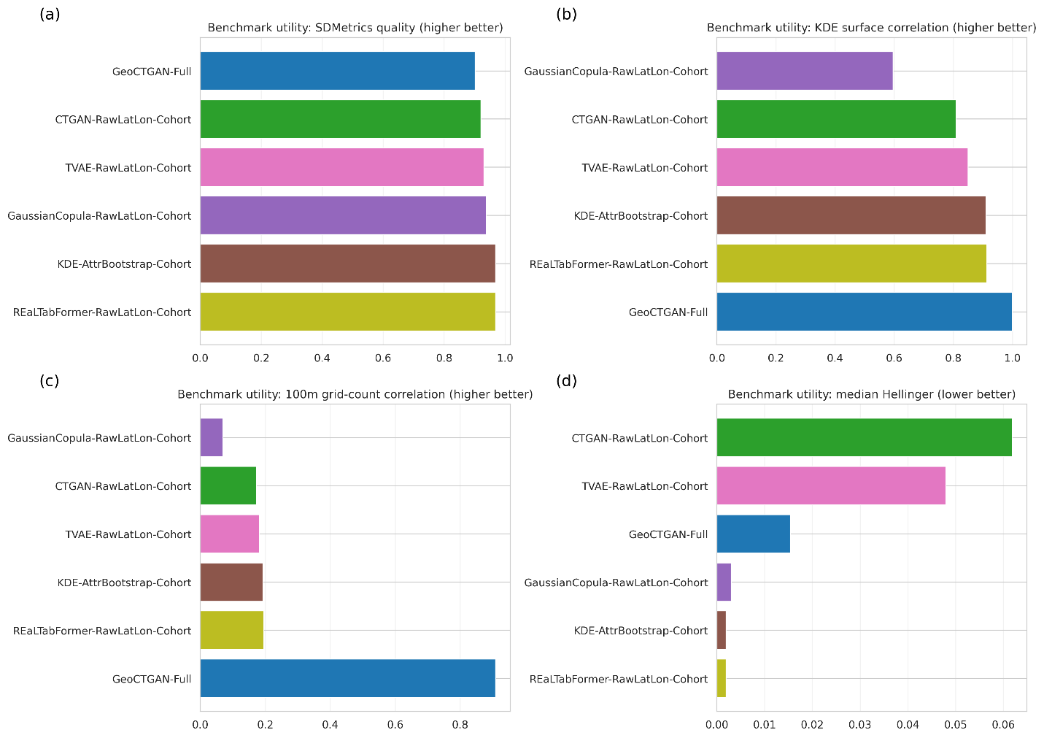
Supplementary Fig. 4 | Benchmark utility comparison across baseline generators and GeoCTGAN.
Comparing GeoCTGAN-Full with five cohort-matched baselines. (a) SDMetrics' overall quality score. (b) Pearson correlation between real and synthetic kernel density estimation (KDE) surfaces. (c) Pearson correlation of 100 m grid-cell counts. (d) Median Hellinger distance across modelled attributes. Higher values indicate better performance in (a-c), whereas lower values indicate better performance in (d).

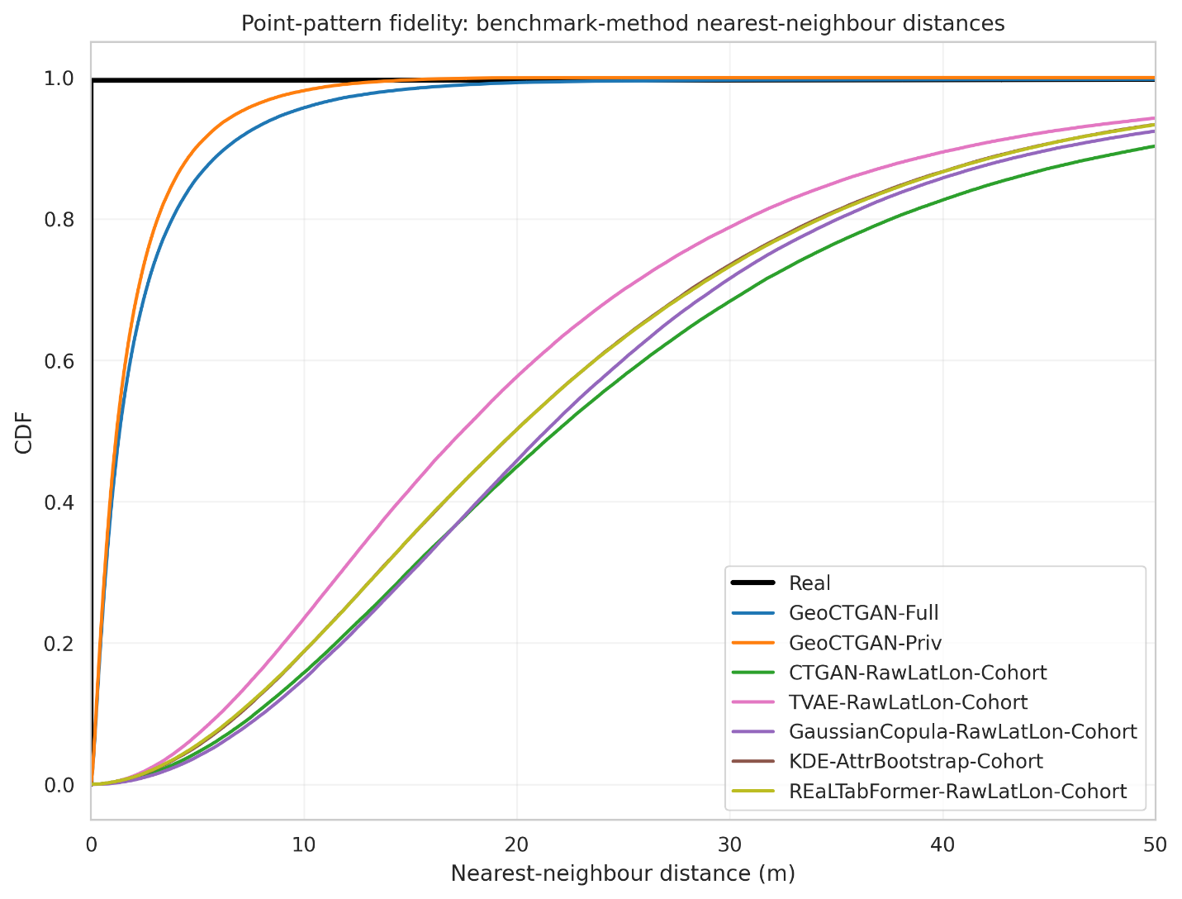
Supplementary Fig. 5 | Point-pattern fidelity assessed using nearest-neighbour distance distributions.
Empirical cumulative distribution functions (CDFs) of nearest-neighbour distances (0-50 m) for the real training data, GeoCTGAN-Full, GeoCTGAN-Priv, and the benchmark models. Curves closer to the real-data distribution indicate better preservation of short-range clustering in the synthetic point pattern.

Supplementary Figs. 6, 7 and 8 illustrate the privacy benchmarking results. Together, these figures show that the privacy-gated release of GeoCTGAN (GeoCTGAN-Priv) substantially reduced near-real spatial overlaps while retaining a utility profile close to that of the full model. They also show that low proximity alone should not be interpreted as evidence of a better privacy-utility balance, as several simpler baselines also exhibited very low overlap of ≤5 m, but only because their spatial outputs were overly diffuse (Supplementary Fig. 5). In contrast, GeoCTGAN-Priv retained coherent multiscale structure and remained analytically usable, although spatially coarser than GeoCTGAN-Full. Supplementary Fig. 7 is particularly helpful for visualizing this distinction because it places near-real proximity and overall utility on the same axis of comparison.
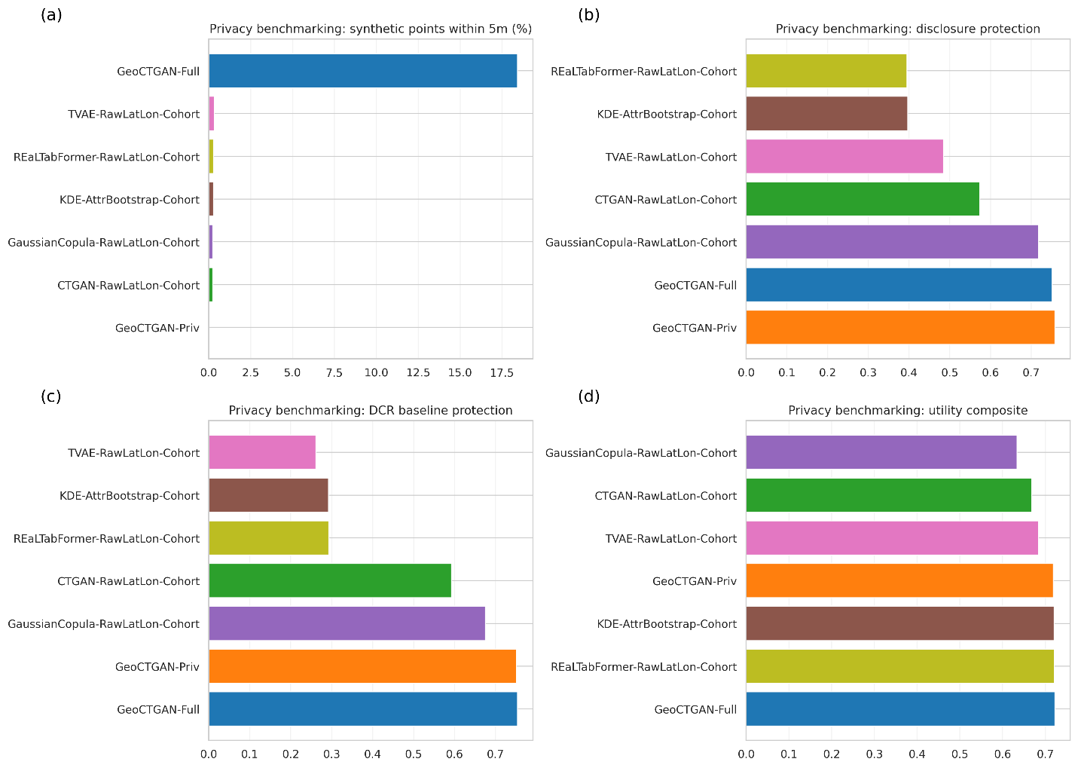
Supplementary Fig. 6 | Privacy benchmarking across GeoCTGAN and baseline generators.
Comparing privacy-related and utility-related metrics across GeoCTGAN-Full, GeoCTGAN-Priv, and the benchmark generator models, showing (a) Percentage of synthetic points located within 5 m of a real training point. (b) SDMetrics disclosure protection estimate. (c) DCR baseline protection. (d) Composite utility score. Lower values are preferable in (a), whereas higher values are preferable in (b-d).
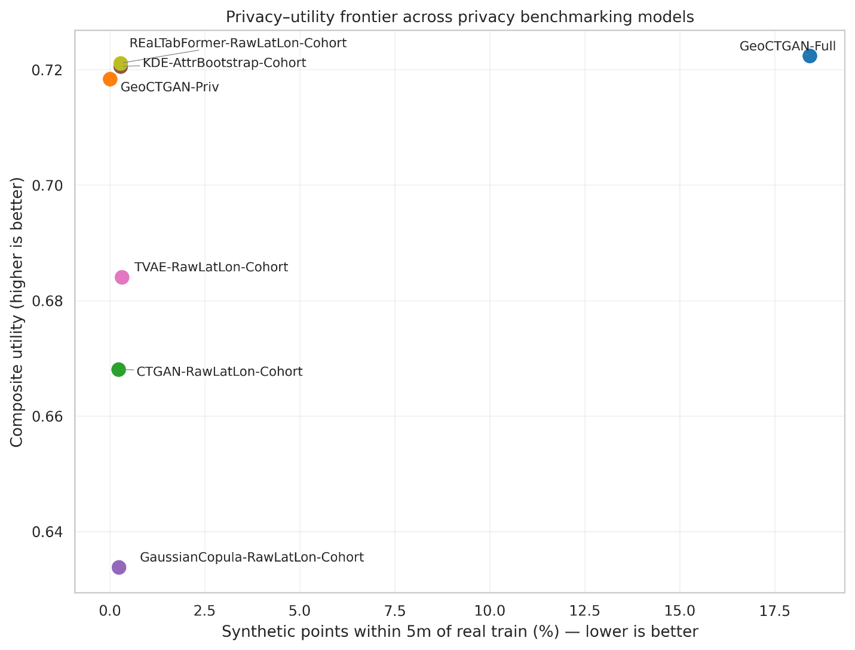
Supplementary Fig. 7 | Privacy-utility assessment across privacy-benchmarked methods.
Scatter plot showing the relationship between near-real spatial proximity and overall synthetic-data utility. The x-axis shows the percentage of synthetic points within 5 m of a real training point, and the y-axis shows the composite utility score. Points toward the upper-left indicate a more favourable privacy-utility balance.

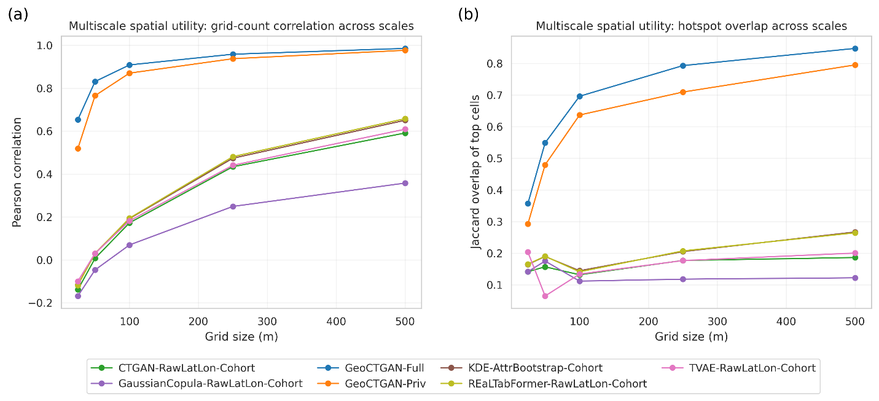
Supplementary Fig. 8 | Multiscale spatial utility benchmarking of grid-count and hotspot fidelity.
Comparison of GeoCTGAN-Full, GeoCTGAN-Priv, and benchmark models across square grids of 25, 50, 100, 250, and 500 m, illustrating (a) Pearson correlation of real and synthetic grid-cell counts. (b) Jaccard overlap of hotspot cells, where hotspots were defined as the top 10% of occupied cells. Higher values indicate better agreement with the real spatial pattern.

Supplementary Figs. S9-S10 report the structural ablation results. These figures show that the three components of GeoCTGAN do not contribute equally. Removing topology or cohorting reduced overall realism to a lesser extent, whereas removing the capacity-constrained reconstruction step led to the sharpest loss of spatial fidelity across scales. In particular, the NoCapacity variant remained clearly weaker on both grid-count agreement and hotspot overlap and did not satisfy the support criterion at any tested scale. In contrast, NoTopology and NoCohort retained much of the broader spatial structure, indicating that topology encoding and temporal cohorting improve realism, but that the capacity-aware reconstruction step is the primary mechanism preserving usable local spatial arrangement.

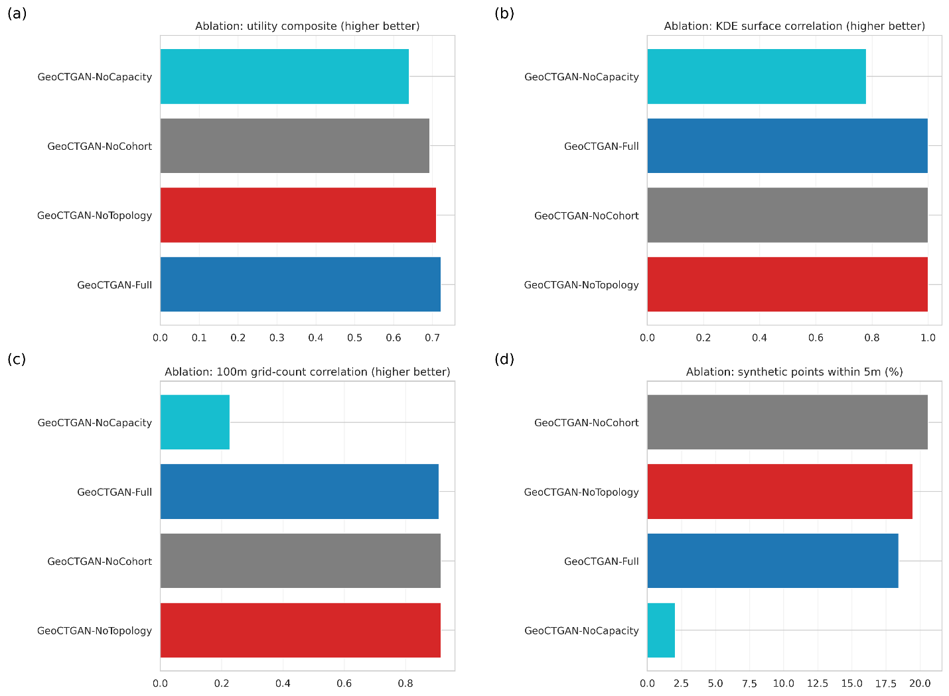

Supplementary Fig. 9 | Structural ablation analysis of GeoCTGAN.
Comparing GeoCTGAN-Full with three ablation variants: NoTopology, NoCohort, and NoCapacity, showing the (a) Composite utility score. (b) KDE surface Pearson correlation. (c) Pearson correlation of 100 m grid-cell counts. (d) Percentage of synthetic points within 5 m of a real training point. Higher values indicate better performance in (a-c), whereas lower values indicate lower near-real spatial overlap in (d).

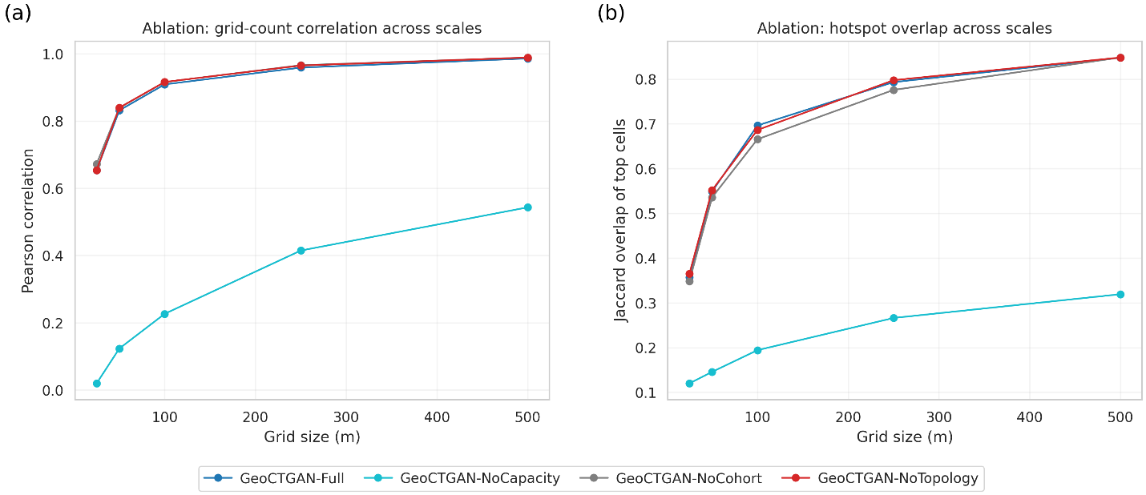

Supplementary Fig. 10 | Multiscale spatial utility across GeoCTGAN ablation variants.
Comparison of GeoCTGAN-Full, NoTopology, NoCohort, and NoCapacity across square grids of 25, 50, 100, 250, and 500 m. (a) Pearson correlation of real and synthetic grid-cell counts. (b) Jaccard overlap of hotspot cells, where hotspots were defined as the top 10% of occupied cells. The figure shows how removing individual components affects spatial agreement at increasingly coarse analysis scales.

References

1 Perozzi, B., Al-Rfou, R. & Skiena, S. in Proceedings of the 20th ACM SIGKDD international conference on Knowledge discovery and data mining. 701-710.
2 Toronto Police Service. Toronto Police Service Public Safety Data Portal, <https://data.torontopolice.on.ca/pages/open-data> (2025).
3 Boeing, G. Modeling and analyzing urban networks and amenities with OSMnx. Geographical Analysis (2025).
4 Řehůřek, R. & Sojka, P. Software framework for topic modelling with large corpora. (2010).
5 Johnson, S. D. & Summers, L. Testing ecological theories of offender spatial decision making using a discrete choice model. Crime & Delinquency 61, 454-480 (2015).
6 Brantingham, P. J. & Brantingham, P. L. Environmental Criminology. (Sage Publications Beverly Hills, CA, 1981).
7 Brantingham, P. J., Brantingham, P. L. & Andresen, M. A. The geometry of crime and crime pattern theory. Environmental Criminology and Crime Analysis 2 (2017).
8 Xu, L., Skoularidou, M., Cuesta-Infante, A. & Veeramachaneni, K. Modeling tabular data using conditional gan. Adv. Neural Inf. Process. Syst. 32 (2019).
9 Scikit-learn Developers. Time-related feature engineering, <https://scikit-learn.org/stable/auto_examples/applications/plot_cyclical_feature_engineering.html?utm_source=chatgpt.com> (2025).
10 Basri, M. A. et al. A Hyperparameter Tuning Framework for Tabular Synthetic Data Generation Methods. Journal of Computational Vision and Imaging Systems 9, 76-79 (2023).
11 Goldberger, J., Hinton, G. E., Roweis, S. & Salakhutdinov, R. R. Neighbourhood components analysis. Adv. Neural Inf. Process. Syst. 17 (2004).
12 Gruteser, M. & Grunwald, D. in Proceedings of the 1st international conference on Mobile systems, applications and services. 31-42.
13 Sweeney, L. k-anonymity: A model for protecting privacy. International journal of uncertainty, fuzziness and knowledge-based systems 10, 557-570 (2002).
14 Park, N. et al. Data synthesis based on generative adversarial networks. arXiv preprint arXiv:1806.03384 (2018).
15 El Emam, K., Mosquera, L. & Hoptroff, R. Practical synthetic data generation: balancing privacy and the broad availability of data. (O'Reilly Media, 2020).
16 El Emam, K. Seven ways to evaluate the utility of synthetic data. IEEE Security & Privacy 18, 56-59 (2020).
17 Baddeley, A., Rubak, E. & Turner, R. Spatial point patterns: methodology and applications with R. Vol. 1 (CRC press Boca Raton, 2016).
18 Bentley, J. L. Multidimensional binary search trees used for associative searching. CACM 18, 509-517 (1975).
19 Berger, V. W. & Zhou, Y. Kolmogorov–smirnov test: Overview. Wiley statsref: Statistics reference online (2014).
20 Silverman, B. W. Density estimation for statistics and data analysis. (Routledge, 2018).
21 Scott, D. W. Multivariate density estimation: theory, practice, and visualization. (John Wiley & Sons, 2015).
22 Kulldorff, M. (2010).
23 Kulldorff, M. (2015).
24 Statistics Canada. Dissemination area (DA), <https://www12.statcan.gc.ca/census-recensement/2021/ref/dict/az/definition-eng.cfm?ID=geo021> (2021).
25 Anselin, L. Global spatial autocorrelation (1), Moran scatter plot and spatial correlogram, <https://geodacenter.github.io/workbook/5a_global_auto/lab5a.html#fn1> (2018).
26 ESRI, E. S. R. I.-. How Cluster and Outlier Analysis (Anselin Local Moran's I) works, <http://pro.arcgis.com/en/pro-app/tool-reference/spatial-statistics/h-how-cluster-and-outlier-analysis-anselin-local-m.htm> (2017).
27 Anselin, L. Local indicators of spatial association—LISA. Geographical analysis 27, 93-115 (1995).
28 Ward, M. D. & Gleditsch, K. S. Spatial regression models. Vol. 155 (Sage Publications, 2018).
29 Kleinbaum, D. G., Kupper, L. L., Nizam, A. & Rosenberg, E. S. Applied regression analysis and other multivariable methods. (Nelson Education, 2013).
30 Ontario Community Health Profiles Partnership. Ontario Marginalization Index (ON-Marg), <https://www.ontariohealthprofiles.ca/onmargON.php#ONMarg2021NHs> (2023).
31 DataCebo. SDMetrics- DisclosureProtectionEstimate, <https://docs.sdv.dev/sdmetrics/data-metrics/privacy/disclosureprotectionestimate> (2025).
32 DataCebo. SDMetrics- DCROverfittingProtection, <https://docs.sdv.dev/sdmetrics/data-metrics/privacy/dcroverfittingprotection> (2025).
33 DataCebo. SDMetrics- DCRBaselineProtection, <https://docs.sdv.dev/sdmetrics/data-metrics/privacy/dcrbaselineprotection> (2025).
34 DataCebo. SDV- GaussianCopulaSynthesizer, <https://docs.sdv.dev/sdv/single-table-data/modeling/synthesizers/gaussiancopulasynthesizer> (2025).
35 Solatorio, A. V. & Dupriez, O. Realtabformer: Generating realistic relational and tabular data using transformers. arXiv preprint arXiv:2302.02041 (2023).
36 SciPy. SciPy Spatial Distance: Jaccard Index, <https://docs.scipy.org/doc/scipy/reference/generated/scipy.spatial.distance.jaccard.html#scipy.spatial.distance.jaccard> (2026).
37 Noble, J. What is Jaccard similarity?, <https://www.ibm.com/think/topics/jaccard-similarity#:~:text=Jaccard%20similarity%20is%20a%20statistical,that%20the%20sets%20are%20identical.> (2025).

