Online Resource 3
HarvestField: A Decision-Support Framework for Robot-Oriented Kiwifruit Canopy Management Using Spatial Harvestability Modelling
Journal of Biosystems Engineering
Caption. Supplementary figures supporting field visualisation, calibration diagnostics, ablation checks, sensitivity analysis, and dynamic harvestability exploration.

Supplementary figure list
This file collects supplementary figures that are not essential for understanding the main text but provide diagnostic support for the field construction, statistical comparisons, sensitivity analysis, and dynamic harvestability extension.

Supplementary Fig. S1. Three-dimensional distribution of the composite harvestability field and fruit positions.

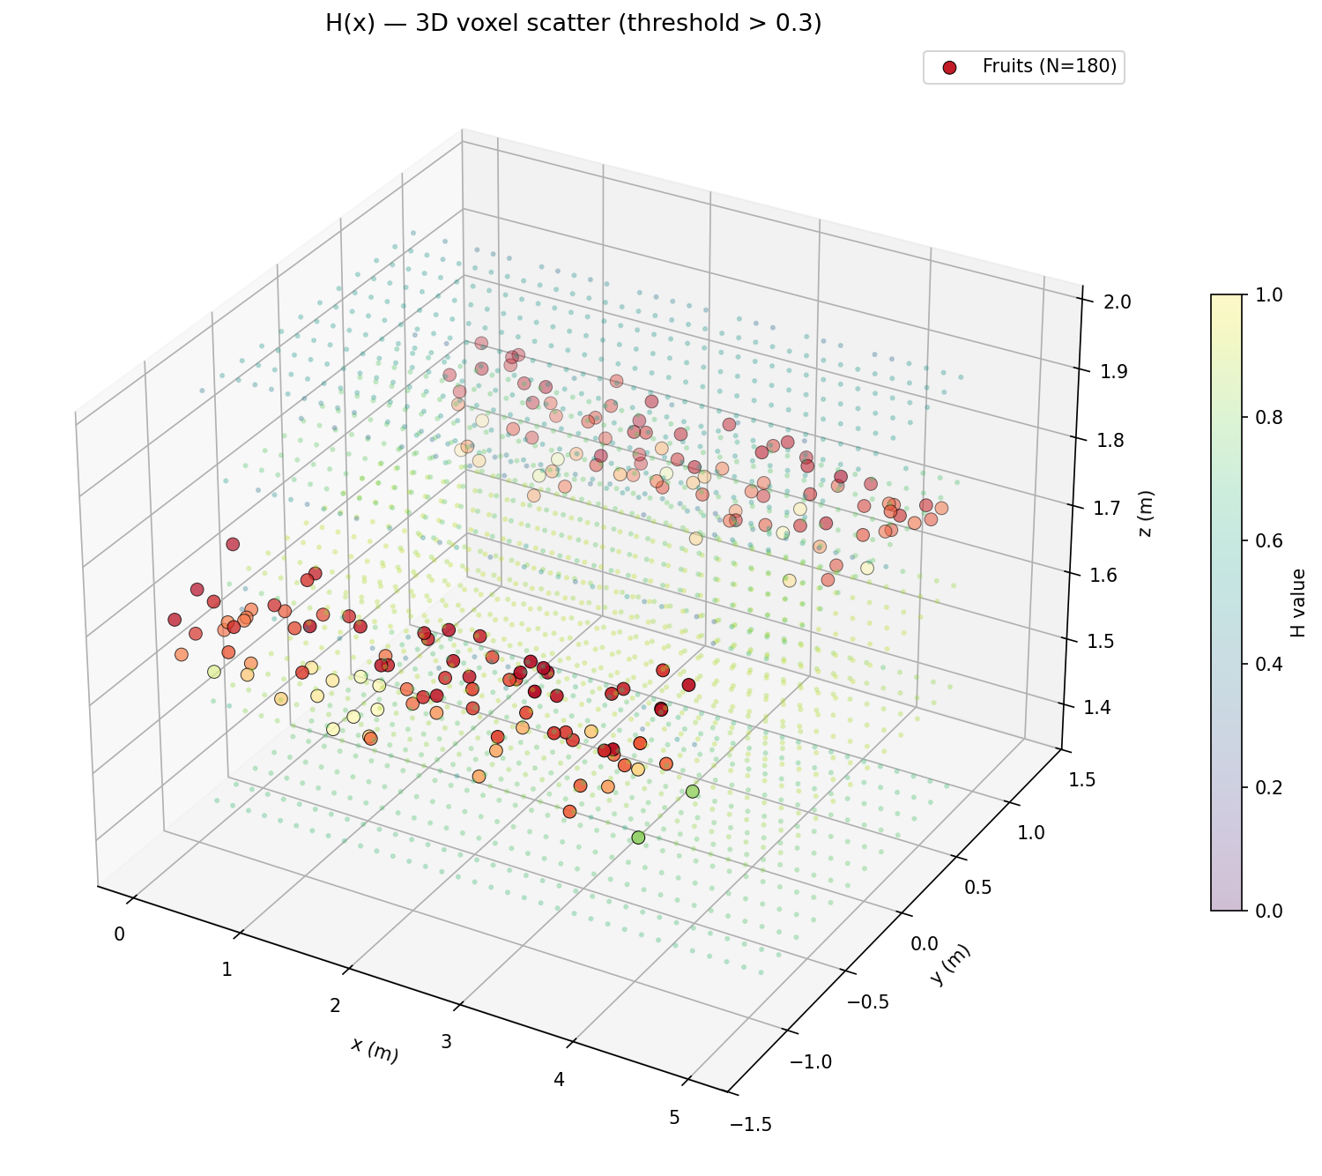

Supplementary Fig. S2. Distribution of harvestability values at fruit positions.

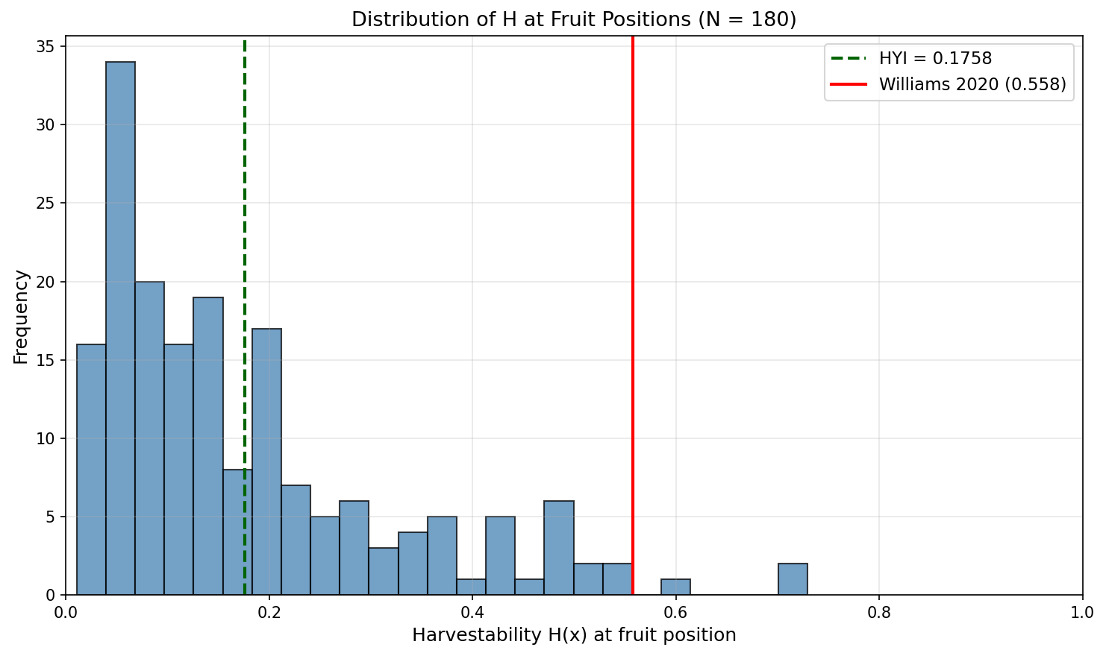

Supplementary Fig. S3. Cross-sectional XZ visualisation of reachability, visibility, clearance, detachability, and composite harvestability.

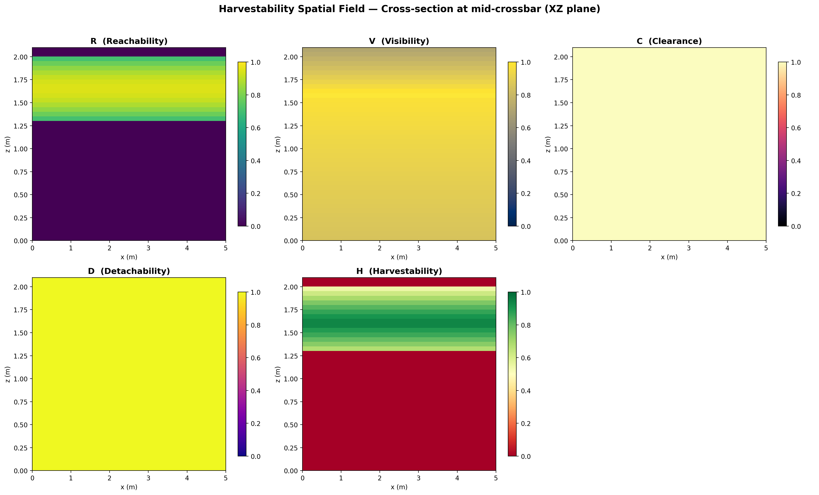

Supplementary Fig. S4. Summary statistics for the harvestability sub-fields and composite field.

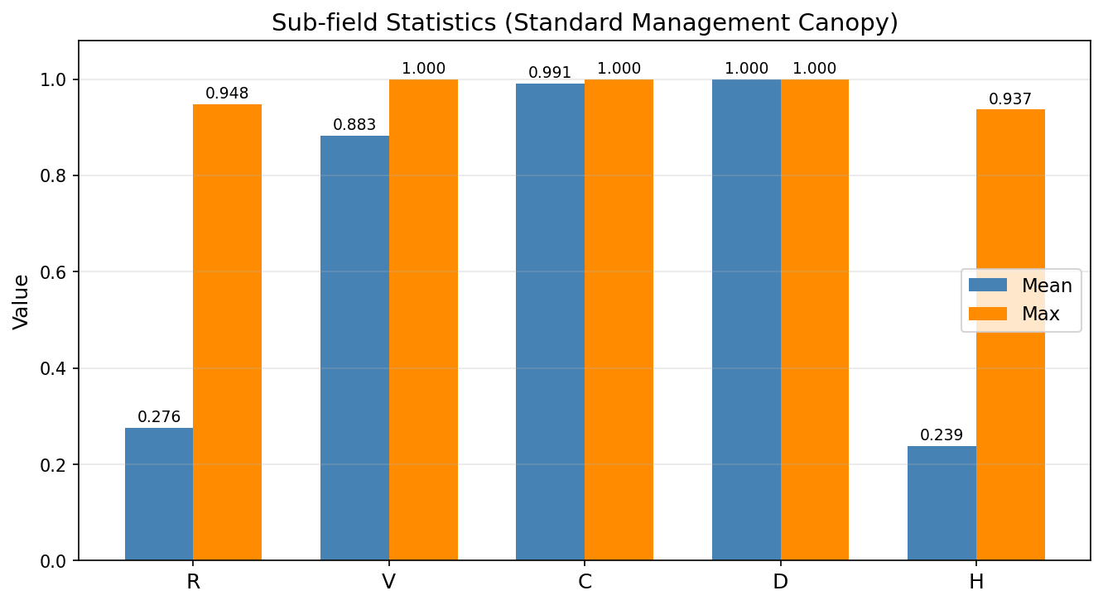

Supplementary Fig. S5. Statistical contrast heatmap for baseline comparisons.

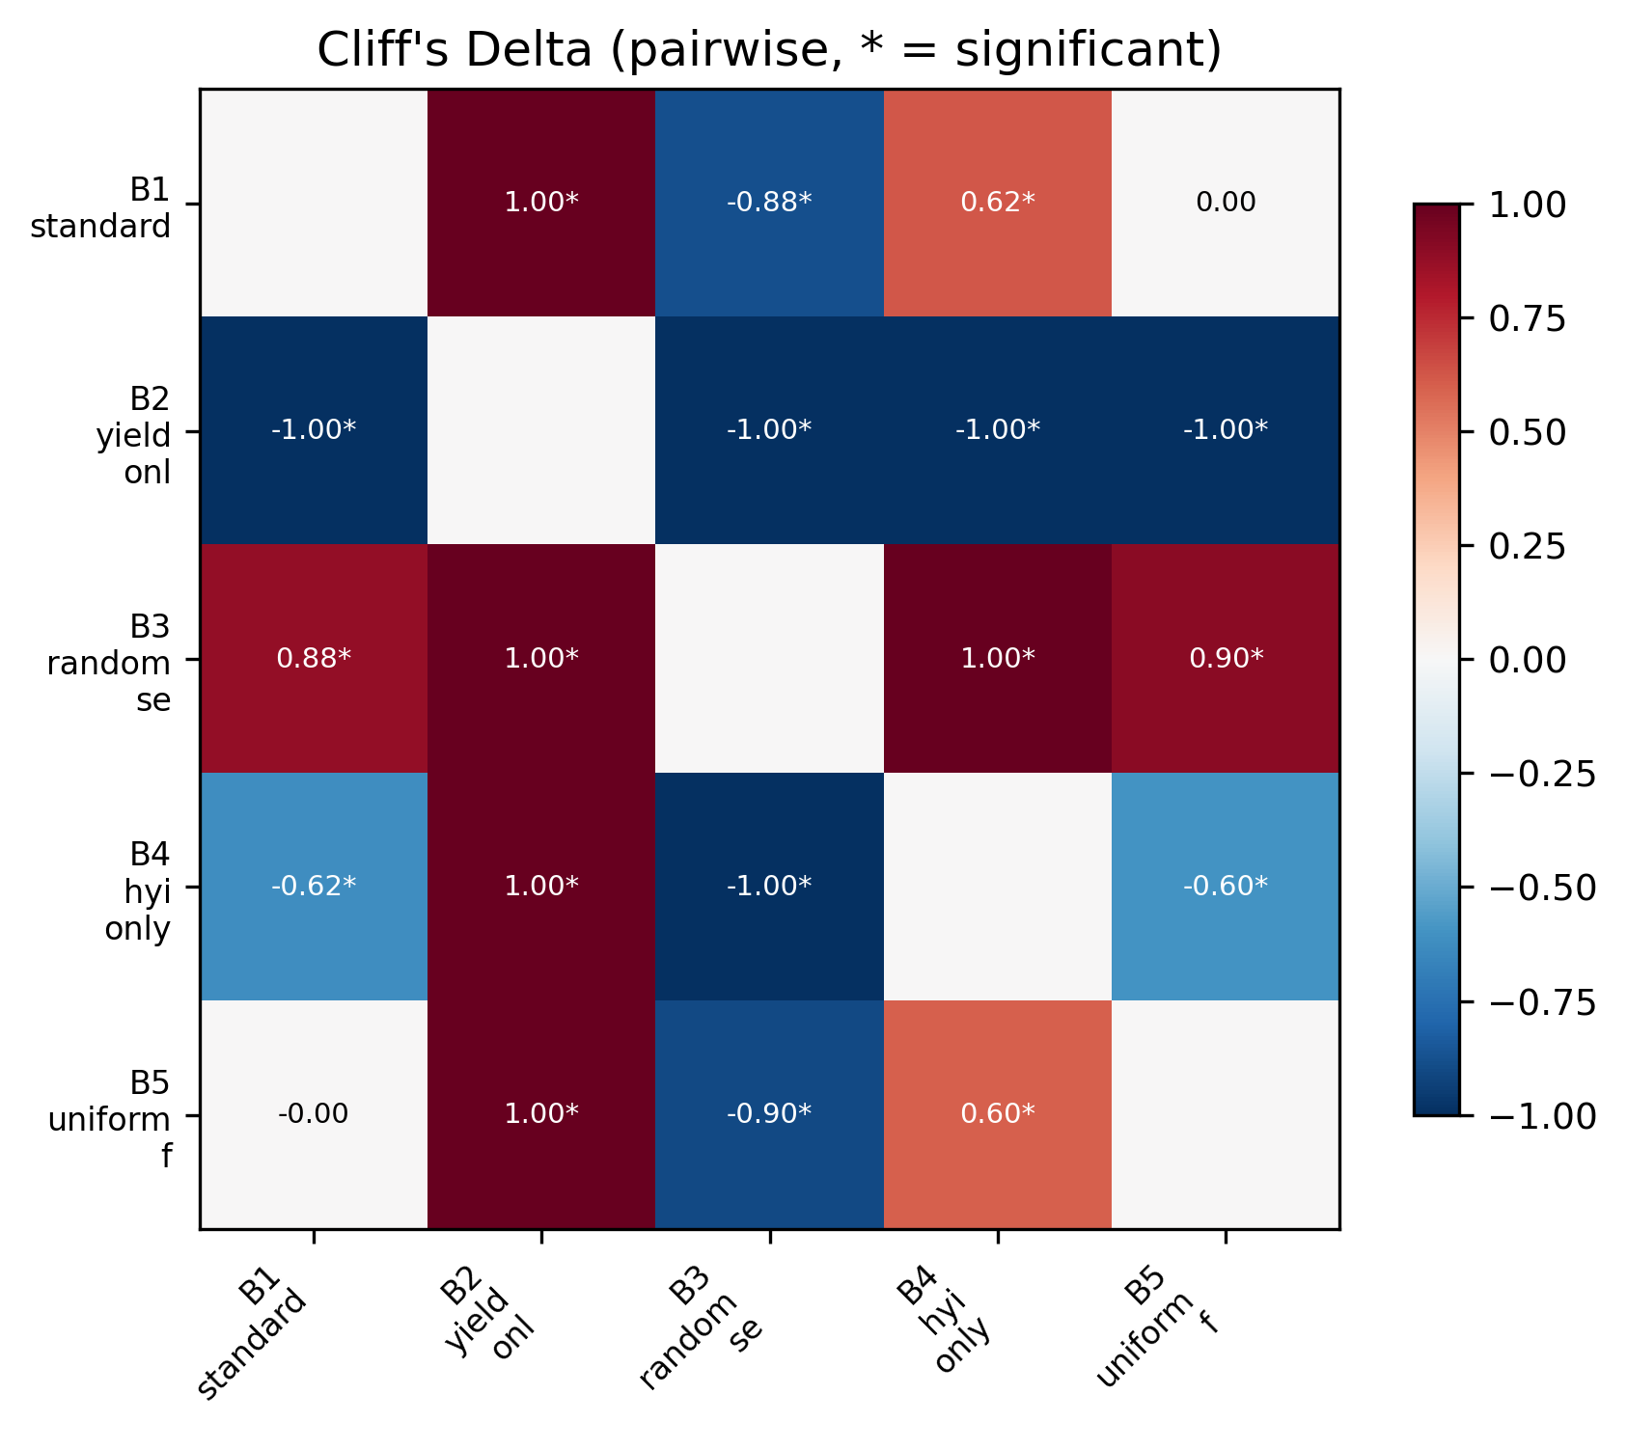

Supplementary Fig. S6. Harvestability distributions under controlled fruit thinning strategies.

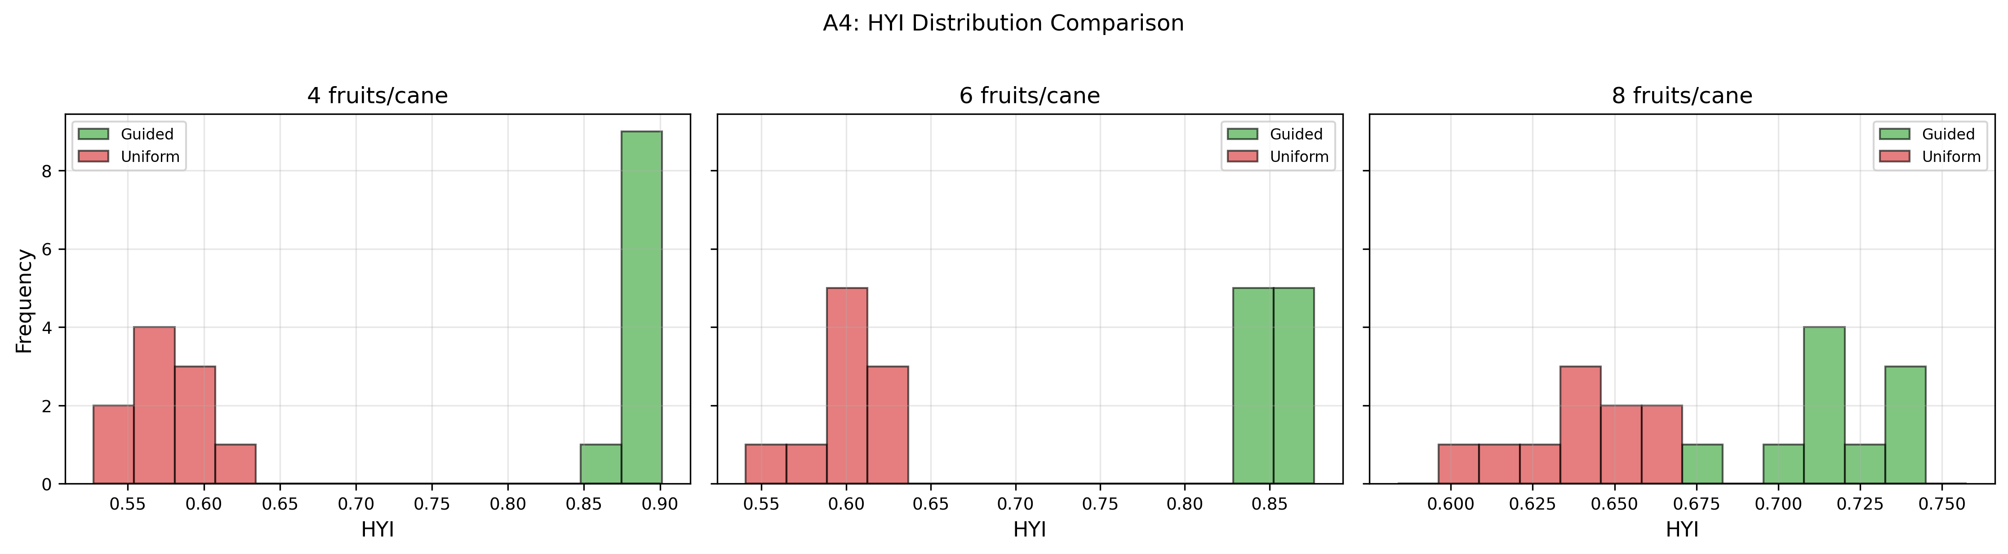

Supplementary Fig. S7. Bootstrap convergence diagnostics for HYI uncertainty analysis.

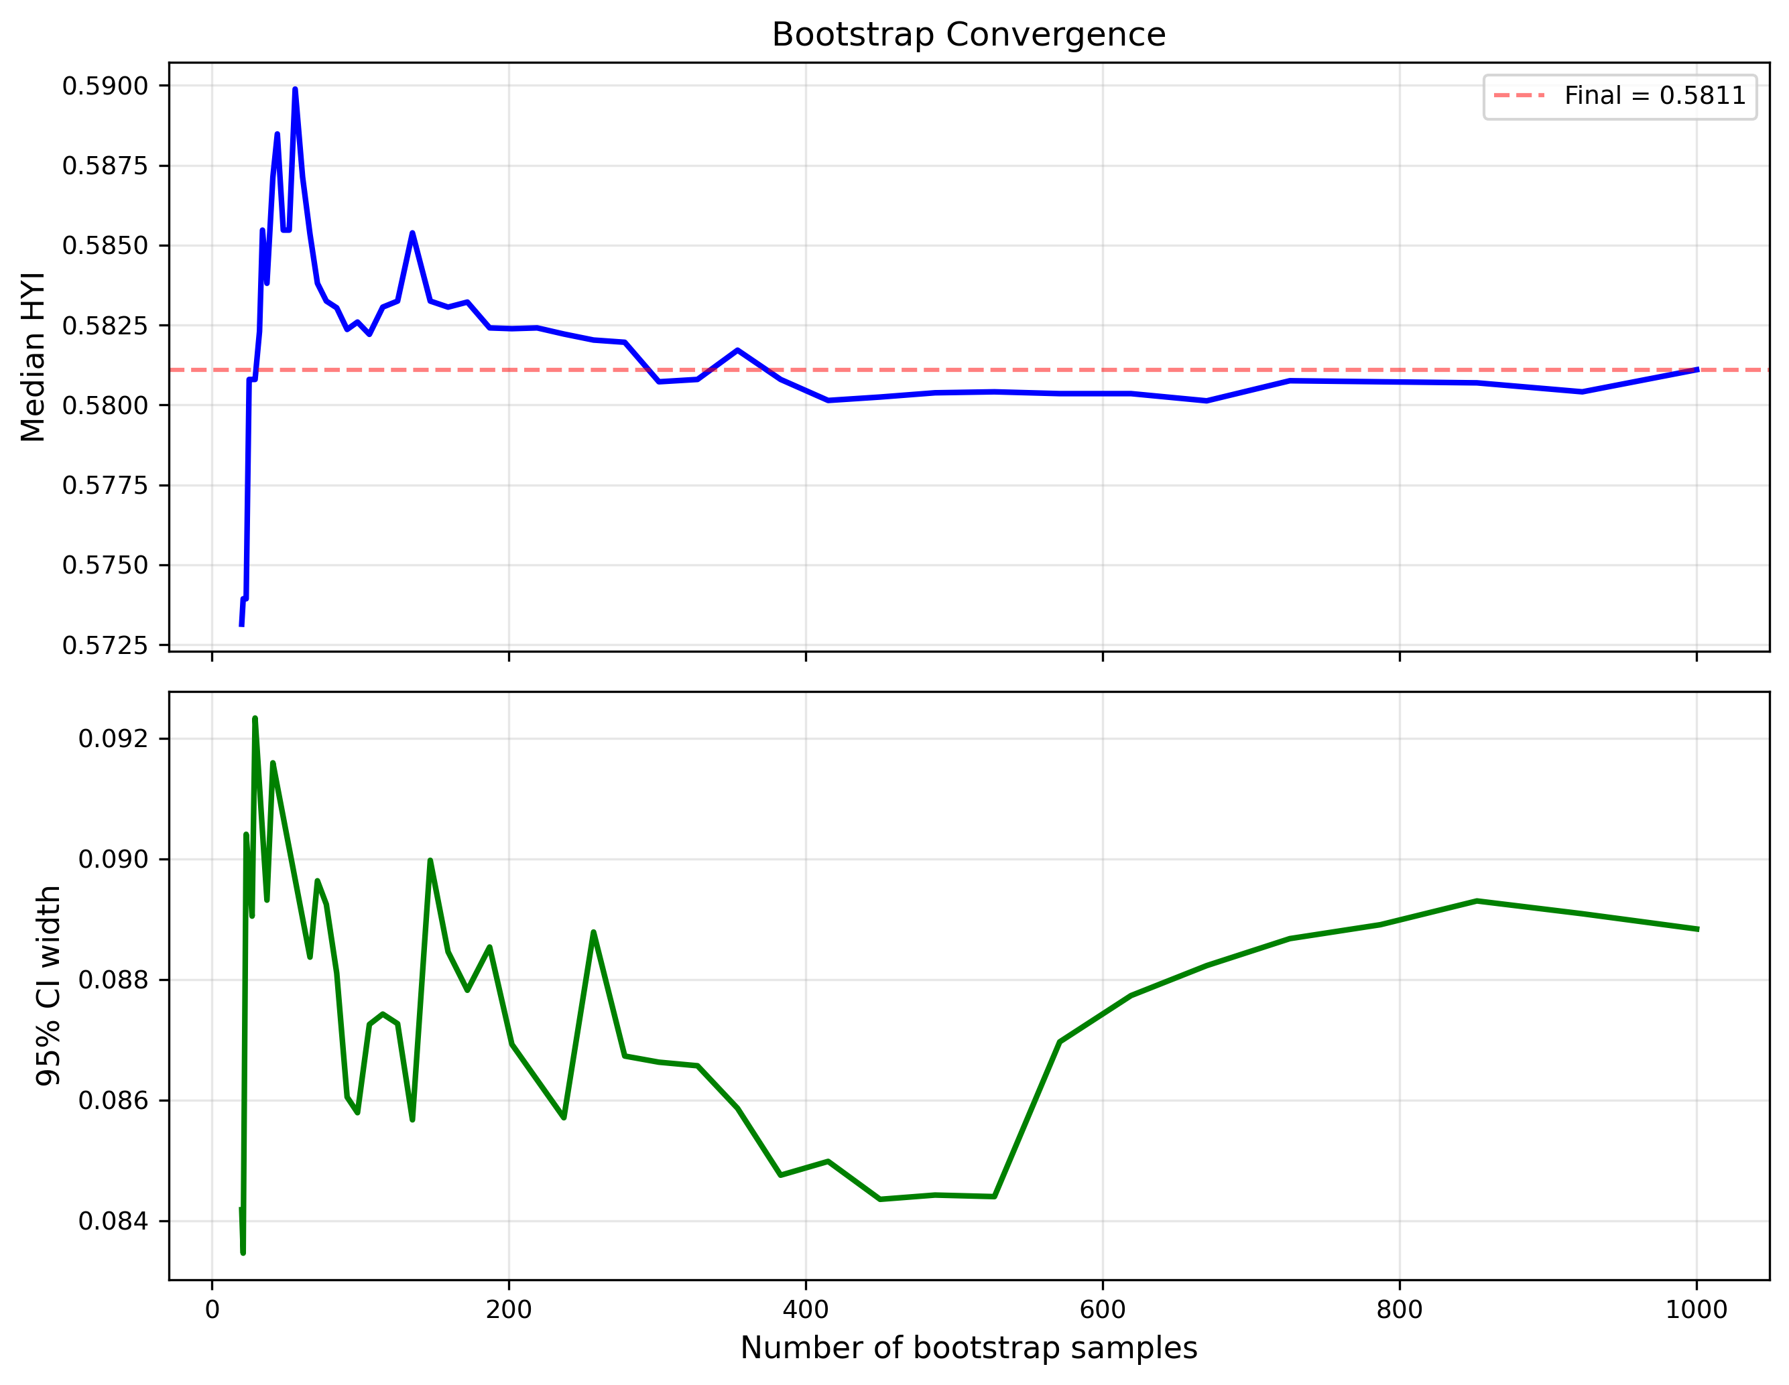

Supplementary Fig. S8. Sobol second-order interaction matrix for HYI.

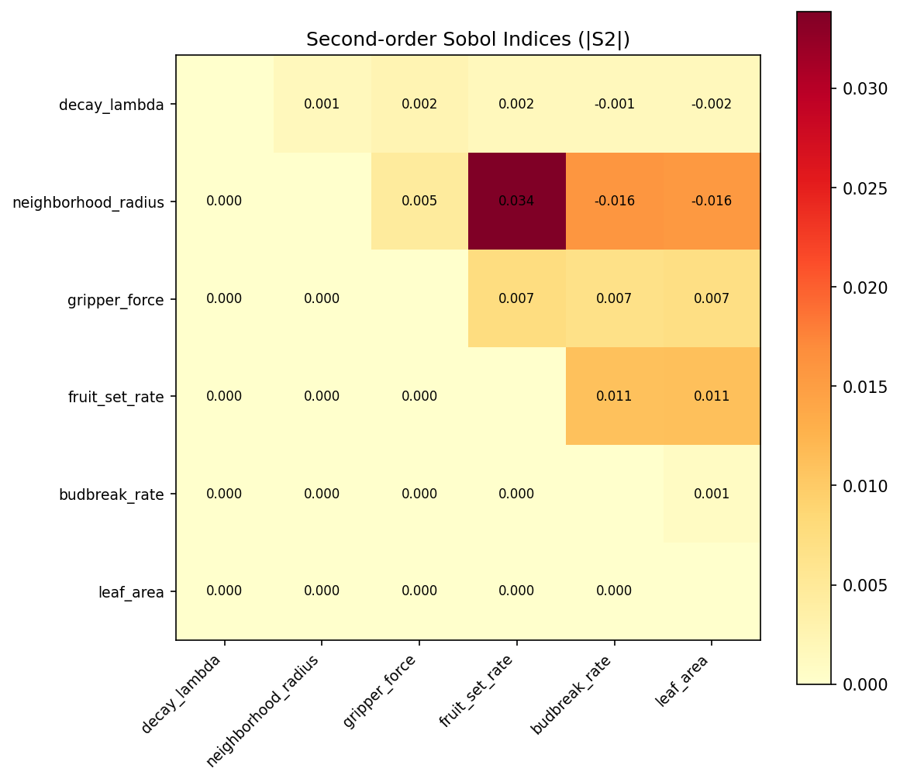

Supplementary Fig. S9. Hypervolume comparison between robot configurations.

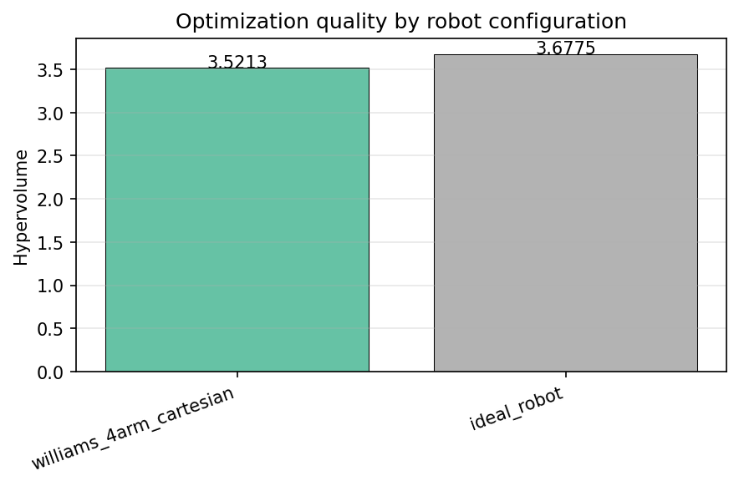

Supplementary Fig. S10. Dynamic HYI evolution under sequential fruit removal.

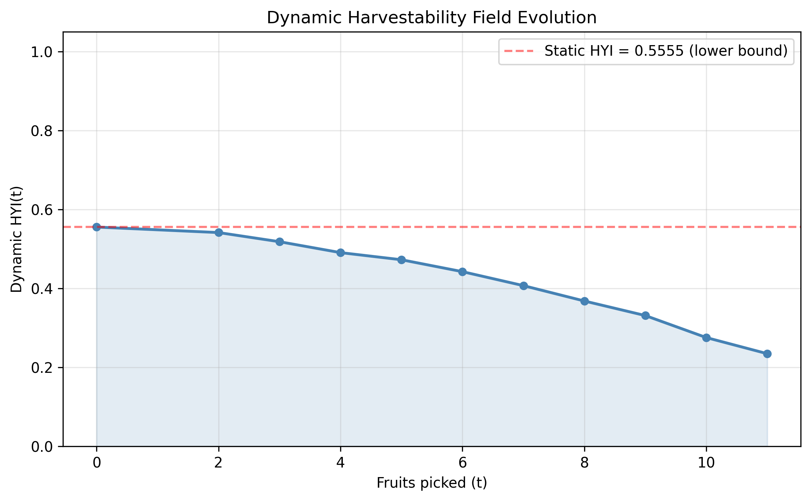

Supplementary Fig. S11. Dynamic mean harvestability evolution under sequential fruit removal.

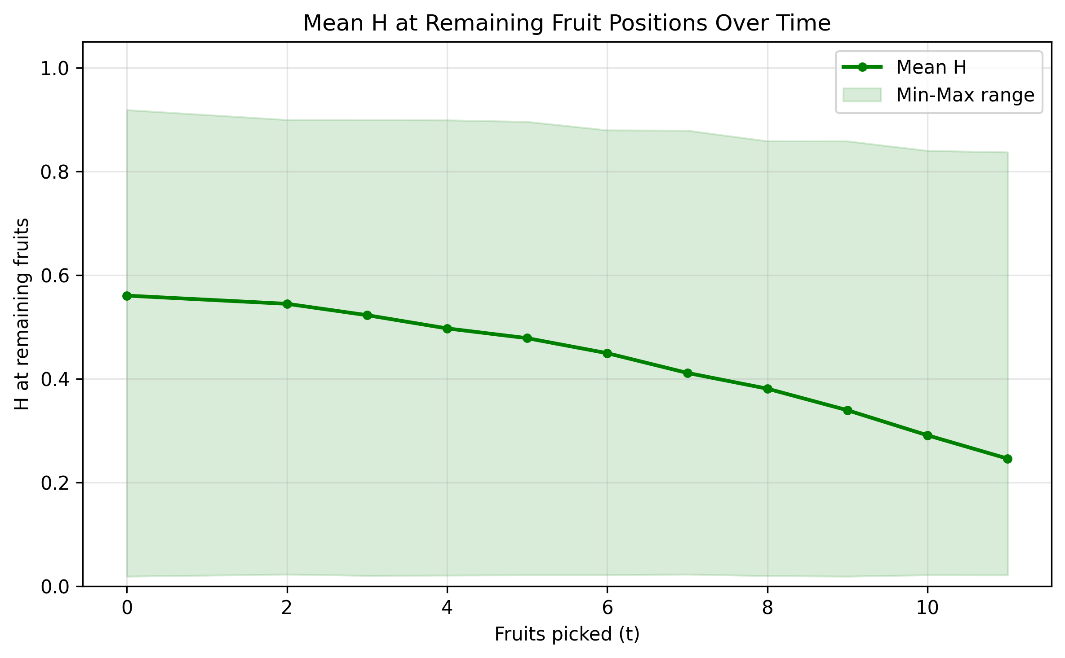

Supplementary Fig. S12. Monotonicity diagnostics for the dynamic harvestability extension.

