Hepatitis B Vaccination Coverage, Awareness and Determinants: The Role of Barriers, Motivators, and Occupational Risks Among Health Science Students at a Nigerian University.

SUPPLEMENTARY FIGURES

Fig. S1 Awareness and vaccination coverage among respondents

Fig. S2 Barriers to Vaccination

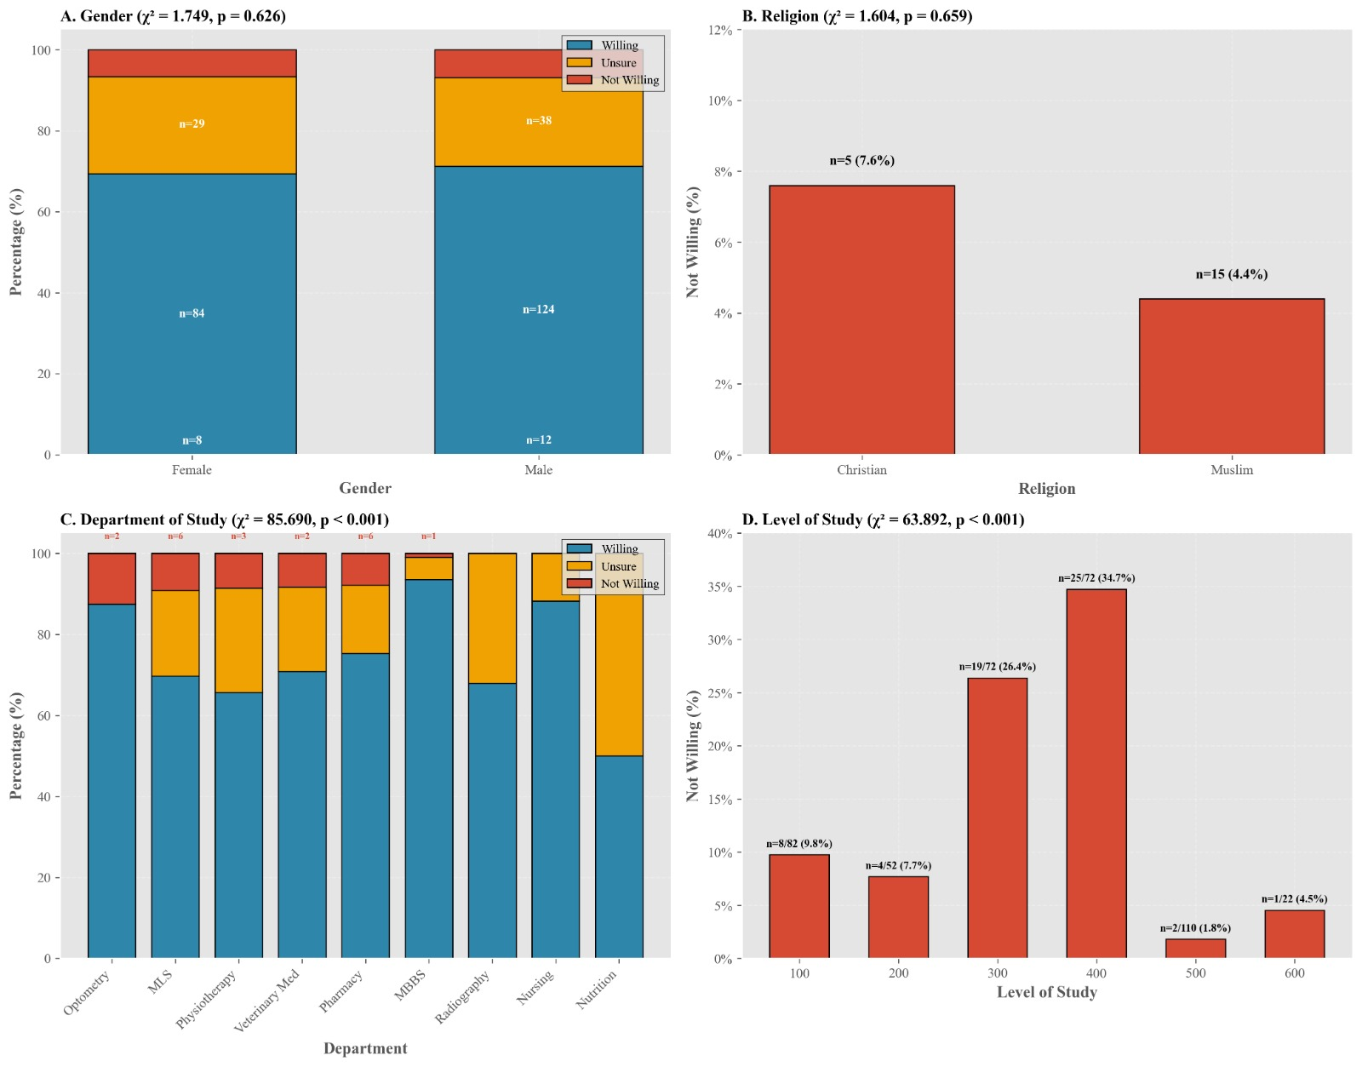
FigS3.tiff Sociodemographic determinants for Hepatitis B vaccination.

APPENDIX 1: INFORMED CONSENT FORM
Title of the Research: Assessment of Hepatitis-B Vaccination Coverage, Barriers, Motivators and Occupational Risk Among Health Science Students in Usmanu Danfodiyo University, Sokoto.

Purpose of Research: To assess the Hepatitis-B Vaccination Coverage, Barriers, Motivators and Occupational Risk Among Health Science Students in Usmanu Danfodiyo University, Sokoto.
Procedure of Research: This study will involve asking you a series of questions in a simple process that involves filling out an online survey regarding Hepatitis Vaccination Coverage, Barriers, Motivators and Occupational Risk Among Health Science Students in Usmanu Danfodiyo University, Sokoto. This is expected to take only about 4-7mins of your time.
Possible Risks, Discomforts and Inconveniences: There are no possible risks, discomforts or inconveniences associated with this study as respondents are only required to fill out the questionnaires administered to them which does not require any personal information except the minimum required as evidence that the research was carried out.
Potential Benefits: It is hoped that this study and its outcome will help provide evidence on hepatitis B vaccination uptake and determinants among health science students, identifying key barriers, motivators, and occupational risks. The findings can inform targeted interventions such as improved vaccine access, health education, and institutional policies, while contributing to evidence-based strategies to reduce infection risk among future healthcare workers in similar low-resource settings.
Modality of Providing Treatments and Action(s) to be taken in case of Injury or Adverse Effects: There is neither injury nor any form of adverse effect expected from this prospective survey.
Confidentiality: All information collected in this study will be coded and no name will be recorded. This cannot be linked to the respondent in any way, and no name or identifier will be used in any publication or report from this study.
Participant's Responsibilities: Give accurate responses during data collection on the survey tool.
Statement of Person Obtaining Informed Consent: I have fully explained this research to the patient and have been given sufficient information leading to an informed decision.
Date………………………………………………………
Signature………………………………………………....
Statement of Person Giving Consent: I have read the description of the research in a language I understand. I have also talked it over with the researcher to my satisfaction and I understand that my participation is voluntary.
Date ………………………………………………………..
Signature…………………………………………………...
For further enquiries, please contact:
Researcher’s Contact
Ismail Tajudeen Hamza
Phone number: 08144454401
Email address: ismailthamza01@gmail.com
College of Health Sciences, Usmanu Danfodiyo University, Sokoto, PMB 2346, Sokoto, Nigeria

APPENDIX 2: DATA COLLECTION TOOL

SECTION A: Socio-Demographic Information
- Age: _______
- Gender: ☐ Male ☐ Female ☐ Other
- Marital Status: ☐ Single ☐ Married ☐ Divorced ☐ Widowed
- Religion: ☐ Islam ☐ Christianity ☐ Other: ______
- Department: ☐ MBBS ☐ Nursing ☐ Pharmacy ☐ MLS ☐ Radiography ☐ Physiotherapy ☐ Optometry ☐ Dietetics
- Level of Study: ☐ 200 ☐ 300 ☐ 400 ☐ 500 ☐ 600
- Type of Residence: ☐ Hostel ☐ Off-campus ☐ With family
- Have you participated in any clinical/hospital posting? ☐ Yes ☐ No
- If yes, how long have you been exposed? ______ months

SECTION B: Hepatitis B Vaccination Status
- Have you heard of the hepatitis B vaccine? ☐ Yes ☐ No
- Have you received any dose of hepatitis B vaccine? ☐ Yes ☐ No
- If yes, how many doses have you received?
☐ One ☐ Two ☐ All three doses (fully vaccinated)
- Where did you receive the vaccine?
☐ University clinic ☐ Private hospital ☐ Public hospital ☐ Campaign/Outreach ☐ Other: ______
- Did you pay for it? ☐ Yes ☐ No
- If no, why haven't you been vaccinated? (check all that apply)
☐ Not aware
☐ Fear of side effects
☐ Not accessible
☐ Not necessary
☐ No time
☐ Expensive
☐ Religious/Cultural beliefs
☐ Other: ________
- Are you willing to take the vaccine in the future? ☐ Yes ☐ No ☐ Not sure

SECTION C: Barriers to Vaccination
Use the scale below to rate each barrier as it applies to your decision to get vaccinated.
1 = Not a barrier | 2 = Minor barrier | 3 = Moderate barrier | 4 = Major barrier
Barrier |  | Hepatitis B
Religious or cultural beliefs |  | ☐ 1 ☐ 2 ☐ 3 ☐ 4
Waiting to see how others react first |  | ☐ 1 ☐ 2 ☐ 3 ☐ 4
Fear of injections/needles |  | ☐ 1 ☐ 2 ☐ 3 ☐ 4
Already immune or had the infection |  | ☐ 1 ☐ 2 ☐ 3 ☐ 4
Inconvenient vaccination process |  | ☐ 1 ☐ 2 ☐ 3 ☐ 4
Lack of information from reliable sources |  | ☐ 1 ☐ 2 ☐ 3 ☐ 4
Other (please specify): ______________________ |  | ☐ 1 ☐ 2 ☐ 3 ☐ 4

SECTION D: Occupational Exposure Risk
- Have you ever had a needle-stick or sharps injury during your training? ☐ Yes ☐ No
- Have you ever had contact with patient’s blood or body fluids? ☐ Yes ☐ No
- Do you always use gloves when handling specimens or patients?
☐ Always ☐ Sometimes ☐ Never
- Are you aware of standard infection control precautions? ☐ Yes ☐ No
- Do you feel at risk of contracting hepatitis B during your training? ☐ Yes ☐ No
- Do you feel at risk of contracting COVID-19 during your training? ☐ Yes ☐ No
- Has your department provided you with PPE (personal protective equipment)? ☐ Yes ☐ No
- Have you received any training on infection control or prevention? ☐ Yes ☐ No

SECTION E: Motivators to Vaccination
Which of the following factors encouraged or would encourage you to get vaccinated? (Tick all that apply)
Motivator | Hepatitis B
Personal protection from infection | ☐
Requirement for clinical posting or institutional policy | ☐
Advice from health workers/lecturers | ☐
Peer/family influence | ☐
Free or subsidized vaccine by the institution | ☐
Trust in public health institutions (NCDC/WHO) | ☐
To protect patients and family | ☐
Peace of mind during clinical exposure | ☐
Information from school lectures/orientation | ☐
Encouragement from religious/community leaders | ☐
Experience with or witnessing infection in others | ☐
Other (please specify): ____________________ | ☐

SECTION F: Feedback and Suggestions
- What do you think can be done to improve vaccine uptake among health science students?
- Any additional comments or suggestions?

