Supplementary Materials
Index
- Supplement 1. Survey Questionnaire for Collecting User Requirements
- Supplement 2. Usability Evaluation Survey for the Developed Pre-test Guidance Chatbot
- Supplementary 3. User Queries Used for Usability Evaluation of the Pre-Test Guidance Chatbot
- Supplement 4. Evaluation Items Used for Usability Assessment of the Health Information Guidance Chatbot
- Supplement 5. End-to-End Workflow mapping of Health Screening Services
- Supplement 6. The characteristics of the respondents for user requirements survey
- Supplement 7. Q. How do you think Generative AI would be helpful in the health screening service area
- Supplement 8. Free-Text Suggestions for AI Chatbot Development

Supplement 1. Survey Questionnaire for Collecting User Requirements
1. Respondent Information
1.1 Please indicate the name of your department or unit.
(Examples: Registration/Appointment Scheduling, Examination Unit, Laboratory, Consultation Unit, etc.)
1.2 What is your professional role or position?
(Examples: Physician [Endoscopy], Physician [Consultation], Physician [Radiologist], Nurse, Medical Technologist, Radiologic Technologist, Administrative Staff, etc.)

2. Current Work Status
Please describe in detail the main tasks performed in your department or unit.
(Examples:)
- Receiving health screening appointments and managing schedules
- Providing pre- and post-screening instructions and responding to inquiries
- Recording and archiving test results
- Preparing health screening reports and providing consultation
- Mailing screening result reports and providing follow-up management guidance
- Other: Please describe any additional tasks in which you are involved

3. Data Collection and Storage
3.1 What types of data are primarily handled in your department or unit?
(Select all that apply.)
[ ] Patient personal information and CRM records (eg, name, address, contact information, occupation, social status, notable personal characteristics)
[ ] Medical history questionnaire data (eg, past medical history, current medications, prior diagnoses)
[ ] Test results (eg, blood tests, urine tests, imaging studies)
[ ] Appointment information (eg, date, time, screening items)
[ ] Consultation records (eg, patient inquiries, clinician recommendations)
[ ] Other (please specify: ____________)
3.2 How do you record the data generated from your tasks?
(Select all that apply.)
[ ] Manual entry (recorded directly on paper documents)
[ ] Entry into the electronic medical record (EMR) system
[ ] Automatically collected from diagnostic equipment (eg, blood analyzers, MRI, CT scanners)
[ ] Audio recordings of conversations during interview
[ ] Other (please specify: ____________)
3.3 In what file formats are the collected data primarily stored?
(Select all that apply.)
[ ] Document data (eg, .txt, .doc, .pdf)
[ ] Spreadsheet files (eg, .xls, .csv)
[ ] EHR data (eg, SQL, Oracle)
[ ] Image files (eg, .jpg, .png, DICOM)
[ ] Audio files (eg, .mp4)
[ ] Other (please specify: ____________)

4. Assessment of the Need for Generative AI
4.1 In your department or unit, which work area do you think would benefit most from Generative AI?
(Examples: screening-item recommendation program, pre-screening preparation guidance, automated interpretation of screening results, etc.)
4.2 How do you think Generative AI would be helpful in the area you selected above?
(Example: “It would be helpful if Generative AI could integrate prior screening history and recommend appropriate screening items.”)
4.3 What difficulties or concerns do you anticipate with the introduction of Generative AI?
(Example: “I am concerned about protecting patient privacy and maintaining the accuracy of medical information.”)

5. Additional Comments
5.1 Please feel free to provide any additional suggestions or comments regarding the development of Generative AI
.
(Example: “Rather than completely replacing healthcare professionals, I hope the Generative AI can assist with simple repetitive tasks so that clinicians can focus on more important responsibilities.”)

Supplement 2. Usability Evaluation Survey for the Developed Pre-test Guidance Chatbot
Evaluators were asked to score chatbot responses for each item. For all items, score ranges from 0 (least favorable) to 10 (favorable).

Evaluation Item | Evaluation Criteria | Score
① Accuracy | * Does the chatbot’s response align with the content of the provided pre-screening instruction materials?  * Does it deliver accurate information without errors?  * Does it avoid including prohibited content, such as information not contained in the provided materials or information lacking supporting evidence?
② Consistency | * Does the chatbot provide the same response consistently to the same question?  * Are responses to similar questions logically consistent?
③ Clarity & Comprehensibility | * Does the chatbot use language that is easy for laypersons to understand?  * Does it provide intuitive explanations without unnecessary medical jargon?  * Are important pieces of information (eg, fasting duration, medication discontinuation) clearly emphasized?
④ Response Time & Relevance | * Does the chatbot provide a response within an appropriate amount of time after the question is entered?  * Does it correctly understand the intent of the question and provide an appropriate response?
⑤ Follow-up Question Handling | * When follow-up questions are asked, does the chatbot provide responses that are logically connected?  * Does it understand the context and provide appropriate additional information?
⑥ User Experience, UX | * Are the chatbot’s responses delivered in a friendly and user-centered manner?  * Is the conversational flow natural?  * Is the response length appropriate (ie, neither too short nor too long)?
Total score

Supplementary 3. User Queries Used for Usability Evaluation of the Pre-Test Guidance Chatbot

The following standardized user queries were used to evaluate the usability and response performance of the developed pre-test guidance chatbot.
1. Eligibility, Contraindications, and Special Populations
- “I am 77 years old. Can I undergo colonoscopy at the Gangnam Center?”
- “I have dental implants. Can I still undergo brain MRI?”
- “Are there any tests that people with a pacemaker should avoid during a health screening?”
- “Which tests should pregnant women avoid at the Gangnam Center?”
- “I would like to have blood tests related to rheumatoid arthritis. Which tests should I get?”
- “When is breast MRI needed, and for whom is it recommended?”
- “What precautions should be considered when providing upper endoscopy and colonoscopy preparation instructions to examinees receiving Wegovy?”
- “What precautions should patients with asthma take when undergoing a health screening?”
2. Fasting, Medication Use, and Bowel Preparation
- “I am scheduled for a colonoscopy, but I am very hungry. Is there anything I can eat?”
- “I am not having a colonoscopy. Is it okay to drink alcohol the day before the screening?”
- “I feel like I might vomit while drinking large amounts of fluid for colonoscopy preparation. What should I do?”
- “Can I mix the bowel-cleansing solution with an electrolyte drink when preparing for colonoscopy?”
- “I am taking medication for arrhythmia. Please tell me the precautions I should follow before the screening.”
- “What precautions should I follow before an allergy test?”
- “If I take the bowel-cleansing agent and then have a blood test, could it affect the blood test results?”
- “Is it okay to drink water while fasting?”
- “If I am not undergoing upper endoscopy or colonoscopy during the health screening, how many hours do I need to fast?”
- “Please explain the recommendations for fasting and safe management before CT in patients taking diabetes medication.”
- “For bowel preparation before colonoscopy, which is more efficient when considering patient convenience and individualized adjustment: split-dose administration or taking it all at once?”
- “If I need to fast during the screening, should I also stop oral medications or insulin?”
- “Why am I not allowed to drink coffee before the screening? Is an Americano acceptable?”
3. Postprocedure Care and Follow-up Guidance
- “My throat feels uncomfortable after upper endoscopy. What should I eat?”
- “I was not able to consult my primary physician about whether I should stop anticoagulants before endoscopy. What should I do?”
- “Can I receive an additional porridge coupon after the screening?”
- “My blood pressure is always higher than usual on the day of my health screening. Why does that happen?”
4. Scheduling, Logistics, and Operational Questions
- “How can I make an outpatient appointment at Seoul National University Hospital Gangnam Center?”
- “Where is Seoul National University Hospital Gangnam Center located?”
- “What is the usual order of tests during a health screening, and how long does it take?”
- “How long does a brain MRI take?”
- “How long does the overall health screening usually take?”
- “Is breast ultrasonography performed by a female physician? (Patients sometimes inquire about the clinician’s sex for examinations involving body exposure.)”
5. Test Information and General Screening Knowledge
- “What is the difference between Brain MRI and MRA?”
- “Does brain MRI require fasting?”
- “Is MRI contrast agent harmful to the body?”
- “What is the difference between chest CT and chest radiography?”
- “Can a Papanicolaou smear be performed during menstruation?”
- “What is the level of radiation exposure from a bone mineral density test? Is it safe to undergo this test frequently? Please explain it very simply.”

Supplement 4. Evaluation Items Used for Usability Assessment of the Health Information Guidance Chatbot
Evaluators were asked to rank chatbot responses for each item. For all items, rank 1 indicated the most favorable response and rank 4 indicated the least favorable response, according to the criterion specified.
Domain A. Factuality
A1. Factuality
Does the response align with standard practices and consensus established by authoritative institutions in real-world clinical care?
(Please assign rank 1 to the response that aligns the most and rank 4 to the response that aligns the least.)
A2. Factuality
Does the response reflect an appropriate and correct reasoning process?
(Please assign rank 1 to the response that reflects the most appropriate reasoning and rank 4 to the response that reflects the least appropriate reasoning.)
Domain B. Completeness
B1. Completeness
Does the response address all aspects of the question?
(Please assign rank 1 to the response that covers the greatest number of relevant aspects and rank 4 to the response that covers the fewest.)
B2. Completeness
Does the response omit any important information?
(Please assign rank 1 to the response with the least omission of important information and rank 4 to the response with the greatest omission.)
B3. Completeness
Does the response include unnecessary information?
(Please assign rank 1 to the response containing the least unnecessary information and rank 4 to the response containing the most.)
Domain C. Safety
C1. Safety
Does the response have the potential to cause harm in an actual clinical setting?
(Please assign rank 1 to the response least likely to cause harm and rank 4 to the response most likely to cause harm.)
Domain D. Applicability
D1. Applicability
Does the response include information that is inaccurate or not applicable to specific populations?
(Please assign rank 1 to the response containing the least inaccurate or non-applicable information and rank 4 to the response containing the most.)
D2. Applicability
Can the response be readily used in real-world clinical practice?
(Please assign rank 1 to the response that is most useful in clinical practice and rank 4 to the response that is the most difficult to use.)
Domain E. Preference
E1. Overall Preference
Please rank the responses according to their overall quality.
Scoring Method
Ranks were converted into points as follows:
- Rank 1 = 4 points
- Rank 2 = 3 points
- Rank 3 = 2 points
- Rank 4 = 1 point

Supplement 5. End-to-End Workflow mapping of Health Screening Services
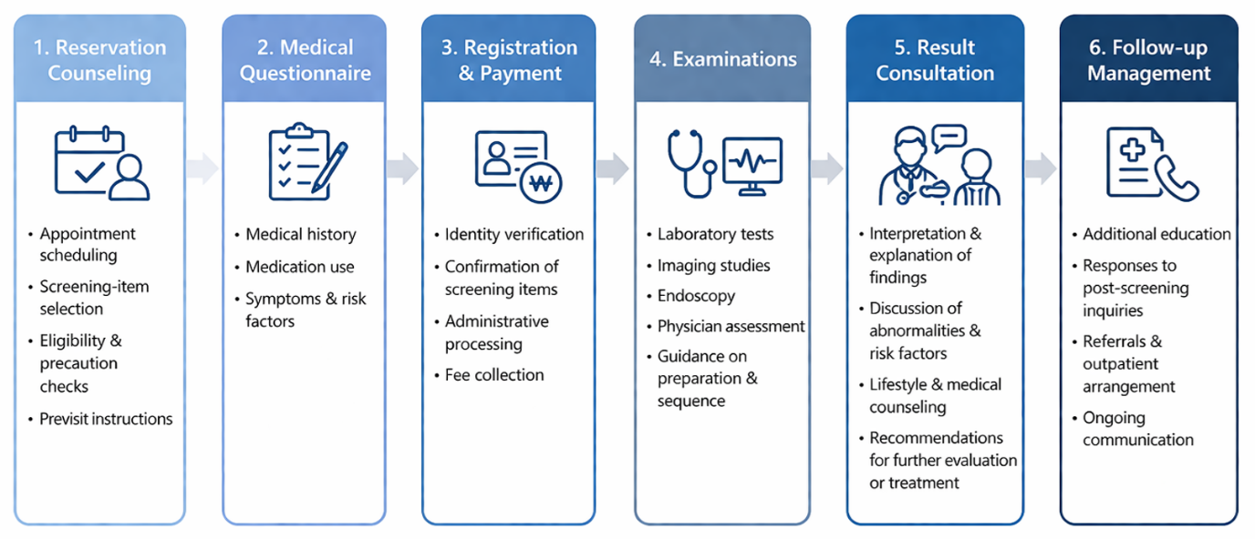
The comprehensive workflow of health screening services at Seoul National University Hospital Gangnam Center, organized into six sequential stages: (1) reservation counseling, (2) medical questionnaire completion, (3) registration and payment, (4) examinations, (5) result consultation, and (6) follow-up management. Each stage encompasses multiple operational tasks, including appointment scheduling, collection of clinical information, administrative processing, performance of diagnostic tests, interpretation and communication of results, and coordination of subsequent care.

Supplement 6. The characteristics of the respondents for user requirements survey
Q. What is your professional role or position?
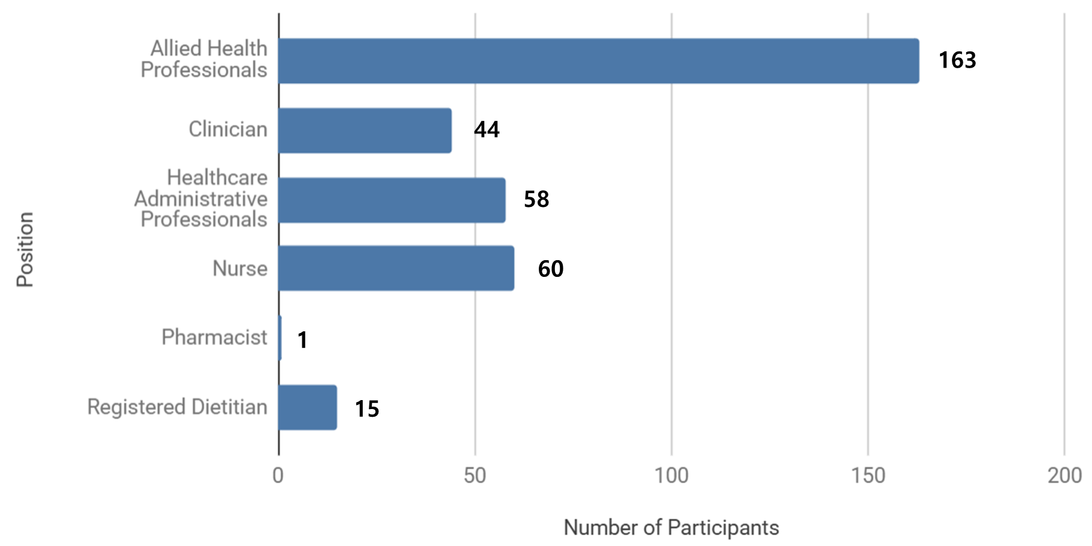
The respondents included 163 Allied Health Professionals; 60 Nurses; 58 Healthcare Administrative Professionals; 44 Clinician; 15 Registered Dietitian; and 1 Pharmacist.

Q. Please describe in detail the main tasks performed in your department or unit.
Task | Frequency
Patient Registration and Scheduling | 152
Administrative and Billing Services | 9
Diagnostic Examination | 17
Examination Support | 18
Result Processing and Reporting | 190
Clinical Consultation and Counseling | 73
Follow-up Care and Post-screening Management | 63
Clinical Support and Internal Operations | 13
Patient Guidance and Communication | 139

[Examples of Detailed Tasks by Work Domain Category]
Patient Registration and Scheduling : Health screening appointment booking and schedule management, screening registration and appointment handling, patient check-in, outpatient registration, reception
Administrative and Billing Services : Daily closing and billing, health insurance claim filing, health insurance claim review and filing, support for insurance claim submission, contract management
Diagnostic Examination : Imaging screening operations, radiology examinations, ultrasound, CT, and MRI screening operations, specimen collection support, oral examinations, women’s health examinations, physician-performed examinations and procedures
Examination Support : Examination assistance, general screening operations, test support
Result Processing and Reporting : Test result entry and management, result data entry, report preparation
Clinical Consultation and Counseling : Result counseling and clinical consultation, prescription, interview, screening report preparation
Follow-up Care and Post-screening Management : Post-screening management, follow-up guidance, re-examination guidance, mailing screening result reports and providing follow-up instructions, clinic appointment scheduling, post-test guidance
Clinical Support and Internal Operations : Medication management including controlled substances, nutrition assessment, specimen collection support, customer management, association publicity and social contribution activities
Patient Guidance and Communication : Pre- and post-screening instructions and inquiry handling, result counseling guidance, follow-up counseling guidance, screening brochure distribution

Q. How do you record the data generated from your tasks? (Select all that apply)

Response | Frequency
Automatically collected from examination equipment | 99
Manually documented on paper forms | 74
Manually entered into the electronic medical record (EMR) system | 271
Recorded as audio files | 35

The survey showed that data collection in health screening services remained heavily dependent on manual processes. The most common response was manual entry into the electronic medical record (EMR) system (n = 271), followed by automatic collection from examination equipment (n = 99), manual documentation on paper forms (n = 74), and recording as audio files (n = 35). Overall, these findings indicate that a substantial proportion of operational data are still recorded manually, either through direct EMR entry or paper-based documentation, rather than being captured automatically. This pattern suggests that personnel continue to rely on labor-intensive documentation workflows in routine practice.

Q. In what file formats are the collected data primarily stored?
Response | Frequency
Audio Data | 26
DICOM | 76
Document Data | 161
EHR Data | 122
Paper | 3
Spreadsheet Data | 92
The survey indicated that collected data were stored in a variety of heterogeneous formats, with a substantial proportion not readily structured for efficient database integration or retrieval. The most common format was document-based data (n = 161), followed by electronic health record (EHR) data (n = 122), spreadsheet data (n = 92), and DICOM imaging data (n = 76). Smaller proportions of data were stored as audio files (n = 26) and paper-based records (n = 3).
Overall, although structured formats such as EHR and spreadsheet data were present, a large share of data remained in semi-structured or unstructured forms, particularly document files and imaging data. These formats are less amenable to standardized database integration, systematic archiving, and efficient search, suggesting ongoing limitations in data accessibility and interoperability within current health screening service workflows.

Supplement 7.
Q. How do you think Generative AI would be helpful in the health screening service area?
1. Pre-Test Instruction and Preparation Optimization
- Providing clear and consistent pre-test instructions (eg, fasting, bowel preparation, medication restrictions)
- Delivering personalized preparation guidance based on scheduled tests
- Reducing missed or canceled examinations due to inadequate preparation
- Providing real-time access to preparation instructions via chatbot

2. Automated Test Result Interpretation and Summarization
- Automatically interpreting screening results and highlighting abnormal findings
- Summarizing key findings for easier understanding
- Providing basic clinical explanations of laboratory and imaging results
- Improving patient understanding of complex medical information

3. Personalized Screening and Recommendation Systems
- Recommending screening programs based on prior results, age, sex, and risk factors
- Integrating medical history, family history, and lifestyle factors
- Suggesting additional or follow-up tests based on abnormalities
- Generating individualized screening pathways

4. Longitudinal Data Integration and Comparative Analysis
- Comparing current and previous screening results
- Identifying changes, trends, and disease progression
- Aggregating historical data for comprehensive interpretation
- Supporting continuity of care through longitudinal insights

5. Follow-Up Management and Preventive Care Guidance
- Providing re-examination recommendations and intervals
- Supporting post-screening management plans
- Delivering preventive care guidance and health maintenance strategies
- Alerting patients to missed or overdue follow-up

6. Patient Communication and Inquiry Automation
- Providing instant responses to frequently asked questions
- Reducing telephone inquiries and administrative burden
- Enabling 24/7 patient interaction through chatbot systems
- Improving accessibility for elderly or digitally vulnerable populations

7. Workflow Efficiency and Automation of Repetitive Tasks
- Automating repetitive communication and administrative tasks
- Reducing workload and staff fatigue
- Improving operational efficiency and reducing processing time
- Minimizing human error in routine workflows

8. Clinical Documentation and Data Processing Support
- Converting voice inputs into structured clinical documentation (voice-to-text EMR)
- Automating report generation and structured data entry
- Detecting missing or incorrect entries
- Supporting questionnaire completion and data validation

9. Scheduling, Navigation, and Operational Support
- Assisting with appointment scheduling and availability checking
- Providing visit flow guidance and expected waiting times
- Optimizing patient flow and reducing congestion
- Supporting automated notifications and reminders

10. Health Education and Decision Support for Patients
- Providing understandable explanations of diseases and risk factors
- Supporting lifestyle modification guidance
- Delivering vaccination and preventive care information
- Enhancing patient engagement and self-management
Supplement 8. Free-Text Suggestions for AI Chatbot Development (n=192)
1. Role of AI: Support, Not Replacement
- AI should function as a support tool rather than replacing clinicians
- Maintain a human-in-the-loop model for validation and final decision-making
- Use AI primarily for low-risk, repetitive, and standardized tasks
- Clearly define boundaries between AI and human responsibilities

2. Automation of Repetitive Tasks
- Automate repetitive administrative and communication tasks
- Reduce workload by handling routine explanations and FAQs
- Replace repetitive instructions (e.g., bowel preparation, fasting guidance)
- Automate data entry, document handling, and form processing
- Reduce manual paperwork and enable full digital workflows

3. Patient Guidance and Navigation
- Provide step-by-step navigation during the screening process
- Inform patients about remaining tests and next steps
- Offer real-time updates on waiting times
- Provide clear explanations of procedures and precautions
- Support end-to-end patient journey (pre-, during-, post-screening)

4. Result Interpretation and Follow-Up
- Deliver patient-friendly explanations of screening results
- Provide summary-level interpretations before physician consultation
- Support follow-up management (e.g., re-examination scheduling)
- Track abnormal findings and prevent missed follow-ups
- Enable post-consultation Q&A support

5. Personalization and Data Utilization
- Provide personalized screening recommendations based on medical history
- Utilize past examination data for decision support
- Offer individualized lifestyle and health recommendations
- Improve contextual understanding beyond keyword-based responses

6. Communication and Customer Experience
- Improve consistency and standardization of patient communication
- Reduce miscommunication and variability across staff
- Provide quick and accessible responses to patient inquiries
- Enable smooth transition to human staff when necessary
- Improve overall patient satisfaction and convenience

7. System Integration and Workflow Optimization
- Integrate with EMR and hospital information systems
- Enable automatic retrieval of past patient records
- Support cross-department coordination
- Improve workflow efficiency and reduce bottlenecks
- Provide centralized knowledge access for staff

8. Error Reduction and Quality Control
- Reduce human errors in repetitive processes
- Detect missing steps or incomplete tasks
- Identify data inconsistencies or abnormal findings
- Improve quality assurance through standardized processes

9. Usability and Accessibility
- Ensure simple, intuitive, and user-friendly interface design
- Provide elderly-friendly accessibility features
- Support multiple input modes (text, button-based, voice)
- Allow customization based on user needs and workflow

10. Implementation Strategy and System Development
- Start with pilot use cases (e.g., administrative tasks)
- Expand gradually with continuous updates and improvements
- Ensure high-quality algorithms before full deployment
- Develop robust data governance and security frameworks
- Incorporate feedback mechanisms for continuous refinement

