Supplementary Material
Antioxidant strategies of four native tree species across seasons in urban and peri-urban Atlantic Forest remnants
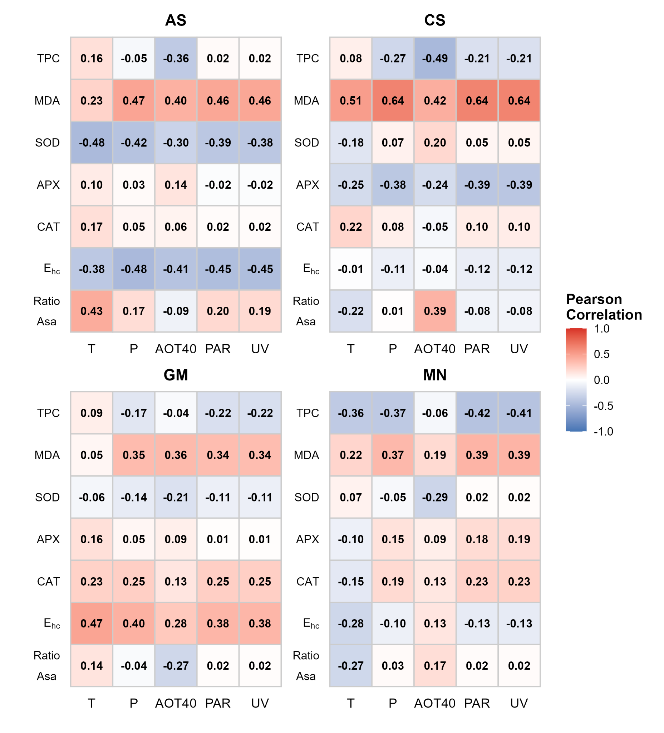
Figure S1. Heatmaps of Pearson correlation coefficients (r) relating leaf biochemical markers to environmental drivers for four native Atlantic Forest tree species. The color scale indicates the strength and direction of the linear relationship: red represents positive correlations (values approaching 1), while blue indicates negative correlations (values approaching -1). AS, Alchornea sidifolia; CS, Casearia sylvestris; GM, Guarea macrophylla; MN, Machaerium nyctitans. MDA, malondialdehyde; TPC: total phenolic compounds; SOD, superoxide dismutase; APX, ascorbate peroxidase; CAT, catalase; Glutathione half-cell reduction potential (E_{hc}); RatioAsA, ascorbate redox state. T, temperature; P, precipitation. AOT40, accumulated ozone exposure over a threshold of 40 ppb; PAR, photosynthetically active radiation; UV, ultraviolet radiation index.
Table S1. Influence of site and season on reduced ascorbate (AsA) levels in Alchornea sidifolia (AS), Casearia sylvestris (CS), Guarea macrophylla (GM), and Machaerium nyctitans (MN). Values indicate the Akaike Information Criterion (AIC) and significance values (p-values) derived from Linear (LM) and Generalized Linear Models (GLM).
Species | Model (family; link) | Formula (structure) | AIC | p-values
AS | LM (Gaussian; identity) | AsA ~ Site + Season | 90.704 | Site = 0.005; Season = 0.057
CS | GLM (Gamma; log) | AsA ~ Site * Season | −31.739 | Site < 0.001; Season < 0.001; Site×Season = 0.017
GM | LM (Gaussian; identity) | AsA ~ Site * Season | −125.33 | Site = 0.001; Season < 0.001; Site×Season = 0.030
MN | LM (Gaussian; identity) | AsA ~ Site + Season | −113.98 | Site < 0.001; Season = 0.141

Table S2. Model-predicted reduced ascorbate (AsA) levels in leaves of Alchornea sidifolia (AS), Casearia sylvestris (CS), Guarea macrophylla (GM), and Machaerium nyctitans (MN) across site × season combinations. Values are fitted means derived from the best-supported model selected separately for each species (Table S1). RMG, Morro Grande Forest Reserve; Matão-IAG, Biosciences Institute Forest Reserve. Values are expressed as µmol g⁻¹ fresh mass (FM).
Species | RMG Dry | Matão-IAG Dry | RMG Rainy | Matão-IAG Rainy
AS | 4.21 | 2.56 | 5.34 | 3.68
CS | 1.3 | 0.068 | 0.165 | 0.044
GM | 0.056 | 0.038 | 0.034 | 0.03
MN | 0.085 | 0.056 | 0.074 | 0.046

Table S3. Influence of site and season on dehydroascorbate (DHA) levels in Alchornea sidifolia (AS), Casearia sylvestris (CS), Guarea macrophylla (GM), and Machaerium nyctitans (MN). Values indicate the Akaike Information Criterion (AIC) and significance values (p-values) derived from Linear (LM) and Generalized Linear Models (GLM).
Species | Model (family; link) | Formula (structure) | AIC | p-values
AS | LM (Gaussian; identity) | DHA ~ 1 (null) | 1.059 | —
CS | GLM (Gamma; log) | DHA ~ Site + Season | −111.23 | Site < 0.001; Season < 0.001
GM | GLM (Gamma; log) | DHA ~ Site | −115.03 | Site = 0.053
MN | GLM (Gamma; log) | DHA ~ Site | −105.55 | Site = 0.006

Table S4. Model-predicted dehydroascorbate (DHA) levels in leaves of Alchornea sidifolia (AS), Casearia sylvestris (CS), Guarea macrophylla (GM), and Machaerium nyctitans (MN) across site × season combinations. Values are fitted means derived from the best-supported model selected separately for each species (Table S3). RMG, Morro Grande Forest Reserve; Matão-IAG, Biosciences Institute Forest Reserve. Values are expressed as µmol g⁻¹ fresh mass (FM).
Species | RMG Dry | Matão-IAG Dry | RMG Rainy | Matão-IAG Rainy
AS | 0.506 | 0.506 | 0.506 | 0.506
CS | 0.279 | 0.007 | 0.091 | 0.0023
GM | 0.011 | 0.034 | 0.011 | 0.034
MN | 0.057 | 0.015 | 0.057 | 0.015

Table S5. Influence of site and season on total ascorbate (TotalAsA) levels in Alchornea sidifolia (AS), Casearia sylvestris (CS), Guarea macrophylla (GM), and Machaerium nyctitans (MN). Values indicate the Akaike Information Criterion (AIC) and significance values (p-values) derived from Linear (LM) and Generalized Linear Models (GLM).
Species | Model (family; link) | Formula (structure) | AIC | p-values
AS | LM (Gaussian; identity) | TotalAsA ~ Site + Season | 91.928 | Site = 0.005; Season = 0.052
CS | GLM (Gamma; log) | TotalAsA ~ Site * Season | −23.487 | Site < 0.001; Season < 0.001; Site×Season = 0.031
GM | LM (Gaussian; identity) | TotalAsA ~ Season | −87.437 | Season = 0.016
MN | GLM (Gamma; log) | TotalAsA ~ Site + Season | −77.279 | Site < 0.001; Season = 0.122

Table S6. Model-predicted total ascorbate (TotalAsA) levels in leaves of Alchornea sidifolia (AS), Casearia sylvestris (CS), Guarea macrophylla (GM), and Machaerium nyctitans (MN) across site × season combinations. Values are fitted means derived from the best-supported model selected separately for each species (Table S5). RMG, Morro Grande Forest Reserve; Matão-IAG, Biosciences Institute Forest Reserve. Values are expressed as µmol g⁻¹ fresh mass (FM).
Species | RMG Dry | Matão-IAG Dry | RMG Rainy | Matão-IAG Rainy
AS | 4.72 | 2.99 | 5.9 | 4.17
CS | 1.55 | 0.075 | 0.265 | 0.047
GM | 0.071 | 0.071 | 0.044 | 0.044
MN | 0.152 | 0.068 | 0.113 | 0.05

Table S7. Influence of site and season on the reduced ascorbate ratio (RatioAsA) in Alchornea sidifolia (AS), Casearia sylvestris (CS), Guarea macrophylla (GM), and Machaerium nyctitans (MN). Values indicate the Akaike Information Criterion (AIC) and significance values (p-values) derived from Linear (LM) and Generalized Linear Models (GLM).
Species | Model (family; link) | Formula (structure) | AIC | p-values
AS | LM (Gaussian; identity) | RatioAsA ~ Site + Season | −70.989 | Site = 0.167; Season = 0.130
CS | LM (Gaussian; identity) | RatioAsA ~ Site | −19.093 | Site = < 0.001
GM | LM (Gaussian; identity) | RatioAsA ~ Site | −5.917 | Site = 0.073
MN | LM (Gaussian; identity) | RatioAsA ~ 1 (null) | −6.666 | —

Table S8. Influence of site and season on reduced glutathione (GSH) levels in Alchornea sidifolia (AS), Casearia sylvestris (CS), Guarea macrophylla (GM), and Machaerium nyctitans (MN). Values indicate the Akaike Information Criterion (AIC) and significance values (p-values) derived from Linear (LM) and Generalized Linear Models (GLM).
Species | Model (family; link) | Formula (structure) | AIC | p-values (Type II)
AS | LM (Gaussian; identity) | GSH ~ Season | 30.067 | Season = 0.145
CS | LM (Gaussian; identity) | GSH ~ Site * Season | −12.842 | Site = 0.213; Season < 0.001; Site×Season = 0.015
GM | GLM (Gamma; log) | GSH ~ Season | 48.307 | Season < 0.001
MN | GLM (Gamma; log) | GSH ~ Site | −9.917 | Site = 0.082

Table S9. Model-predicted reduced glutathione (GSH) levels in leaves of Alchornea sidifolia (AS), Casearia sylvestris (CS), Guarea macrophylla (GM), and Machaerium nyctitans (MN) across site × season combinations. Values are fitted means derived from the best-supported model selected separately for each species (Table S8). RMG, Morro Grande Forest Reserve; Matão-IAG, Biosciences Institute Forest Reserve. Values are expressed as µmol g⁻¹ fresh mass (FM).
Species | RMG Dry | Matão-IAG Dry | RMG Rainy | Matão-IAG Rainy
AS | 1.58 | 1.58 | 1.33 | 1.33
CS | 0.542 | 0.616 | 0.47 | 0.212
GM | 2.21 | 2.21 | 0.48 | 0.48
MN | 0.439 | 0.27 | 0.439 | 0.27

Table S10. Influence of site and season on oxidized glutathione (GSSG) levels in Alchornea sidifolia (AS), Casearia sylvestris (CS), Guarea macrophylla (GM), and Machaerium nyctitans (MN). Values indicate the Akaike Information Criterion (AIC) and significance values (p-values) derived from Linear (LM) and Generalized Linear Models (GLM).
Species | Model (family; link) | Formula (structure) | AIC | p-values
AS | GLM (Gamma; log) | GSSG ~ Site + Season | −80.483 | Site = 0.150; Season = 0.003
CS | GLM (Gamma; log) | GSSG ~ Site * Season | −134.800 | Site = 0.243; Season < 0.001; Site×Season = 0.002
GM | GLM (Gamma; log) | GSSG ~ Site + Season | −41.151 | Site = 0.087; Season = 0.023
MN | LM (Gaussian; identity) | GSSG ~ Site * Season | −52.181 | Site = 0.146; Season = 0.082; Site×Season = 0.001

Table S11. Model-predicted oxidized glutathione (GSSG) levels in leaves of Alchornea sidifolia (AS), Casearia sylvestris (CS), Guarea macrophylla (GM), and Machaerium nyctitans (MN) across site × season combinations. Values are fitted means derived from the best-supported model selected separately for each species (Table S10). RMG, Morro Grande Forest Reserve; Matão-IAG, Biosciences Institute Forest Reserve. Values are expressed as µmol g⁻¹ fresh mass (FM).
Species | RMG Dry | Matão-IAG Dry | RMG Rainy | Matão-IAG Rainy
AS | 0.136 | 0.096 | 0.066 | 0.046
CS | 0.027 | 0.04 | 0.014 | 0.004
GM | 0.262 | 0.14 | 0.112 | 0.06
MN | 0.063 | 0.195 | 0.103 | 0.045

Table S12. Influence of site and season on total glutathione (TotalGSH) levels in Alchornea sidifolia (AS), Casearia sylvestris (CS), Guarea macrophylla (GM), and Machaerium nyctitans (MN). Values indicate the Akaike Information Criterion (AIC) and significance values (p-values) derived from Linear (LM) and Generalized Linear Models (GLM).
Species | Model (family; link) | Formula (structure) | AIC | p-values
AS | LM (Gaussian; identity) | TotalGSH ~ Season | 30.808 | Season = 0.078
CS | GLM (Gamma; log) | TotalGSH ~ Site * Season | −17.817 | Site = 0.019; Season < 0.001; Site×Season < 0.001
GM | GLM (Gamma; log) | TotalGSH ~ Season | 51.456 | Season < 0.001
MN | GLM (Gamma; log) | TotalGSH ~ Site * Season | −1.410 | Site = 0.611; Season = 0.726; Site×Season = 0.004

Table S13. Model-predicted total glutathione (TotalGSH) levels in leaves of Alchornea sidifolia (AS), Casearia sylvestris (CS), Guarea macrophylla (GM), and Machaerium nyctitans (MN) across site × season combinations. Values are fitted means derived from the best-supported model selected separately for each species (Table S12). RMG, Morro Grande Forest Reserve; Matão-IAG, Biosciences Institute Forest Reserve. Values are expressed as µmol g⁻¹ fresh mass (FM).
Species | RMG Dry | Matão-IAG Dry | RMG Rainy | Matão-IAG Rainy
AS | 1.69 | 1.69 | 1.39 | 1.39
CS | 0.569 | 0.655 | 0.501 | 0.216
GM | 2.4 | 2.4 | 0.56 | 0.56
MN | 0.378 | 0.598 | 0.619 | 0.288

Table S14. Influence of site and season on glutathione half-cell reduction potential (E_{hc}) in Alchornea sidifolia (AS), Casearia sylvestris (CS), Guarea macrophylla (GM), and Machaerium nyctitans (MN). Values indicate the Akaike Information Criterion (AIC) and significance values (p-values) derived from Linear (LM) and Generalized Linear Models (GLM).
Species | Model (family; link) | Formula (structure) | AIC | p-values
AS | LM (Gaussian; identity) | E_{hc} ~ Season | 185.380 | Season = 0.152
CS | LM (Gaussian; identity) | E_{hc} ~ 1 (null) | 193.880 | —
GM | LM (Gaussian; identity) | E_{hc} ~ Season | 188.410 | Season = 0.059
MN | LM (Gaussian; identity) | E_{hc} ~ 1 (null) | 208.920 | —

Table S15. Influence of site and season on total phenolic content (TPC) in Alchornea sidifolia (AS), Casearia sylvestris (CS), Guarea macrophylla (GM), and Machaerium nyctitans (MN). Values indicate the Akaike Information Criterion (AIC) and significance values (p-values) derived from Linear (LM) and Generalized Linear Models (GLM).
Species | Model (family; link) | Formula (structure) | AIC | p-values
AS | LM (Gaussian; identity) | TPC ~ Site | 166.39 | Site = 0.001
CS | GLM (Gamma; log) | TPC ~ Site + Season | 99.894 | Site = 0.010; Season = 0.143
GM | LM (Gaussian; identity) | TPC ~ 1 (null) | 66.59 | —
MN | LM (Gaussian; identity) | TPC ~ Site + Season | 118.21 | Site = 0.106; Season = 0.019

Table S16. Influence of site and season on superoxide dismutase (SOD) activity in Alchornea sidifolia (AS), Casearia sylvestris (CS), Guarea macrophylla (GM), and Machaerium nyctitans (MN). Values indicate the Akaike Information Criterion (AIC) and significance values (p-values) derived from Linear (LM) and Generalized Linear Models (GLM).
Species | Model (family; link) | Formula (structure) | AIC | p-values
AS | LM (Gaussian; identity) | SOD ~ 1 (null) | 444.49 | —
CS | LM (Gaussian; identity) | SOD ~ 1 (null) | 381.67 | —
GM | LM (Gaussian; identity) | SOD ~ Season | 324.32 | Season = 0.096
MN | GLM (Gamma; log) | SOD ~ Site | 372.48 | Site = 0.044

Table S17. Influence of site and season on catalase (CAT) activity in Alchornea sidifolia (AS), Casearia sylvestris (CS), Guarea macrophylla (GM), and Machaerium nyctitans (MN). Values indicate the Akaike Information Criterion (AIC) and significance values (p-values) derived from Linear (LM) and Generalized Linear Models (GLM).
Species | Model (family; link) | Formula (structure) | AIC | p-values
AS | LM (Gaussian; identity) | CAT ~ 1 (null) | 215.64 | —
CS | GLM (Gamma; log) | CAT ~ 1 (null) | 210.42 | —
GM | LM (Gaussian; identity) | CAT ~ Site * Season | 189.68 | Site = 0.502; Season = 0.042; Site×Season = 0.068
MN | GLM (Gamma; log) | CAT ~ Site * Season | 227.13 | Site = 0.399; Season = 0.011; Site×Season = < 0.001

Table S18. Influence of site and season on ascorbate peroxidase (APX) activity in Alchornea sidifolia (AS), Casearia sylvestris (CS), Guarea macrophylla (GM), and Machaerium nyctitans (MN). Values indicate the Akaike Information Criterion (AIC) and significance values (p-values) derived from Linear (LM) and Generalized Linear Models (GLM).
Species | Model (family; link) | Formula (structure) | AIC | p-values
AS | LM (Gaussian; identity) | APX ~ Site * Season | 387.47 | Site = 0.165; Season = 0.435; Site×Season = 0.026
CS | GLM (Gamma; log) | APX ~ Season | 378.77 | Season = 0.006
GM | LM (Gaussian; identity) | APX ~ 1 (null) | 360.82 | —
MN | GLM (Gamma; log) | APX ~ 1 (null) | 421.36 | —

Table S19. Influence of site and season on malondialdehyde (MDA) levels in Alchornea sidifolia (AS), Casearia sylvestris (CS), Guarea macrophylla (GM), and Machaerium nyctitans (MN). Values indicate the Akaike Information Criterion (AIC) and significance values (p-values) derived from Linear (LM) and Generalized Linear Models (GLM).
Species | Model (family; link) | Formula (structure) | AIC | p-values (Type II)
AS | GLM (Gamma; log) | MDA ~ Season | 229.78 | Season < 0.001
CS | LM (Gaussian; identity) | MDA ~ Season | 224.74 | Season < 0.001
GM | LM (Gaussian; identity) | MDA ~ Season | 211.93 | Season = 0.103
MN | GLM (Gamma; log) | MDA ~ Season | 229.91 | Season = 0.001

