Supplemental Information

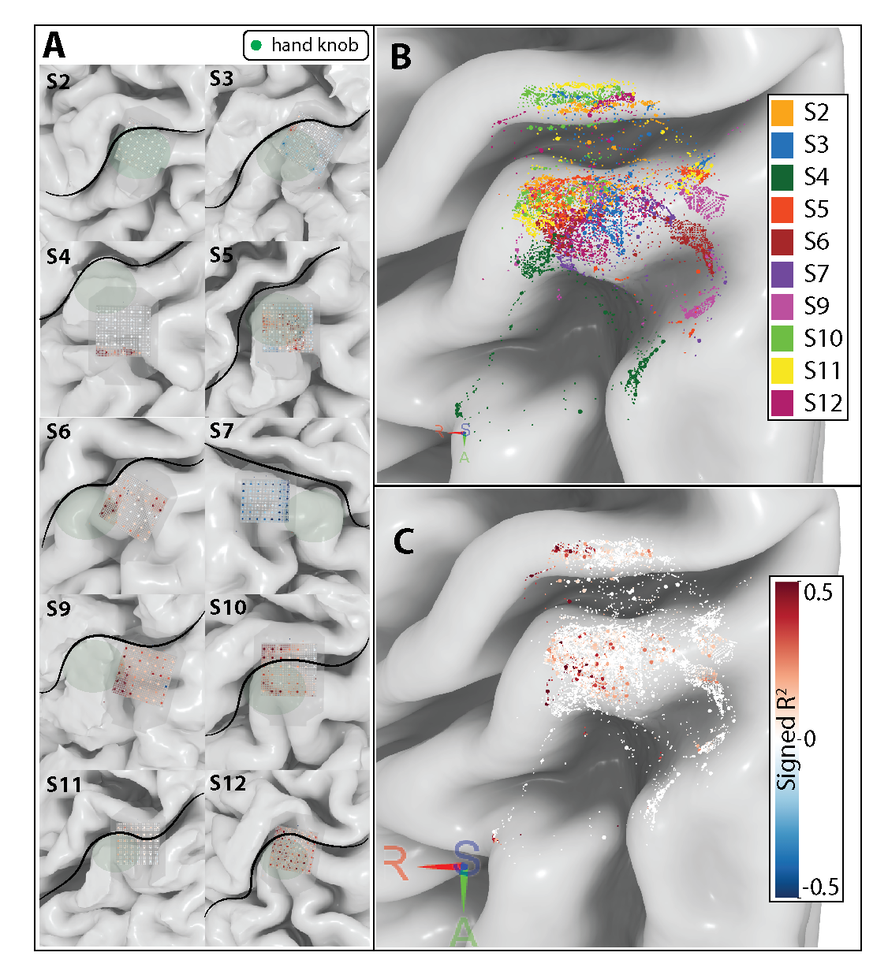
Supplemental Fig. 1. Individual patient electrodes were mapped onto their native brain surface using an intraoperative CT coregistered to the preoperative MRI. The hdMEA has three radiopaque fiducials that were used to map to patient anatomy using the YAEL software on RAVE. Individual electrode values in dB change from baseline were represented on a color map from -1 to 1. Individual channels were then mapped to the “fsaverage” brain (Panel B) and the effect size for changes between movement and rest were plotted in the common mapped electrodes.
Supplemental Fig. 2. Velocity curves and chosen baseline periods for the isolated joint paradigm for participants 4, 6, 9, 10, 12.
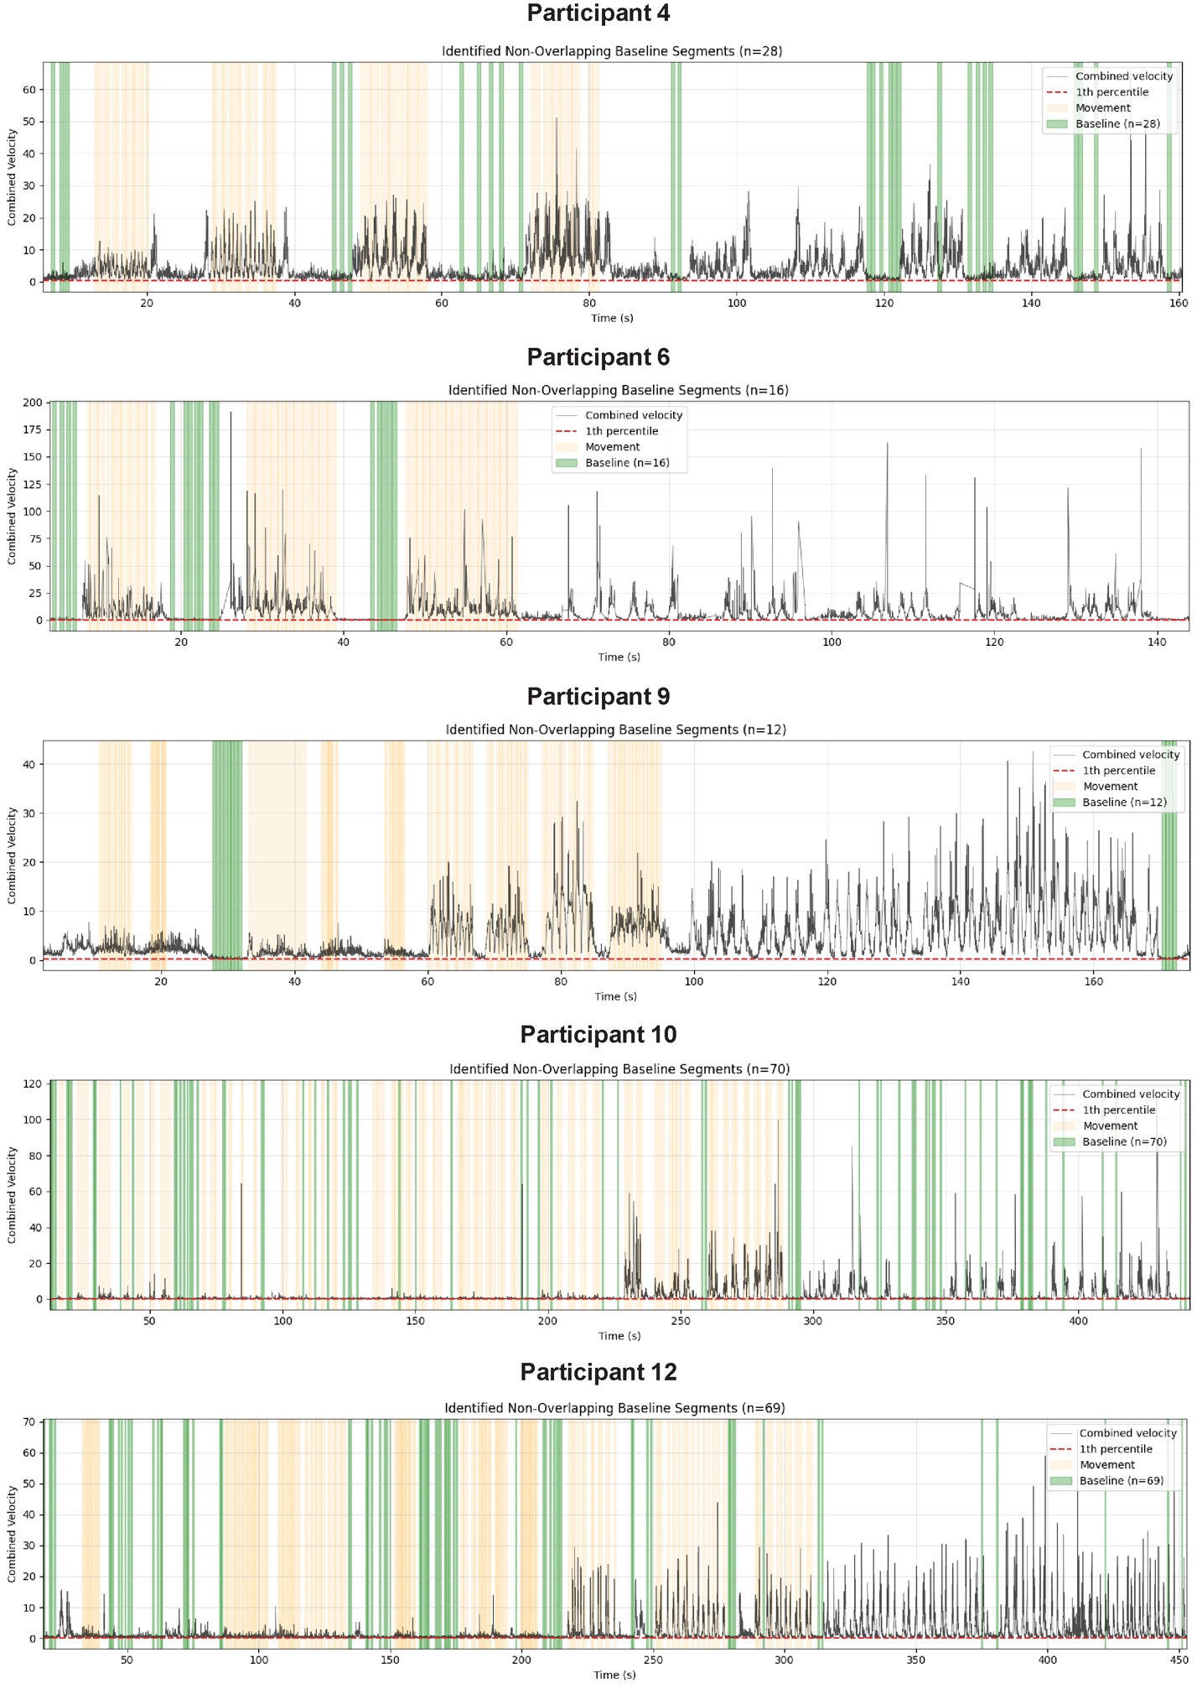
Supplemental Fig. 3. For participants 4, 6, 9, 10 and 12: dB changes between movement and rest related to each joint mobilization.
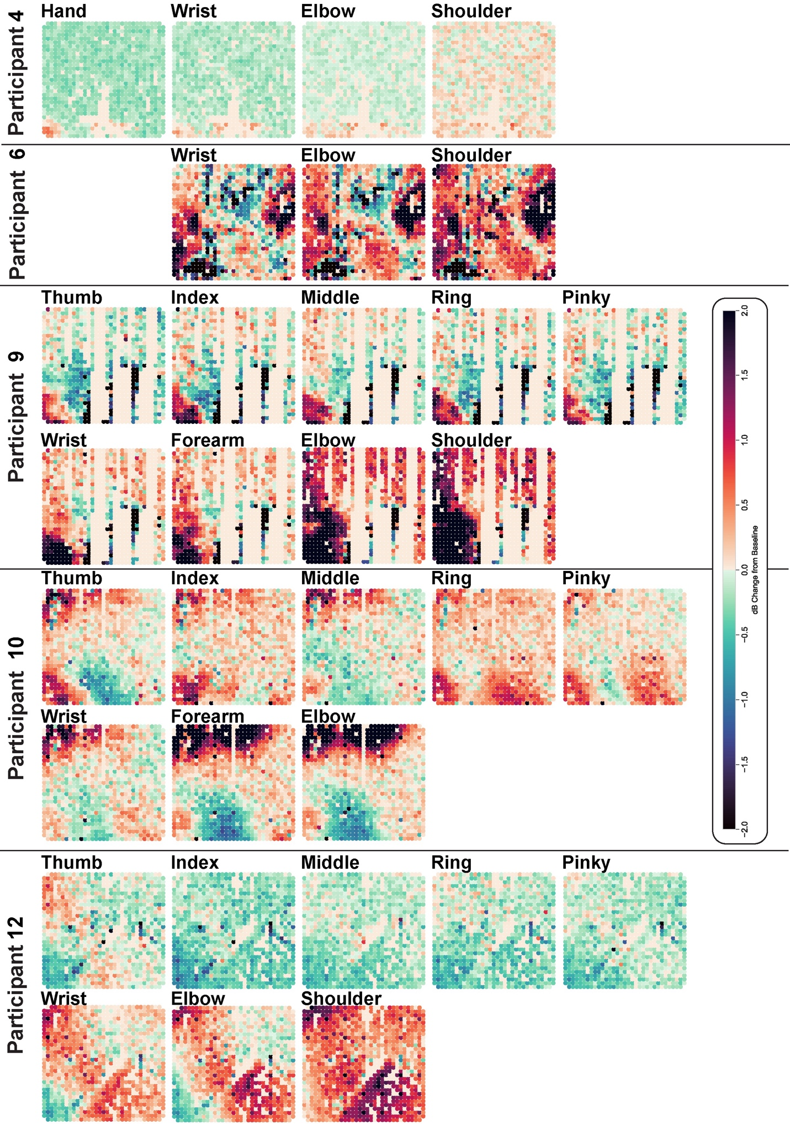
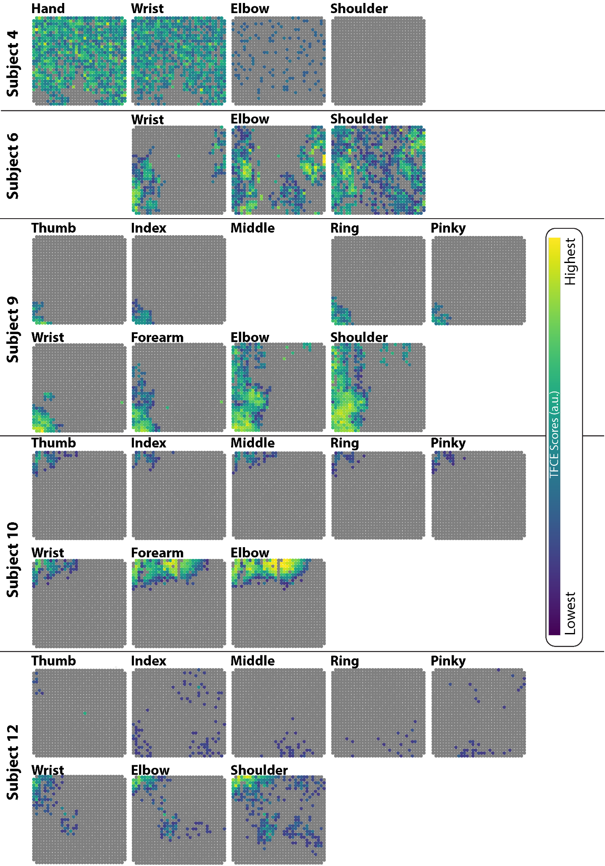
Supplemental Fig. 4. For participants 4, 6, 9, 10 and 12: TFCE scores between movement and rest related to each joint mobilization
Supplemental Fig. 5. For participants 4, 6, 9, 10 and 12: signed R² between movement and rest related to each joint mobilization.
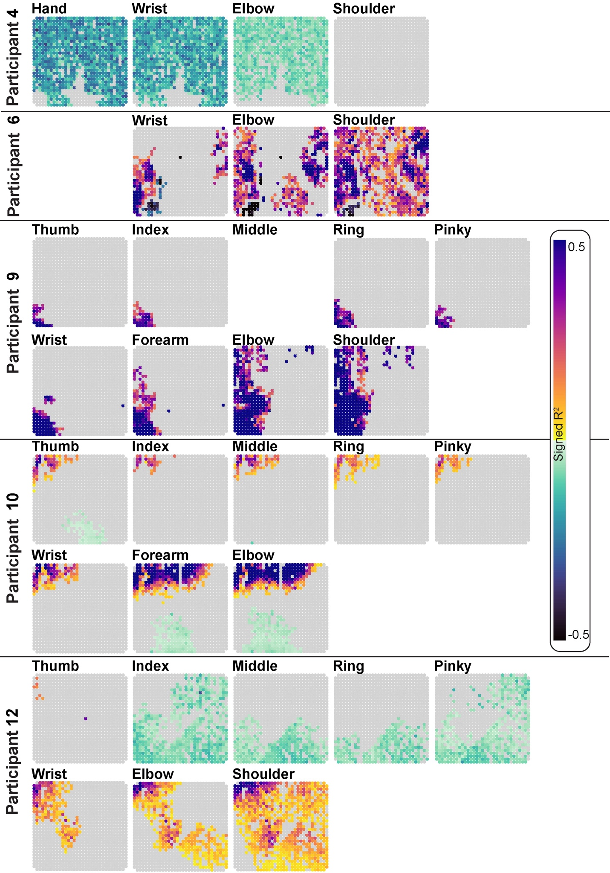
Supplemental Fig. 6. Coverage map of the brain surface in the normative surface brain (“fsaverage”) with M1 and S1 being outlined as the precentral and postcentral gyri, respectively.
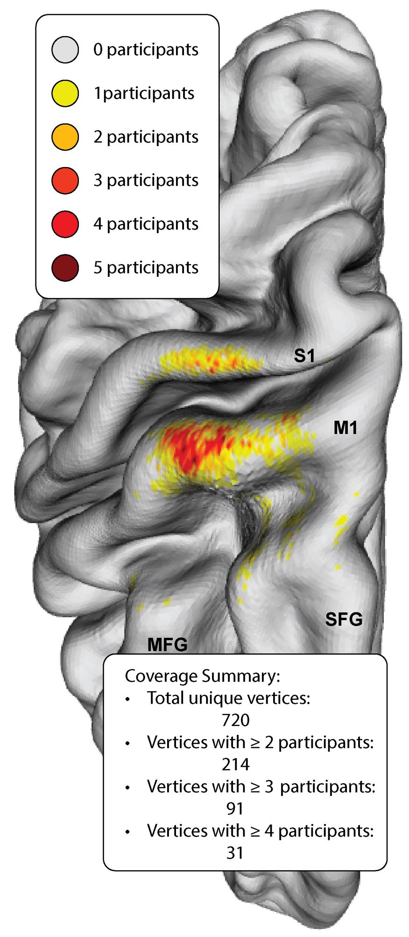
Supplemental Fig. 7. Velocity curves per trials for each participant for trials included and excluded due to excessive movement in the baseline and immediate post-movement periods.
