Supplementary information

Additional results
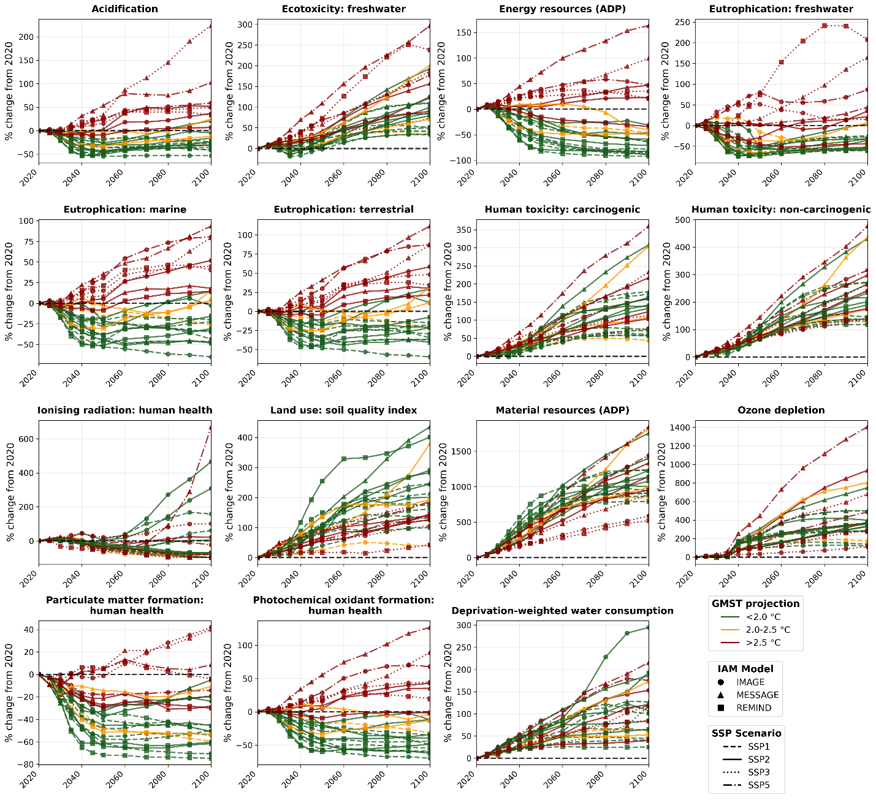
Figure SI1 | Annual environmental impacts of global final energy provision across climate mitigation pathways. Percentage change in annual impacts relative to 2020, from 2020 to 2100, across EF3.1 environmental indicators and 24 mitigation pathways. The horizontal dashed line marks zero change relative to the 2020 baseline. Colours indicate end-of-century global mean surface temperature (GMST) outcomes, with dark green for less than 2.0 degrees Celsius, orange for 2.0 to 2.5 degrees Celsius, and dark red for more than 2.5 degrees Celsius. Marker shapes denote models, with circles for IMAGE, triangles for MESSAGE, and squares for REMIND. Line styles represent Shared Socioeconomic Pathways (SSP), with dashed lines for SSP1, solid lines for SSP2, dotted lines for SSP3, and dash-dot lines for SSP5. All values are shown for the global aggregate.

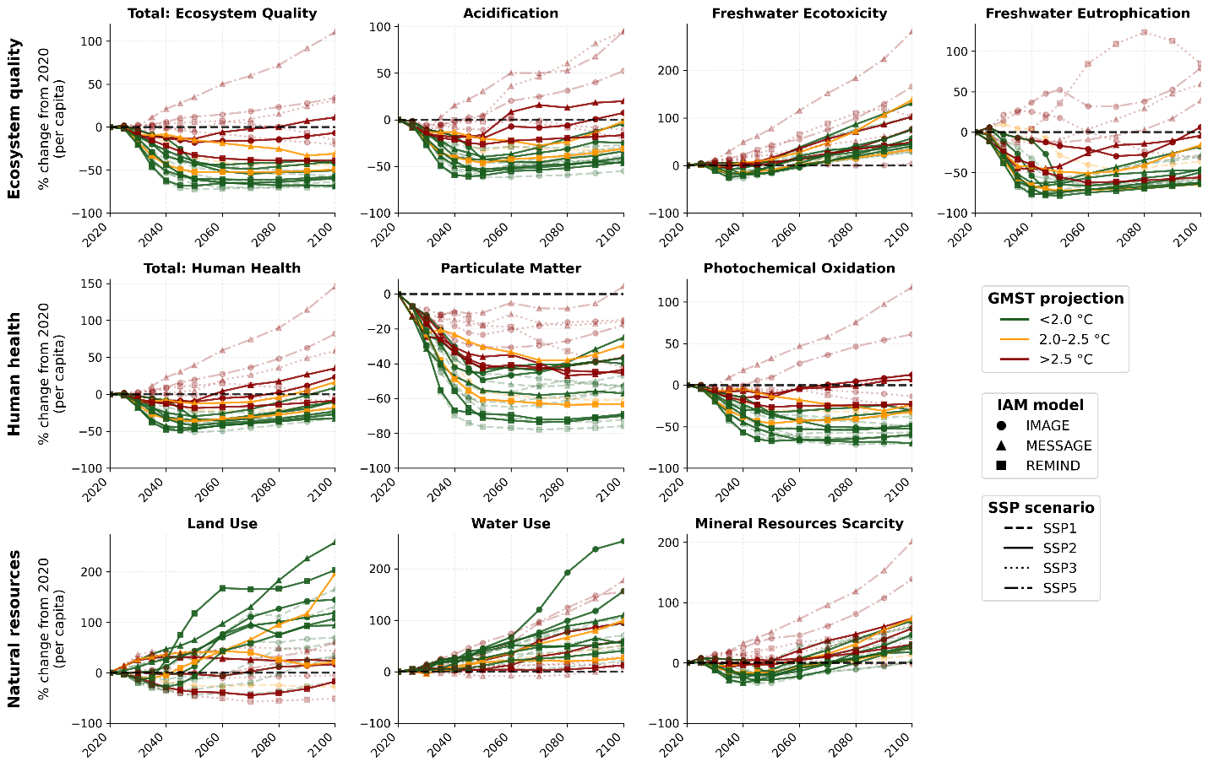
Figure SI2 | Per-capita annual environmental impacts of global final energy provision across climate mitigation pathways. Percentage change in annual per-capita impacts relative to 2020, from 2020 to 2100, across ten environmental indicators and 24 mitigation pathways. Per-capita values are obtained by dividing global aggregate impacts by the scenario-specific global population projected by each IAM for each pathway and year. Panels are organised by area of protection: ecosystem quality (total ecosystem quality in local species loss over time, acidification, freshwater ecotoxicity, freshwater eutrophication), human health (total human health in DALYs, particulate matter formation, photochemical ozone formation), and natural resources (land use, freshwater use, scarcity-weighted mineral resource use). The horizontal dashed line marks zero change relative to the 2020 baseline. Colours indicate end-of-century global mean surface temperature (GMST) outcomes, marker shapes denote IAM models, and line styles represent SSP scenarios, all as in Fig. SI1, with SSP2 scenarios emphasised with higher opacity.

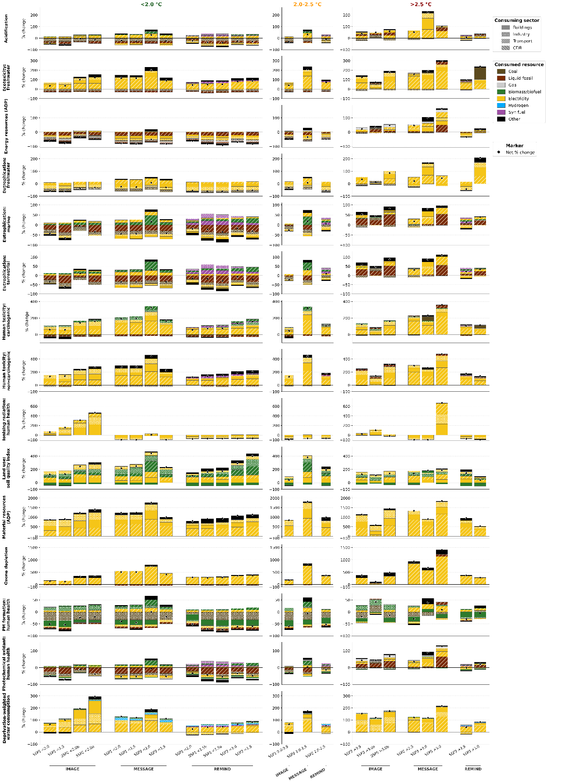
Figure SI3 | Sectoral and energy supply alternative contributions to changes in environmental impacts by 2100. Stacked bar charts show the relative contribution of consuming sectors and energy supply options to the change in EF3.1 impact categories between 2020 and 2100. Environmental indicators include ‘Total: Ecosystem Quality’, ‘Total: human health’, ‘Freshwater Ecotoxicity’, ‘Land use’, and ‘Water use’. Values are expressed as percentage change relative to the total 2020 impacts. Bars are grouped by end-of-century global mean surface temperature (GMST) outcome, with columns representing pathways below 2.0 degrees Celsius, between 2.0 and 2.5 degrees Celsius, and above 2.5 degrees Celsius. Within each column, pathways are grouped by Integrated Assessment Model (IAM) and Shared Socioeconomic Pathway (SSP). Colours indicate energy supply options, hatching denotes consuming sectors, and diamond markers represent the net change in total impacts for each pathway. Only the main contributing sector and option combinations are shown explicitly, with remaining contributions aggregated as ‘Other’.
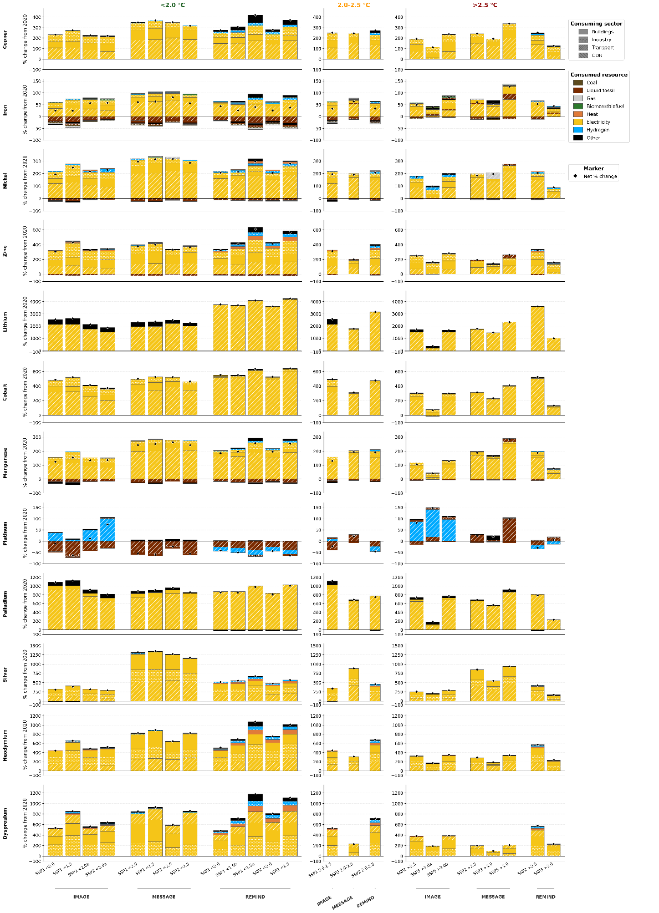
Figure SI4 | Sectoral and energy supply alternative contributions to changes in primary metal extraction by 2050. Stacked bar charts show the relative contribution of consuming sectors and energy supply options to the change in primary metal extraction between 2020 and 2050. Values are expressed as percentage change relative to the total 2020 values. Bars are grouped by end-of-century global mean surface temperature (GMST) outcome, with columns representing pathways below 2.0 degrees Celsius, between 2.0 and 2.5 degrees Celsius, and above 2.5 degrees Celsius. Within each column, pathways are grouped by Integrated Assessment Model (IAM) and Shared Socioeconomic Pathway (SSP). Colours indicate energy supply options, hatching denotes consuming sectors, and diamond markers represent the net change in total impacts for each pathway. Only the main contributing sector and option combinations are shown explicitly, with remaining contributions aggregated as ‘Other’.
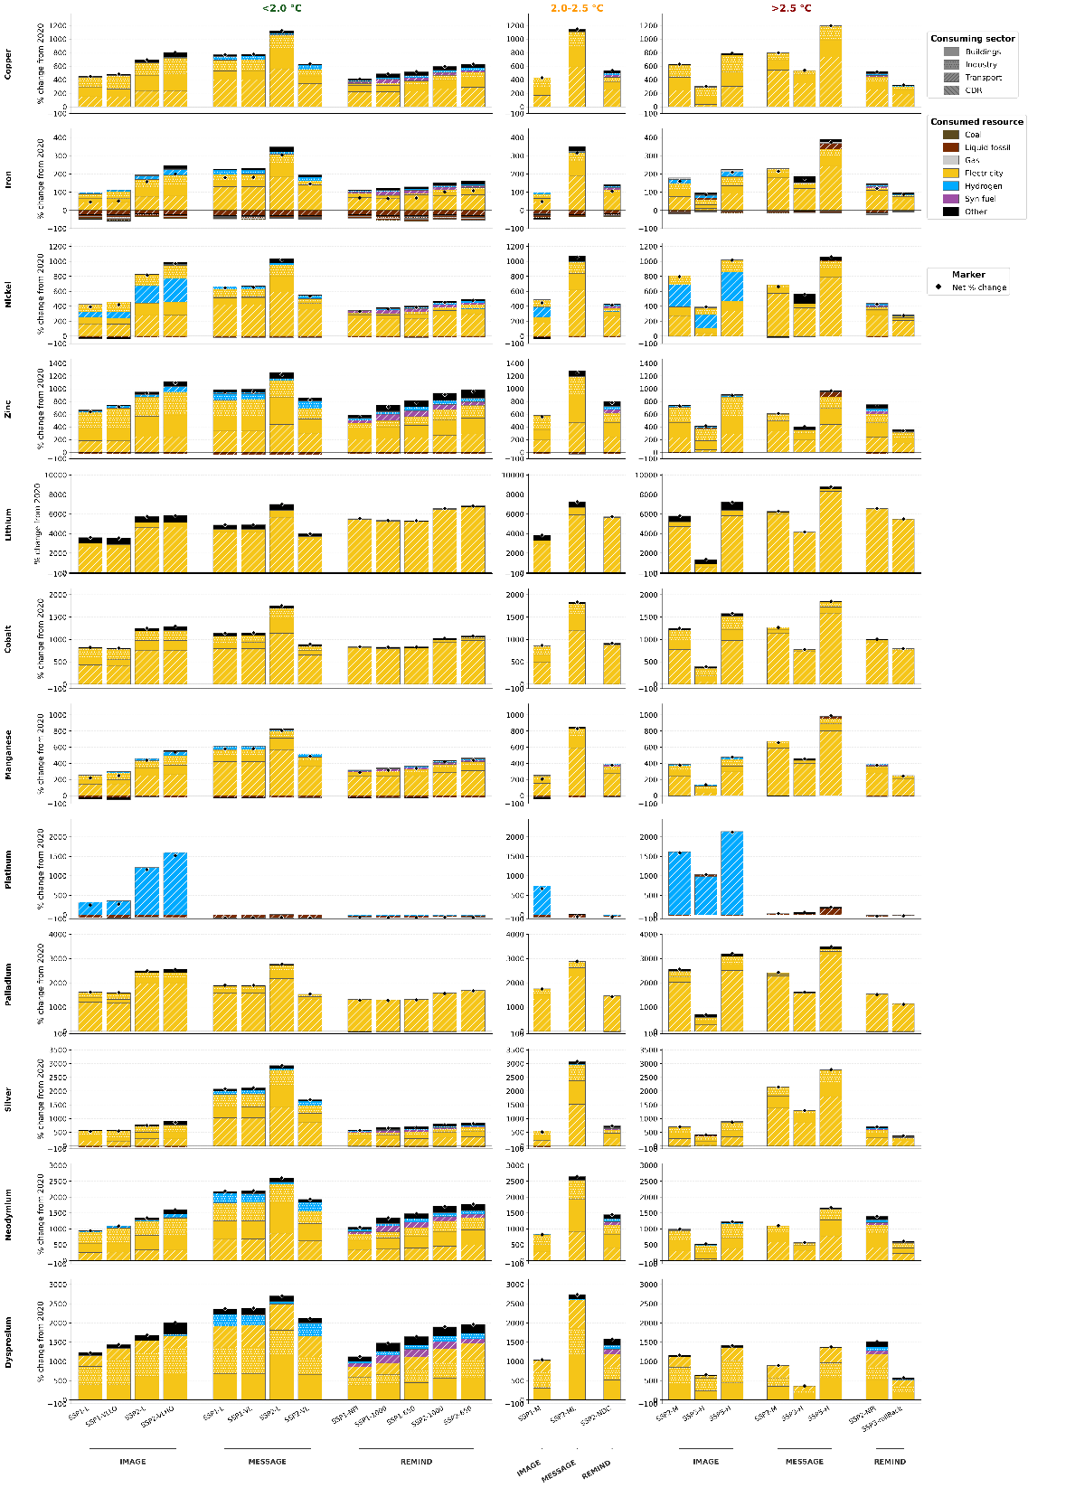
Figure SI5 | Sectoral and energy supply alternative contributions to changes in primary metal extraction by 2100. Stacked bar charts show the relative contribution of consuming sectors and energy supply options to the change in primary metal extraction between 2020 and 2100. Values are expressed as percentage change relative to the total 2020 values. Bars are grouped by end-of-century global mean surface temperature (GMST) outcome, with columns representing pathways below 2.0 degrees Celsius, between 2.0 and 2.5 degrees Celsius, and above 2.5 degrees Celsius. Within each column, pathways are grouped by Integrated Assessment Model (IAM) and Shared Socioeconomic Pathway (SSP). Colours indicate energy supply options, hatching denotes consuming sectors, and diamond markers represent the net change in total impacts for each pathway. Only the main contributing sector and option combinations are shown explicitly, with remaining contributions aggregated as ‘Other’.

Sensitivity analysis: increased recycling input rates (RIR)
To assess the sensitivity of metal extraction demand to higher secondary supply, we perform a scenario in which recycling input rates are linearly increased to 2050. This exercise represents an optimistic benchmark, as global demand for many metals increases sharply across most regions, limiting the extent to which secondary material availability can scale relative to total demand. The purpose of this analysis is to evaluate the robustness of the main results and to demonstrate the flexibility of the modelling framework in incorporating supply-side parameter changes.
Recycling input rates are modified at the global market level within the LCA database. The following adjustments are implemented:
- Cobalt: increased original ecoinvent value a 50%.
- Copper: recycling input rate increased original ecoinvent value a 20%.
- Lithium: increased original ecoinvent value a 30%.
- Manganese (battery applications): increased from 0% to 10%.
- Nickel: increased original ecoinvent value a 30%.
- Platinum group metals: unchanged, as existing recycling rates are already high at around 30% and close to observed saturation levels.
- Rare earth elements: increased ecoinvent value a 35%.
- Silver: increased original ecoinvent value a 40%.
- Steel: no modification, as its production is explicitly modelled in the IAM scenarios.
- Zinc: increased original ecoinvent value a 30%.
Recycling rates are increased linearly from 2020 to 2050 and held constant thereafter. Despite these adjustments, the central findings of the study remain unchanged:
- Ambitious mitigation pathways continue to shift metal demand forward in time, resulting in sharper near-term extraction requirements.
- Cumulative extraction over the century remains broadly similar across warming categories.
- The comparative environmental performance of pathways across environmental categories is not materially altered.
These results indicate that while enhanced recycling can moderate primary extraction pressures for certain metals and is certainly a lever to match supply and demand, it does not fundamentally alter the structural patterns identified in the main analysis.
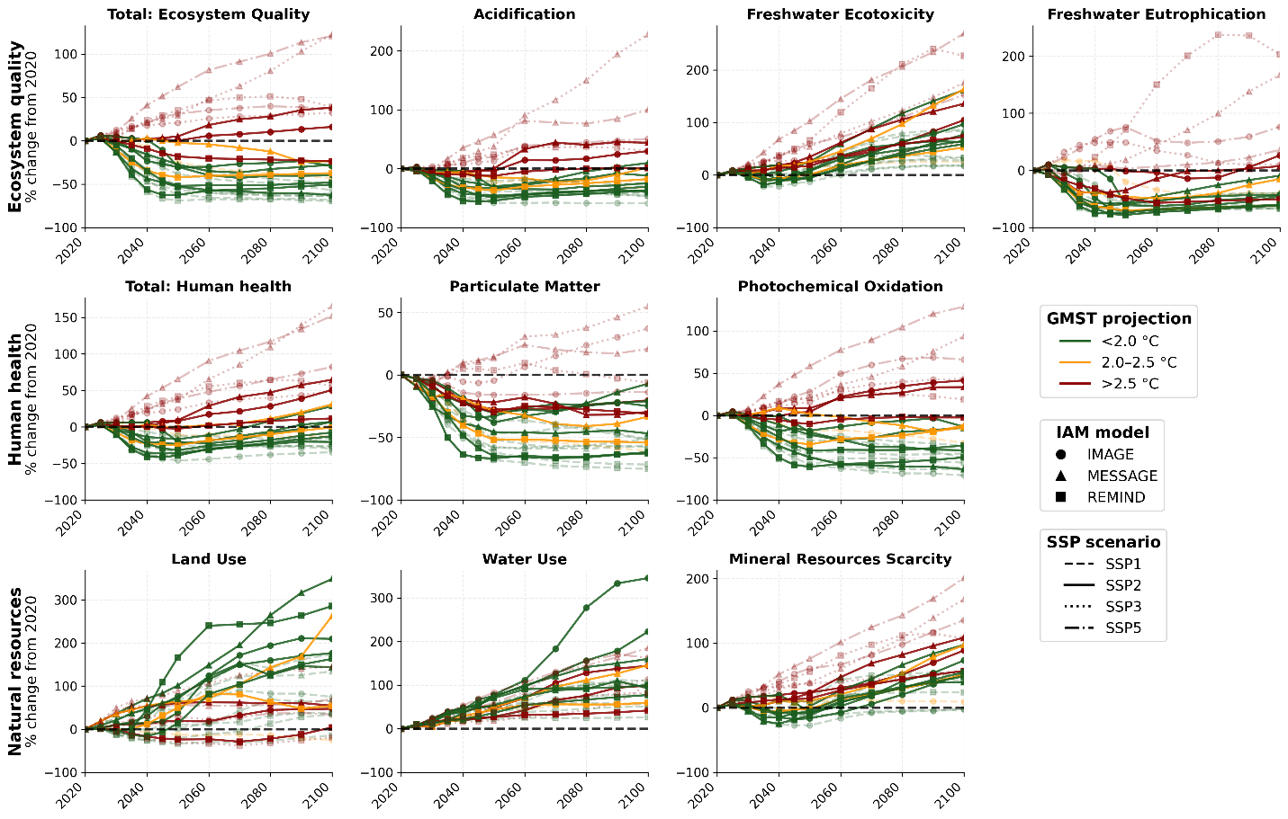
Figure SI6 | Annual environmental impacts of global final energy provision across climate mitigation pathways in the case of increased recycling input rates. Percentage change in annual impacts relative to 2020, from 2020 to 2100, across ten environmental indicators and 24 mitigation pathways. Panels are organised by area of protection: ecosystem quality (total ecosystem quality in local species loss over time, acidification, freshwater ecotoxicity, freshwater eutrophication), human health (total human health in DALYs, particulate matter formation, photochemical ozone formation), and natural resources (land use, freshwater use, mineral resource scarcity). The horizontal dashed line marks zero change relative to the 2020 baseline. Colours indicate end-of-century global mean surface temperature (GMST) outcomes, marker shapes denote Integrated Assessment Models (IAMs), and line styles represent Shared Socioeconomic Pathways (SSPs), all as in Fig. SI1.
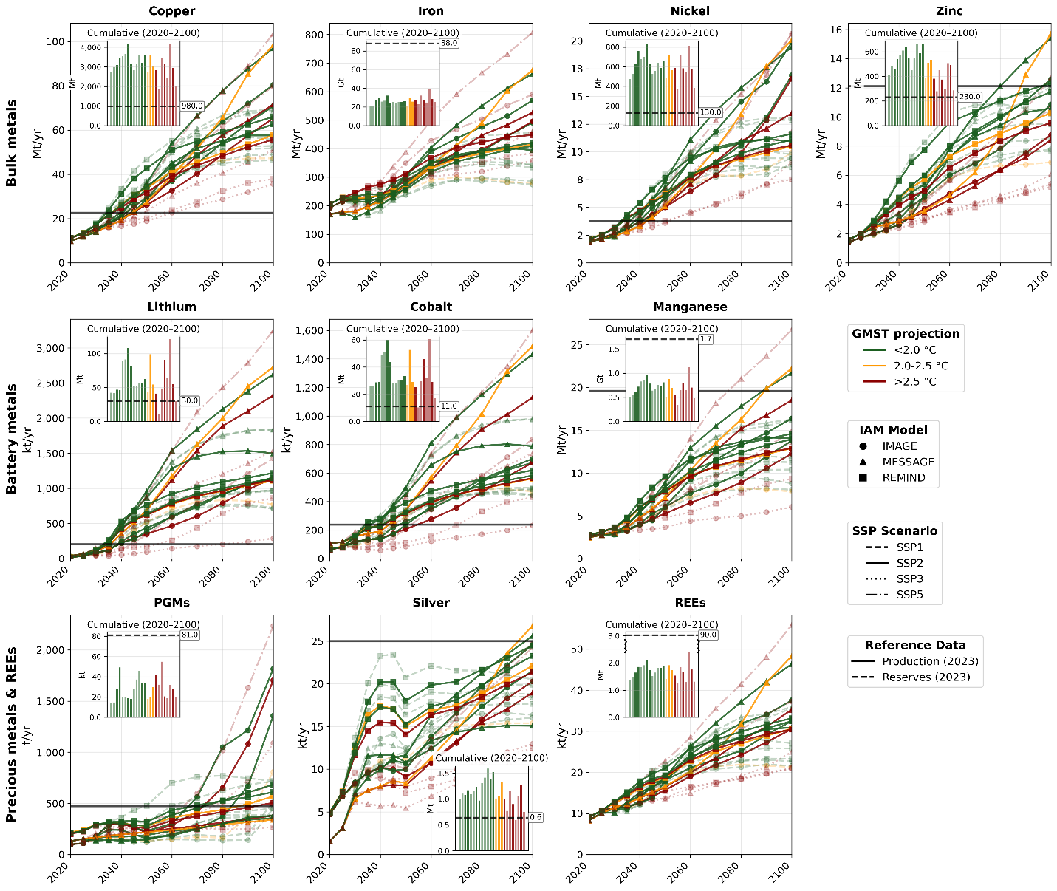
Figure SI7 | Timing and scale of metal demand across energy system pathways in the case of increased recycling input rates. Trajectories of annual primary metal extraction from 2020 to 2100 across 24 energy system pathways, shown for bulk metals (copper, iron, nickel, zinc), battery metals (lithium, cobalt, manganese), and precious metals and rare earth elements (platinum group metals, silver, rare earth elements). Insets show cumulative primary extraction from 2020 to 2100 for each pathway. Horizontal solid lines indicate 2023 global primary metal production, and horizontal dashed lines indicate 2023 reserves for each metal. Colours indicate end-of-century global mean surface temperature (GMST) outcomes, marker shapes denote Integrated Assessment Models (IAMs), and line styles represent Shared Socioeconomic Pathways (SSPs), all as in Fig. SI1.

