Supplementary Materials
Agency effects excluding first trial of choice
We asked whether the amounts wagered were dependent on whether participants were granted agency in the task while removing the first trial where participants selected the cue first.
Consistent with the main analysis, results revealed that participants wagered more on trials where they selected their own cue than on trials where the cue was randomly assigned to them.
In Experiment 1, participants wagered on average 24.5 bills (SD = 13.31) on self-chosen cues compared to 21.43 bills (SD = 13.92) on assigned cues (LMM predicting wager from agency, controlling for trial with random slopes and intercepts: b = 3.1, t (73.19) = 4.99, p < .001; See Fig. 1a). This effect replicated in Experiment 2, where participants wagered 31.33 bills (SD = 14.12) on self-chosen cues versus 27.77 bills (SD = 14.79) on assigned cues (b = 3.45, t (65.16) = 5.58, p < .001; see Fig. 1b).
Agency effect was also evident in Experiment 3 such that , participants wagered on average 21.05 bills (SD = 12.88) on self-chosen cues compared to 18.34 bills (SD = 12.79) on assigned cues (LMM predicting wager from agency condition, controlling for reward multiplier, with random slopes and intercepts, b = 6.9, t (54.34) = 7.7, p < .001; see Fig. 1c).
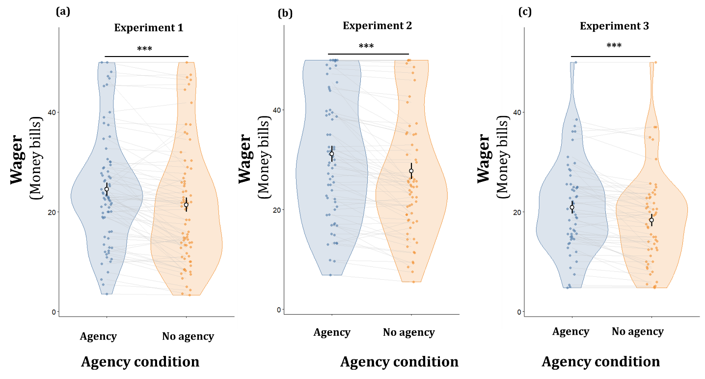
Fig. 1. A sense of control boosts risk-taking. Participants wagered more when they selected which cue to wager on (Agency condition) relative to when the cue was assigned to them (No Agency condition). Results are shown for (a) Experiment 1 (In-person) and (b) Experiment 2 (Online Replication) and (c) Experiment 3 (online). Individual dots represent mean wagers for each participant; central points and error bars reflect the group mean ± 1 SD. *** p < .001, * p < .05.

Having established that agency increases risk-taking, we next examined whether it also influences risk escalation. To test this, we fitted linear mixed-effects models predicting wagers from agency, trial, and their interaction, including random intercepts and slopes. The analysis did not reveal an interaction effect between the two (Experiment 1: b = 0.0009, t (1177) = 0.001, p = 0.998, BF01 = 5.97 ; Experiment 2: b = 0.07, t (1048.5)= 1.94, p = 0.052, BF₀₁ = 0.85 ; Experiment 3: b = 0.02, t (807.2) = 0.3, p = 0.76, BF₀₁ = 3.65; see Fig. 2a–c). For these analyses, we excluded interaction slopes from the random effects structure, increasing degrees of freedom which biases the model toward significance - yet null effects remained evident. This suggests that agency affects the magnitude of risk-taking but leaves the temporal dynamics through which risk escalates over time unchanged. Although the interaction approached significance in Experiment 2, the corresponding Bayes Factor provided no consistent evidence in either direction, and the effect did not replicate in Experiments 1 or 3. Taken together, these results suggest that agency affects the overall magnitude of risk-taking but leaves the temporal trajectory of escalation unchanged.

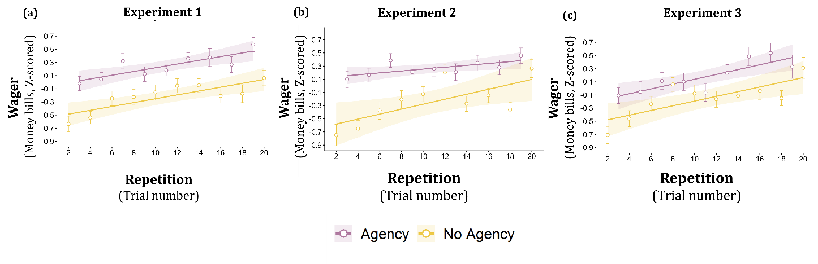
Fig. 2. Risk-taking escalates gradually with repetition independent of agency. Risk-taking, measured as the amount wagered per trial, increased significantly across repetitions in (a) Experiment 1 (N =74 ), (b) Experiment 2 (N = 66), and (c) Experiment 3 (N = 55) regardless of whether participants chose the cue to wager on (agency condition) or were assigned it (no agency condition) . In all three experiments, agency elevated the overall level of wagering but did not modulate the rate of escalation. lines represent linear model predictions separately for each agency condition; shaded areas correspond to 95% confidence intervals. Each dot represents the mean wager across all participants for that trial. Error bars indicate the standard error of the mean.

