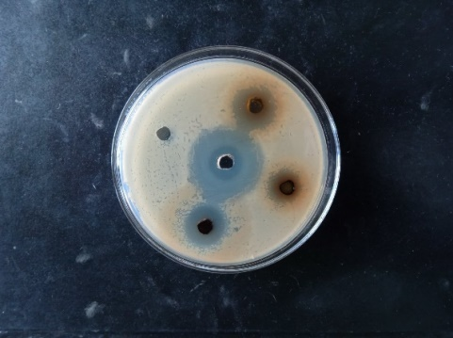
E.coli
OS-E
OS-M
OS-D
PC
NC
(a)
Figure : Test plates showing stronger ZOI produced by O. siliculosum against E. coli for OS-D, OS-M, and OS-E extracts

Full name of sample | Sample (50 mg/mL) | ZOI (mm) against bacterial strains
Full name of sample | Sample (50 mg/mL) | PC | SS | PC | SA | PC | KP | PC | E. coli
O. siliculosum-mediated Ag NPs | OS-Ag | 25 | 6 | 24 | 7 | 25 | 7 | 26 | 8

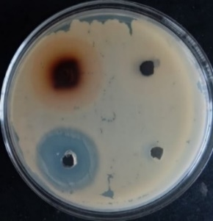
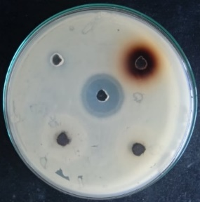
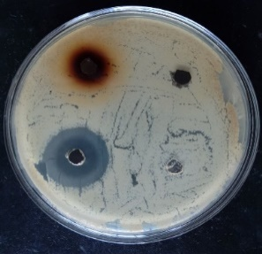
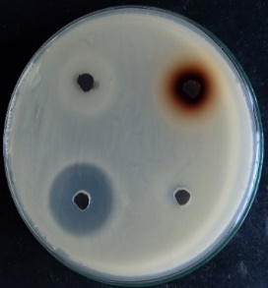
Figure: ZOI of aqueous extract, and Ag NPs synthesized using O. siliculosum against (a) S. sonnei, (b) S. aureus, (c) K. pneumoniae, and (d) E. coli

(a)
SS
Aq.ext
Ag NPs
NC
PC
SA
Ag NPs
Ag NPsNps
PC
N.C
Aq.ext
(b)
KP
PC
Aq.ext
Ag NPs
NC
(c)
E.coli
PC
AgNPs
Aq.ext
NC
(d)

Table: Percentage yield of crude extract of plants in different solvents

S.N. | Name of Plants | % yield of Aq. Extract | % yield of MeOH Extract | % yield of EtOH Extract | % yield of EtOAc Extract | % yield of DCM Extract | % yield of Hexane. Extract
21 | Onychium siliculosum (Leaves) | 15.5 | 13.03 | 11.004 | 8.52 | 2.471 | 1.05
Name of plant-part extract | Symbol | Al | Te | Fl | Po | Co | Qu | Gl | Sa | RS | PA | Ta | C
Aqueous leaf extract of O. siliculosum | LOS-A  Or OS-A | ++ | ++ | ++ | ++ | + | ++ | + | ++ | + | + | + | +
Methanol leaf extract of O. siliculosum | LOS-M  Or OS-M | ++ | ++ | ++ | ++ | + | + | + | - | + | + | + | +
Ethanol leaf extract of O. siliculosum | LOS-E  Or OS-E | ++ | ++ | ++ | + | + | + | + | + | + | + | + | +
Ethyl acetate leaf extract of O. siliculosum | LOS-EA Or OS-EA | ++ | + | ++ | + | + | + | + | - | - | + | + | +
DCM leaf extract of O. siliculosum | LOS-D Or OS-H | ++ | + | ++ | + | + | + | + | + | - | - | + | +
Hexane leaf extract of O. siliculosum | LOS-H  Or OS-H | + | + | ++ | + | + | + | + | + | - | - | - | -
Table : Result of phytochemical analysis of crude extracts of plants

Notes: Respective phytochemical test are represent by symbol, Al= alkaloids, Te = terpenoids, Fl = flavonoids, Po= polyphenols, Co = coumarins, Qu = Quinone, Gl = glycosides, Sa = saponins, RS = reducing sugar, PA= protein and amino acids, Ta = tannins, C = carbohydrates, which are given in top of each column, and, the (+) sign for presence, (++), for intense presence and (-) sign for absence of phytochemicals based on the test outcome.

Name of plant part extract and synthesized NPs | Notation (sample= 50mg/mL) | ZOI (mm) against bacterial strains
Name of plant part extract and synthesized NPs | Notation (sample= 50mg/mL) | PC (1mg/mL) | SS | PC | SA | PC | KP | PC | E. coli
O. siliculosum-mediated Ag NPs | OS-Ag | 25 | 6 | 24 | 7 | 25 | 7 | 26 | 8
Aqueous leaf extract of O. siliculosum | OS -A | 25 | 7 | 24 | 6 | 25 | 6 | 26 | 6
Methanol leaf extract of O. siliculosum | OS -M | 25 | 8 | 24 | 7 | 25 | 7 | 26 | 19
Ethanol leaf extract of O. siliculosum | OS -E | 25 | 6 | 24 | 8 | 25 | 8 | 26 | 15
Ethyl acetate leaf extract of O. siliculosum | OS -EA | 25 | 15 | 24 | 11 | 25 | 7 | 26 | 6
DCM leaf extract of O. siliculosum | OS -D | 25 | 13 | 24 | 15 | 25 | 14 | 26 | 14
Hexane leaf extract of O. siliculosum | OS-H | 25 | 7 | 24 | 6 | 25 | 6 | 26 | 7

