Metagenomic characterization of viral communities across coastal matrices highlights bivalves as integrative sentinel hosts within a One Health framework

Supplemental Material

- Katie Vigil¹, Tiong Gim Aw^{1*}
¹Department of Environmental Health Sciences, School of Public Health and Tropical Medicine, Tulane University, New Orleans, LA, USA.
* Correspondence:
Tiong Gim Aw
taw@tulane.edu

- Keywords: nanopore sequencing, metagenomics, viruses, oyster, mussel, One Health

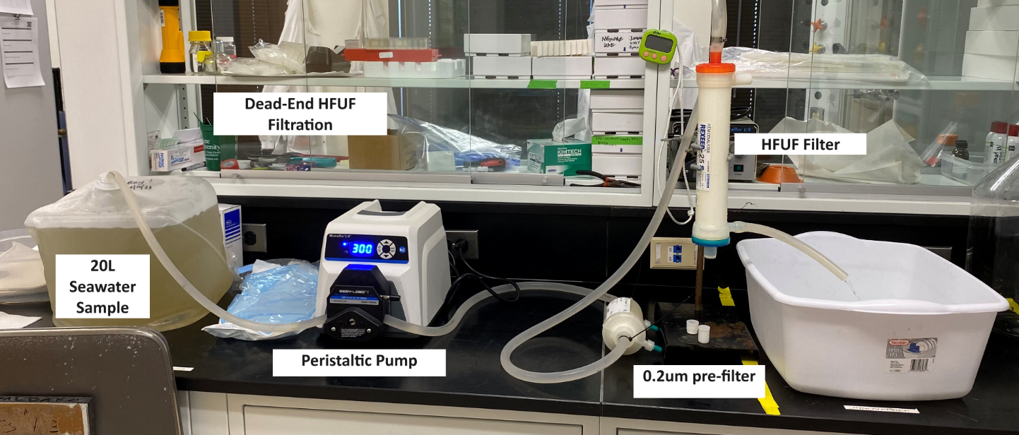

Figure S1. Dead-end hollow fiber ultrafiltration (HFUF) with 0.22uM pre-filter setup to process 20L of water collected from Barataria bay.
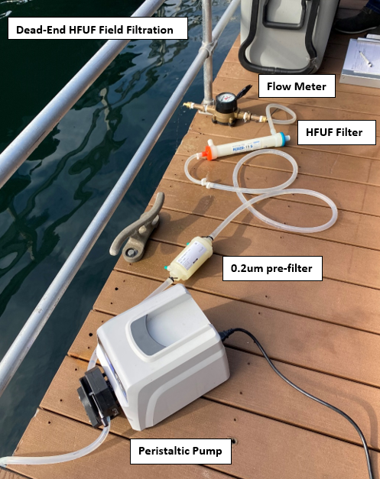
Figure S2. Dead-end hollow fiber ultra filtration (HFUF) with 0.22uM pre-filter setup to process seawater as measured with a flow meter in San Diego Bay.

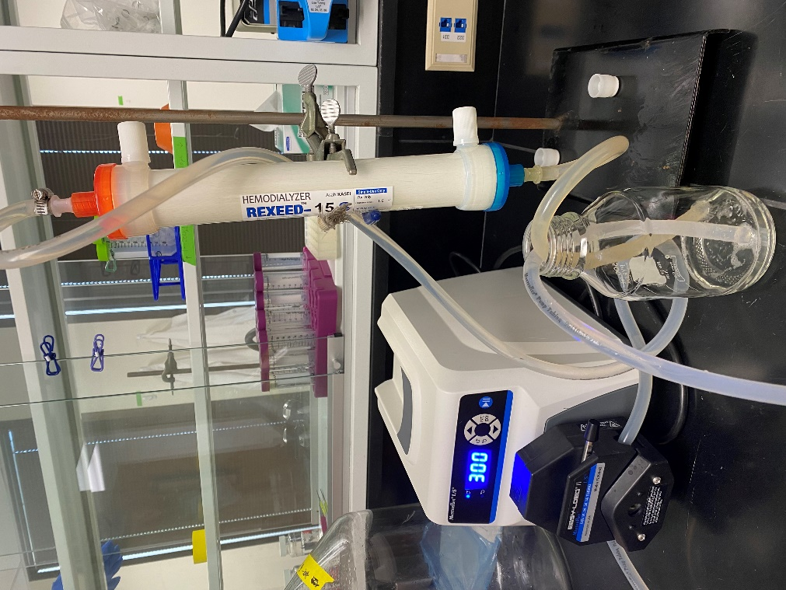

Figure S3. HFUF elution of viruses into 0.1% tween elution buffer using reverse circulation.

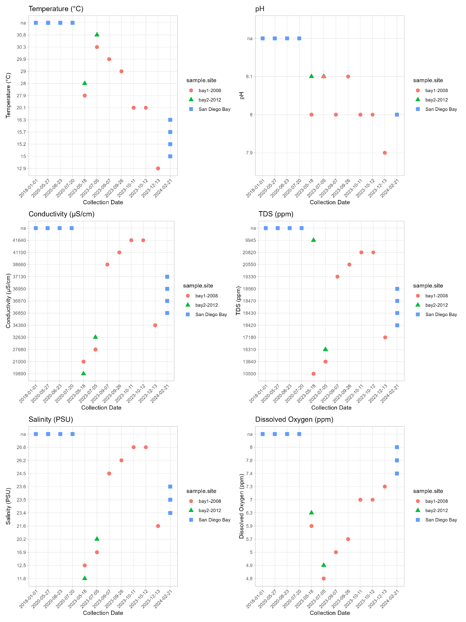
Figure S4. Water quality parameters for Barataria Bay (bay1-2008 and bay2-2012) oyster community collection site and San Diego Bay. Note that no water quality parameters were collected for the San Diego Bay sea lion, dolphin and mussel samples collected in 2018 and 2020.

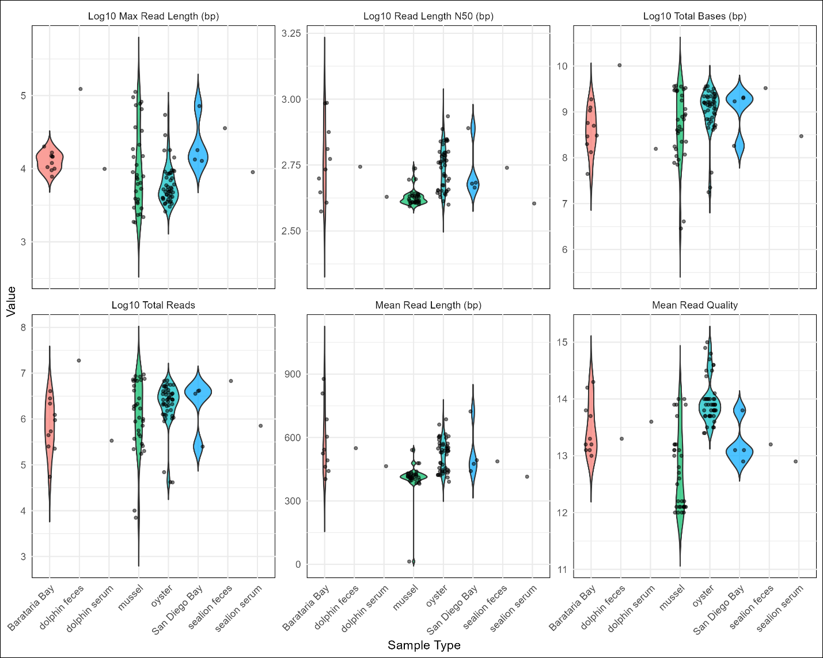
Figure S5. Violin plot of quality control measures reported by Nanoplot from mussels (n=263), oysters (n=230), Barataria Bay (n=10), San Diego Bay (n=4), dolphin feces (n=4) and sealion feces (n=5) , dolphin serum (n=4) and sealion serum (n=3).

Figure S6. Each point represents a viral alignment detected by the Hecatomb workflow following initial statistical filtering (E-value < 1 × 10⁻²⁰ and alignment length ≥150 bp or amino acids). Alignments are plotted by alignment length (x-axis) and percent identity (y-axis), with colors indicating alignment type (teal = protein, aa; red= nucleotide, nt). Panels are faceted by viral family, showing the twenty families with the highest total read support. Vertical dashed lines indicate the alignment length threshold (150), while horizontal dashed lines indicate identity thresholds used for downstream biological filtering (60% for protein alignments and 75% for nucleotide alignments). These thresholds divide the plots into quadrants that facilitate visual identification of high-confidence viral hits (long alignments with high sequence identity) versus lower-confidence or potentially spurious matches. This visualization guided the final identity-based filtering applied to generate the curated viral dataset used in downstream analyses.

Table S1. PhiX 174 and MS2 Primers, probes and dPCR conditions.
Target | Primer/Probe Name | Primer/Probe Sequence | Target (Genome Position) | dPCR Conditions | References
PhiX174 | PhiX174 Forward  PhiX174 Reverse  PhiX174 Probe | 5’-ACAAAGTTTGGATTGCTACTGACC-3'  5’-CGGCAGCAATAAACTCAACAGG-3'  5’-FAM-CTCTCGTGCTCGTCGCTGCGTTGA-BHQ-3' | 508-531  630-609  533-556 | 1 cycle-95ºC 10min  40 cycles-95ºC 5s, 60ºC 15s | [1]
MS2 | MS2 1 Forward  MS2 1 Reverse  MS2 Probe | 5′-GTCCATACCTTAGATGCGTTAGC-3′  5′-CCGTTAGCGAAGTTGCTTGG-3′  5′-FAM-ACGTCGCCAGTTCCGCCATTGTCG-BHQ-3′ | 1261-1284  1420-1401  1391-1367 | 1 cycle-55ºC 10min  1 cycle-96ºC 10min  40 cycles-96ºC 5s, 55ºC 20s | [2]

Table S2. MS2 and Phi X 174 matrix spike % recovery results from Barataria Bay.
Matrix Spike Results | MS2 |  | PhiX 174
sample | avg. cp/L | % Recovery | avg. cp/L | % Recovery
21-Bay1 spike#1 09/26/23 | 1.68E+09 | 0.22% | 3.17E+10 | 17.85%
22-Bay1 spike #2 09/26/23 | 2.72E+09 | 0.36% | 3.18E+10 | 17.92%
23 miliq spike | 8.21E+10 | 11.91% | 3.95E+10 | 22.23%
27-Bay1 spike #3 10/13/23 | 9.02E+10 | 7.41% | 1.49E+11 | 83.63%
28-Bay1 spike #4 10/13/23 | 5.61E+10 | 10.84% | 9.38E+10 | 59.79%
Phage Culture Spike Stock Concentration | MS2 culture 7.57E+11 cp/L |  | phix 174 culture 1.78E+11 cp/L

References
1. Verreault, D., et al., Comparison of polycarbonate and polytetrafluoroethylene filters for sampling of airborne bacteriophages. Aerosol Science and Technology, 2010. 44(3): p. 197-201.
2. Gendron, L., et al., Evaluation of filters for the sampling and quantification of RNA phage aerosols. Aerosol Science and Technology, 2010. 44(10): p. 893-901.

