Supplementary Materials

Prediction of Neoadjuvant Therapy Response in Locally Advanced Gastric Cancer Based on ctSLEP Score and Spectral CT

- Supplementary Information
- Supplementary Figures
- Supplementary Tables
- Supplementary Reference
Supplementary Information
Supplementary Appendix 1: Clinicopathological Characteristics
Clinical Data: Patient information collected included gender, age, body mass index (BMI), preoperative Clinical T (cT) and N (cN), tumor location (cardia/fundus, body, antrum/pylorus, or involving ≥2/3 of the stomach), Borrmann classification under gastroscopy, histological differentiation (well/moderately vs. poorly/undifferentiated), and NAT regimen type (NAC alone or combination therapy).
Pre-NAT peripheral blood parameters—neutrophil, lymphocyte, monocyte counts, and hematocrit (HCT)—were recorded to calculate the neutrophil-to-lymphocyte ratio (NLR), lymphocyte-to-monocyte ratio (LMR), and extracellular volume (ECV). Serum carcinoembryonic antigen (CEA) and carbohydrate antigen 19-9 (CA19-9) levels were also measured, with positive thresholds defined as CEA > 5 ng/mL and CA19-9 > 27 U/mL.
Supplementary Appendix 2: Neoadjuvant Therapy (NAT) Regimens
Patients received neoadjuvant chemotherapy (NAC) alone or NAC combined with immunotherapy and/or targeted therapy(median 4 cycles, range 2–8). After NAT completion, all patients underwent radical gastrectomy (total, distal, or proximal) with D2 lymphadenectomy.
1. NAC Regimens (2–4 cycles):
- SOX regimen: Oxaliplatin 130 mg/m² IV infusion; S-1 60 mg/m² orally, twice daily for 14 days.
- FLOT regimen: Docetaxel 50 mg/m², Oxaliplatin 85 mg/m², Leucovorin 200 mg/m², and 5-FU 2,600 mg/m² IV every 2 weeks.
- Paclitaxel-based regimen: Paclitaxel 100 mg/m², Oxaliplatin 130 mg/m² IV infusion; S-1 60 mg/m² orally, twice daily for 14 days.
- XELOX regimen: Oxaliplatin 130 mg/m² IV infusion; Capecitabine 1,000 mg/m² orally, twice daily for 14 days.
- Immunotherapy: PD-L1 inhibitors—Sintilimab or Atezolizumab.
- Targeted Therapy:
- HER2-targeted therapy: Trastuzumab.
- VEGF inhibitor: Bevacizumab.
- VEGFR inhibitor: Apatinib.
- EGFR inhibitor: Cetuximab.

Supplementary Appendix 3: Key imaging features for differentiating ctSI, ctEMVI, ctLVI, and ctOPM at cT4a stage^{[1]}
Imaging Feature | Key Imaging Findings | Primary Interpretation
ctSI | Irregular or nodular serosal changes with blurring/obliteration of the perigastric fat plane, without continuity into extramural vessels or lymphatic structures. | Serosal invasion
ctEMVI | Intraluminal soft-tissue density within extramural veins, often with venous dilatation and/or irregular venous margins. | Extramural venous invasion
ctLVI | Flocculent or strand-like soft-tissue extensions directed toward adjacent lymph nodes. | Extramural lymphatic/lymph node involvement
ctOPM | Peritoneal/omental involvement manifested as increased fat attenuation, stranding, nodularity, and/or ascites. | Peritoneal/omental metastasis/involvement
Supplementary Appendix 4: Endpoints
- Primary Endpoint – Tumor Regression Grade (TRG) Response.
Tumor response following neoadjuvant therapy (NAT) was evaluated using the Becker Tumor Regression Grade (TRG) classification system. TRG 1b was defined as residual tumor cells accounting for less than 10% of the tumor area; TRG 2 as 10%–50% residual tumor cells; and TRG 3 as more than 50% residual tumor cells.Patients with TRG 1a or TRG 1b were classified as responders, whereas those with TRG 2 or TRG 3 were classified as non-responders.
All pathological assessments were independently performed by two experienced pathologists, and any discrepancies were resolved by consensus.
2. Secondary Endpoint – Relapse-Free Survival (RFS)
Relapse-free survival (RFS) was defined as the interval from the date of baseline CT examination to the occurrence of tumor recurrence or metastasis. Recurrence or metastasis was confirmed by imaging modalities (CT, MRI, PET-CT, or ultrasonography), laboratory examinations, and/or endoscopic evaluation. All patients were followed for a minimum of 3 months, and the study endpoint was set at February 9, 2026.

Supplementary Appendix 5: Consistency Analysis
Kappa values were employed to assess agreement between the two readers’ qualitative diagnoses, while the intraclass correlation coefficient (ICC) was employed to evaluate intra-reader reliability for quantitative measurements. Kappa or ICC values of 0.00–0.20, 0.21–0.40, 0.41–0.60, 0.61–0.80, and 0.81–1.00 were interpreted as low, fair, moderate, good, and near-perfect correlations, respectively.The same cutoffs were applied to both κ and ICC values.
Metric | Purpose | Interpretation (Value Range)
Cohen’s kappa (κ) | Assess agreement between two readers for qualitative diagnoses. | 0.00–0.20: low;  0.21–0.40: fair;  0.41–0.60: moderate;  0.61–0.80: good;  0.81–1.00: near-perfect
Intraclass correlation coefficient (ICC) | Evaluate intra-reader reliability for quantitative measurements.

Supplementary Figures

Supplementary Figure S1: Multi-parameter images of energy spectrum CT in LAGC patients
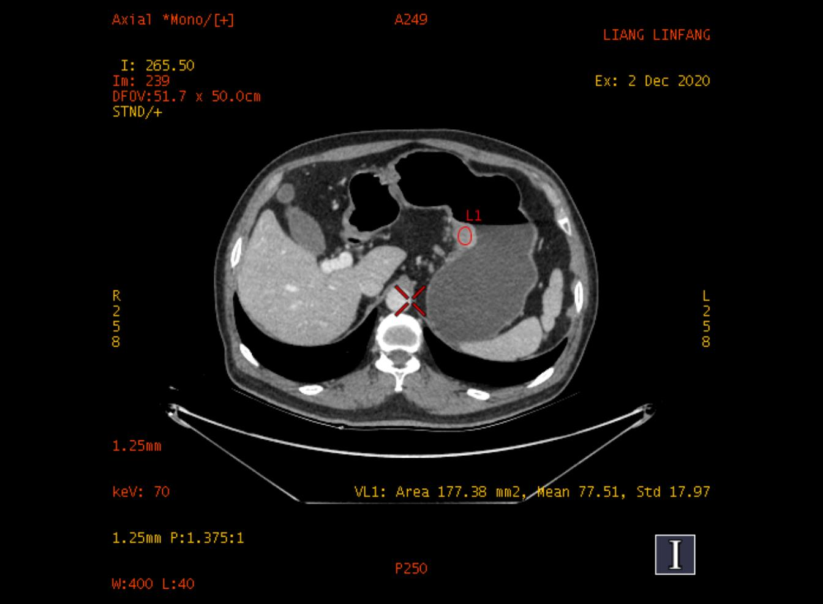  (a) | 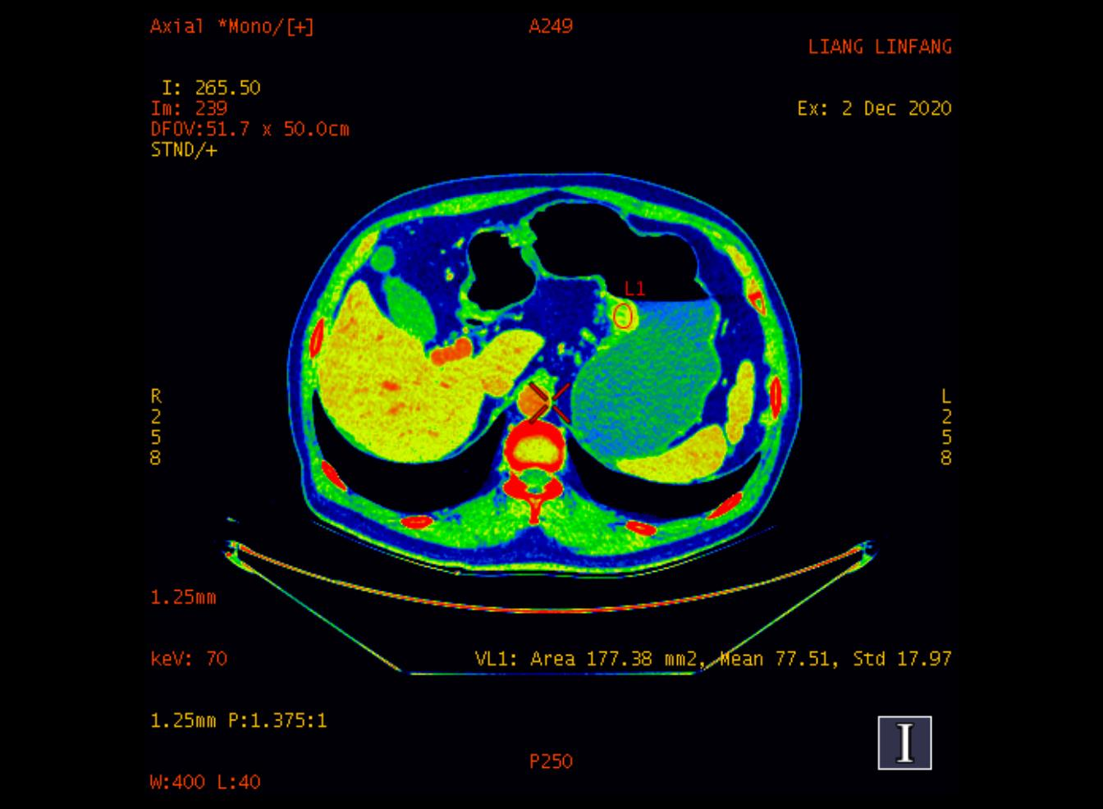  (b)
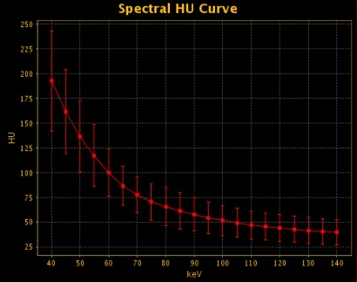  (c) | 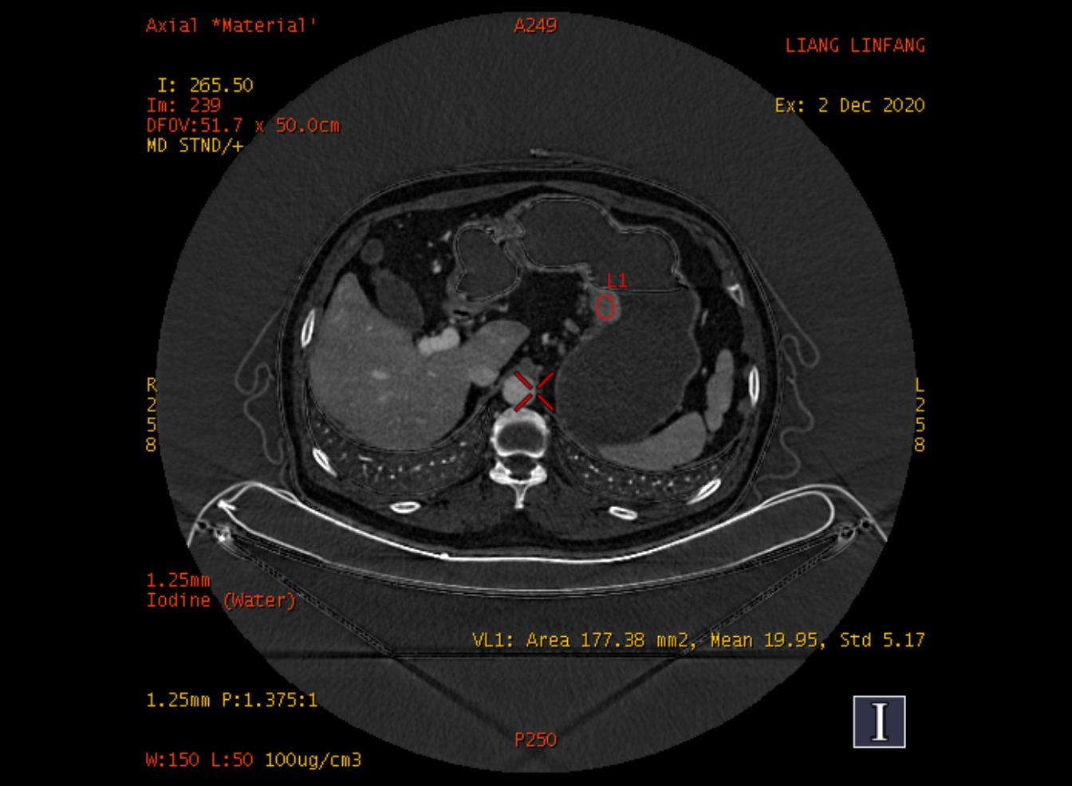  (d)
(a) 70 Kev single-energy image; (b) pseudocolor image; (c) energy spectrum curve; (d) iodine water image.

Supplementary Figure S2: Scree plot of principal components
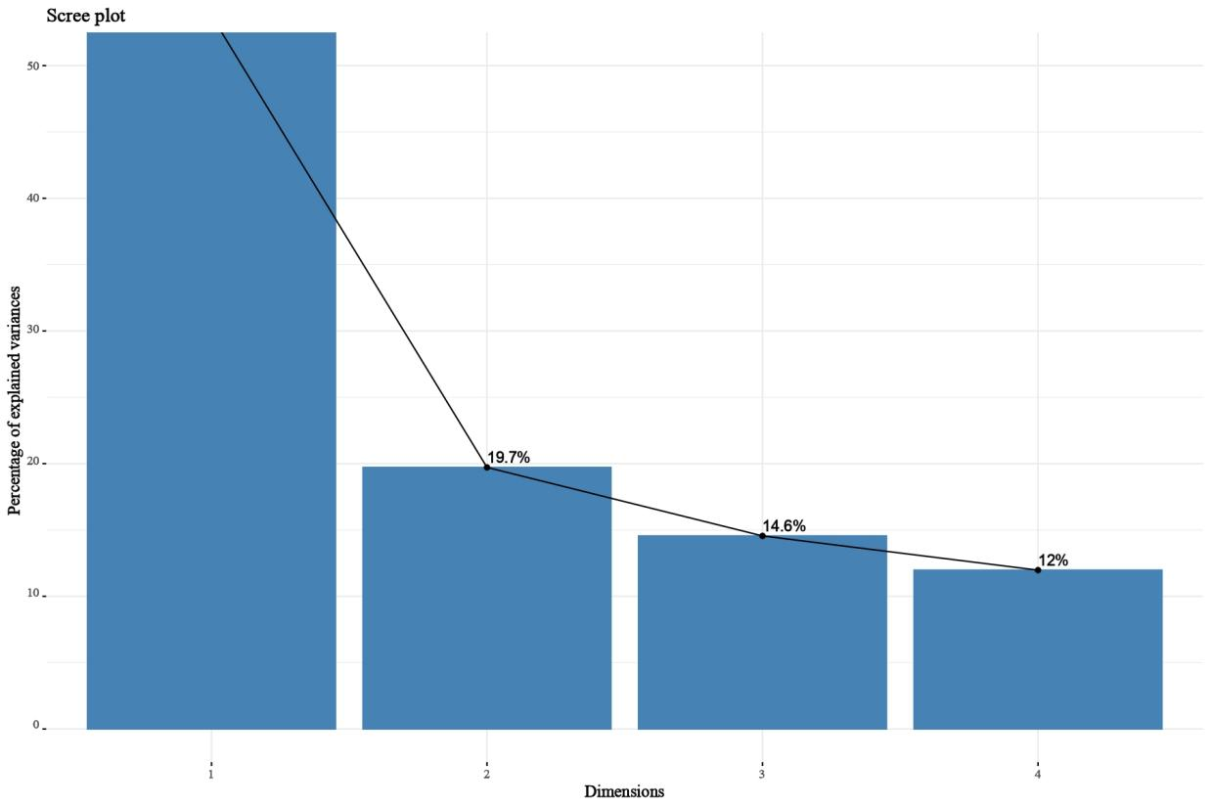
Legend: The scree plot displays eigenvalues and the explained variance ratio of each principal component (PC), used to determine the number of PCs retained.

Supplementary Figure S3: TIME Distribution by RFS Status
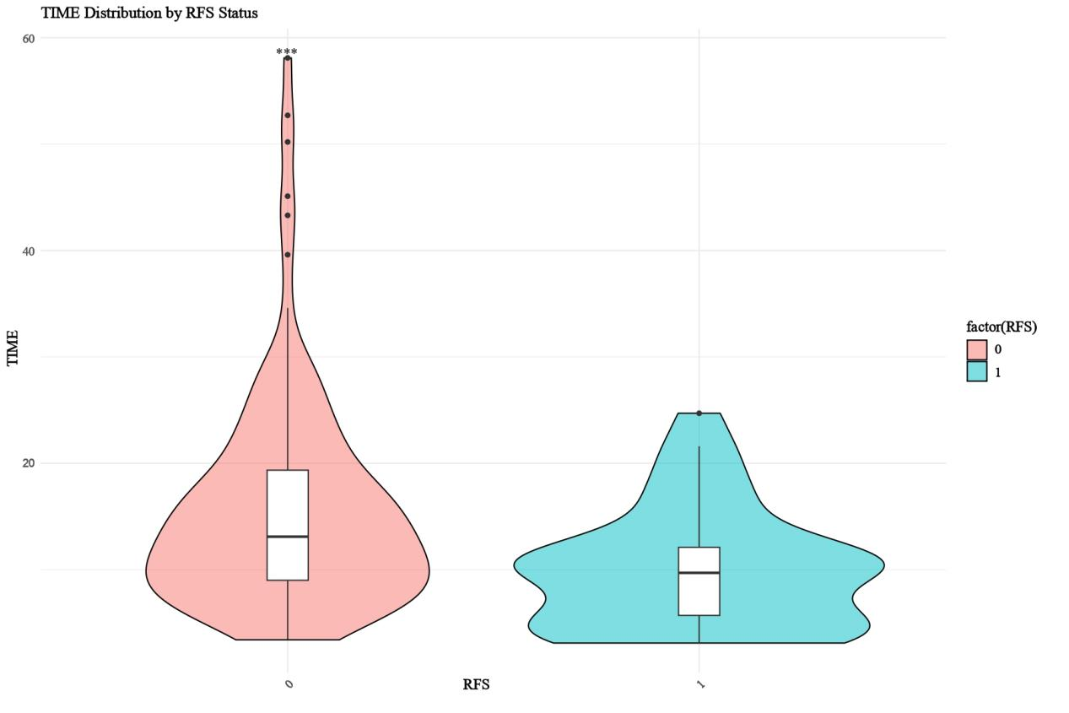
Legend: This figure illustrates the distribution of TIME based on RFS status, where 0 represents the negative group with no recurrence or metastasis, and 1 represents the positive group with recurrence or metastasis.

Supplementary Tables

Supplementary Table S1: Detailed CT acquisition protocols
CT Scanning Parameters | Values
Scanning Mode | Gemstone Spectral Imaging (GSI)
Tube Voltage | Rapid switching between 80 and 140 kVp
Tube Current | 375 mAs
Field of View | 500 × 500 mm
Pitch | 0.992
Matrix | 512 × 512
Detector Width | 80 mm
Rotation Time | 0.6–0.8 s per rotation
Acquisition Slice Thickness | 5 mm
Reconstruction Slice Thickness | 1.25 mm
All CT examinations were performed using a gemstone spectral imaging (GSI)–based spectral CT scanner (256-Q1 slice CT scanner; GE Healthcare, Waukesha, WI, USA). The scanning range extended from the top of the diaphragm to the lower pole of both kidneys.
Patient Instructions and Imaging Phases | Description
Fasting | 6–8 hours before CT examination
Oral Water Intake | 800–1000 mL prior to scanning
Scan Coverage | From the diaphragm to the lower pole of both kidneys
Non-contrast Scan | Performed before contrast administration
Arterial Phase (AP) | Triggered using bolus-tracking technique
Venous Phase (VP) | Acquired 30 s after AP (~60 s delay), covering neck to pelvis
Delayed Phase (DP) | Acquired 60 s after AP (~90 s delay), covering the abdomen
Contrast Injection Protocol | Values
Contrast Agent | Non-ionic iodinated contrast medium (Iohexol)
Iodine Concentration | 300 mg I/mL
Injection Dose | 1.5 mL/kg body weight
Injection Rate | 3–4 mL/s
Injection Route | Via antecubital vein using a power injector
After image acquisition, spectral images were reconstructed using 40% adaptive statistical iterative reconstruction (ASIR-V).

Supplementary Table S2: The description of clinical staging method for primary tumor (Clinical T (cT) and N (cN) Staging According to the 8th Edition UICC/AJCC TNM System^{[2,3]})
Stage | Definition
cTX | Primary tumor cannot be assessed
cT0 | No evidence of primary tumor
cT1 | Tumor invades lamina propria, muscularis mucosae, or submucosa
cT1a | Tumor invades lamina propria or muscularis mucosae
cT1b | Tumor invades submucosa
cT2 | Tumor invades muscularis propria
cT3 | Tumor penetrates the subserosal connective tissue without invasion of adjacent structures
cT4a | Tumor invades the serosa (visceral peritoneum)
cT4b | Tumor directly invades adjacent structures
cNX | Regional lymph nodes cannot be assessed
cN0 | No regional lymph node metastasis
cN1 | Metastasis in 1–2 regional lymph nodes
cN2 | Metastasis in 3–6 regional lymph nodes
cN3 | Metastasis in ≥7 regional lymph nodes

Supplementary Table S3: Measurement methods and definitions of spectral CT parameters and derived indices.
Variable | Measurement Methods | Definition
IC | Using iodine density images generated by the post-processing workstation to obtain the IC value of the ROI. | Iodine concentration (IC) represents the iodine content per unit volume (mg/mL) in tissue, reflecting tumor vascularity and permeability.
λHU | λHU was calculated using the formula: λHU = (CT40kev − CT70kev) / 30. | A material-specific spectral attenuation curve is created by plotting CT values at different energy levels, each tissue showing a distinct slope (λHU).
Zeff | Using Zeff maps generated by post-processing workstation to obtain the Zeff value of ROI in one click. | The effective atomic number (Zeff) represents the atomic composition of a material or tissue, reflecting its X-ray absorption characteristics.
nIC | nIC was calculated using the formula: nIC = IC / ICₐₒ. | Normalized iodine concentration (nIC) is adjusted to the iodine concentration of the aorta (ICₐₒ) to reduce patient and scanning variability.
ECV | ECV (%) = (1 − HCT) × (ICDP / ICₐₒDP) × 100%. | Extracellular volume fraction (ECV) measures the tumor’s extracellular matrix proportion, indicating fibrosis or vascularity based on iodine-based imaging.
AEF | AEF = ICAP / ICDP. | Arterial enhancement fraction (AEF) quantifies the arterial perfusion contribution in the tumor, based on iodine concentration differences at various phases.
Note: λHU = slope of the spectral attenuation curve; IC = iodine concentration; nIC = normalized iodine concentration; Zeff = effective atomic number; ECV = extracellular volume fraction; AEF = arterial enhancement fraction. Across AP/VP/DP phases.

Supplementary Table S4a: Explained Variance Ratio of Principal Components
PC | Explained variance (%) | Cumulative variance (%)
PC1 | 53.76 | 53.76
PC2 | 19.72 | 73.48
PC3 | 14.55 | 88.03
PC4 | 11.97 | 100.00

Supplementary Table S4b: Principal component loading coefficients for four imaging features
Feature | PC1 | PC2 | PC3 | PC4
ctSI | -0.523 | -0.269 | 0.632 | 0.505
ctEMVI | -0.554 | -0.152 | 0.123 | -0.809
ctOPM | -0.397 | 0.913 | -0.017 | 0.098
ctLVI | -0.512 | -0.267 | -0.765 | 0.284
Note: Absolute loading magnitude reflects the relative contribution of each feature to the corresponding principal component.

Supplementary Table S5: Analysis of the Consistency of Multi-parameter Spectral CT Between Two Radiologists
Variables | Radiologist 1  （first reading） | Radiologist 1  （second reading） | Radiologist 2  （first reading） | Intraobserver ICC | InterobserverICC
ICAP | 13.23 (11.00, 16.97) | 13.39 (10.65, 16.96) | 13.62 (10.63, 18.05) | 0.909 | 0.907
ICaAP | 120.34(101.14, 140.22) | 128.18 (100.55, 145.13) | 126.47 (106.23, 148.78) | 0.958 | 0.908
nICAP | 0.11 (0.08, 0.14) | 0.11 (0.08, 0.14) | 0.11 (0.08, 0.15) | 0.950 | 0.958
40kevAP | 136.03 (116.55, 166.37) | 137.26 (114.46, 171.05) | 140.42 (114.25, 188.00) | 0.771 | 0.857
70kevAP | 62.92 (53.46, 72.02) | 63.57 (53.07, 73.48) | 64.44 (50.87, 82.42) | 0.722 | 0.813
ICVP | 16.64 (13.98, 20.56) | 16.34 (13.79, 19.75) | 16.82 (13.57, 20.53) | 0.846 | 0.895
ICaVP | 38.89 (34.43, 41.67) | 39.64 (34.87, 42.39) | 38.87 (33.78, 41.88) | 0.954 | 0.905
nICVP | 0.39 (0.35, 0.51) | 0.40 (0.33, 0.46) | 0.42 (0.35, 0.50) | 0.850 | 0.887
40kevVP | 169.98 ± 37.49 | 173.84 ± 46.36 | 167.94 ± 41.10 | 0.959 | 0.904
70kevVP | 72.67 ± 14.61 | 74.20 ± 18.81 | 71.47 ± 16.34 | 0.951 | 0.884
ICDP | 16.11 ± 4.16 | 17.20 ± 4.48 | 17.10 ± 4.50 | 0.889 | 0.911
ICaDP | 27.45 (24.73, 29.83) | 26.46 (21.61, 32.96) | 26.01 (21.57, 31.20) | 0.847 | 0.780
nICDP | 0.56 ± 0.13 | 0.59 ± 0.13 | 0.59 ± 0.15 | 0.861 | 0.894
40kevDP | 171.16 ± 39.89 | 172.19 ± 38.55 | 164.06 ± 43.75 | 0.869 | 0.826
70kevDP | 73.98 ± 15.80 | 74.74 ± 15.30 | 71.63 ± 15.07 | 0.817 | 0.844
The consistency of spectral CT parameters was excellent, with intraobserver ICC values ranging from 0.722 to 0.959 and interobserver ICC values ranging from 0.780 to 0.958.

The two observers demonstrated high interreader agreement in assessing the ctSI, ctEMVI, ctOPM, and ctLVI statuses, with κ values of 0.68,0.752, 0.711 and 0.701 respectively.
Supplementary Table S6: Variance inflation factor (VIF) values of variables before and after variable exclusion(A VIF value greater than 5 indicates potential multicollinearity)
Variable | VIF (Before Exclusion) | VIF (After Exclusion)
ctSI | 1.861 | 1.851
ctEMVI | 1.590 | 1.568
ctOPM | 1.121 | 1.122
ctLVI | 1.347 | 1.329
ICAP | 7.079 | Excluded
nICAP | 2.626 | 1.571
ICVP | 5.810 | 2.964
nICVP | 3.553 | 3.219
AEF | 3.349 | 1.496
NLR | 1.105 | 1.084

Supplementary Table S7: Comparison of the predictive efficacy of eight models
Models | Sets | Sensitivity | Specificity | Accuracy | PPV | NPV
Model 1 | Training | 0.600 | 0.844 | 0.700 | 0.848 | 0.594
Model 1 | Testing | 0.571 | 0.700 | 0.625 | 0.727 | 0.538
Model 2 | Training | 0.754 | 0.867 | 0.800 | 0.891 | 0.709
Model 2 | Testing | 0.750 | 0.700 | 0.729 | 0.778 | 0.667
Model 3 | Training | 0.554 | 0.933 | 0.709 | 0.923 | 0.592
Model 3 | Testing | 0.571 | 0.800 | 0.667 | 0.800 | 0.571
Model 4 | Training | 0.662 | 0.933 | 0.773 | 0.935 | 0.656
Model 4 | Testing | 0.643 | 0.650 | 0.646 | 0.720 | 0.565
Model 5 | Training | 0.708 | 0.911 | 0.791 | 0.920 | 0.683
Model 5 | Testing | 0.714 | 0.700 | 0.708 | 0.769 | 0.636
Model 6 | Training | 0.785 | 0.800 | 0.791 | 0.850 | 0.720
Model 6 | Testing | 0.857 | 0.600 | 0.750 | 0.750 | 0.750
Model 7 | Training | 0.831 | 0.756 | 0.800 | 0.831 | 0.756
Model 7 | Testing | 0.857 | 0.600 | 0.750 | 0.750 | 0.750
Model 8 | Training | 0.846 | 0.778 | 0.818 | 0.846 | 0.778
Model 8 | Testing | 0.893 | 0.600 | 0.771 | 0.758 | 0.800
The model uses a 0.7 and 0.3 split for the training set and testing set. The training set undergoes 5-fold cross-validation, and grid search is used to determine the best parameters. AUC: area under the curve. PPV:positive predictive value. NPV:negative predictive value.

Supplementary Table S8: Multivariable Cox proportional hazards analysis of invasive imaging score for relapse-free survival(RFS)
Model | HR | 95% CI | P | C-index
ctSI | 1.85 | 0.91–3.78 | 0.09 | 0.650
ctEMVI | 5.16 | 1.97–13.47 | <0.001 | 0.738
ctOPM | 7.51 | 3.55–15.89 | <0.001 | 0.782
ctLVI | 15.24 | 2.07–112.02 | 0.008 | 0.717
Weighted_index | 2.63 | 1.86–3.72 | <0.001 | 0.825

Supplementary Reference

1 Li Q, Jiang Z, Zhu Y et al (2025) CT-based scores for extramural vascular invasion and occult peritoneal metastasis correlate with gastric cancer survival. Eur Radiol 35:5733-5747
2 Amin MB, Greene FL, Edge SB et al (2017) The Eighth Edition AJCC Cancer Staging Manual: Continuing to build a bridge from a population-based to a more "personalized" approach to cancer staging. CA Cancer J Clin 67:93-99
3 Lin JX, Desiderio J, Lin JP et al (2020) Multicenter Validation Study of the American Joint Commission on Cancer (8th Edition) for Gastric Cancer: Proposal for a Simplified and Improved TNM Staging System. J Cancer 11:3483-3491

