Supplementary Materials

Pressure-induced monotonic enhancement of T_{c} to over 30 K in the superconducting Pr_{0.82}Sr_{0.18}NiO₂ thin films
N. N. Wang^{1,2=}, M. W. Yang^{1,2=}, K. Y. Chen^{1,2}, Z. Yang^{1,2}, Z. H. Zhu^{1,2}, Y. Uwatoko³, X. L. Dong^{1,2}, J. P. Sun^{1,2*}, K. J. Jin^{1,2*}, and J.-G. Cheng^{1,2*}
¹Beijing National Laboratory for Condensed Matter Physics and Institute of Physics, Chinese Academy of Sciences, Beijing 100190, China
²School of Physical Sciences, University of Chinese Academy of Sciences, Beijing 100190, China
³Institute for Solid State Physics, University of Tokyo, Kashiwa, Chiba 277-8581, Japan
= These authors contributed equally to this work.
E-mails: jpsun@iphy.ac.cn, kjjin@iphy.ac.cn, jgcheng@iphy.ac.cn

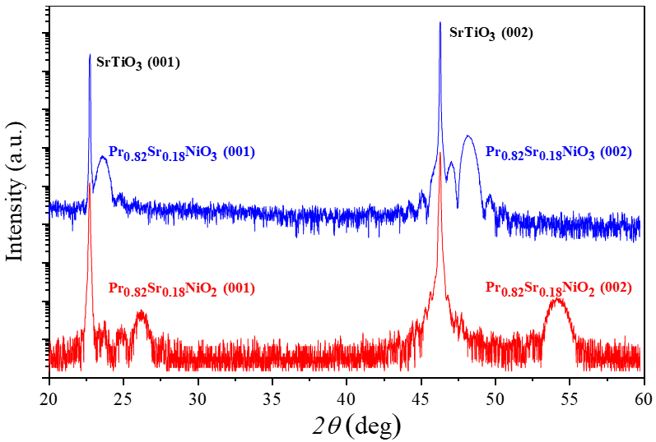
Figure S1. X-ray diffraction θ-2θ symmetric scans of ~12-nm-thick Pr_{0.82}Sr_{0.18}NiO₃ (blue) and Pr_{0.82}Sr_{0.18}NiO₂ (red) films capped with ~2-nm-thick SrTiO₃ layers grown on (001)-oriented SrTiO₃ substrates.
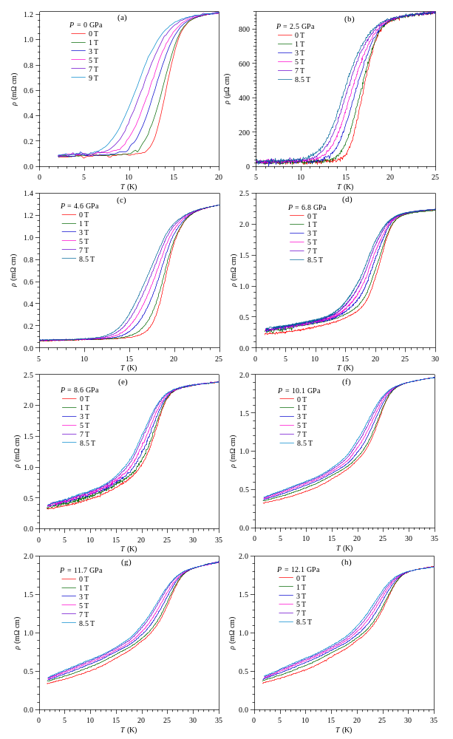
Figure S2. Temperature dependences of the resistivity with magnetic fields up to 8.5 T at various pressures up to 12.1 GPa for sample #1.
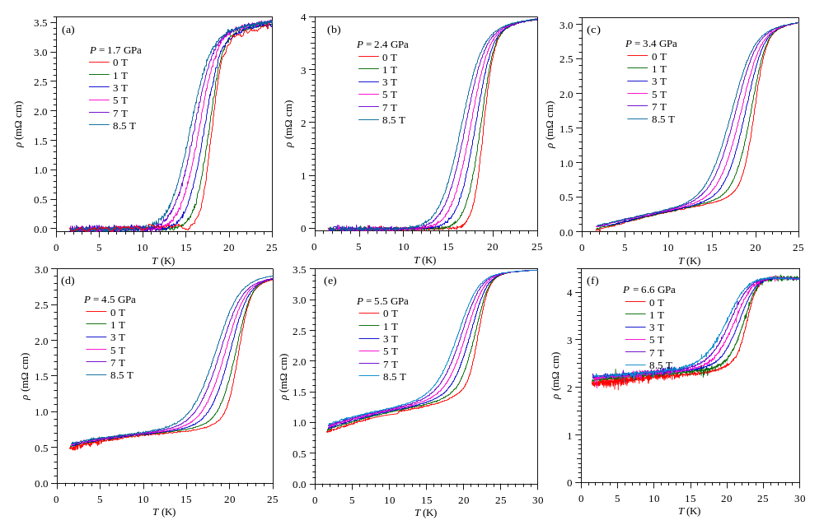
Figure S3. Temperature dependences of the resistivity with magnetic fields up to 8.5 T at various pressures up to 6.6 GPa for sample #2.

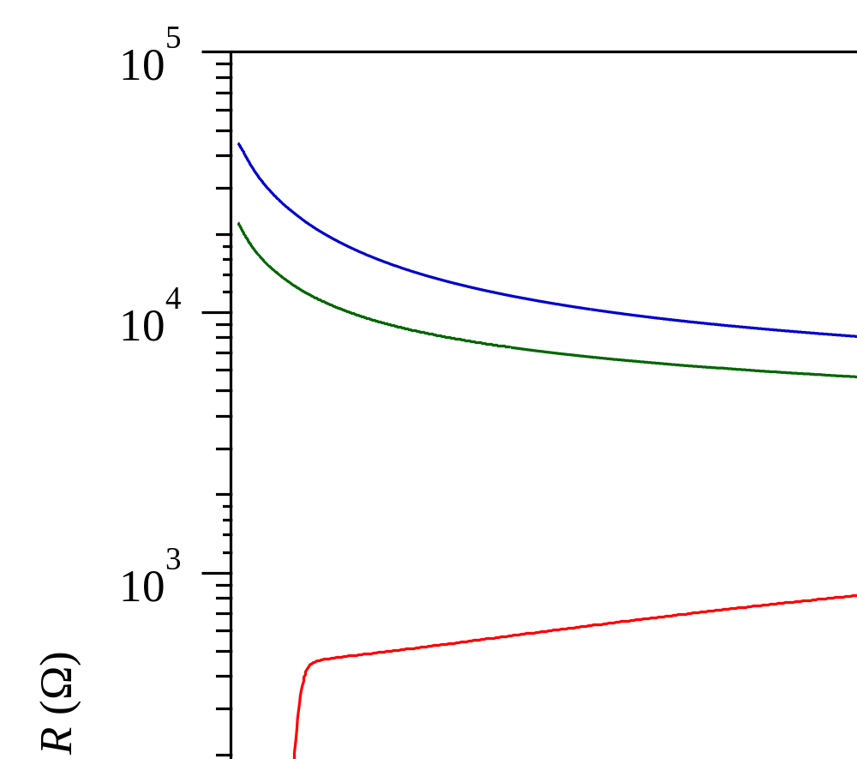
Figure S4. Temperature dependences of the resistance at 0, 2 and 4 GPa by employing the h-BN solid PTM.

