Supplementary Information

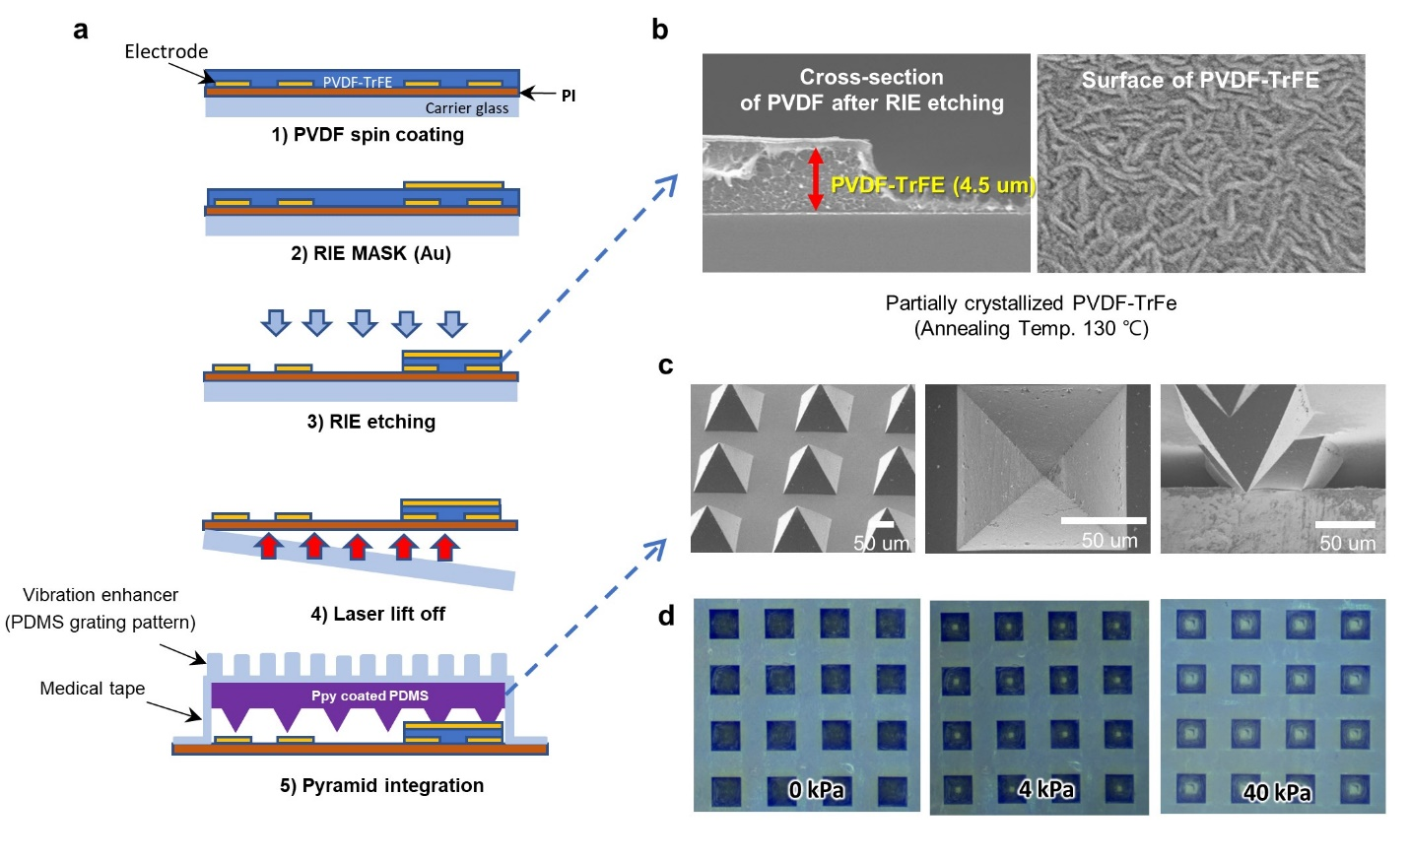
Supplementary Figure 1. Fabrication of the ultra-flexible bimodal sensor array. a, schematic of fabrication process flow, spin coating, e-beam deposition, RIE compatible on carrier glass and ultra-flexible sensor is peeled off by the laser lift-off process. b, SEM image of cross-section of PVDF-TrFE after RIE etching (left), c, SEM image of PDMS micro-pyramids, tilted view, top view, side view under pressure. d, optical microscopic images of deformed Micro-pyramid as the applied pressure: 0 kPa, 4 kPa and 40 kPa.
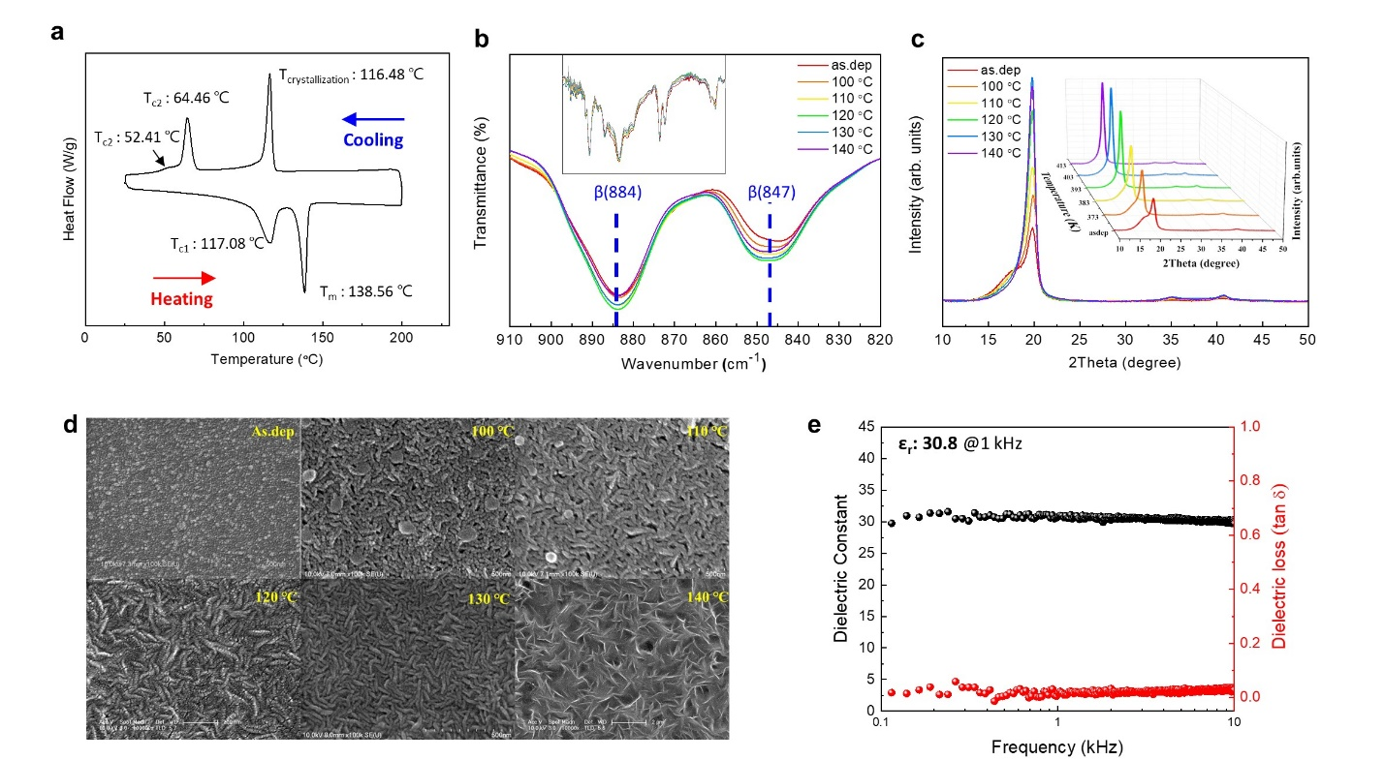
Supplementary Figure 2. PVDF-TrFE dynamic pressure sensor characteristics. (a) Differential scanning calorimetry results of PVDF-TrFE pellet. (b) FT-IR spectra, (c) XRD patterns, and (d) FE-SEM images of PVDF-TrFE thin films treated at different annealing temperatures (as.dep, 100, 110, 120, 130, and 140 °C). (e) Dielectric constant and dielectric loss of thin films annealed at 130 °C (εr: 30.8 @ 1 kHz).
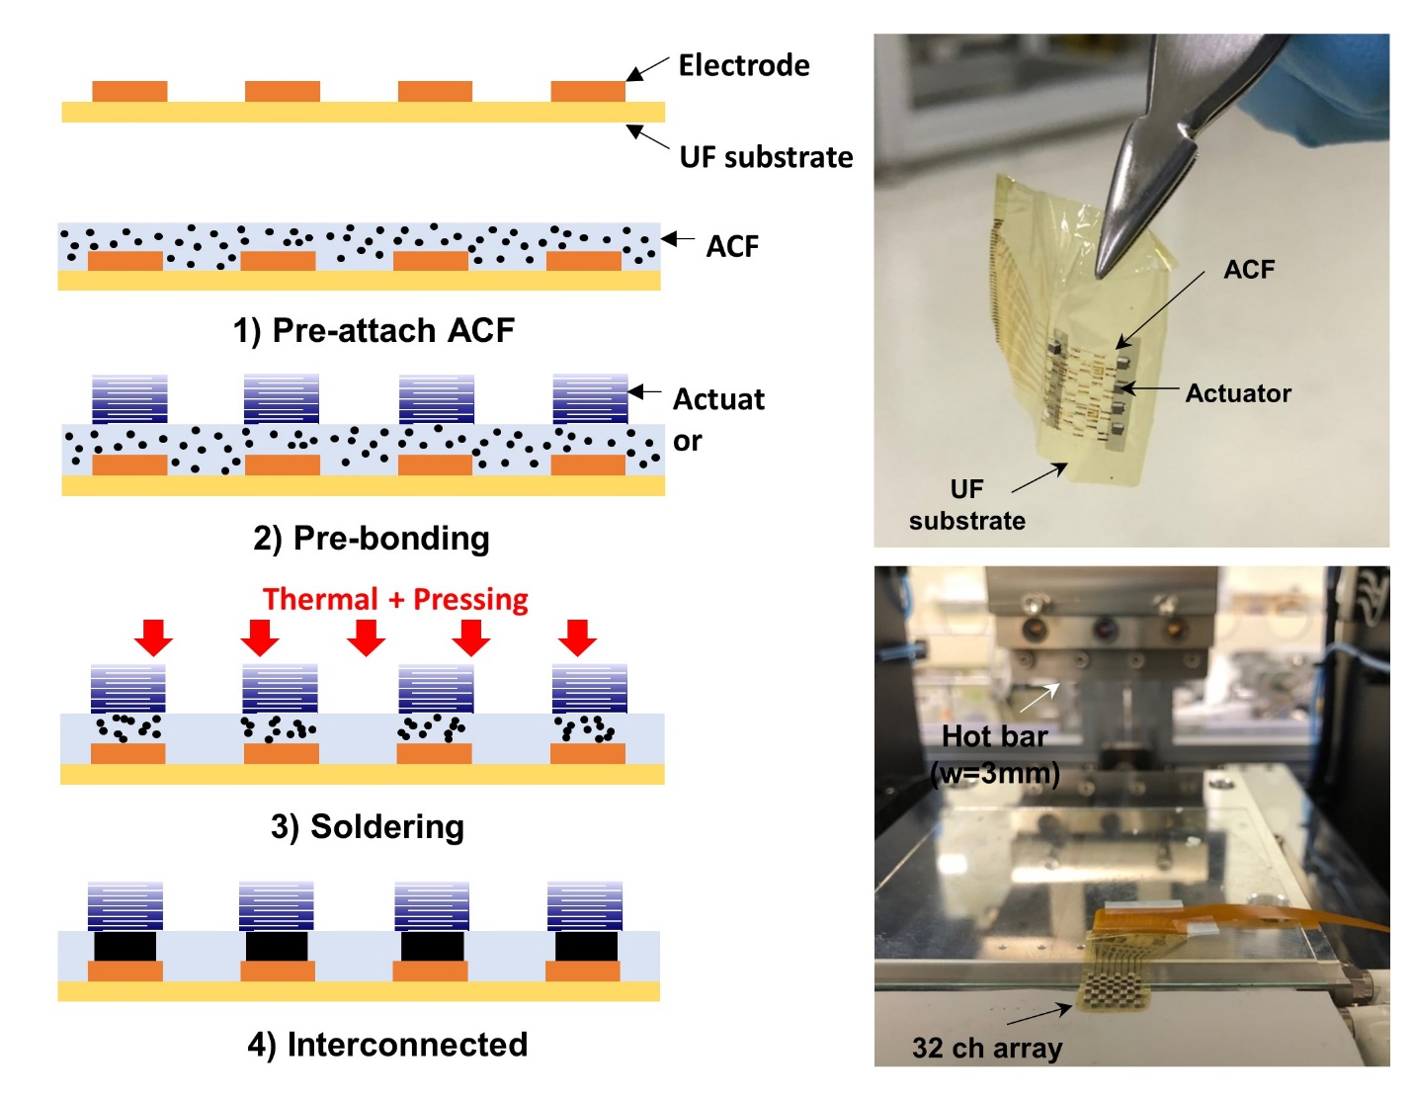
Supplementary Figure 3. Fabrication of ultra-flexible actuator array. Anisotropic conductive film (ACF) bonding has been used for establishing electrical contact between ultra-flexible substrate and miniaturized piezoelectric actuator.

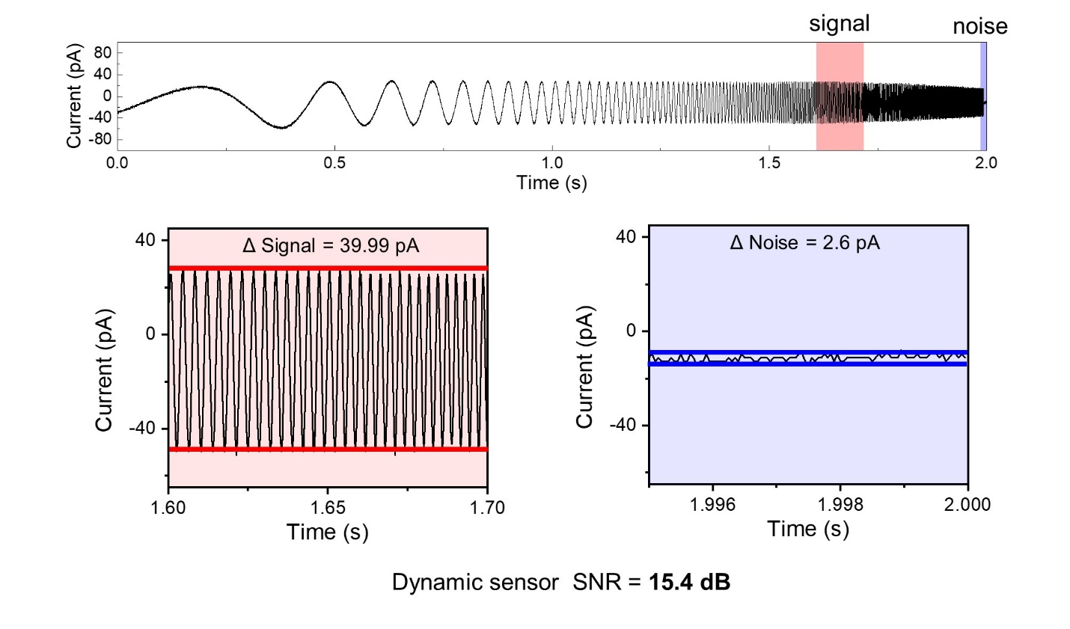
Supplementary Figure 4. Dynamic sensor characteristics, SNR of dynamic pressure sensor. Sine wave sweep signal (from 1 Hz to 1 kHz) was applied to the sensor and signal-to-noise ratio was calculated.

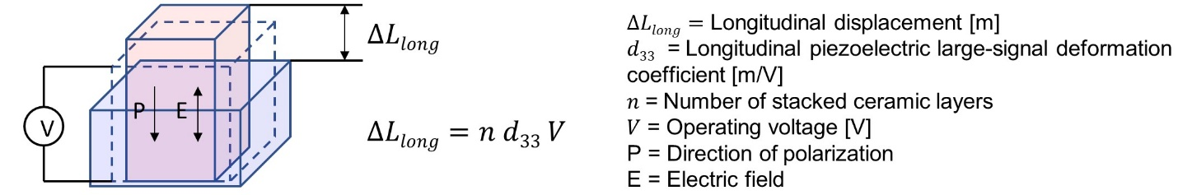
Supplementary Figure 5. Actuation mechanism of multi-layered piezo-ceramic actuator. Expansion and contraction of piezoelectric material when electric field is applied along the direction of polarization. Displacement is proportional to applied voltage, piezoelectric coefficient, and number of stacked ceramic layers.

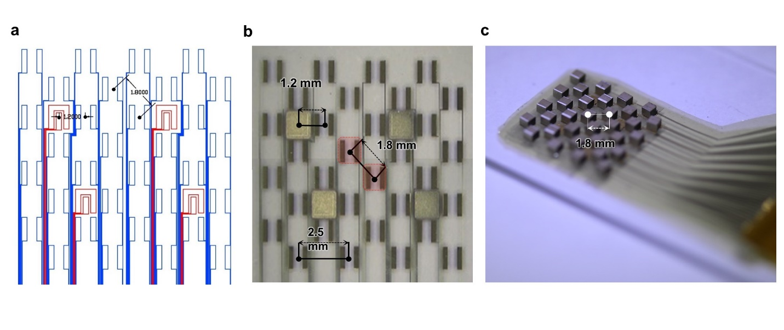Supplementary Figure 6. Dimensions of tactile sensor and actuator array. (a) Schematic of ultra-flexible substrate electrode patterns. Ultra-flexible substrate has a diagonal pitch resolution of 1.8 mm, with a chess board pattern. (b) Image of ultra-flexible bimodal tactile sensor with dimensions shown. (c) Image of ultra-flexible tactile actuator on slide glass with dimension.

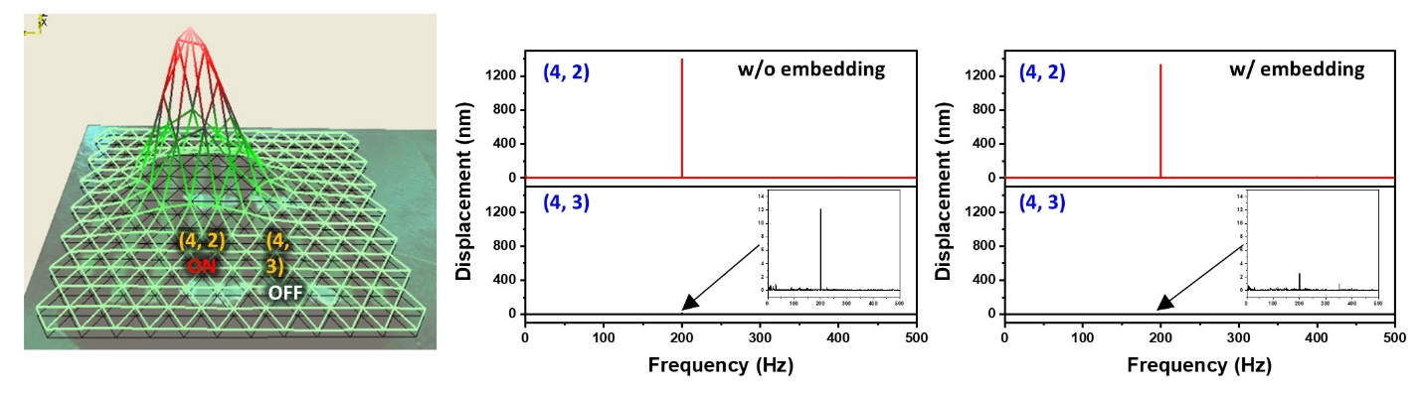
Supplementary Figure 7. Spatial resolution of sub-mm actuator array with and without PDMS embedding. Vibration at the adjacent pixel measured by LSV: the (4,2) pixel was turned on and vibrations at (4,2) and (4,3) were measured. Vibrational displacement was 12 nm at the (4,3) pixel without PDMS embedding and 3 nm with PDMS embedding.

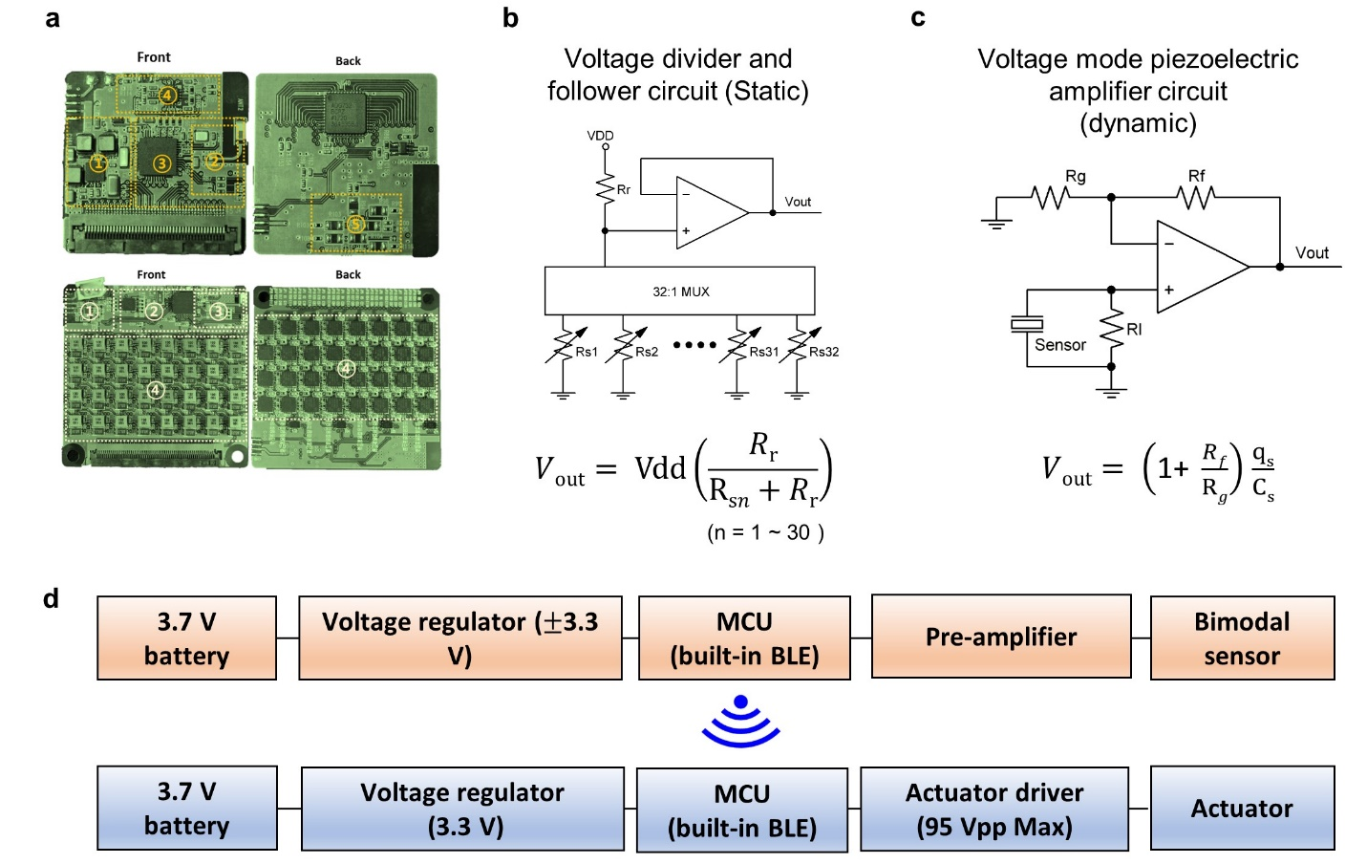
Supplementary Figure 8. Design and circuit diagram for tele-haptic system. (a) Image of wireless circuit board, (b) circuit diagram of static pressure sensor, (c) circuit diagram of dynamic pressure sensor, (d) system block diagram of wireless board for tele-haptic system.

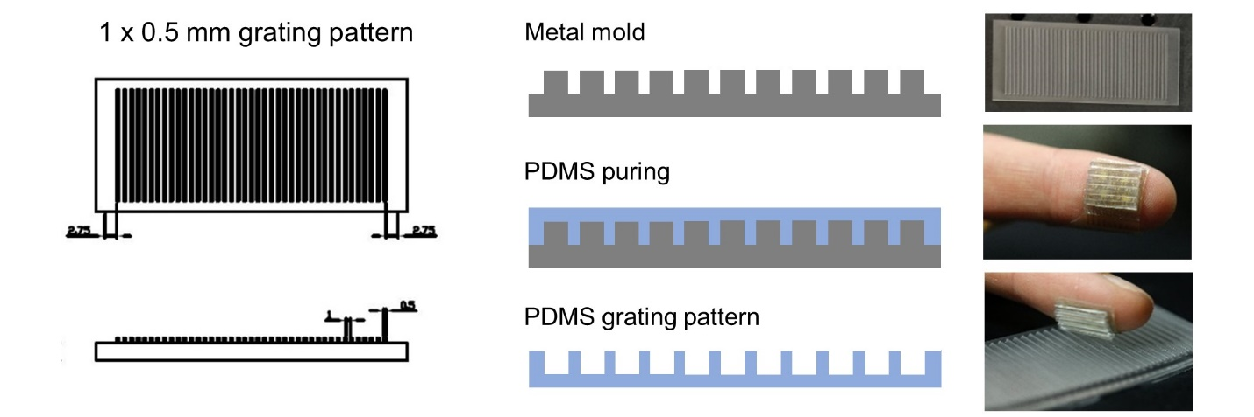

Supplementary Figure 9. PDMS grating pattern for vibration amplifier. Grating PDMS film has a width of 0.5 mm and a gap of 1 mm.

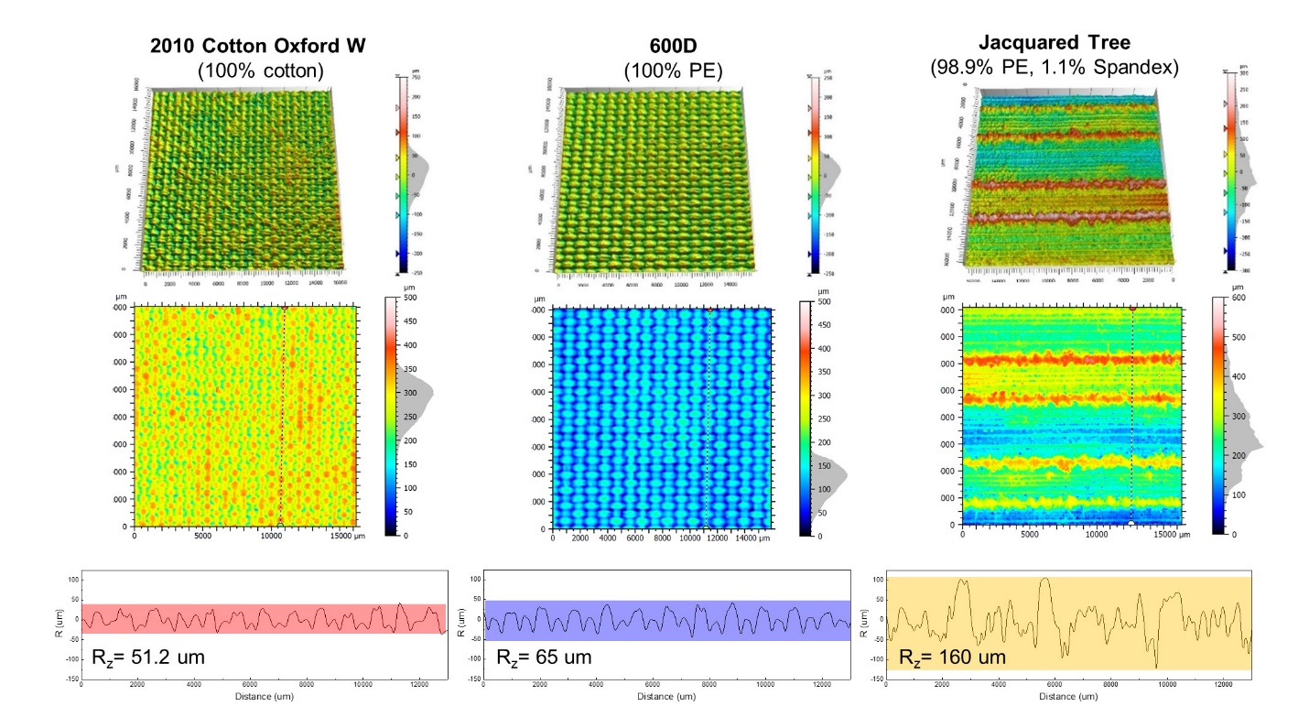
Supplementary Figure 10 Surface roughness of textile. (a) 3D scan of three different types of fabric (2010 cotton oxford W, 600D, and Jacquard Tree) by confocal microscopy. (b) 2D images of each fabric. (c) Line profile to quantify the roughness of fabrics in terms of the vertical average maximum height.

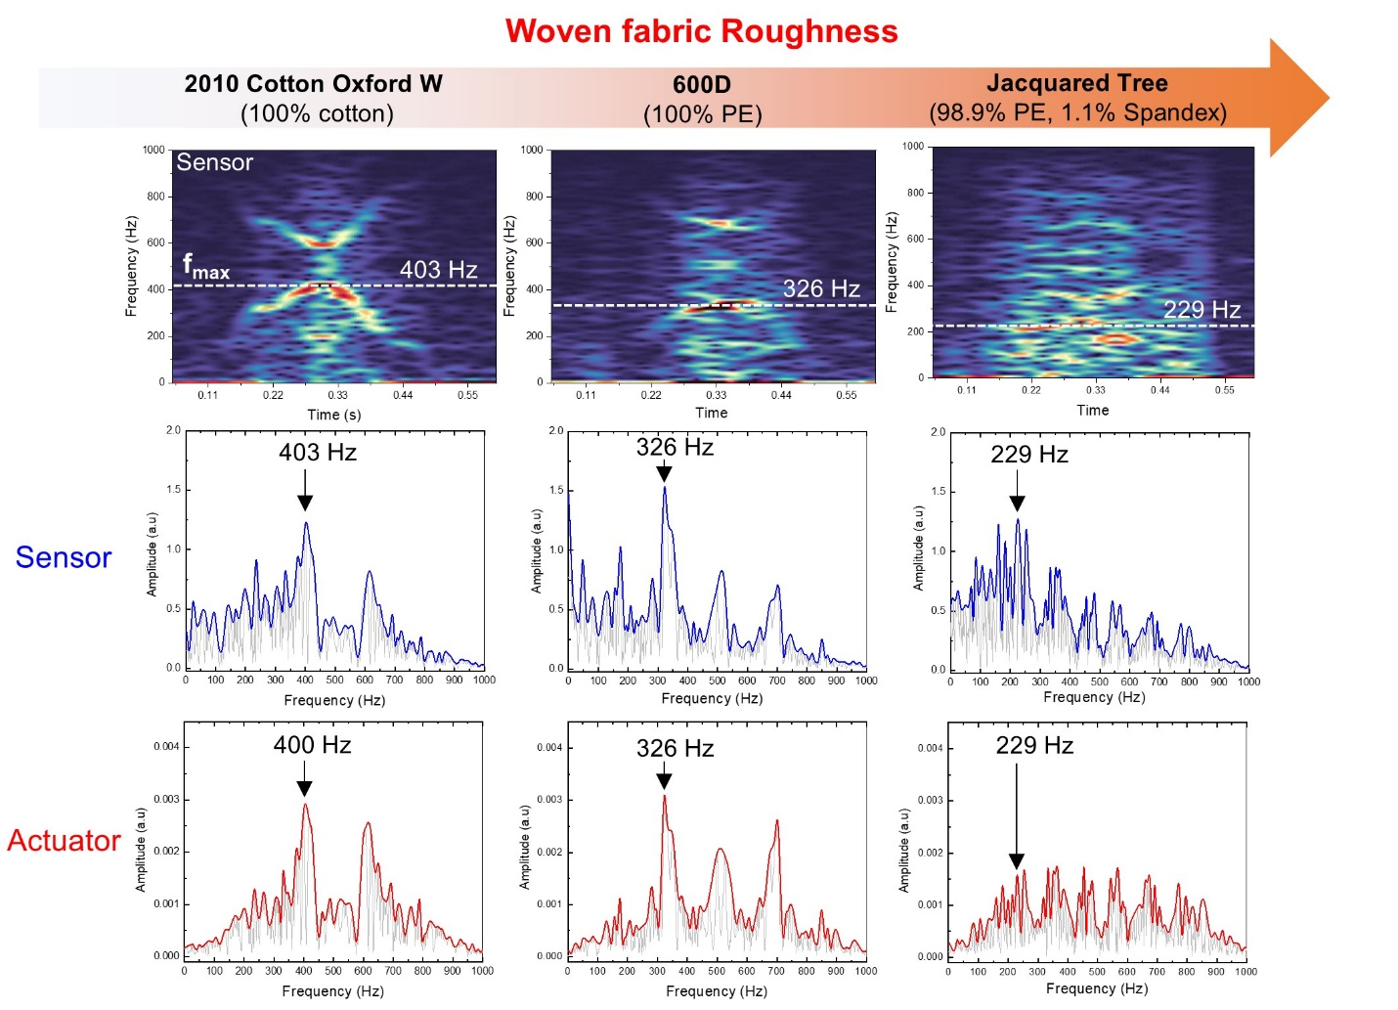
Supplementary Figure 11 Correlation of tactile acquisition and rendering system. STFT spectrogram of sensor signal corresponding to fabric 1: 2010 cotton oxford W, 100% cotton (left), fabric 2: 600D, 100% polyester (centre), and fabric 3: Jacquard Tree, 98.9% polyester, 1.1% Spandex (right). FFT of sensor (blue) and actuator signal (red).

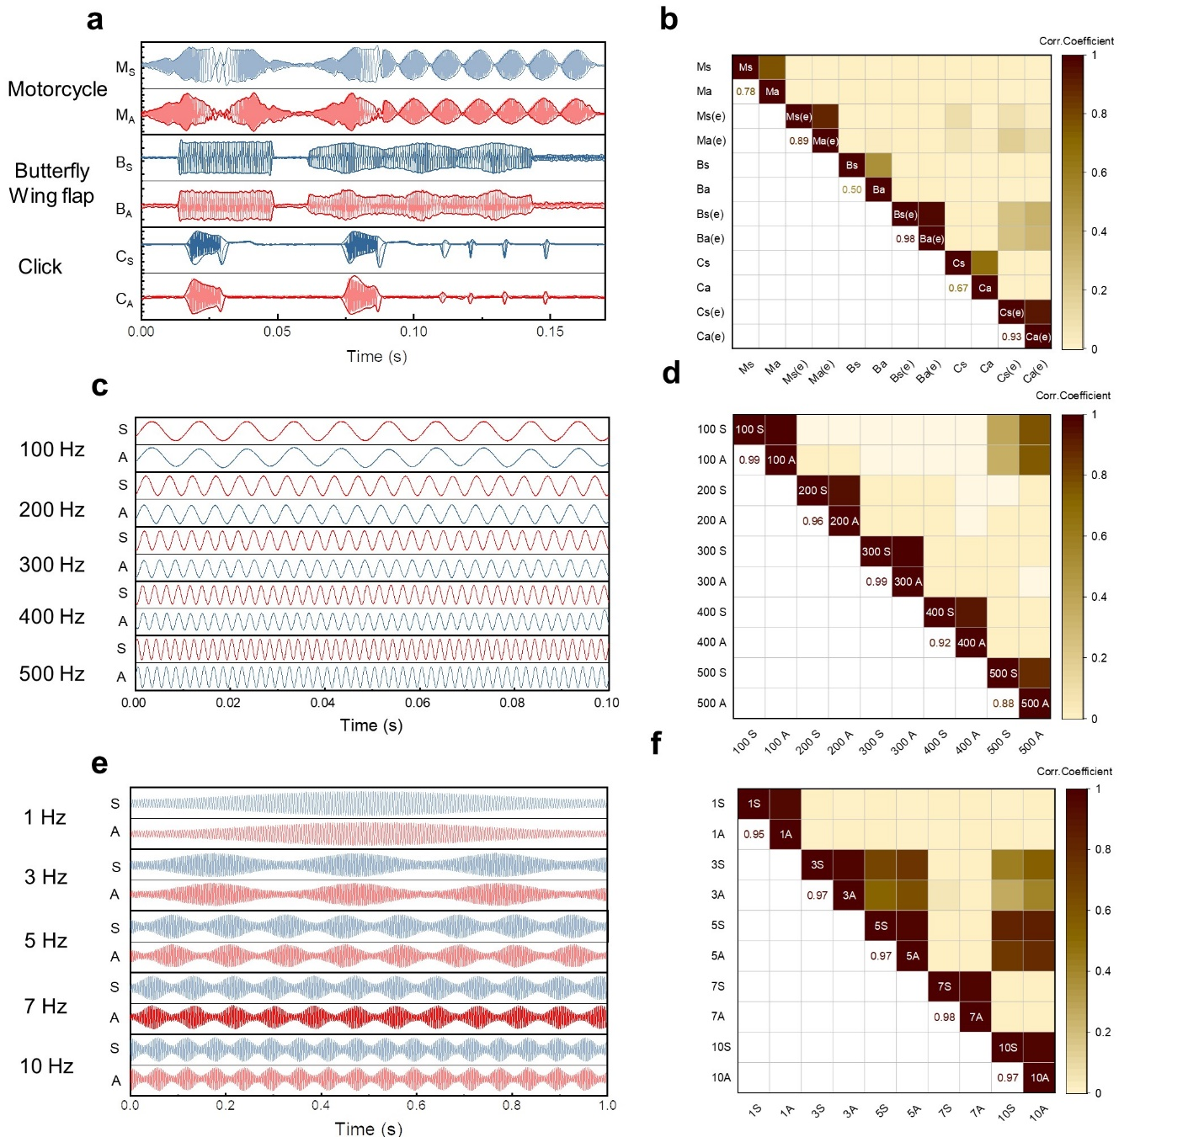

Supplementary Figure 12 Correlation of tactile acquisition and rendering system. Acquired tactile sensor output voltage(red) and rendered vibrational displacements(blue) of tactile actuator by transmitted sensor signals. The waveforms are a, motorcycle (M_{S}, M_{A}), butterfly flapping (B_{S}, B_{A}), and click (C_{S}, C_{A}) (boreas 1901 evaluate kit). b, correlation matrix correlogram between the signals acquired by the sensor (M_{S}, B_{S}, C_{S}) and the rendered actuator signals (M_{A}, B_{A}, C_{A}). The M_{S, A}(e), B_{S, A}(e) and C_{S, A}(e) were envelope of sensor and actuator signals. The waveforms of sensor and actuator c, at 100-500 Hz and e, amplitude modulation (1-10 Hz) with carrier frequency of 300 Hz. d, f, correlation matrix of each waveforms describing correlation coefficient between acquired sensor and rendered actuator signals.

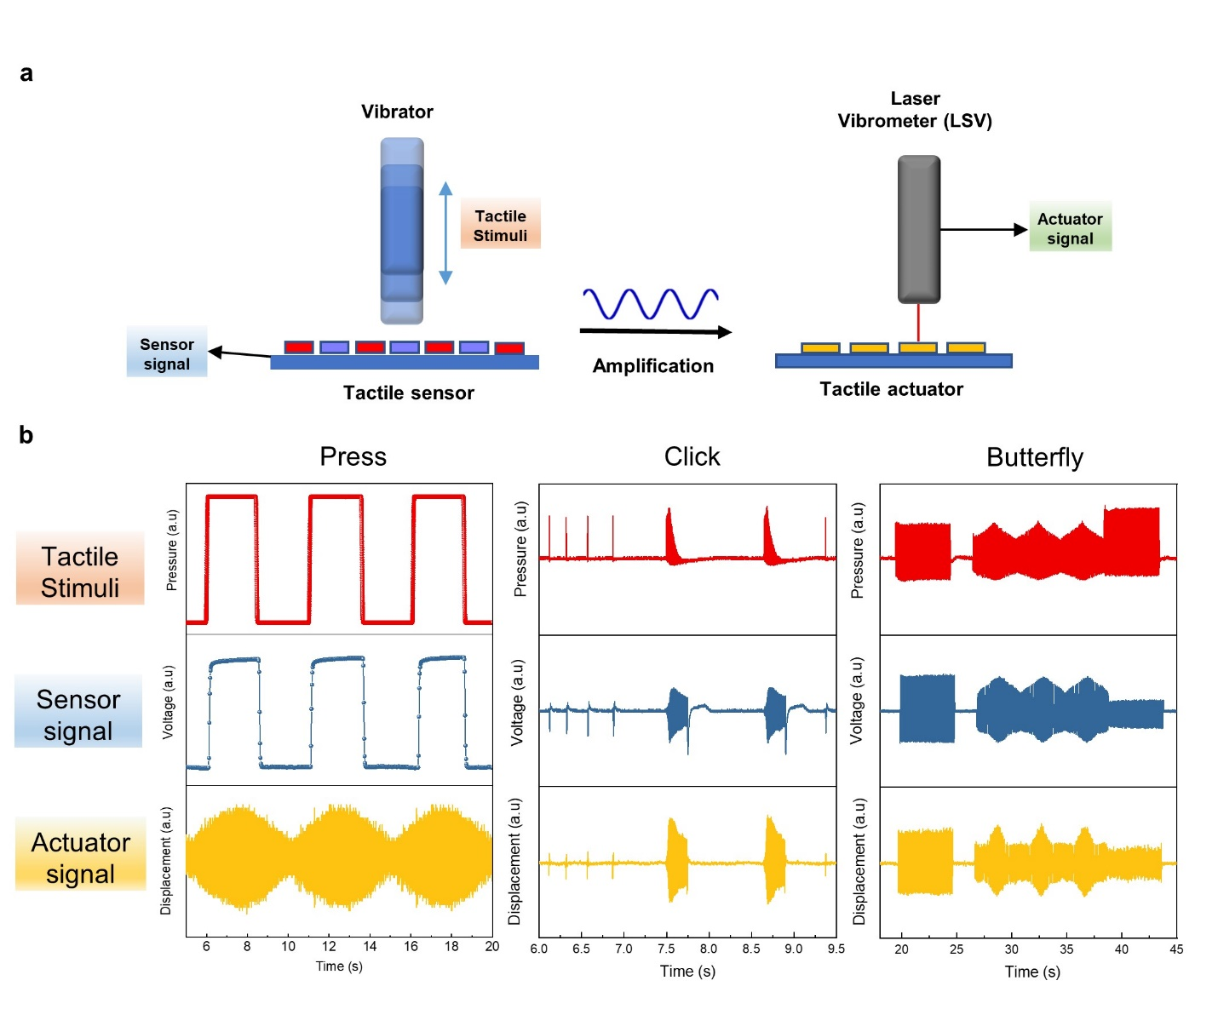Supplementary Figure 13 Demonstration of tactile acquisition and rendering system. (a) Schematic of tactile acquisition and rendering system. Tactile stimuli were generated by vibrator and detected by tactile sensor. Transmitted tactile signals are rendered by tactile actuator and measured by LSV equipment. (b) Measured tactile stimuli, sensor signal, and actuator signal during the press, by applying click and butterfly wing flapping pattern.

