A Universal Modular High-Plex MALDI Mass Spectrometry Imaging Platform

Alexandre Goossen^{1,2,†}, Laurine Lagache^{1,†}, Yanis Zirem^{1,†}, Tommy Zhang³, Julien Salzet¹, Soulaimane Aboulouard¹, Vincent Rigolot², Christophe Biot², Nawale Hajjaji^{1,4}, Julia Laskin³, Michel Salzet^{1,5,* ‡}, Cédric Lion^{2,*‡}, Isabelle Fournier^{1,5,* ‡}

¹Univ. Lille, Inserm, CHU Lille, U1192 - Protéomique Réponse Inflammatoire Spectrométrie de Masse - PRISM, F-59000 Lille, France
²Univ. Lille, CNRS, UMR8576 – Unité de Glycobiologie Structurale et Fonctionnelle, UGSF, F-59000 Lille, France
³J. Tarpo Jr. and M. Tarpo Department of Chemistry, College of Science, Purdue University, West Lafayette, Indiana 47907, United States.
⁴Department of Senology, Oscar Lambret Center, F-59000 Lille, France
⁵Institut Universitaire de France, 75000 Paris

† Equal contribution
*Co-Corresponding author
‡ Equal contribution

Correspondence to:
Prof. Isabelle Fournier, Réponse Inflammatoire et Spectrométrie de Masse (PRISM) - Inserm U1192 - Bât SN3, 1er étage, Campus Cité Scientifique, Université de Lille, F-59655 Villeneuve d’Ascq Cedex. Phone: +33 (0)320 434 194; email: isabelle.fournier@univ-lille.fr
Prof. Michel Salzet, Réponse Inflammatoire et Spectrométrie de Masse (PRISM) - Inserm U1192 - Bât SN3, 1er étage, Campus Cité Scientifique, Université de Lille, F-59655 Villeneuve d’Ascq Cedex. Phone: +33 (0)320 434 194; email: michel.salzet@univ-lille.fr.
Prof. Cédric Lion, Unité de Glycobiologie Structurale et Fonctionnelle, UGSF - CNRS- Bât C9, 2e étage, Campus Cité Scientifique, Université de Lille, F-59655 Villeneuve d’Ascq Cedex. Phone: +33 (0)320 436 908; email: cedric.lion@univ-lille.fr
A

B
Alcohol | Arginine Tag | Reaction yield (u.)
Methanol | L-Arginine methyl ester dihydrochloride  C₇H₁₆N₄O₂ · 2HCl | 94%
Ethanol | L-Arginine ethyl ester dihydrochloride  C₈H₁₈N₄O₂ · 2HCl | 72%
Deuterated methanol | L-Arginine methyl-d3 ester dihydrochloride  C₇H₁₃D₃N₄O₂ · 2HCl | 67%
Isopropanol | L-Arginine isopropyl ester dihydrochloride  C₉H₂₀N₄O₂ · 2HCl | 93%
Butanol | L-Arginine butanyl ester dihydrochloride  C₁₀H₂₂N₄O₂ · 2HCl | 78%
Isoamyl alcohol | L-Arginine isoamyl ester dihydrochloride  C₁₁H₂₄N₄O₂ · 2HCl | 80%
Allyl alcohol | L-Arginine allyl ester dihydrochloride  C₉H₁₈N₄O₂ · 2HCl | 65%
¹⁵N₂ Ethanol | L-Arginine-(guanidineimino-¹⁵N₂) ethyl ester dihydrochloride  C₈H₁₈N₂¹⁵N₂O₂ · 2HCl | 81%
Isopropanol¹⁵N₂ | L-Arginine-(guanidineimino-¹⁵N₂) isopropyl ester dihydrochloride  C₉H₂₀N₂¹⁵N₂O₂ · 2HCl | 75%
Butanol¹⁵N₂ | L-Arginine-(guanidineimino-¹⁵N₂) butanyl ester dihydrochloride  C₁₀H₂₂N₂¹⁵N₂O₂ · 2HCl | 83%
Supplementary Table 1: Arginine and ester derivatives MS reporter structures synthesized before addition onto the clickable UV photocleavable moiety. (A) Esterification reaction used to functionalize the arginine and (B) Table of the different esters generated and their respective reaction yield.

A

Clickable Photocleavable Tags | Tag MWmono (u.) | Reaction yield (u.) | Arginine Derivative MS reporter | MS reporter MWmono (u.)  (after UV exposition) | m/z reporter MWmono (u.)  (after UV exposition)
methyl ((1-(4-((1-azido-13-oxo-3,6,9-trioxa-12-azahexadecan-16-yl)oxy)-5-methoxy-2-nitrophenyl)ethoxy)carbonyl)argininate  C₂₉H₄₇N₉O₁₂ | 713.75 | 48% | T1:  L-Arginine methyl ester | 188.1273 | 189.1346
ethyl ((1-(4-((1-azido-13-oxo-3,6,9-trioxa-12-azahexadecan-16-yl)oxy)-5-methoxy-2-nitrophenyl)ethoxy)carbonyl)argininate  C₃₀H₄₉N₉O₁₂ | 727.77 | 27% | T2:  L-Arginine ethyl ester | 202.1430 | 203.1503
methyl-d3 ((1-(4-((1-azido-13-oxo-3,6,9-trioxa-12-azahexadecan-16-yl)oxy)-5-methoxy-2-nitrophenyl)ethoxy)carbonyl)argininate  C₂₉H₄₄D₃N₉O₁₂ | 716.76 | 43% | T3:  L-Arginine methyl-d3 ester | 191.1479 | 192.1552
isopropyl ((1-(4-((1-azido-13-oxo-3,6,9-trioxa-12-azahexadecan-16-yl)oxy)-5-methoxy-2-nitrophenyl)ethoxy)carbonyl)argininate  C₃₁H₅₁N₉O₁₂ | 741.80 | 18% | T4:  L-Arginine isopropyl ester | 216.1586 | 217.1659
butyl ((1-(4-((1-azido-13-oxo-3,6,9-trioxa-12-azahexadecan-16-yl)oxy)-5-methoxy-2-nitrophenyl)ethoxy)carb.nyl)argininate  C₃₂H₅₃N₉O₁₂ | 755.83 | 63% | T5:  L-Arginine butanyl ester | 230.1743 | 231.1816
isopentyl ((1-(4-((1-azido-13-oxo-3,6,9-trioxa-12-azahexadecan-16-yl)oxy)-5-methoxy-2-nitrophenyl)ethoxy)carbonyl)argininate  C₃₃H₅₅N₉O₁₂ | 769.85 | 50% | T6:  L-Arginine isoamyl ester | 244.1899 | 245.1972
allyl ((1-(4-((1-azido-13-oxo-3,6,9-trioxa-12-azahexadecan-16-yl)oxy)-5-methoxy-2-nitrophenyl)ethoxy)carbonyl)argininate  C₃₁H₄₉N₉O₁₂ | 739.86 | 33% | T7:  L-Arginine allyl ester | 214.1430 | 215.1503
ethyl ((1-(4-((1-azido-13-oxo-3,6,9-trioxa-12-azahexadecan-16-yl)oxy)-5-methoxy-2-nitrophenyl)ethoxy)carbonyl)argininate -(guanidineimino-¹⁵N₂)  C₃₀H₄₉N₇¹⁵N₂O₁₂ | 729.76 | 35% | ‍T8:  L-Arginine-(guanidineimino-¹⁵N₂) ethyl ester | 204.1371 | 205.1444
isopropyl ((1-(4-((1-azido-13-oxo-3,6,9-trioxa-12-azahexadecan-16-yl)oxy)-5-methoxy-2-nitrophenyl)ethoxy)carbonyl)argininate-(guanidineimino-¹⁵N₂)  C₃₁H₅₁N₇¹⁵N₂O₁₂ | 743.79 | 38% | ‍T9:  L-Arginine-(guanidineimino-¹⁵N₂) isopropyl ester | 218.1527 | 219.1600
butyl ((1-(4-((1-azido-13-oxo-3,6,9-trioxa-12-azahexadecan-16-yl)oxy)-5-methoxy-2-nitrophenyl)ethoxy)carbonyl)argininate-(guanidineimino-¹⁵N₂)  C₃₂H₅₃N₇¹⁵N₂O₁₂ | 757.81 | 42% | ‍T10:  L-Arginine-(guanidineimino-¹⁵N₂) butanyl ester | 232.1684 | 233.1757
Supplementary Table 2: List of clickable Tags and their corresponding MS reporters. (A) Coupling reaction for the functionalization of photocleavable probes with arginine esters and (B) Table include the molecular weight given in monoisotopic masses of the clickable tags and expected photocleavable products as well as the expected m/z in the MALD-MS.

A
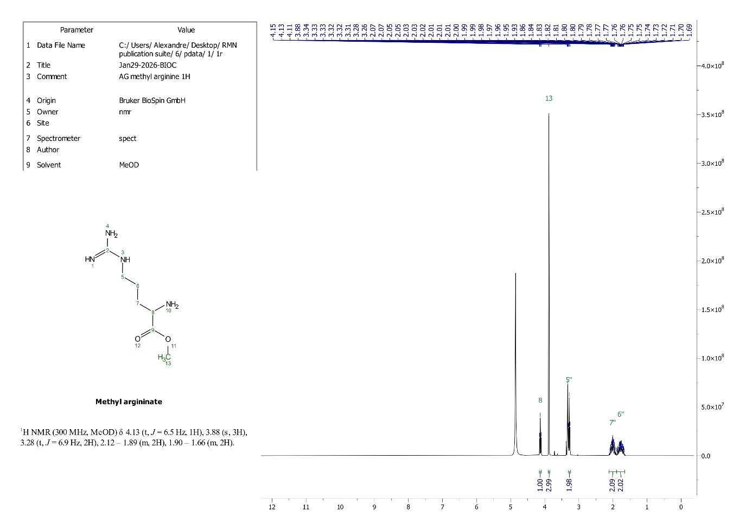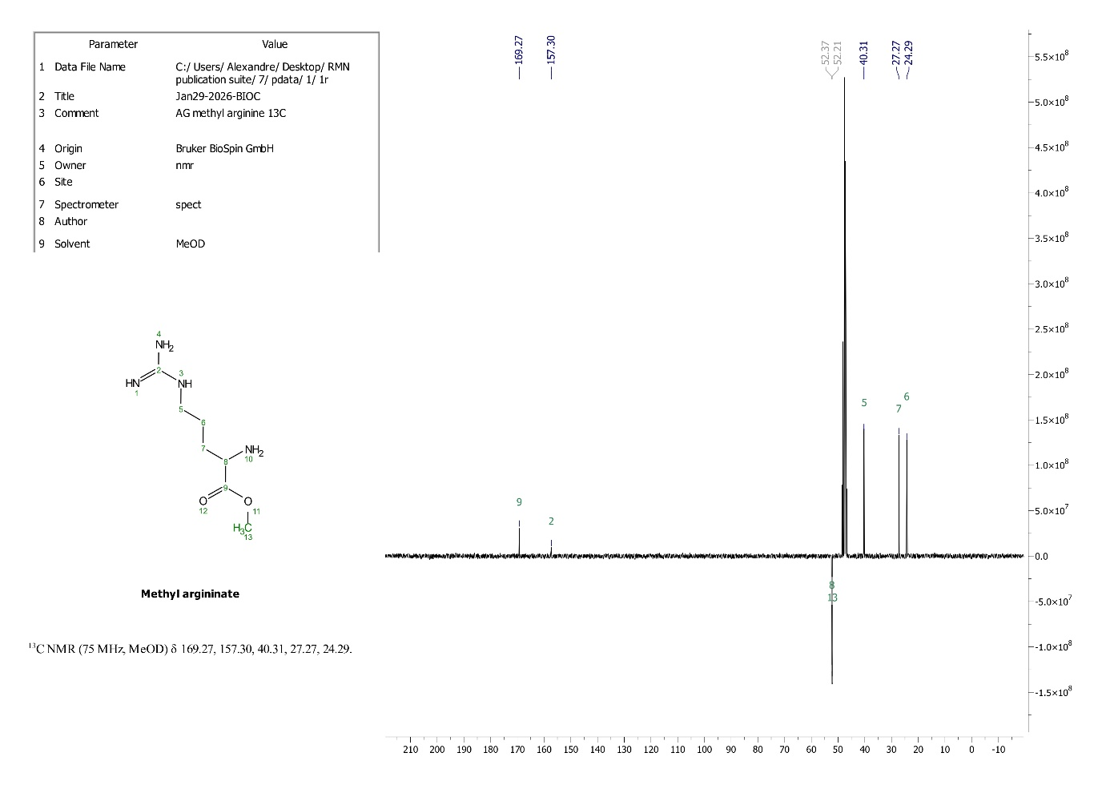

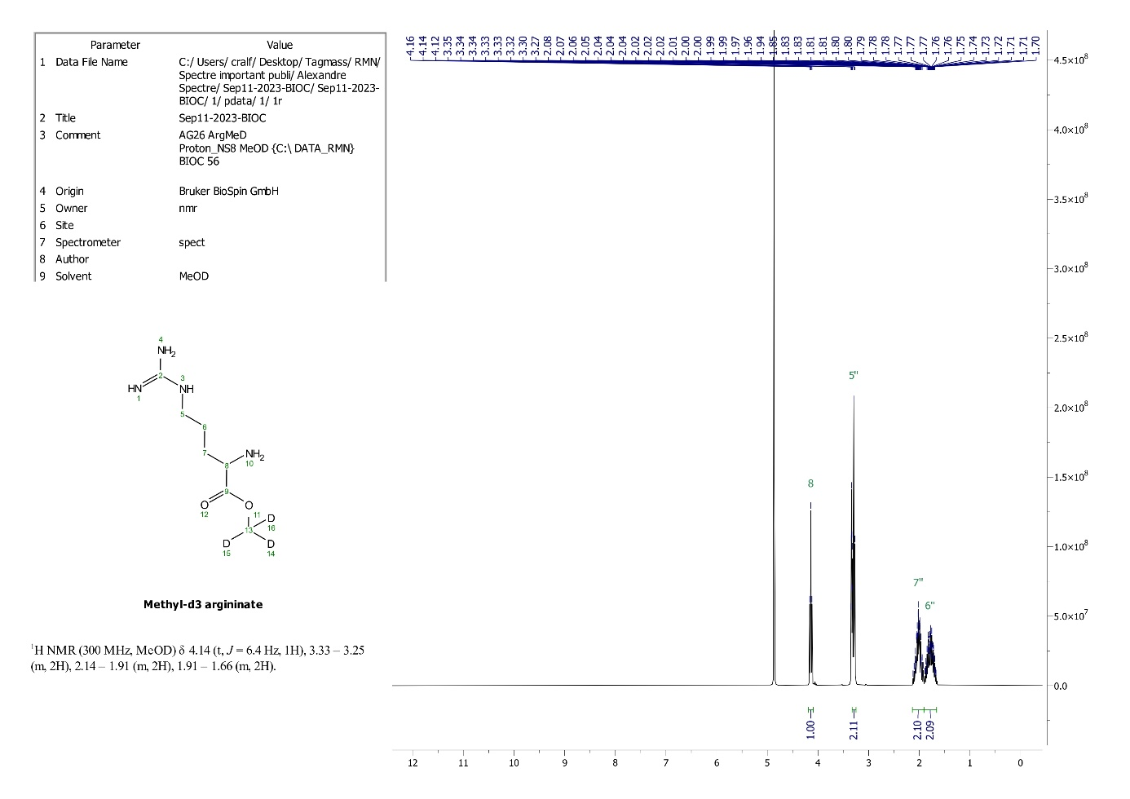
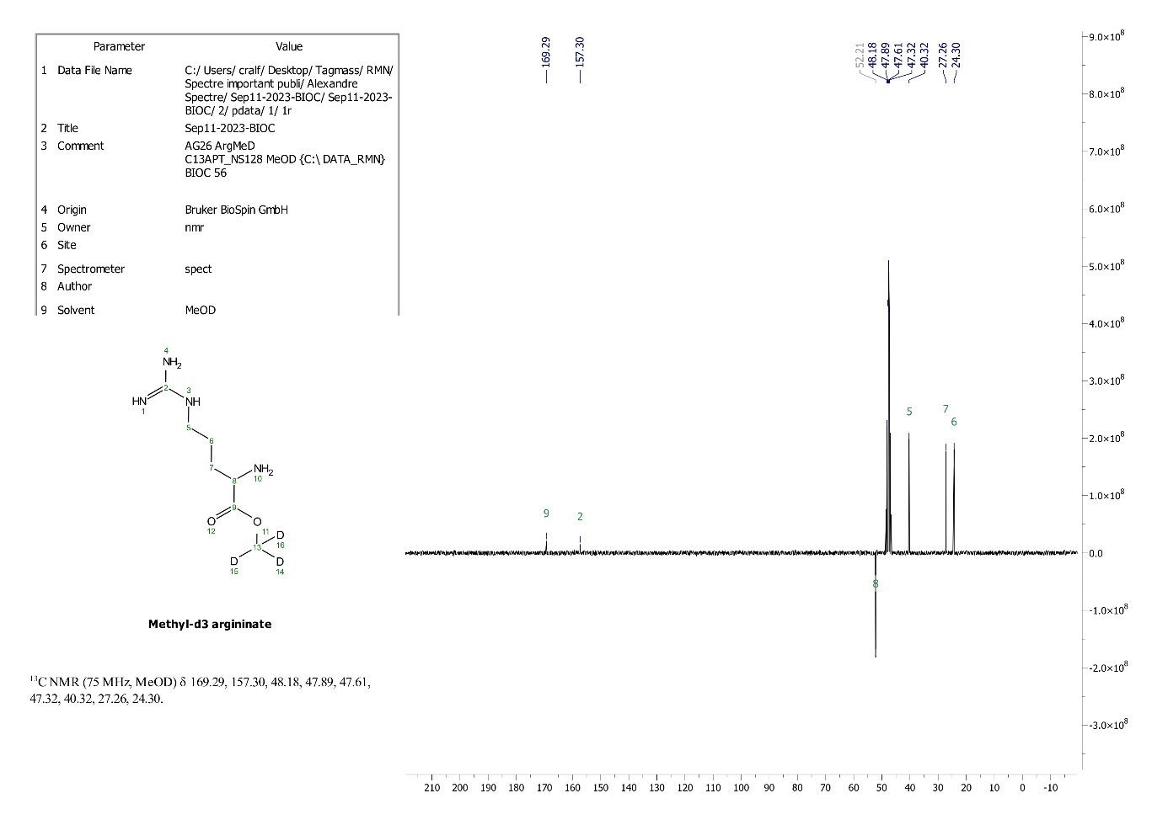

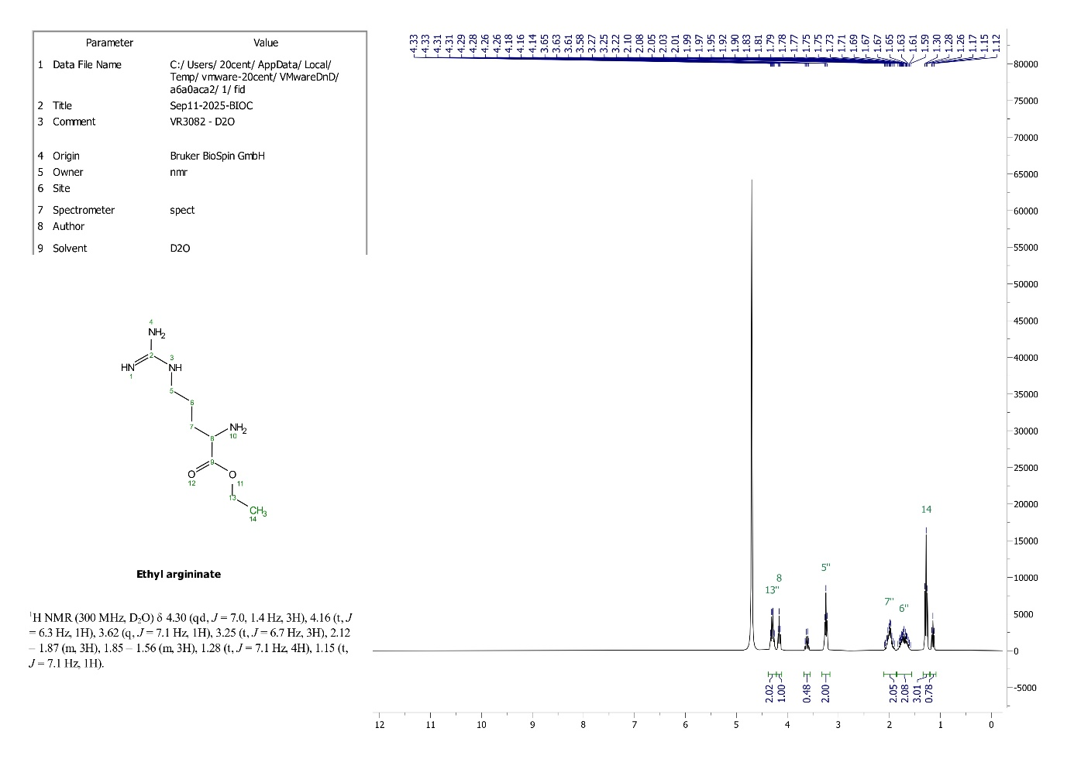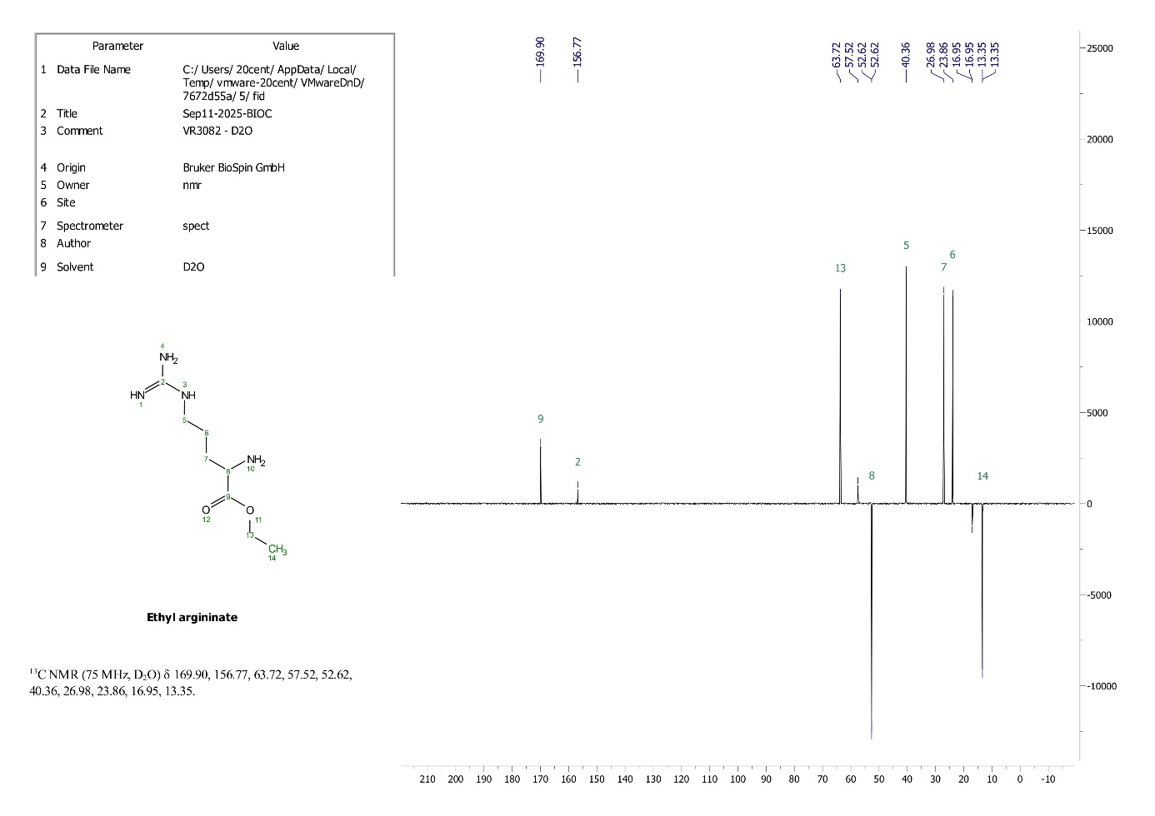

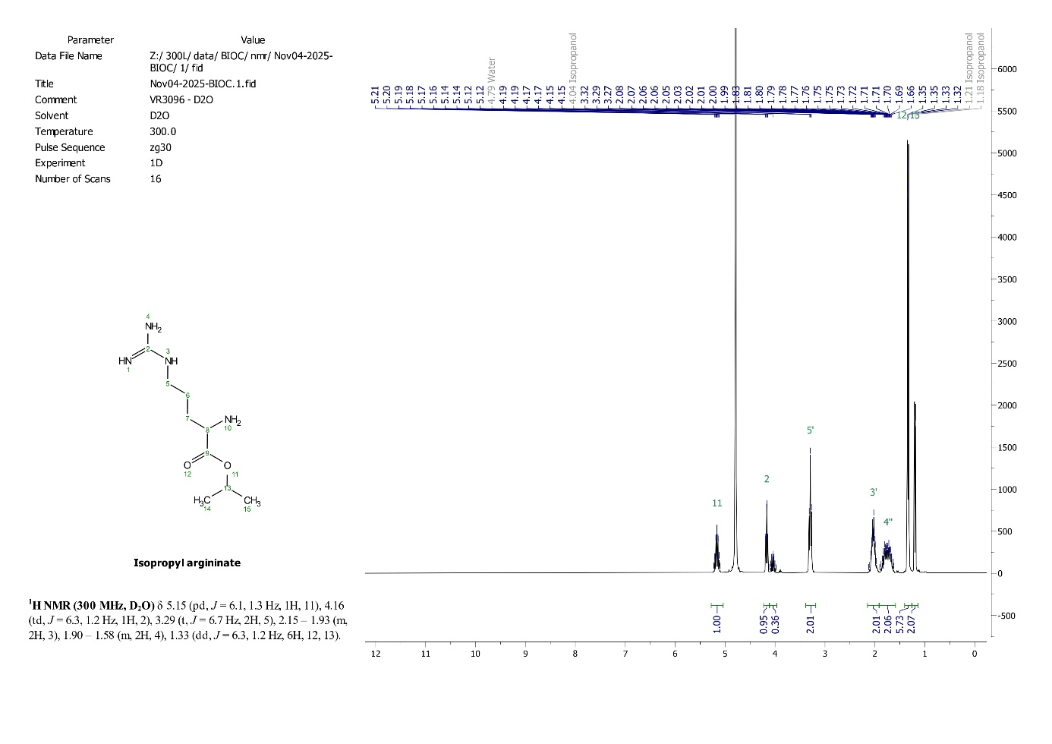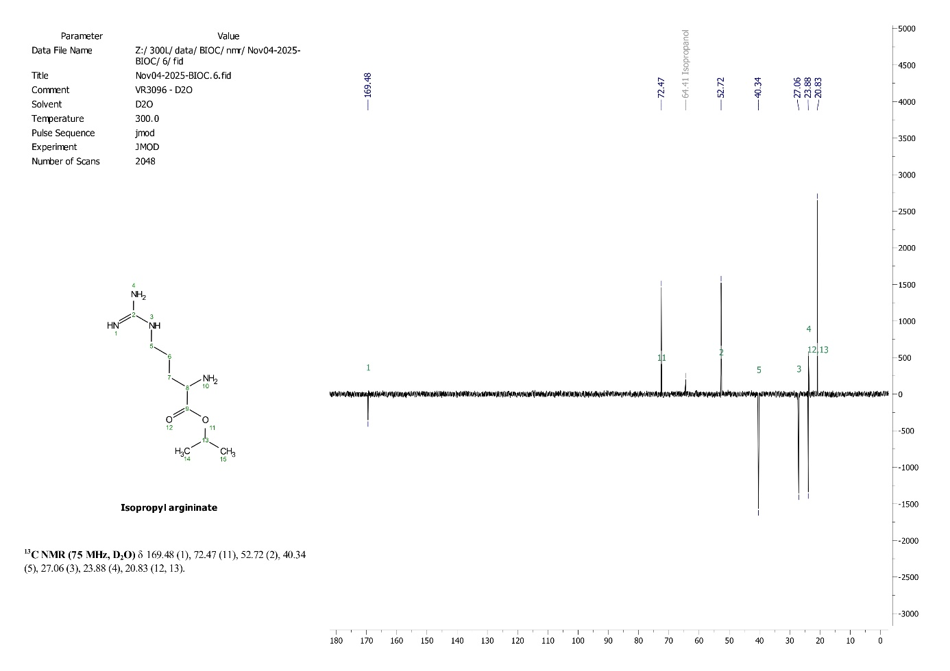

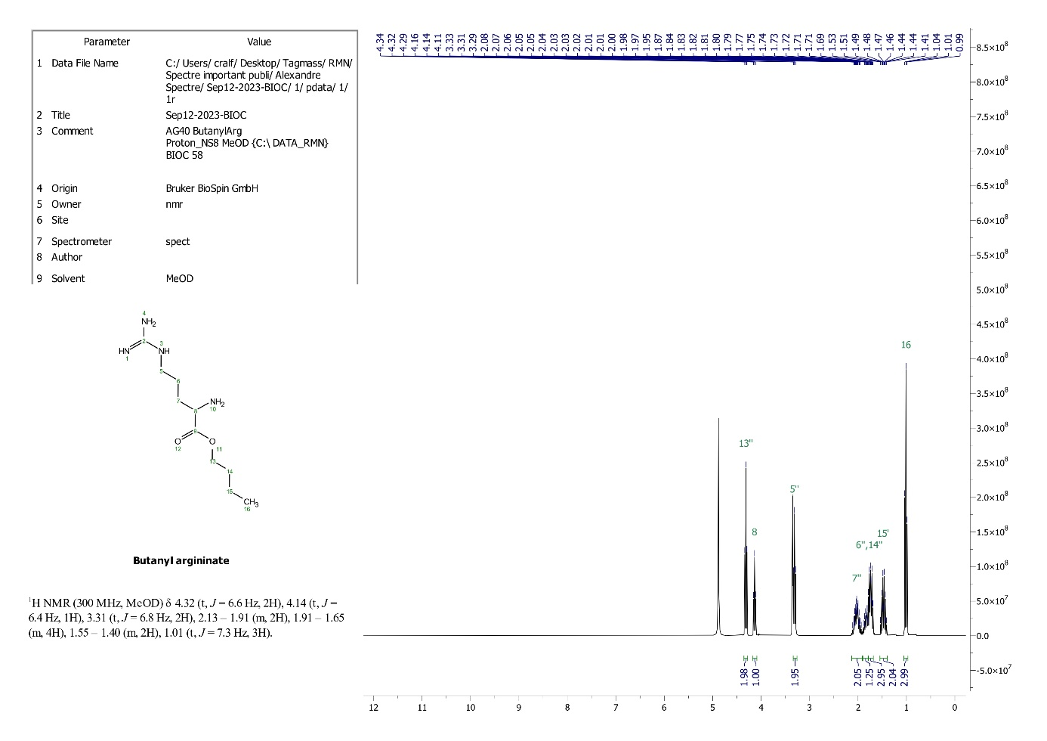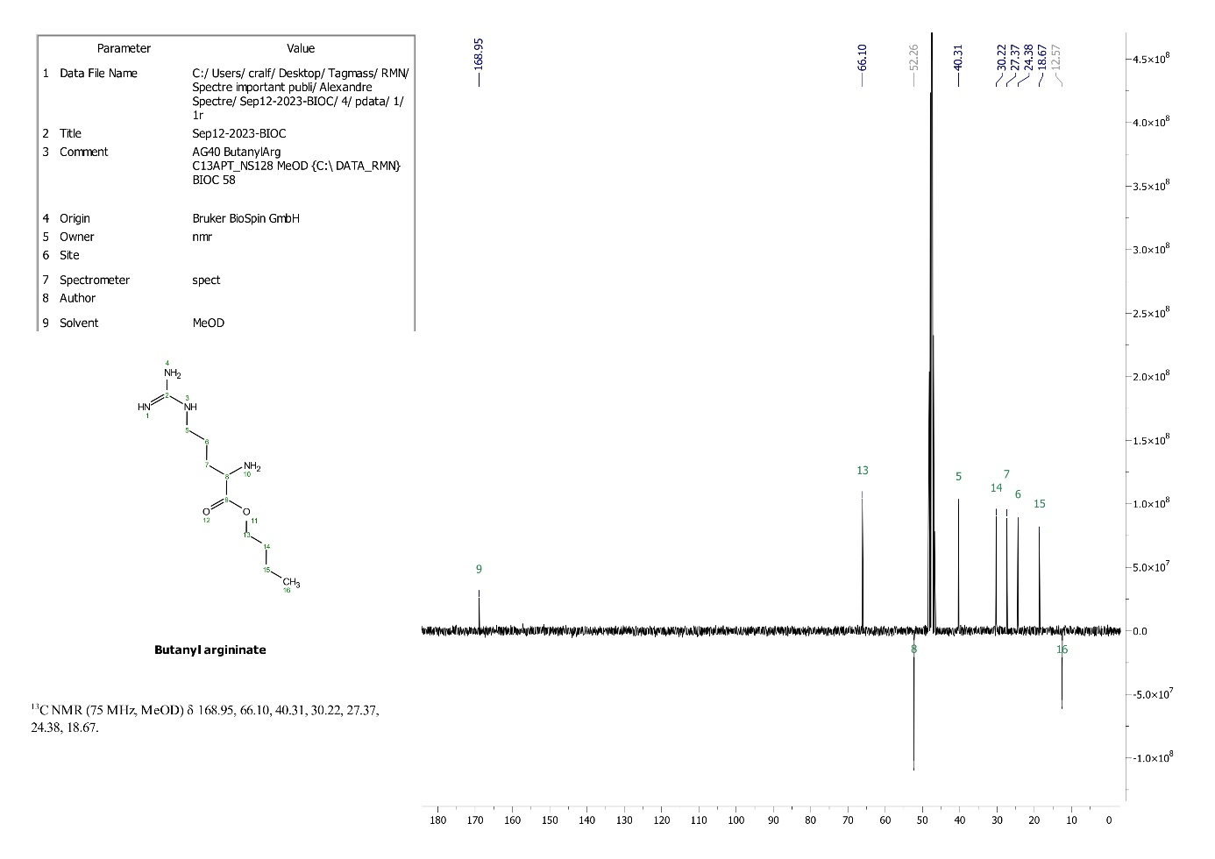

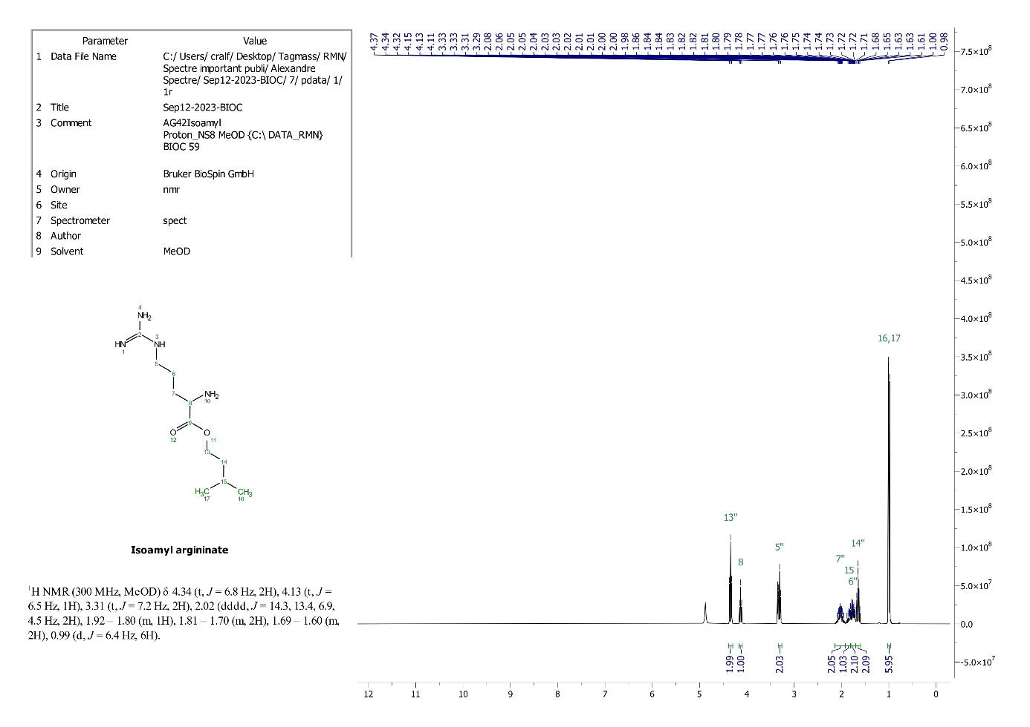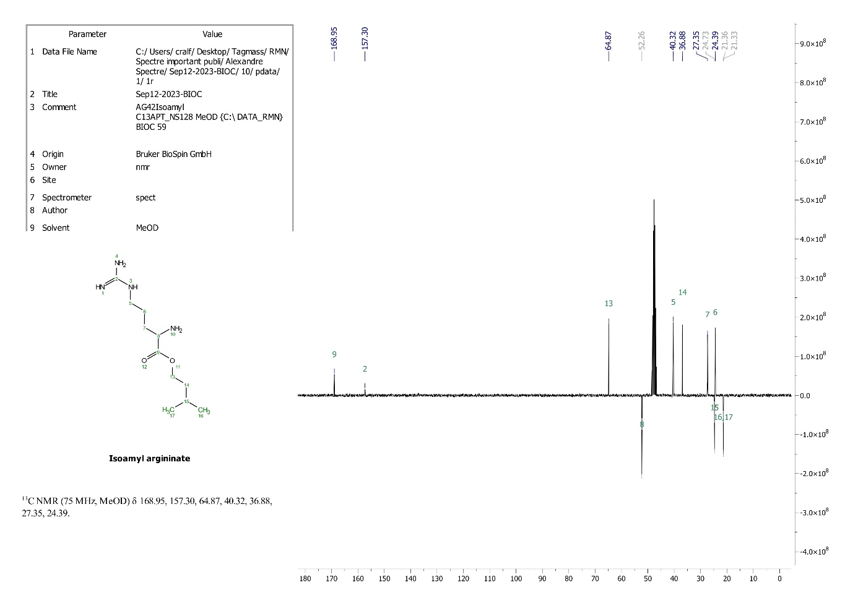

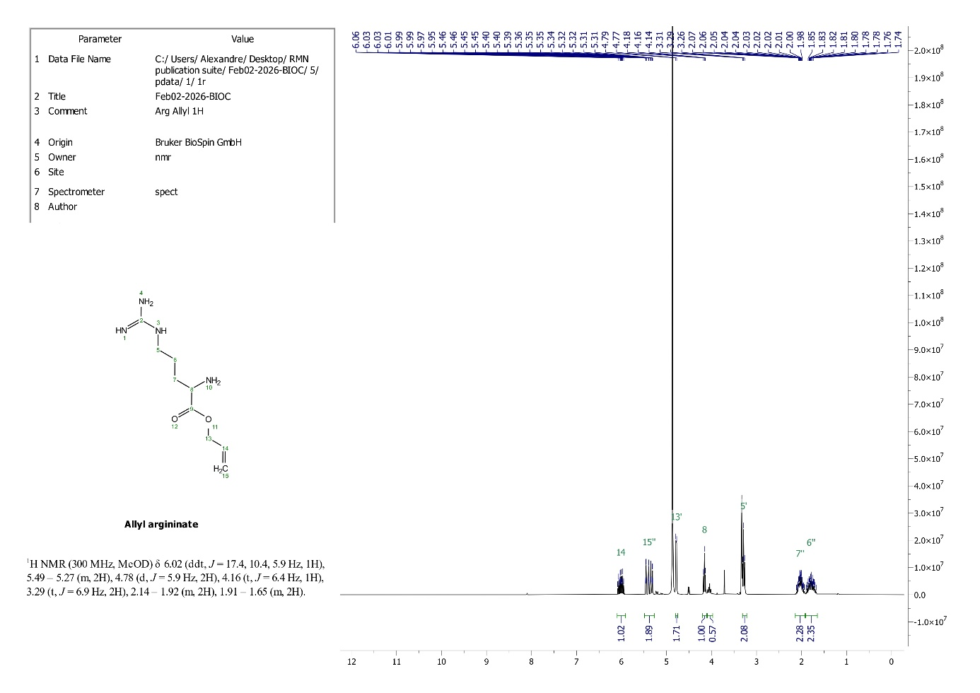
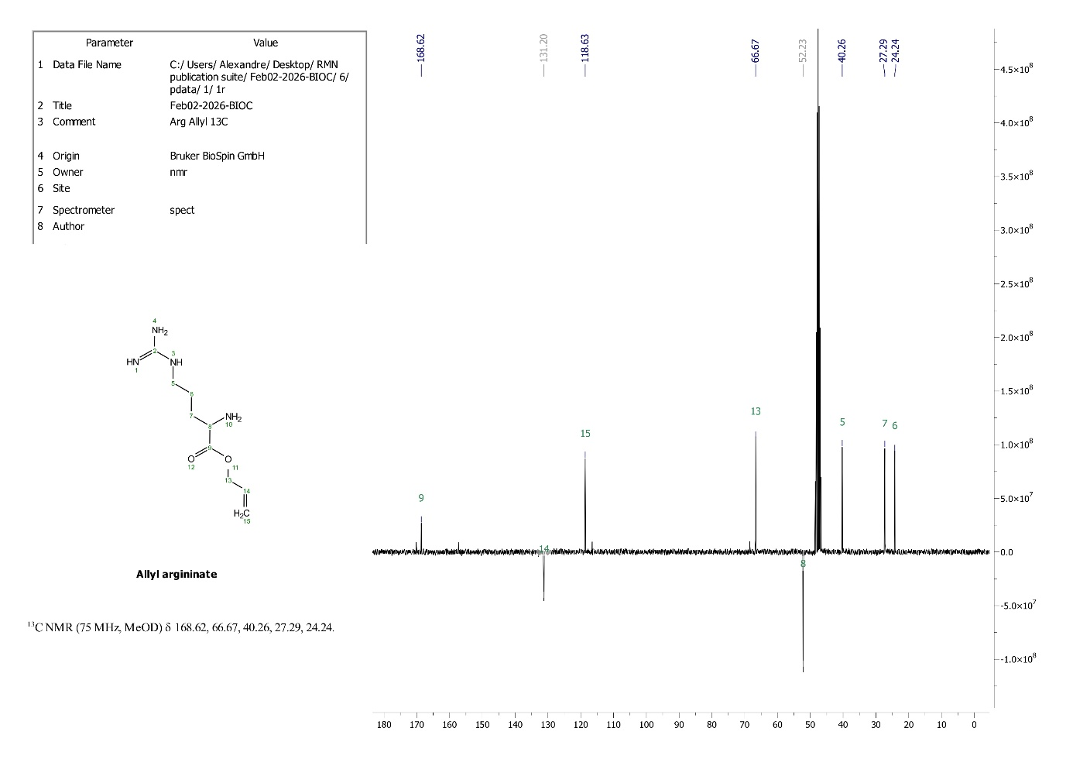

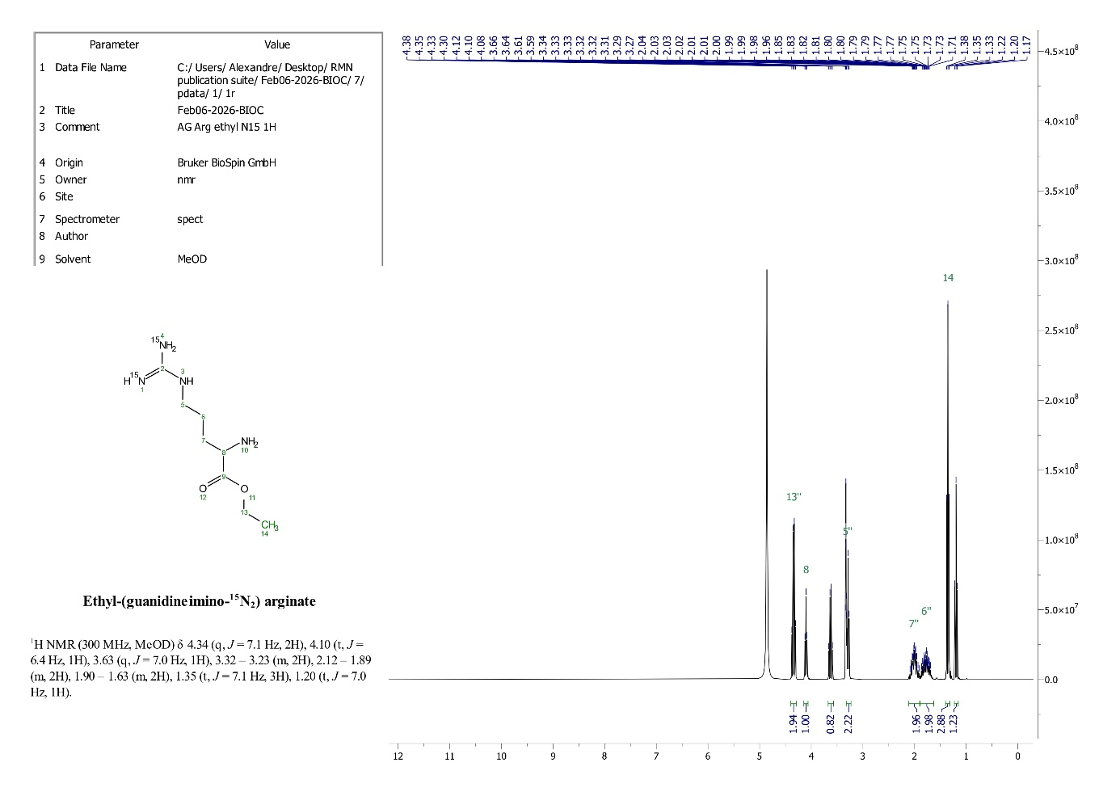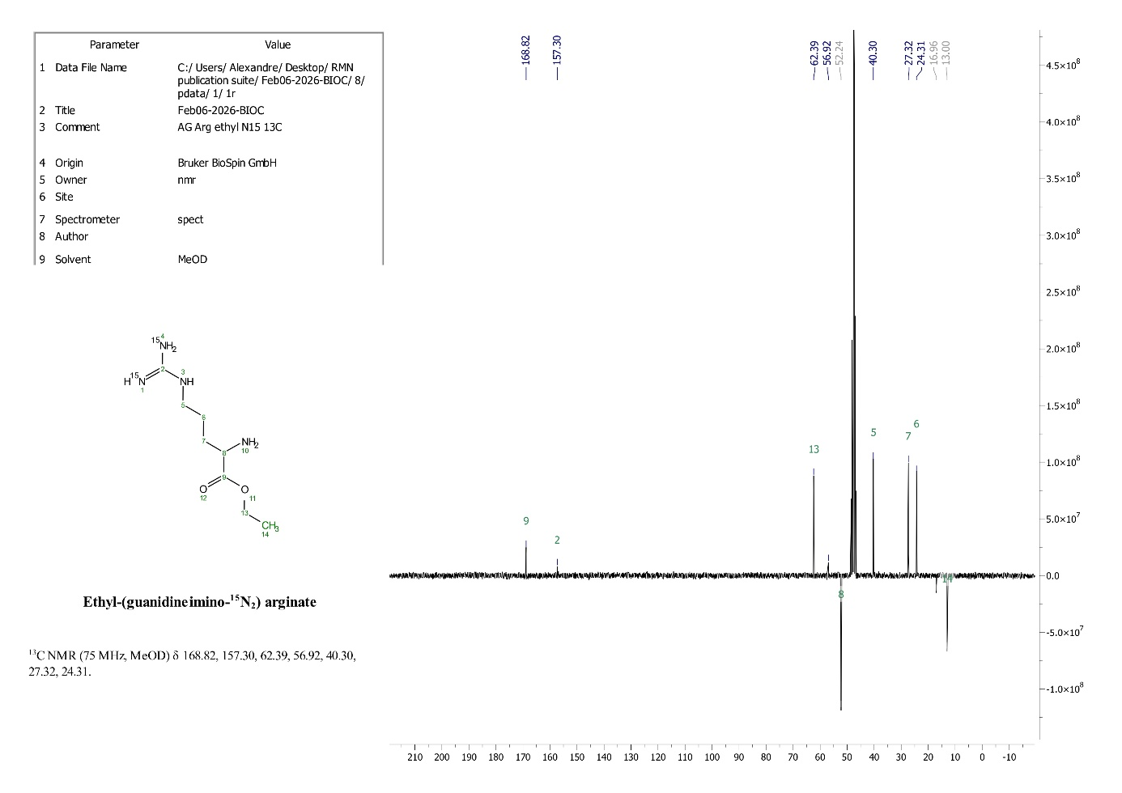

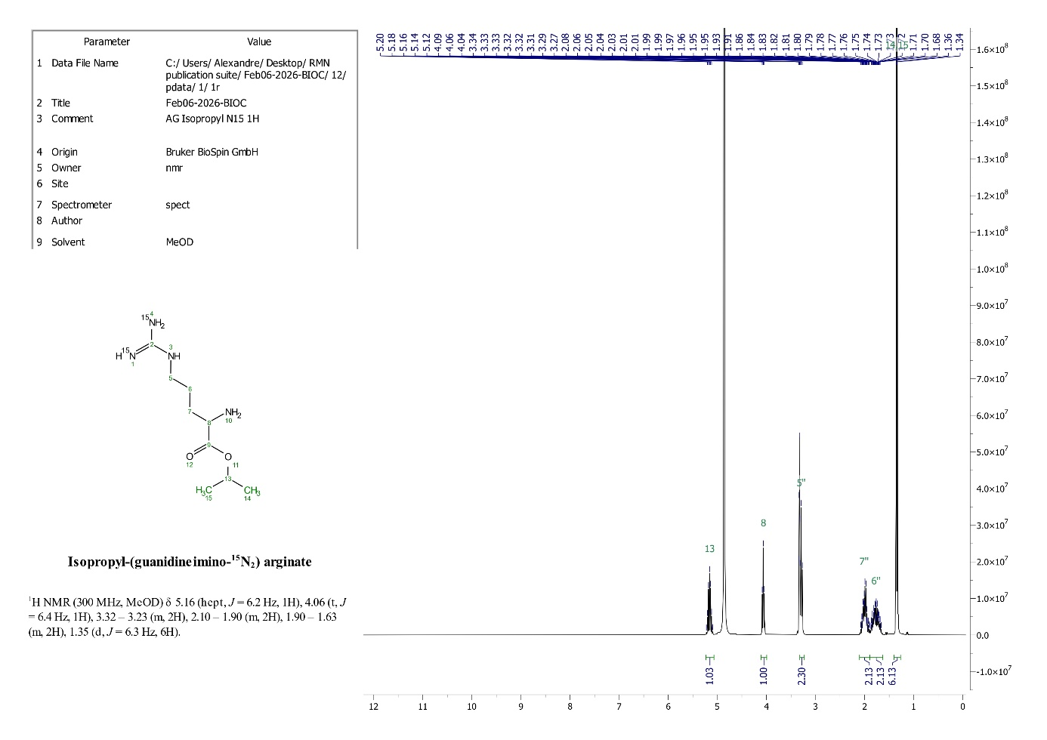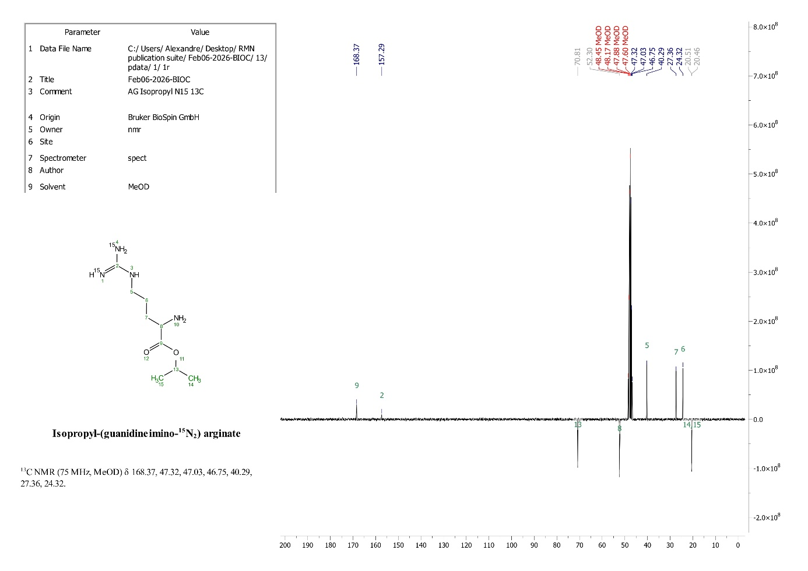

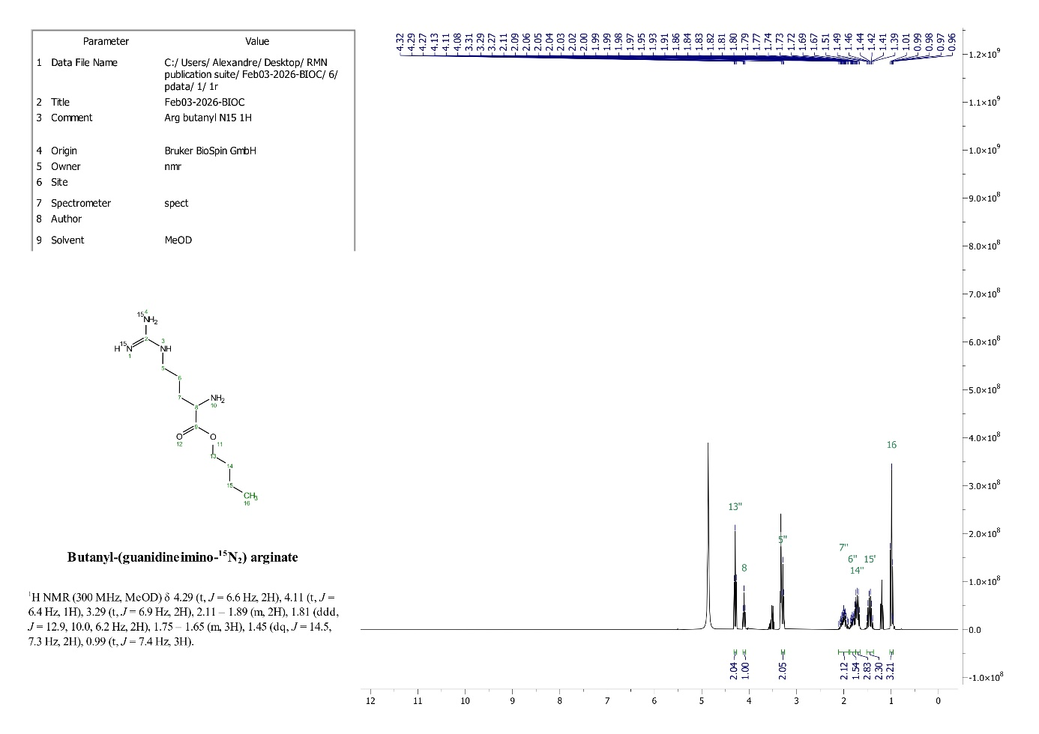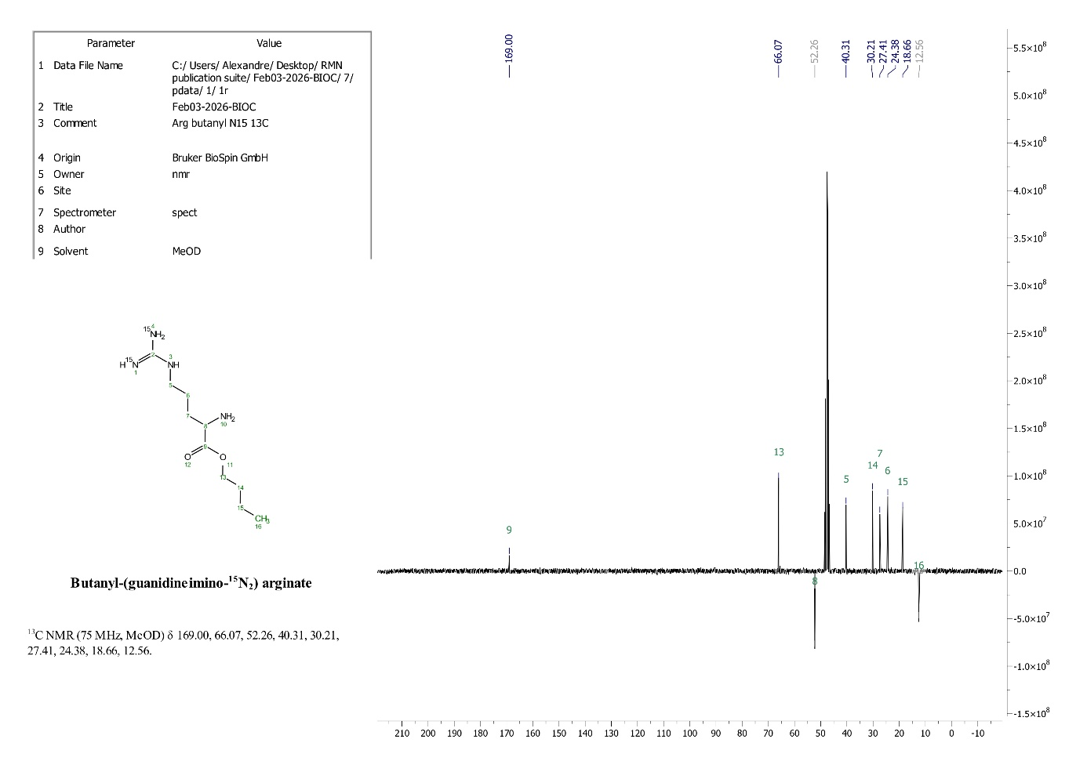

B
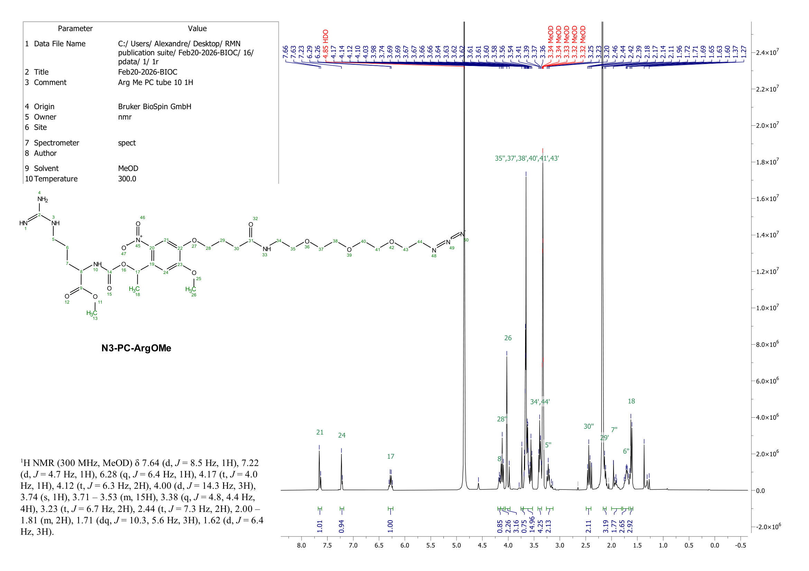
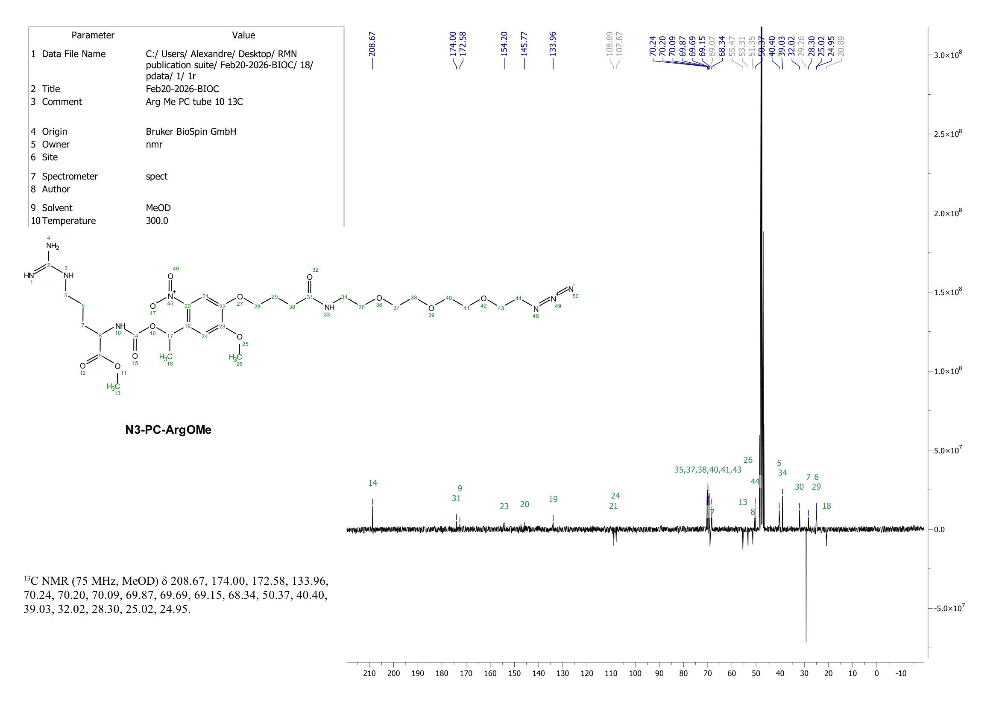
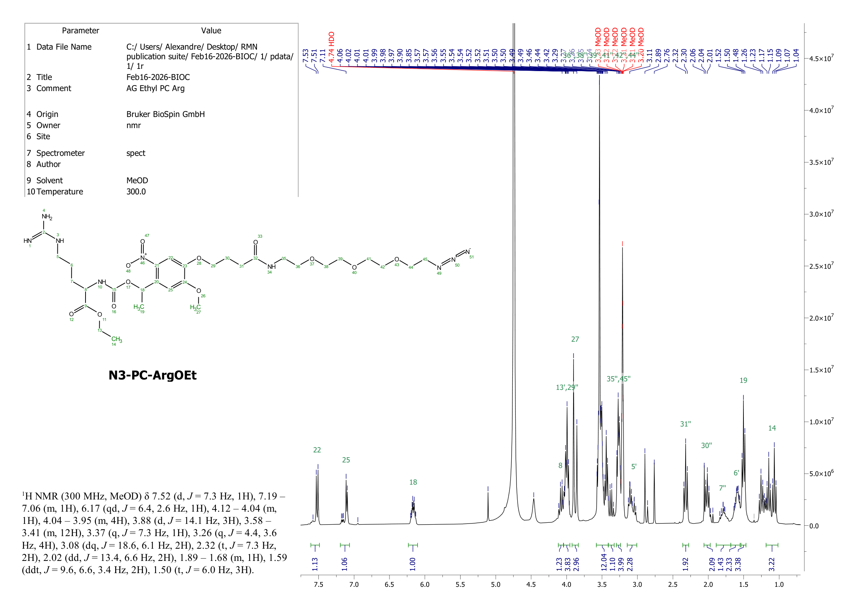
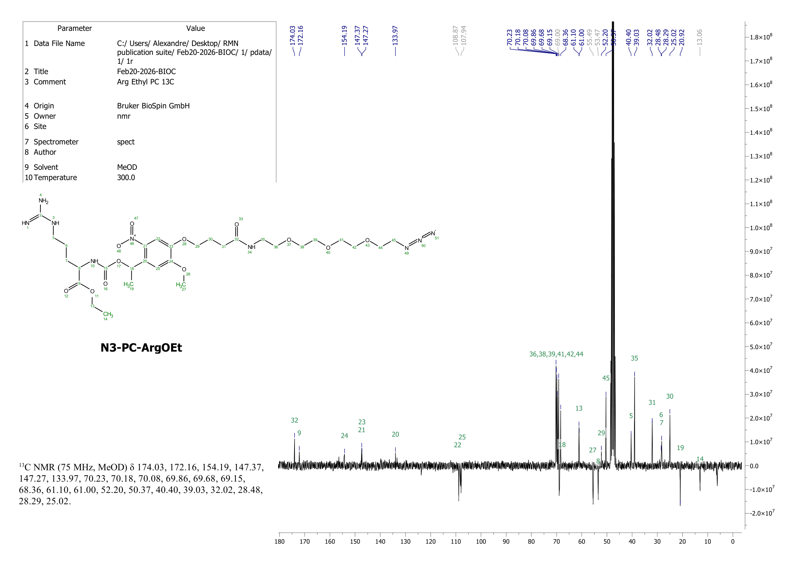
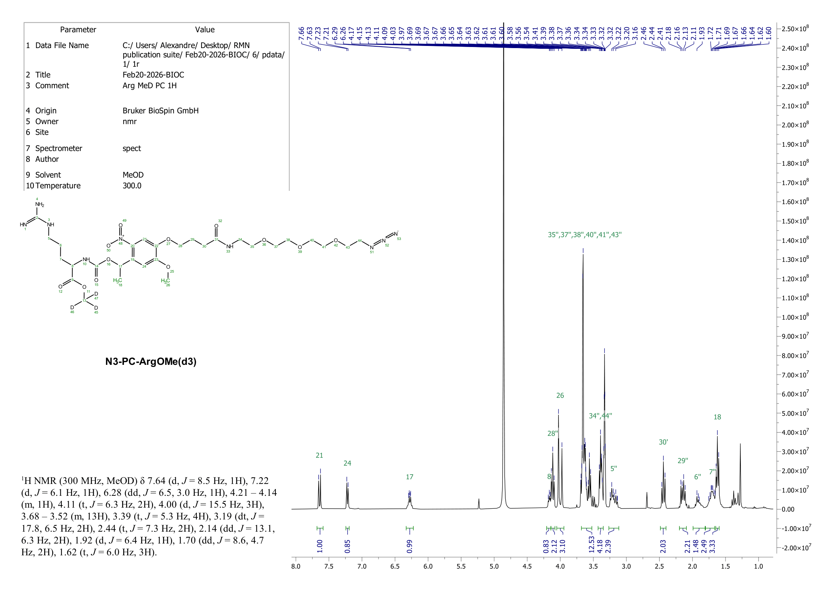
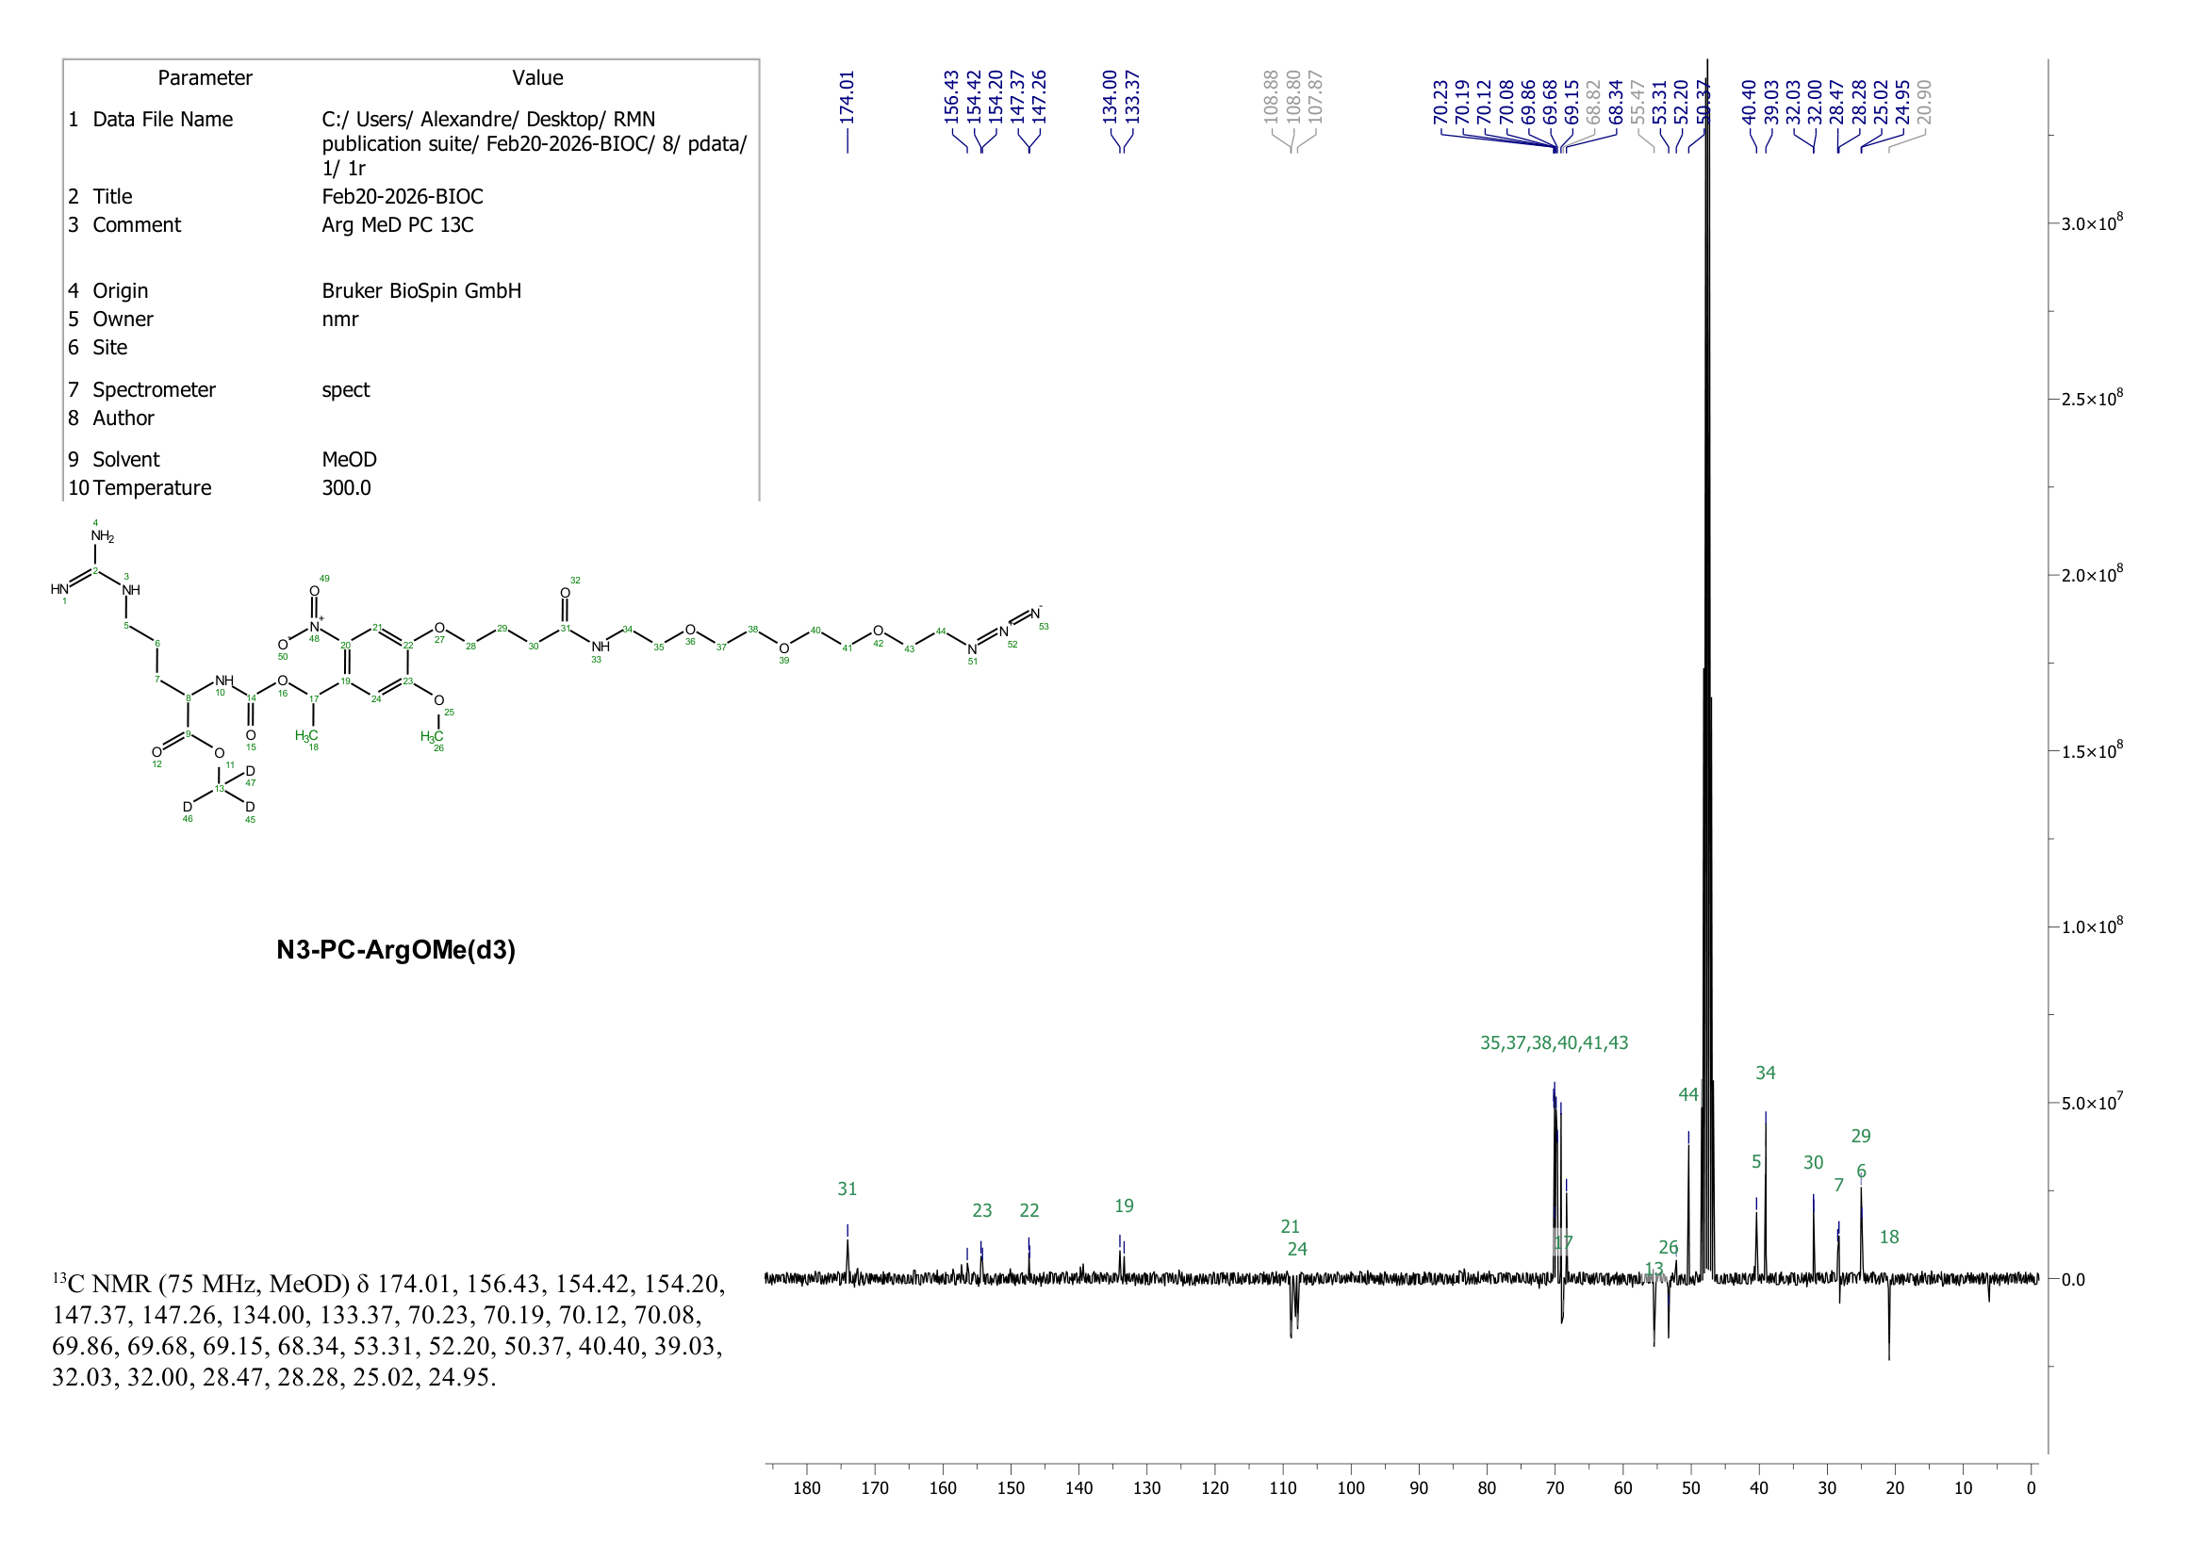
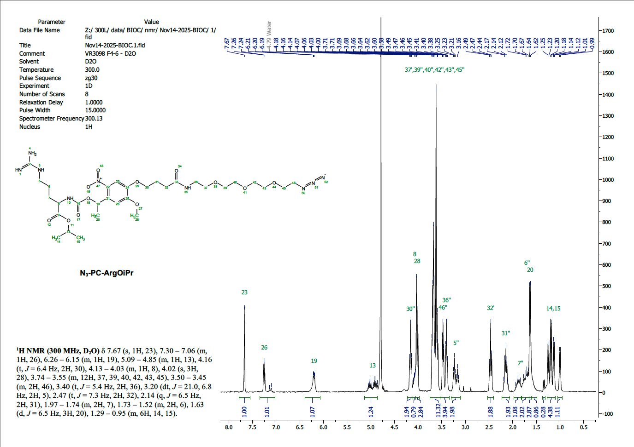
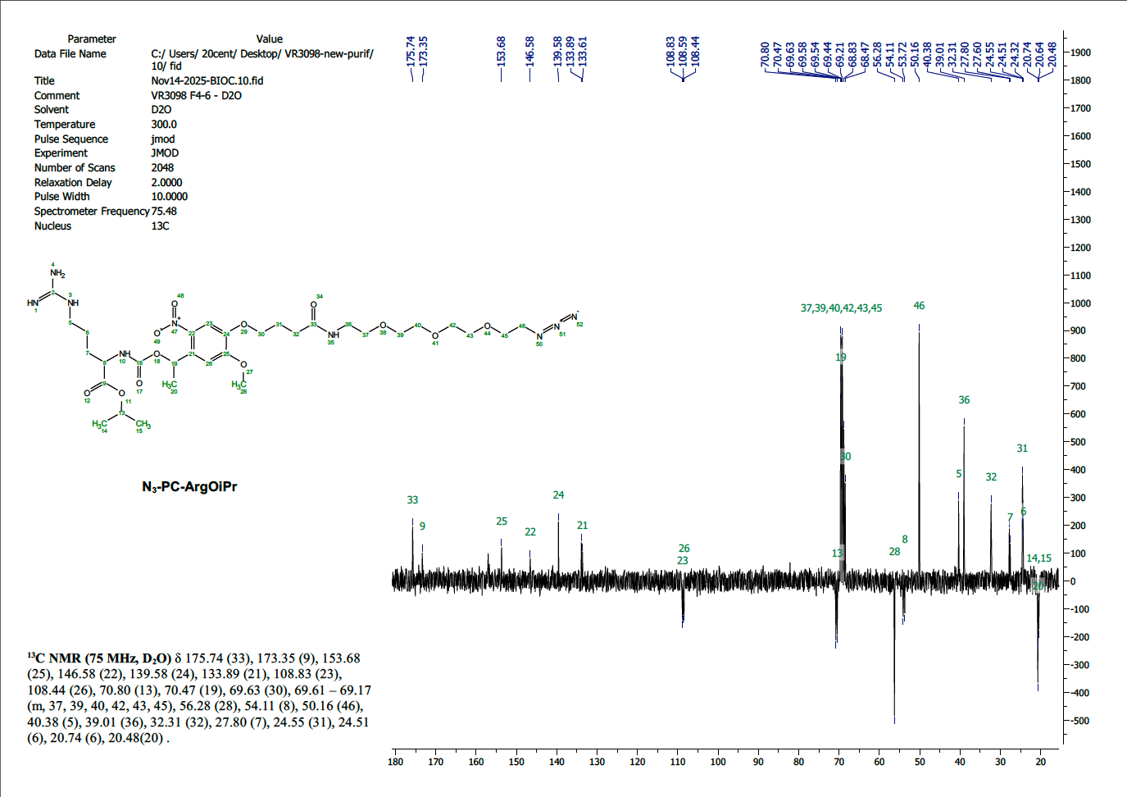
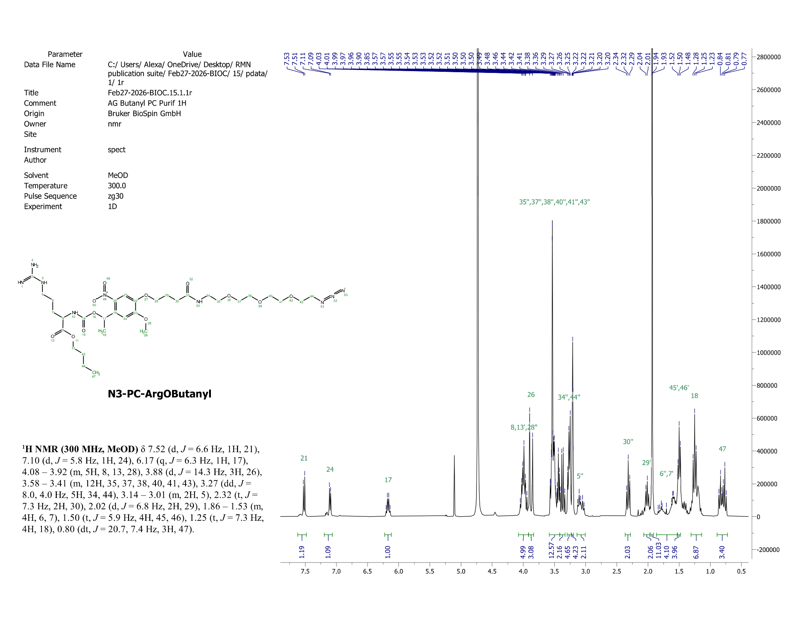
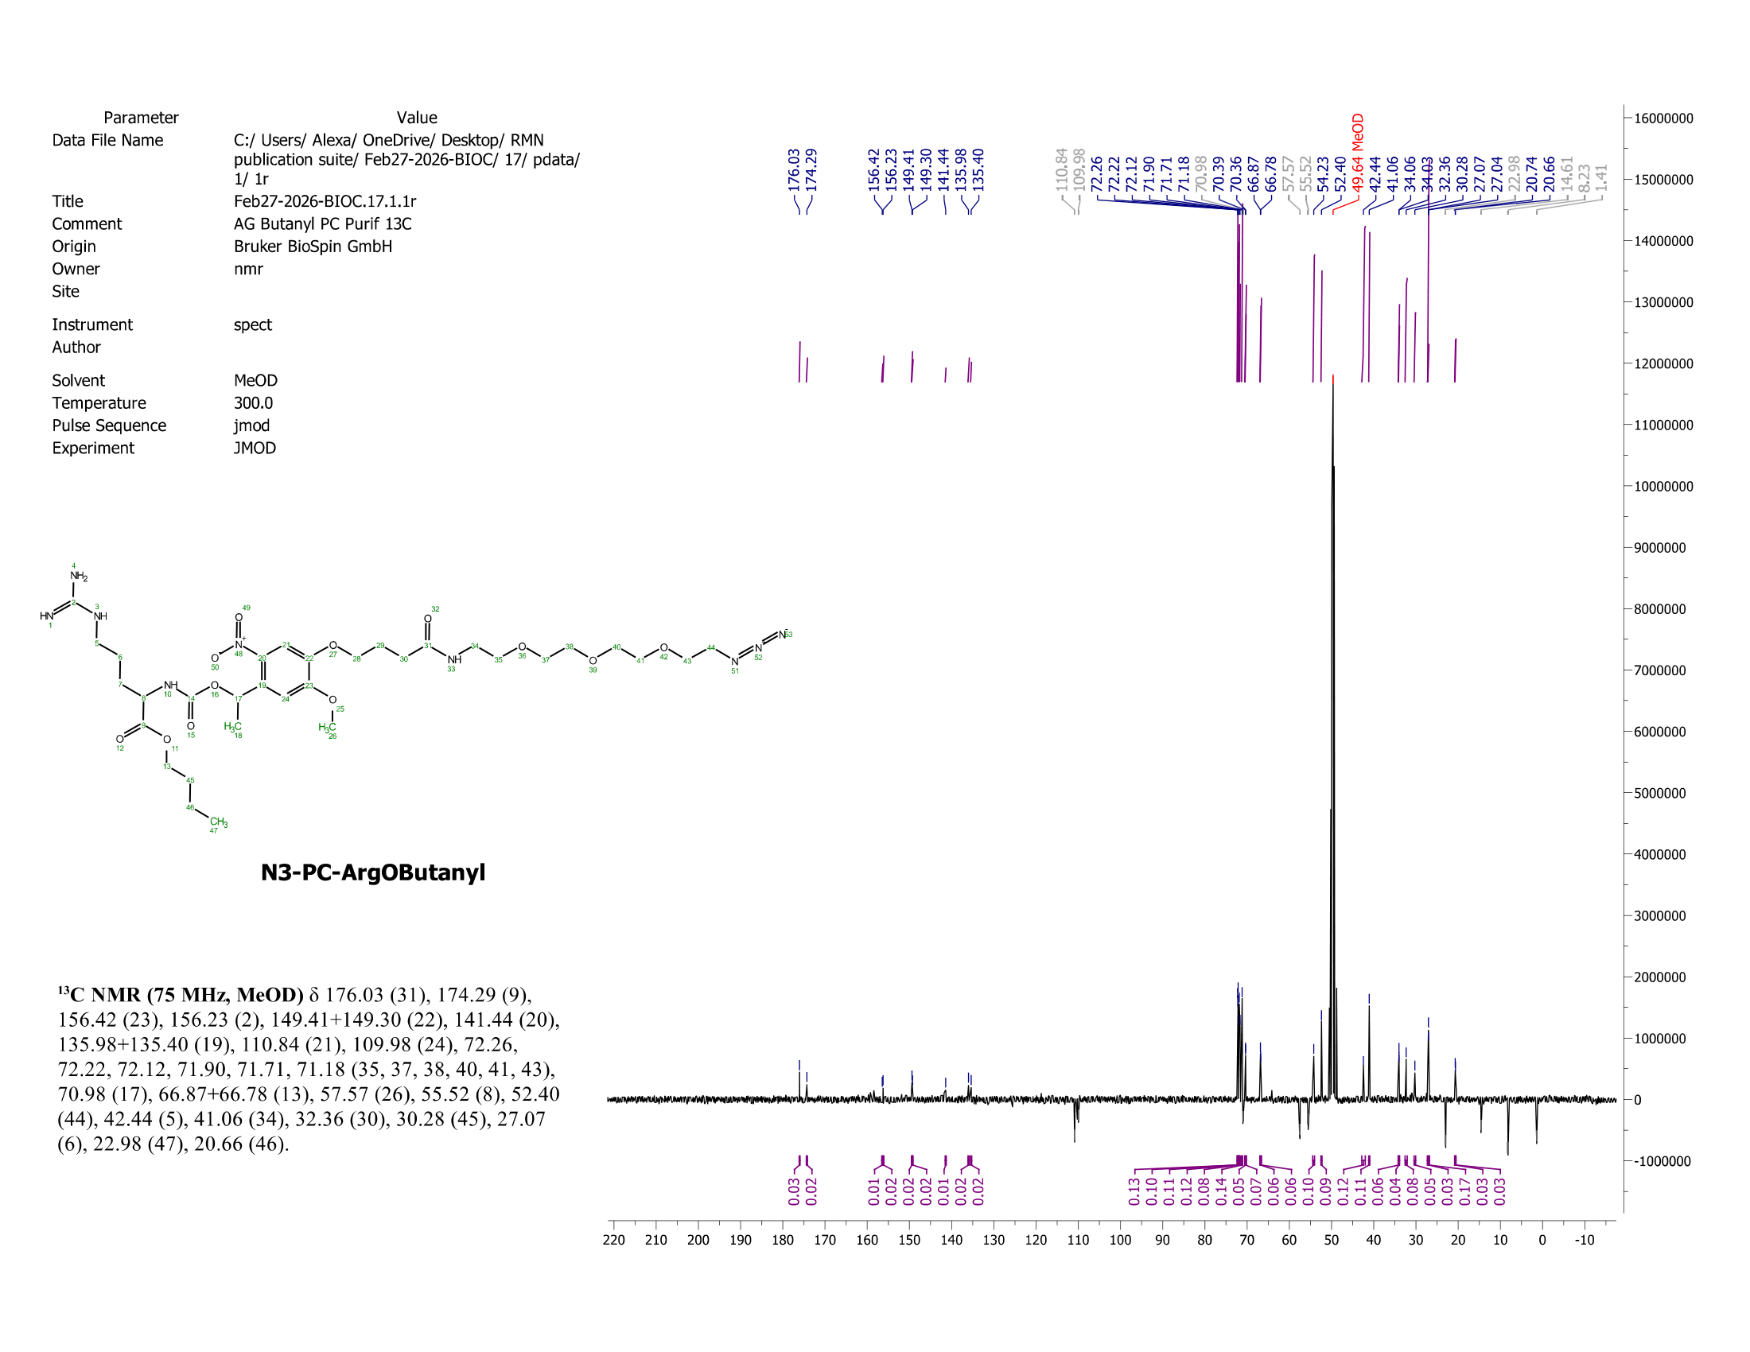
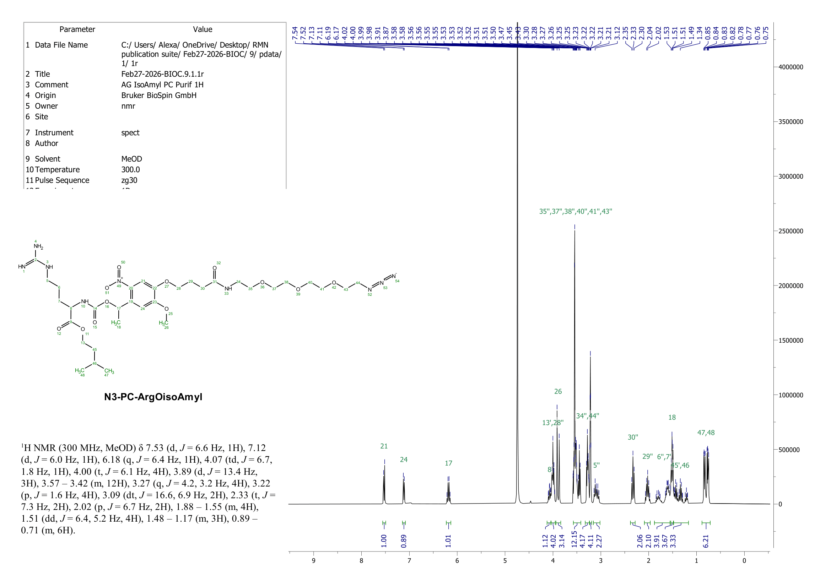
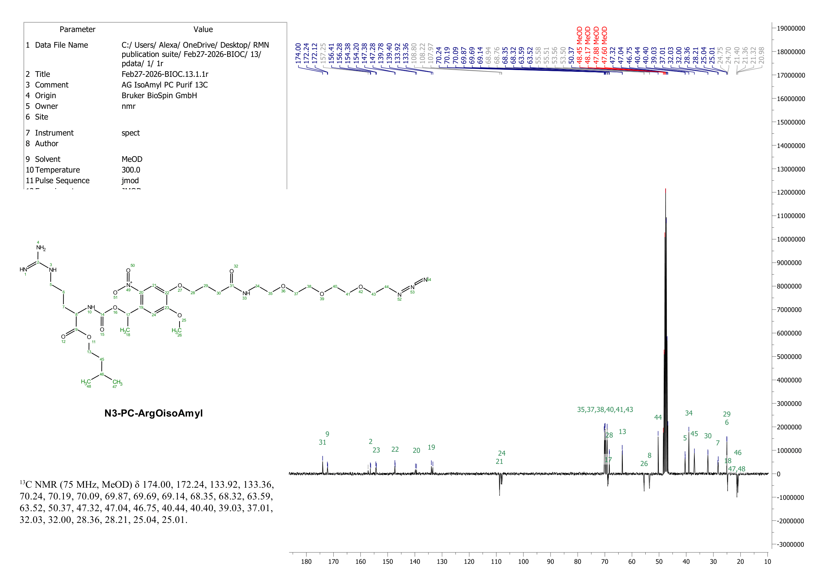
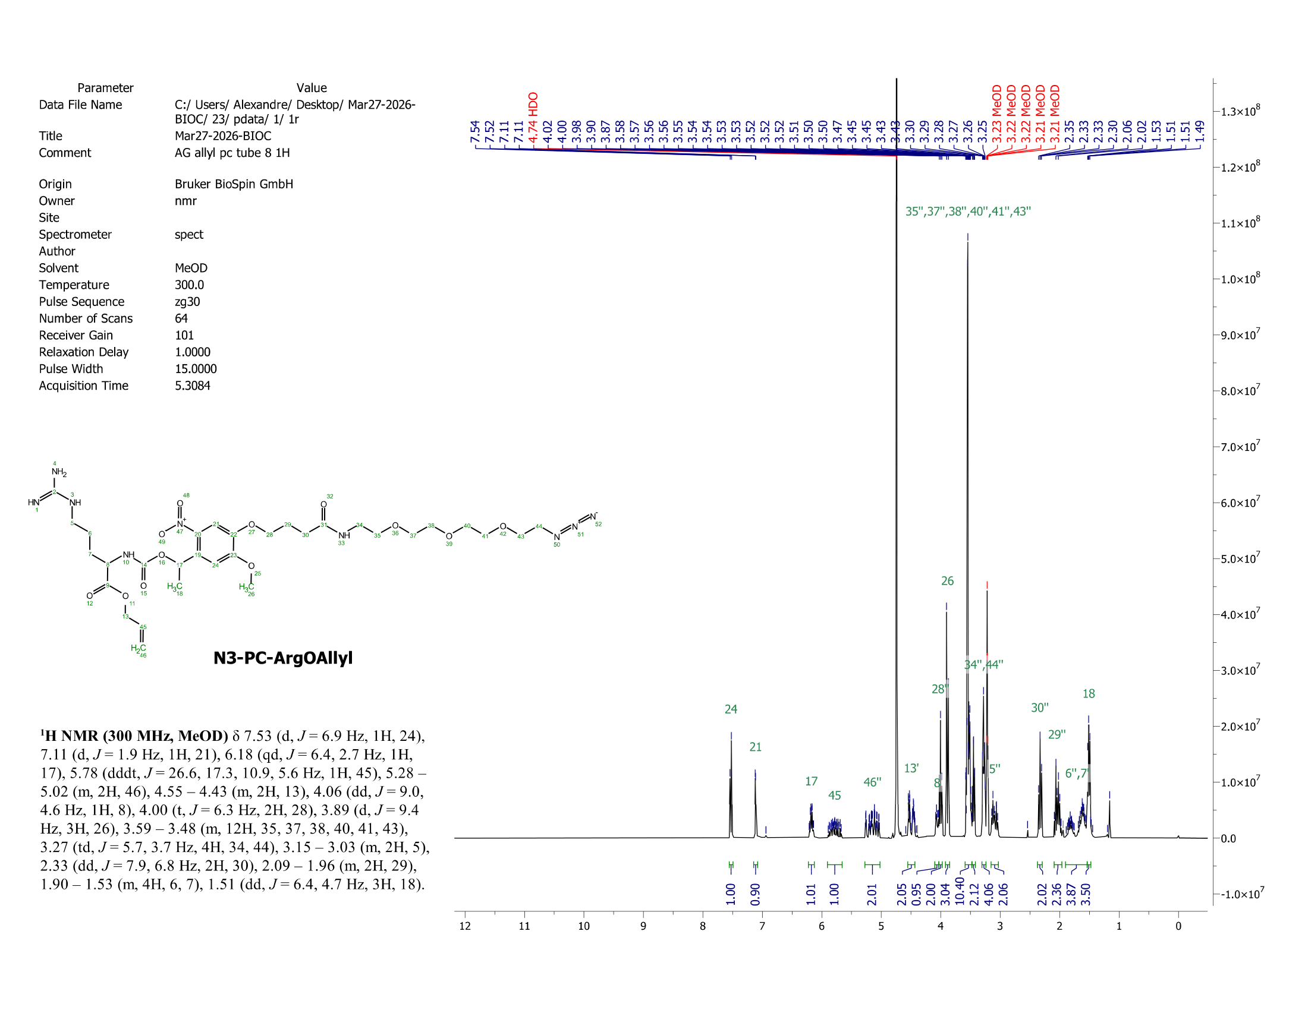
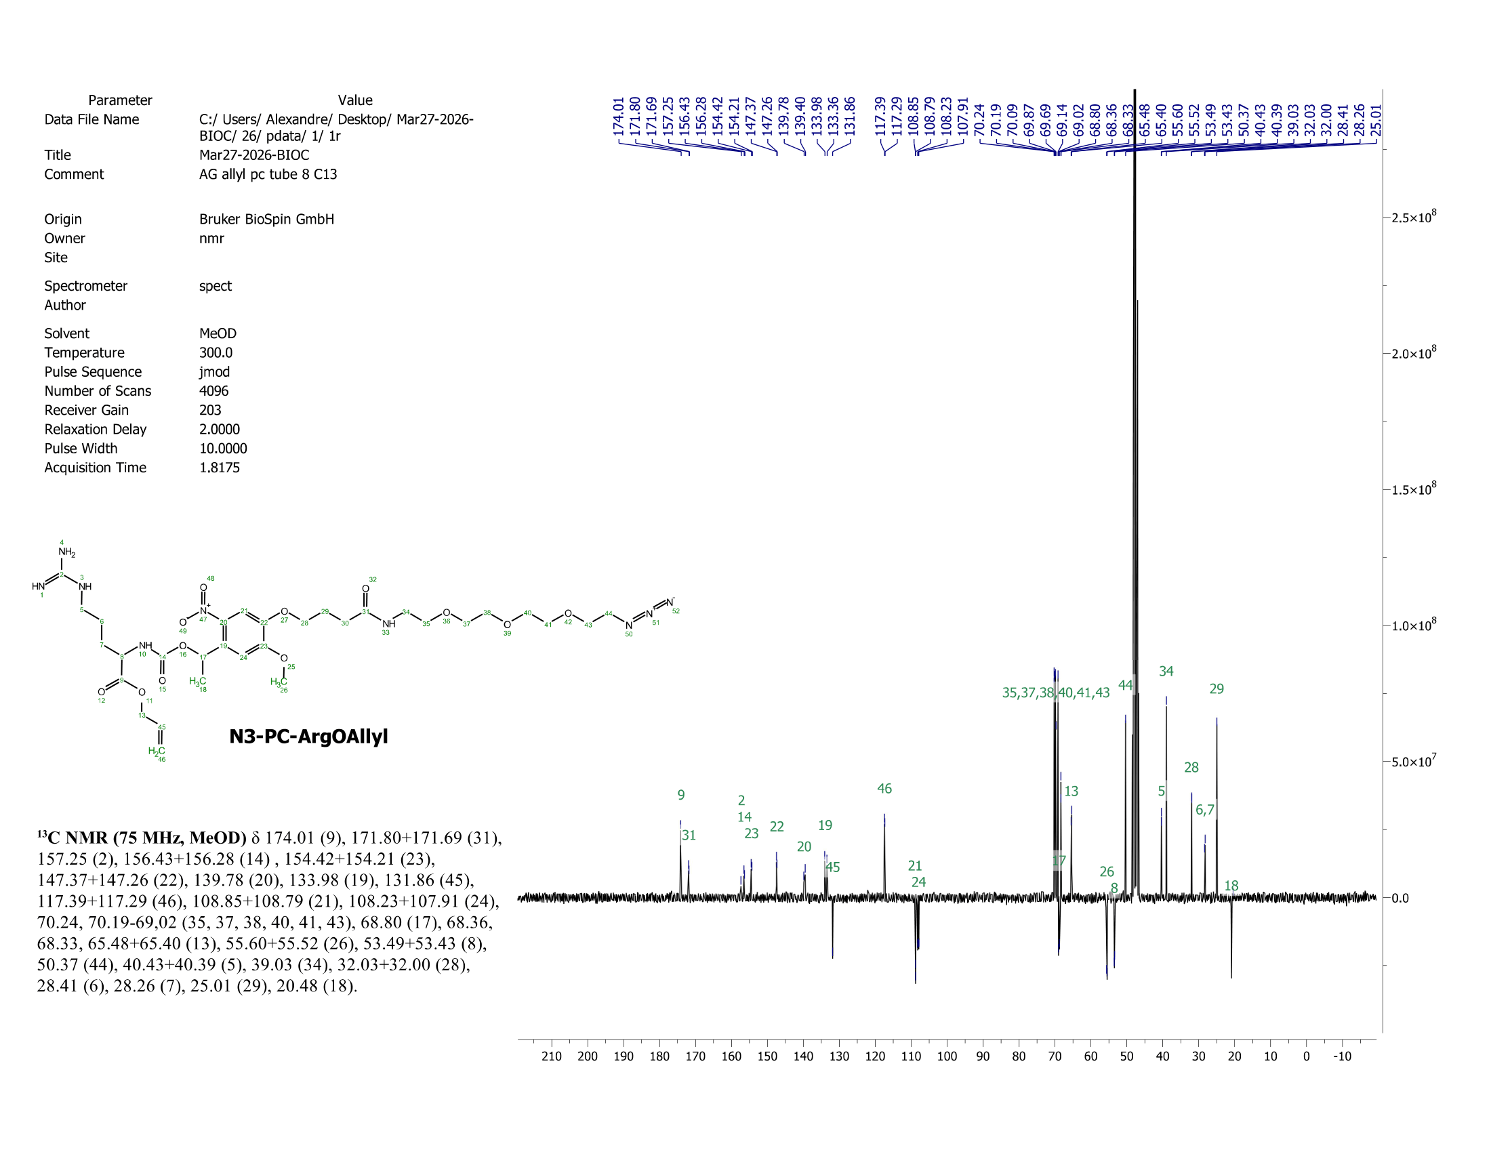
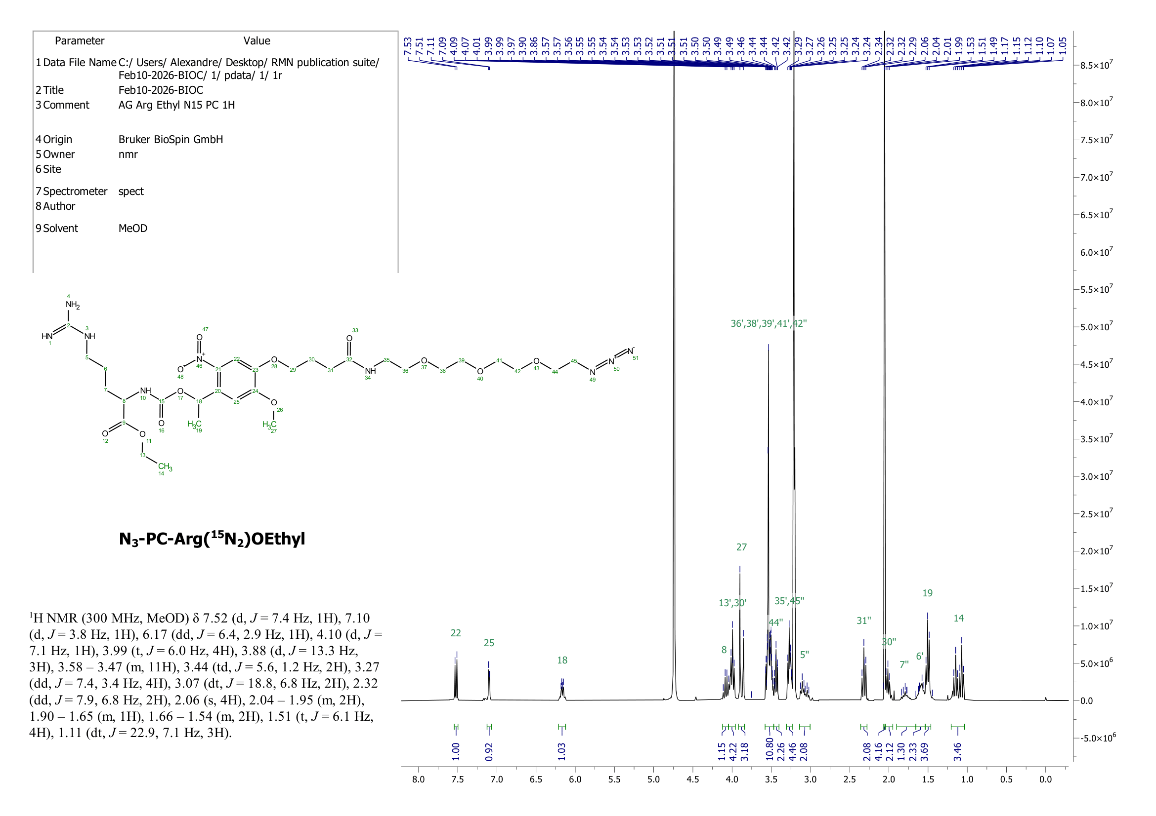
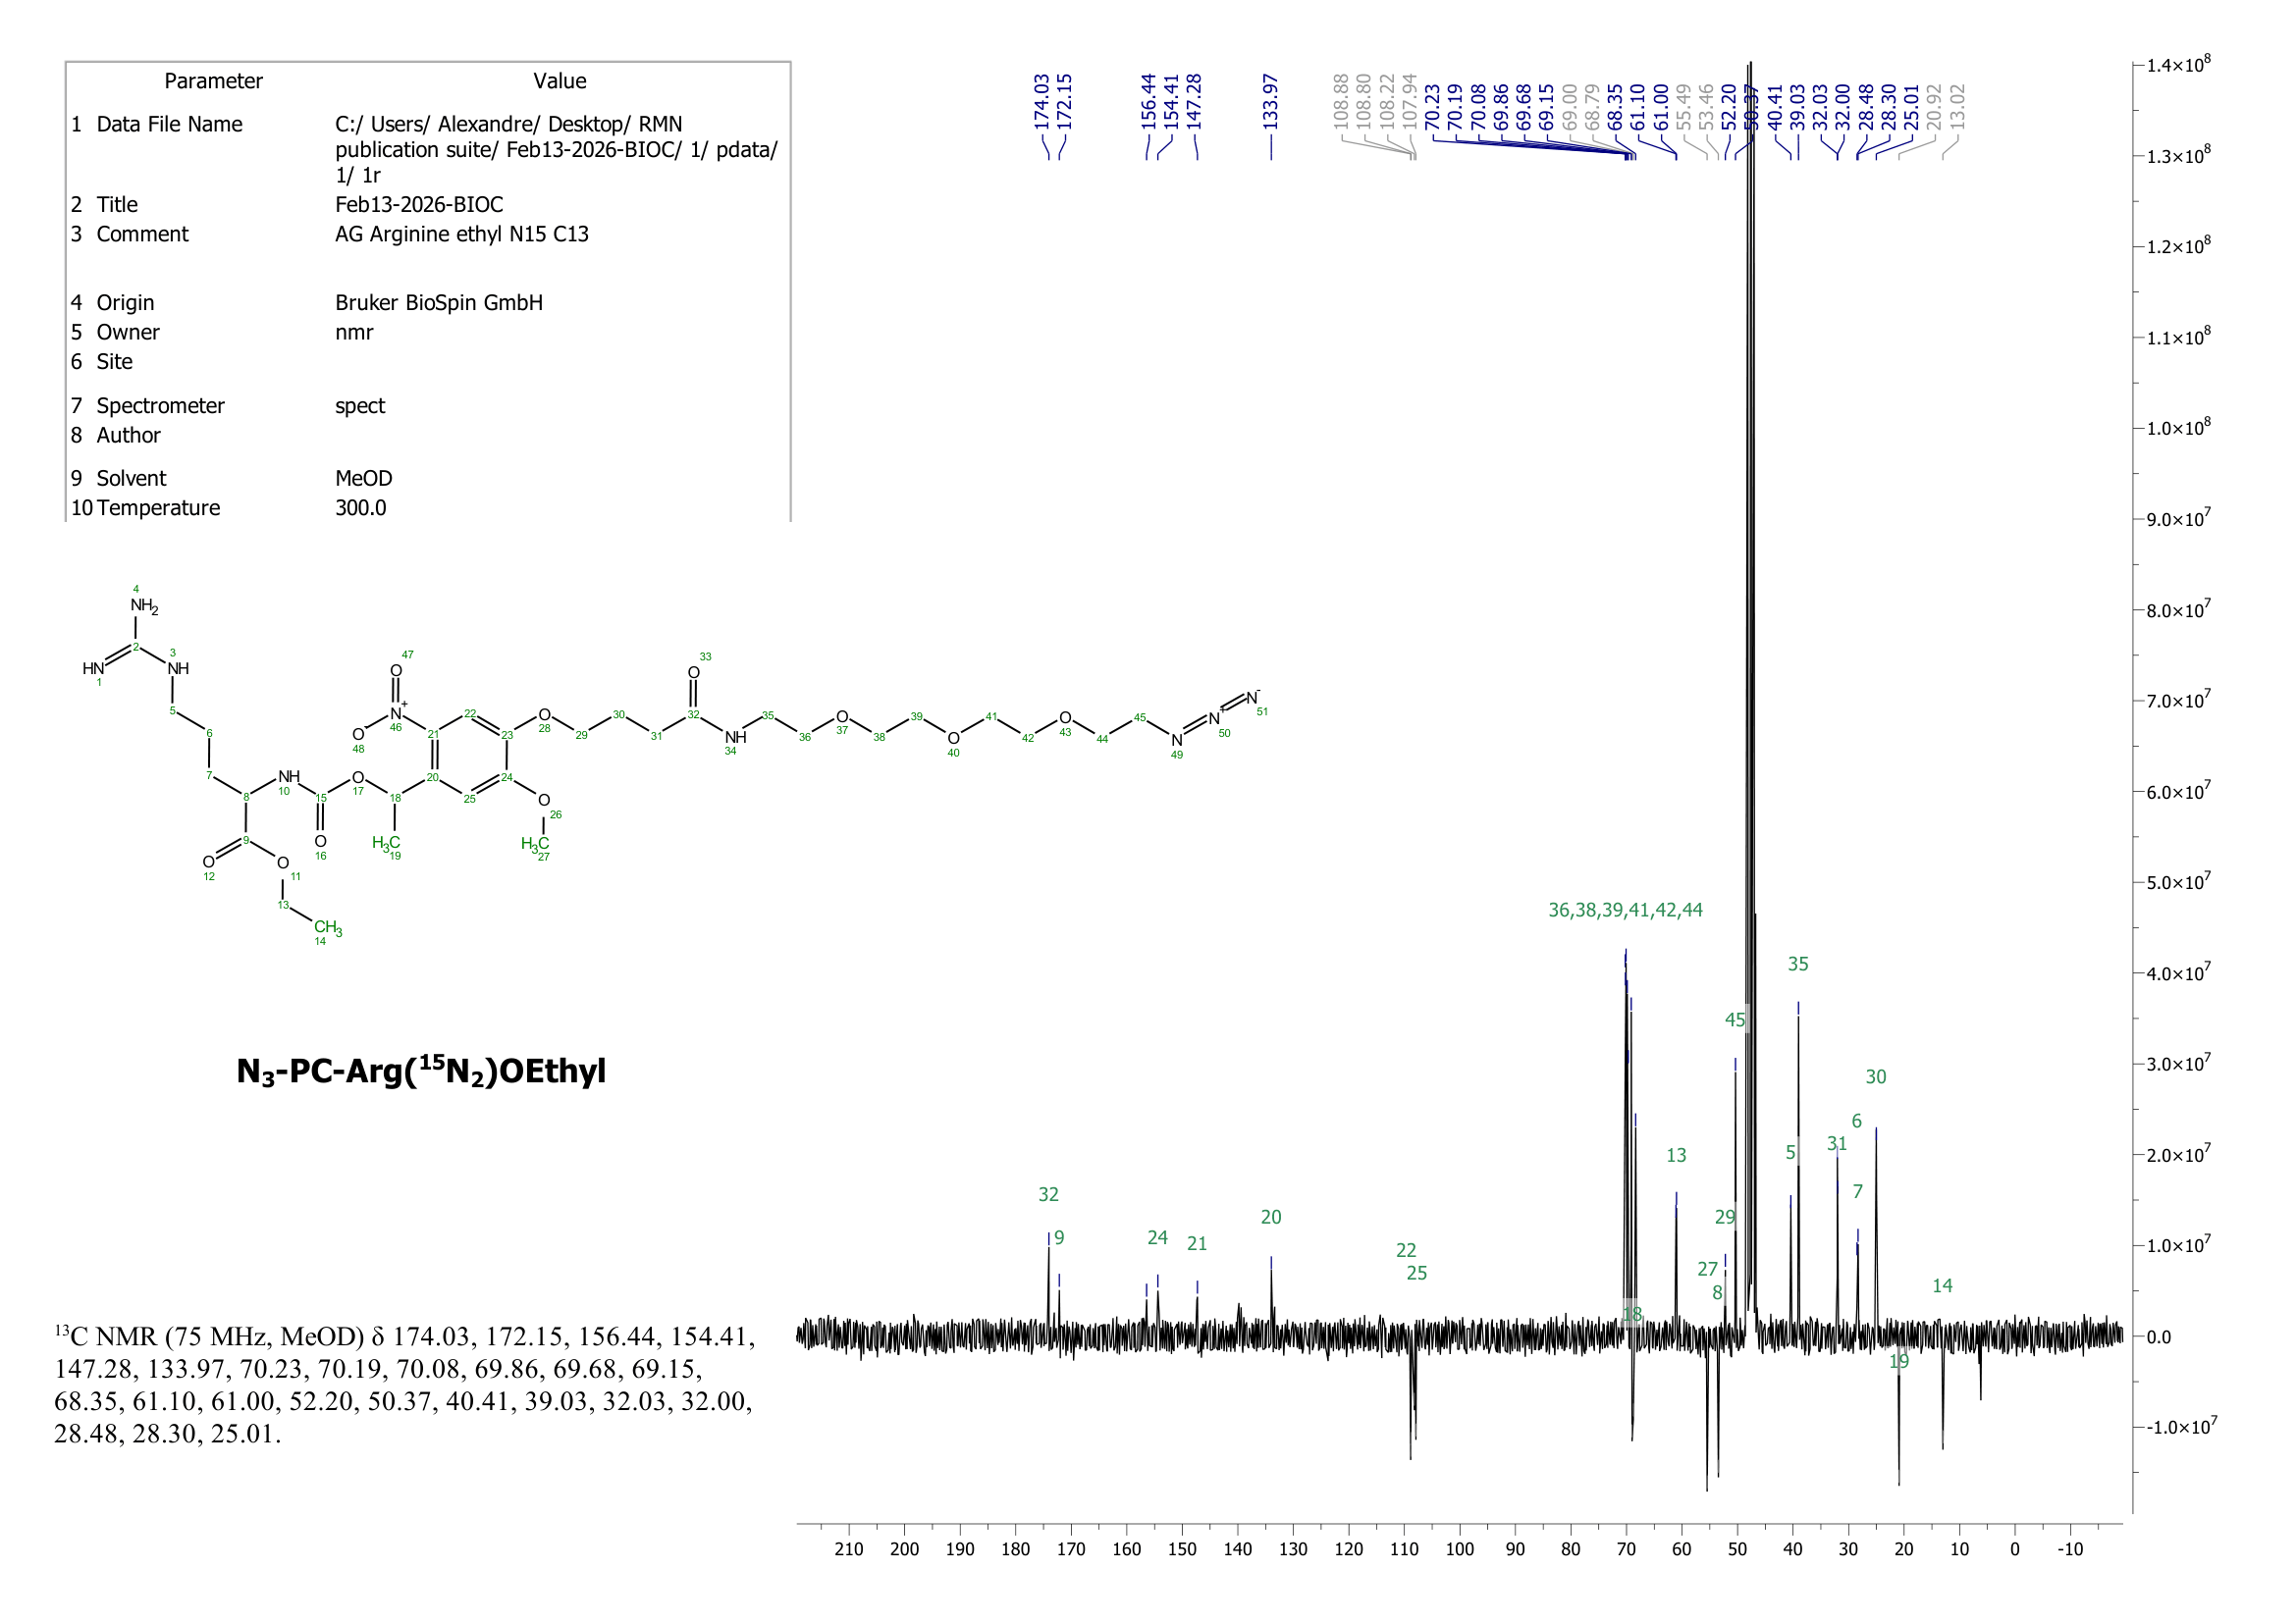
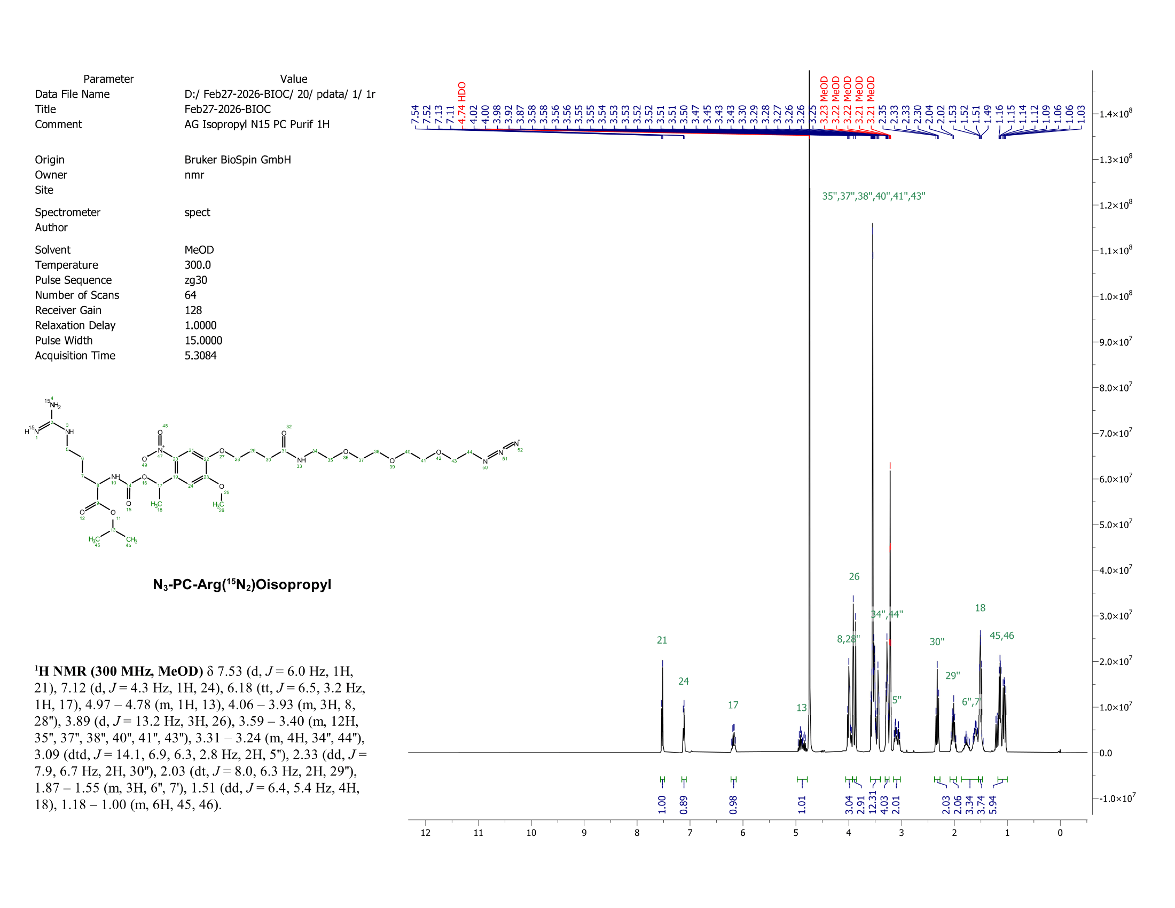
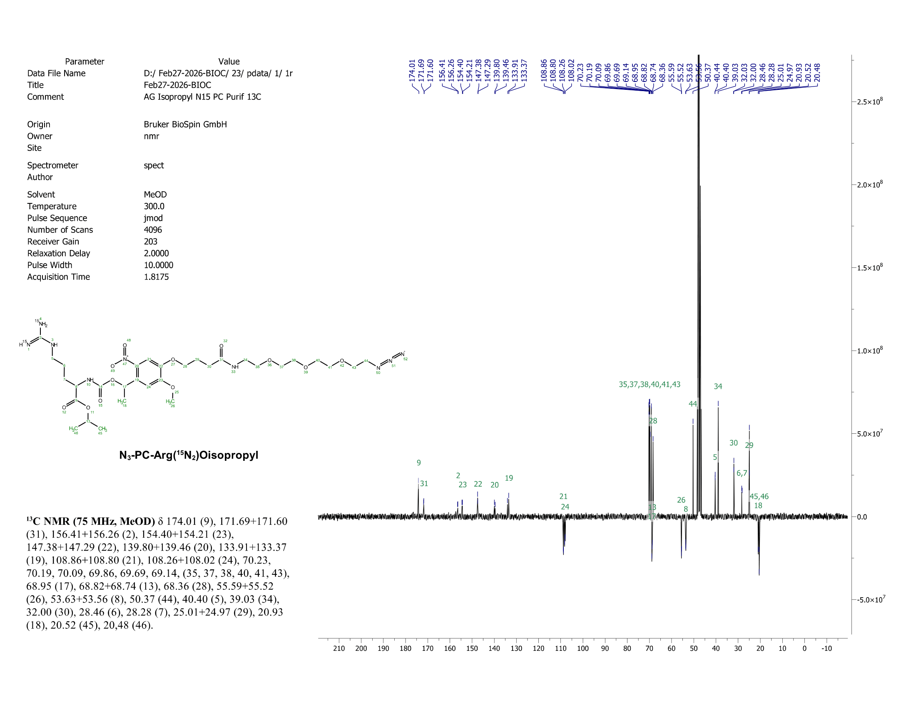
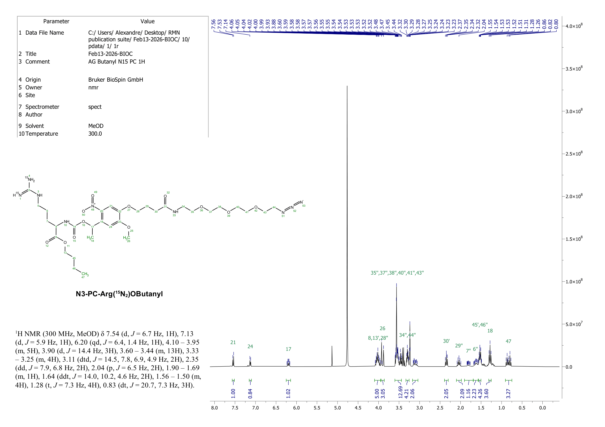
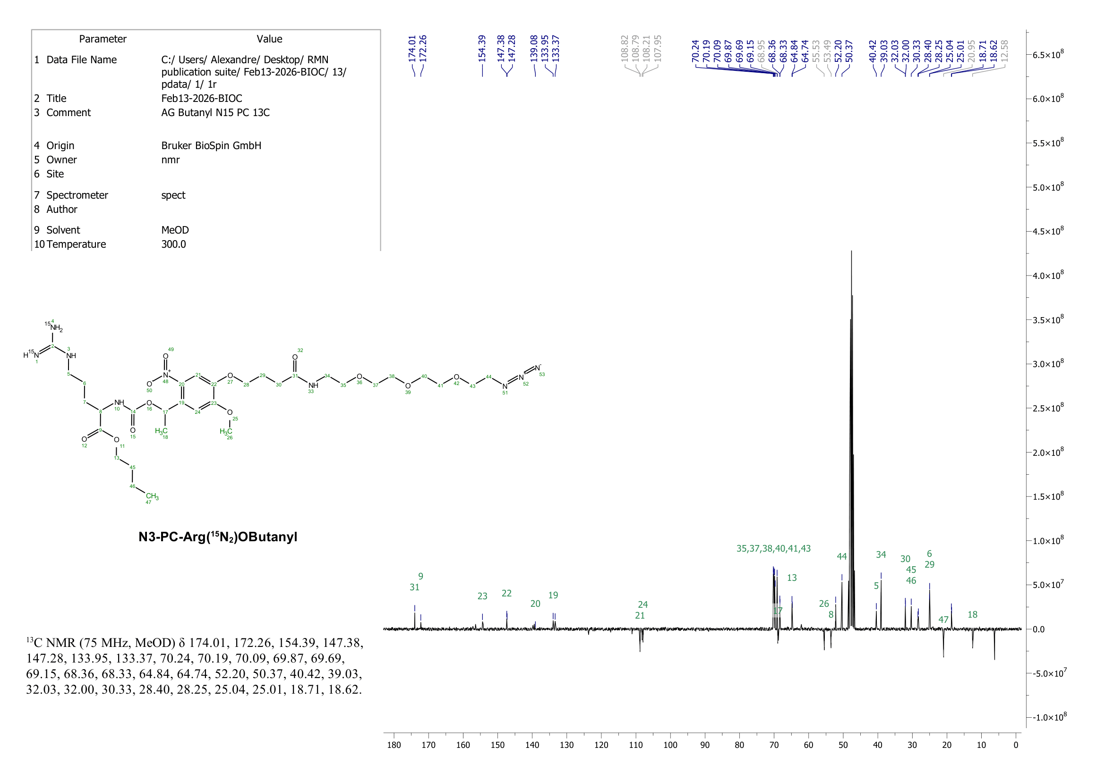
Supplementary Figure 1: NMR spectra of the 10 synthesized reporters and clickable Tags. Table include the molecular weight given in monoisotopic masses of the clickable tags and expected photocleavable products as well as the expected m/z in the MALD-MS. (A) ¹H NMR and ¹3C NMR spectra of the reporters and (B) ¹H NMR and ¹3C NMR spectra of the clickable tags.
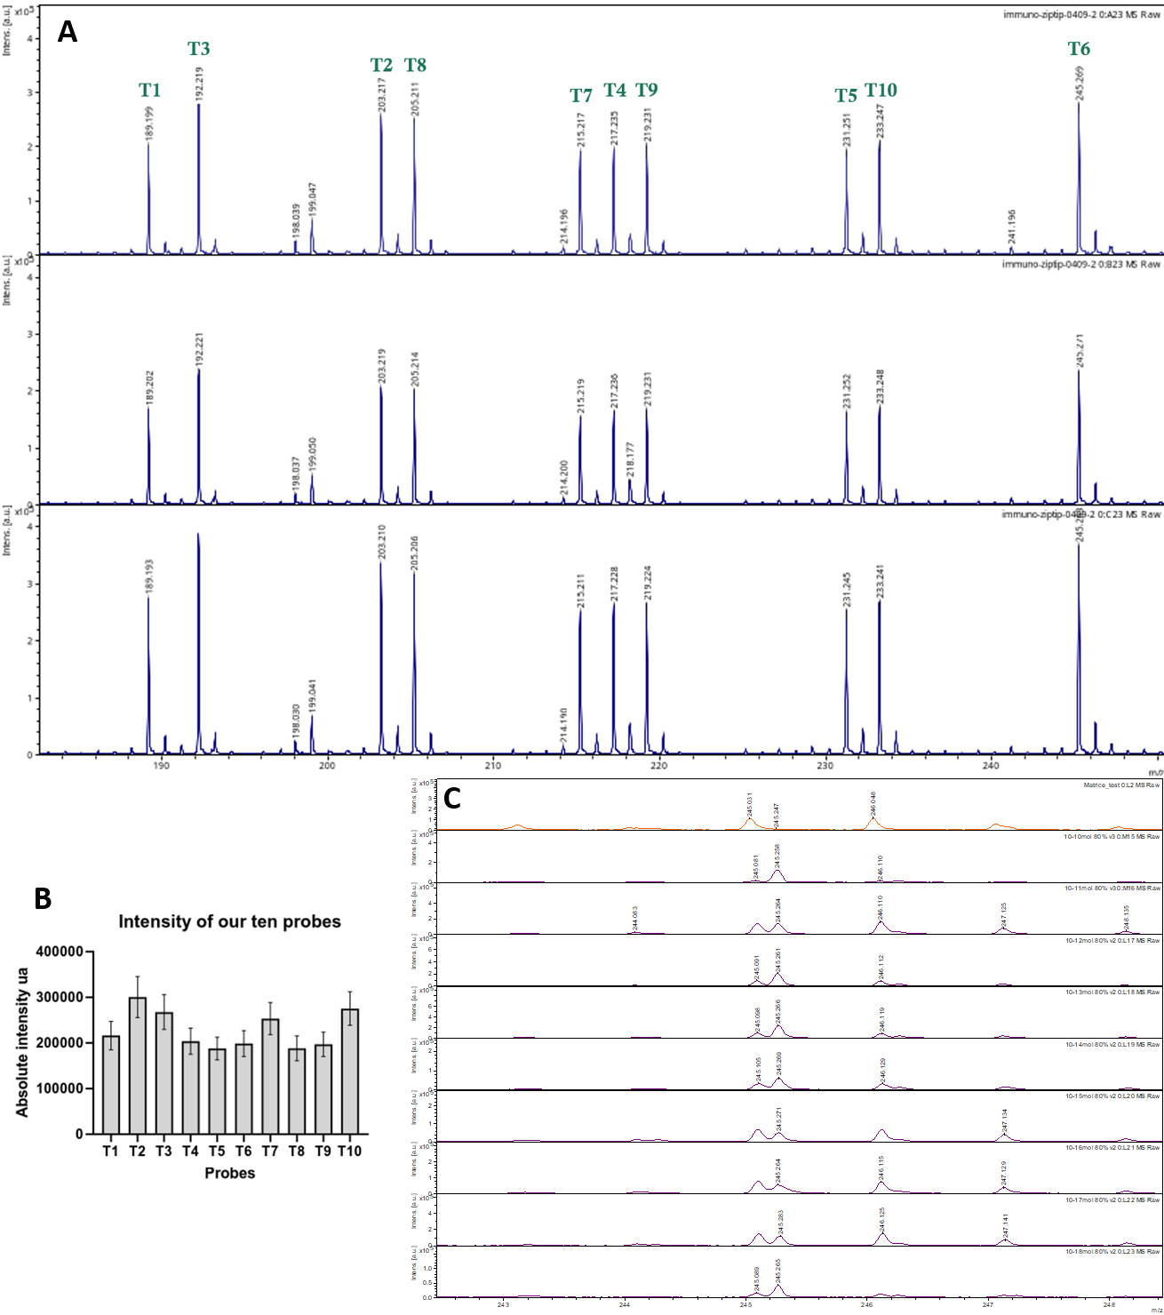
Supplementary Figure 2: Evaluation of the MS reporter detection. (A) MALDI-TOF MS spectrum of a mixture of the 10 Tags after photocleavage (20 min exposition) showing the signals of the different MS reporters and (B) Averaged Tag signals over 3 measurements showing a close response of the 10 Tags. (C) Detection threshold of a reporter MS following UV exposure of the corresponding T6 photocleavable probe

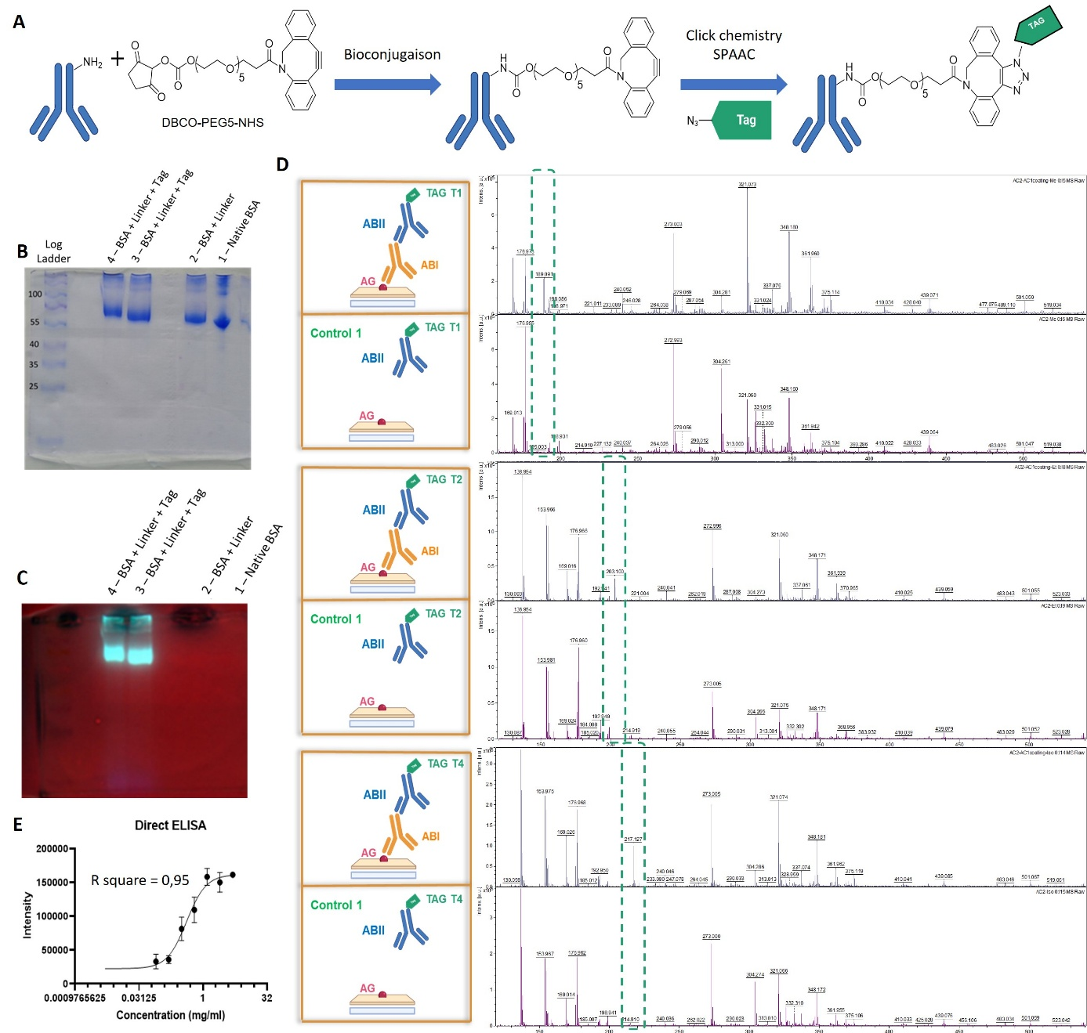
Supplementary Figure 3: Evaluation of the Tagged antibodies. (A) Schematic representation of the synthesis workflow used for the antibody tagging. Briefly, the antibody is modified on the accessible lysine using a DBCO-NHS ester enabling then the addition of the Tag by click-chemistry. (B-C) SDS-PAGE gel detection of the antibody untagged or tagged using a fluorescent Tag (i.e., a fluorescent report is clicked instead of the MS reporter) using Coomassie staining (B) and fluorescence analysis (C) confirming the successful conjugation as shown by the molecular weight shift. (D) Indirect ELISA assays conducted with tagged-antibodies using T1, T2, and T4 tags using pig IgG as antigen, rabbit anti-pig primary antibody and a goat tagged anti-rabbit secondary antibody demonstrating successful modification of the antibody. (E) Direct ELISA quantification using T5 tagged rabbit primary antibody directed against pig and pig IgG as antigen. The plot reports the intensity of the MS signal versus the concentration of the antigen and presents a typical evolution expected from ELISA also demonstrating the possibility for absolute quantification in the antigen range showing a linear variation.

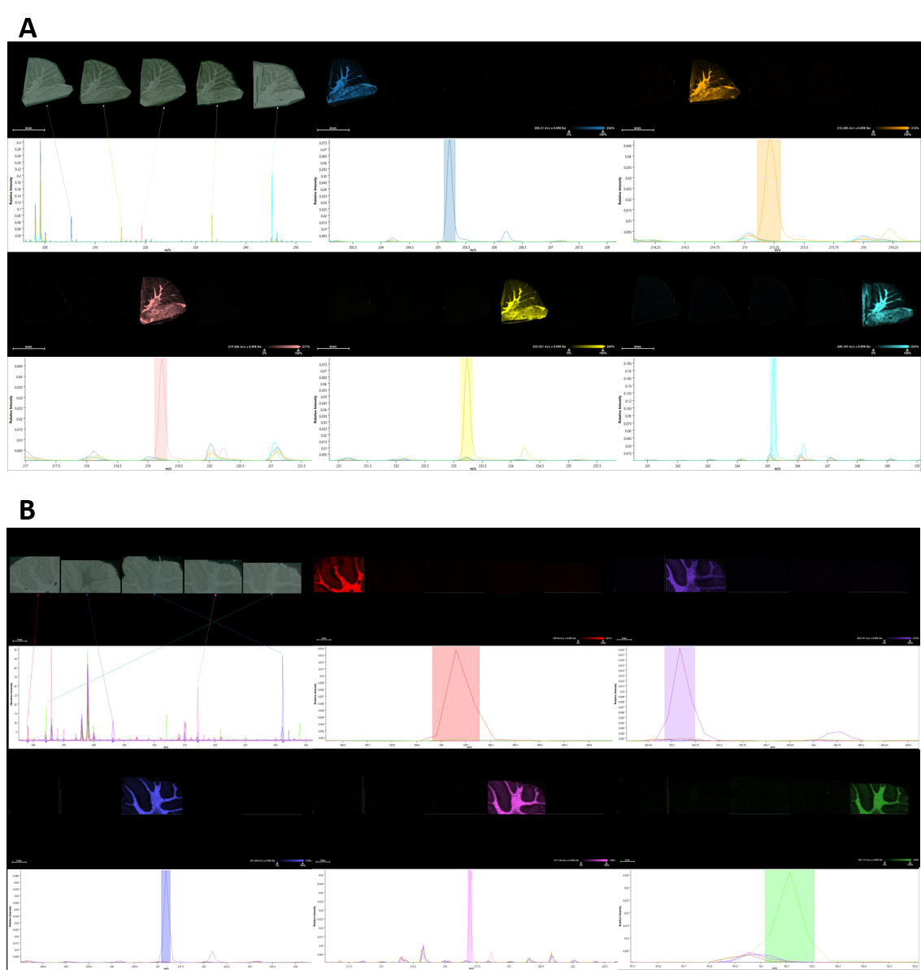
Supplementary Figure 4. Evaluation of the MS reporter response for the 10 Tags. MALDI-IHC experiments using tagged anti-GFAP antibodies. Tagged GFPA antibodies were produced for each of the different 10 tags and the 1-plex IHC was performed from fresh frozen rat brain tissue sections. MALDI-MS imaging experiments were realized on the rapifleX (A) and timsTOF fleX (B) instruments respectively at 20 µm spatial resolution.

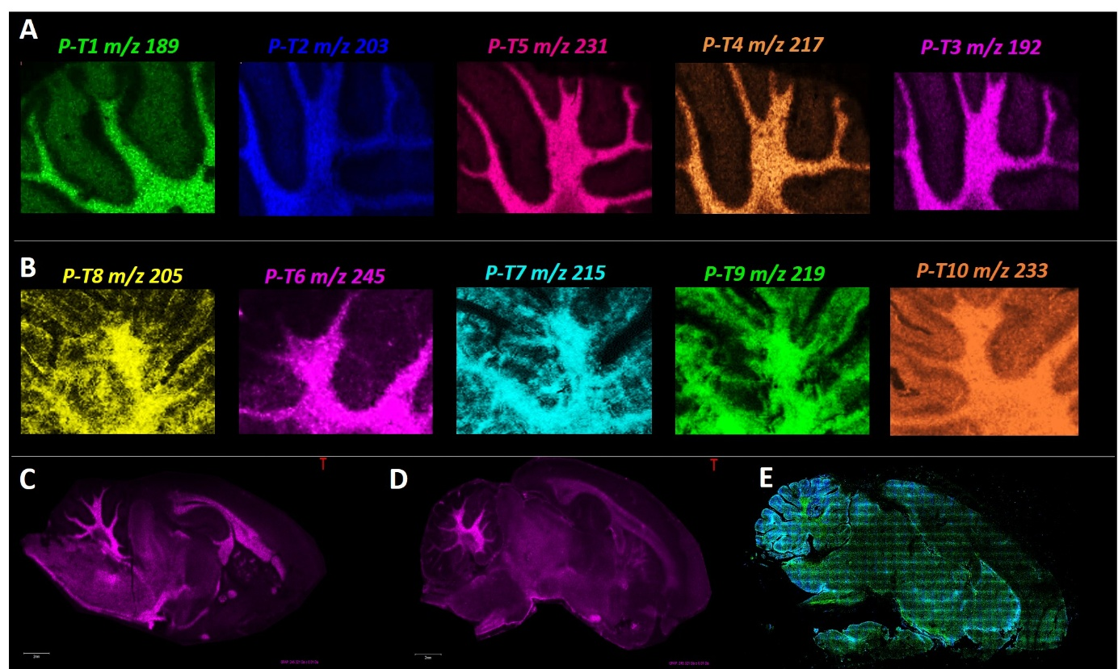
Supplementary Figure 5. MALDI IHC MS Imaging against GFAP using the tagged anti-GFAP antibody with the 10 different Tags. (A) MALDI IHC MS Imaging 1-plex of GFAP from fresh frozen rat brain tissues with T1 to T5 and (B) MALDI IHC MS Imaging 1-plex of GFAP from FFPE rat brain tissues with T6 to T10. The experiments compare the response using different tags to modify the same anti-GFAP antibodies and demonstrate that the signal response across the different images is similar for the different tags. (C) Validation using a fluorescent tagged antibody directed against GFAP.

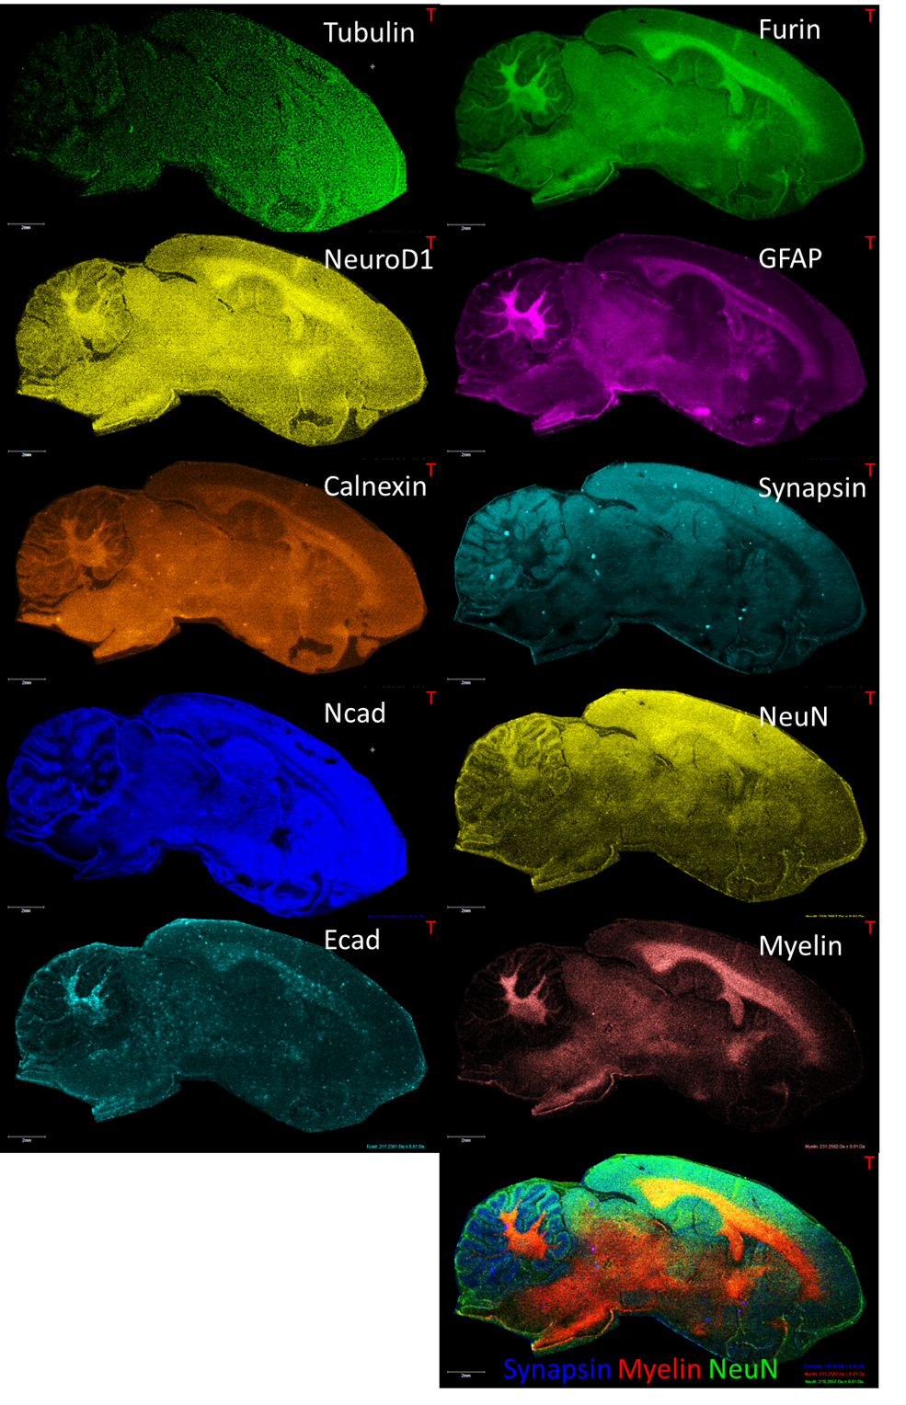
Supplementary Figure 6. 10-plex MALDI IHC from FFPE rat brain sagittal tissue section. The 10 tags were used to modify the 10 antibodies directed against Tubulin-β3, Furin, NeuroD1, GFAP, Calnexin, Synapsin, Ncad, NeuN, Ecad, Myelin and used in the same MALDI-IHC experiment. Each panel present the resulting MALDI image of the corresponding target and the bottom panel an overlay of 3 of the targets (Synapsin, Myelin and NeuN) on the same image. Acquisition was performed on the rapifleX MALDI-TOF at 20 µm spatial resolution.
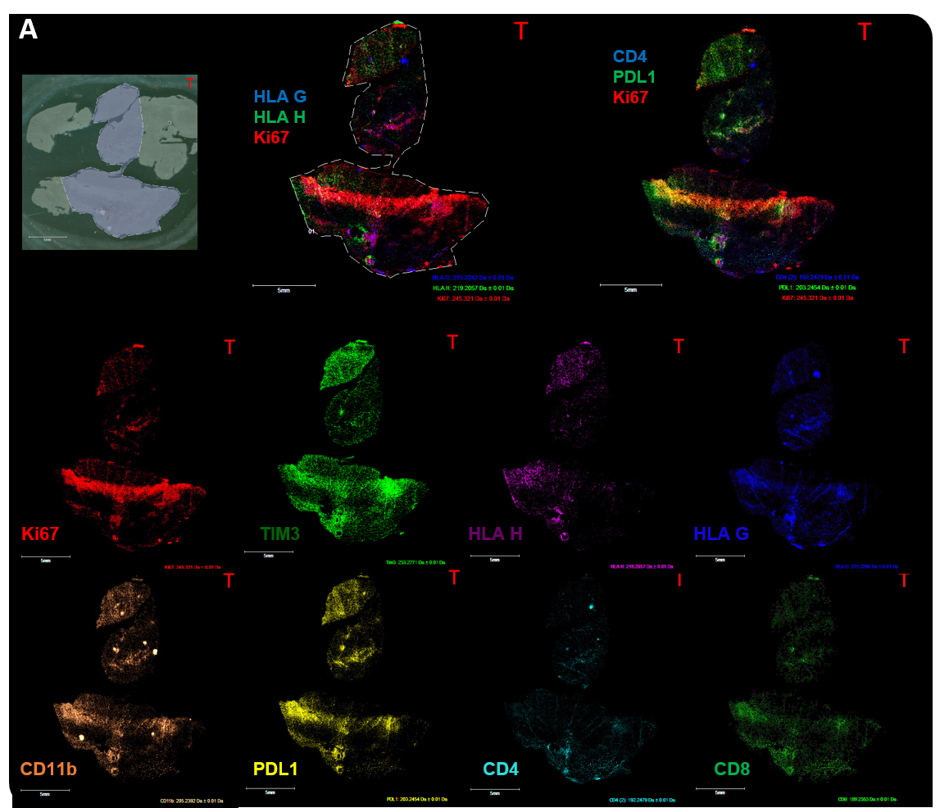
Supplementary Figure 7: 8-plex MALDI IHC of an FFPE tissue section of a glioblastoma. 8 of the Tags (T1, T2, T3, T6-T10) were used to modify primary antibodies directed against 8 different targets, namely, Ki67, TIM3, HLA-H, HLA-G, CD11b, PDL-1, CD4 and CD8 and performed MALDI IHC MS Imaging. (A) Scan of the tissue section indicating the area that was imaged. (B) Two overlay images of 3 different targets (HLA-G, HLA-H and Ki67 on the left and CD4, PDL1 and Ki67 on the right). (C) individual images of the different targets. Acquisition was performed on the rapifleX at 20 µm of spatial resolution.

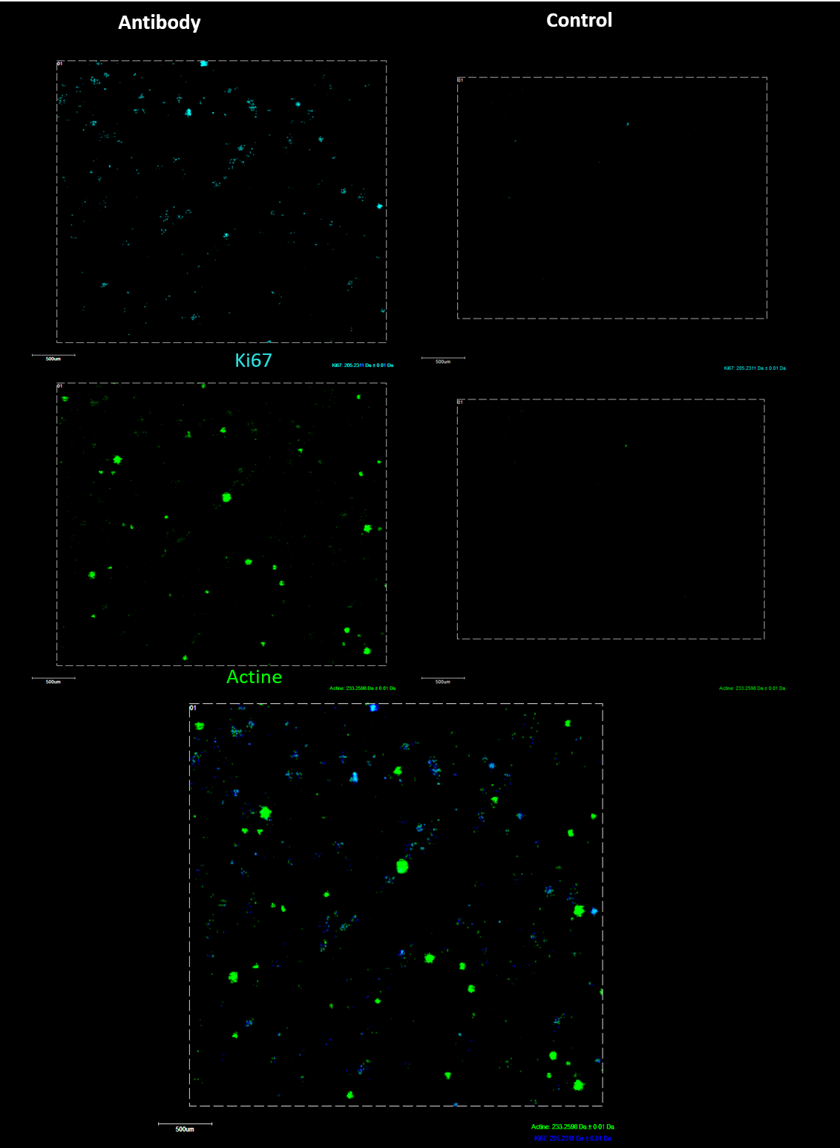
Supplementary Figure 8. 2-plex MALDI IHC on breast cancer tumoroids. Anti-Ki67 and -Actine primary antibodies were tagged using T2 and T10, respectively and used to perform IHC from tumoroids of a luminal breast cancer. Images were acquired on the rapifleX MALDI-TOF at 10 µm spatial resolution.

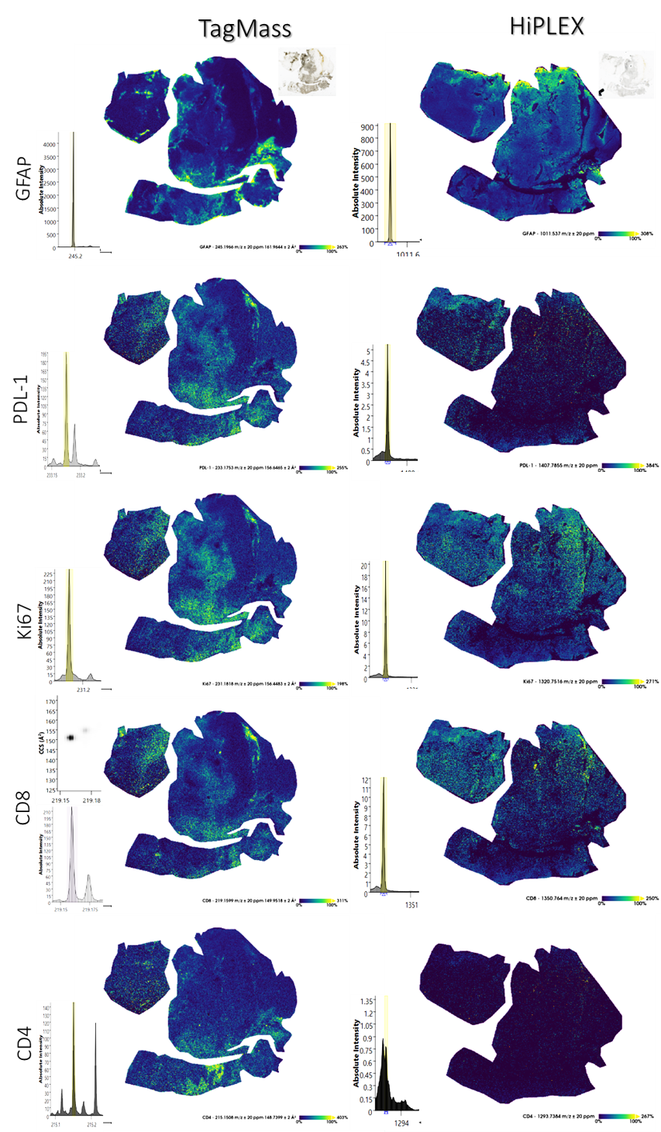
Supplementary Figure 9. 5-plex MALDI IHC from glioblastoma comparison with commercial solution. MALD IHC experiments were performed using tagged antibodies directed against GFAP, PDL-1, Ki67, CD8 and CD4. The images were compared to the same experiments run on a mirror tissue section using the or HiPLEX probes from AmberGen. For each probe the left panel presents a zoom around the MS reporter signal and on the right the reconstructed images. Images were acquired using a timsTOF flex at 20 µm spatial resolution.
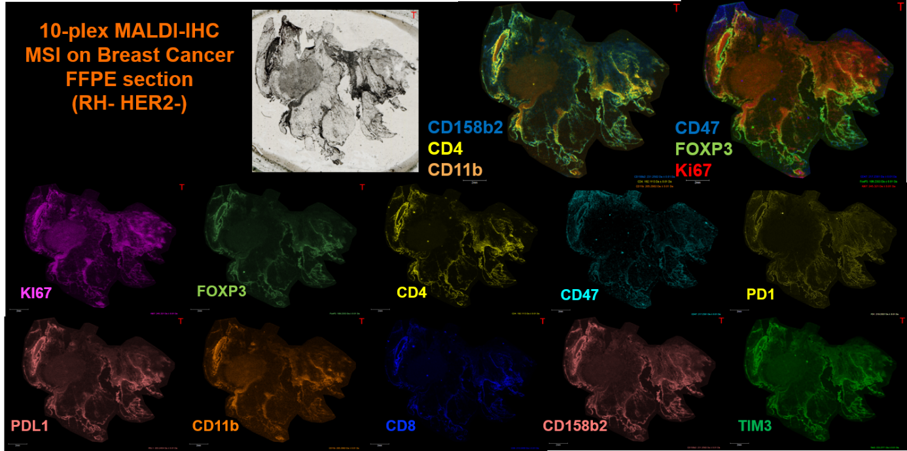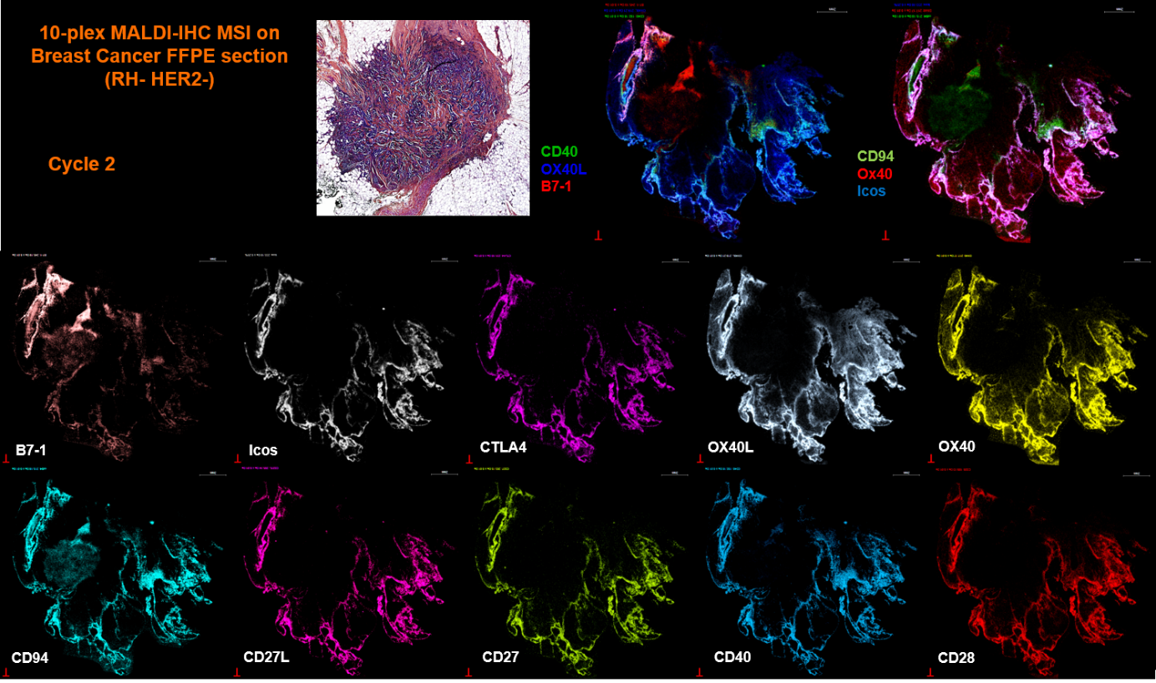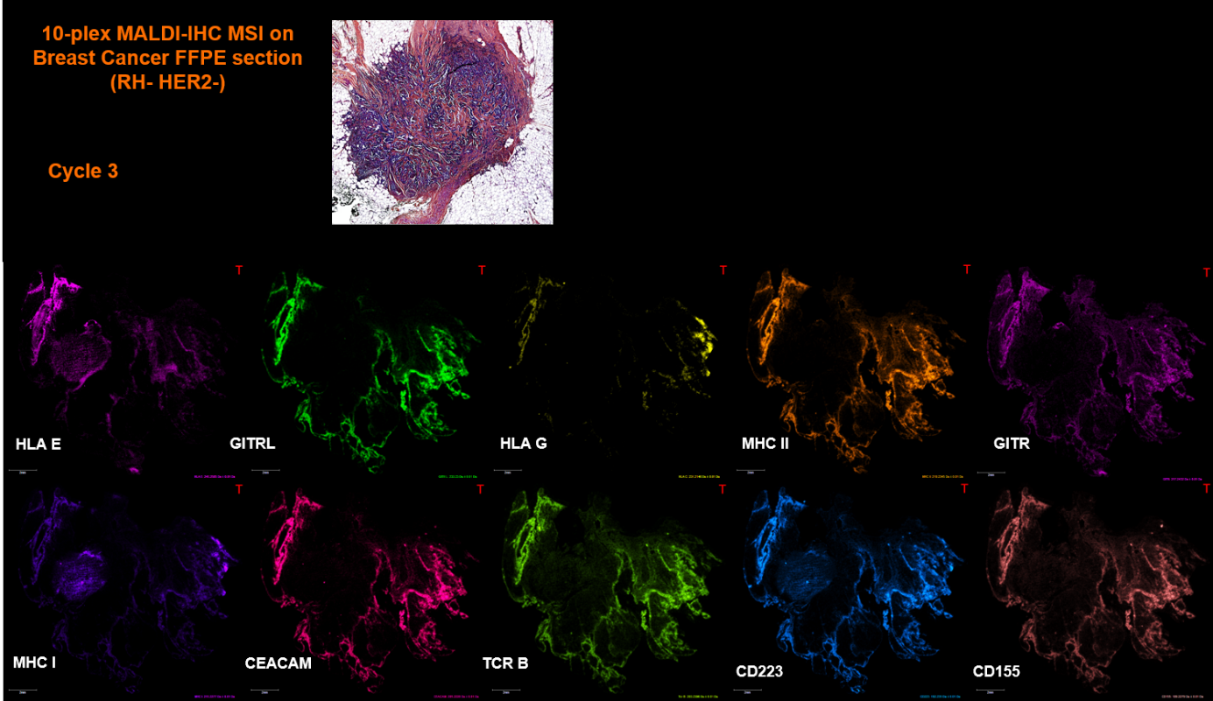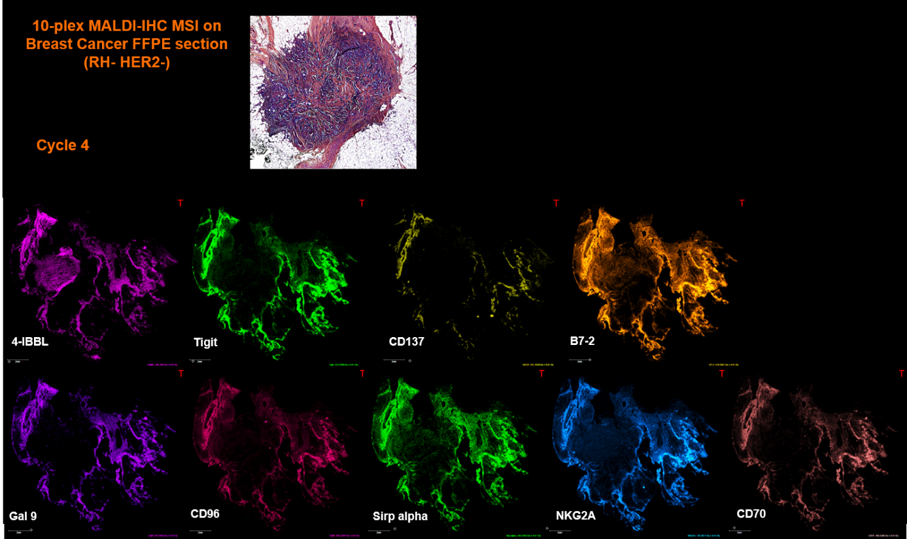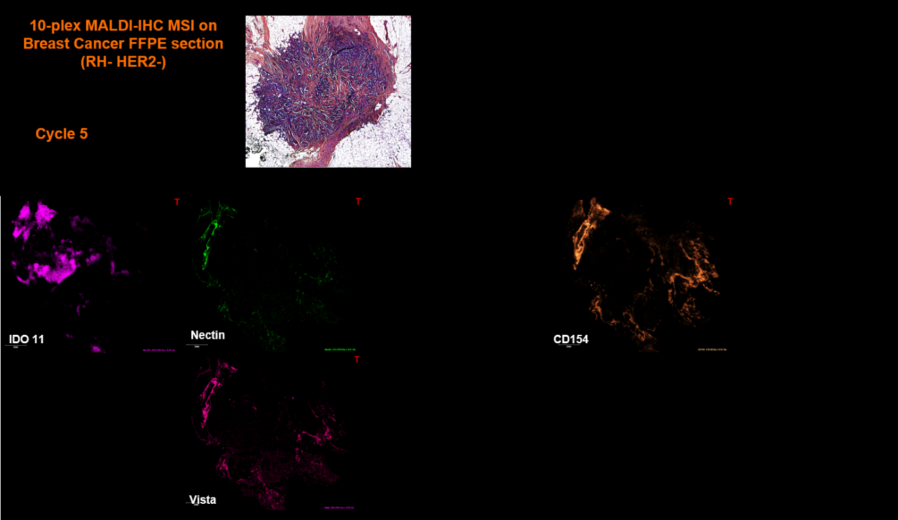
Supplementary Figure 10. 44-plex MALDI IHC experiments in five consecutive cycles. For each cycle after MALDI-IHC, the matrix was removed and the tissue was subjected to a photocleavage step to inactivate the remaining probes, allowing a new cycle to be initiated. Each panel presents the MALDI images acquired across the successive cycles; the fifth cycle contains the remaining markers. Images were acquired on a RapifleX MALDI-TOF at 20 µm spatial resolution.

Supplementary Figure 11. Control the 44-plex MALDI IHC experiments in 5 consecutive cycles. MALDI-MS images of the 10 MS reporters (T1-T10) between cycle 1 and cycle 2 after the MALDI matrix has been removed from the tissues, and subsequent photocleavage. The matrix is reapplied to the tissues for imaging. These controls demonstrate that no signal is observed for the MS reporter before a new cycle begins.

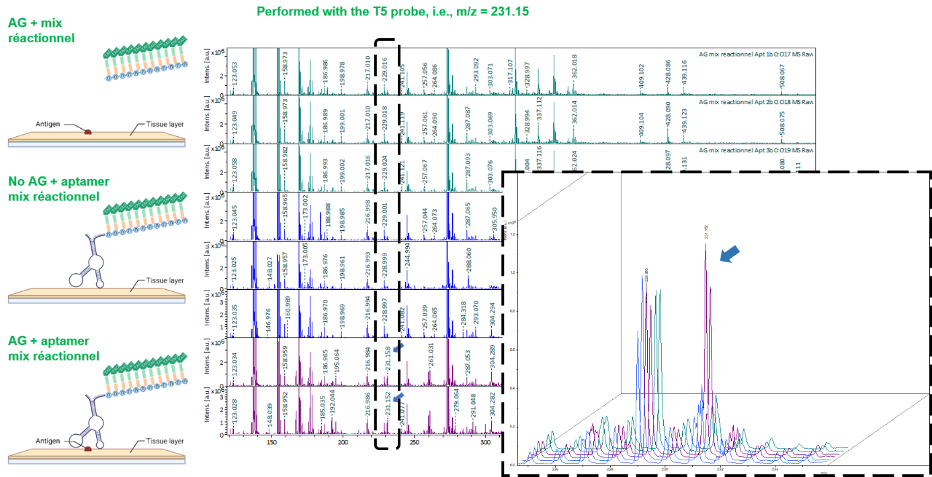
Supplementary Figure 12. Evaluation of the Tagged aptamer probes. Tagged anti-IL-10 aptamer was obtained by elongation of a U tail on which the T5 tag was clicked. This aptamer was used in an assay equivalent to a direct ELISA using IL-10 as antigen. The MALDI-TOF MS spectra show that the MS reporter signal at m/z 231.15 is only observed when both the antigen and the aptamer are present and not observed in the control (either no antigen (blue spectra) or no aptamer (green spectra) demonstrating the specificity of the detected signal.
Supplementary Figure 13. 4-plex aptamer MALDI-IHC from FF rat brain section. Four aptamers targeting α-synuclein, IL-10, N-cadherin and IL-6 were tagged and used in IHC-like experiments on a breast cancer tissue section. The antibody-based Ki67 image is shown as a previously acquired spatial reference. Images were acquired on a RapifleX instrument at a spatial resolution of 20 µm.

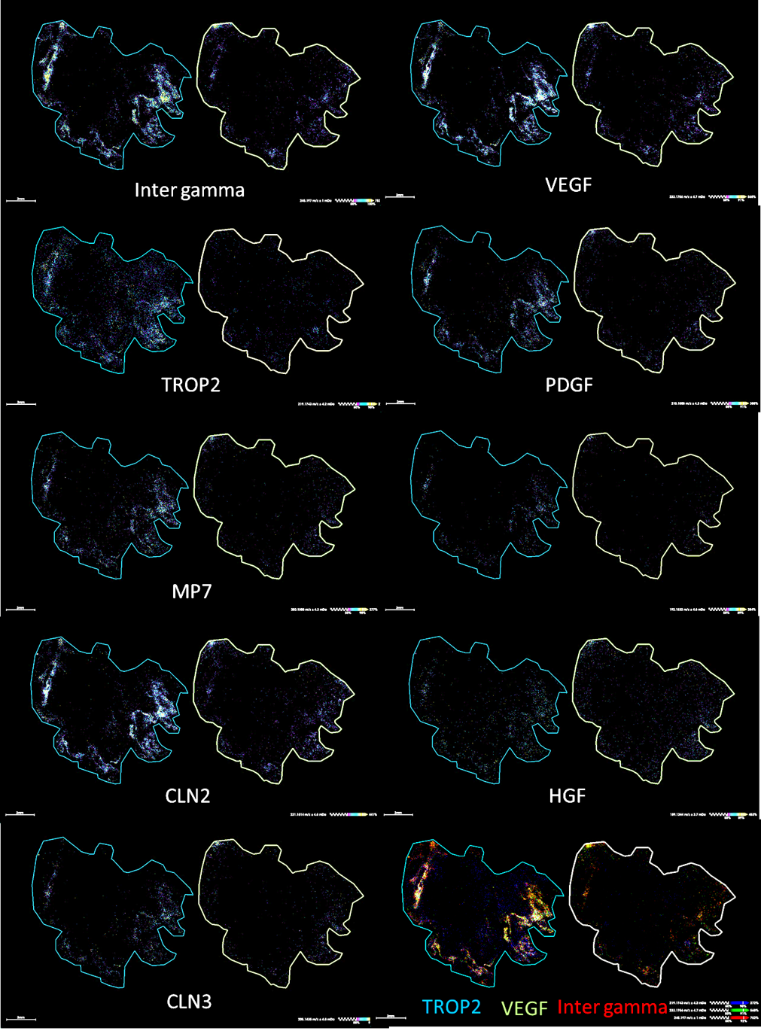
Supplementary Figure 14. 9-plex aptamer MALDI-IHC from FFPE breast cancer tissue. Eight aptamers targeting IFN-γ, VEGF, TROP2, PDGF, MMP7, CLN2, HGF, and CLN3 were tagged and used in IHC-like experiments on a breast cancer tissue section. The antibody-based Ki67 image is shown as a previously acquired spatial reference. Blue outlines indicate aptamer-based images and white outlines indicate the matched reaction-mixture-only control. Images were acquired on a timsTOF fleX instrument at a spatial resolution of 20 µm.
Supplementary Figure 15. 5-plex RNA MALDI-ISH on rat brain tissue. Five different RNA probes, including one miRNA (miR181c), three RNAs (GAPDH, Gad1, Lhx8), and one lncRNA (Chat), were tagged using the U-tail approach and used to perform ISH. The left and right panels present the antisense and sense probes, respectively. For miR181c, GAPDH, Gad1, and Lhx8, the antisense probe provides the specific signal, and the sense probe serves as the negative control. For the lncRNA Chat, the signal is observed with the probe labeled “sense” in this panel set, consistent with the transcript orientation used for probe naming, whereas the counterpart probe serves as the control. The bottom panel presents the lncRNA Chat, miR181c, and GAPDH overlay on the same image for the antisense-related set (GAPDH, mi181c, left) and the sense-related set (Chat, right). The images were acquired on a timsTOF fleX instrument at a spatial resolution of 20 µm.

Supplementary Figure 16. 2-plex MALDI IHC mixed panel lectin and antibody. The lectine Concanavalin A and the anti-GFAP antibody were tagged with T6 and T10 respectively and used for MALDI IHC. The Concanavalin A targets α-mannosyl and α-glucosyl residues in glycoproteins. The images were acquired on a RapifleX instrument at a spatial resolution of 20 µm.

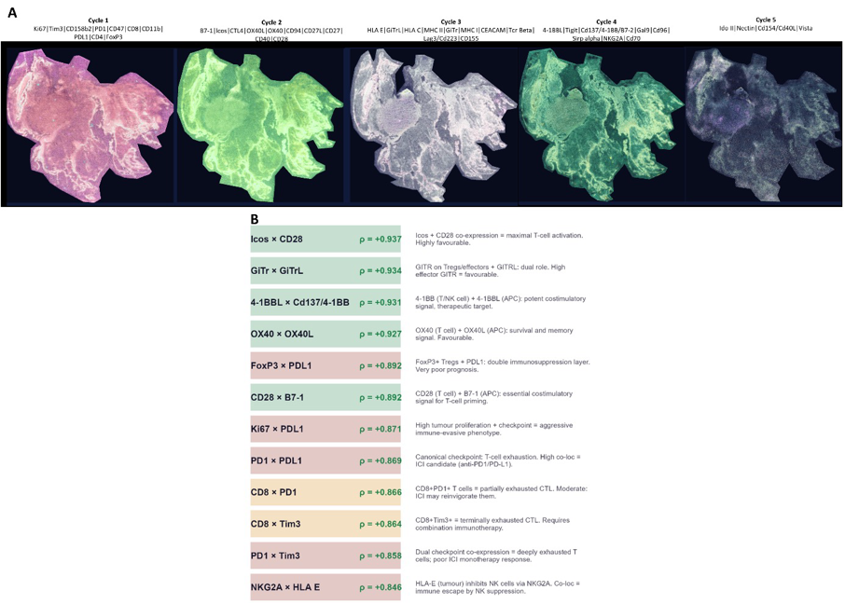Supplementary Figure 17. Per-cycle marker overlay images and annotated co-localization table for the 44-plex MALDI-IHC TNBC dataset. (A) Full-tissue RGB marker overlay images for each of the five acquisition cycles. Each image represents the RGB composite of all markers acquired within that cycle, enabling visual assessment of the spatial distribution of the functional marker groups across the tissue. The complete marker composition of each cycle is provided in Supplementary Data 1. (B) Annotated table of the top 12 spatially co-localized immune pathway pairs (ρ ≥ 0.846), ranked by Spearman correlation coefficient. For each pair, the ρ value and a concise biological interpretation are provided. The four highest co-localized pairs are pro-immune co-stimulatory axes: ICOS×CD28 (ρ = 0.937), GiTr×GiTrL (ρ = 0.934), 4-1BBL×CD137/4-1BB (ρ = 0.931), and OX40×OX40L (ρ = 0.927). Immunosuppressive pairs include FoxP3×PD-L1 (ρ = 0.892), reflecting a double immunosuppression layer, and NKG2A×HLA-E (ρ = 0.846), indicating tumour-mediated NK cell inhibition. Mixed exhaustion pairs include CD8×PD-1 (ρ = 0.866), CD8×Tim-3 (ρ = 0.864), and PD-1×Tim-3 (ρ = 0.858), collectively indicating a partially to terminally exhausted cytotoxic T-cell infiltrate.

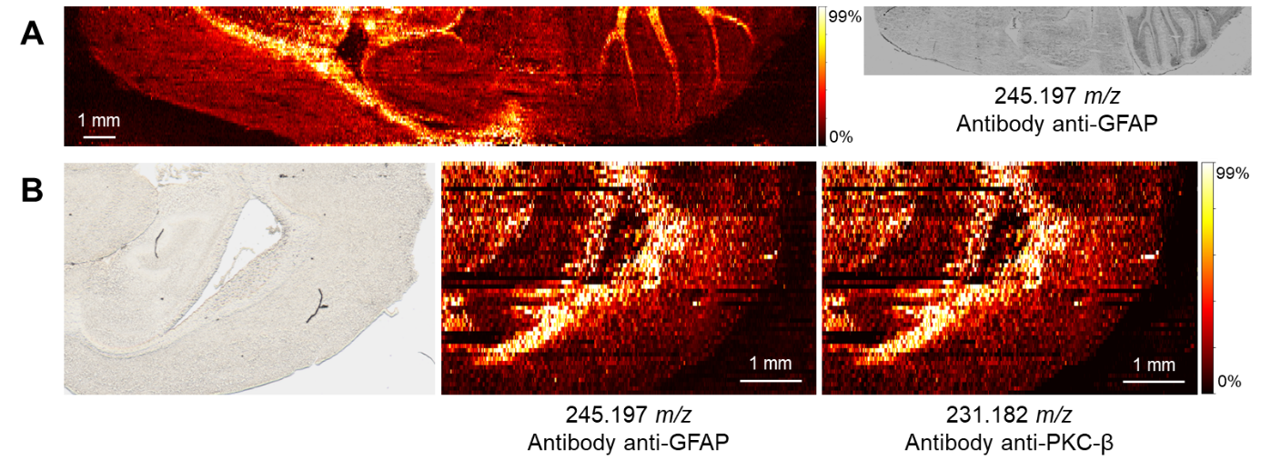
Supplementary Figure 18. Nano-DESI MSI IHC. (A) Single-plex MSI of GFAP target (T6) via nano-DESI MSI on a sagittal rat brain section. The spatial distribution of the signal confirms the efficient cleavage of the acid-sensitive carbamate linkage and the specificity of the antibody probe. (B) 2-plex MSI with simultaneous mapping of GFAP (T6) and protein kinase C beta (PKC-β via T5) on a horizontal rat brain section. Ion images are TIC normalized, and the color bars are scaled to 99% of maximum signal.

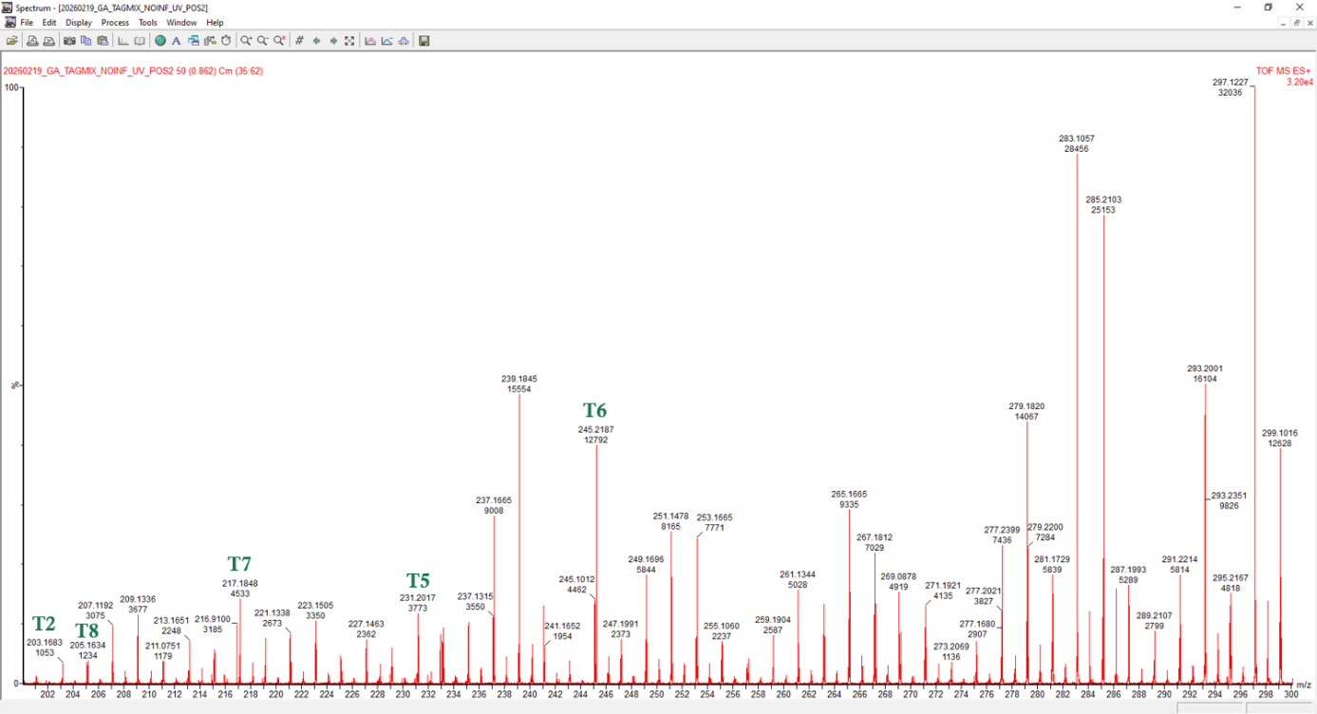
Supplementary Figure 19. Clickable Tags for SpiderMass technology. SpiderMass MS spectra of the Tags in the positive ion mode after the UV photocleavage for a mix of the Tags (T2, T5, T6, T7, T8). Acquisition was performed on the SpiderMass prototype

