Remote expert elicitation to determine the prior probability distribution for Bayesian sample size determination in international randomized controlled trials: Application to the Bronchiolitis in Infants Placebo Versus Epinephrine and Dexamethasone (BIPED) Study
Supplementary Material
- Clinical Case Study for Elicitation
Consider a 6 month old presenting in the winter months to the ED. His symptoms started 2 days ago with a runny nose and mild cough. One day ago, he developed a fever (up to 39 C rectally) and a worsening cough. Today his mother notes he is having a harder time latching onto the breast, taking about 50-75% of usual volumes, has had two wet diapers since waking at 7 am (it is now 3 pm), and seems to be having a hard time to breath. On physical examination his oxygen saturation is 93%, temperature is 38 C rectally, heart rate is 150 bpm, respiratory rate is 55 bpm, he has mild to moderate intercostal and subcostal indrawing and diffuse inspiratory and expiratory wheezes. You diagnosis him with bronchiolitis.

- Screenshot of Web Interface
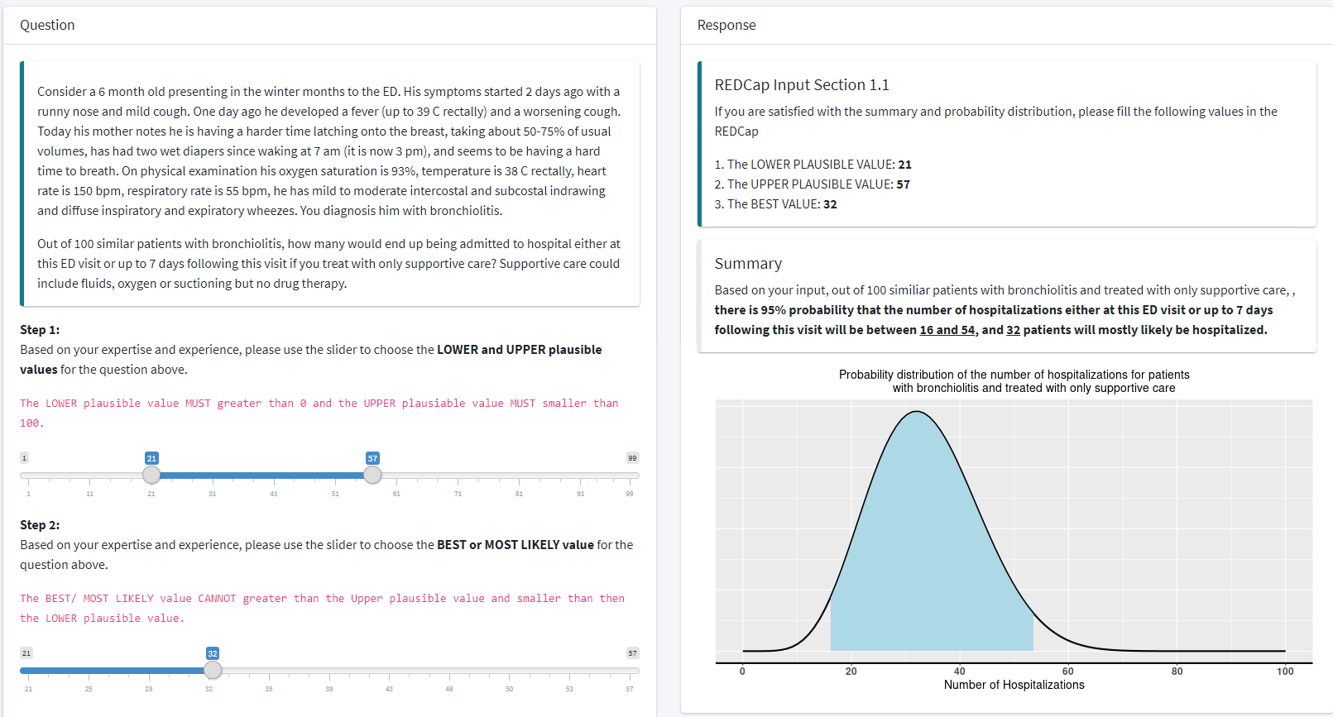

- De-identified boxplot to facilitate group discussion
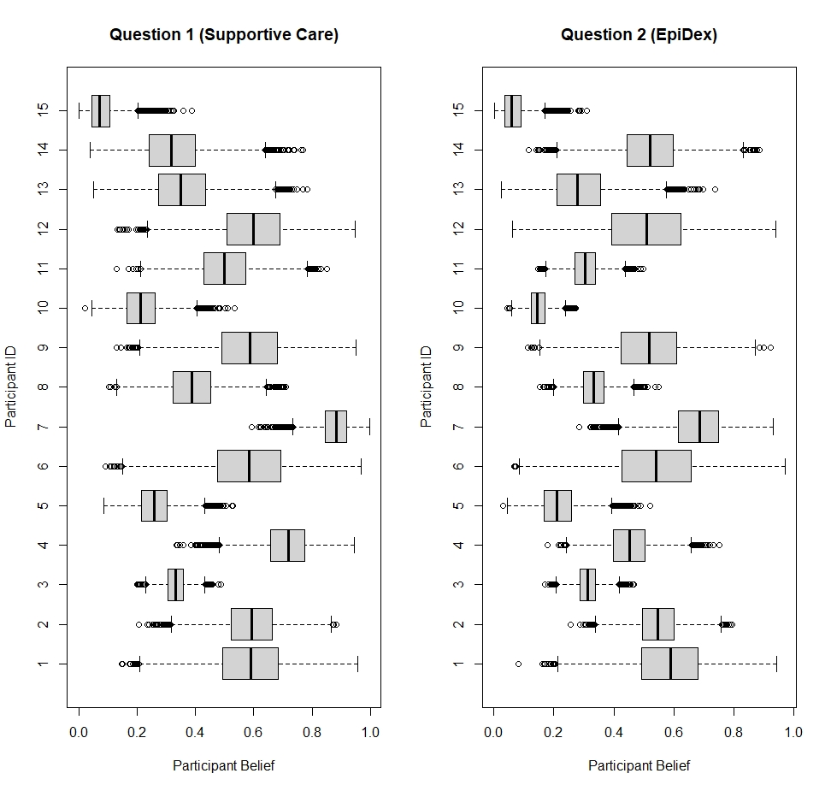
Figure S1: Boxplots displaying the individual elicited distributions from the first round of elicitation for hospitalisation probability under a) supportive care (left), or b) treatment with the combination of epinephrine and dexamethasone (EpiDex, right). Participants are numbered by their enrolment time in the BIPED elicitation study. These boxplots were displayed during the elicitation exercise to facilitate the group discussion, with each workshop only displaying and discussing the individual elicited distributions from experts participating in that workshop.
- Elicited prior distributions by workshop
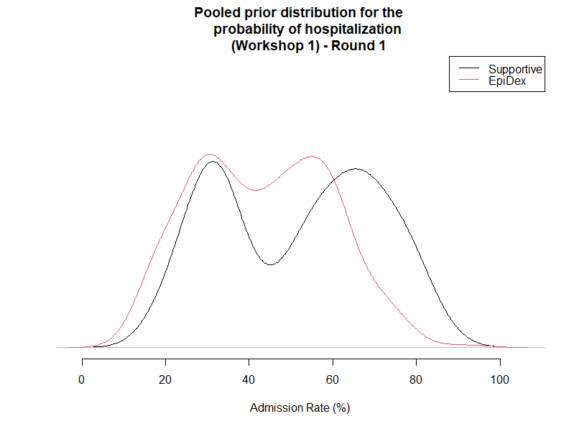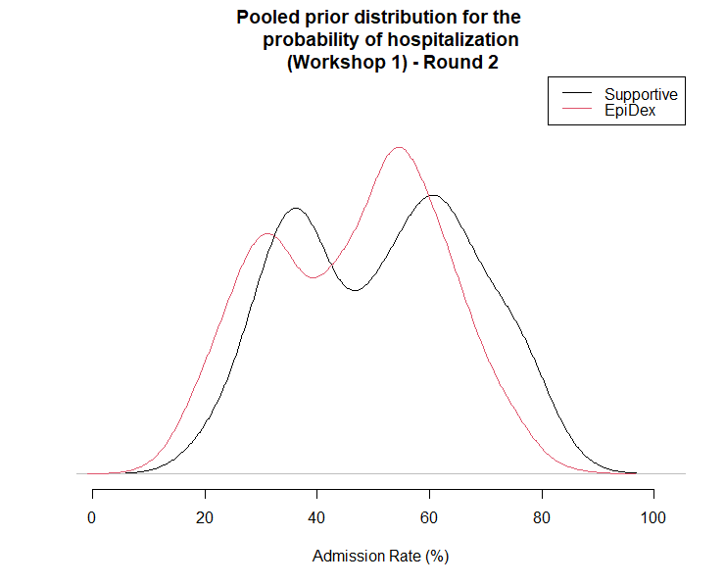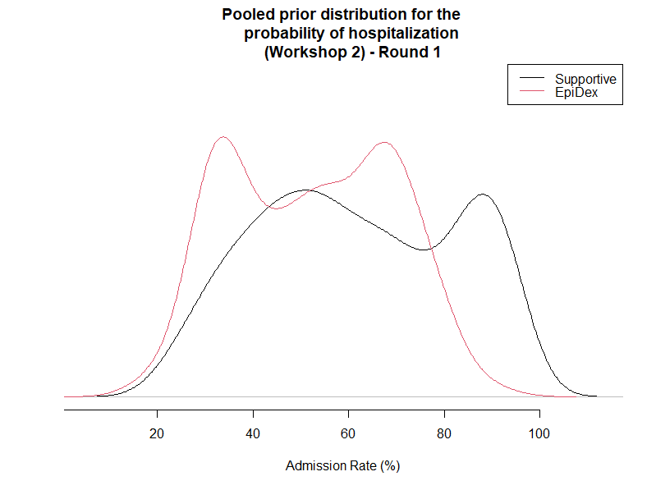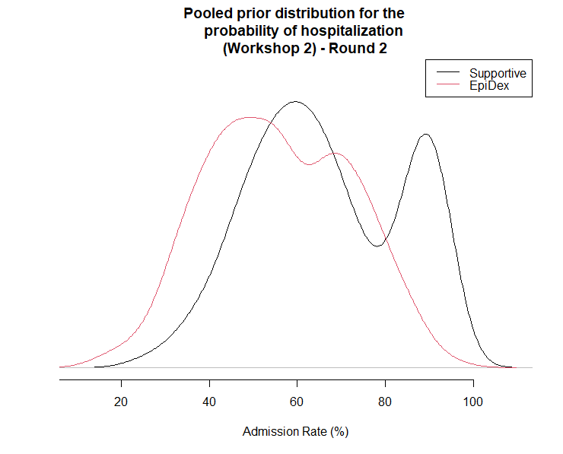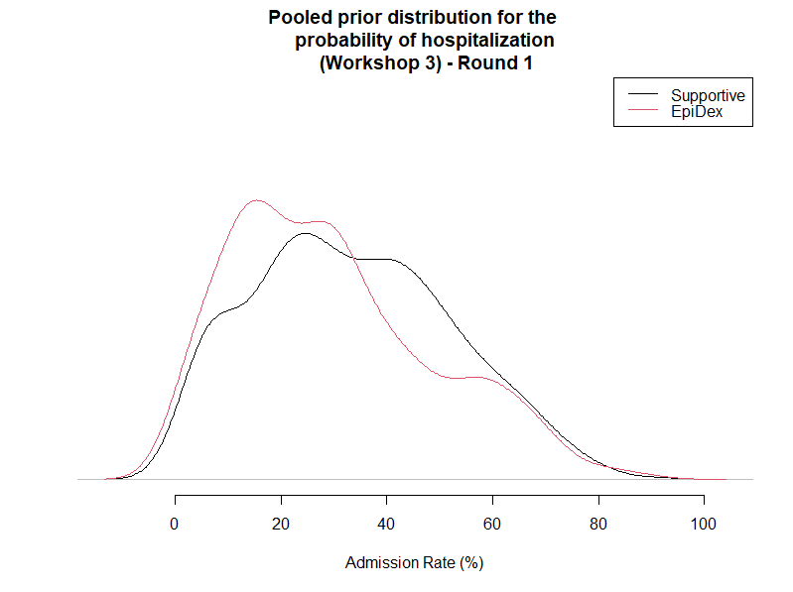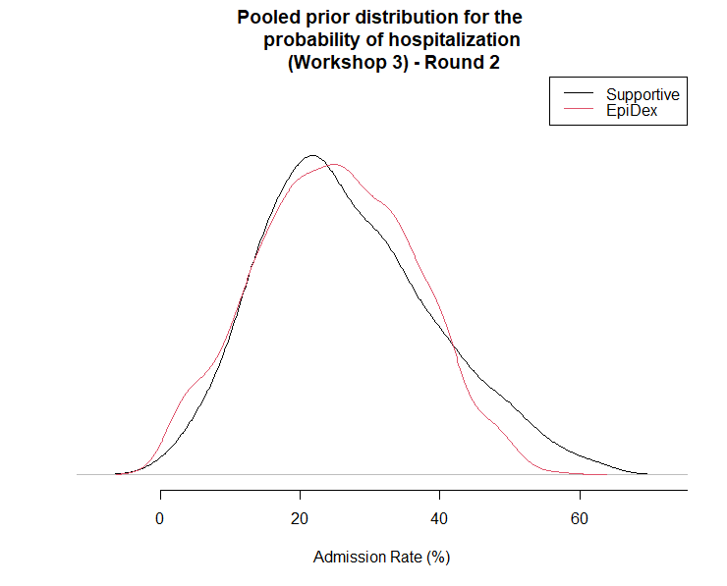
Figure S2: Pooled elicited prior distributions for hospitalisation probability under a) supportive care (black line), or b) treatment with the combination of epinephrine and dexamethasone (EpiDex, red line). Distributions for first elicitation round left; second round right. The top two plots display the distribution from the first elicitation workshop, the middle two from the second elicitation workshop and the bottom two from the third workshop.
- Elicited prior distributions by expert practice region
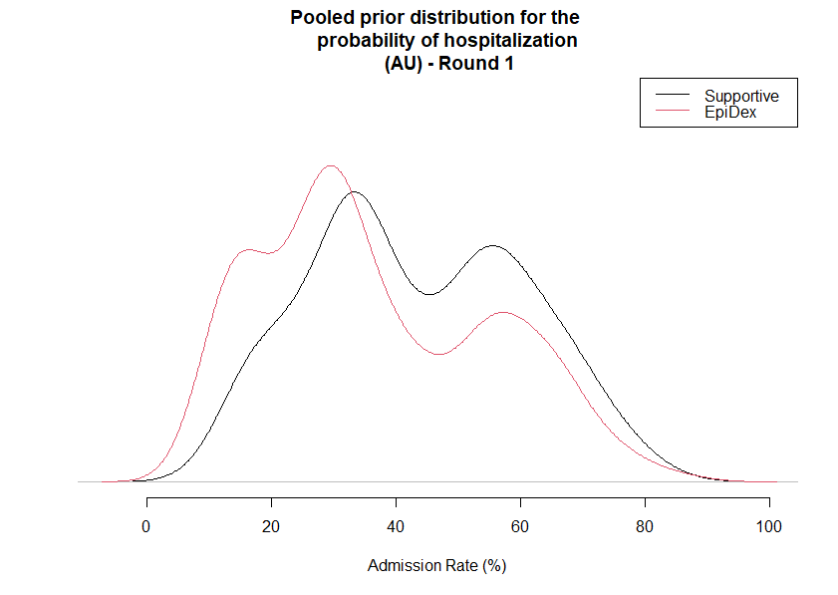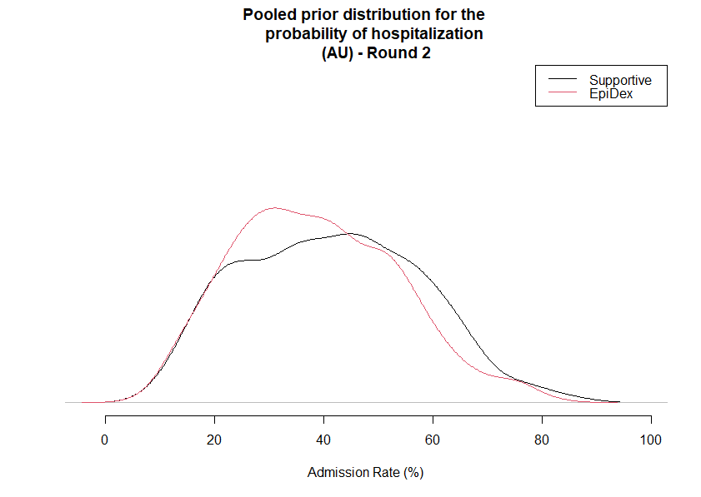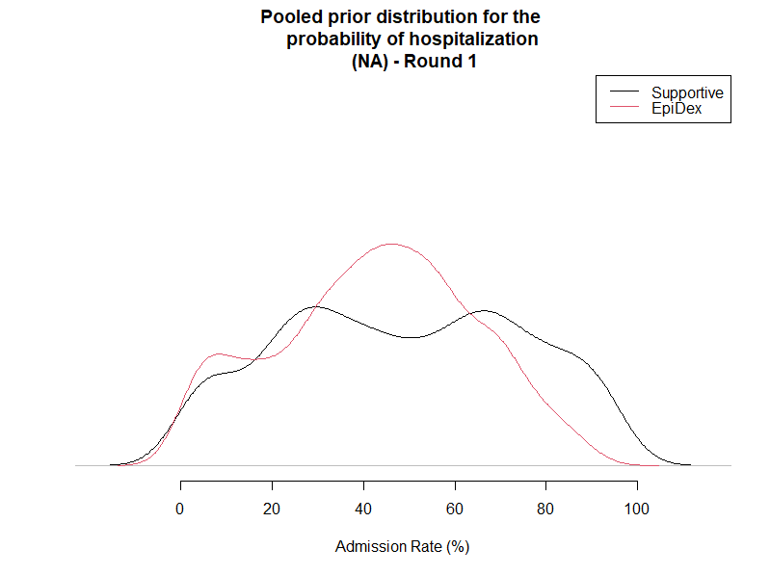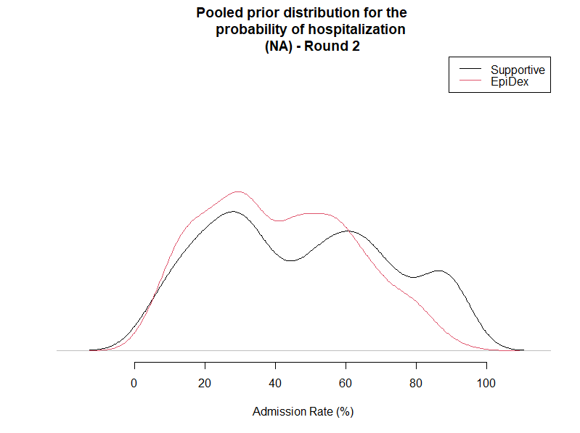
Figure S3: Pooled elicited prior distributions for hospitalisation probability under a) supportive care (black line), or b) treatment with the combination of epinephrine and dexamethasone (EpiDex, red line). Experts who practice in Australia and New Zealand (AU) on top; in North America (NA) bottom.

