Interfacial control of mineral fillers in vat photopolymerization: effects on dispersion and mechanical response

Giuseppe Ferrara,^{1&} Gaia Ghiselli,^{1&} Simone Maturi,¹ Rosario Carmenini,¹ Erica Locatelli,¹ Cristina Siligardi,² Letizia Sambri¹ and Mauro Comes Franchini^{1,*}

¹Department of Industrial Chemistry “Toso Montanari”, University of Bologna, Via P. Gobetti 85, 40129 Bologna, Italy
²Università Degli Studi Di Modena E Reggio Emilia-Unimore. Dipartimento di Ingegneria “Enzo Ferrari” Via P. Vivarelli, 10. 41125 Modena, Italy

SUPPORTING INFORMATION

MATERIALS AND METHODS
CaCO₃ synthesis
Equimolar quantities of CaCl₂ and K₂CO₃ were weighted and separately dissolved in ethylene glycol (EG) at 60°C. After complete solubilization, K₂CO₃ solution was dropped in the CaCl₂ solution while maintaining the temperature and under vigorous stirring. At completion of the process, the solution was centrifuged at 3900rpm for 30 minutes. The supernatant was discarded, and the precipitate was washed and resuspended in ethanol and centrifuged at 3900rpm for 15 minutes. This process was repeated two more times. At the end of the cleaning procedure, the precipitate was filtered and dried at 80°C.
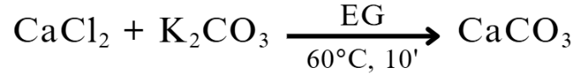
Scheme S1: CaCO3 synthesis method

Printing process
Specimens for tensile test have been designed using computer-assisted design (CAD) following the ISO-37 Type 2 specifications (5x2 mm² cross-section, 25 mm gauge length). The 3D models were sliced using Chitubox Pro V 2.0 software provided by the printers' company. A Phrozen Sonic Mini 8K LCD 3D printer was used for 3D printing all of the specimens; this printer was equipped with a 7.1’’ Mono LCD screen (Linear Projection LED Module) with a XY resolution of 22 µm (1152 ppi), a layer thickness resolution in the range of 0.01–0.30 mm and a total printing size of 29×29×42 cm, with a maximum printing speed of 80m/hr. The exposure time for each layer was optimized to 25 seconds to obtain the best resolution of the final printed specimen. After printing the 3D models, the specimens were removed from the printing plate and washed carefully with isopropanol to remove all the non-printed liquid resin. The specimens were then post cured for 10 minutes at room temperature using UV curing oven (Formlabs, FormCure 1st generation, 405 nm, 39 W) and then left exposed to environmental light and air for one week before the tensile test.

CHEMICAL AND MORPHOLOGICAL CHARACTERIZATION
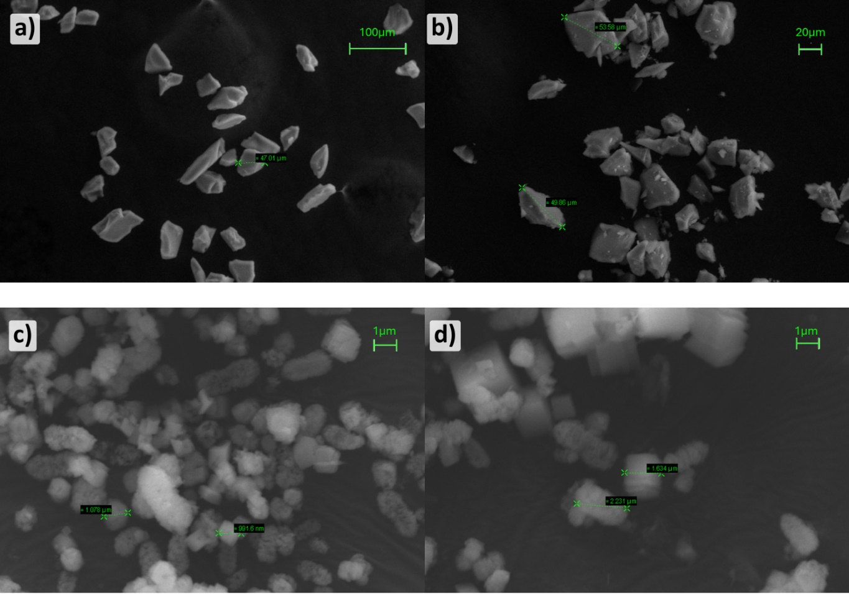
Figure S1: SEM images of n-Si particles (a), f-Si particles (b), n-Ca particles (c) and f-Ca particles (d). In both cases the shape and average size of the particles didn’t vary considerably after the functionalization process.

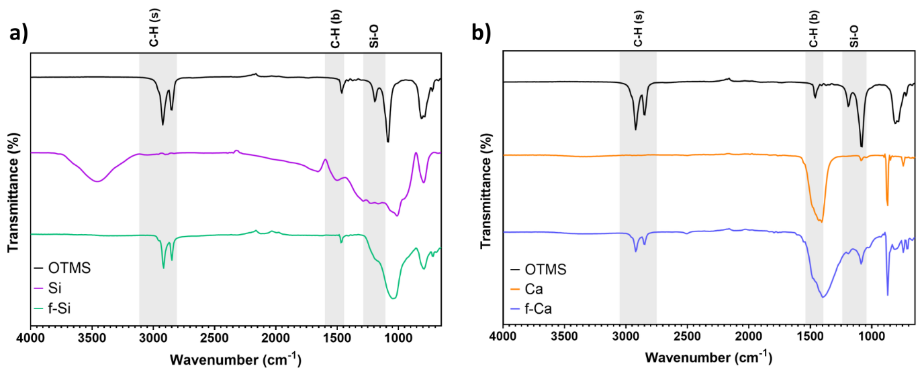
Figure S2: ATR-FTIR spectra overlay of silica (a) and calcium carbonate (b) inorganic particles before and after the functionalization procedure. The spectrum of neat OTMS shows the expected aliphatic characteristics peaks, with intense C-H stretching bands at 2920 cm⁻¹ and 2850 cm⁻¹, C-H bending vibrations at 1460 cm⁻¹ and additional contributions in the fingerprint region and at 1190 cm⁻¹ and 1090 cm⁻¹, attributed to the Si-O bond [1]. For calcium carbonate, partial overlap with the intense carbonate-related absorption in the 1440–1410 cm⁻¹ region can mask weaker OTMS contributions in the fingerprint range; however, the aliphatic stretching bands remain distinctly detectable, supporting successful surface functionalization for both mineral substrates.

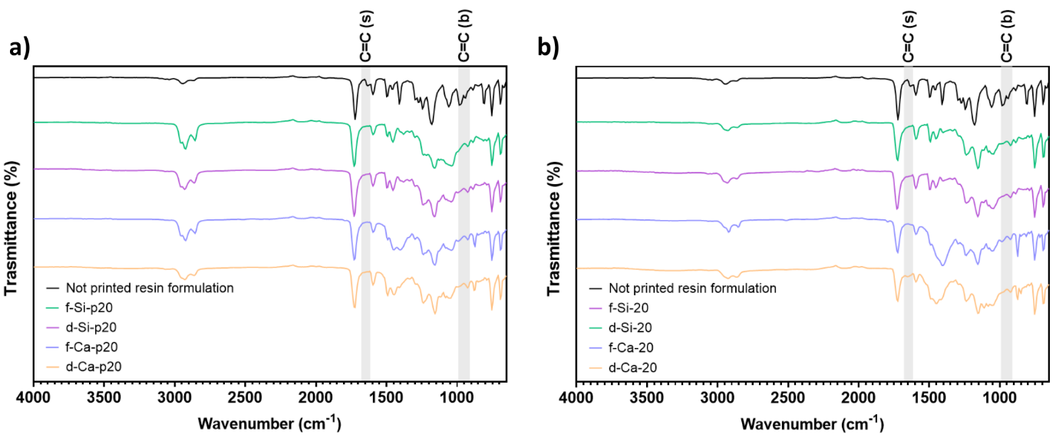
Figure S3: FTIR spectra of printed specimens of a) the plasticizer-containing formulations and b) plasticizer-free formulations. The spectra are relative to specimens loaded with 20% of inorganic filler. Notably, across all formulations, the characteristic bands associated with vinyl moieties (the stretching bands at 1620–1680 cm⁻¹ and the bending bands at 910–990 cm⁻¹) were absent after printing and post-curing. These results indicate that neither silica nor calcium carbonate, regardless of surface treatment, inhibit the photopolymerization process under the selected exposure conditions.

REFERENCES

[1] Launer P, Arkles B (2013) Infrared Analysis of Organosilicon Compounds. In: Silicon Compounds: Silanes & Silicones. Gelest, Inc Morrisville, pp 175-178

