Supporting Information
Spectral Image Contrast Based Flow Digital Nanoplasmon-metry for Ultrasensitive Antibody Detection
Sheng-Hann Wang,ª Chia-Wen Kuo,ª Shu-Cheng Lo,^{a,b} Wing Kiu Yang,ª and Pei-Kuen Wei^{a,}*

ªResearch Center for Applied Sciences, Academia Sinica, Taipei 11529, Taiwan.
^{b}Institute of Applied Mechanics, National Taiwan University, Taipei 11221, Taiwan.
*Corresponding author: Pei-Kuen Wei,
128 Academia Road, Section 2, Nankang, Taipei 11529, Taiwan.
Tel.: +886 2 2787 3146
Fax.: +886 2 2787 3122
E-mail address: pkwei@sinica.edu.tw

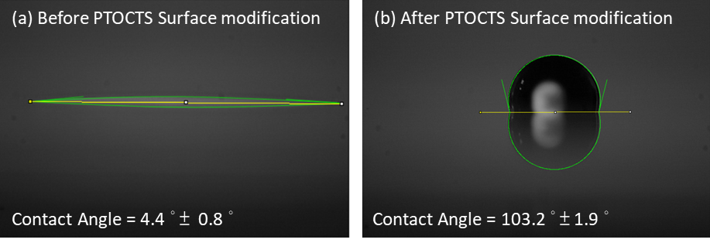
Figure S1. Contact angles of the glasses (a) before and (b) after the trichloro(1H,1H,2H,2H-perfluorooctyl)silane (PTOCTS) surface modification. Sample number = 12.

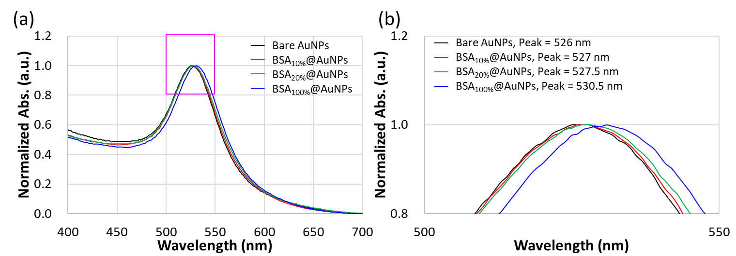
Figure S2. UV-Vis absorption spectra of bare and different ratios of BSA to PEG-(NH₂)₂ modified AuNPs.

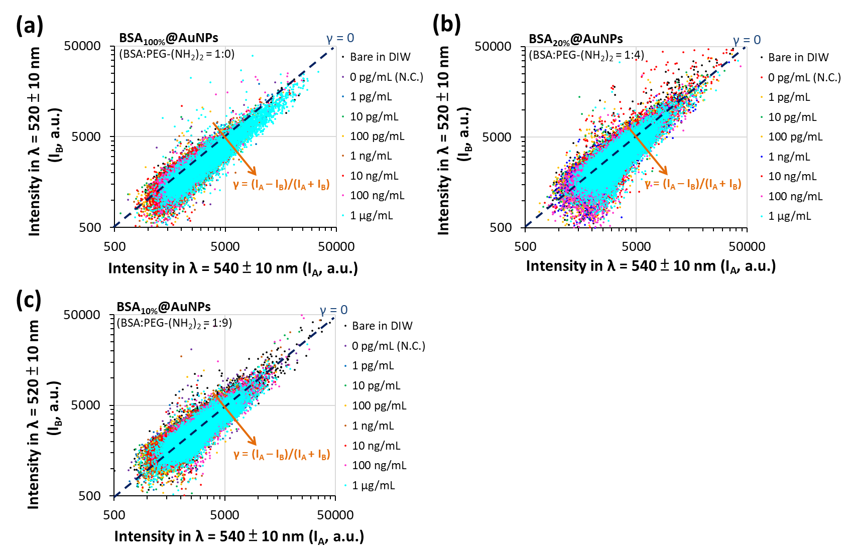
Figure S3. Intensity scatters plot of the bare AuNPs, and the different ratios of BSA to PEG-(NH₂)₂ modified AuNPs before and after conjugated with various concentrations of anti-BSA. (a) BSA_{100%}@AuNPs, (b) BSA_{20%}@AuNPs, and (c) BSA_{10%}@AuNPs.

Table S1. Conversion table of the wt% ratio to molecule ratio of BSA and PEG-(NH₂)₂.
wt% ratio | molecule ratio
1:0 | 1:0
1:4 | 1:100
1:9 | 1:225
1:19 | 1:475

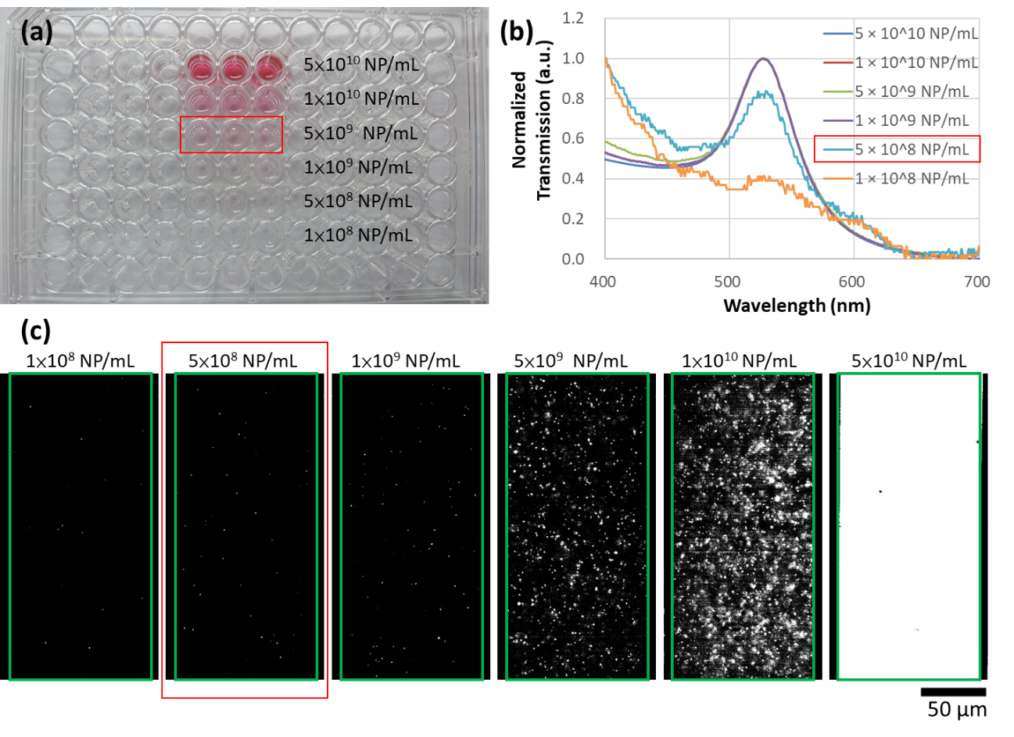
Figure S4. Test results of minimal detectable concentration of AuNPs by (a) naked-eye, (b) UV-Vis absorption spectra, and (c) flow digital nanoplasmon-metry (FDNM). The analyte is the 50-nm bare AuNPs with different concentrations. The minimal detectable concentration is 5 × 10⁹ NP/mL for naked-eye and 5 × 10⁸ NP/mL for the UV-Vis absorption spectra and FDNM. Even though the absorption spectrum of the 5 × 10⁸ NP/mL is not as smooth as 1 × 10⁹ NP/mL, the spectrum can still be analyzed and identified by employing the Gaussian fitting.

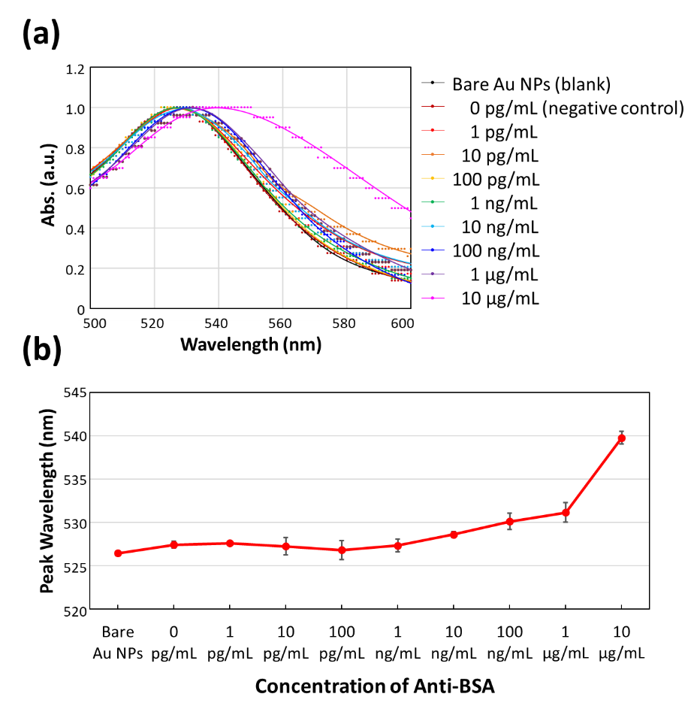
Figure S5. (a) UV-Vis absorption spectra of the BSA_{20%}@AuNPs conjugated with various concentrations of the anti-BSA in TE buffer and the peaks of LSPR absorption were analyzed and identified by employing the Gaussian fitting as shown in (b).

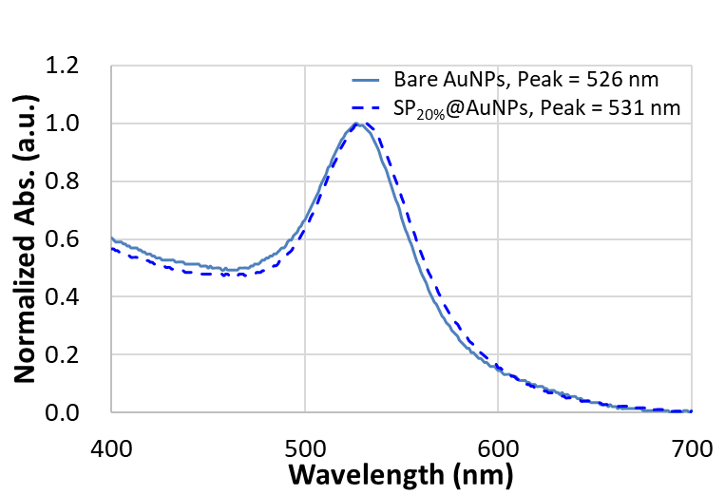
Figure S6. UV-Vis absorption spectra of bare and SP_{20%}@AuNPs.
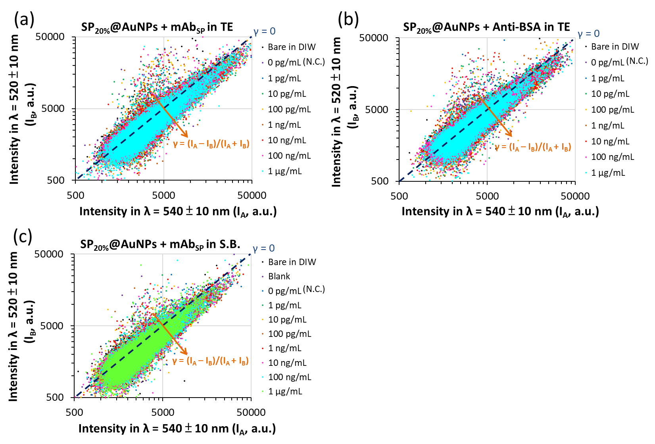
Figure S7. Intensity scatters plots of the bare AuNPs and the SP_{20%}@AuNPs in response to the various concentrations of (a) the mAb_{SP}, and (b) anti-BSA in TE buffer, and (c) mAb_{SP} in artificial saliva (without any additive proteins) and that contains HSA, IgA, IgG, and IgM.

Table S2. List of the LSPR-immunoassay in protein detection.
Plasmonic structure | Analysis |  | Analytes | Signal Amplification | Matrix | LOD | Ref.
Plasmonic structure | Detection | Analog/Digital
AuNPs | Absorption Spectra | Analog | Anti-protein A | None | Pure | 1 μg/mL | [1]
AuNPs | Absorption Spectra | Analog | Alpha Fetoprotein | None | Complicated | 100 ng/mL | [2]
AuNPs | Absorption Spectra | Analog | tumor necrosis factor -alpha (TNF-α) | None | Complicated | 100 ng/mL | [3]
AgNPs | Absorption Spectra | Analog | Dengue NS1 | None | Complicated | 60 ng/mL | [4]
Au layer on SiO₂ NPs | Absorption Spectra | Analog | immunoglobulins | None | Complicated | 100 pg/mL | [5]
Au Nanospike | Absorption Spectra | Analog | Antibody gainst the SARS-CoV-2 spike protein | None | Complicated | 80 pg/mL | [6]
Triangular silver nanosurfaces | Absorption Spectra | Analog | Human Epididymis Protein 4 (HE4) | None | Complicated | 35 pg/mL (1pM) | [7]
AuNPs | Colorimetric  (Naked-eyed) | Analog | Thrombin | None | Pure | ~360 ng/mL (10 nM) | [8]
AuNPs | Colorimetric  (LFAs) | Analog | Antibodies against the SARS-CoV-2 Virus | None | Complicated | 1 ng/mL | [9]
AuNPs | Colorimetric  (LFAs) | Analog | Human IgG | Horseradish peroxidase (HRP) | Pure | 200 pg/mL | [10]
AuNPs | Colorimetric  (Fluorescence) | Analog | BSA  β-galactosidase  cytochrome c | Fluorescent dye labeled | Pure | ~5.5μg/mL (110 nM)  ~1.9μg/mL (4 nM)  ~2.6 μg/mL (215 nM) | [11]
AuNPs | Colorimetric  (Fluorescence) | Analog | Thrombin | Fluorescent dye labeled | Pure | ¬ 5 ng/mL (0.14 nM) | [12]
AuNPs | Spectral Image Contrast | Digital | Anti-BSA  Antibodies against the SARS-CoV-2 SP | None | Complicated | 10 pg/mL | This work

References
1. Thanh NTK, Rosenzweig Z: Development of an Aggregation-Based Immunoassay for Anti-Protein A Using Gold Nanoparticles. Analytical Chemistry 2002, 74:1624-1628.
2. Nietzold C, Lisdat F: Fast protein detection using absorption properties of gold nanoparticles. Analyst 2012, 137:2821-2826.
3. Oh B-R, Huang N-T, Chen W, Seo JH, Chen P, Cornell TT, Shanley TP, Fu J, Kurabayashi K: Integrated Nanoplasmonic Sensing for Cellular Functional Immunoanalysis Using Human Blood. ACS Nano 2014, 8:2667-2676.
4. Austin Suthanthiraraj PP, Sen AK: Localized surface plasmon resonance (LSPR) biosensor based on thermally annealed silver nanostructures with on-chip blood-plasma separation for the detection of dengue non-structural protein NS1 antigen. Biosensors and Bioelectronics 2019, 132:38-46.
5. Endo T, Kerman K, Nagatani N, Hiepa HM, Kim D-K, Yonezawa Y, Nakano K, Tamiya E: Multiple Label-Free Detection of Antigen−Antibody Reaction Using Localized Surface Plasmon Resonance-Based Core−Shell Structured Nanoparticle Layer Nanochip. Analytical Chemistry 2006, 78:6465-6475.
6. Funari R, Chu K-Y, Shen AQ: Detection of antibodies against SARS-CoV-2 spike protein by gold nanospikes in an opto-microfluidic chip. Biosensors and Bioelectronics 2020, 169:112578.
7. Duan R, Xi M: A Novel Label-Free Biosensor for Detection of HE4 in Urine Based on Localized Surface Plasmon Resonance and Protein G Directional Fixed. Journal of Nanomaterials 2020, 2020:8613240.
8. Xia F, Zuo X, Yang R, Xiao Y, Kang D, Vallée-Bélisle A, Gong X, Yuen JD, Hsu BBY, Heeger AJ, Plaxco KW: Colorimetric detection of DNA, small molecules, proteins, and ions using unmodified gold nanoparticles and conjugated polyelectrolytes. Proceedings of the National Academy of Sciences 2010, 107:10837-10841.
9. Li Z, Yi Y, Luo X, Xiong N, Liu Y, Li S, Sun R, Wang Y, Hu B, Chen W, et al: Development and clinical application of a rapid IgM-IgG combined antibody test for SARS-CoV-2 infection diagnosis. Journal of Medical Virology 2020, 92:1518-1524.
10. Parolo C, de la Escosura-Muñiz A, Merkoçi A: Enhanced lateral flow immunoassay using gold nanoparticles loaded with enzymes. Biosensors and Bioelectronics 2013, 40:412-416.
11. You C-C, Miranda OR, Gider B, Ghosh PS, Kim I-B, Erdogan B, Krovi SA, Bunz UHF, Rotello VM: Detection and identification of proteins using nanoparticle–fluorescent polymer ‘chemical nose’ sensors. Nature Nanotechnology 2007, 2:318-323.
12. Wang W, Chen C, Qian M, Zhao XS: Aptamer biosensor for protein detection using gold nanoparticles. Analytical Biochemistry 2008, 373:213-219.

