Artificial intelligence integrating diagnostic clinical feature recognition for cervical lesion diagnosis and biopsy position locating under colposcopy

Contens
S1 The accuracy of DIC feature extraction 2
S2 The DIC's architecture and Comparison the performance with other models 3
S3 Human-machine comparison 3
S4 Routine colposcopic impressions 4
S5 The performance in predicting biopsy locations 5
S6 Composition illustration of the data 5
S7 Standards for excluding images 5
S8 Annotation software, methods, and rules 6
S9 Feature encoding 7
S10 Importance ranking of feature SHAP value 8
S11 Visual interface and structured report 10

S1 The accuracy of DIC feature extraction
The model developed in this study is based on the precise recognition of six key clinical features, which are crucial for achieving a high accuracy in lesion detection. The model adopts a fully supervised learning approach, using medical images independently annotated by experienced colposcopists as the golden standard for feature extraction. The dataset includes 3,452 images from 1,691 patients.
Acetowhite epithelium: This feature is classified into three categories: faintly white, opaque white, and none. The training dataset consists of 1,133 images with faintly white, 992 images with opaque white, and 617 images with none. In the validation set, there are 225 images with faintly white, 257 with opaque white, and 120 with none. The model achieved an accuracy of 74.3%.
Mosaic: This feature is classified into three categories: fine, coarse, and none. The training dataset consists of 58 images with fine mosaic, 195 images with coarse mosaic, and 2,489 images with none. In the validation set, there are 13 images with fine mosaic, 57 images with coarse mosaic, and 532 images with none. The model achieved an accuracy of 94.8%.
Punctation: This feature is classified into three categories: fine, coarse, and none. The training dataset includes 95 images with fine punctation, 438 images with coarse punctation, and 2,209 images with none. In the validation set, there are 23 images with fine punctation, 90 images with coarse punctation, and 489 images with none. The model achieved an accuracy of 90.5%.
Margin: This feature is classified into three categories: irregular, distinct, and sharp. The training dataset contains 1,216 images with irregular margin, 771 images with distinct margin, and 755 images with sharp margin. In the validation set, there are 246 images with irregular margin, 177 images with distinct margin, and 179 images with sharp margin. The model achieved an accuracy of 78.5%.
Inner border sign: This feature is classified into two categories: presence and absence. The training dataset includes 267 images with a presence inner border sign and 2,475 images with absence inner border sign. In the validation set, there are 91 images with a presence inner border sign and 511 images with absence inner border sign. The model achieved an accuracy of 93.2%.
Atypical Vessels: This feature is classified into two categories: presence and absence. The training dataset includes 228 images with atypical vessels and 2,514 images with no atypical vessels. In the validation set, there are 65 images with atypical vessels and 537 images with no atypical vessels. The model achieved an accuracy of 96.2%.
The model developed in this study achieved precision, sensitivity, specificity, and accuracy in the extraction of the six features. Detailed results are provided in Supplementary Supplementary Table 1.
Supplementary Table 1
Features | Precision %  （CI=95%） | Sensitivity %  （CI=95%） | Specificity %  （CI=95%） | Accuracy %  （CI=95%） | AUC %  （CI=95%）
Acetowhite epithelium | 78.5  (75.6-81.1) | 74.3  (71.1-77.2) | 88.9  (86.9-90.7) | 74.3  (71.1-77.2) | 92.2  (90.6-93.7)
Mosaic | 94.6  (92.9-96.2) | 94.8  (93.2-96.3) | 75.4  (67.7-82.6) | 94.8  (93.2-96.3) | 93.9  (90.8-96.5)
Punctation | 90.5  (88.2-91.7) | 90.5  (88.4-92.7) | 81.4  (76.9-85.5) | 90.5  (88.4-92.7) | 93.2  (90.9-95.4)
Margin | 80.2  (77.3-83.0) | 78.5  (75.5-81.5) | 89.1  (87.5-90.6) | 78.5  (75.5-81.5) | 92.3  (90.5-93.8)
Inner border sign | 93.1  (91.1-94.9) | 93.2  (91.3-94.9) | 81.7  (76.2-86.7) | 93.2  (91.3-94.9) | 93.4  (90.7-96.0)
Atypical Vessels | 96.3  (95.0-97.5) | 96.2  (94.8-97.5) | 92.7  (88.4-96.4) | 96.2  (94.8-97.5) | 98.0  (96.5-99.3)

S2 The DIC's architecture and Comparison the performance with other models
This study employs a parallel deep model for classification and segmentation to delineate the extent of lesion and identify corresponding features (as shown in Supplementary Figure 1). One branch of the model uses SegFormer for lesion region delineation. SegFormer introduces a lightweight refinement module that enhances feature map quality by employing convolutional layers and depthwise separable convolutions. Batch normalization and channel attention mechanisms are added to refine spatial and semantic features. This module addresses issues of blurred boundaries and incomplete segmentation regions in colposcopic images. Due to the class imbalance in the four categories of colposcopic images, the study incorporates a combined loss function (Dice + Tversky) to improve segmentation accuracy. Dice loss optimizes region overlap, while Tversky loss balances false positives and false negatives, maintaining accuracy without bias toward the dominant class. This enhancement strategy balances data sufficiency and computational efficiency, ensuring robust model training while preventing excessive redundancy.
Another branch of the model uses EfficientNet to extract and classify the six features. Based on the predefined coding rules, the extracted features are assigned corresponding codes. Finally, the delineated regions, along with the one-hot encoded features, are fed into the machine learning model to obtain the corresponding lesion classification.
The DIC model developed in this study was systematically compared with current mainstream models, including ResNet50, VIT (Vision Transformer), and Swim (Swin Transformer). All models were trained, validated, and tested on the same dataset, and their performance results are detailed in Supplementary Table 2. Among the mainstream models, ResNet50 performed the best. Compared to ResNet50, DIC demonstrated significant performance improvements across all four categories, specifically in sensitivity, specificity, positive predictive value (PPV), negative predictive value (NPV), and AUC.

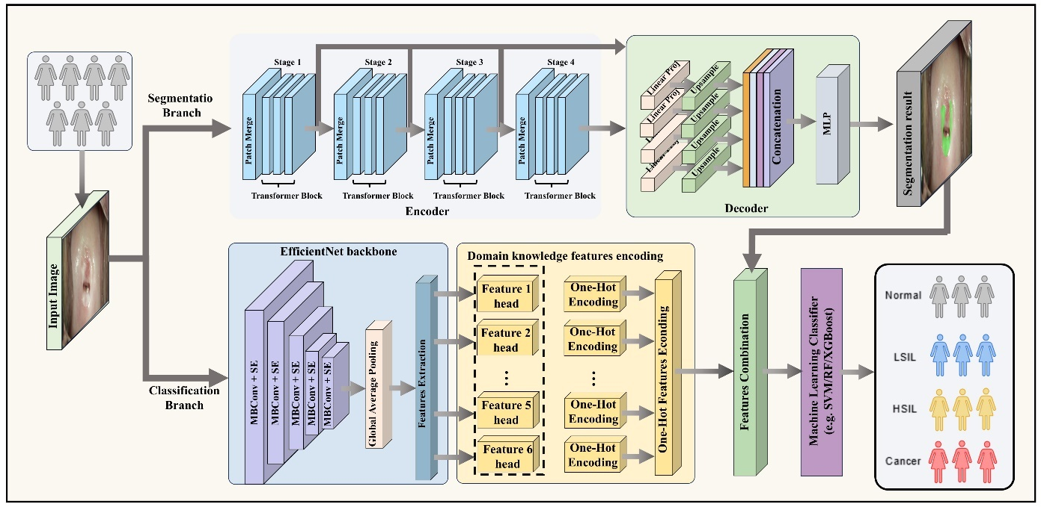
Supplementary Figure 1 DIC architecture diagram

S3 Human-machine comparison
Supplementary Table 2 Comparison between DIC and colposcopists.
Group category | normal % (95% CI) | LSIL % (95% CI) | HSIL % (95% CI) | cancer % (95% CI)
Indicator: Accuracy
DIC | 96.21 (94.81-97.24) | 88.23 (86.11-90.12) | 89.51 (87.43-91.34) | 99.32 (98.61-99.73)
Exp Colposcopists | 86.50*** (84.50-88.65) | 76.23*** (73.77-78.78) | 85.78** (83.67-87.85) | 98.25* (97.47-99.02)
Inexp Colposcopists | 77.75***^^^  (75.65-79.92) | 67.00***^^^  (64.78-69.20) | 78.78***^  (76.77-80.95) | 95.33***  (94.18-96.42)
Indicator: Sensitivity
DIC | 95.23 (92.31-97.13) | 84.70 (80.41-88.24) | 73.02 (66.91-78.43) | 94.02 (88.22-97.14)
Exp Colposcopists | 80.00*** (75.92-83.90) | 71.18*** (66.32-75.86) | 60.84** (54.45-66.60) | 85.04* (78.76-91.31)
Inexp Colposcopists | 76.21***  (72.39-79.84) | 52.98***^^^  (49.27-56.78) | 41.37***  (36.24-46.64) | 64.96***  (57.32-72.41)
Indicator: Specificity
DIC | 96.71 (95.13-97.81) | 89.93 (87.41-92.02) | 94.32 (92.51-95.72) | 100.00 (99.63-100.00)
Exp Colposcopists | 89.70*** (87.56-91.85) | 78.68*** (75.79-81.71) | 93.06 (91.35-94.65) | 100.00 (100.0-100.0)
Inexp Colposcopists | 78.51***^^^  (75.93-81.07) | 73.81***  (71.35-76.28) | 89.70*  (88.05-91.27) | 99.35  (98.95-99.66)
Indicator: PPV
DIC | 93.52 (90.32-95.61) | 80.31(75.80-84.12) | 78.94 (72.90-83.93) | 100.00 (96.63-100.00)
Exp Colposcopists | 79.28*** (74.72-83.34) | 61.89*** (57.58-66.53) | 71.89*** (66.09-77.50) | 100.0^{ns} (100.0-100.0)
Inexp Colposcopists | 63.99***^^^  (59.71-68.25) | 49.50***^^^  (45.10-54.03) | 54.51**^^^  (48.07-60.66) | 93.02***  (88.75-96.35)
Indicator: NPV
DIC | 97.62 (96.11-98.53) | 92.43 (90.1194.22) | 92.31 (90.22-93.91) | 99.24 (98.41-99.63)
Exp Colposcopists | 90.11***  (87.86-92.22) | 84.89***  (81.97-87.57) | 89.06***  (86.87-91.03) | 98.06***^^^  (97.18-98.90)
Inexp Colposcopists | 87.17***^^^  (84.70-89.29) | 76.53***^^^  (73.56-79.46) | 84.00***^^^  (81.79-86.41) | 95.54***^^^  (94.37-96.75)
*Significant difference between the DIC and target group. *,p < 0.05; **, p < 0.01; ***, p < 0.001.
*Significant difference between the Exp Colposcopists and target group. ^,p < 0.05; ^^, p < 0.01; ^^^, p < 0.001.

S4 Routine colposcopic impressions
Supplementary Table 3 Comparison between DIC and colposcopic impressions.
Group category | normal % (95% CI) | LSIL % (95% CI) | HSIL % (95% CI) | cancer % (95% CI) | overall
Indicator: Accuracy
DIC | 91.64 (91.09-92.16) | 89.23 (88.25-89.47) | 92.62 (92.10-93.12) | 99.36 (99.19-99.50) | 93.21 (92.66-93.56)
Colposcopic impressions | 70.90 (69.91-71.86) | 63.85 (62.82-64.87) | 84.88 (84.10-85.63) | 98.91 (98.67-99.11) | 79.64 (78.88–80.37)
Indicator: Sensitivity
DIC | 91.56 (90.10-91.83) | 85.96 (84.8-87.17) | 74.07 (72.0-76.19) | 91.89 (88.92-94.33) | 85.87 (84.46-87.39)
Colposcopic impressions | 57.17 (55.63-58.70) | 70.44 (68.64-72.17) | 42.98 (40.53-45.46) | 78.26 (72.78-82.90) | 62.21 (59.40–64.81)
Indicator: Specificity
DIC | 92.26 (91.54-92.95) | 90.25 (89.53-90.94) | 96.84 (96.46-97.21) | 99.67 (99.56-99.77) | 94.76 (94.27-95.22)
Colposcopic impressions | 83.42 (82.29-84.49) | 60.92 (59.66-62.17) | 94.38 (93.81-94.90) | 99.56 (99.39-99.68) | 84.57 (83.79–85.31)
Indicator: PPV
DIC | 90.75 (89.95-91.52) | 80.55 (79.38-81.67) | 84.21 (82.60-85.75) | 92.09 (89.51-94.50) | 86.90 (85.36-88.36)
Colposcopic impressions | 75.87 (74.31-77.37) | 44.50 (42.98-46.03) | 63.42 (60.46-66.28) | 84.62 (79.44-88.68) | 67.10 (64.30–69.59)
Indicator: NPV
DIC | 91.69 (91.04-92.39) | 93.19 (92.66-93.75) | 94.24 (93.82-94.70) | 99.66 (99.54-99.76) | 94.70 (94.27-95.15)
Colposcopic impressions | 68.10 (66.84-69.34) | 82.24 (81.07-83.36) | 87.95 (87.19-88.68) | 99.32 (99.12-99.48) | 84.40 (83.56–85.22)

S5 The performance in predicting biopsy locations
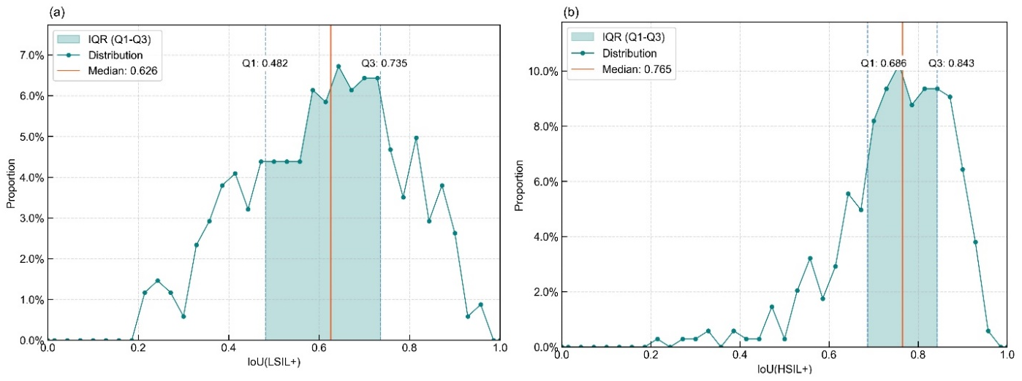
Supplementary Figure 2 The performance in predicting biopsy locations.
(a) The median mIoU for LSIL+ lesions. (b) The median mIoU for HSIL+ lesions

S6 Composition illustration of the data
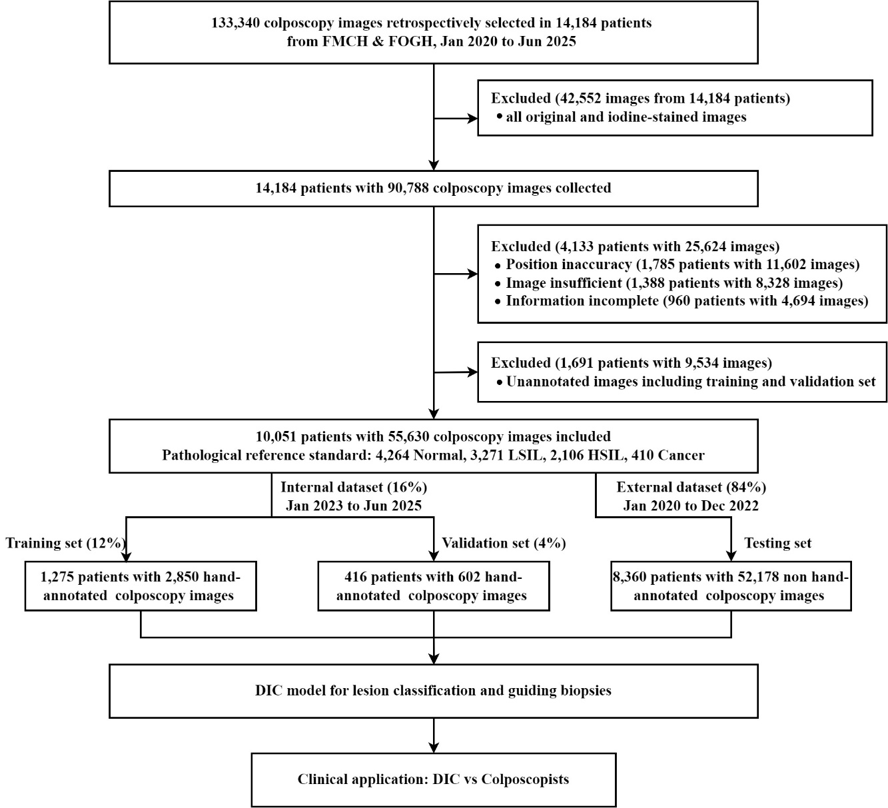
Supplementary Figure 3 Composition illustration of the data used in this study.
(Exp: experience. Inexp: inexperience. FMCH: Fujian Maternity and Child Health Hospital.
FOGH: Fujian Obstetrics and Gynecology Hospital)

S7 Standards for excluding images
The images primarily collected during colposcopic examinations include original images, acetic acid-white images, and iodine-stained images (as shown in Supplementary Figure 4). For each case, the clinician saves all three types of images, totaling 9-10 images. Since the acetic acid reaction is the most pronounced and is the primary basis for clinical judgment, this study excluded all original images, iodine-stained images, and some acetic acid-white images. Ultimately, for the training and validation sets, only images annotated by clinicians were retained, while for the test set, all acetic acid-white images were retained, amounting to approximately 6-7 images/patient. Subsequently, case selection was performed, excluding those with incomplete information, images that did not meet criteria (as shown in Supplementary Figure 5), inaccurate positioning (as shown in Supplementary Figure 6), and patients over the age of 18. A total of 10,051 patients with 55,630 colposcopic images were included for model training, validation, and testing.
(a) | (b) | (c)
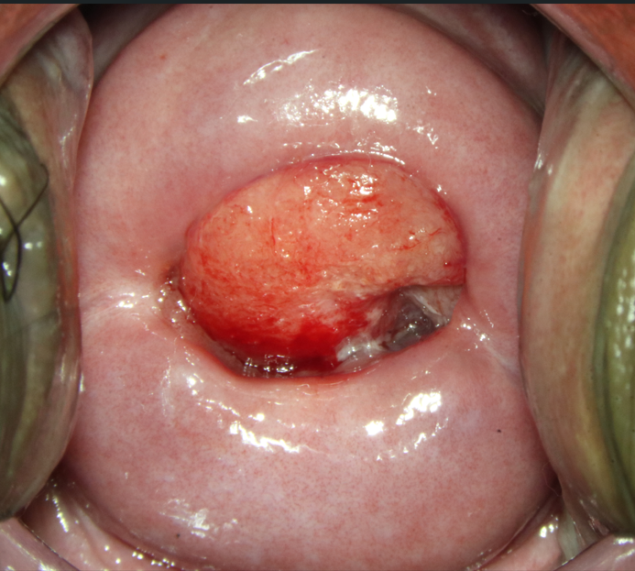 | 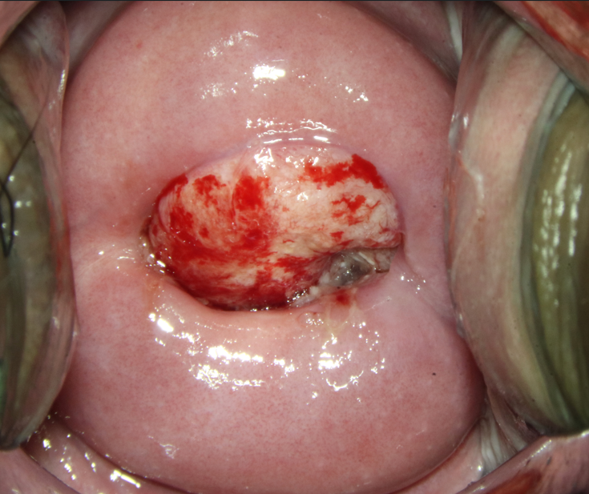 | 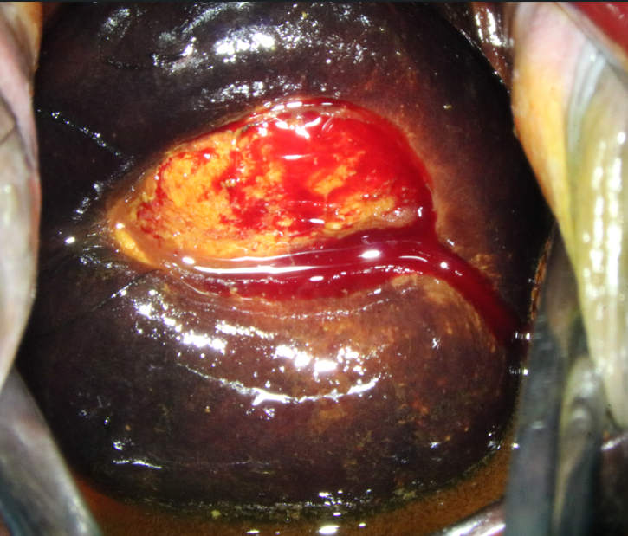
Supplementary Figure 4 Three different modes of images.
(a) Original image. (b) Acetic acid-white image. (c) Iodine-stained image.
(a) | (b) | (c)
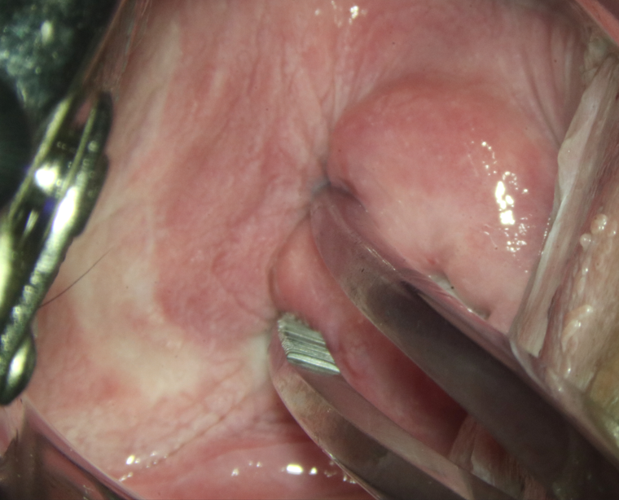 | 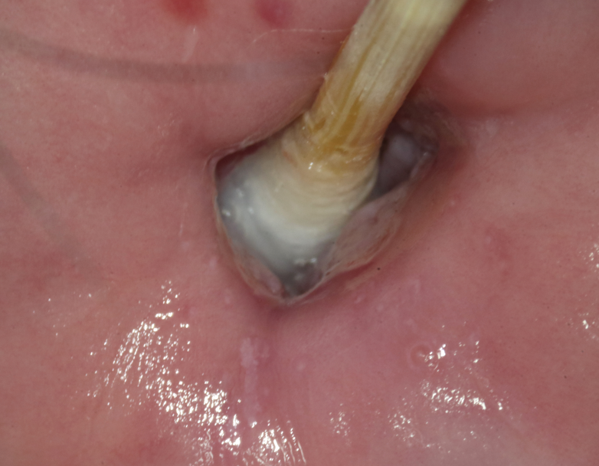 | 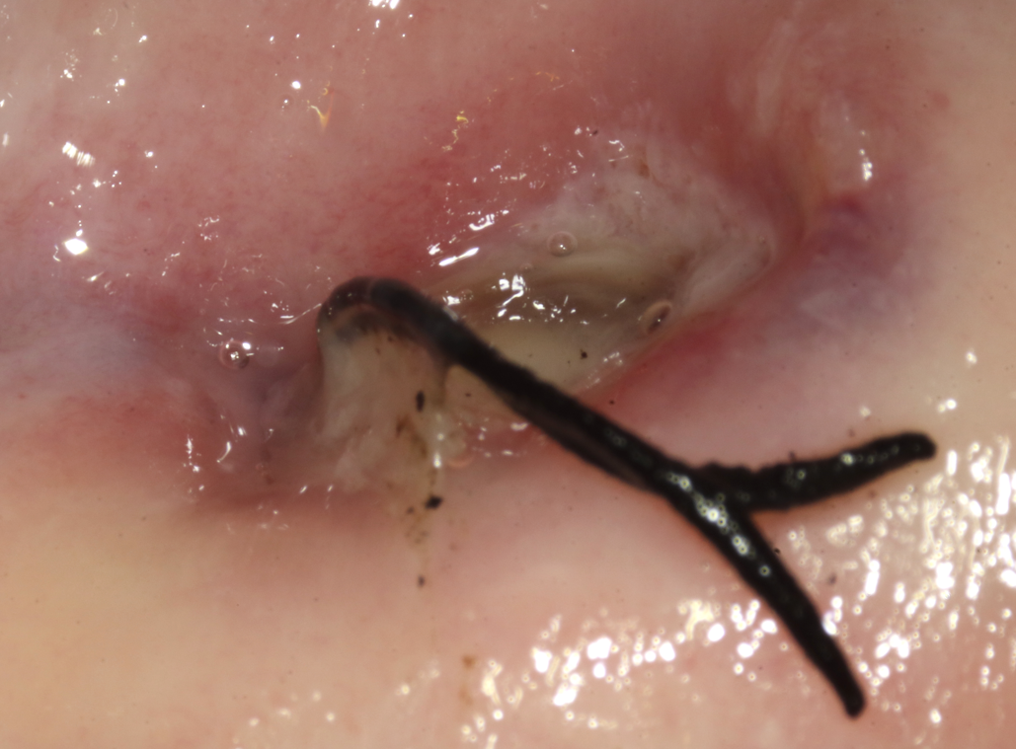
(d) | (e) | (f)
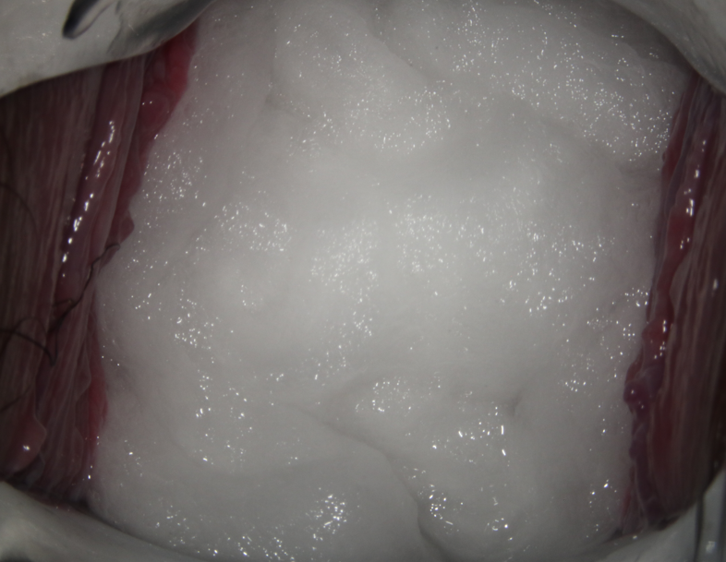 | 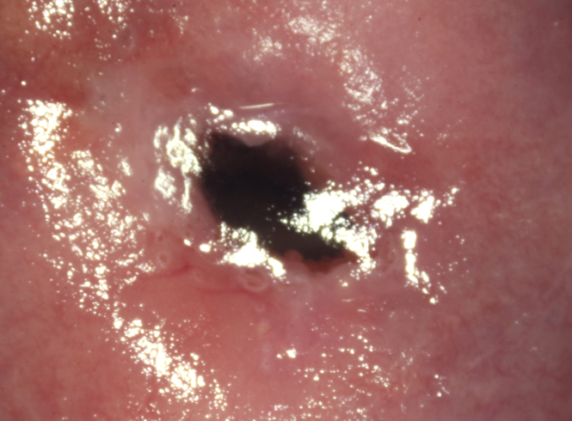 | 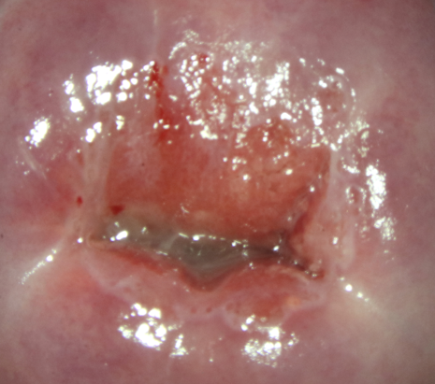
Supplementary Figure 5 Exclusion criteria examples. (a)/(b) Instrument interference.
(c)/(d) Foreign object interference (cotton/thread). (e) Blurriness. (f) Reflection.
(a) | (b) | (c)
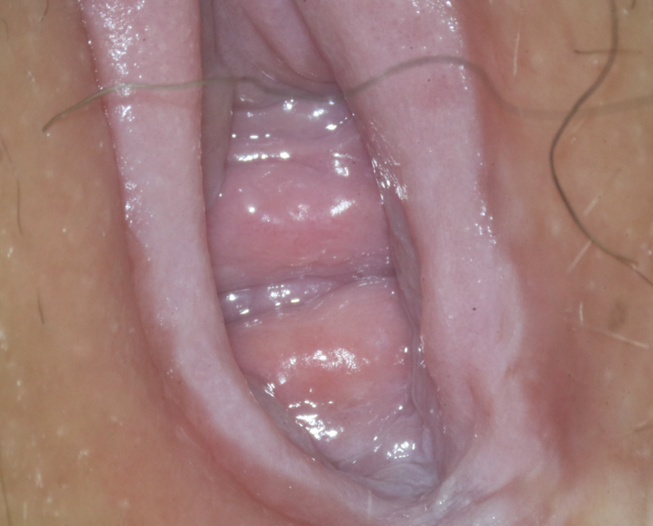 | 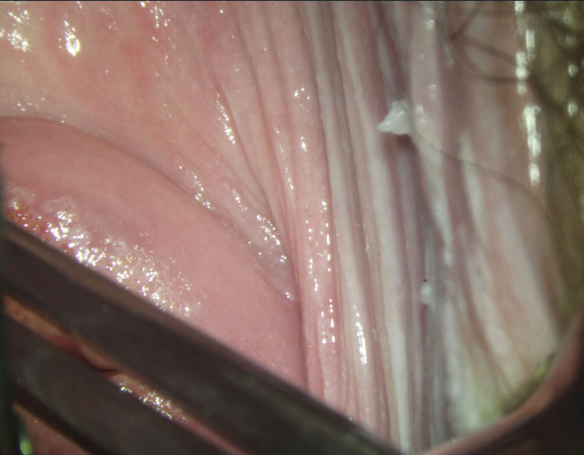 | 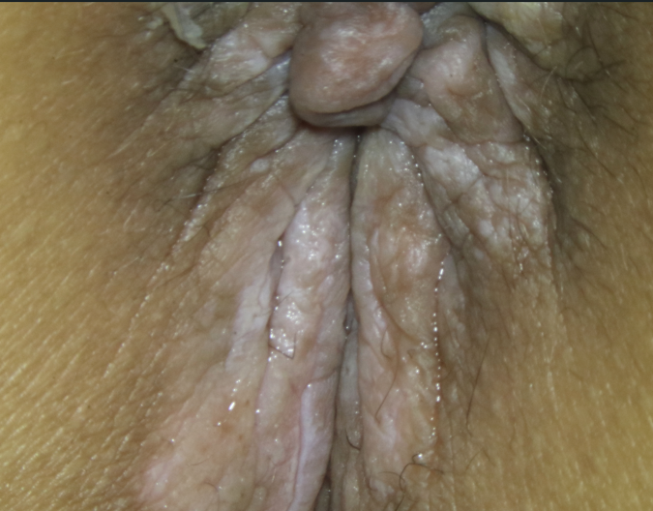
Supplementary Figure 6 Inaccurate positioning examples.
(a) Vulva. (b) Incomplete exposure of the cervix. (c) Anorectal junction.

S8 Annotation software, methods, and rules
The annotation software used in this study is Labelme 3.16.2. The classification results were compared to histopathological results as the golden standard. Colposcopists primarily performed the delineation extent of the lesion, which involved image segmentation. First, one colposcopist delineated the lesion areas in each image, and Supplementary Figure 7 shows the delineation results for LSIL, HSIL, and cancer. Then, a second colposcopist reviewed the annotations, and in cases of discrepancies, a third colposcopist arbitrated and confirmed the final annotations. The consensus delineation result was used as the golden standard for image segmentation.
(a) | (b) | (c)
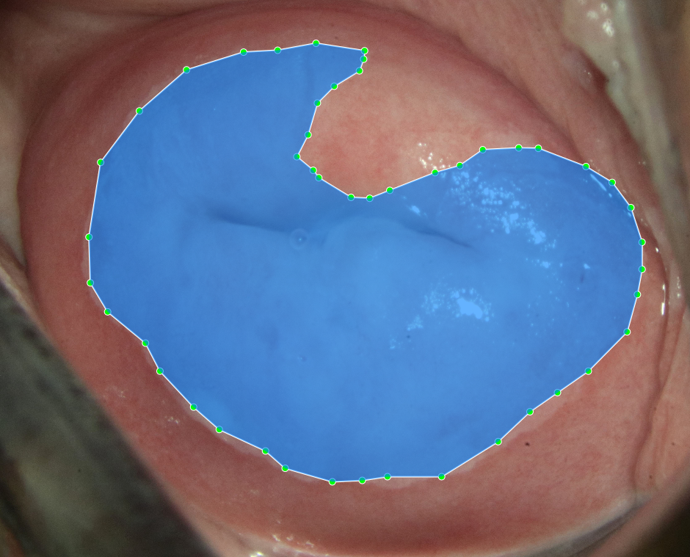 | 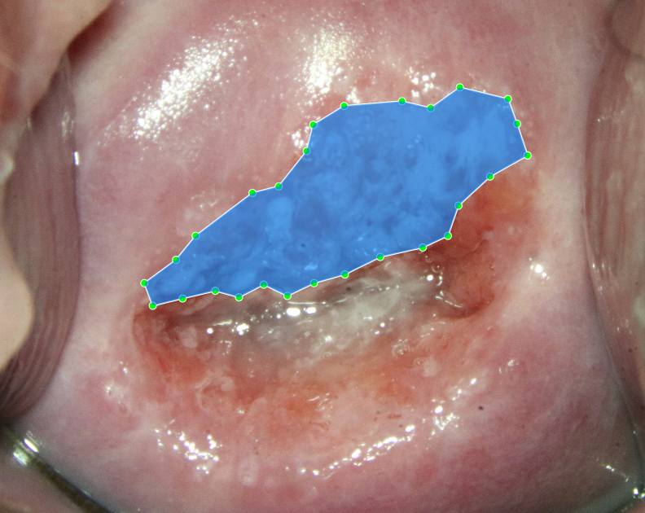 | 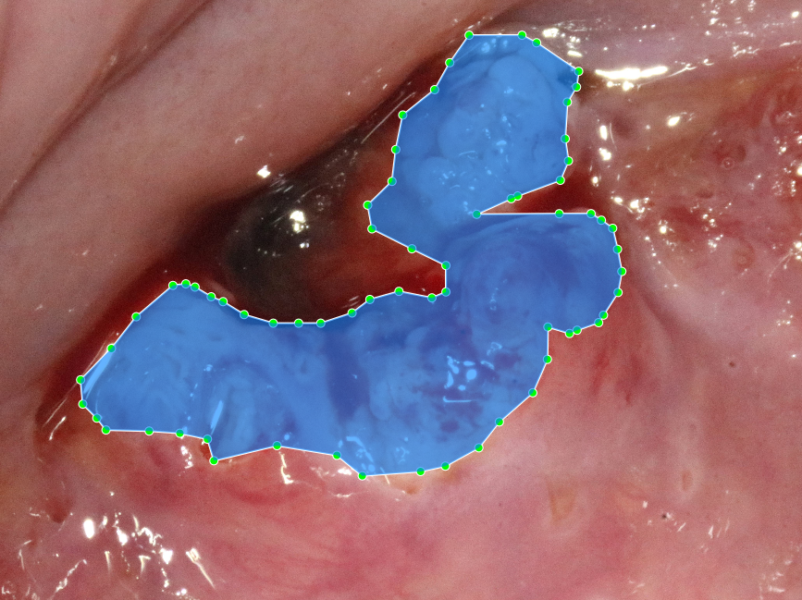
Supplementary Figure 7 Clinical colposcopist annotation diagram.
(a) LSIL lesion. (b) HSIL lesion. (c) cancer lesion.

S9 Feature encoding
Feature encoding was performed based on the selected six image features and their clinical characteristics. For acetowhite epithelium, different levels of lesion severity exhibit faintly white and opaque white textures. When there is no lesion, no acetic acid reaction is observed. Therefore, it is encoded as: faintly white is 2, opaque white is 1, and none is 0. Depending on the characteristics of each feature, they were encoded with either two or three categories, with the specific encoding rules shown in Supplementary Figure8.
Typical images of the six selected features are shown in Supplementary Figure 9. However, multiple features may coexist in one image, and these features are often too unobvious to identify. To ensure the accuracy of model training, three experienced colposcopists were involved in the feature encoding annotations. First, two of the colposcopists independently performed the feature encoding for each image. In cases of disagreement, a third colposcopist acted as an arbitrator to confirm the final annotations. The resulting feature annotations were used as the training and validation samples for the model.
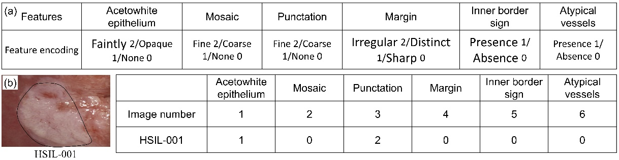
Supplementary Figure 8 Features encoding. (a) Encoding rules. (b) Example.

(a) | (b) | (c)
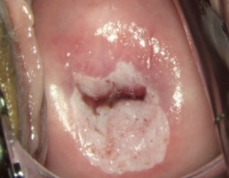 | 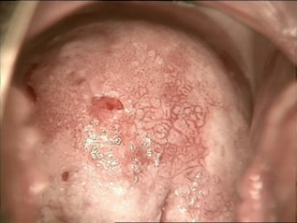 | 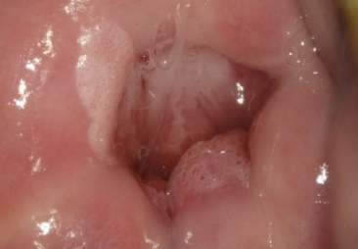
(d) | (e) | (f)
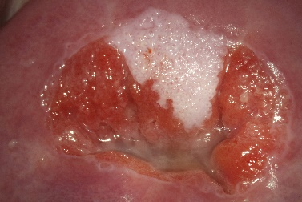 | 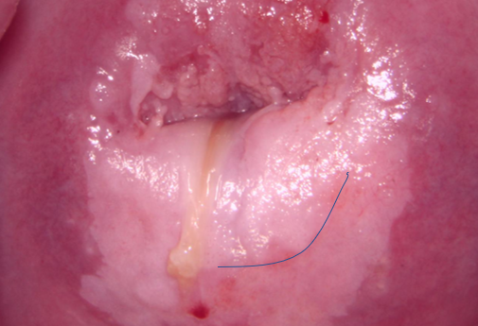 | 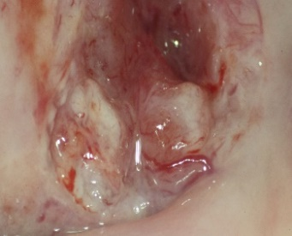
Supplementary Figure 9 Select typical images of 6 features. (a) Acetowhite epithelium. (b) Mosaic. (c) Punctation
(d) Margin. (e) Inner border sign. (f) Atypical vessels.

S10 Importance ranking of feature SHAP value
During the model development process, an interdisciplinary expert group was formed, consisting of 6 experience colposcopists, 2 statistical experts, and 1 model algorithm expert from China. The team conducted online consensus meetings to review and select potential predictive variables. Using SHAP (SHapley Additive exPlanations), the importance ranking of the 16 predictive factors was determined for the prediction of LSIL, HSIL, and cancer cervical lesions (as shown in Supplementary Figure 10). To present the results more intuitively, the top 9 predictive factors for each of the three cervical lesions are listed in Supplementary Table 3. These top 9 factors include acetowhite epithelium, mosaic, atypical vessels, margin, inner border sign, punctation, age, involved gland, and irregular bleeding.
After further evaluation by the clinical expert consensus, it was determined that "involved gland" and "irregular bleeding" lacked stable discriminatory value in cervical lesion diagnosis, and were therefore excluded. As a result, 6 image predictive factors were selected for feature recognition: acetowhite epithelium, mosaic, atypical vessels, margin, inner border sign, and punctation.

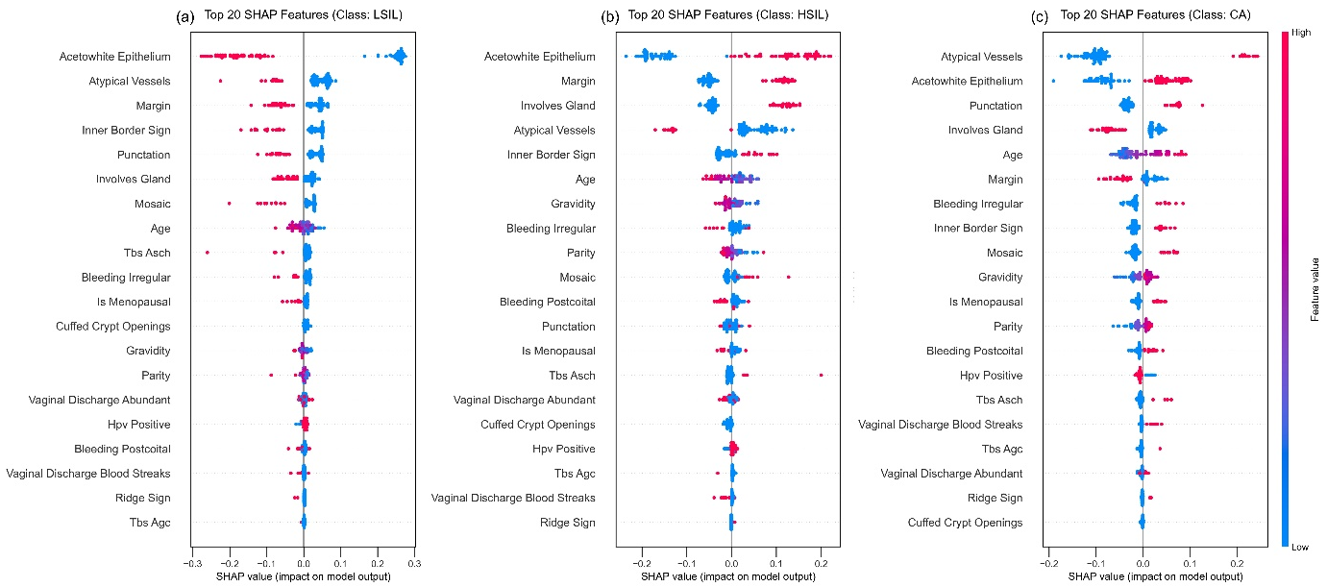
Supplementary Figure 10 Importance ranking of feature SHAP value. (a) LSIL ranking. (b) HSIL ranking. (c) cancer ranking.

Supplementary Table 4 Importance ranking of feature SHAP value in difference lesions
Rank | LSIL | HSIL | cancer
1 | Acetowhite epithelium | Acetowhite epithelium | Atypical vessels
2 | Atypical vessels | Margin | Acetowhite epithelium
3 | Inner border sign | Atypical vessels | Age
4 | Margin | Involved gland | Punctation
5 | Punctation | Age | Involved gland
6 | Mosaic | Inner border sign | Inner border sign
7 | Involved gland | Punctation | Mosaic
8 | Age | Irregular bleeding | Margin
9 | Irregular bleeding | Mosaic | Irregular bleeding

To validate the consistency of feature diagnosis results with clinical outcomes, three patients (LSIL, HSIL, and cervical cancer) diagnosed by histopathology were randomly selected. These patients are illustrated in Supplementary Figure 11 which displays the SHAP predictive interpretation diagram. The first case was a 19-year-old LSIL patient, with the most significant predictive factors being acetowhite epithelium, atypical vessels, and punctation. The second case was a 24-year-old HSIL patient, with key predictive factors including acetowhite epithelium, margins, and atypical vessels. The third case was a 48-year-old cervical cancer patient, with primary predictive factors being atypical vessels, acetowhite epithelium, and punctation.
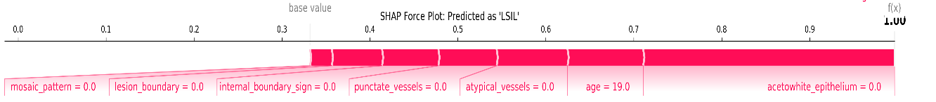
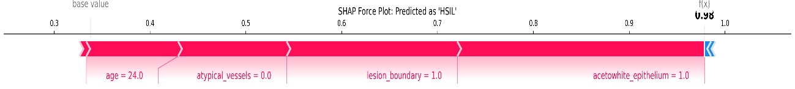
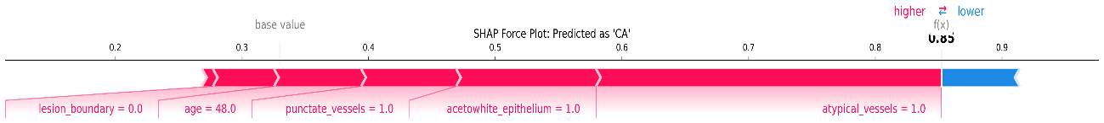
Supplementary Figure 11 SHAP predicted in difference lesions

S11 Visual interface and structured report

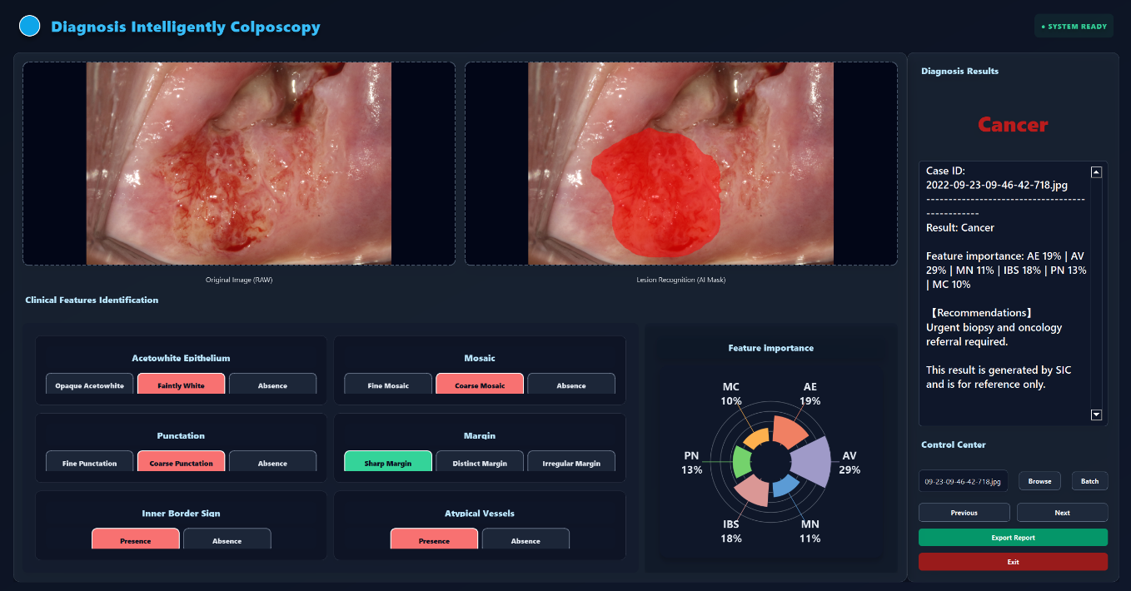
Supplementary Figure 12 Visual interface

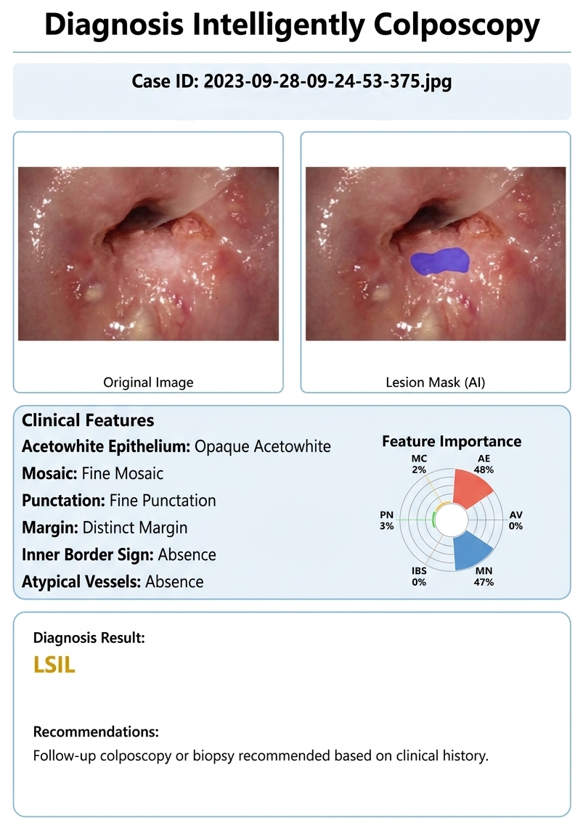
Supplementary Figure 13 Structured report

