Supplementary Materials for

Prokaryotes regulate particulate organic carbon export in suspended and sinking particle fractions

Table of Contents

Supplementary Methods 2
Marine Snow Catcher Deployment Protocol 2
MSC sampling 6
DNA extraction and shotgun sequencing 6
Supplementary Figure Captions 7

Supplementary Methods

Marine Snow Catcher Deployment Protocol

- To set the Marine snow catcher mechanism in open position push the central pole (D) upwards until the two pin holes are aligned, and the pin can be located to hold it in place (E)– done lying down on deck
- Take the pole and plunger (B) from the base and locate into the pole running through the length of the snow catcher (C). The poles should be secured together with a pin thus must be aligned correctly – vertically held by crane
- Gently lower into base locating the bottom of the pole into the hole in the clear Perspex base (J).
- Clip shut (K) the base and top of snow catcher and cable tie the clips for extra security. It will only locate in one orientation indicated by the notched part in the base and metal frame. Use ratchet straps to secure
- Lift over side of deck and hold vertically to allow for steps 6-8
- Attach the release mechanism (F) to the rope/wire:
  - Slot rope into groove (G) in release mechanism.
  - Tighten slightly to prevent it falling out using small spanner (H)
  - Adjust position of the release mechanism so the release rope attached to the snow catcher is taught (I) when the pole inside is pushed into the open position.
  - Once in place tighten release completely. However, do not over tighten as the threading is brass and it may be damaged.
- Remove the pin (E) from the top of the snow catcher holding the mechanism open (this should be only one when snow catcher is upright. The central pole with closing valves should only move very slightly when the pin is removed.
- Ensure the two taps are closed so it doesn’t leak (L).
- Deploy and stand by for 10 minutes, then fire by sending messenger down on the rope – ensure messenger is secured on properly so is not lost.
- Bring back on deck and stand upright for 2-3 hours.
- Open the top tap (L) all the way to air in. Slowly open the bottom tap and allow top 95 L of water to drain out slowly. This is to ensure that not too much turbulence is created, and particles are re-suspended.
- Gently lift the top of the snow catcher away from the base.
- Put lid on tray and take away for analysis.

N.B. Don’t put end of snow catcher which locates into the base directly on the ground as it may be damaged and affect the seal.

Internal and External Schematics of Snow Catcher
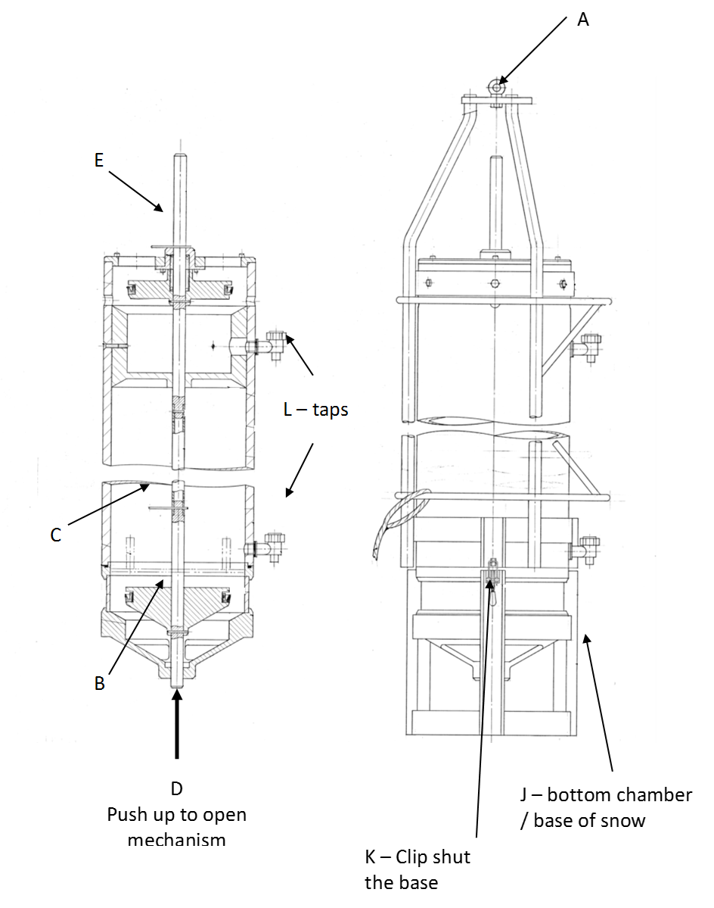

Release Mechanism (F)

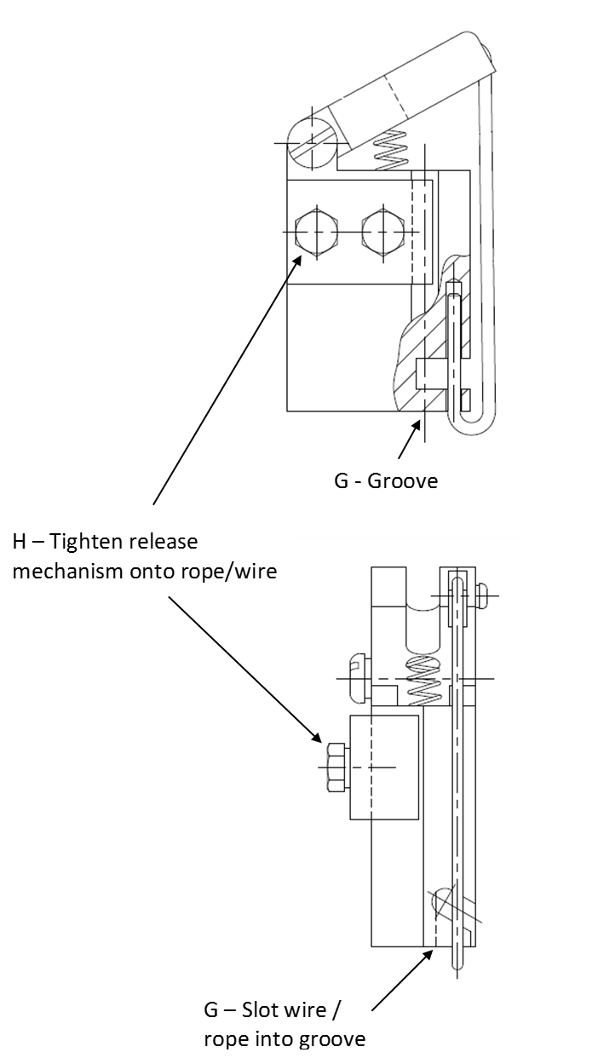

General Diagram
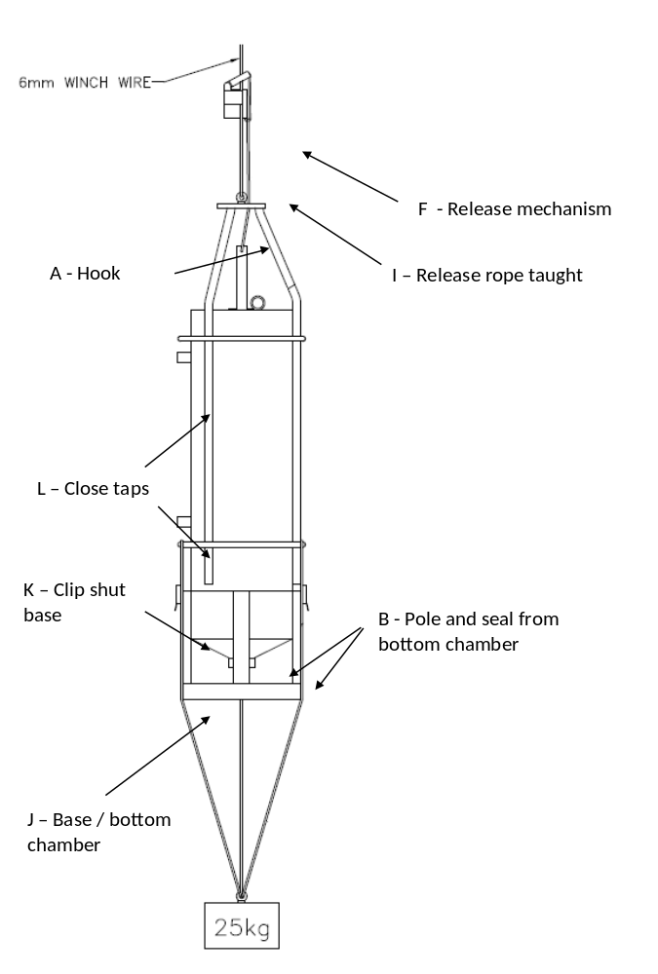

MSC sampling

The MSC was deployed and allowed to stand-by for 10 minutes in the water before recovering it back on deck. After 2 hours of settling on deck, a suspended sample is collected from a tap at the top of the MSC, following which all but the water at the bottom of the sample is drained from the MSC and discarded. The water at the very bottom of the MSC was retained as the sinking sample. After sample collection, both the suspended and sinking particle-pools were homogenised prior to being split using a Folsom splitter for POC, particulate organic nitrogen (PON) and metagenomic analysis.

The aluminium tin with the GF/F filters containing the organic materials were analysed in the Department of Archaeometry at the University of Cape town where they were combusted in a Flash 2000 organic elemental analyser (Thermo Scientific, Bremen, Germany) and the gases passed to a Delta V Plus isotope ratio mass spectrometer (IRMS) (Thermo Scientific, Bremen, Germany) via a Conflo IV (Thermo Scientific, Bremen, Germany) gas control unit.

DNA extraction and shotgun sequencing

The isolated genomic DNA was quantified with Qubit 2.0 DNA HS Assay (ThermoFisher, Massachusetts, USA). Library preparation was performed using the NexteraXT library kit (Illuma, California, USA) per manufacturer’s recommendations. the final library quantity was measured by KAPA SYBR® FAST qPCR with QuantStudio ® 5 System (Applied Biosystems, California, USA), and library quality evaluated by TapeStation HSD1000 ScreenTape (Agilent Technologies, CA, USA). Illumina® 8-nt dual-indices were used. Equimolar pooling of libraries was performed based on QC values and sequenced on an Illumina® HiSeq (Illumina, California, USA) with a read length configuration of 150 PE for 20 M PE reads (10M in each direction) per sample.

Supplementary Figure Captions

Supplementary Figure S1: Ancillary data from the SOTS sites obtained from CTD data. A) Temperature (in ºC) and salinity plot showing the five sampling stations. B) Chlorophyll depth profile for five stations by determined by CTD fluorescence sensor and C) the MLD integrated Chlorophyll.

Supplementary Figure S2. The overview of the Prokaryotic community composition for five stations at Class level for SP and SK particle-pool. A) Bacterial community composition and B) Archaeal community composition at class level.

Supplementary Figure S3. Read recruitment for our 24 MAGs against the 10 raw shotgun metagenomic reads. A) Bacterial read recruitment represented as relative abundance and B) Archaeal read recruitment.

Supplementary Figure S4. The central metabolic function and electron transport chain (ETC) complexes present on our MAGs. A) Bacterial central metabolism and ETC complexes and B) Archaeal central metabolism and ETC complexes.

Supplementary Table S1: SOTS Marine Snow Catcher sampling site from five stations with date, time, and depth. Sampling station are number based on sampling date and time.

Station | Latitude | Longitude | Date | Time | Sampling Depth (m)
1 | -46.84722 | 142.34565 | 2019/03/19 | 19:39 | 110
2 | -46.85883 | 141.64348 | 2019/03/21 | 21:17 | 100
3 | -46.85242 | 141.82053 | 2019/03/24 | 02:46 | 100
4 | -46.85495 | 142.11442 | 2019/03/28 | 21:09 | 110
5 | -46.85517 | 142.36775 | 2019/03/30 | 20:33 | 110

