Supplementary Material

Description of Novosphingobium fluminis sp. nov., a psychrotolerant species isolated from freshwater stream capable of utilizing various monocyclic and polycyclic aromatic compounds

Da Chan Kim†, You Ju Ham† and Seung Bum Kim*

Department of Microbiology and Molecular Biology, College of Bioscience and Biotechnology, Chungnam National University, 99, Daehak-ro, Yuseong, Daejeon 34134, Republic of Korea

Corresponding author: Seung Bum Kim
E-mail: sbk01@cnu.ac.kr, Phone: +82 42 821 6412, Fax: +82 42 822 7367

Table S1. Top matches of entries to strain MMS21-SN21R^{T} based on BLAST search using the 16S rRNA sequence
Accession | Description | Sequence length (bp) | Identity (%) | Geographic origin (Country)
HQ222275.1 | Uncultured clone Van45 | 1,502 | 98.74 | Anaerobic vanillin enrichment culture with nitrate (UK)
HQ222279.1 | Uncultured clone Van67 | 1,511 | 98.74 | Anaerobic vanillin enrichment culture with nitrate (UK)
JF747981.1 | Uncultured clone FrsFi214 | 1,450 | 98.67 | Sulfidic spring (Italy)
HQ222277.1 | Uncultured clone Van61 | 1,515 | 98.67 | Anaerobic vanillin enrichment culture with nitrate (UK)
FJ801185.1 | Uncultured clone ZWB2-14 | 1,451 | 98.60 | Alpine wetland (China)
HQ222261.1 | Uncultured clone Van3 | 1,490 | 98.60 | Anaerobic vanillin enrichment culture with nitrate (UK)
LR640827.1 | Uncultured bacterium | 1,409 | 98.86 | Wastewater treatment system (Denmark)
JQ088381.1 | Uncultured clone M17-10-B05 | 1,446 | 98.53 | Crude oil reservoir (China)
LR636160.1 | Uncultured bacterium | 1,411 | 98.72 | Wastewater treatment system (Denmark)
MF062674.1 | N. aromaticivorans R2A6.5-2 | 1,452 | 98.39 | Tai sui immersion liquid (China)

Table S1. Whole genome-based identity indices (%) between strain MMS21-SN21R^{T} and mostly related species within Novosphingobium
Species | 16S rRNA | dDDH | orthoANI
Novosphingobium taihuense DSM 17507^{T} | 98.36 | 22.2 | 79.45
Novosphingobium lubricantis KSS165-70^{T} | 97.98 | 21.7 | 79.19
Nocosphingobium subterraneum DSM 21447^{T} | 97.94 | 22.0 | 79.07
Novosphingobium hassiacum DSM 14552^{T} | 97.58 | 23.5 | 80.20
Nocosphingobium aromaticivorans DSM 12444^{T} | 97.65 | 22.5 | 79.79
Nocosphingobium jiangmenense MW275979^{T} | 96.81 | 22.4 | 79.76
Novosphingobium olei TW-4^{T} | 97.87 | 20.6 | 76.56

Table S2. Biosynthetic gene clusters for secondary metabolites in the genome of strain MMS21-SN21R^{T} predicted by antiSMASH bacterial version
Type | Size (kb) | Most similar known cluster | Similarity confidence
Ranthipeptide | 21.5 | - | -
Terpene-precursor | 20.9 | - | -
Terpene | 24.3 | Zeaxanthin | Medium
Betalactone | 28.8 | - | -
Type III PKS | 41.1 | - | -
Lassopeptide | 20.3 | - | -

Table S3. Enzymes potentially related with aromatic compound degradation in strain MMS21-SN21R^{T} and selected species of Novosphingobium
Strains: 1, MMS21-SN21R^{T}; 2, N. taihuense CGMCC 1.3432^{T}; 3, N. hassiacum DSM 14552^{T}; 4, N. album H3SJ31-1^{T}; 5, N. aromaticivorans DSM 12444^{T}; 6, N. indicum CGMCC 1.6784^{T}; 7, N. guangzhouense SA925^{T}; 8, N. lentum NBRC 107847^{T}; 9, N. pentaromativorans US6-1^{T}; 10, N. terrae GeG26^{T}; 11, N. capsulatum DS 1207^{T}.
A. Monooxygenases
Enzymes | 1 | 2 | 3 | 4 | 5 | 6 | 7 | 8 | 8 | 10 | 11
Anthraniloyl-CoA monooxygenase |  |  | 1
Cyclohexanone monooxygenase |  |  |  |  | 3 |  | 1 |  | 2
Dimethylaniline monooxygenase (N-oxide forming) |  |  |  |  | 1
FAD-dependent monooxygenase | 4 |  |  | 1 | 5 |  | 1 | 1 |  | 7 | 3
Flavin containing monooxygenase FMO |  |  |  |  | 5 |  |  | 6
4-Hydroxyacetophenone monooxygenase |  |  | 1
4-Hydroxybenzoate 3-monooxygenase | 1 | 1 | 1 |  | 1 |  |  | 1 | 1 | 1
p-Nitrophenol 4-monooxygenase |  |  |  |  |  |  | 2
Phenylalanine 4-monooxygenase | 1 |  |  |  |  | 1 |  | 1 |  | 1 | 1
(Putative) Quinol monooxygenase | 3 | 3 | 1 | 1 |  |  |  | 4 |  | 5 | 1
Salicylate 1-monooxygenase |  |  |  |  |  |  | 2
Vanillate O-demethylase monooxygenase subunit |  | 3 | 3
Total | 9 | 7 | 7 | 2 | 15 | 1 | 6 | 13 | 3 | 14 | 5

B. Dioxygenases
Protein | 1 | 2 | 3 | 4 | 5 | 6 | 7 | 8 | 9 | 1 | 11
Alpha-ketoglutarate-dependent dioxygenase AlkB | 1
Anthranilate 1,2-dioxygenase |  |  |  |  |  |  | 2 |  | 2
Anthranilate 1,2-dioxygenase small subunit |  |  | 1 |  |  | 2
Aromatic ring-cleavage dioxygenase |  |  |  |  |  |  |  |  | 1
Aromatic ring- hydroxylating dioxygenase |  |  |  |  |  |  |  |  | 2
Aromatic ring-hydroxylating dioxygenase subunit alpha | 27 |  |  | 14 |  |  |  | 2 |  | 15 | 16
Aromatic-ring-hydroxylating dioxygenase subunit beta | 2 |  |  | 1 | 9 |  | 3 | 5 |  | 2 | 1
Aromatic ring-opening dioxygenase subunit LigA | 1
Benzene1,2-dioxygenase |  |  |  |  |  |  | 1 |  | 1
Benzoate 1,2-dioxygenase, α-subunit |  |  |  |  | 1 |  | 1 |  |  | 1
Benzoate 1,2-dioxygenase, large subunit |  |  |  |  |  | 1 | 2
Benzoate/toluate 1,2-dioxygenase α-subunit |  | 2 | 1
Benzoate/toluate 1,2-dioxygenase β-subunit |  | 2 | 1
Biphenyl 2,3-dioxygenase |  |  |  |  |  | 2 | 1
Hypothetical biphenyl dioxygenase β-subunit |  |  |  |  |  | 4
Catechol 1,2-dioxygenase |  | 1 | 1 | 1 |  |  | 1 |  | 1
Catechol 2,3-dioxygenase |  | 1 |  |  |  |  | 1
Catechol 2,3-dioxygenase-like lactoylglutathione lyase family enzyme |  | 17 | 11
2-Chlorobenzoate 1,2-dioxygenase |  |  |  |  | 1
6-Chlorohydroxyquinol-1,2-dioxygenase |  |  |  |  |  |  | 1
Class III extradiol dioxygenase β-subunit | 1 |  |  |  | 2 |  |  | 1 |  | 1 | 1
Class III extradiol ring-cleavage dioxygenase | 2 |  |  |  |  |  |  | 1 |  | 3 | 3
2,4'-Dihydroxyacetophenone dioxygenase | 4 | 1 | 1 | 1 | 2 | 1 |  | 4 |  |  | 3
3,4'-Dihydroxyphenylacetate dioxygenase |  |  | 1
2,3-Dihydroxybiphenylpropionate 1,2-dioxygenase |  |  |  |  |  |  | 1
2,3-Dihydroxyphenylpropionate 1,2-dioxygenase |  |  |  |  |  |  |  |  |  |  | 1
3,4-Dihydroxy-9,10-secoandrosta-1,3,5(10)-triene-9,17-dione 4,5-dioxygenase |  | 1
4,5-Dioxygenase |  |  |  |  |  |  |  |  | 1
Dioxygenase family protein |  |  |  |  |  |  |  | 2
Fe²⁺ dependent dioxygenase |  |  |  | 1 |  |  | 1 |  |  | 2 | 1
Fe²⁺ dependent extradiol dioxygenase |  |  |  |  |  | 1
DOPA 4,5-dioxygenase |  | 1 | 1
DOPA 4,5-dioxygenase family protein | 1 |  |  |  |  |  |  |  |  | 1
4,5-DOPA dioxygenase extradiol |  |  |  | 2 |  |  |  | 1
Extradiol ring-cleavage dioxygenase | 1
Extradiol dioxygenase |  |  |  |  |  |  | 1
Gentisate 1,2-dioxygenase |  | 1 | 2 |  |  |  |  |  | 4 | 2
Glyoxalase/bleomycin resistance protein/dioxygenase |  |  |  |  | 18 | 1 |  |  | 1
Glyoxalase/bleomycin resistance/extradiol dioxygenase family protein |  |  |  |  |  |  |  | 1
Homogentisate 1,2-dioxygenase | 1 |  |  | 1 |  |  |  |  |  | 2 | 1
4-Hydroxyphenylpyruvate dioxygenase | 1 | 1 | 1 | 1 | 2 | 1 | 1 | 1 | 1 | 1 | 1
Hydroxyquinol 1,2-dioxygenase |  |  |  |  |  |  |  |  |  |  | 2
Intradiol ring-cleavage dioxygenase |  |  |  |  | 2 |  | 1 |  |  | 1
Naphthalene 1,2-dioxygenase |  |  |  |  |  |  | 1 |  | 4
Naphthalene 1,2-dioxygenase beta subunit |  |  | 1
3-Phenylpropionate dioxygenase |  |  |  |  |  |  | 1
3-Phenylpropionate/cinnamic acid dioxygenase α-subunit |  |  |  |  |  | 4
3-Phenylpropionate/cinnamic acid dioxygenase β-subunit | 2 |  |  |  |  | 1 |  | 1
3-Phenylpropionate/cinnamic acid dioxygenase small subunit |  | 3 | 1
3-Phenylpropionate/trans-cinnamate dioxygenase ferredoxin reductase subunit |  | 1 | 2
Phenylpropionate dioxygenase-like ring-hydroxylating dioxygenase large terminal subunit |  | 12 | 6
Protocatechuate 3,4-dioxygenase |  |  |  |  |  |  | 1 |  | 9 | 1
Protocatechuate 4,5-dioxygenase α-subunit | 2 | 2 | 2 |  | 2 |  | 1 | 2 |  | 2 | 2
Protocatechuate 4,5-dioxygenase β-subunit |  | 2 | 3 |  | 2
Ring-cleaving dioxygenase |  |  |  |  |  |  |  | 1
Ring hydroxylating dioxygenase, α-subunit |  |  |  |  | 4
Toluate 1,2-dioxygenase β-subunit |  |  |  |  |  | 1
Tryptophan 2,3-dioxygenase |  |  |  |  |  | 1 |  |  | 1
Total | 46 | 48 | 36 | 22 | 45 | 20 | 20 | 22 | 28 | 34 | 32

Table S4. List of genes for glycoside hydrolase family proteins in strain MMS21-SN21R^{T}
Accession no. | Protein (Product) | Length (aa)
MDT0506478.1 | GH family 25 | 231
MDT0507072.1 | GH family 130 | 414
MDT0507459.1 | GH family 97 | 650
MDT0508126.1 | GH family 97 | 686
MDT0508132.1 | GH family 32 | 441
MDT0508137.1 | GH family 68 | 372
MDT0508297.1 | GH family 3 N-terminal domain-containing | 633
MDT0508508.1 | GH family 3 N-terminal domain-containing | 805
MDT0509753.1 | GH family 3 C-terminal domain-containing | 891
MDT0509897.1 | GH family 2 TIM barrel-domain containing | 865
MDT0510112.1 | GH family 2 TIM barrel-domain containing | 904
MDT0510113.1 | GH family 78 catalytic domain | 1053

Figure Legends
Fig. S1. Electron microscopic images of cell morphology of MMS21-SN21R^{T}. (A) Scanning electron microscope. Scale bar, 1 μm. (B) Transmission electron microscope. Scale bar, 500 nm.
Fig. S2. Two-dimensional thin-layer chromatogram for polar lipid of strain MWE-103^{T} treated with phosphomolybdic acid spraying reagent. PG, phosphatidylglycerol; PE, phosphatidylethanolamine; GL, unidentified glycolipid; PL, unknown phospholipid.
Fig. S3. Heatmap based on the orthoANI values showing the phylogenomic relationship between strain between strain MMS21-SN21R^{T} and related species of Novosphingobium.
Fig. S4. Subsystem category distribution for strain MMS21-SN21R^{T} annotated using the RAST server. Forty-two counts were categorized in metabolism of aromatic compounds.
Fig. S5. Benzoate degradation pathway map of strain MMS21-SN21R^{T} by KEGG. Twenty-nine gene categorized in benzoate degradation pathway.
Fig. S1.
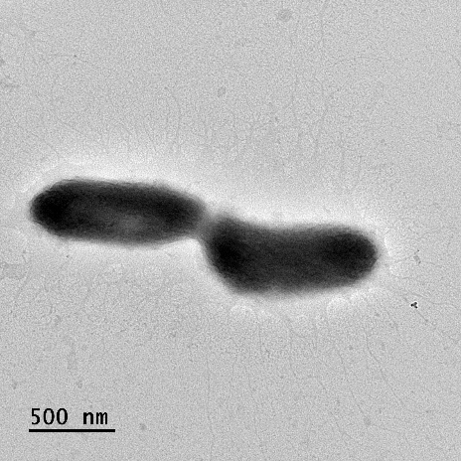
(A)
(B)
Figure S2.
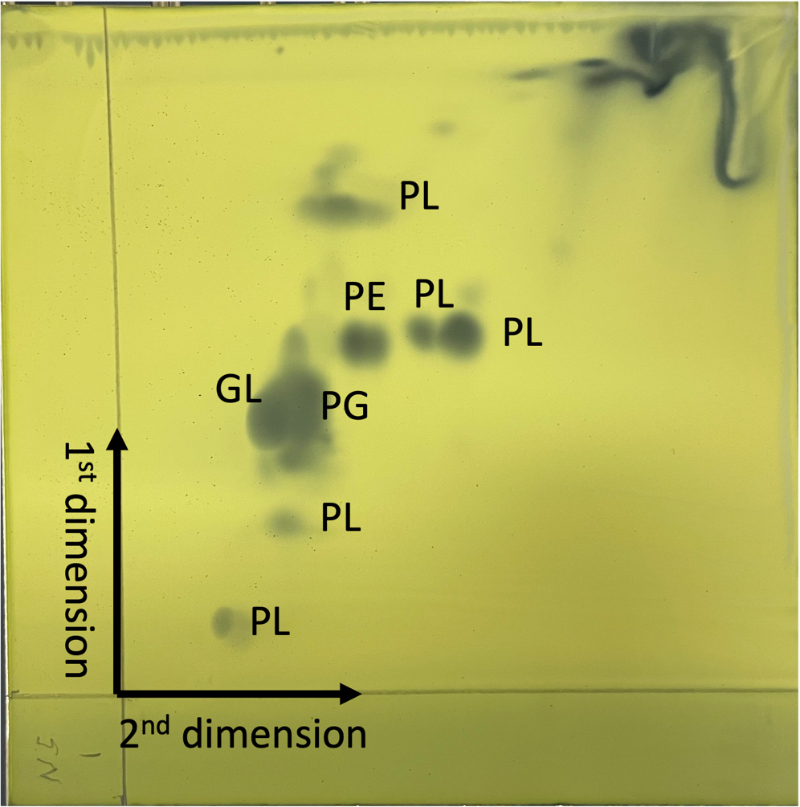
B

Figure S3.
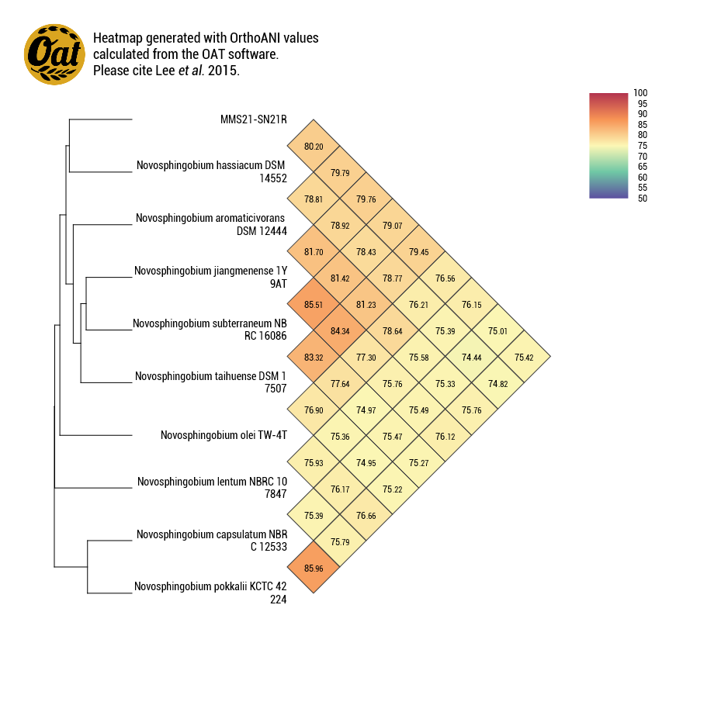
Novosphingobium pokkalii KCTC 42224^{T}
MMS21-SN21R^{T}
Novosphingobium hassiacum DSM 14552^{T}
Novosphingobium aromaticivorans DSM 12444^{T}
Novosphingobium jiangmenense 1T9AT^{T}
Novosphingobium subterraneum NBRC 16086^{T}
Novosphingobium taihuense DSM 17507^{T}
Novosphingobium olei TW-4T^{T}
Novosphingobium lentum NBRC 107847^{T}
Novosphingobium capsulatum NBRC 12533^{T}
Figure S4.
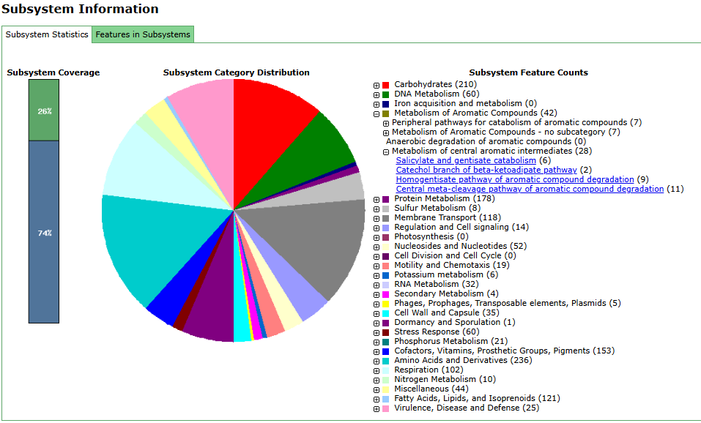
Figure S5.
