Supplementary Appendix:
Criteria | Details
Inclusion criteria
Breast cancer subtype definitions | TNBC cohort: ER <10% or PR <10% by IHC  Endocrine-refractory cohort: HR+ (ER ≥10% or PR ≥10% by IHC)  HER2 status: HER2-negative if not amplified per ASCO/CAP guidelines; HER2-low classification per NCCN guidance
Prior therapy | Participants must have been treated with at least one (1) line of systemic therapy after diagnosis of metastatic disease, anticipate or have progressive disease or adverse events requiring discontinuation of their current regimen, and must not be able to transition to another approved systemic therapy shown to improve overall survival.  (Participants who cannot receive or decline to receive standard therapy that has been shown to prolong overall survival, or if such therapy is not deemed in the participant’s best interest, will be eligible, if other eligibility criteria are met. If appropriate, participants may remain on treatment during biopsy, screening and initial tissue review/testing for this study.)
Endocrine resistance | HR+ disease must be deemed refractory to endocrine therapy by treating oncologist, confirmed by study team
Age | ≥18 years
Performance status | ECOG ≤2; Karnofsky ≥60%
Disease evaluation | Measurable disease per RECIST v1.1
Tissue availability | Archival FFPE tumor from biopsy within 6 months required for ENLIGHT reliability; if >1 line of therapy since biopsy, re-biopsy may be requested; if unavailable, biopsy at the NIH Clinical Center may be offered. Participants must submit 20 slides or 3 cores for analysis.
Organ function requirements | • Leukocytes ≥3,000/mcL  • Absolute neutrophil count ≥1,200/mcL  • Hemoglobin ≥8 g/dL  • Total bilirubin ≤1.5× ULN (unless known Gilbert’s disease)  • AST and ALT ≤3× ULN  • Creatinine ≤1.5× ULN or CrCl >60 mL/min/1.73 m²
Medical requirements | Must be able to take oral medications; controlled hypertension/diabetes with annual follow-up
Reproductive health | Men and women of childbearing potential must use effective contraception when required by therapy; duration per agent-specific guidance
General willingness and consent | Willing to comply with study procedures and follow-up; written informed consent required
Brain metastases | Allowed if treated ≥4 weeks prior, asymptomatic, and not requiring further local therapy
Viral infections | • HIV: undetectable viral load on anti-retroviral therapy ≥6 months  • HBV: undetectable viral load on suppressive therapy  • HCV: cured or on active therapy with undetectable viral load
Concurrent malignancies | Permitted if prognosis or therapy is unlikely to affect safety or efficacy assessment per PI judgment
Cardiac function | If prior cardiotoxic therapy or cardiac history, must be New York Heart Association Class IIb or less
Exclusion criteria
Active disease complications | Active visceral crisis, symptomatic brain metastases needing urgent therapy, or leptomeningeal disease
Comorbidities limiting safety or compliance | Uncontrolled illness or lab abnormalities increasing study risk or interfering with assessment
Cardiac conditions | Symptomatic heart failure, unstable angina, or significant arrhythmia
Pulmonary and hepatic disorders | Continuous oxygen requirement, decompensated cirrhosis, or dialysis-dependent kidney disease
Pregnancy | Positive serum or urine β-HCG at screening
Tissue quality | Inadequate tumor specimens for sequencing (e.g. failed extraction/quality control); re-screening allowed if re-biopsy feasible

Supplementary Table 1. Detailed Inclusion and Exclusion Criteria. TNBC: Triple-negative breast cancer. ER: Estrogen receptor. PR: Progesterone receptor. HR: Hormone receptor. IHC: Immunohistochemistry. ECOG: Eastern Cooperative Oncology Group. RECIST: Response Evaluation Criteria in Solid Tumors. FFPE: Formalin-fixed, paraffin embedded. ULN: Upper limit of normal. ASCO/CAP: American Society of Clinical Oncology / College of American Pathologists. NCCN: National Comprehensive Cancer Network.
Detailed Objectives and Endpoints
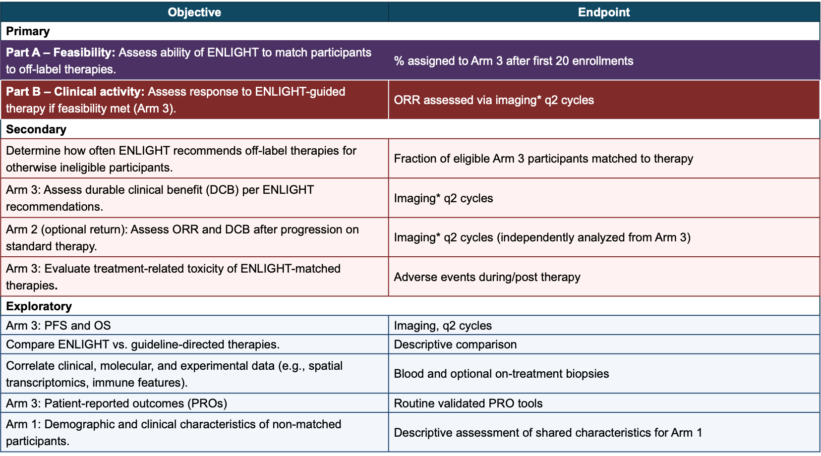

*RECIST v1.1
AEs graded per CTCAE v5.0; PROs collected electronically at predefined intervals.

Supplemental Table 2. Detailed Objectives and Endpoints. This table outlines which objectives and endpoints are assessed during each stage of the study. The Primary Objective corresponds to Figure 2. Additional secondary and exploratory endpoints will be evaluated as feasibility is met. PFS: Progression-free survival. OS: Overall survival. PROs: Patient-reported outcomes.

Biospecimen Collection
Test/Assay | Type/Volume of Blood (approx.) per sample¹ |  | Tube Type | Location of Specimen Analysis
Tissue Samples
Next generation sequencing, DNA/RNA, Spatial Transcriptomics and Tumor Microenvironment, Whole-slide H+E Digital Imaging, DNA Methylation | Tissue-  Tumor Archival Tissue or Biopsy (FFPE) |  | NA | Laboratory of Pathology  Pangea Biomed (coded)
Blood Samples
Pharmacogenetics | 1 x 6 mL EDTA tube (lavender top) |  | EDTA tube (lavender top) | Clinical Pharmacology Program (CPP)
Circulating tumor DNA/RNA | 1 x 10 mL Streck tube (brown/black top) |  | Streck tube (brown/black top) | Clinical Pharmacology Program (CPP)
Peripheral blood RNA sequencing | 1 x 2.5 ml PAXgene tube (red top) |  | EDTA tube (lavender top) | Clinical Pharmacology Program (CPP)Pangea Biomed (coded)
PBMCs-  158 Immune Cell Subsets by FACS  Functional analysis of immune cell subsets by FACS  Antigen specific immune response by cytokine staining assay | 6-8 x 10 mL sodium heparin tubes (green top) (60-80 mL) |  | Sodium heparin (green top tubes) | Center for Immuno-Oncology (CIO)
Soluble Analytes (soluble factors, cytokines) | 1 x 8 mL SST (gold top) |  | SST | Center for Immuno-Oncology (CIO)

Supplemental Table 3. Detailed Biospecimen Collection. This table outlines the biospecimens that are being collected for the correlative analyses on study.
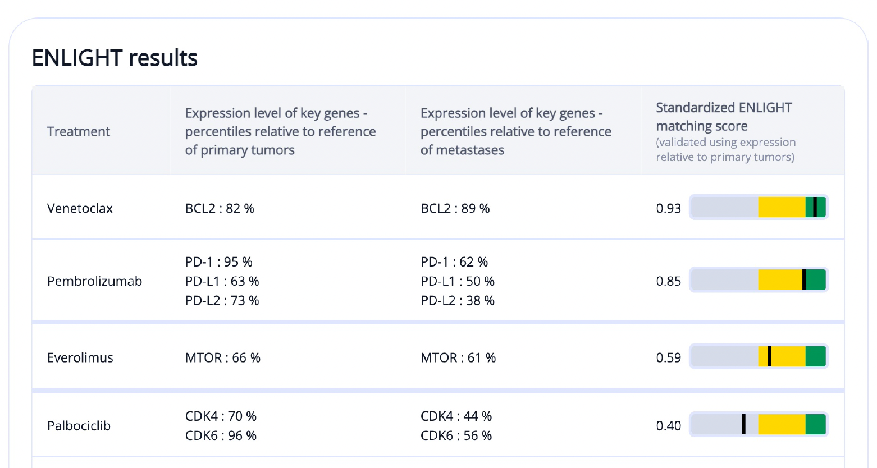

4

1

2

3

Supplemental Figure 1. Example ENLIGHT sample report. From left to right: (1) Treatment options within the SYNTHESIS-Breast study; (2) Expression of target genes for treatment for the participant compared with primary tumor gene expression data – higher target levels supports drug response; (3) Expression of target genes for treatment for the participant compared with metastatic tumor gene expression data; (4) ENLIGHT matching scores (green: strongest match; yellow: potential match; gray: no match). ENLIGHT matching scores include not only expression levels of target genes of interest, but also genetic interactions and expression levels of interacting genes.

