Supporting Information
A “Living-Derived” Biomimetic Pro-Regenerative Platform Orchestrates Redox-Immuno-Angiogenic Synergy for Comprehensive Diabetic Wound Remodeling

Hao Guo ^{a,1}, Jian Li ^{a,1}, Chengcheng Gu ª, Ning Liu ª, Jie Sun ª, Danhui Wang ª, Siyuan Meng ª, Dongshu Geng ª, Yunfei Lian^{a,} ^{b, *}, Fangnan Lv ^{a, *}, Meirong Huo ^{a, *}

ª Department of Pharmaceutics, China Pharmaceutical University, Nanjing 211198, China.
^{b} Nanjing Sairicon Biomedical Technology Co., Ltd., Nanjing 210039, China

* Corresponding authors.
E-mail address: lyf_snpharma@126.com (Y. Lian), lvfangnan@126.com (F. Lv), huomeirongcpu@163.com (M. Huo)
¹These authors contributed equally to this work.
Graphical abstract

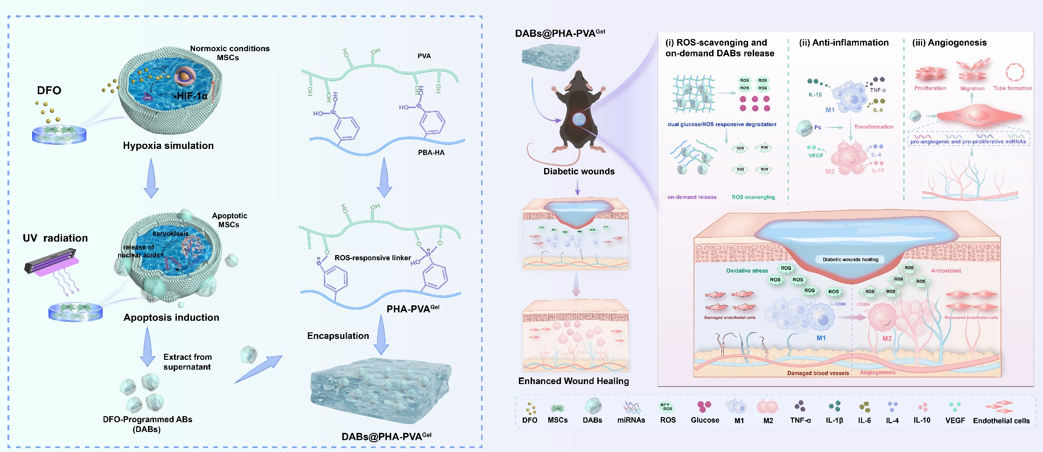

Supporting Figures

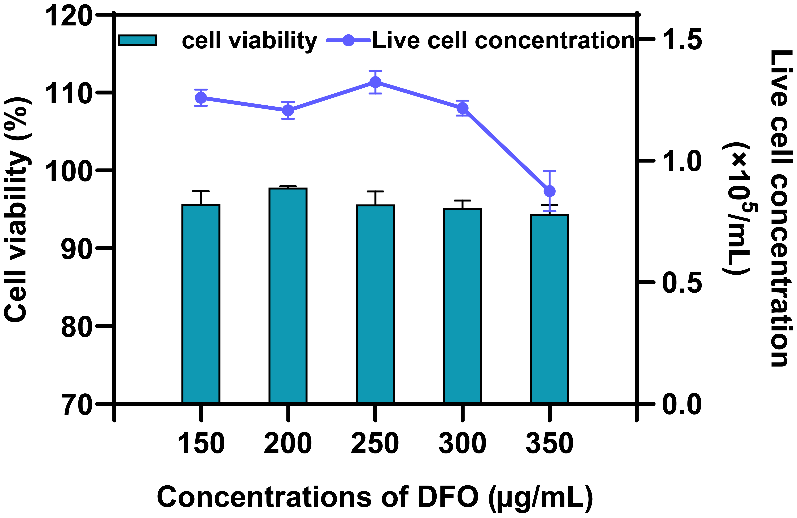
Fig. S1. Effect of DFO concentration on MSCs cell viability (n = 3).

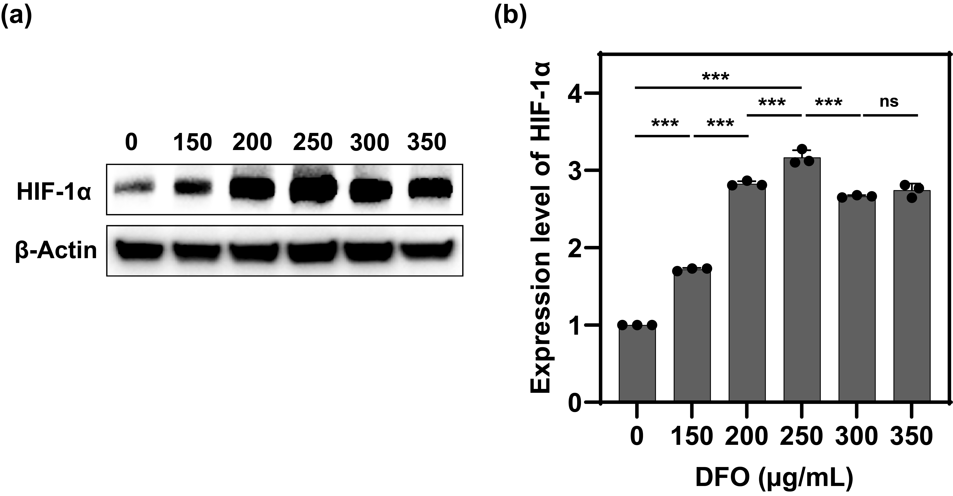
Fig. S2. Expression of HIF-1α within MSCs after incubation with different concentrations of DFO for 24 h. (a) Western Blot analysis of HIF-1α. (b) Quantitative analysis of the HIF-1α expression (using Image J software) (n = 3). ***p < 0.001.

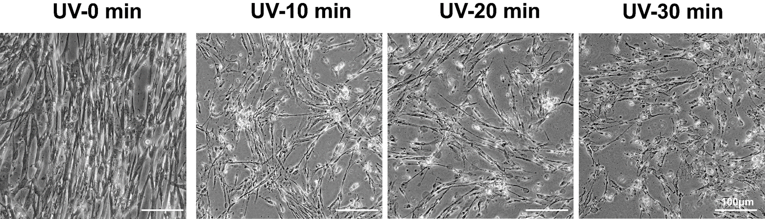
Fig. S3. Morphological changes of MSCs induced by UV irradiation at different time (Scale bar = 100 μm).
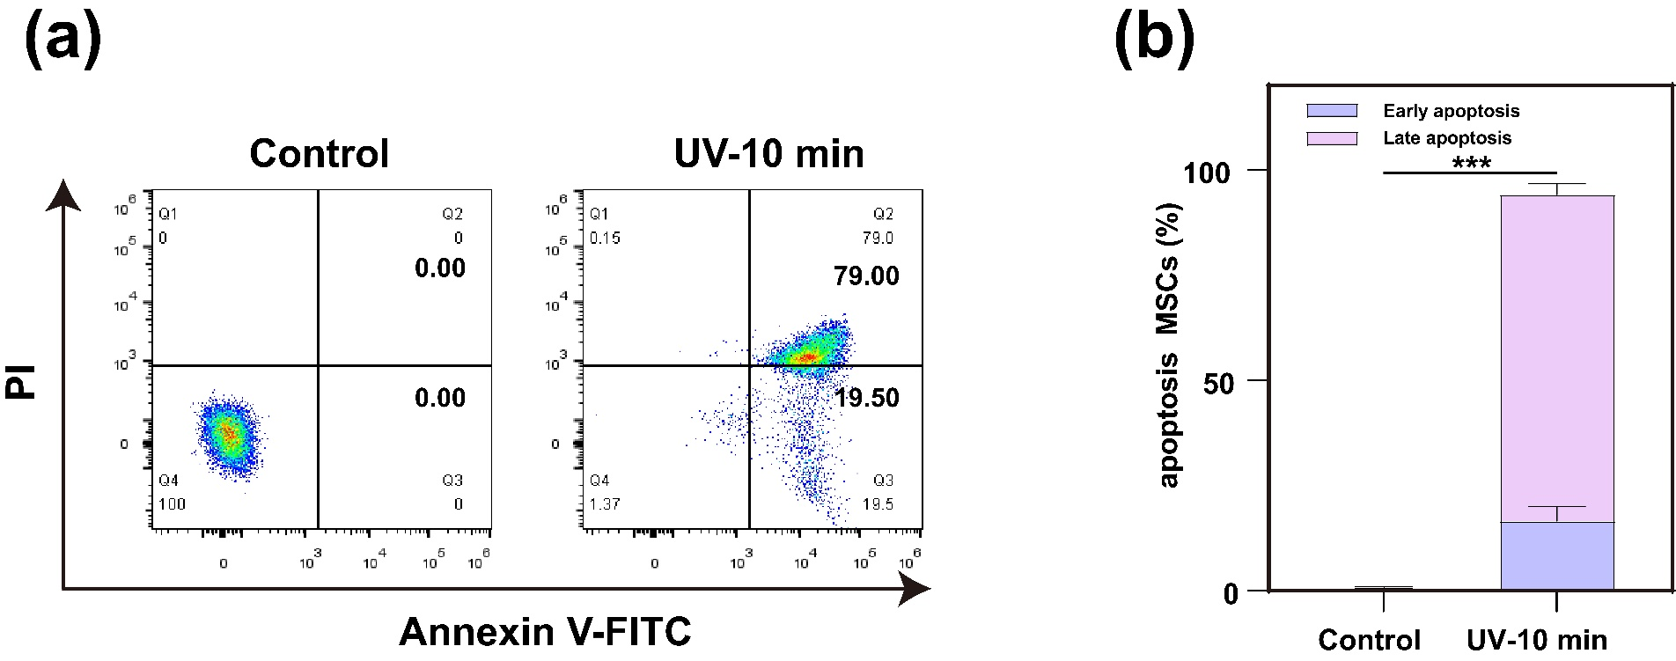
Fig. S4. Cell apoptosis analysis of MSCs after 10 min UV-induced culture for 24h. (n = 3). (a) Cell apoptosis of MSCs after 10 min UV-induced culture for 24 h by flow cytometry. (b) Quantitative analysis of MSCs apoptosis cells after 10 min UV-induced culture for 24 h (n = 3). ***p < 0.001.

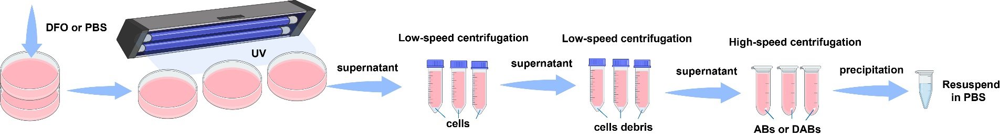
Fig. S5. Schematic of the procedure used for the isolation of ABs and DABs via sequential centrifugation.
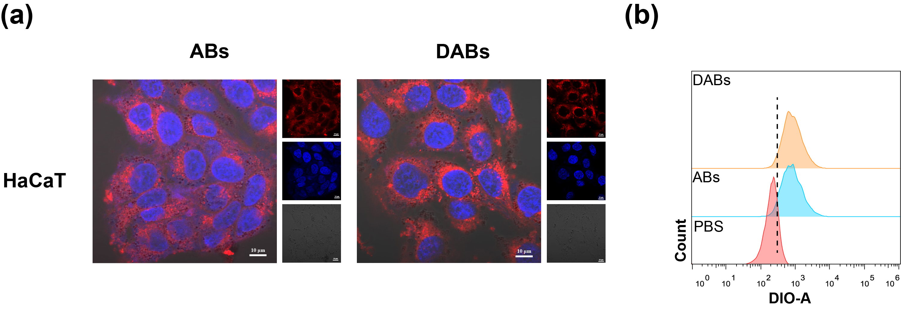
Fig. S6. (a) Cellular uptake of HaCaT cells after being treated with ABs and DABs for 4 h by confocal laser scanning microscope. (Scale bar = 10 μm). (b) Cellular uptake of HaCaT cells after treated with ABs and DABs for 4 h by flow cytometry.
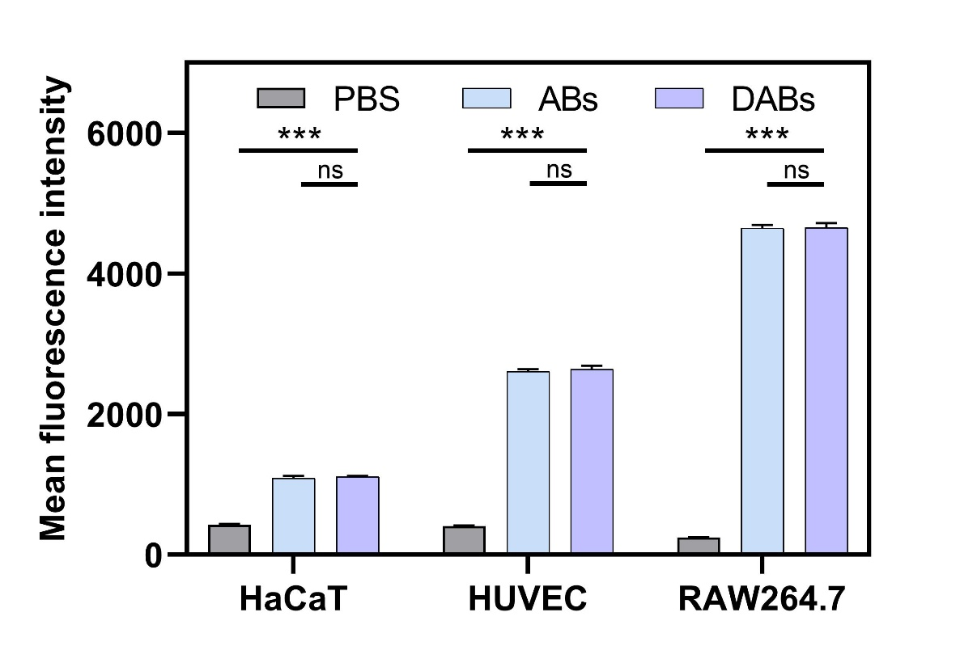
Fig. S7. Cellular uptake of HaCaT, HUVEC, and RAW264.7 cells after being treated with ABs and DABs for 4 h by flow cytometry (n = 3). ***p < 0.001.

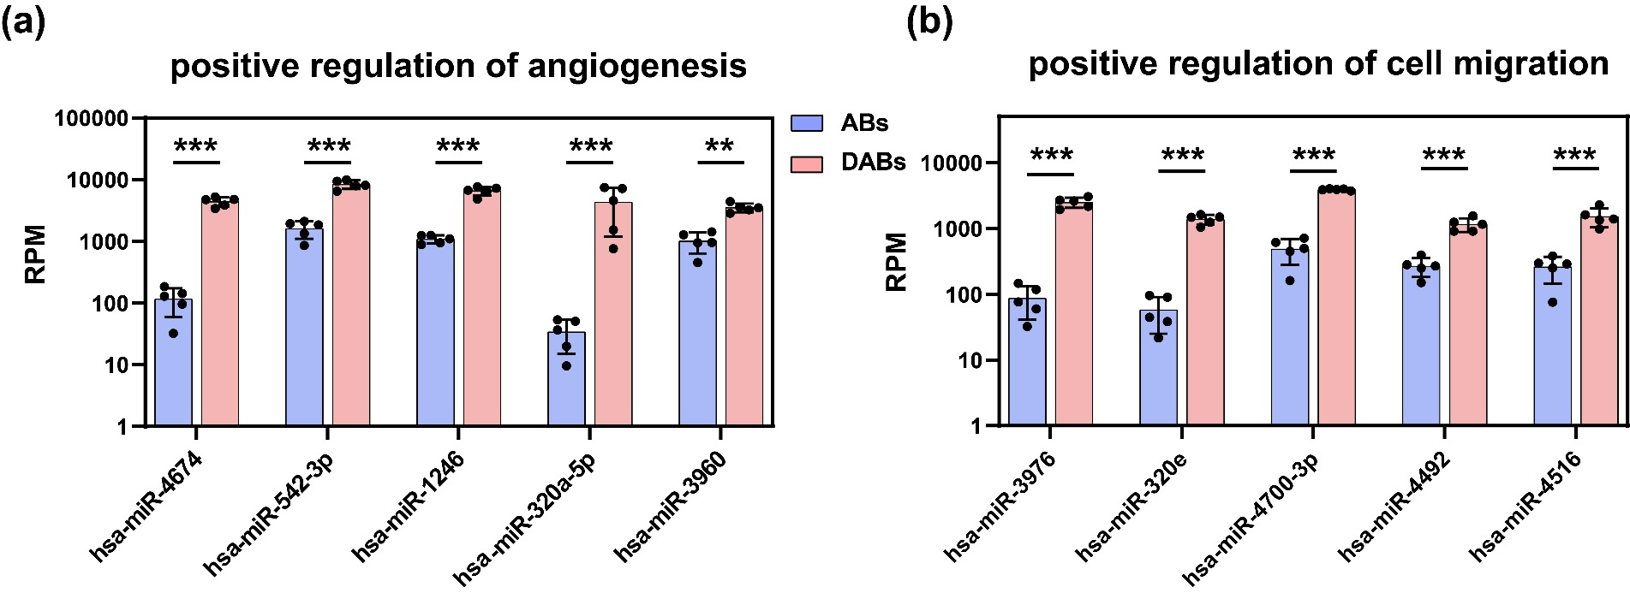
Fig. S8. Expression of the differential miRNAs that are significant to diabetic wound regeneration, including (a) positive regulation of angiogenesis and (b) positive regulation of cell migration (n = 5). **p < 0.01, ***p < 0.001.

Fig. S9. PPI network showing the interaction relationship among the predicted target genes (colored by miRNA category) of the 10 significantly upregulated miRNAs in DABs, corresponding to the hub gene networks identified by the MCODE algorithm.
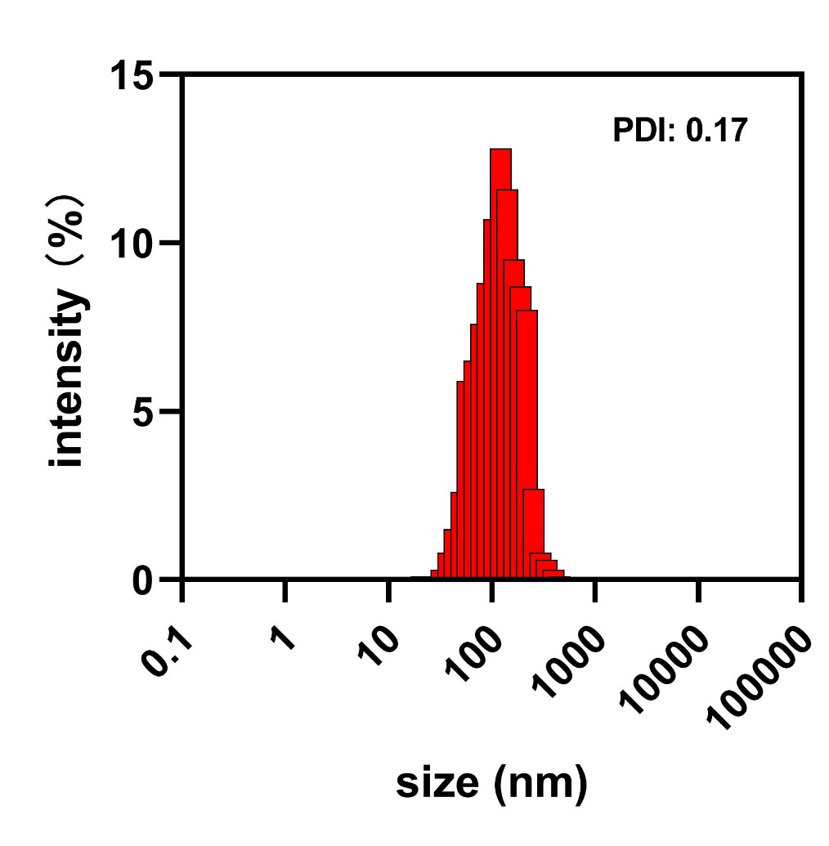
Fig. S10. Particle size distribution of exosomes.
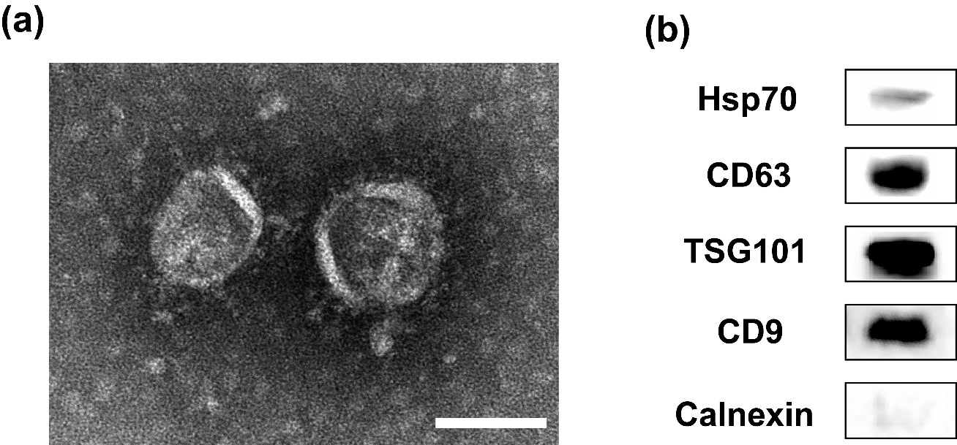
Fig. S11. Identification of Exosomes. (a) TEM morphological characterization of exosomes (Scale bar = 50 nm). (b) WB identification of exosome surface markers CD9, CD63, TSG101, and Hsp70.

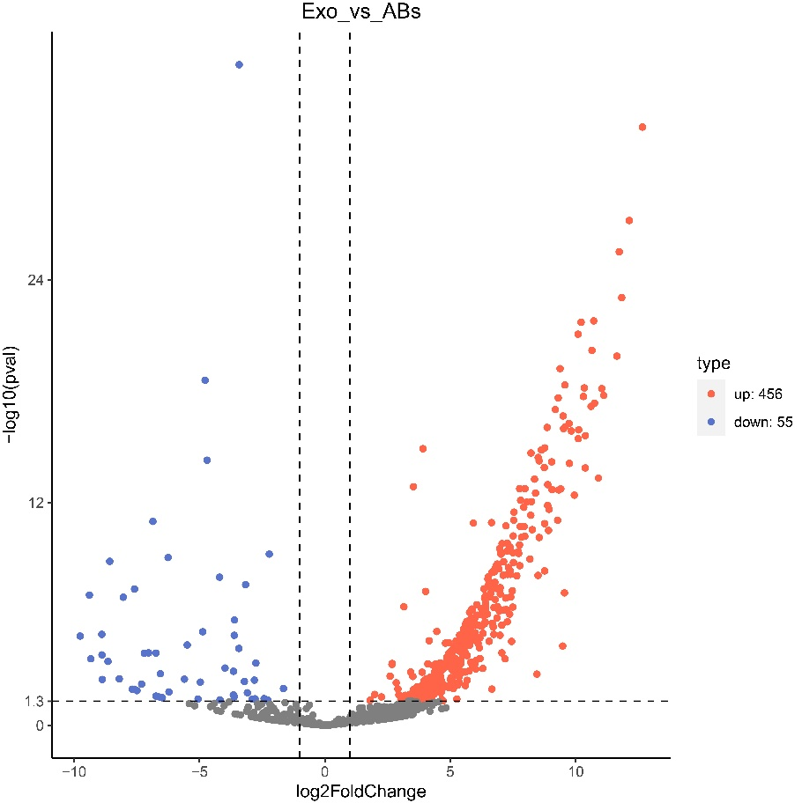
Fig. S12. Volcano plot of differentially expressed miRNAs (Exo vs ABs).
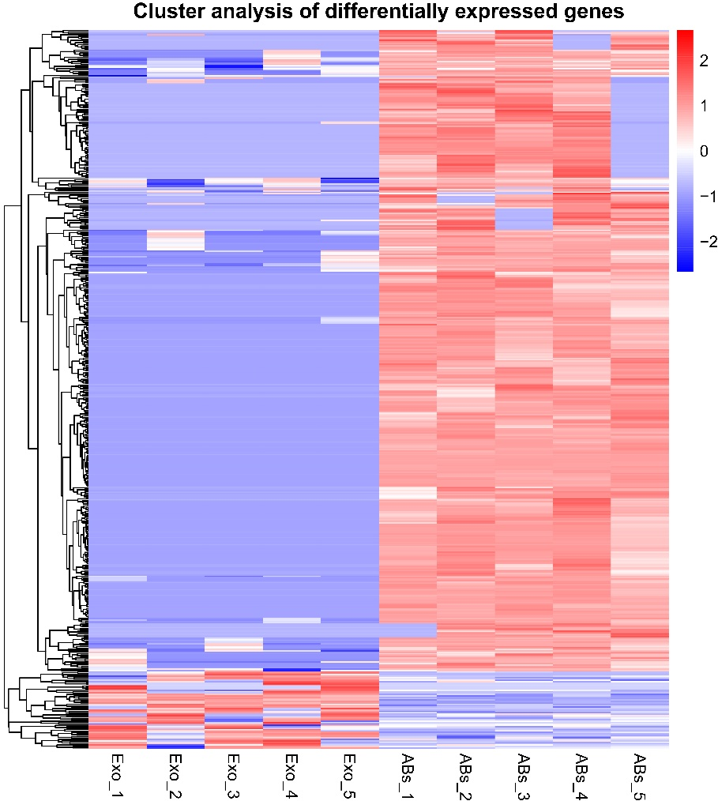
Fig. S13. Clustering heatmap of differentially expressed miRNAs (Exo vs ABs).
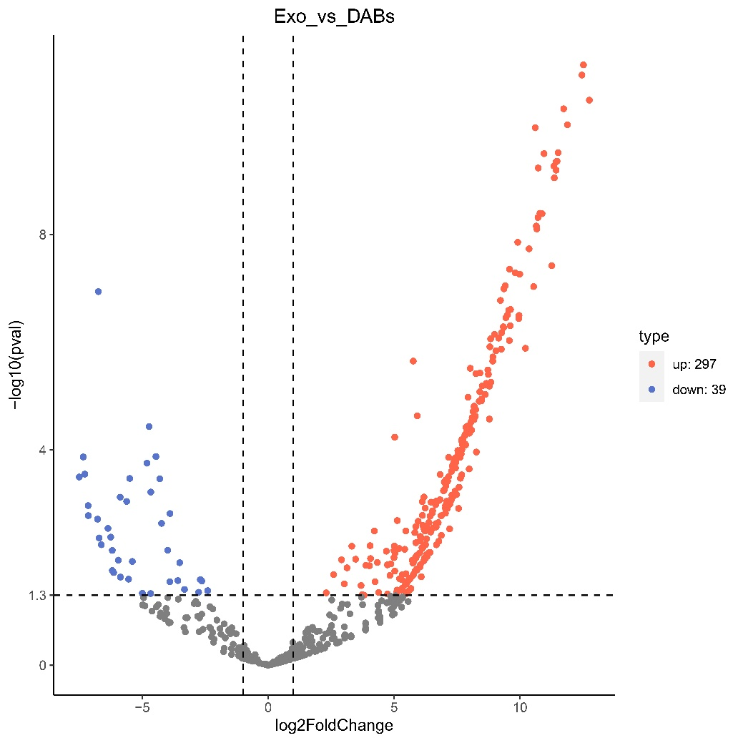
Fig. S14. Volcano plot of differentially expressed miRNAs (Exo vs DABs).
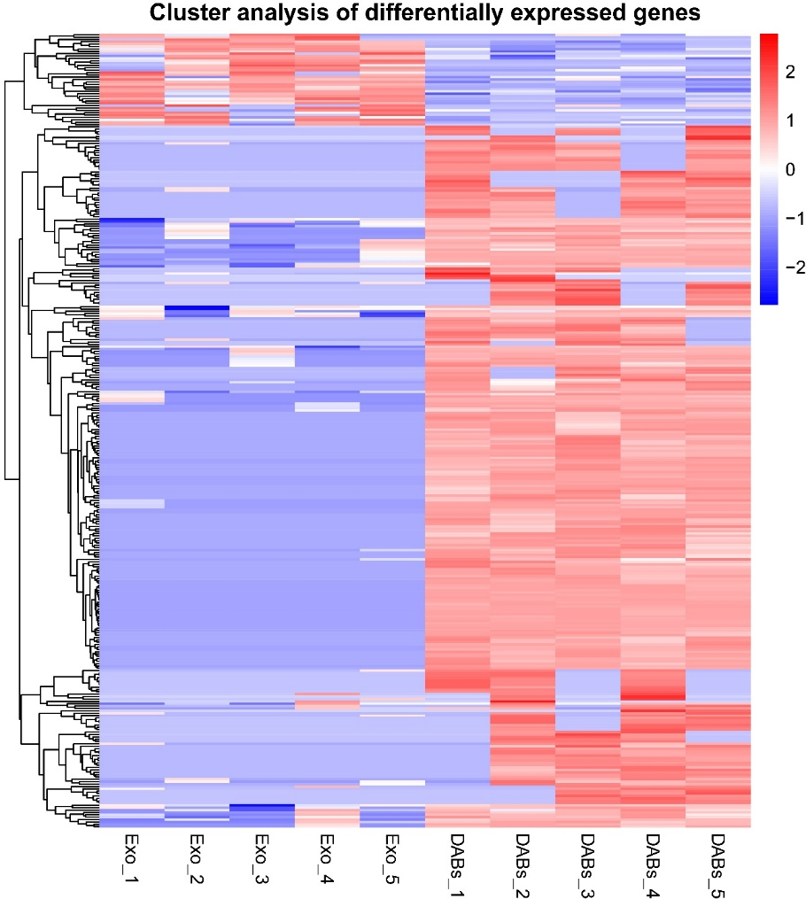
Fig. S15. Clustering heatmap of differentially expressed miRNAs (Exo vs DABs).

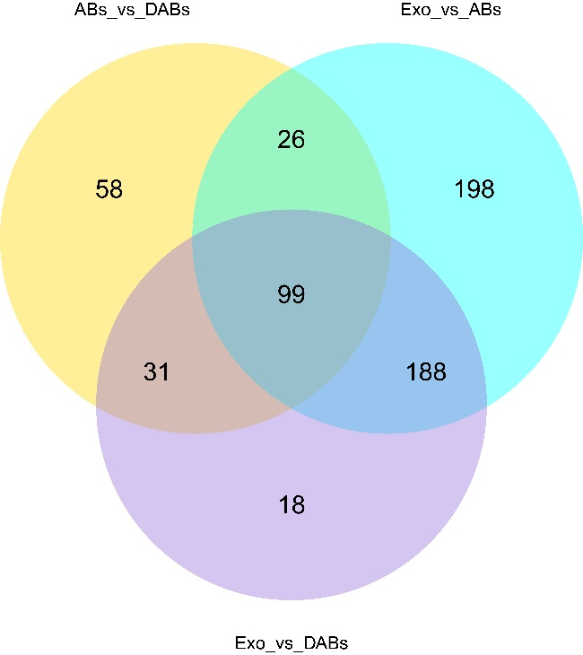
Fig. S16. Venn diagram of differentially expressed miRNAs in Exo, ABs, and DABs.
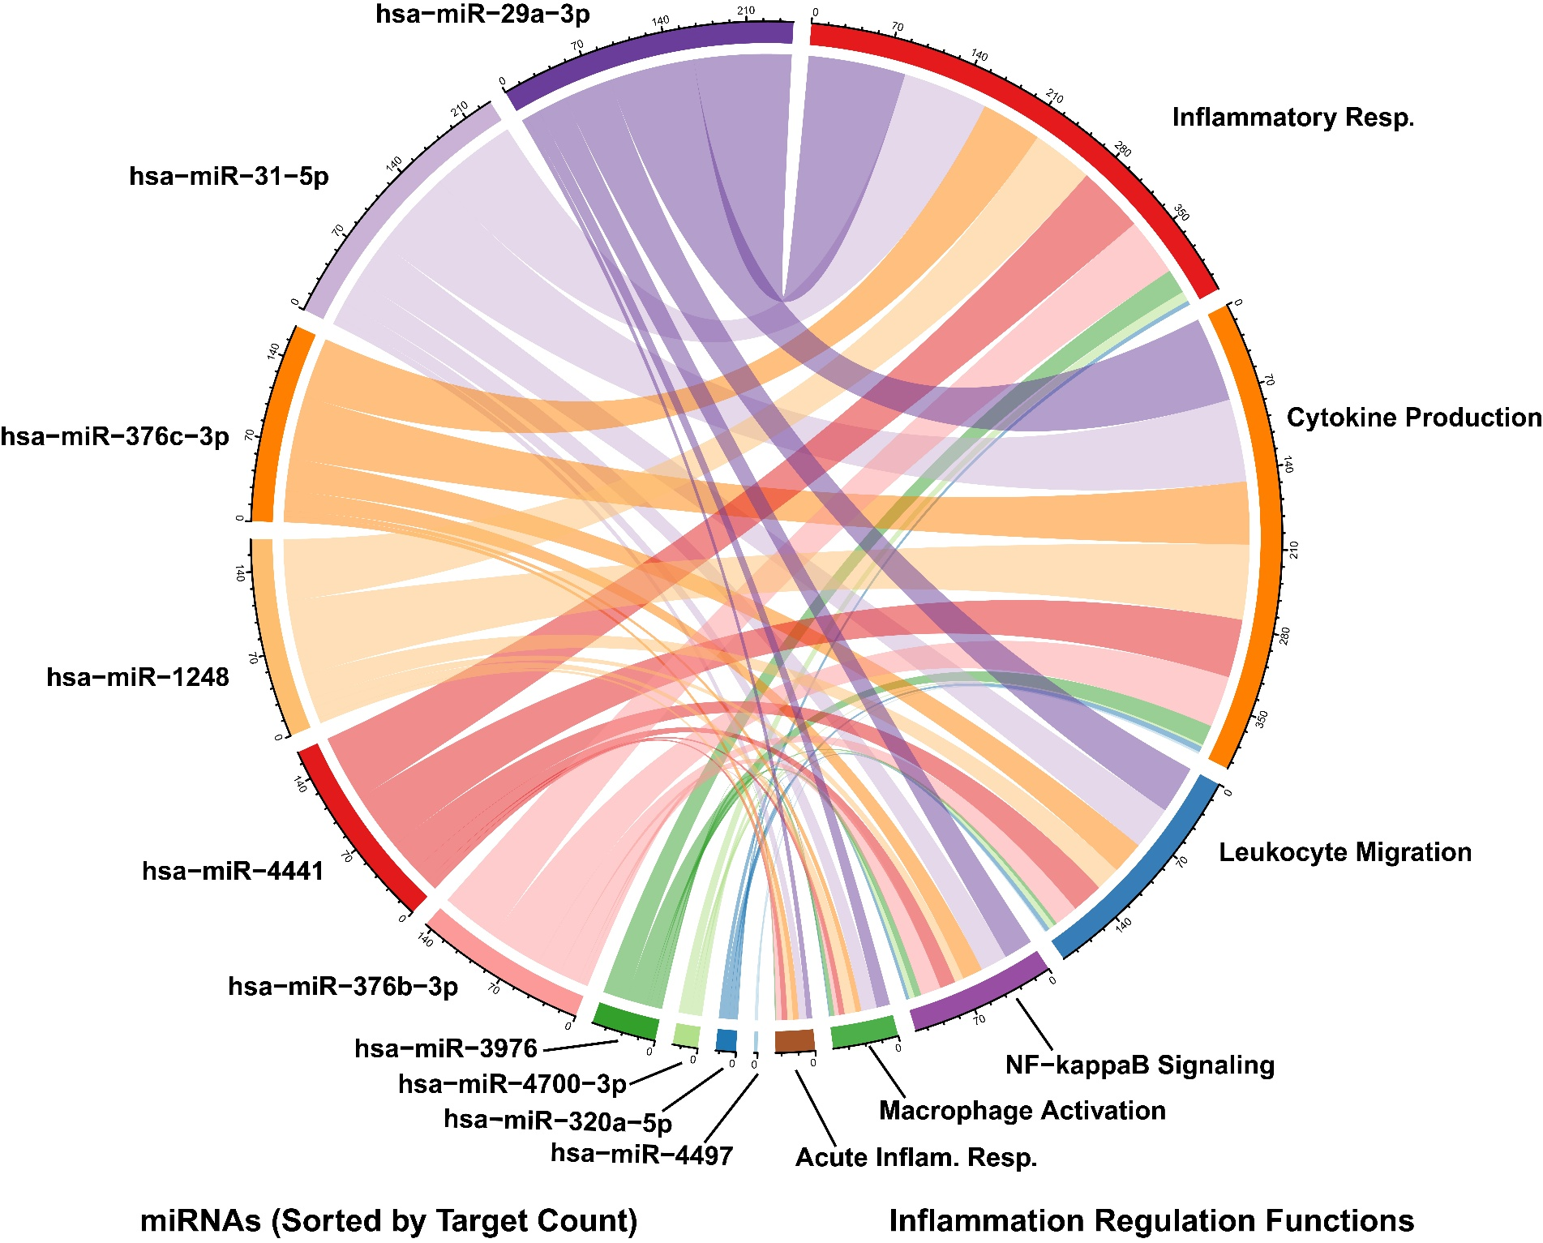
Fig. S17. Chord diagram showing the functional associations between the predicted target genes of the top 10 upregulated miRNAs in DABs relative to Exosomes and inflammation-related biological processes, including inflammatory response, cytokine production, leukocyte migration, NF-κB signaling, macrophage activation, and acute inflammatory response.

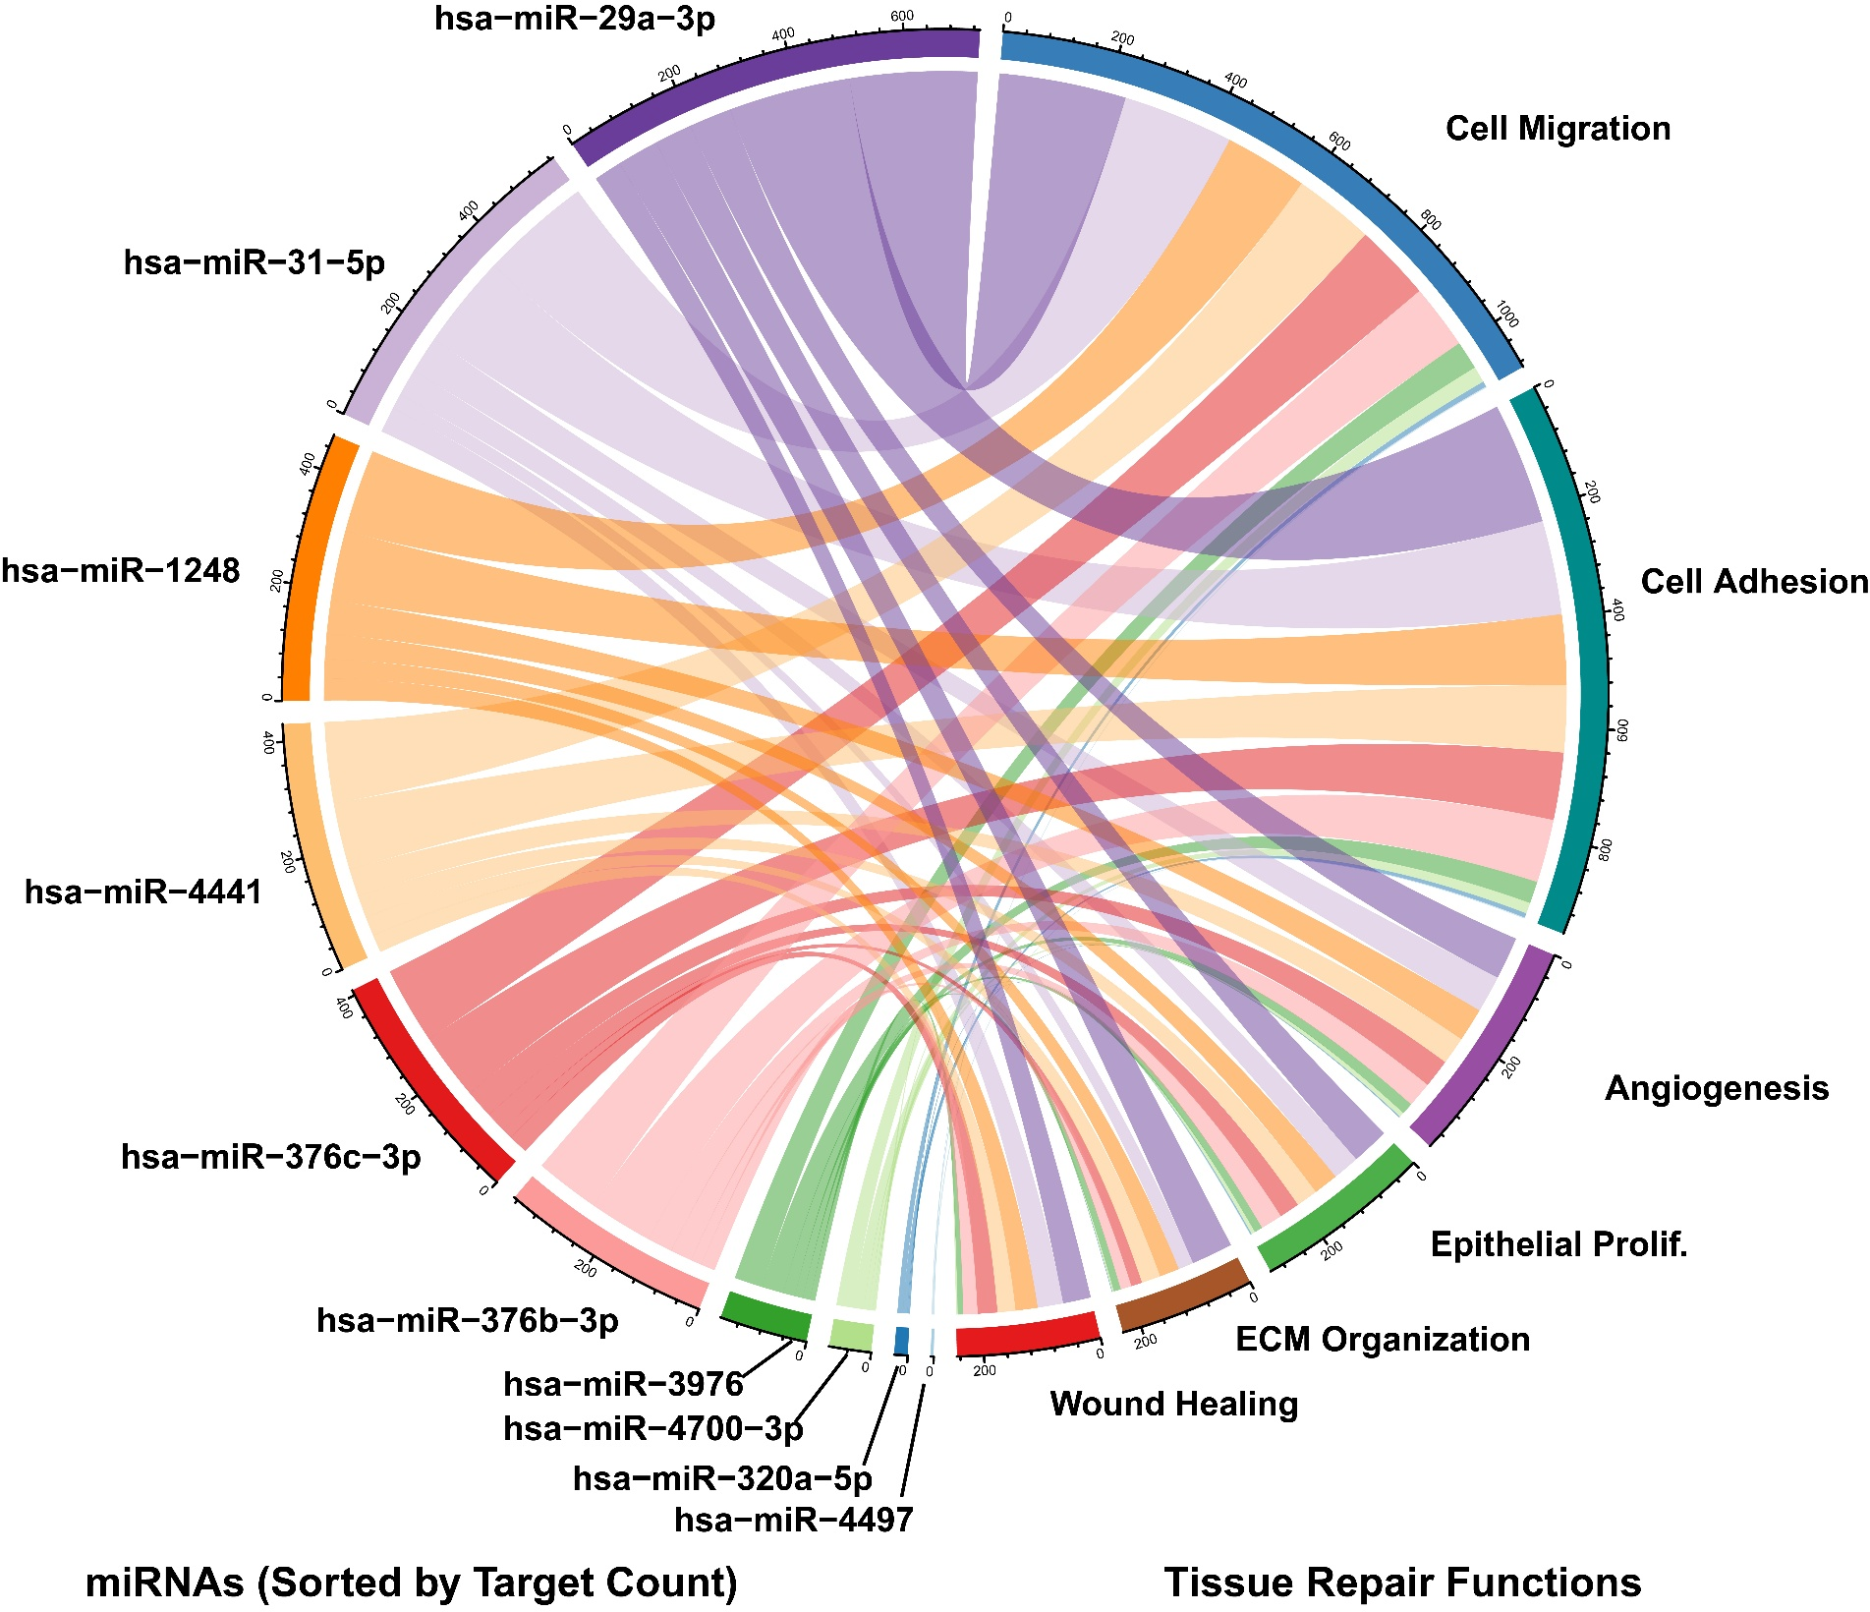
Fig. S18. Chord diagram showing the functional associations between the predicted target genes of the top 10 upregulated miRNAs in DABs relative to Exosomes and tissue repair functions, including cell migration, cell adhesion, angiogenesis, epithelial proliferation, extracellular matrix (ECM) organization, and wound healing.
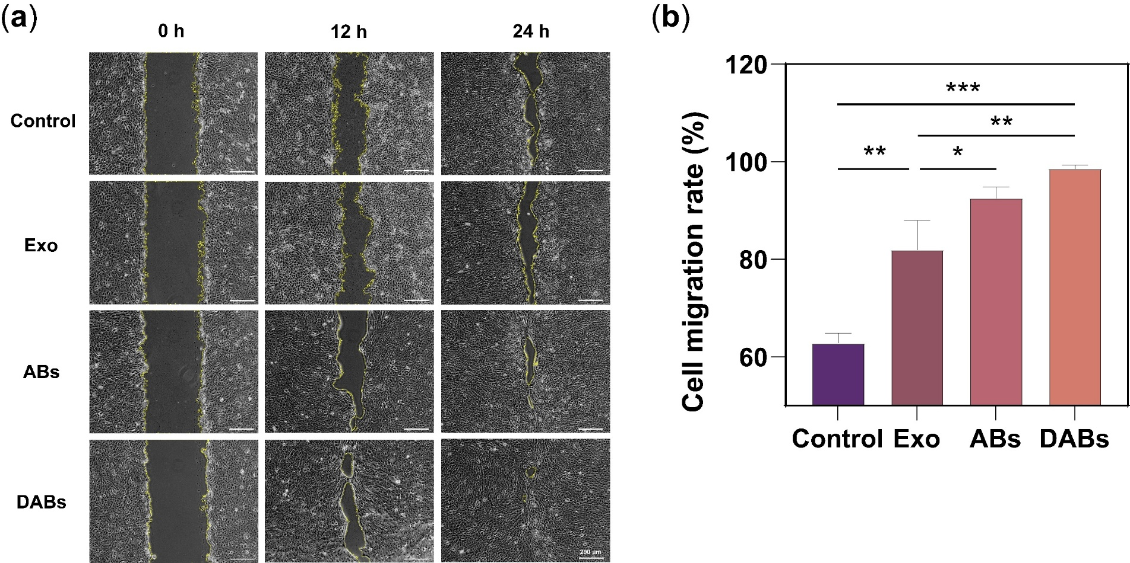
Fig. S19. DABs facilitated the migration of HaCaT. (a) Representative images of scratch assays in HaCaT treated with Exo, ABs, and DABs. (b) Cell migration of HaCaT cells treated with different formulations for 24 h. (n = 3) *p < 0.05, **p < 0.01, ***p < 0.001.

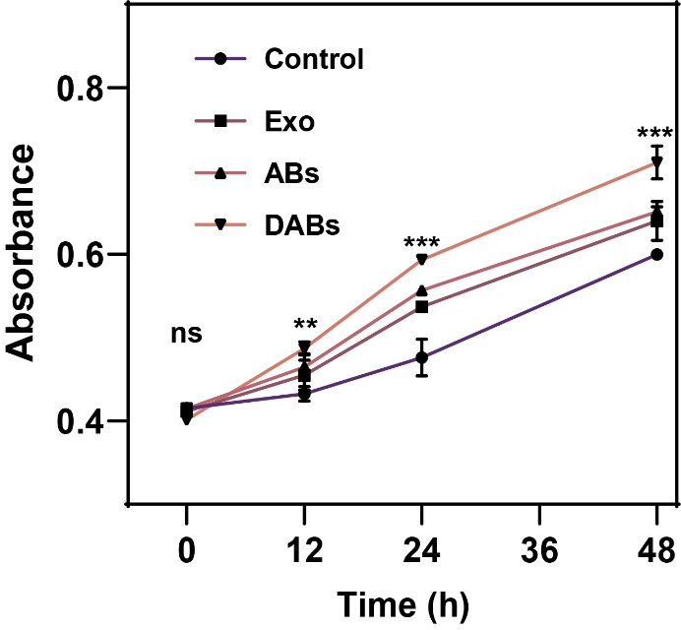
Fig. S20. DABs facilitated the proliferation of HUVECs (n = 3). **p < 0.01, ***p < 0.001.

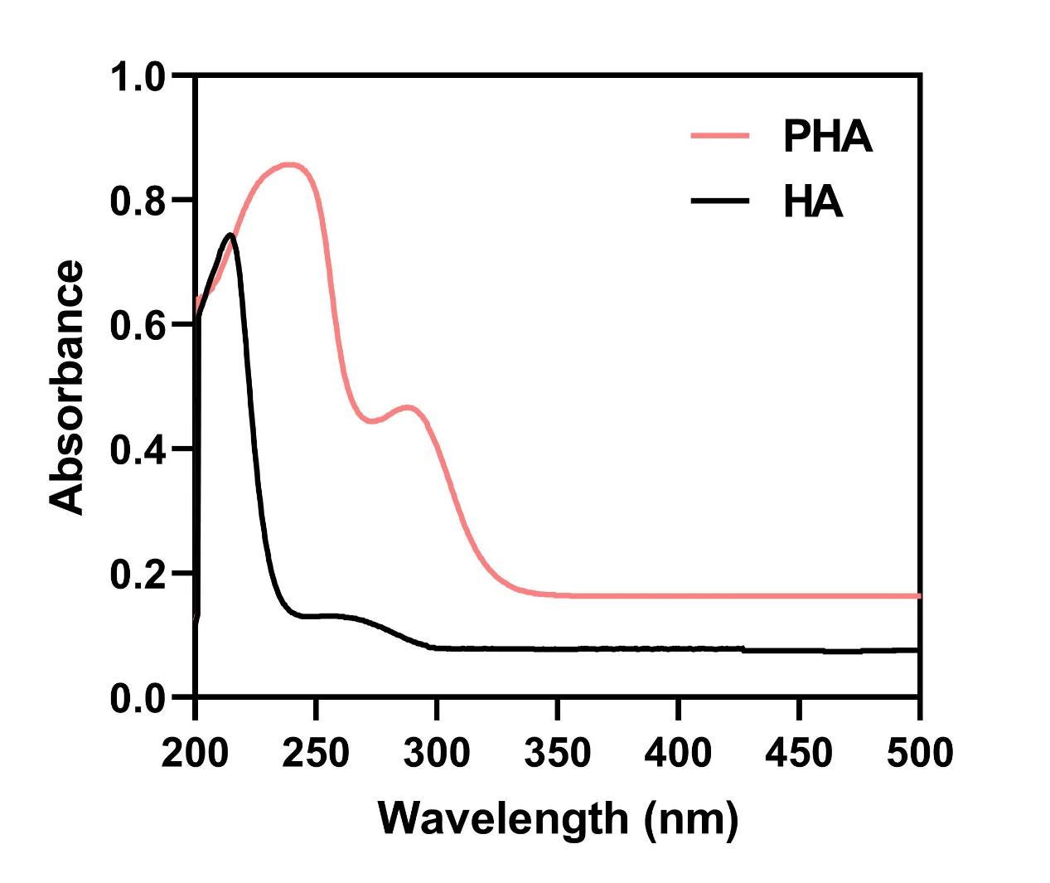
Fig. S21. UV-vis spectra of HA and PHA. PHA exhibited a characteristic absorption peak at ~280 nm, indicative of the phenyl ring from PBA.

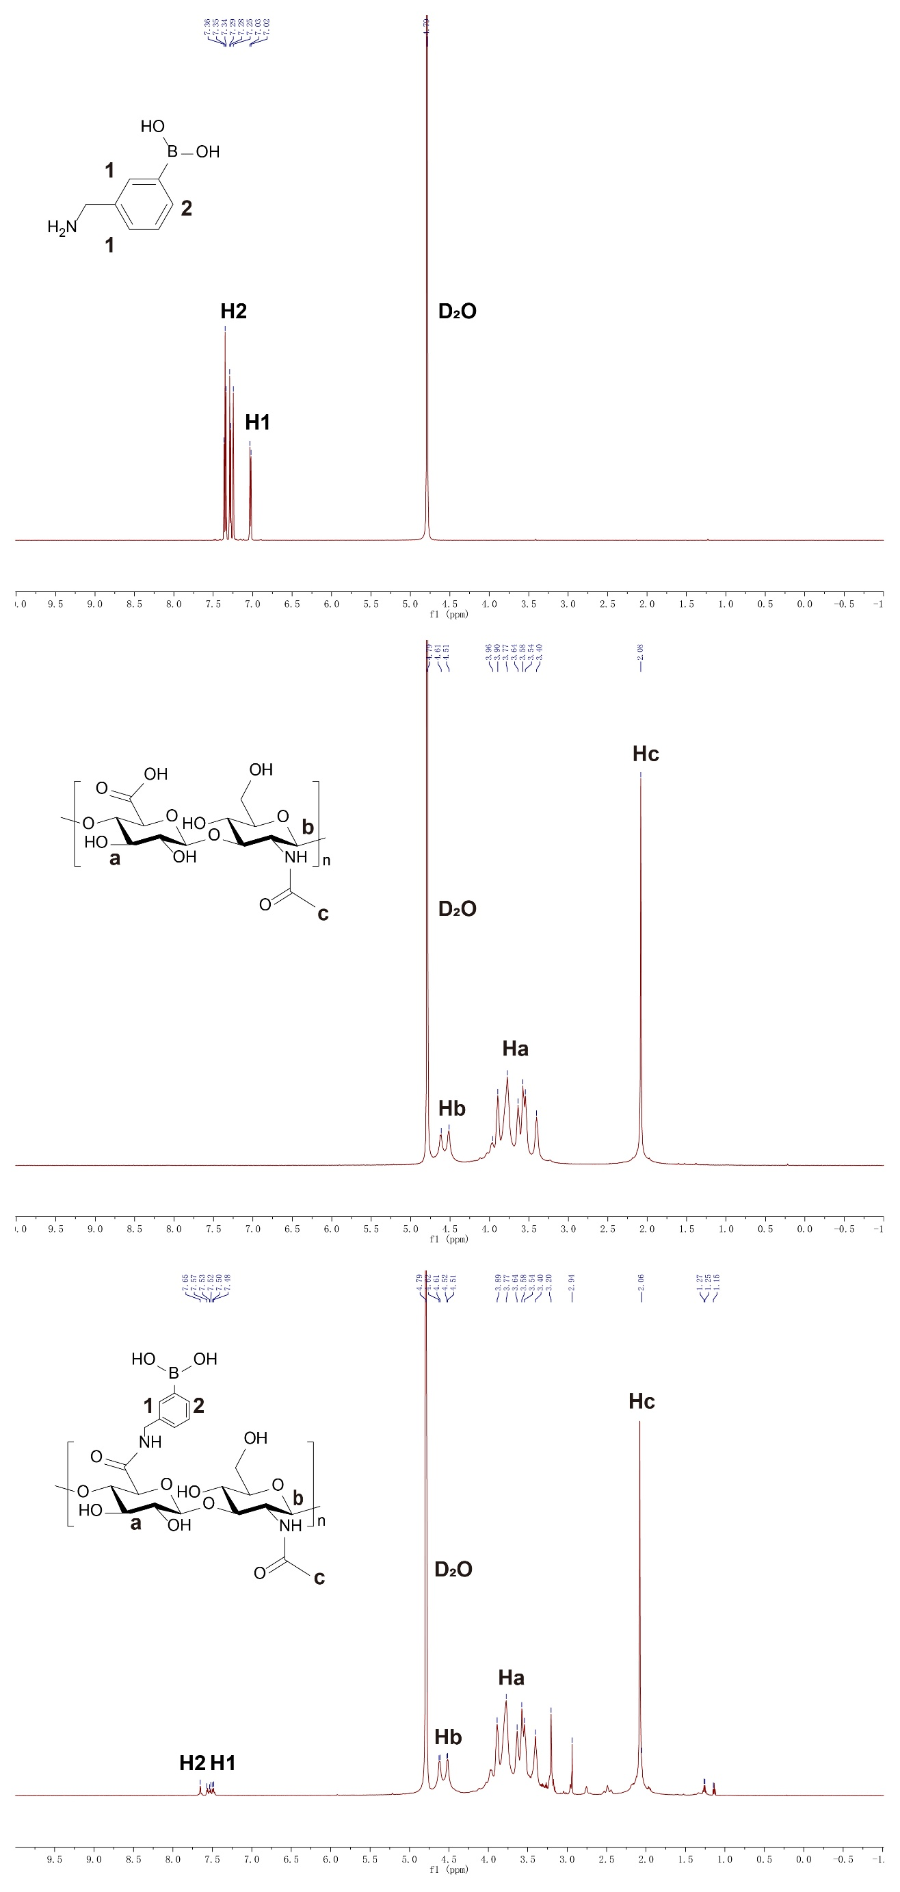
Fig. S22. ¹H-NMR (D₂O) spectra of PHA. Distinct aromatic proton signals appearing at 7.0–8.0 ppm were consistent with aminophenylboronic acid, confirming successful PBA incorporation.
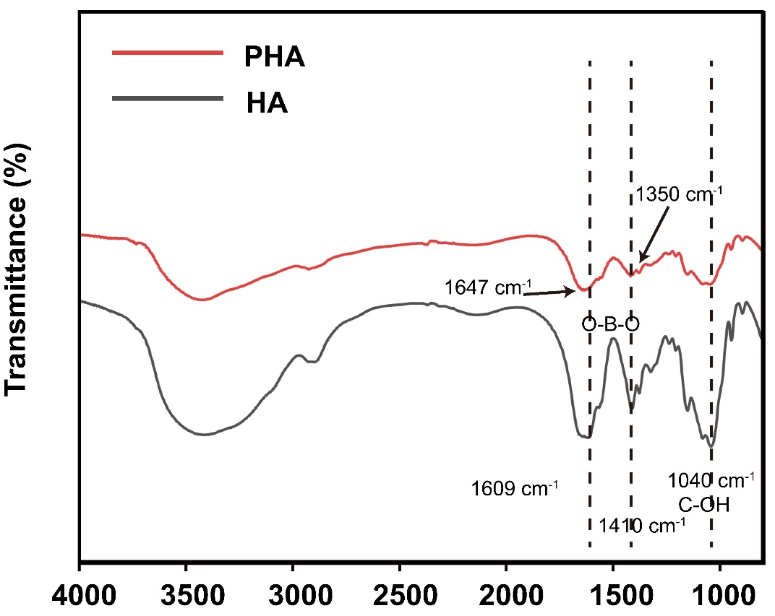
Fig. S23. FT-IR spectra of HA and PHA. Characteristic absorption bands at 1647 cm⁻¹ (amide) and 1350 cm⁻¹ (O–B–O) appeared in PHA but were absent in native HA.

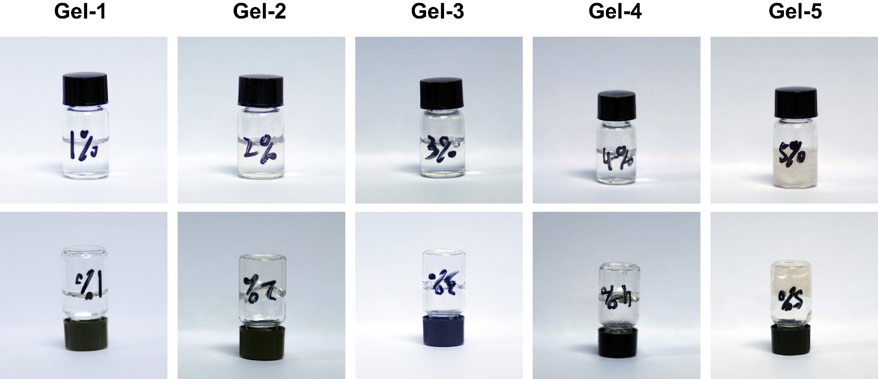
Fig. S24. Photographs showed the gelation of the hydrogels.

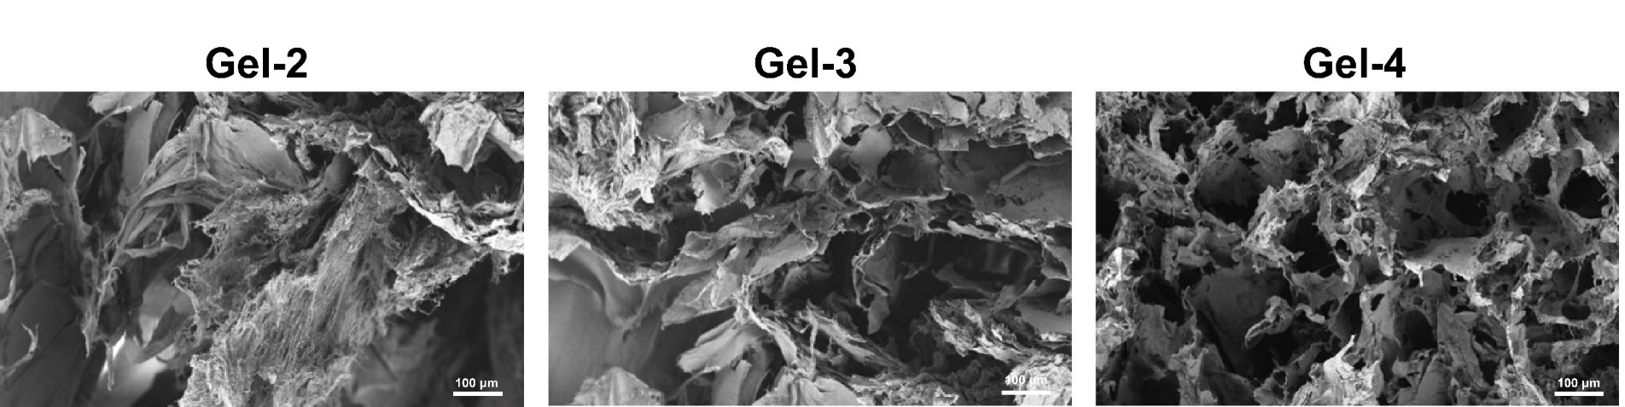
Fig. S25. The morphology of hydrogel characterized by SEM. (Scale bar = 100 μm)

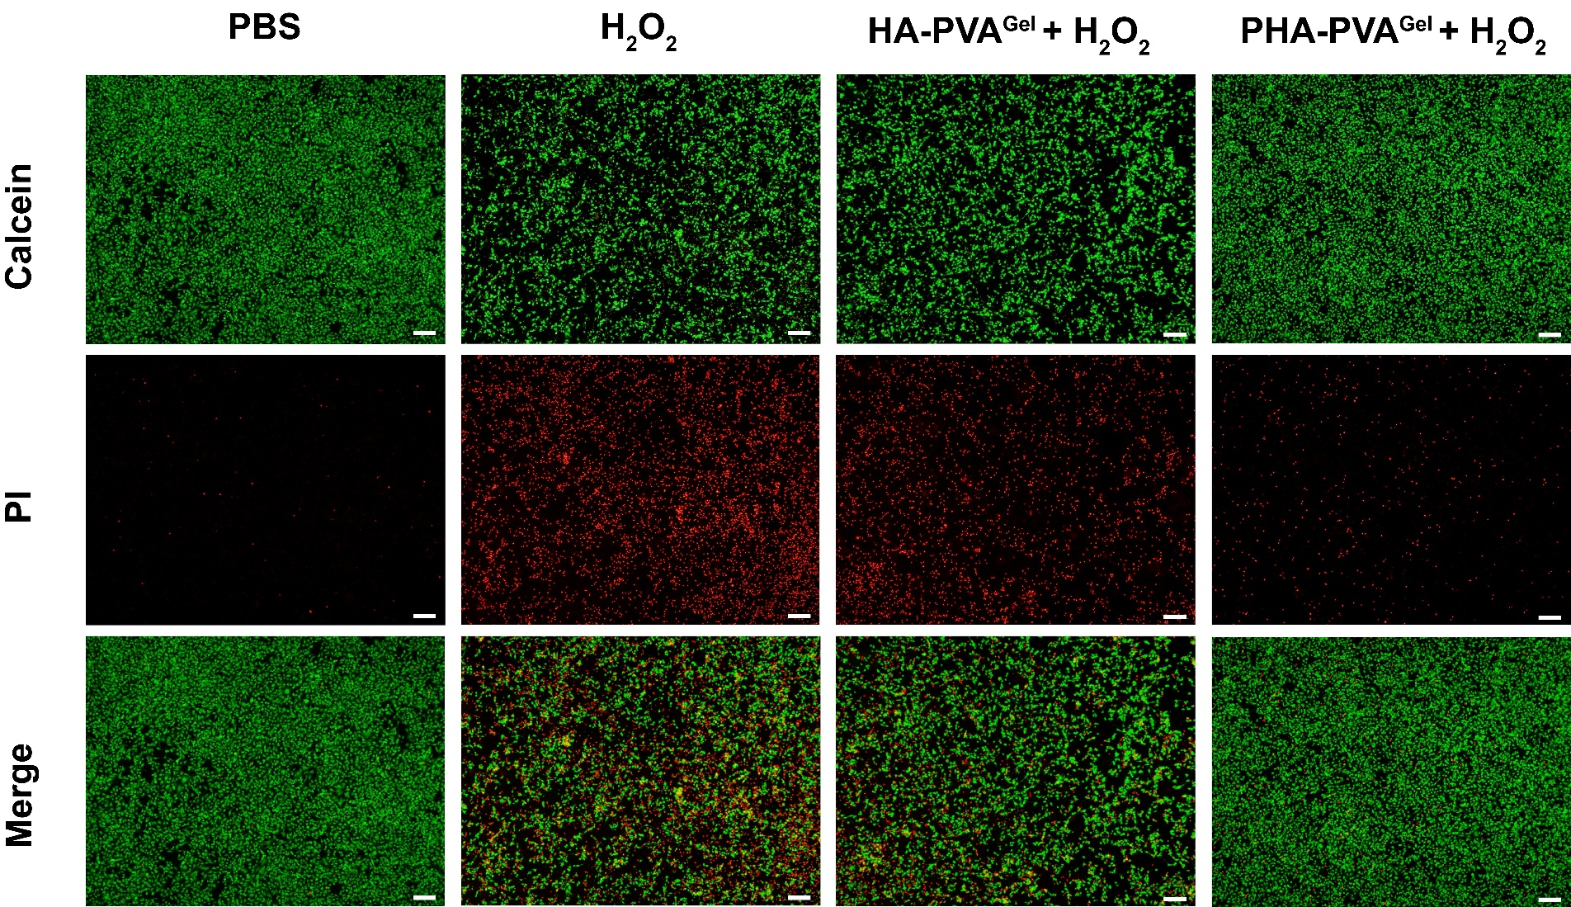
Fig. S26. Representative Live/Dead staining images of HUVEC (Green: live; Red: dead) following exposure to H₂O₂. The results demonstrate that PHA-PVA^{Gel} effectively prevents H₂O₂-induced cell death, exhibiting superior cytoprotective capability compared to the HA-PVA^{Gel} and H₂O₂-only groups (Scale bars = 200 μm).
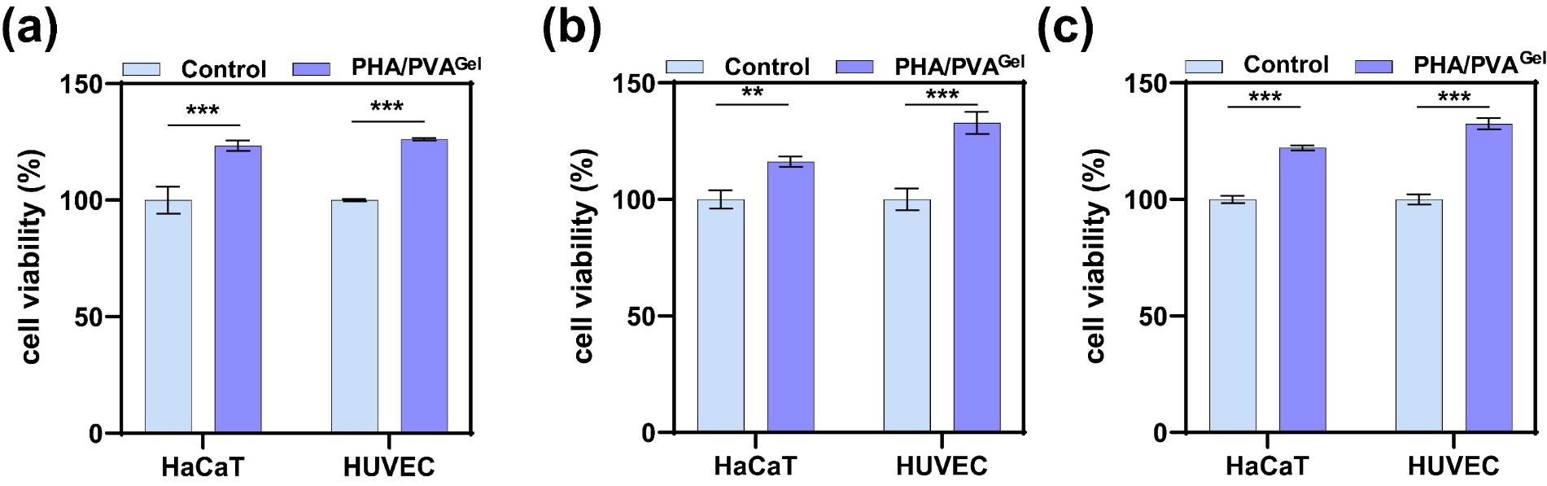
Fig. S27. The effect of PHA-PVA^{Gel} on the cell viability of HaCaT and HUVEC at (a) 24 h, (b) 48 h, and (c) 72 h (n = 3). **p < 0.01, ***p < 0.001.
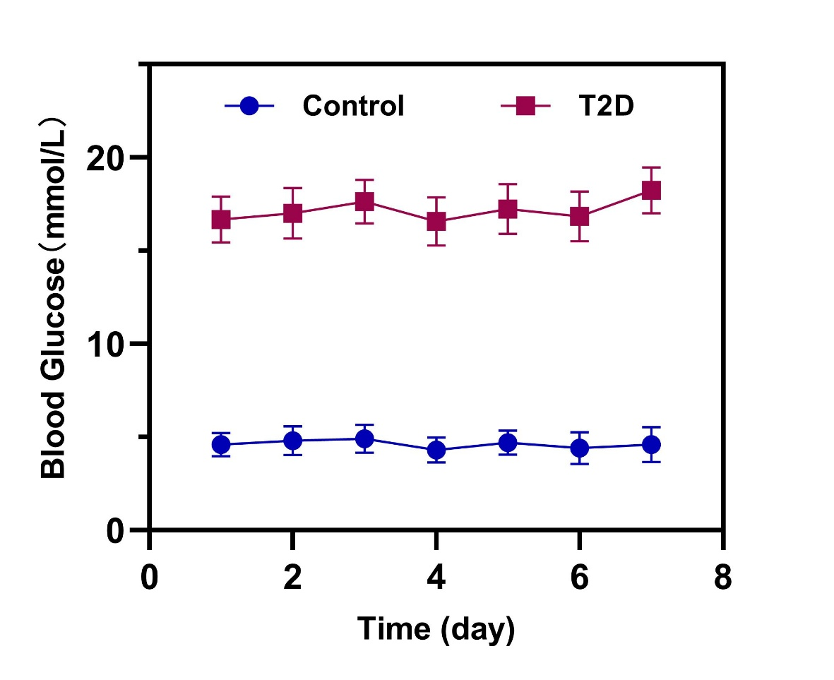
Fig. S28. Changes in blood glucose levels in mice.
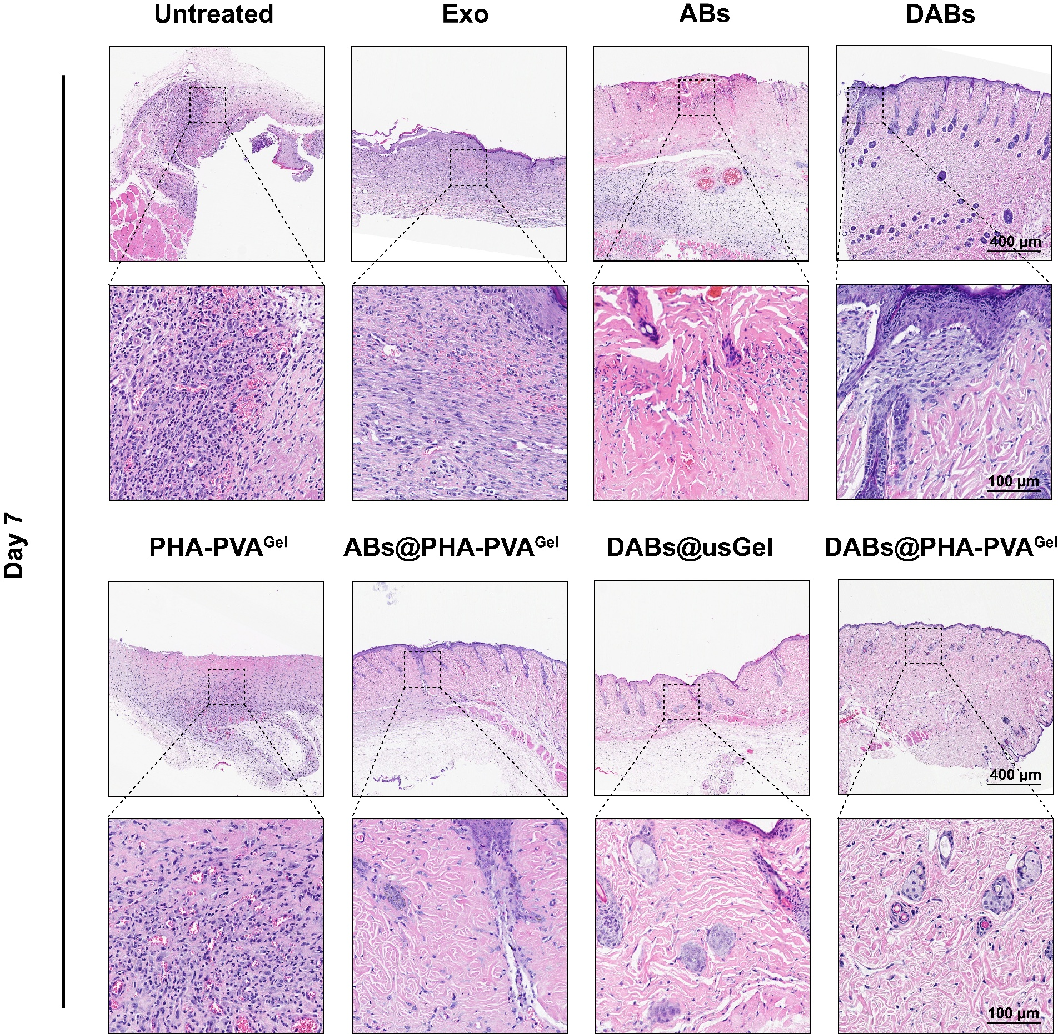
Fig. S29. Representative H&E staining images of the wound area at day 7 after the first treatment (Scale bar = 400 μm and 100 μm).
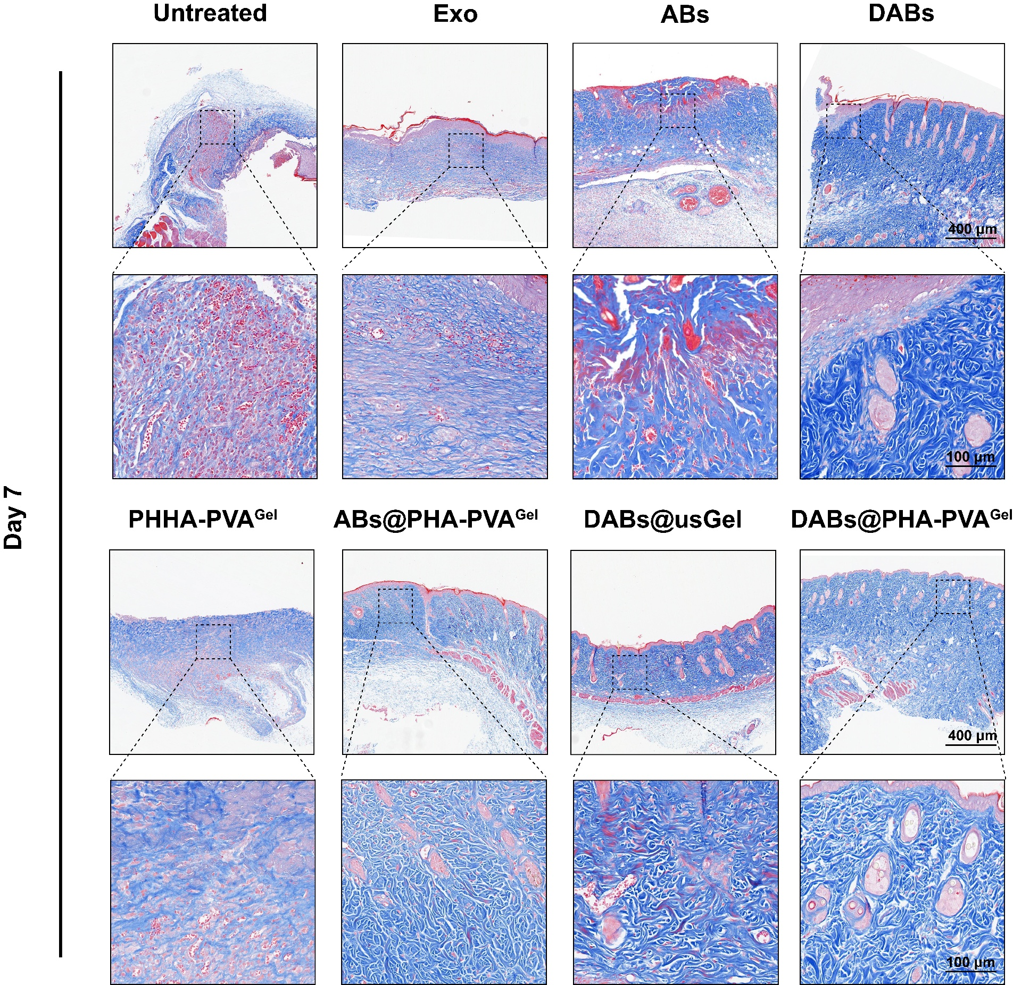
Fig. S30. Representative Masson staining images of the wound area at day 7 after the first treatment (Scale bar = 400 μm and 100 μm).
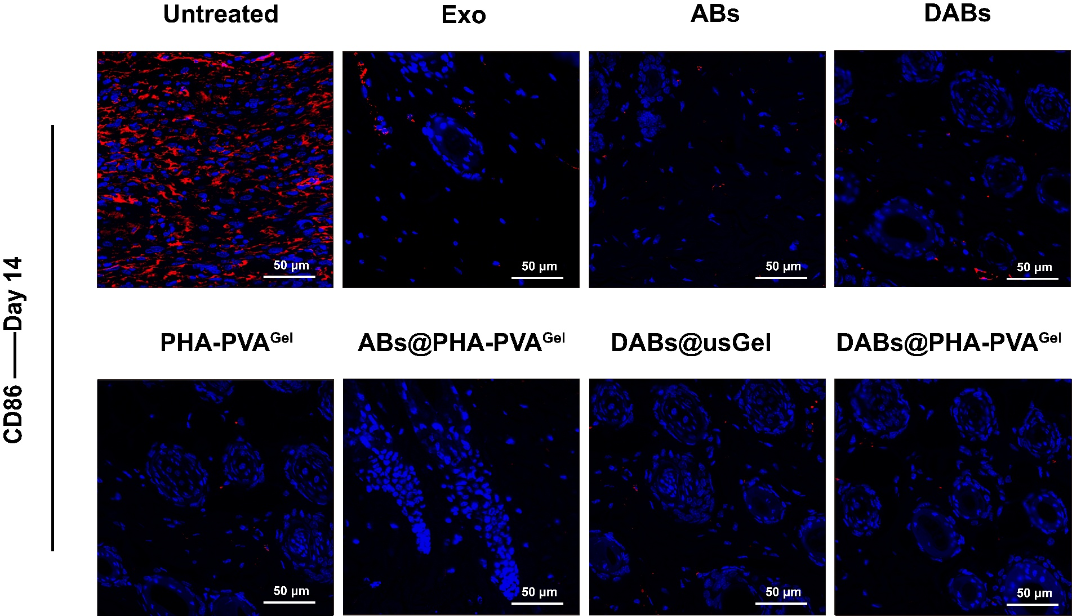
Fig. S31. Immunofluorescence staining of CD86 in wound areas on day 14 (Scale bar = 50 μm).

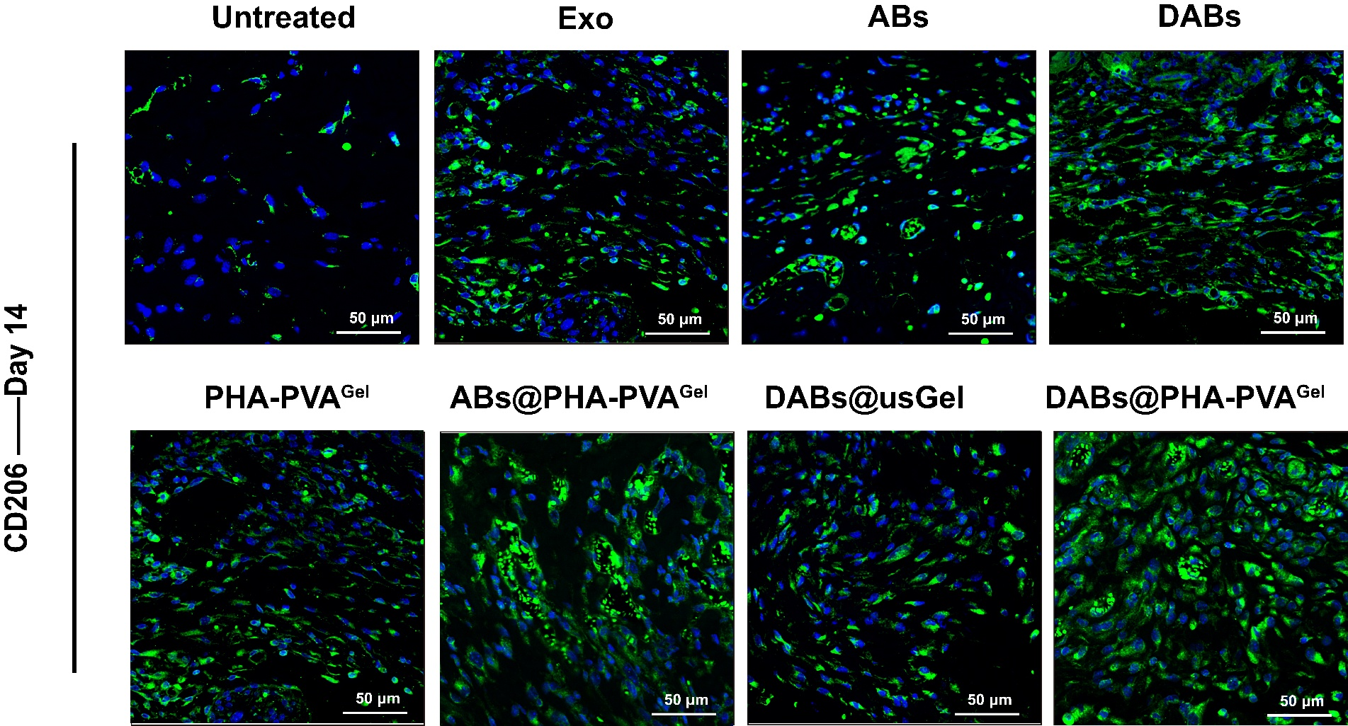
Fig. S32. Immunofluorescence staining of CD206 in wound areas on day 14 (Scale bar = 50 μm).
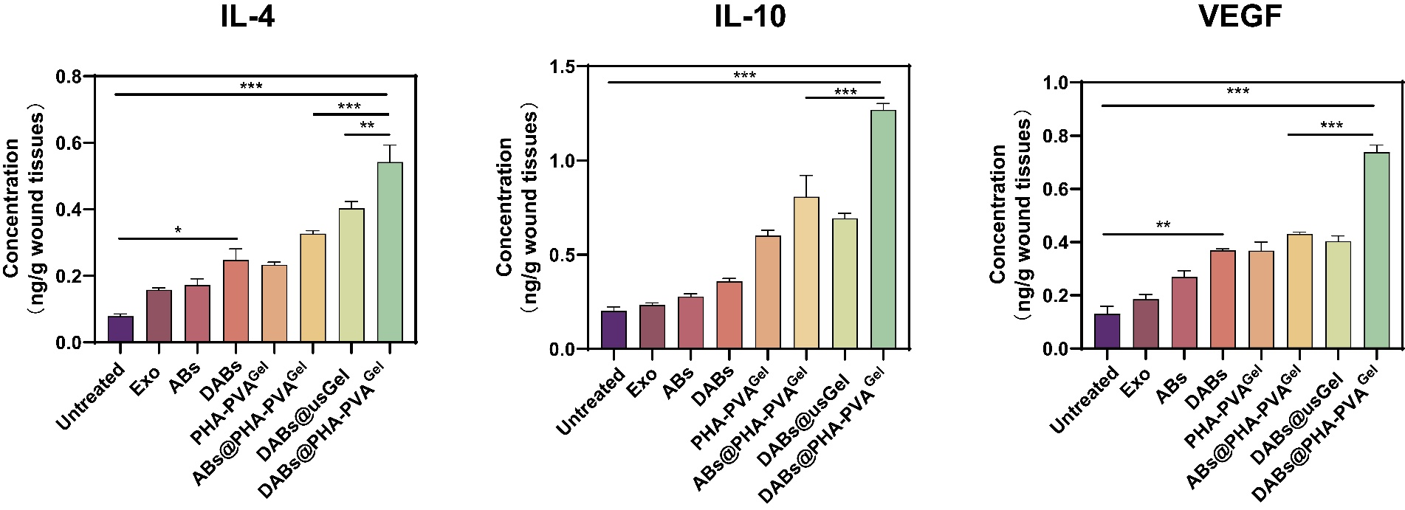
Fig. S33. ELISA detection of IL-4, IL-10, and VEGF in wound areas after being treated with various formulations (n=3). *p < 0.05, **p < 0.01, ***p < 0.001

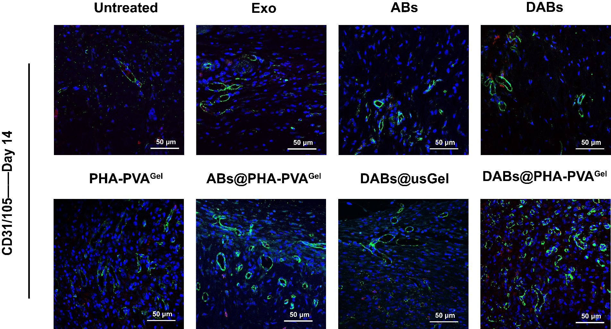
Fig. S34. Immunofluorescence staining of CD31 (Green)/CD105 (Red) in wound areas after being treated with various formulations on day 14 (Scale bar = 50 μm).
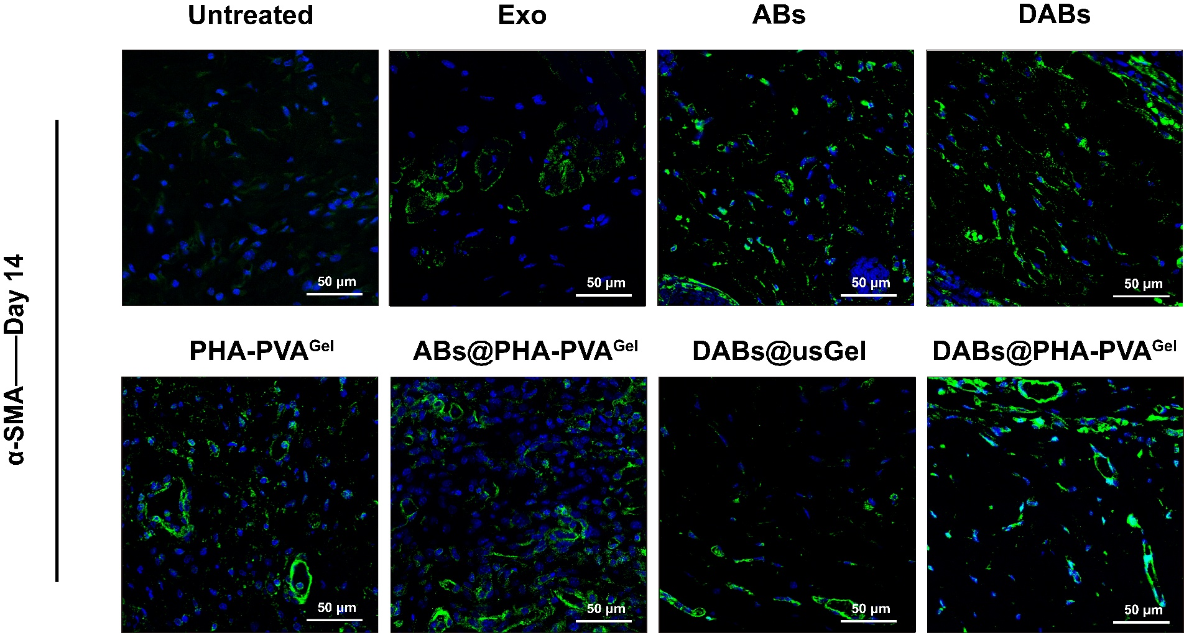
Fig. S35. Immunofluorescence staining of α-SMA in wound areas after being treated with various formulations on day 14 (Scale bar = 50 μm).

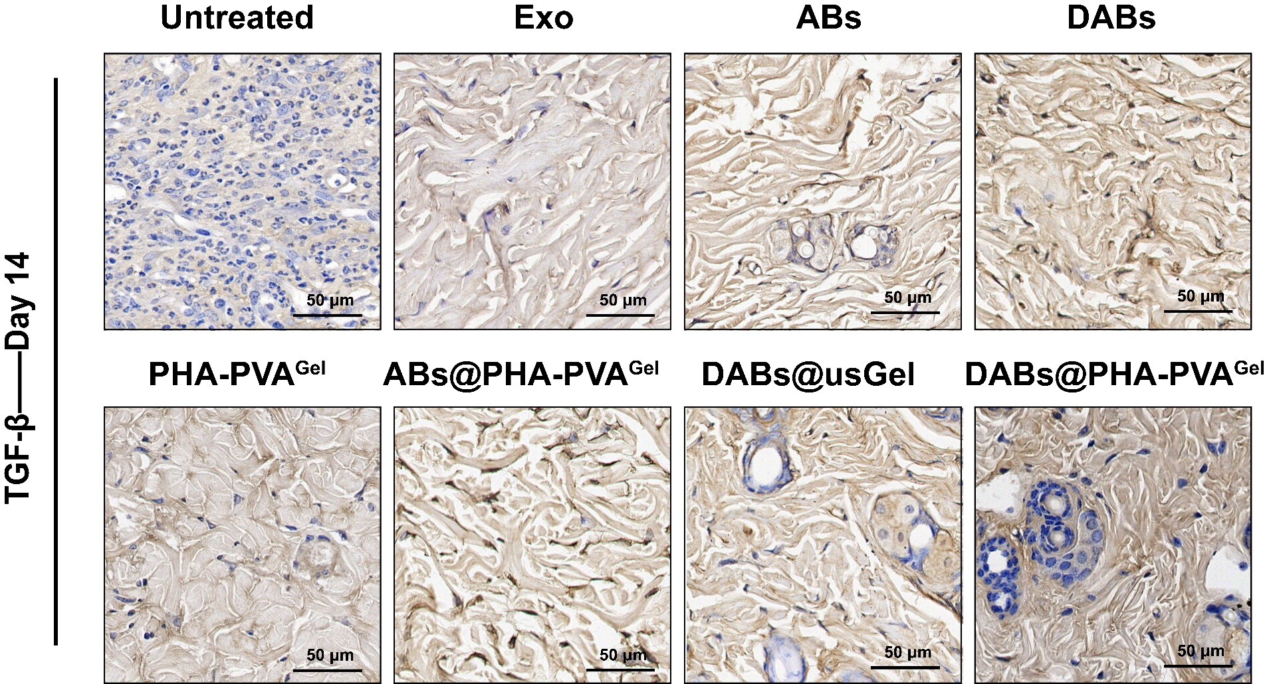
Fig. S36. Immunohistochemistry staining of TGF-β in wound areas after being treated with various formulations on day 14 (Scale bar = 50 μm).

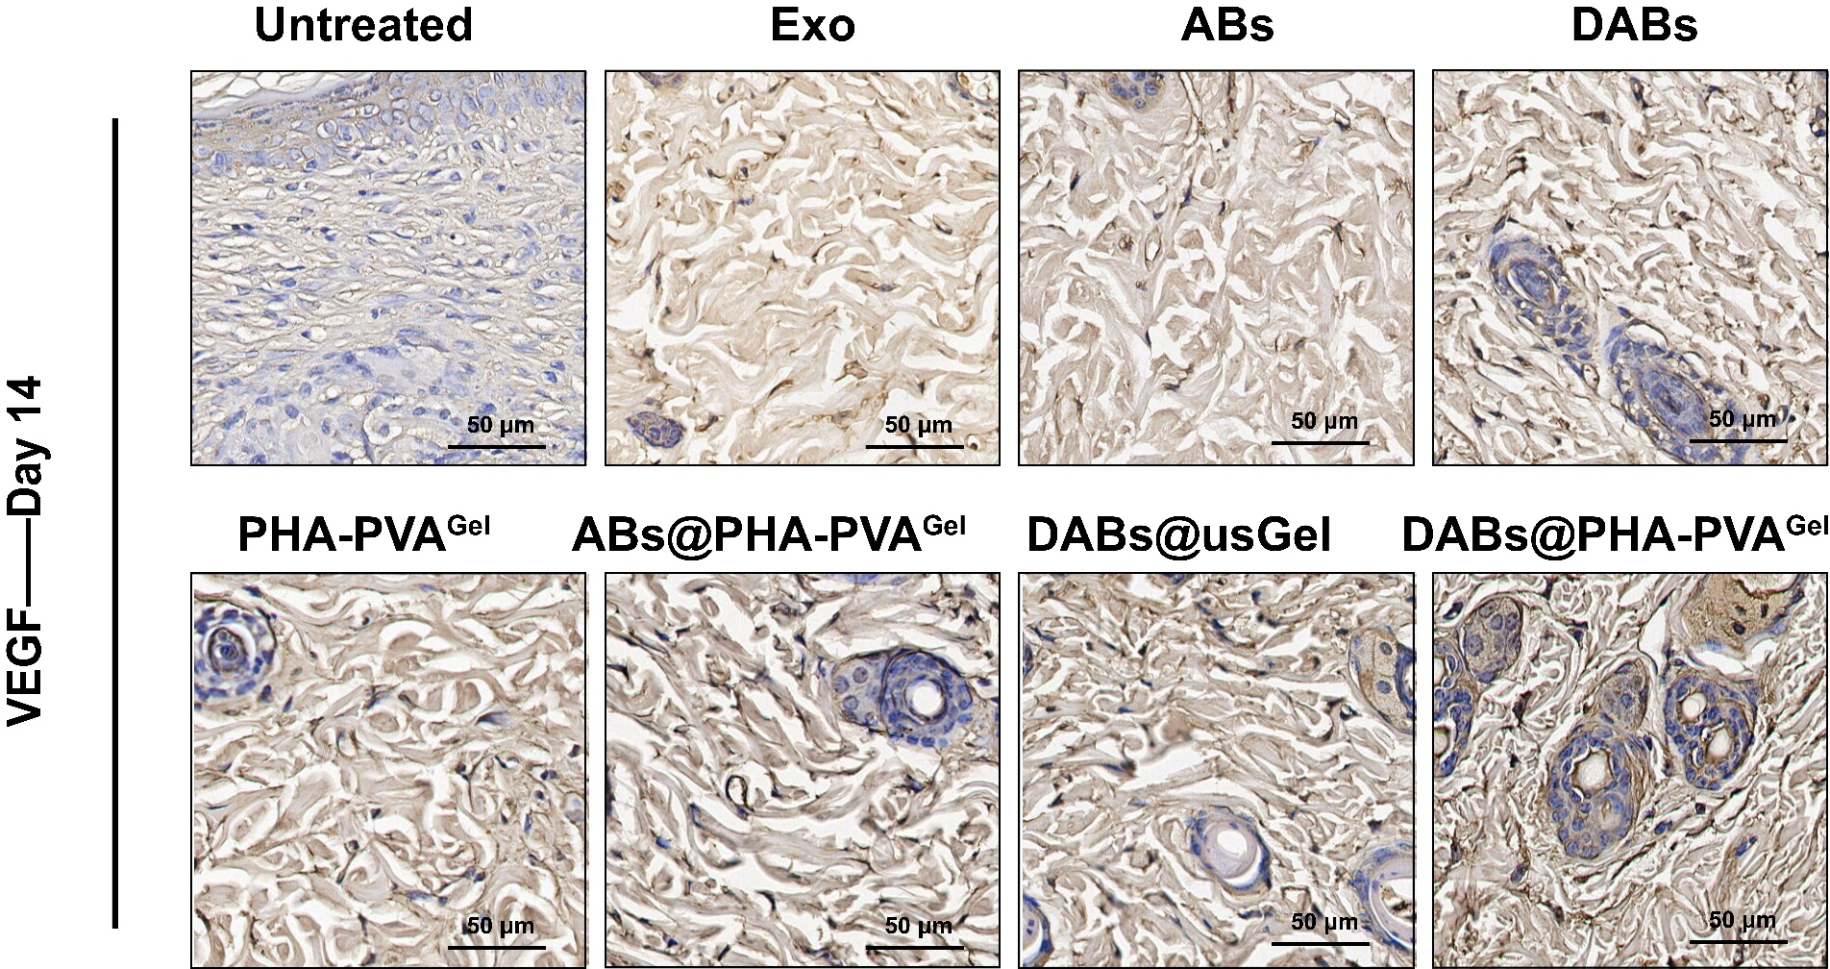
Fig. S37. Immunohistochemistry staining of VEGF in wound areas after being treated with various formulations on day 14 (Scale bar = 50 μm).

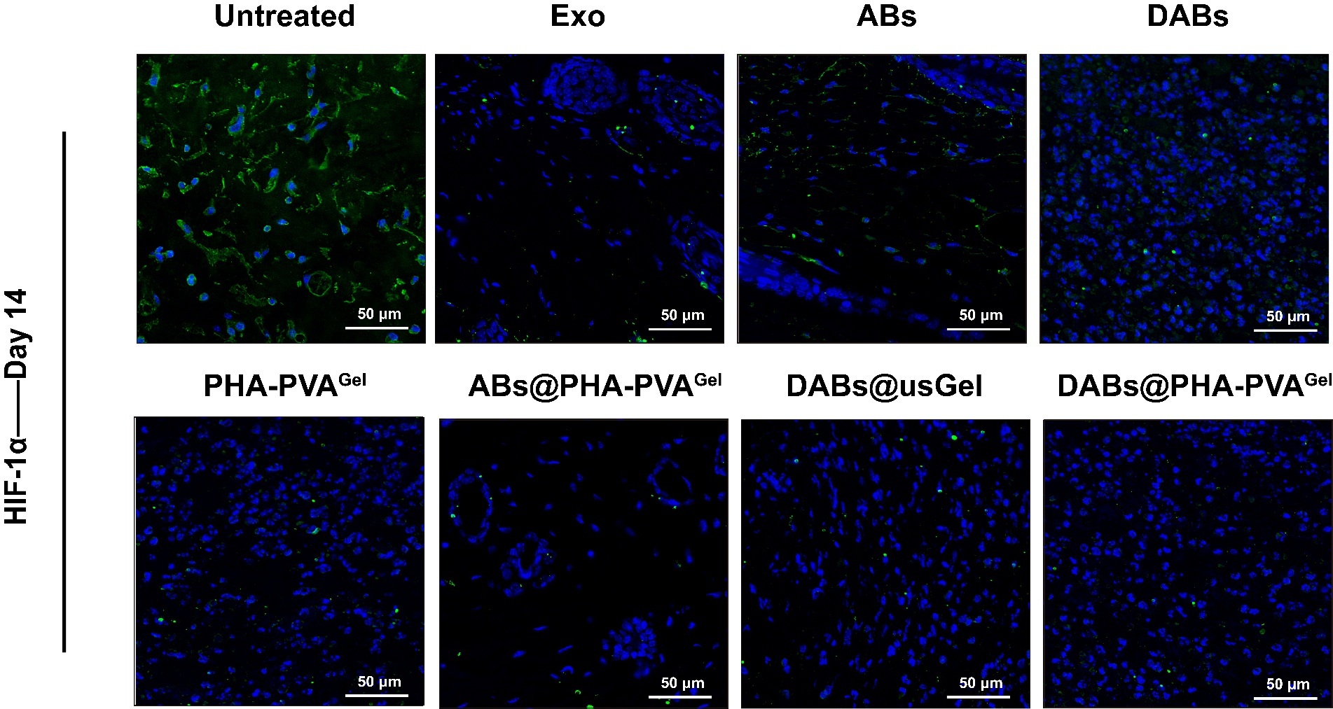
Fig. S38. Immunofluorescence staining of HIF-1α in wound areas after being treated with various formulations on day 14 (Scale bar = 50 μm).
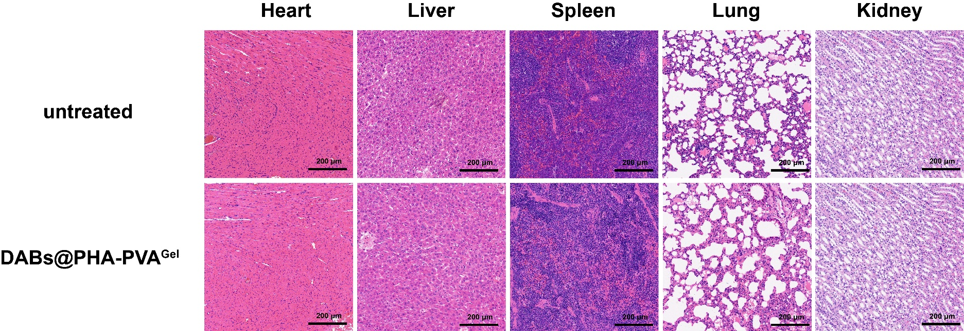
Fig. S39. H&E images of major organs (heart, liver, spleen, lung, and kidney) after being treated with untreated group and DABs@PHA-PVA^{Gel} group (Scale bar = 200 μm).

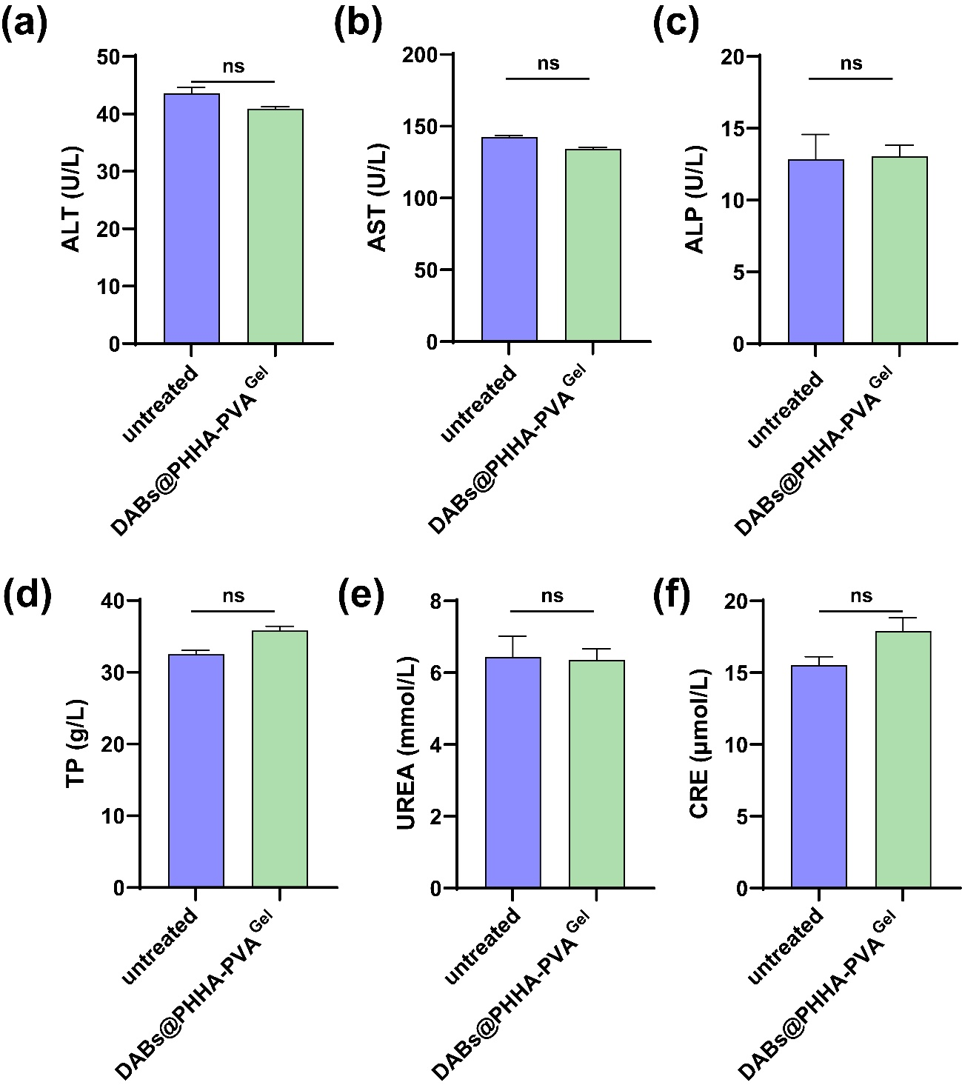
Fig. S40. Liver (A, B, C, and D) and kidney (E and F) functions of serum of mice in the saline group and DABs@PHA-PVA^{Gel} group (n=3).
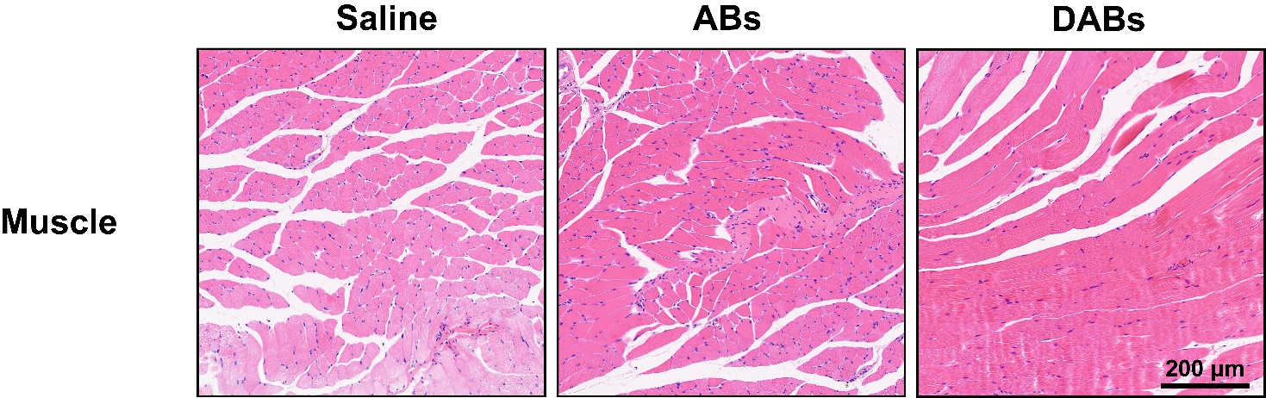
Fig. S41. H&E staining images of muscle after intramuscular injection of ABs and DABs for 7 days (Scale bar = 200 μm).
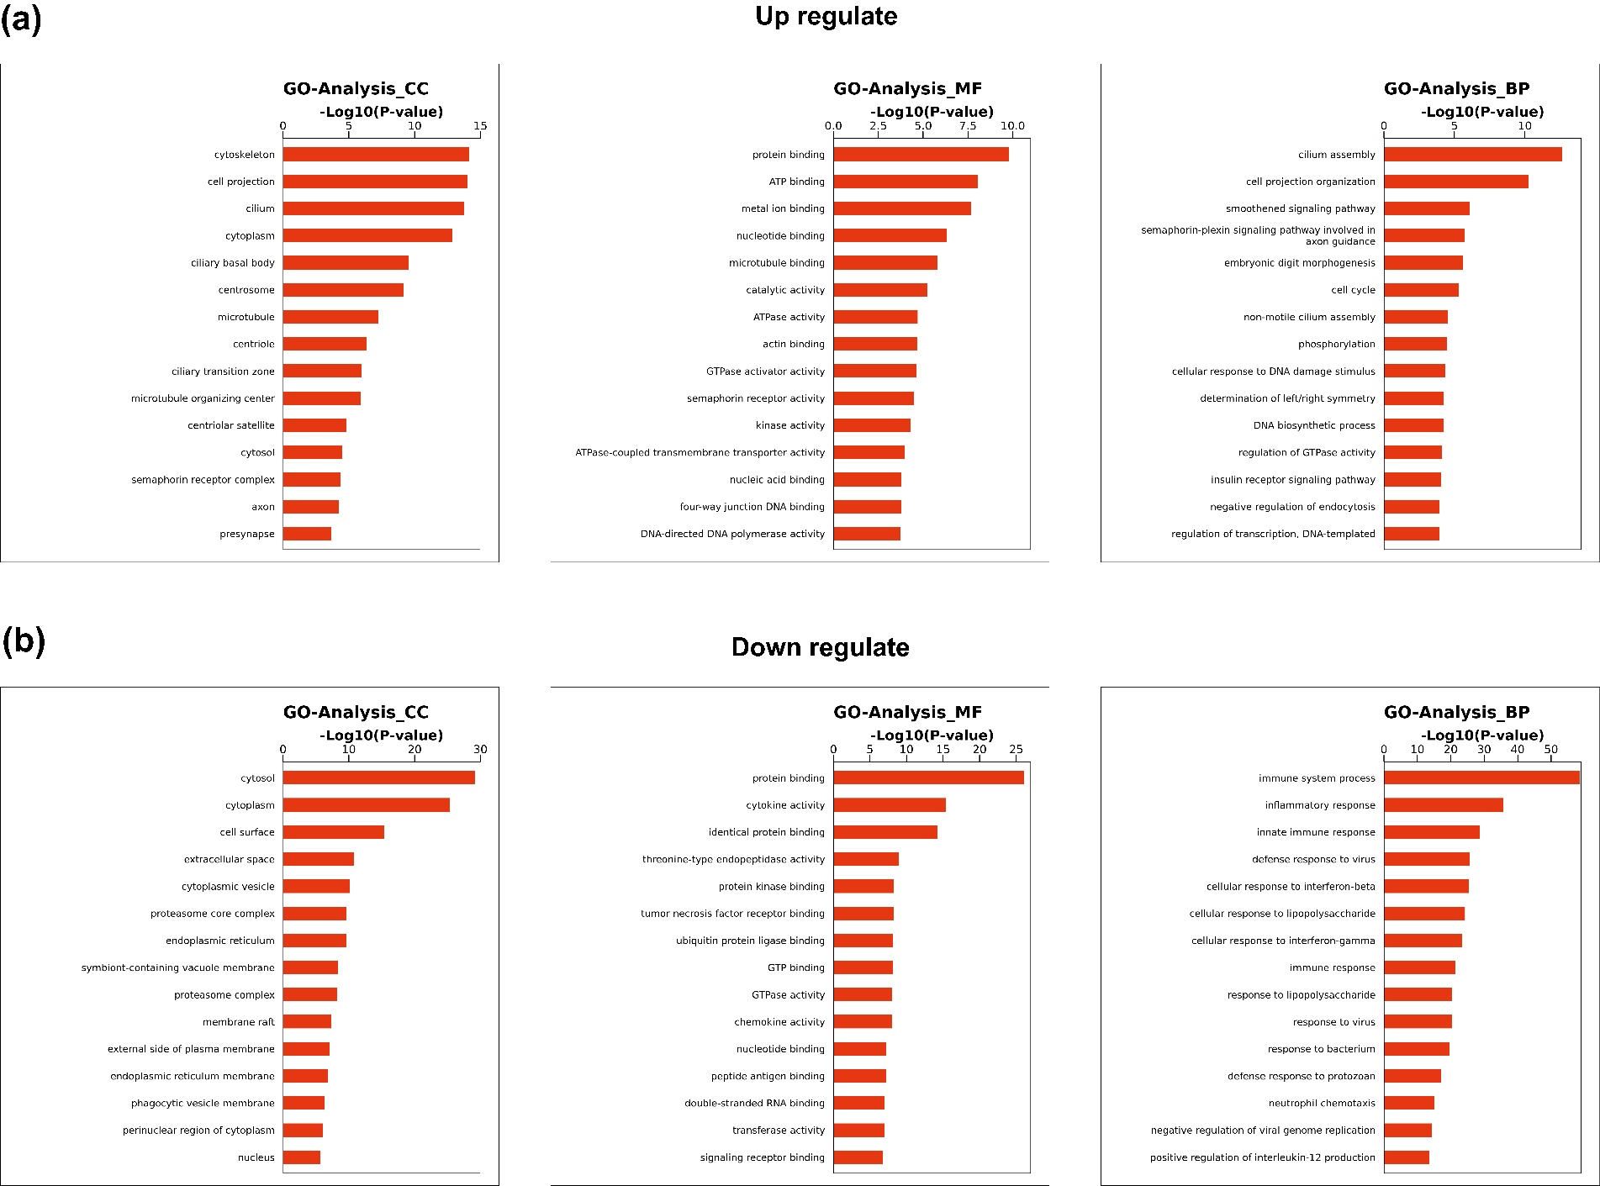
Fig. S42. GO enrichment map of differentially expressed genes between the untreated group and DABs@PHA-PVA^{Gel}.
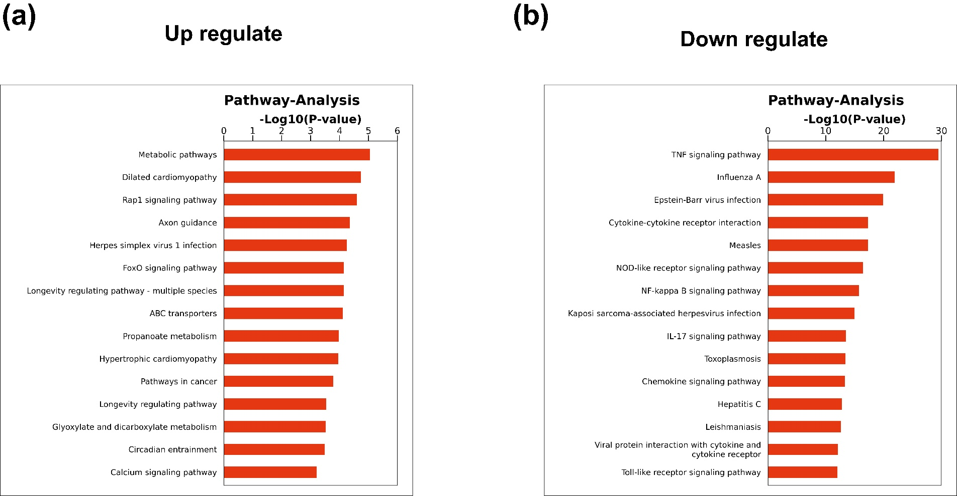
Fig. S43. KEGG enrichment analysis of differentially expressed genes between the untreated group and DABs@PHA-PVA^{Gel}.
Supporting Tables
Tab. S1 Sequencing data statistic.
Sample | Clean reads |  | Clean bases | GC content | ≥Q 30
Control-1 | 88931236 | 13288875885 |  | 50.13% | 93.69%
Control-2 | 90291982 | 13492981620 |  | 50.10% | 93.56%
Control-3 | 48247830 | 7208747182 |  | 49.94% | 93.63%
DABs@PHA-PVA^{Gel}-1 | 81645292 | 12208734520 |  | 50.35% | 93.49%
DABs@PHA-PVA^{Gel}-2 | 95290442 | 142394823 48 |  | 50.34% | 93.42%
DABs@PHA-PVA^{Gel}-3 | 75713030 | 11316612860 |  | 50.27% | 93.51%

Tab. S2 Statistics of sequence alignment results of the sample sequencing data and the selected reference genome.
Sample | Total Reads | Mapped reads rates | Unique mapped reads rates
Control-1 | 88764288 | 98.80% | 94.10%
Control-2 | 90143556 | 98.60% | 93.90%
Control-3 | 48164212 | 98.50% | 93.70%
DABs@PHA-PVA^{Gel}-1 | 81452778 | 98.80% | 94.40%
DABs@PHA-PVA^{Gel}-2 | 95065854 | 98.70% | 94.30%
DABs@PHA-PVA^{Gel}-3 | 75499548 | 98.80% | 94.60%

