Supplementary Table S1|. Representative optical ratiometric thermometry methods with emission bands lying within the NIR biological window.
Materials | T Range (K) | S_{r} (%/ K) | Mode ( nm) | Ref.
Sc₂(MoO₄)₃:Yb³⁺/Er³⁺ | 298-623 | 12.9 | Lifetime₁₅₃₈ | This work
LiLaP₄O₁₂:Yb³⁺/Cr³⁺ | 100-475 | 1.2 | FIR_{820/975} | 1
LiLaP₄O₁₂:Nd³⁺/Cr³⁺ | 293-323 | 4.89 | FIR_{810/1048} | 2
LaF₃:Tm³⁺ | 297-361 | 1.90 | FIR_{1470/1230} | 3
LuVO₄:Yb³⁺/Er³⁺@SiO₂ | 298-523 | 0.182 | FIR_{1469/1527} | 45
TTA-NaYF₄: Nd³⁺ | 283-323 | 7.1 | FIR_{540/1060} | 4
Al₄B₂O₉:Yb³⁺/Nd³⁺ | 298-333 | 2.6 | FIR_{800/920} | 5
LaF₃:Yb³⁺/Er³⁺@LaF₃:Yb³⁺/Tm³⁺ | 293-323 | 5 | FIR_{1000/1550} | 46
YVO₄:Yb³⁺/Tm³⁺ | 300-1009 | 2.13 | FIR_{940/800} | 6
YAlO₃:Nd³⁺ | 293-611 | 1.83 | FIR_{820/890} | 7
Na₂K(Lu₃Si₆O₁₈):Yb³⁺/Er³⁺ | 12-450 | 2.6 | FIR_{1125/1640} | 8

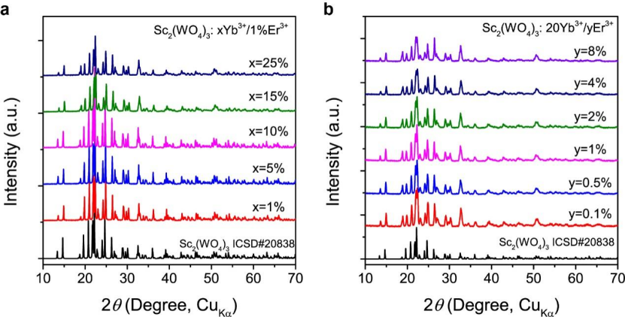
Supplementary Figure 1| Structural characterization. a. XRD patterns of Sc₂(MoO₄)₃:xYb/1%Er crystals with different Yb³⁺ doped concentrations at room temperature. b. XRD patterns of Sc₂(MoO₄)₃:20%Yb/yEr crystals with different Er³⁺ doped concentrations at room temperature.

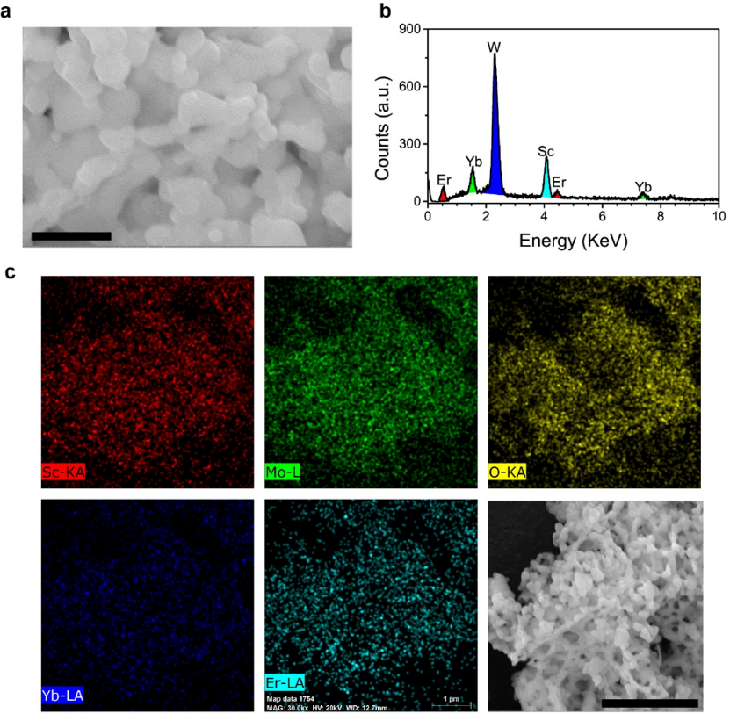
Supplementary Figure 2| Morphology and chemical compositions. a. Typical SEM images of the Sc₂(MoO₄)₃:20%Yb/1%Er phosphors. The scale bar is 1 μm. b. EDX data taken from a single particle. c. Elemental maps of Sc, Mo, O, Yb and Er in Sc₂(MoO₄)₃:20%Yb/1%Er particle. The scale bar is 5 μm.

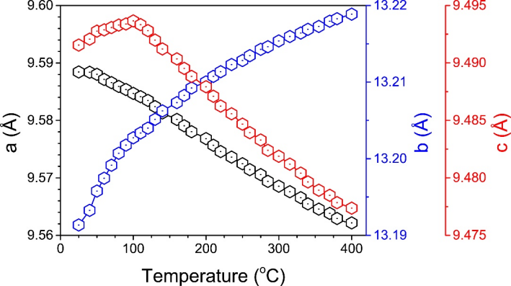
Supplementary Figure 3| Lattice changes with temperature. Temperature-dependent unit cell parameters a, b, and c of the Sc₂(MoO₄)₃:20%Yb/1%Er phosphors derived from in situ SXRD patterns.

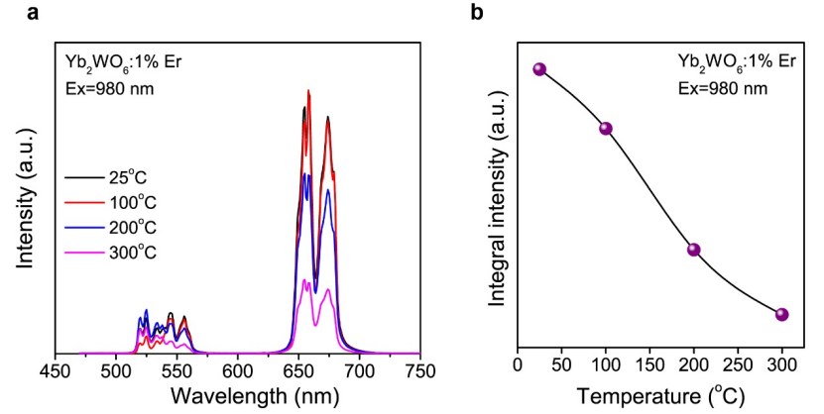
Supplementary Figure 4| Emission spectra in Yb₂WO₆:1%Er³⁺ phosphor. a. Upconversion emission spectra of the Yb₂WO₆:1%Er³⁺ crystals as a function of temperature under 980 nm excitation. b. Integral emission intensity of Yb₂WO₆: 1%Er³⁺ crystals as a function of temperature.

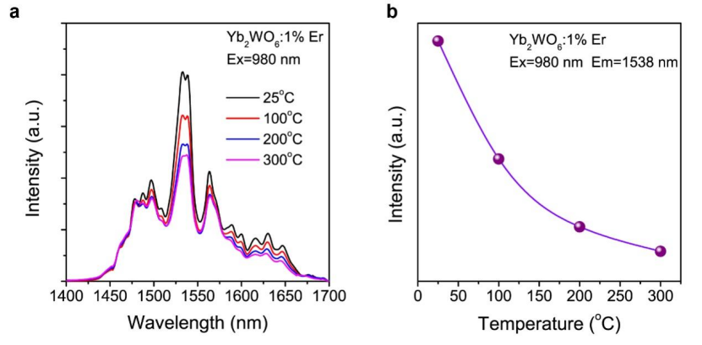
Supplementary Figure 5| Spectra in Yb₂WO₆:1%Er phosphor. a. Downshifting emission spectra of Yb₂WO₆:1%Er. b. Integral emission intensity of Yb₂WO₆:1%Er crystals as a function of temperature.

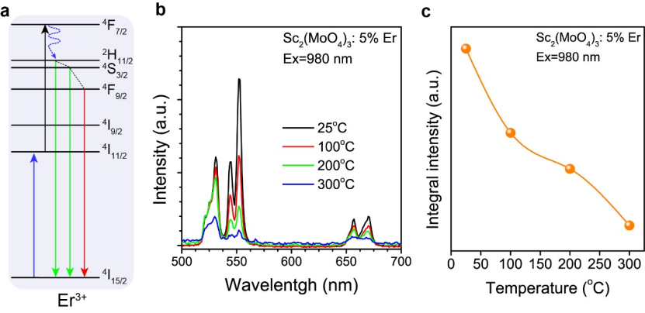
Supplementary Figure 6| Emission spectra in Sc₂(MoO₄)₃:5%Er³⁺ phosphor. a. Simplified energy level diagram showing upconversion process via excited-state absorption of Er³⁺. b. Upconversion emission spectra of the Sc₂(MoO₄)₃:5%Er³⁺ crystals as a function of temperature under 980 nm excitation. c. Integral emission intensity of Sc₂(MoO₄)₃:5%Er³⁺ crystals as a function of temperature.
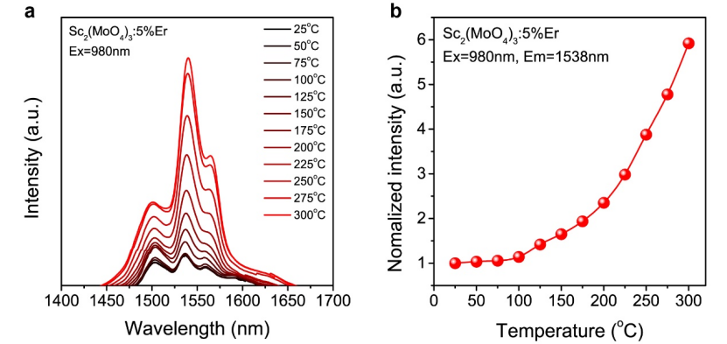
Supplementary Figure 7| Temperature-dependent spectra in Sc₂(MoO₄)₃:5%Er phosphor. a. Downshifting emission spectra of Sc₂(MoO₄)₃:5%Er under 980 nm excitation. b Normalized NIR emission intensities of Sc₂(MoO₄)₃:5%Er³⁺as a function of temperature.

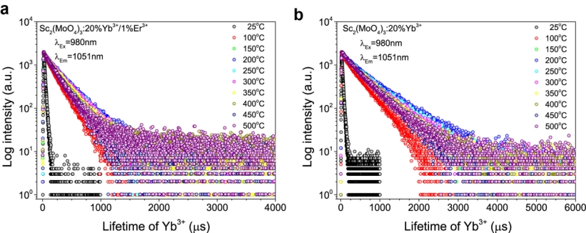

Supplementary Figure 8| Temperature-dependent luminescence decay curves of ²F_{5/2} excited state of Yb³⁺. a. and b. Temperature-dependent luminescence decay curves of ²F_{5/2} excited state of Yb³⁺ in Yb³⁺/Er³⁺-codoped and Yb³⁺-single doped SMO, respectively.

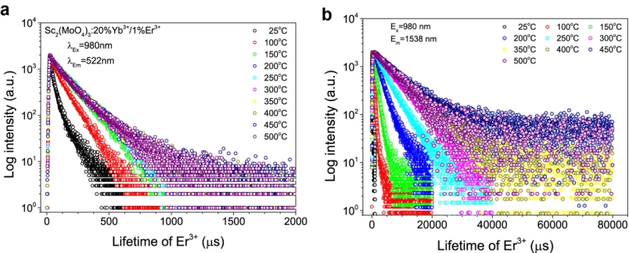

Supplementary Figure 9| Temperature-dependent luminescence decay curves of ²H_{11/2} and ⁴I_{11/2} excited states of Er³⁺. a. and b. Temperature-dependent luminescence decay curves of ²H_{11/2} and ⁴I_{11/2} excited states of Er³⁺ in Yb³⁺/Er³⁺-codoped SMO, respectively.

References
- Marciniak, L. et al. Nanocrystalline NIR-to-NIR luminescent thermometer based on Cr³⁺,Yb³⁺ emission, Sens. Actuators, B, 243, 388-393 (2017).
- Marciniak, L. et al. A new generation of highly sensitive luminescent thermometers operating in the optical window of biological tissues, J. Mater. Chem. C, 4, 5559-5563 (2016).
- Ximendes, E. C. et al. Thulium doped LaF₃ for nanothermometry operating over 1000 nm, Nanoscale, 11, 8864-8869 (2019).
- Xu, M. et al. Ratiometric nanothermometer in vivo based on triplet sensitized upconversion, Nat. Commun. 9, 2698 (2018).
- Silva, A. F. et al. Thermal sensitivity of frequency upconversion in Al₄B₂O₉:Yb³⁺/Nd³⁺ nanoparticles, J. Mater. Chem. C, 5, 1240-1246 (2017).
- Runowski, M. et al. Luminescent nanothermometer operating at very high yemperature-sensing up to 1000 K with upconverting nanoparticles (Yb³⁺/Tm³⁺), ACS Appl. Mater. Interf. 12, 43933-43941 (2020)
- Hernandez-Rodríguez, M. A. et al. Comparison of the sensitivity as optical temperature sensor of nano-perovskite doped with Nd³⁺ ions in the first and second biological windows. Sens. Actuators, B 255, 970-976 (2018).
- Ananias, D. et al. Near-infrared ratiometric Luminescent thermometer based on a new lanthanide silicate, Chem. Eur. J., 24, 11926-11935 (2018).

