Table S1. Intraoperative Blood Loss in matched cohorts stratified by variables
Characteristics | Manipulator-assisted group  (N = 70), mL | Manipulator-free group  (N = 70), mL | P value
Surgical complex level
I | 84.3 ± 63.2 | 42.8 ± 35.1 | 0.01
II | 93.0 ± 68.5 | 41.7 ± 24.3 | 0.02
III | 124.7 ± 95.5 | 91.9 ± 57.1 | 0.04
Benign/malignant status
Benign | 95.3 ± 80.2 | 43.7 ± 31.9 | 0.04
Malignancy | 103.8 ± 80.6 | 72.4 ± 53.1 | 0.01
Body mass index, kg/m²
<25 | 89.8 ± 90.3 | 56.4 ± 32.4 | 0.01
≥25 | 106.8 ± 68.9 | 64.4 ± 43.9 | 0.03
Uterine dimension, cm³
<200 | 96.7 ± 66.8 | 53.5 ± 44.6 | 0.01
≥200 | 101.2 ± 98.2 | 67.6 ± 56.1 | 0.02

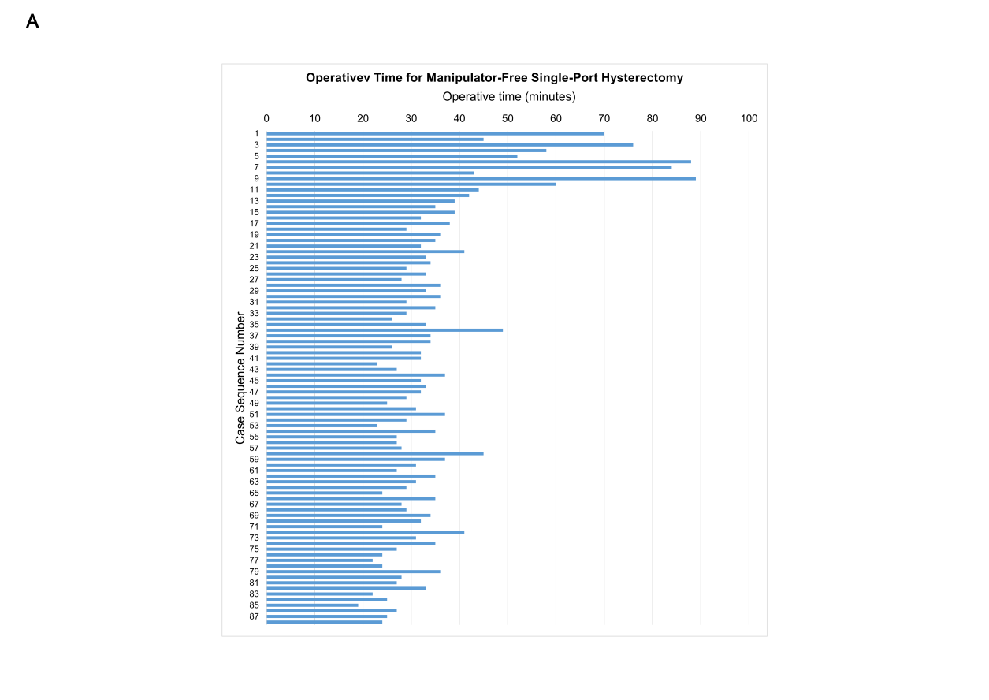
Figure S1A. Operative time for manipulator-free single-port laparoscopic hysterectomy.
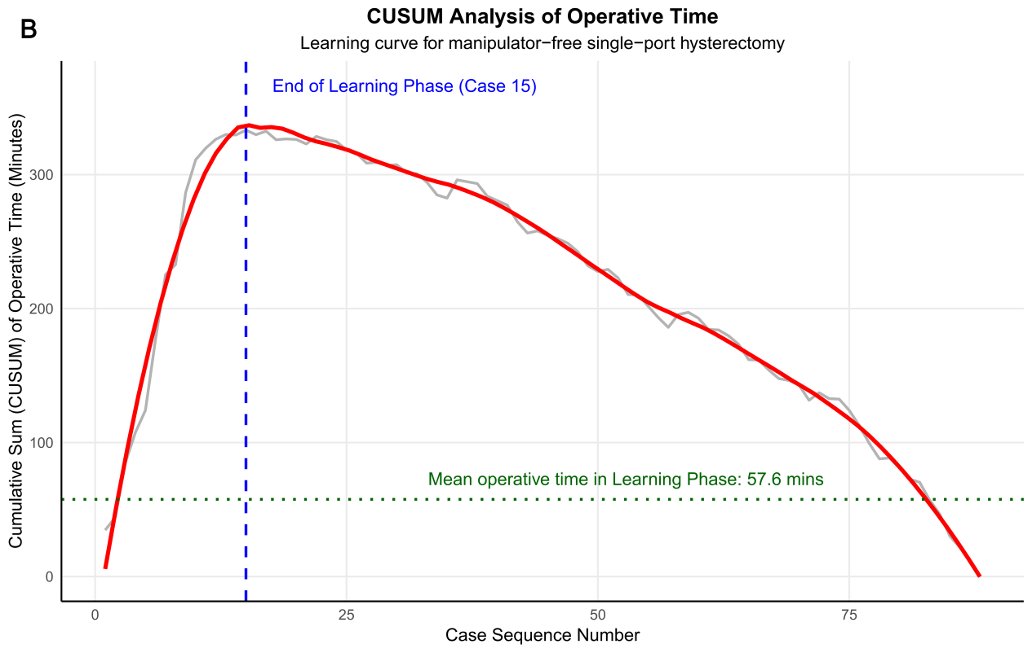
Figure S1B. CUSUM Analysis of Operative Time. The solid red line represents the trend derived from locally estimated scatterplot smoothing (LOESS; span=0.2), illustrating the underlying proficiency gain. The thin grey line depicts the raw CUSUM values, reflecting case-by-case variation around the mean operative time. The vertical dashed blue line indicates the inflection point (Case 15), estimated as the end of the learning phase.

