Table S1. Optimization of AgNO₃ concentration for the green synthesis of silver nanoparticles using Zingiberales leaf extracts at 60 °C. All reactions were performed with a fixed extract-to-AgNO₃ volume ratio of 1:9 (v/v) and heated for 2 h. Data represent mean ± SD of three independent experiments (n = 3).
Plant Species | AgNO₃ Conc. (mM) | Extract:  AgNO₃ (v/v) | Time to Color Change (min) | λmax (nm) | SPR Intensity (A.U.) | FWHM (nm) | Visual Aggregation at 2 h* | Colloidal Stability at 24 h**
A. calcarata | 0.1 | 1:9 | 18 ± 2 | 445 ± 3 | 0.85 ± 0.05 | 65 ± 5 | 0 | Stable
 | 0.25 | 1:9 | 14 ± 1 | 442 ± 2 | 1.05 ± 0.07 | 72 ± 4 | 0 | Stable
 | 0.5 | 1:9 | 10 ± 1 | 448 ± 4 | 1.20 ± 0.08 | 85 ± 6 | 1 | Partially stable
 | 1.0 | 1:9 | 7 ± 1 | 455 ± 5 | 1.45 ± 0.10 | 105 ± 7 | 2 | Unstable
 | 2.0 | 1:9 | 4 ± 1 | 462 ± 6 | 1.65 ± 0.12 | 145 ± 8 | 3 | Unstable
E. cardamomum | 0.1 | 1:9 | 20 ± 2 | 430 ± 3 | 0.80 ± 0.04 | 60 ± 4 | 0 | Stable
 | 0.25 | 1:9 | 15 ± 1 | 428 ± 2 | 1.00 ± 0.06 | 68 ± 5 | 0 | Stable
 | 0.5 | 1:9 | 11 ± 1 | 435 ± 4 | 1.15 ± 0.07 | 82 ± 6 | 1 | Partially stable
 | 1.0 | 1:9 | 8 ± 1 | 442 ± 5 | 1.40 ± 0.09 | 102 ± 7 | 2 | Unstable
 | 2.0 | 1:9 | 5 ± 1 | 450 ± 6 | 1.60 ± 0.11 | 140 ± 8 | 3 | Unstable
H. psittacorum | 0.1 | 1:9 | 16 ± 2 | 420 ± 3 | 0.90 ± 0.05 | 55 ± 4 | 0 | Stable
 | 0.25 | 1:9 | 12 ± 1 | 418 ± 2 | 1.10 ± 0.06 | 62 ± 5 | 0 | Stable
 | 0.5 | 1:9 | 9 ± 1 | 425 ± 4 | 1.25 ± 0.08 | 78 ± 6 | 1 | Partially stable
 | 1.0 | 1:9 | 6 ± 1 | 432 ± 5 | 1.50 ± 0.10 | 98 ± 7 | 2 | Unstable
 | 2.0 | 1:9 | 3 ± 1 | 440 ± 6 | 1.70 ± 0.12 | 135 ± 8 | 3 | Unstable
*Visual aggregation at 2 h was scored as: 0 = none (clear solution), 1 = slight turbidity, 2 = moderate turbidity, 3 = visible precipitate. **Colloidal stability at 24 h at room temperature: Stable = no visible precipitate; Partially stable = slight sediment; Unstable = heavy precipitation.
Table S2. XRD-derived crystallite size of biogenic AgNPs calculated using the Scherrer equation from the (111) reflection at ~38.1°.
AgNP formulation | 2θ (°) | FWHM (°) | Crystallite size (nm)
A. calcarata–AgNPs | 38.10 | 0.21 ± 0.02 | 41 ± 3
E. cardamomum–AgNPs | 38.10 | 0.25 ± 0.02 | 34 ± 3
H. psittacorum–AgNPs | 38.10 | 0.43 ± 0.03 | 20 ± 2
Note: Crystallite size (D) was calculated using the Debye-Scherrer equation: D = (K·λ) / (β·cos θ) , where K = 0.9 (shape factor for spherical particles), λ = 1.5406 Å (Cu Kα radiation), β is the full width at half maximum (FWHM) corrected for instrumental broadening, and θ is the Bragg angle. The (111) reflection was selected for analysis as it represents the most intense and well-resolved peak in the diffractograms (Fig. 3). The smallest crystallite size observed for H. psittacorum–AgNPs correlates with the enhanced steric hindrance imposed by its alkaloid-rich phytochemical corona, as identified via LC–MS/MS (Table 2).

Experimental Parameters and Raw Data for Silver Release Study

Fixed Experimental Parameters
The following parameters were kept constant throughout the release experiments:
- V₀ (Total volume of receptor medium): 100 mL
- Vᵢ (Sampling volume per interval): 2 mL
- M_{total} (Total initial silver content in dialysis bag): 500 µg
These values were selected based on commonly reported conditions in nanoparticle release studies to ensure reproducibility and comparability.

Raw Concentration Data (Cₙ) and Corresponding Cumulative Release (Rₙ)

Release Profile at pH 7.4 (Physiological Condition)
Target release: ~17% at 8 h and ~48% at 72 h
Table S3. Raw concentration values (Cₙ) and cumulative Ag⁺ release percentages (Rₙ) from H. psittacorum-AgNPs at pH 7.4 (physiological condition) determined by the dialysis bag method over 72 h. Data represent mean ± SD of three independent experiments (n = 3).
Time (h) | Cₙ (µg/mL) | Cumulative Release Rₙ (%)
0 | 0.00 ± 0.00 | 0.0 ± 0.0
1 | 0.30 ± 0.03 | 6.0 ± 0.6
2 | 0.49 ± 0.04 | 9.9 ± 0.8
4 | 0.68 ± 0.05 | 13.9 ± 1.0
8 | 0.82 ± 0.06 | 16.9 ± 1.2
12 | 1.05 ± 0.08 | 21.8 ± 1.6
24 | 1.43 ± 0.10 | 29.8 ± 2.1
48 | 1.85 ± 0.12 | 39.0 ± 2.5
72 | 2.27 ± 0.15 | 47.8 ± 3.2
Note: The cumulative release percentage (Rₙ) was calculated using the equation: Rₙ = (V0⋅Cn+Vi⋅ΣCi)/Mtotal(V0​⋅Cn​+Vi​⋅ΣCi​)/Mt​otal × 100, where V₀ = 100 mL (release medium volume), Vᵢ = 2 mL (sampling volume), and M_total = 500 µg (initial silver mass quantified by ICP-OES). The subdued burst release (16.9% within 8 h) and limited cumulative release (47.8% after 72 h) confirm the integrity of the phytochemical corona under physiological conditions.
Table S4. Raw concentration values (Cₙ) and cumulative Ag⁺ release percentages (Rₙ) from H. psittacorum-AgNPs at pH 5.5 (tumor-mimetic condition) determined by the dialysis bag method over 72 h. Data represent mean ± SD of three independent experiments (n = 3).
Time (h) | Cₙ (µg/mL) | Cumulative Release Rₙ (%)
0 | 0.00 ± 0.00 | 0.0 ± 0.0
1 | 0.75 ± 0.06 | 15.0 ± 1.2
2 | 1.19 ± 0.09 | 24.0 ± 1.8
4 | 1.56 ± 0.11 | 32.0 ± 2.3
8 | 1.93 ± 0.13 | 40.0 ± 2.7
12 | 2.49 ± 0.16 | 52.0 ± 3.3
24 | 3.09 ± 0.19 | 65.0 ± 4.0
48 | 3.53 ± 0.21 | 75.0 ± 4.5
72 | 3.76 ± 0.23 | 81.0 ± 4.9
Note: Cumulative release percentages (Rₙ) were calculated using the equation: Rₙ = (V0⋅Cn+Vi⋅ΣCi)/Mtotal(V0​⋅Cn​+Vi​⋅ΣCi​)/Mt​otal × 100, where V₀ = 100 mL, Vᵢ = 2 mL, and M_{total} = 500 µg. The pronounced burst release (40.0% within 8 h) and substantially higher cumulative release (81.0% after 72 h) compared to physiological pH (Table S3) confirm the pH-responsive, stimuli-sensitive dissolution of the alkaloid-rich phytochemical corona under acidic tumor-mimetic conditions. A gradual plateau in release was noted after 48 h, consistent with depletion of surface-accessible silver ions.
Table S5. Preliminary antimicrobial activity of biogenically synthesized silver nanoparticles determined by the agar well diffusion method. Data represent zone of inhibition (ZOI) in mm (mean ± SD, n = 3 independent experiments).
Bacteria | Plant Source | 10 µg/mL | 20 µg/mL | 40 µg/mL | 80 µg/mL | 100 µg/mL
MRSA | A. calcarata | 4.0 ± 0.3 | 4.5 ± 0.4 | 5.0 ± 0.2 | 5.2 ± 0.3 | 5.5 ± 0.4
 | E. cardamomum | 3.0 ± 0.2 | 3.5 ± 0.3 | 4.0 ± 0.2 | 4.5 ± 0.3 | 5.0 ± 0.3
 | H. psittacorum | 4.5 ± 0.4 | 5.0 ± 0.3 | 5.5 ± 0.3 | 6.0 ± 0.2 | 6.5 ± 0.3
K. pneumoniae | A. calcarata | 3.0 ± 0.3 | 3.5 ± 0.4 | 4.0 ± 0.3 | 4.5 ± 0.2 | 5.0 ± 0.3
 | E. cardamomum | 4.0 ± 0.2 | 4.5 ± 0.3 | 5.0 ± 0.2 | 5.2 ± 0.3 | 5.5 ± 0.4
 | H. psittacorum | 5.0 ± 0.3 | 5.5 ± 0.3 | 6.0 ± 0.2 | 6.5 ± 0.2 | 7.0 ± 0.2
E. coli | A. calcarata | 5.0 ± 0.4 | 5.3 ± 0.3 | 5.5 ± 0.3 | 6.0 ± 0.3 | 6.2 ± 0.4
 | E. cardamomum | 2.0 ± 0.3 | 2.5 ± 0.3 | 3.0 ± 0.2 | 3.5 ± 0.3 | 4.0 ± 0.3
 | H. psittacorum | 3.5 ± 0.3 | 4.0 ± 0.3 | 4.5 ± 0.2 | 5.0 ± 0.2 | 5.5 ± 0.2
P. aeruginosa | A. calcarata | 2.0 ± 0.2 | 2.5 ± 0.3 | 3.0 ± 0.2 | 3.5 ± 0.3 | 4.0 ± 0.3
 | E. cardamomum | 0.0 ± 0.0 | 1.0 ± 0.1 | 2.0 ± 0.2 | 2.5 ± 0.3 | 3.0 ± 0.3
 | H. psittacorum | 3.0 ± 0.3 | 3.5 ± 0.2 | 4.0 ± 0.2 | 4.5 ± 0.2 | 5.0 ± 0.3
Gentamicin (Positive Control) | – | 22.0 ± 1.0 | – | – | – | –
Sterile H₂O (Negative Control) | – | 0.0 ± 0.0 | – | – | – | –
Note: Zones of inhibition were measured after 24 h incubation at 37 °C and include the diameter of the well (6 mm). Values in bold indicate the largest inhibition zone for each bacterial strain at the given concentration. H. psittacorum-AgNPs consistently exhibited the largest inhibition zones across the majority of tested conditions, corroborating their superior antibacterial potency as quantified by MIC/MBC assays (Table 5). The apparent discrepancy between ZOI and MIC values for E. coli (where A. calcarata shows larger zones despite higher MIC) is attributable to differences in nanoparticle diffusion kinetics in solid agar versus liquid broth; smaller, more mobile nanoparticles (e.g., H. psittacorum) diffuse more rapidly, resulting in a lower local concentration gradient at the well periphery. Negative controls (sterile distilled water) produced no inhibition, confirming assay validity.
Table S6. Evaluation of potential interference of H. psittacorum-derived AgNPs with the MTT assay using cell-free controls.
Concentration (µg/mL) | Absorbance at 570 nm (Mean ± SD, n=3) | Interference Relative to Blank
0 (blank) | 0.05 ± 0.01 | 1.00×
10 | 0.06 ± 0.02 | 1.20×
20 | 0.07 ± 0.01 | 1.40×
30 | 0.08 ± 0.02 | 1.60×
50 | 0.10 ± 0.02 | 2.00×
100 | 0.13 ± 0.03 | 2.60×
150 | 0.16 ± 0.04 | 3.20×
200 | 0.18 ± 0.04 | 3.60×
Note: H. psittacorum-AgNPs (0–200 µg/mL) were incubated in complete culture medium (DMEM + 10% FBS) for 48 h in the absence of cells, followed by addition of MTT (20 µL of 5 mg/mL solution) and further incubation for 4 h. Formazan was dissolved in DMSO and absorbance was measured at 570 nm. Values represent mean ± SD of three independent experiments (n = 3). An absorbance threshold of OD = 0.10 (indicated by the red dashed line in Fig. S5) was defined as the limit of acceptable interference, corresponding to a 2-fold increase over background. At the IC₅₀ concentration of H. psittacorum-AgNPs (32.8 µg/mL; Table 3), the measured interference (OD ≈ 0.08) remains below this threshold, and any residual contribution was mathematically subtracted during IC₅₀ calculation using the formula: Corrected Viability (%) = [(A_treated cells − A_AgNPs only) / (A_untreated cells − A_blank)] × 100. This rigorous correction confirms the reliability of the reported IC₅₀ values and ensures that the observed cytotoxicity reflects genuine biological activity rather than nanoparticle-dye optical interference.

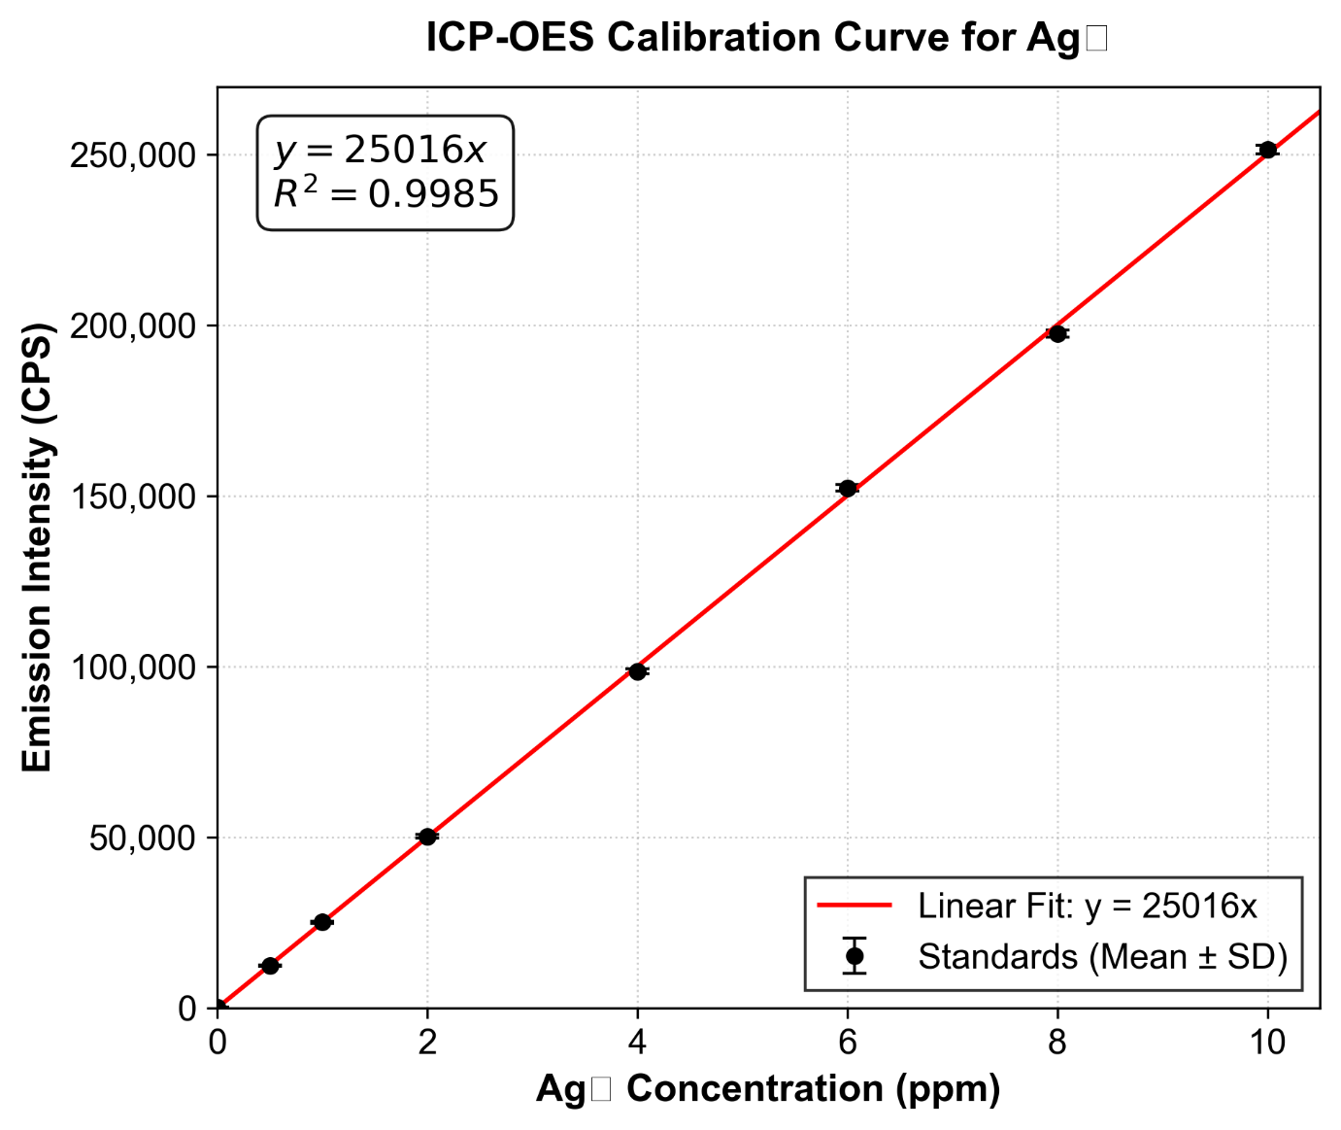
Fig. S1. External calibration curve for the quantitative determination of Ag⁺ ion concentrations via ICP-OES analysis. The linear regression model (y=25016x), forced through the origin, demonstrated a highly significant correlation between standard concentrations and emission intensities (R²=0.9985). Data points represent the mean ± standard deviation (SD) of triplicate instrument readings. This validated calibration was directly applied to convert the raw emission intensities of the dialysis samples into the precise cumulative Ag⁺ release percentages presented in Fig. 7.
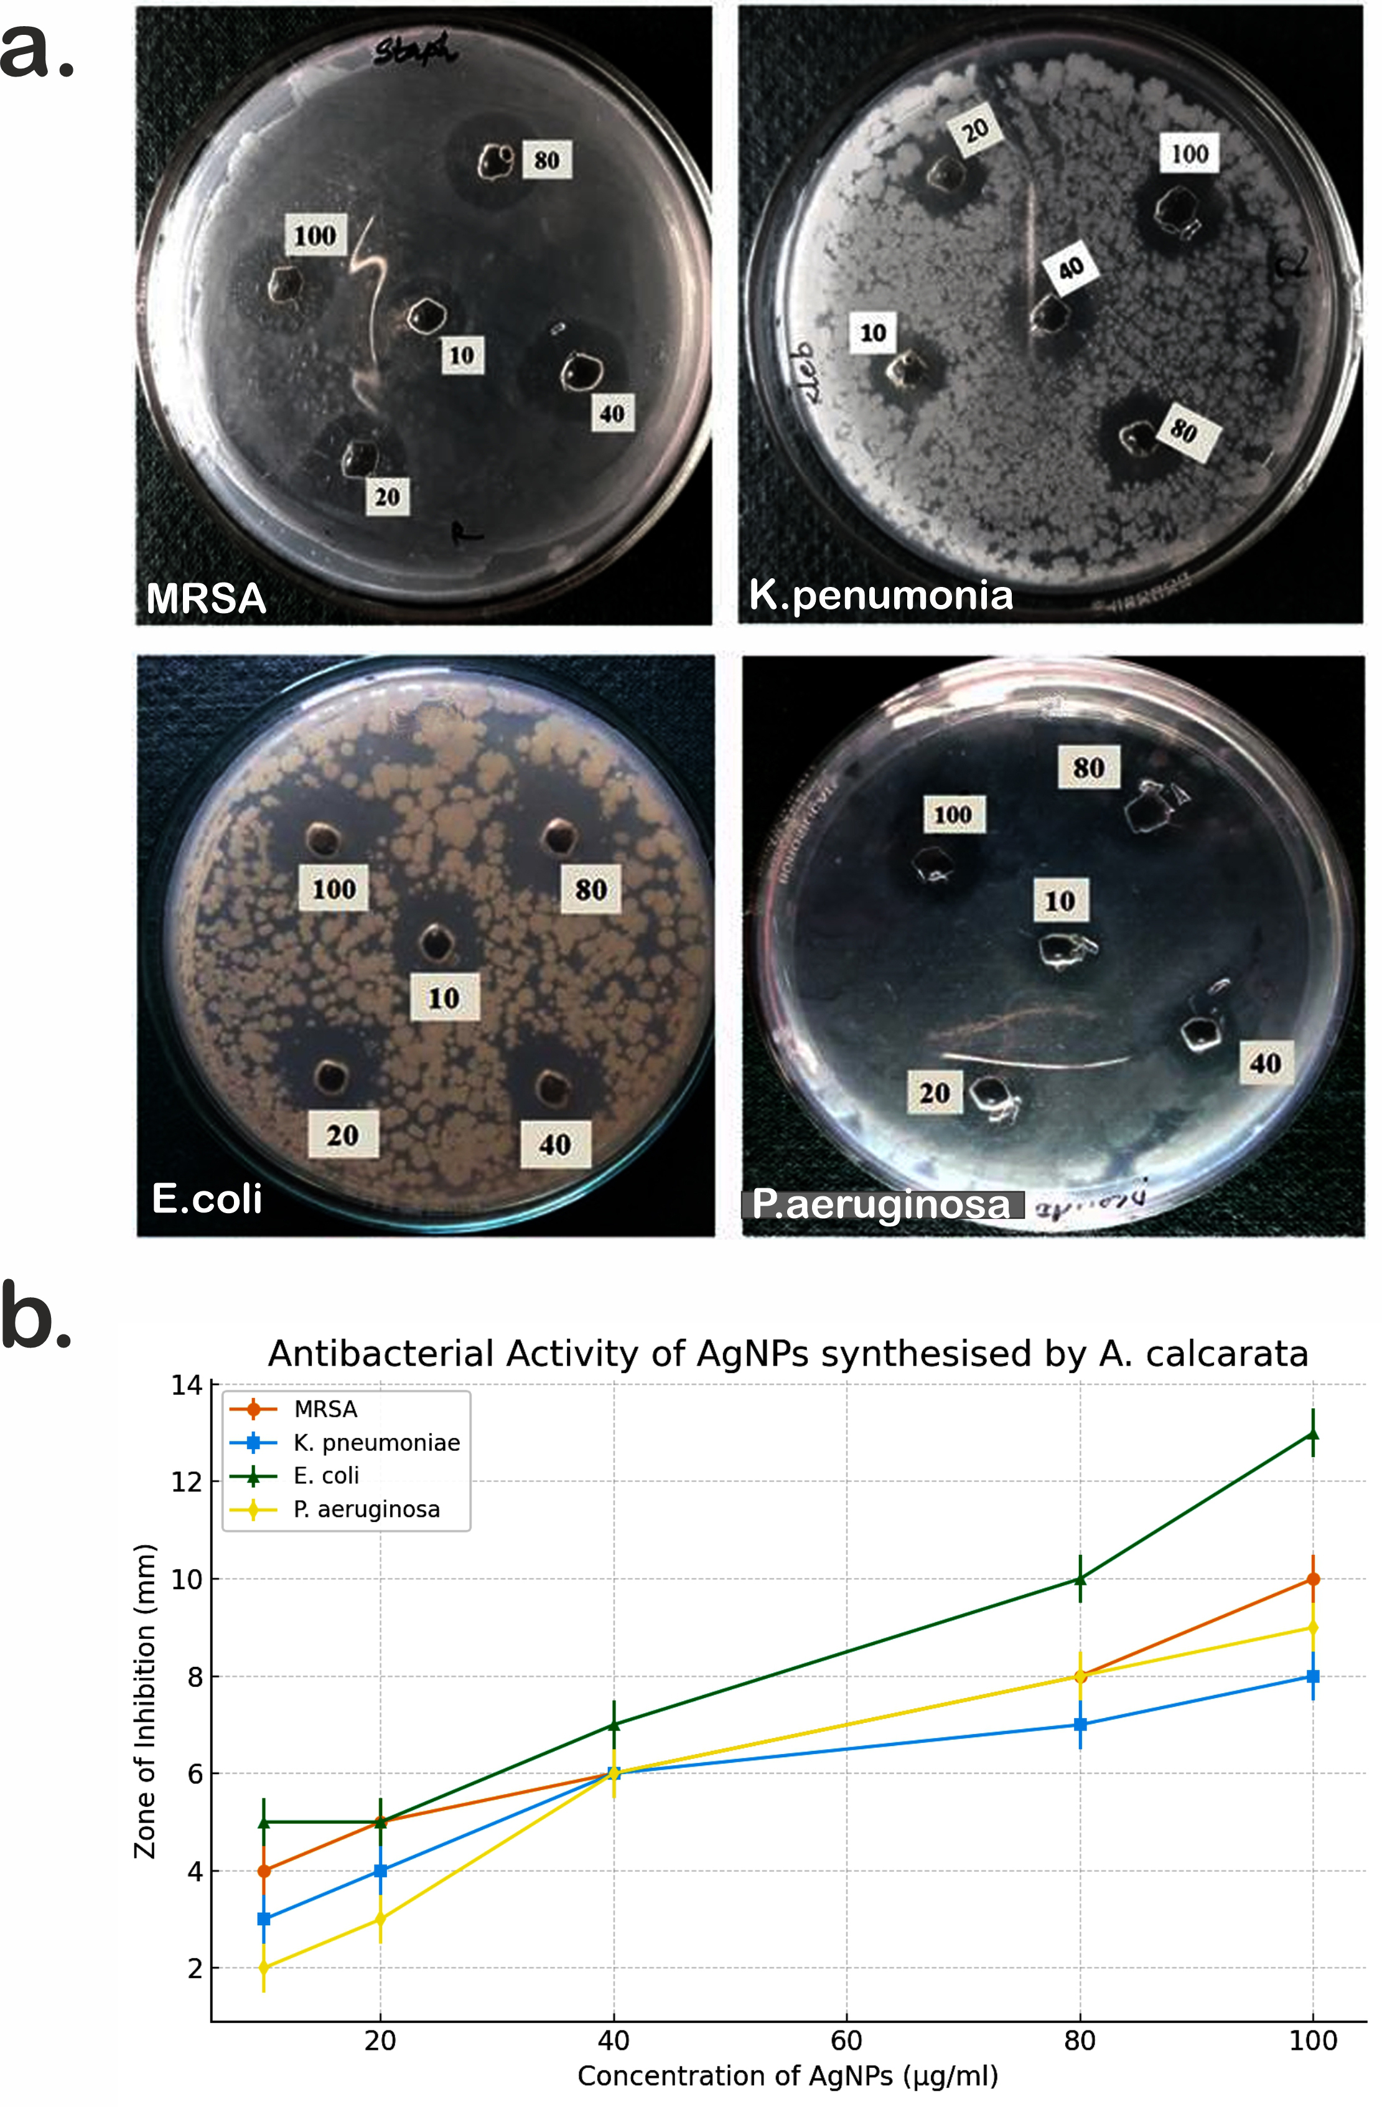
Figure S2. Preliminary antimicrobial activity assessment of biogenic silver nanoparticles synthesized using Alpinia calcarata leaf extract. (a) Representative agar-well diffusion images showing concentration-dependent zones of inhibition (ZOI) against methicillin-resistant Staphylococcus aureus (MRSA), Klebsiella pneumoniae, Escherichia coli, and Pseudomonas aeruginosa following 24 h incubation at 37 °C with A. calcarata-AgNPs at concentrations of 10–100 µg mL⁻¹. (b) Quantitative representation of the antibacterial activity, plotted as mean ZOI (mm) ± SD (n = 3 independent experiments) versus AgNP concentration (µg mL⁻¹). ZOI values include the well diameter (6 mm). The corresponding numerical data are provided in Table S5. The observed dose-dependent inhibition qualitatively corroborates the MIC/MBC findings presented in Table 5 of the main text.
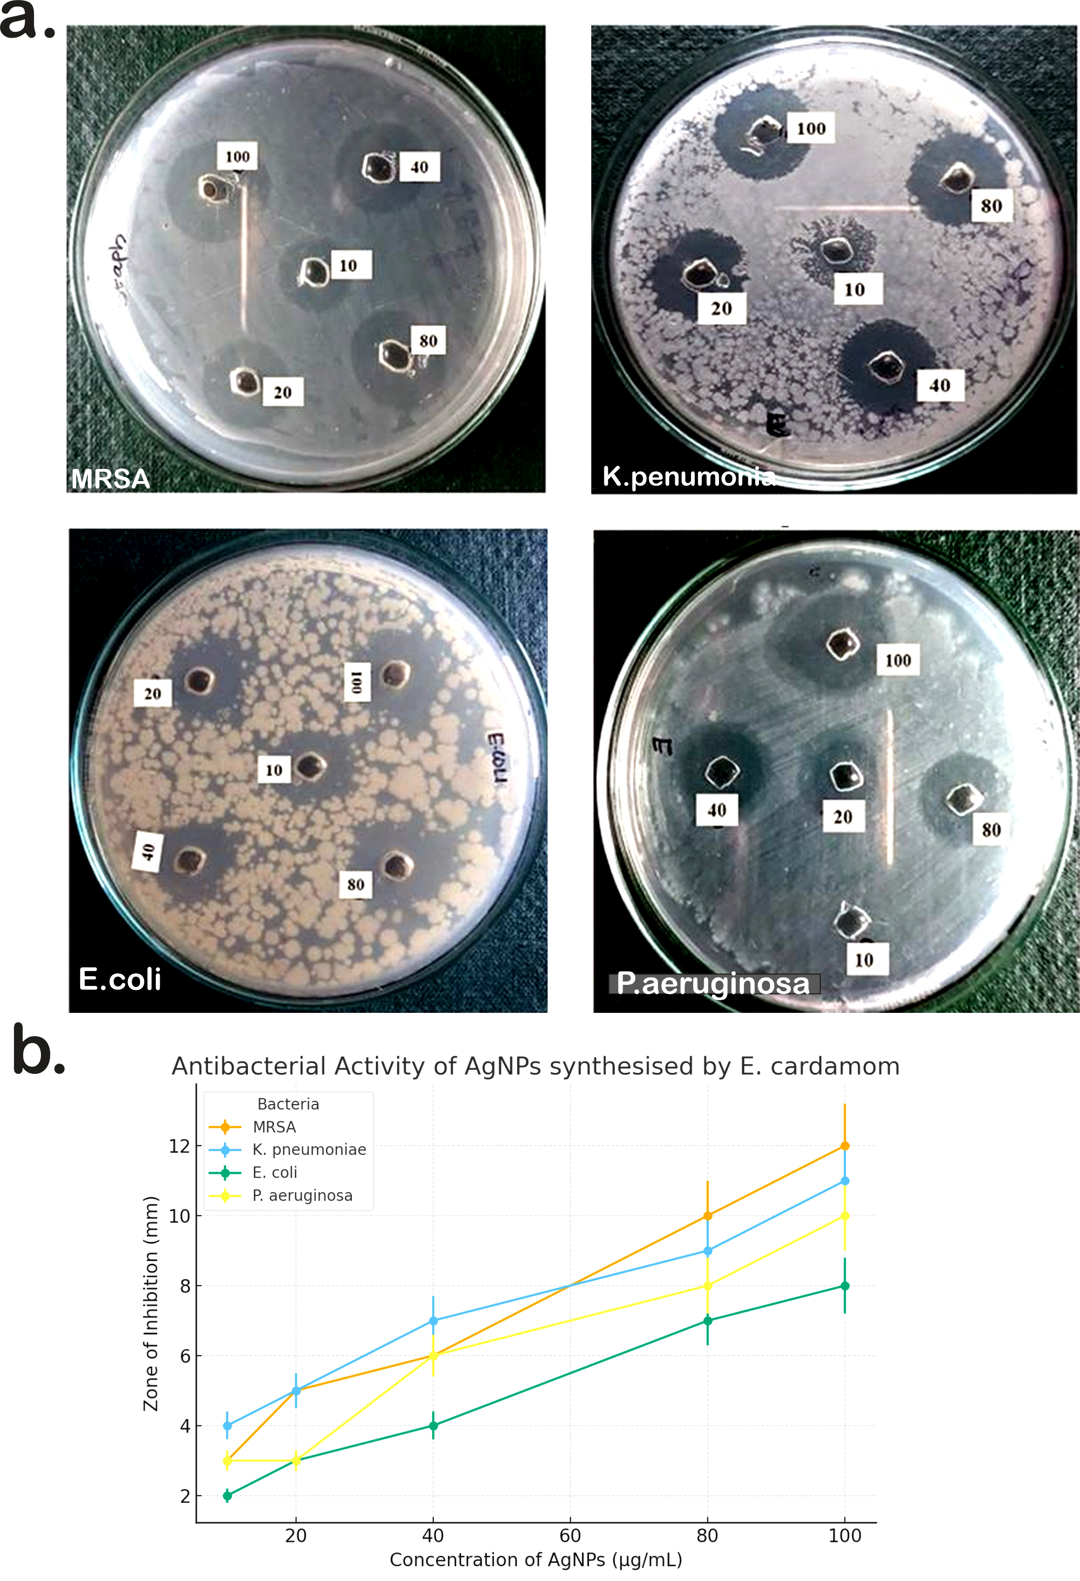
Figure S3. Preliminary antimicrobial activity assessment of biogenic silver nanoparticles synthesized using Elettaria cardamomum leaf extract. (a) Representative agar-well diffusion images showing concentration-dependent zones of inhibition (ZOI) against methicillin-resistant Staphylococcus aureus (MRSA), Klebsiella pneumoniae, Escherichia coli, and Pseudomonas aeruginosa following 24 h incubation at 37 °C with E. cardamomum-AgNPs at concentrations of 10–100 µg mL⁻¹. (b) Quantitative representation of the antibacterial activity, plotted as mean ZOI (mm) ± SD (n = 3 independent experiments) versus AgNP concentration (µg mL⁻¹). ZOI values include the well diameter (6 mm). The corresponding numerical data are provided in Table S5. The observed dose-dependent inhibition qualitatively corroborates the MIC/MBC findings presented in Table 5 of the main text.
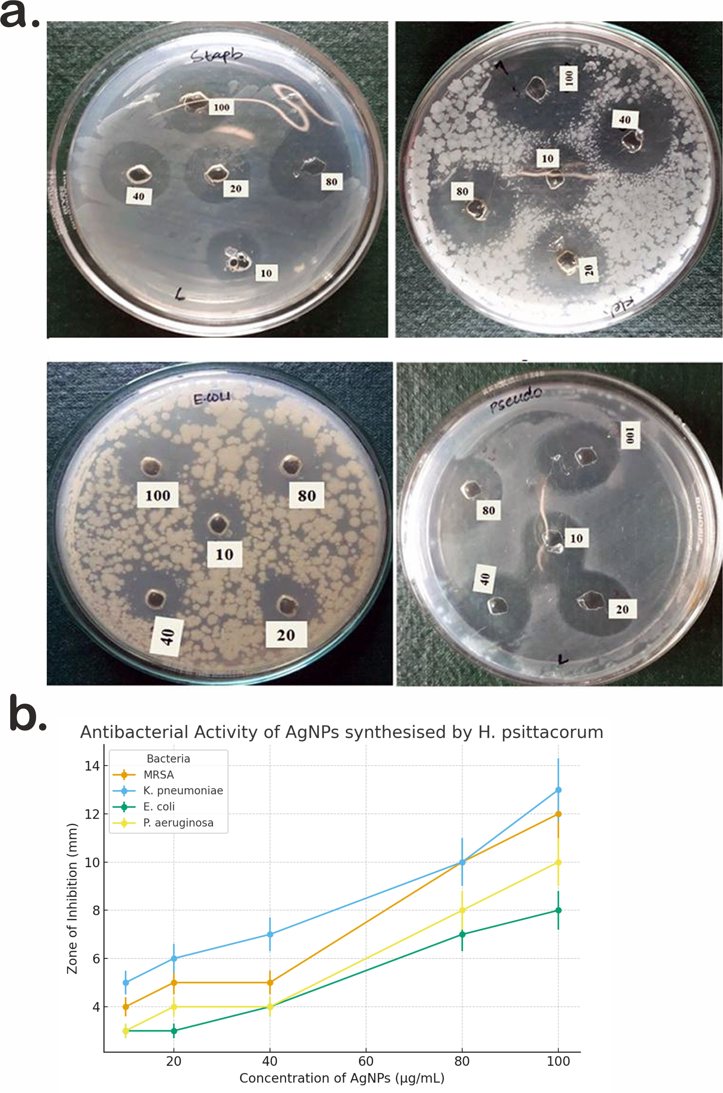
Figure S4. Preliminary antimicrobial activity assessment of biogenic silver nanoparticles synthesized using Heliconia psittacorum leaf extract. (a) Representative agar-well diffusion images showing concentration-dependent zones of inhibition (ZOI) against methicillin-resistant Staphylococcus aureus (MRSA), Klebsiella pneumoniae, Escherichia coli, and Pseudomonas aeruginosa following 24 h incubation at 37 °C with H. psittacorum-AgNPs at concentrations of 10–100 µg mL⁻¹. (b) Quantitative representation of the antibacterial activity, plotted as mean ZOI (mm) ± SD (n = 3 independent experiments) versus AgNP concentration (µg mL⁻¹). ZOI values include the well diameter (6 mm). The corresponding numerical data are provided in Table S5. Notably, H. psittacorum-AgNPs consistently exhibited the largest inhibition zones across all tested bacterial strains, reflecting their superior antibacterial potency and corroborating the lowest MIC values presented in Table 5 of the main text.
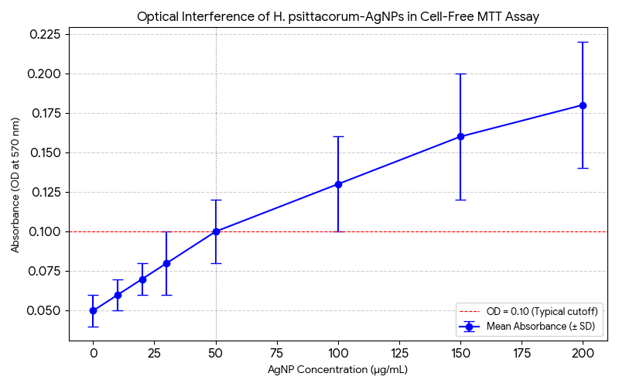
Figure S5. Evaluation of optical interference of H. psittacorum-derived AgNPs in the cell-free MTT assay. H. psittacorum-AgNPs (0–200 µg/mL) were incubated in complete culture medium for 48 h without cells, followed by MTT addition and formazan solubilization in DMSO. Absorbance was measured at 570 nm. Data are expressed as mean ± SD (n = 3). The red dashed line indicates the commonly accepted threshold for negligible interference (OD = 0.10). Absorbance remained below this threshold up to ~70 µg/mL, confirming minimal interference at concentrations relevant to the observed cytotoxic range (IC₅₀ ≈ 32.8 µg/mL). This low interference is attributed to the effective biogenic capping by alkaloid-rich phytochemicals from H. psittacorum extract.

