Intensifying fire weather narrows the window of firebreak effectiveness in Canadian forests
Xuezheng Zong¹, Xianli Wang^{1,2*}, Sean C. P. Coogan¹, Dante Castellanos-Acuna², Tom Swystun³, Mike D. Flannigan¹
¹ Department of Natural Resource Science, Faculty of Science, Thompson Rivers University, 805 TRU Way, Kamloops, BC V2C 0C8, Canada
² Northern Forestry Centre, Canadian Forest Service, Natural Resources Canada, 5320 122 Street, Edmonton, AB T6H 3S5, Canada
³ Great Lakes Forestry Centre, Canadian Forest Service, Natural Resources Canada, 1219 Queen Street East, Sault Ste. Marie, ON P6A 2E5, Canada

Corresponding Author: Xianli Wang (01-825-510-1217; xianli.wang@nrcan-rncan.gc.ca)

Table 1 Example of firebreak guidelines in some different regions
Countries or geographical regions | Width | Purposes | Sources
USA | 3-152 meters | Stopping or significantly reducing the spread of wildfire resulting from excessive biomass accumulations | Conservation Practice Standard: Firebreak (Code 394)¹
Canada | 30-200 meters | Helping individuals and communities mitigate the risk of loss from wildfires | FireSmart: Protecting Your Community from Wildfire
Australia | 2-10 meters | Minimizing the spread of fire and allowing access by emergency vehicles | Firebreak Notice² Requirements and Bushfire Information 2023–24³
China | 30-90 meters | Wildfire risk mitigation | National Forest Fire Prevention Plan (2016) for 2016–2025⁴
Europe | 20-30 meters | Increasing the safety and efficiency of ground fighting  manoeuvres, and enabling the implementation of backfires | Forest Fire (CFPA-E Guideline No 6:2016 N)⁵

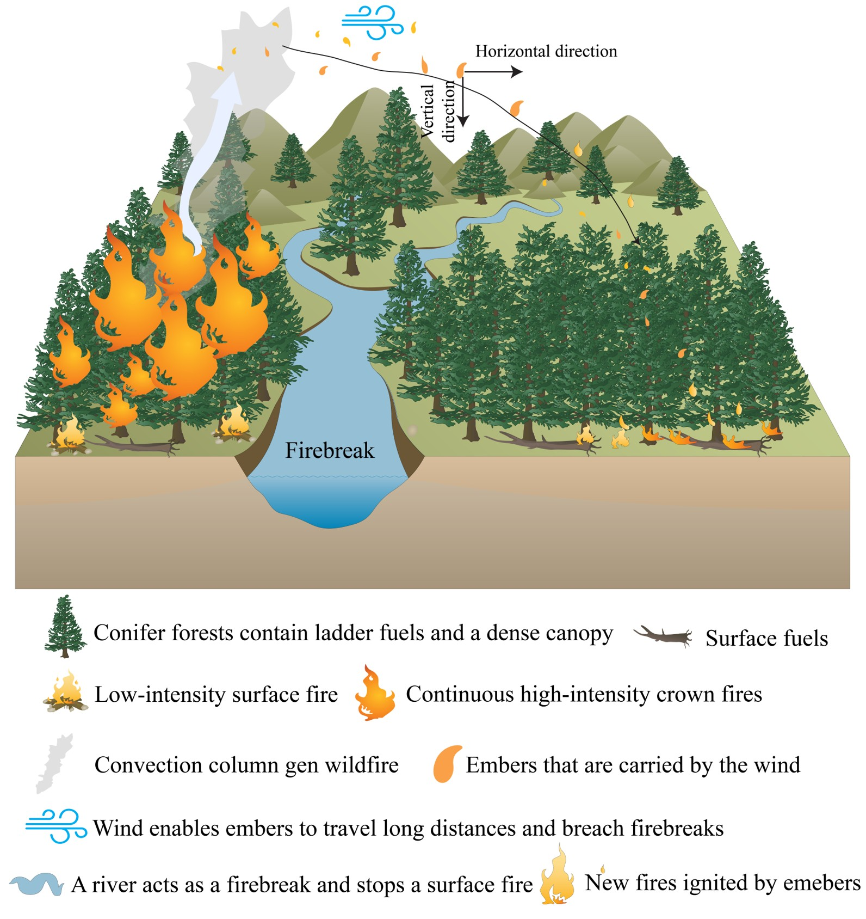
Fig. 1. Schematic illustrating how extreme fires breach firebreaks via spotting.

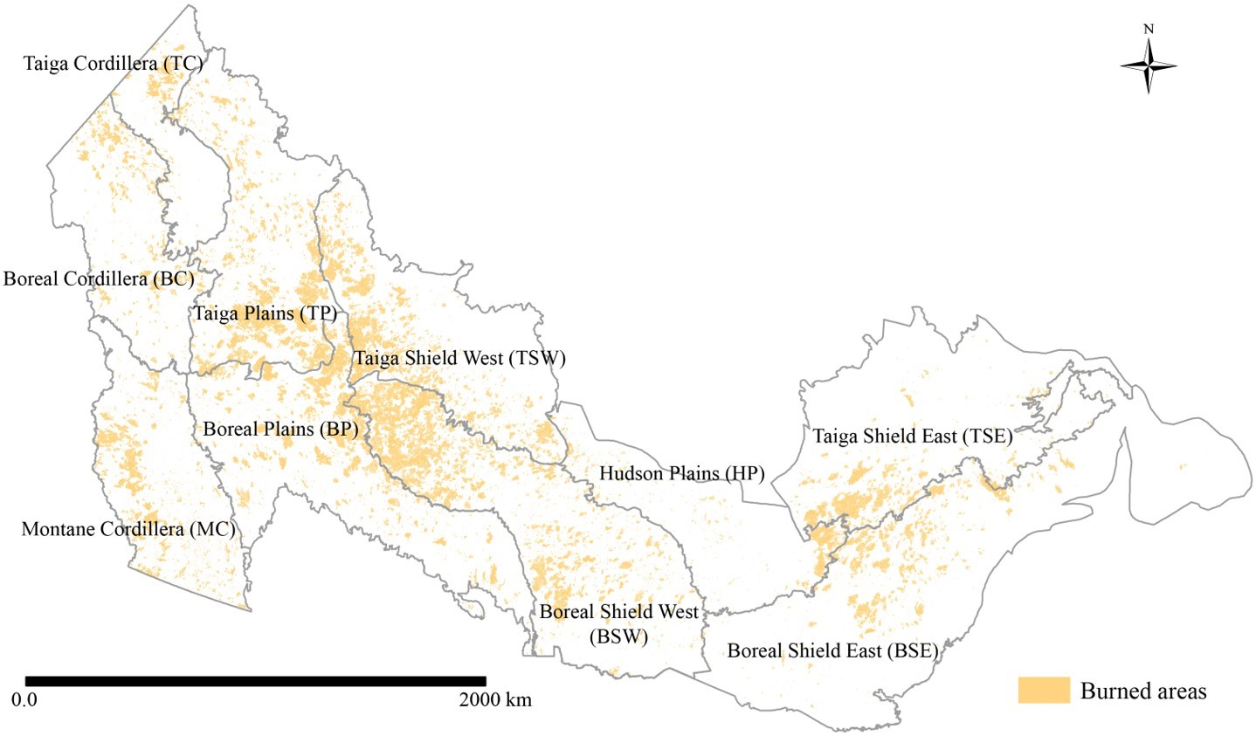
Fig. 2. The Canadian Ecozones and wildfire burned area during the analysis period of 2001-2023.
Wildfire data from the National Burned Area Composite (NBAC) with 30 m spatial resolution.

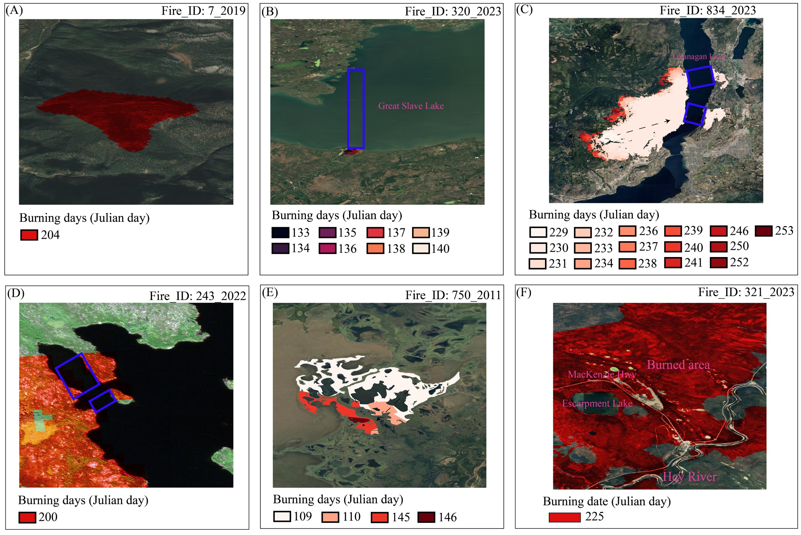
Fig. 3. Examples of spatial interactions between firebreaks and fires.
(A) Wildfire ignition and spread without contact with a firebreak. (B) Firebreak successfully halting wildfire spread. (C) Spotting-driven breach of a linear firebreak. (D) Spotting-driven breach of a non-linear firebreak. (E) Firebreak entirely encompassed by the wildfire. (F) Fire breaching multiple firebreaks on the same burning day. The subsequent analysis considered only the average width of firebreaks within the blue rectangles.

Table 2 Firebreak breaches in different seasons
Seasons | Types | Non-breaching | Spotting-caused breaching | Breaching with undetermined pathway
Spring  (March–May) | Road | 0 | 1057 | 0
Spring  (March–May) | Bare areas | 121 | 1 | 300
Spring  (March–May) | Water bodies | 1756 | 2095 | 1409
Summer  (June–August) | Road | 0 | 1773 | 0
Summer  (June–August) | Bare areas | 1184 | 1282 | 1284
Summer  (June–August) | Water bodies | 3587 | 10169 | 1648
Autumn  (September and October) | Road | 0 | 17 | 0
Autumn  (September and October) | Bare areas | 16 | 35 | 1
Autumn  (September and October) | Water bodies | 33 | 50 | 0
Winter  (February) | Road | 0 | 4 | 0
Winter  (February) | Bare areas | 0 | 0 | 1
Winter  (February) | Water bodies | 0 | 0 | 0

Table 3 Historical firebreak breaching and non-breaching events in different ecozones
Ecozones | Non-breaching | Spotting-caused breaching | Breaching with undetermined pathways
Boreal Cordillera (BC) | 316 | 562 | 197
Boreal Plains (BP) | 479 | 1227 | 274
Boreal Shield East (BSE) | 256 | 881 | 184
Boreal Shield West (BSW) | 1468 | 5004 | 1179
Hudson Plains (HP) | 86 | 392 | 71
Montane Cordillera (MC) | 1344 | 2469 | 823
Taiga Cordillera (TC) | 90 | 209 | 77
Taiga Plains (TP) | 694 | 1533 | 536
Taiga Shield East (TSE) | 174 | 800 | 142
Taiga Shield West (TSW) | 1790 | 3416 | 1150

Table 4 Model accuracies (F1-score) in predicting firebreak breaches in ten ecozones
Ecozones | Spotting-driven firebreak breaches |  |  |  |  | Overall firebreak effectiveness
Ecozones | RF | KNN | Nnet | SVM | XGBoost | RF | KNN | Nnet | SVM | XGBoost
Boreal Cordillera (BC) | 0.72 | 0.63 | 0.62 | 0.63 | 0.67 | 0.68 | 0.64 | 0.63 | 0.63 | 0.63
Boreal Plains (BP) | 0.65 | 0.57 | 0.62 | 0.59 | 0.62 | 0.64 | 0.57 | 0.62 | 0.62 | 0.63
Boreal Shield East (BSE) | 0.68 | 0.63 | 0.64 | 0.55 | 0.64 | 0.69 | 0.64 | 0.64 | 0.54 | 0.63
Boreal Shield West (BSW) | 0.64 | 0.60 | 0.61 | 0.55 | 0.62 | 0.66 | 0.60 | 0.61 | 0.54 | 0.61
Hudson Plains (HP) | 0.61 | 0.53 | 0.57 | 0.54 | 0.56 | 0.62 | 0.49 | 0.53 | 0.59 | 0.60
Montane Cordillera (MC) | 0.69 | 0.63 | 0.56 | 0.63 | 0.65 | 0.70 | 0.63 | 0.59 | 0.55 | 0.63
Taiga Cordillera (TC) | 0.65 | 0.57 | 0.56 | 0.54 | 0.61 | 0.66 | 0.55 | 0.54 | 0.56 | 0.62
Taiga Plains (TP) | 0.70 | 0.60 | 0.57 | 0.63 | 0.66 | 0.70 | 0.63 | 0.60 | 0.67 | 0.63
Taiga Shield East (TSE) | 0.66 | 0.56 | 0.56 | 0.64 | 0.64 | 0.66 | 0.53 | 0.58 | 0.65 | 0.65
Taiga Shield West (TSW) | 0.69 | 0.59 | 0.61 | 0.62 | 0.63 | 0.69 | 0.62 | 0.61 | 0.68 | 0.64

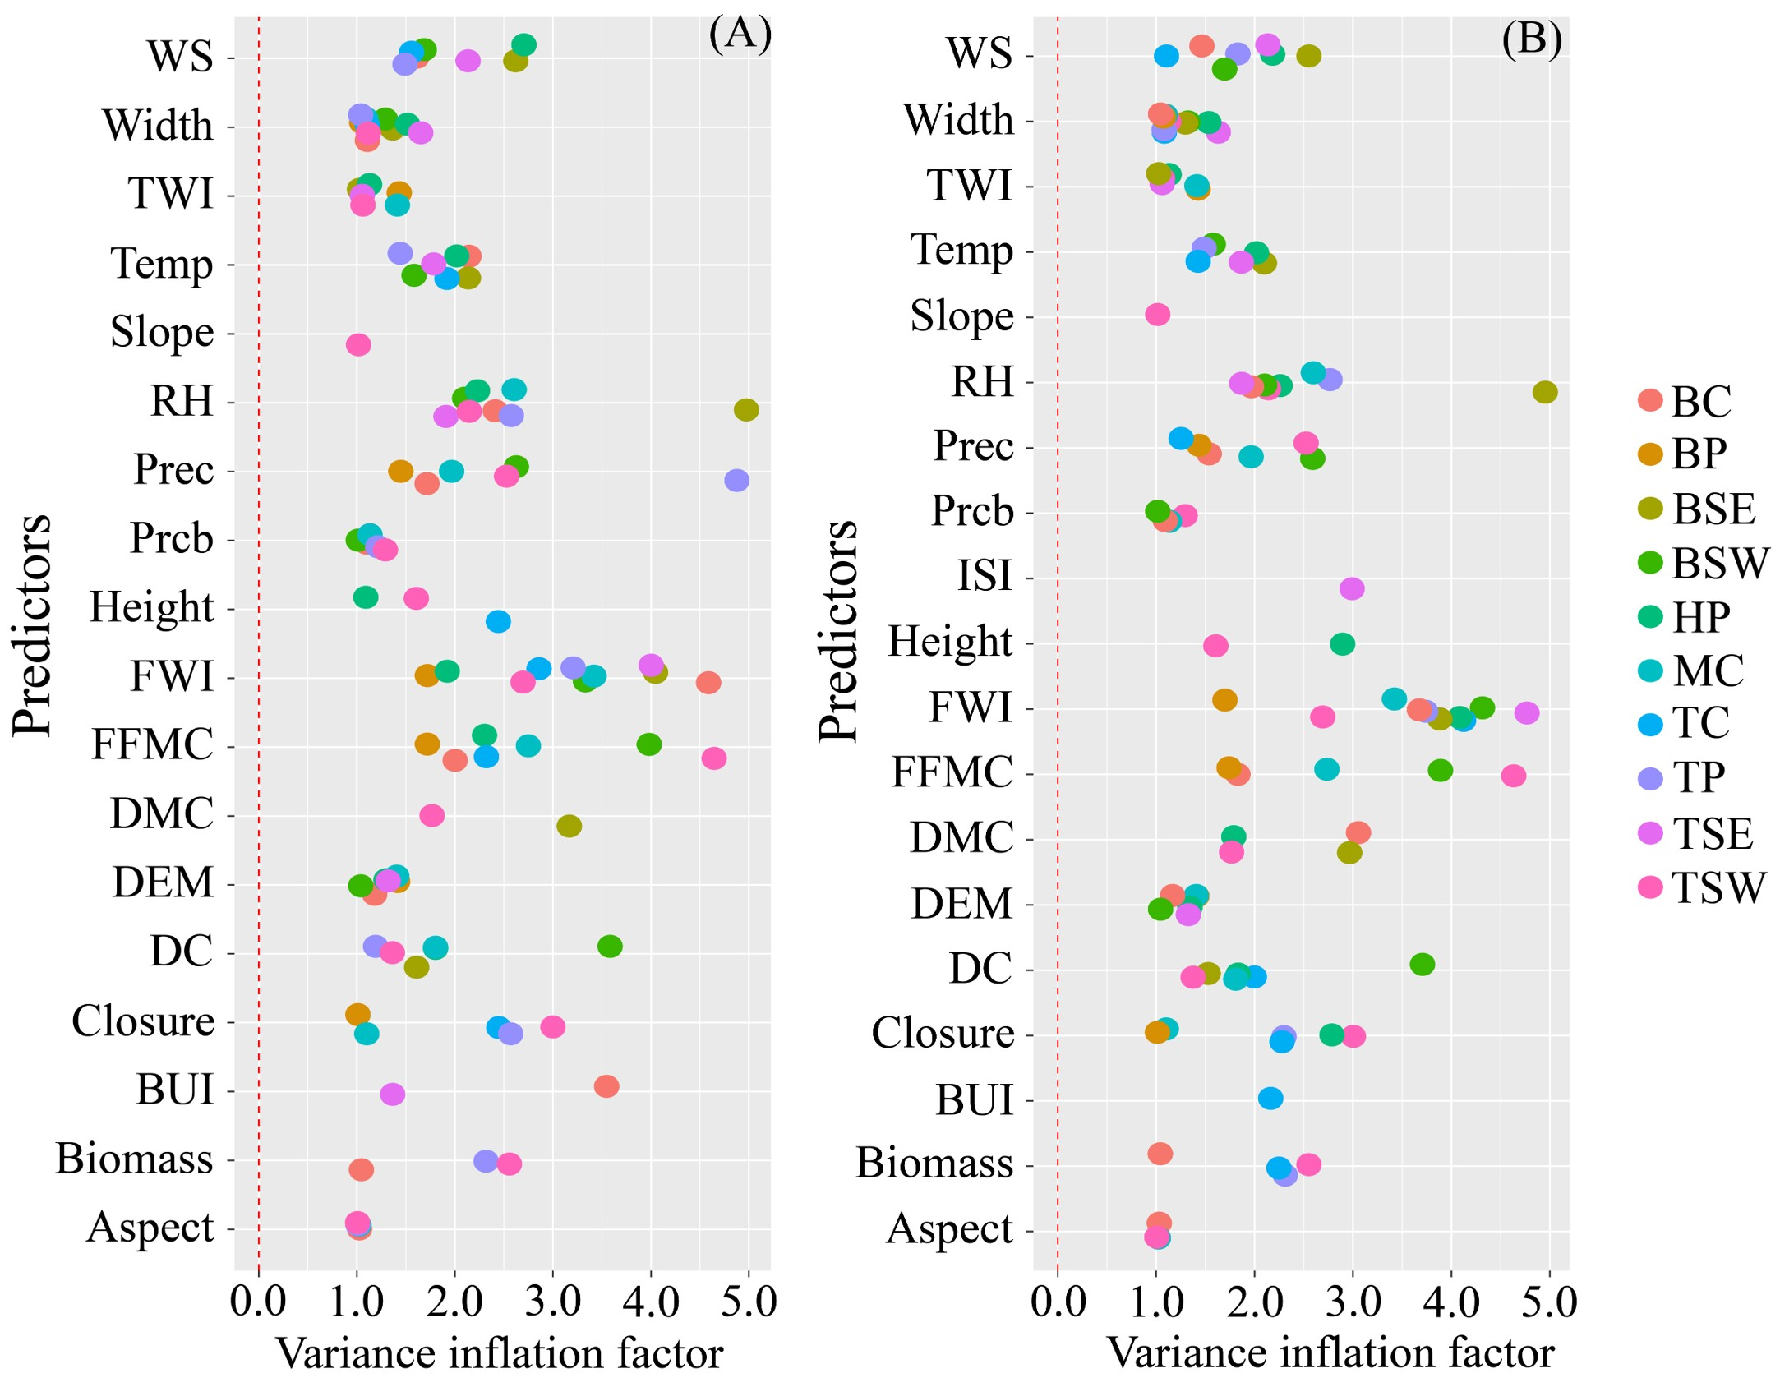
Fig. 4 Predictors used in modeling firebreak breaches. (A) Predictors for spotting-caused FBEs. (B) Predictors for overall FBEs. Predictors with VIF > 5 were removed from the models.
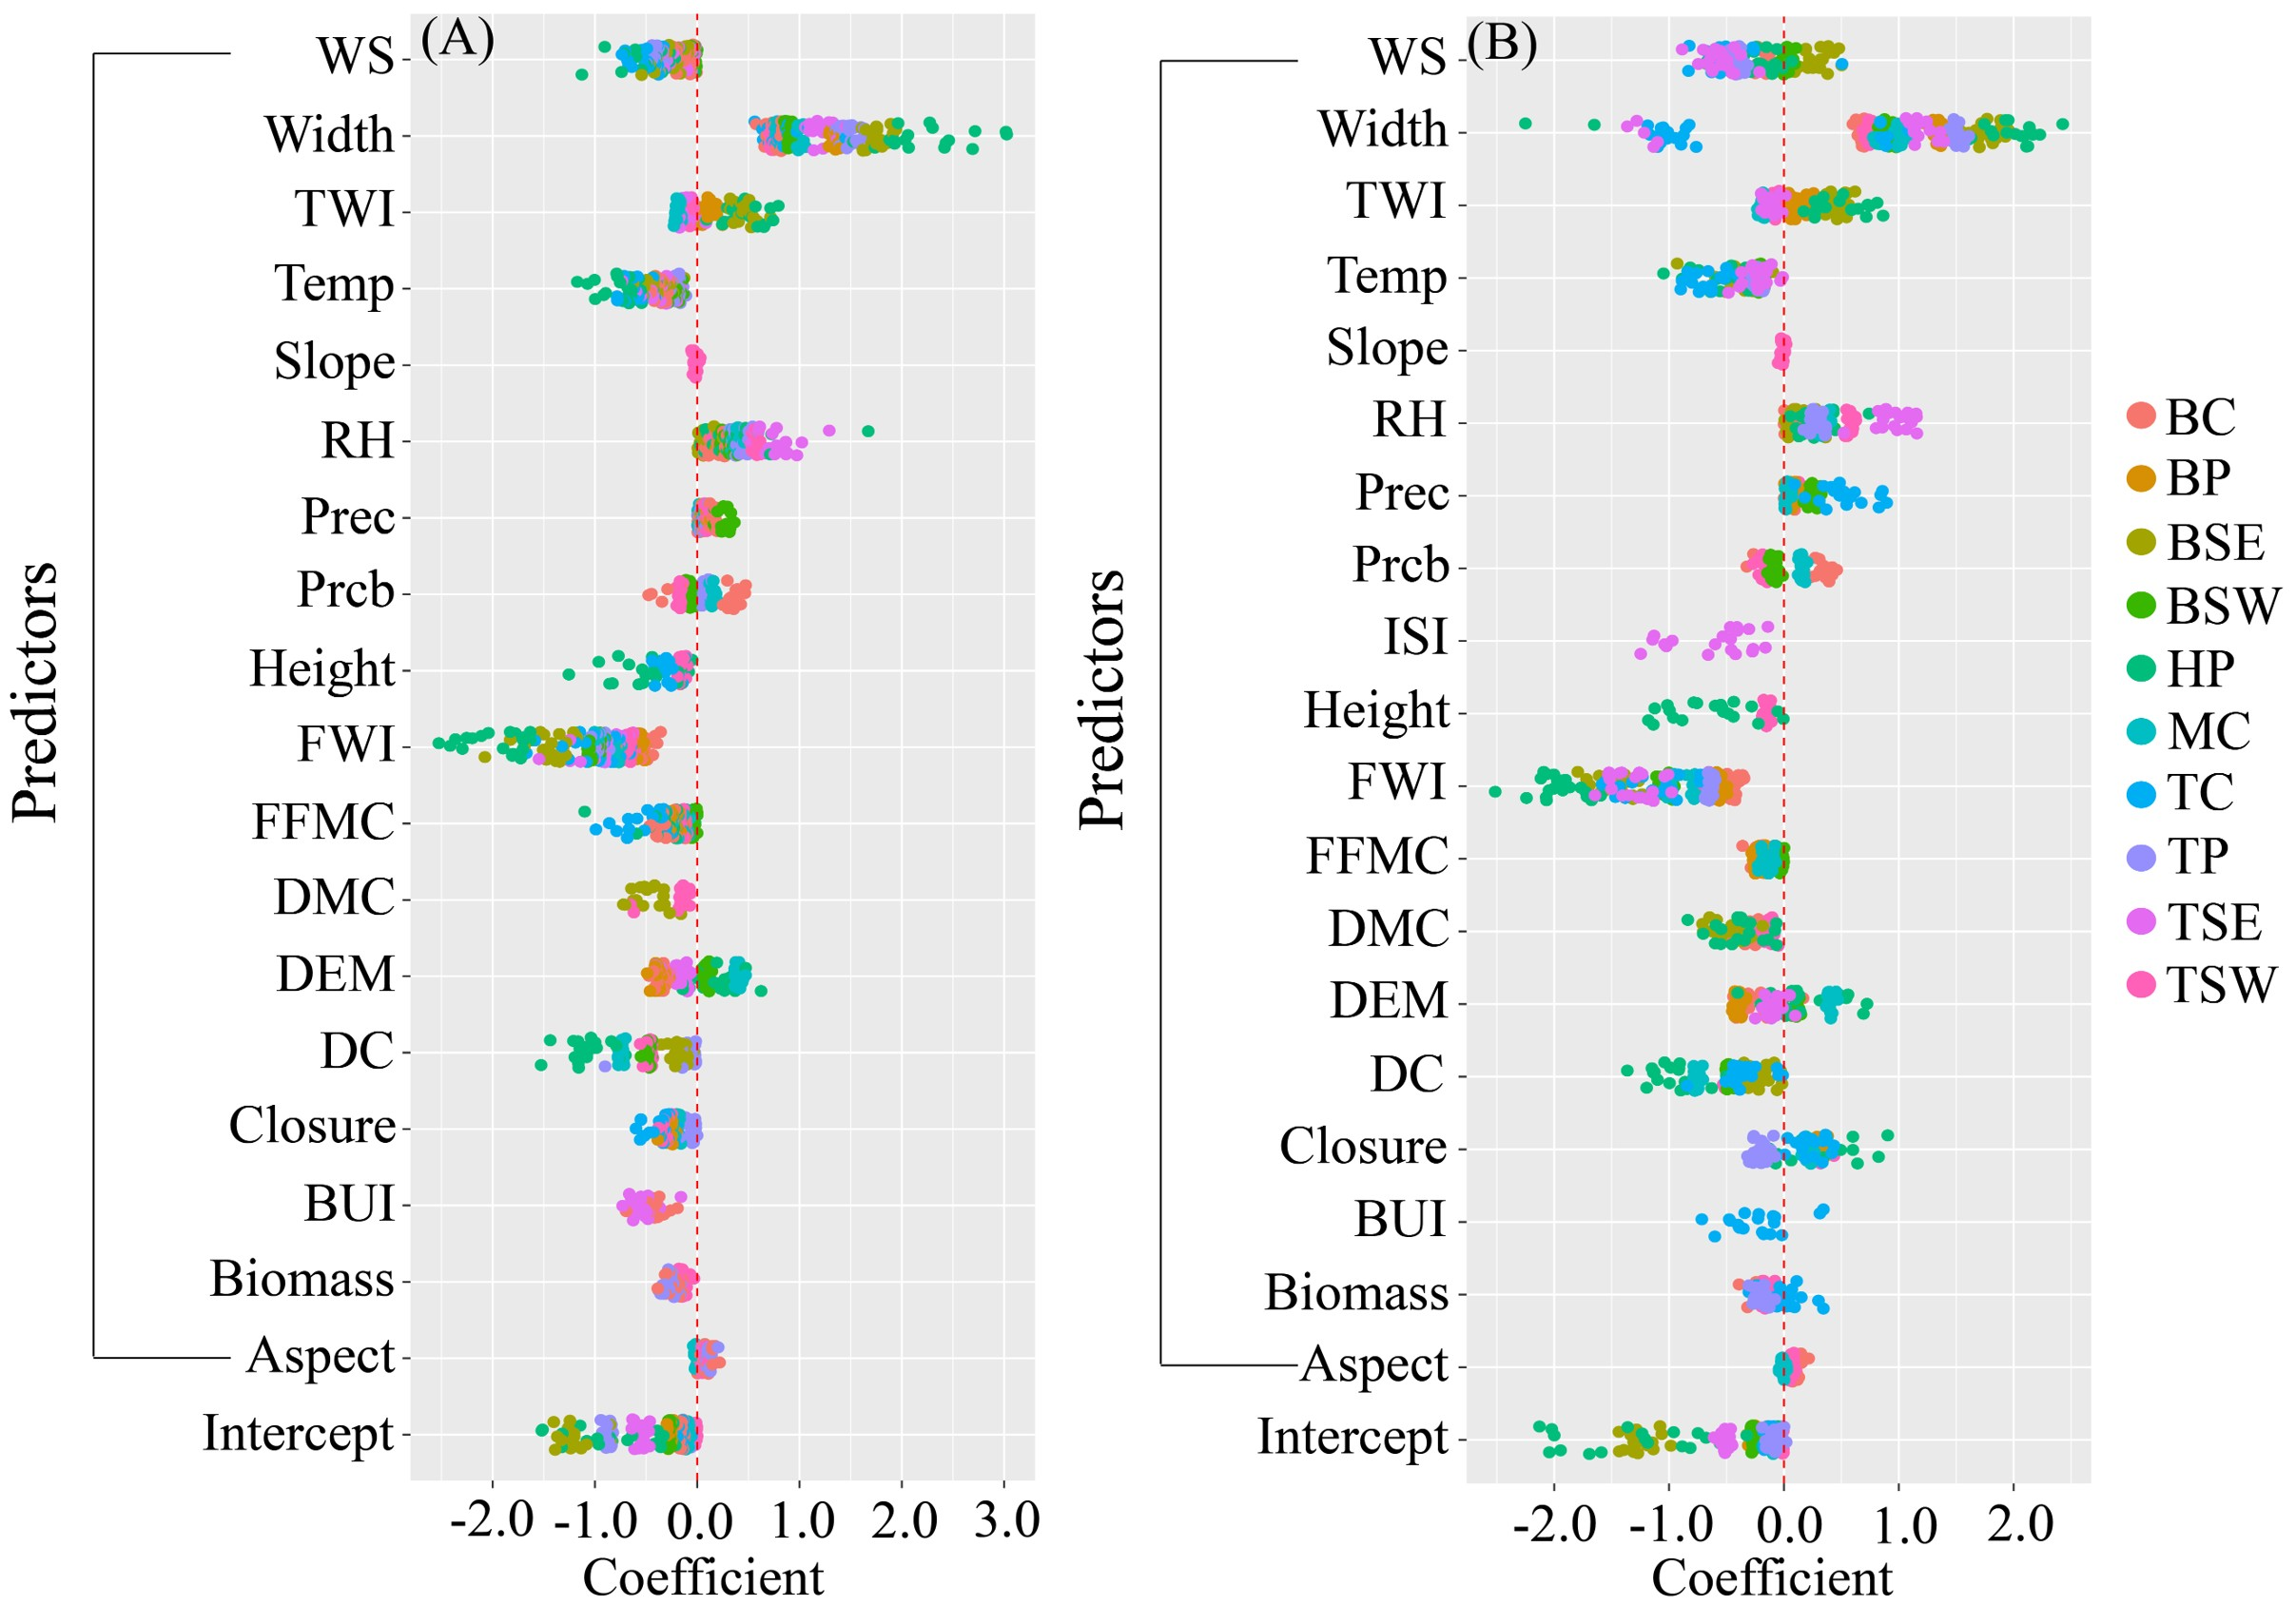
Fig. 5 Coefficients of predictors associated with firebreak breaches. (A) Coefficients from twenty logistic regression models for spotting-caused FBEs. (B) Coefficients from twenty logistic regression models for overall FBEs.
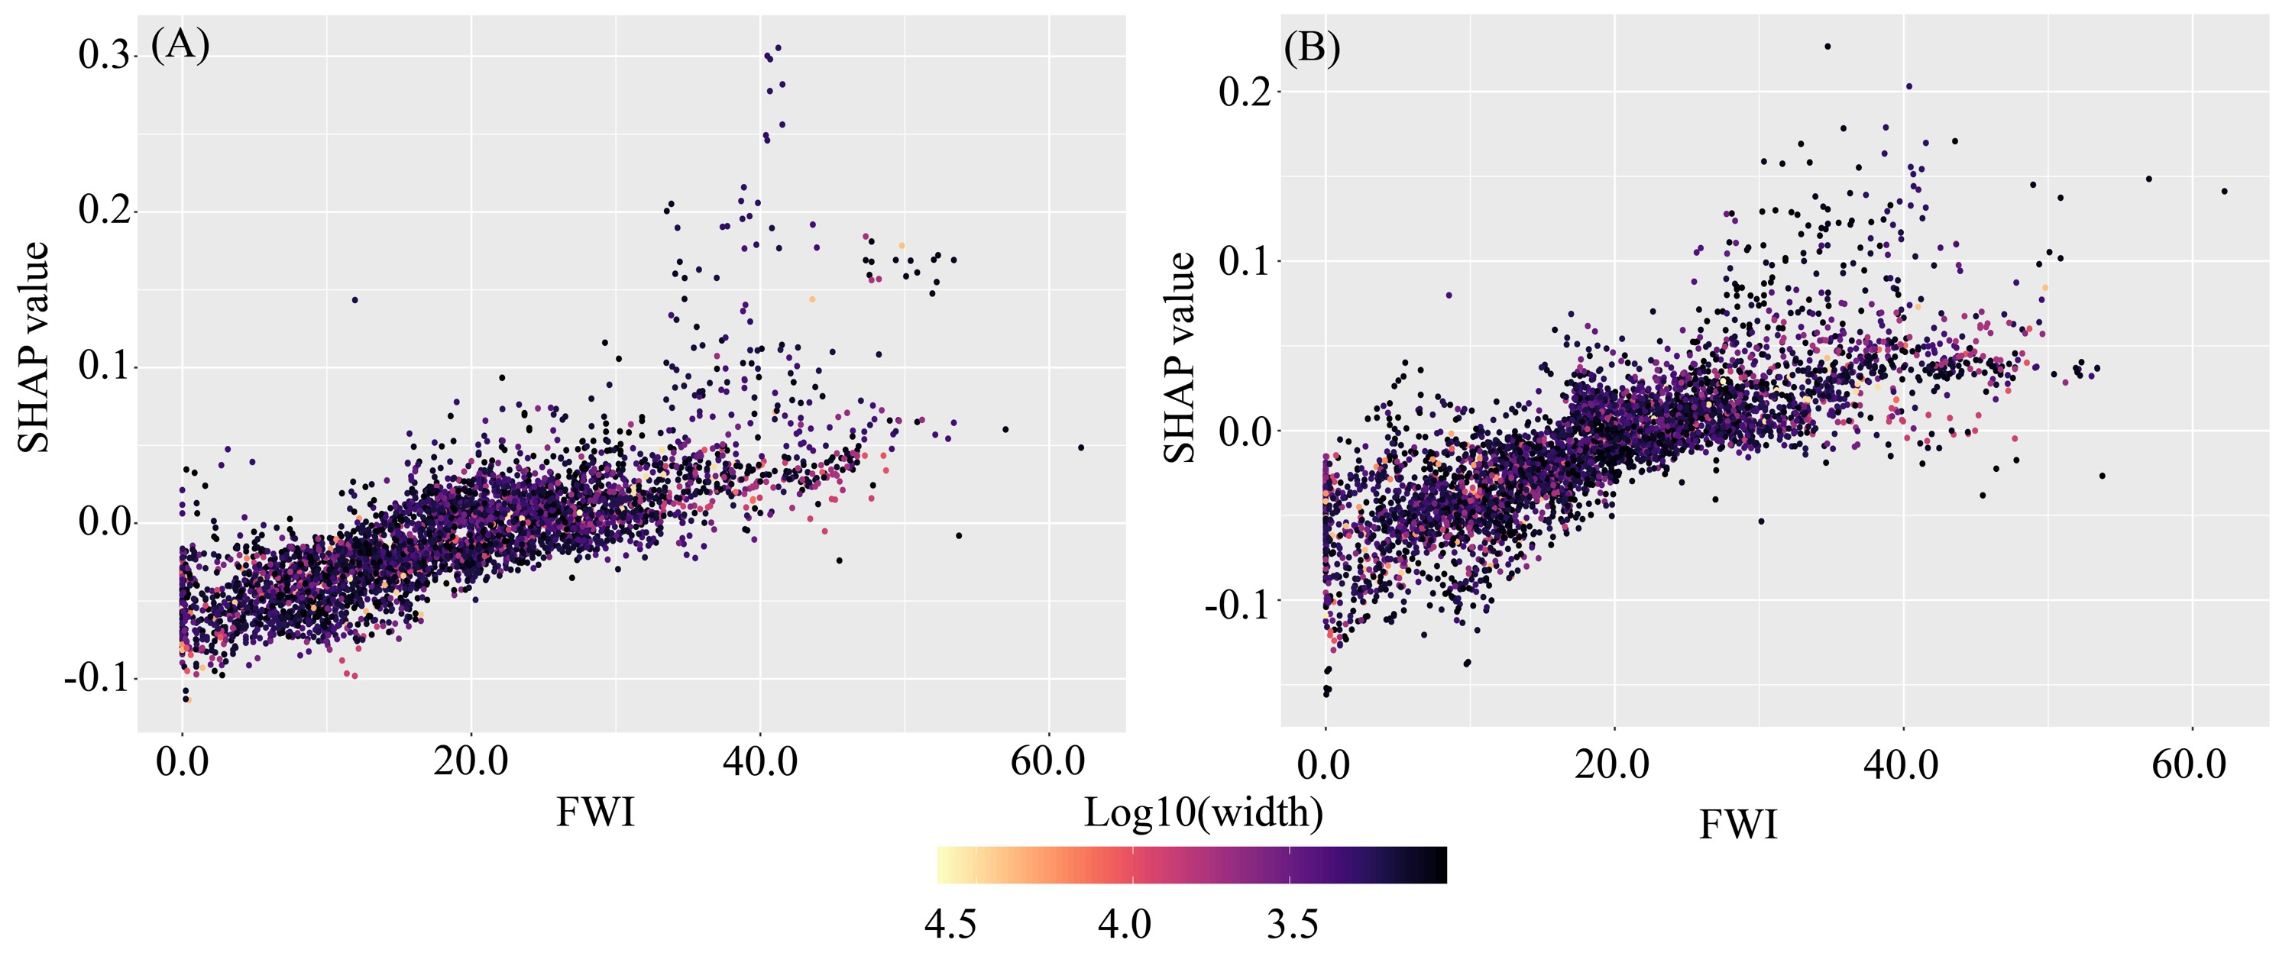
Fig. 6. Influence of firebreak width on the relationship between fire weather and spotting-caused breaches (A) or overall firebreak effectiveness (B). The effect of FWI on breaches is represented by SHAP values from random forest models. Narrow firebreaks are more likely to be breached (SHAP value>0) under high fire weather conditions (daily FWI > 20), whereas wider firebreaks (>3,000 m) can effectively stop fires (negative SHAP value) under most conditions.
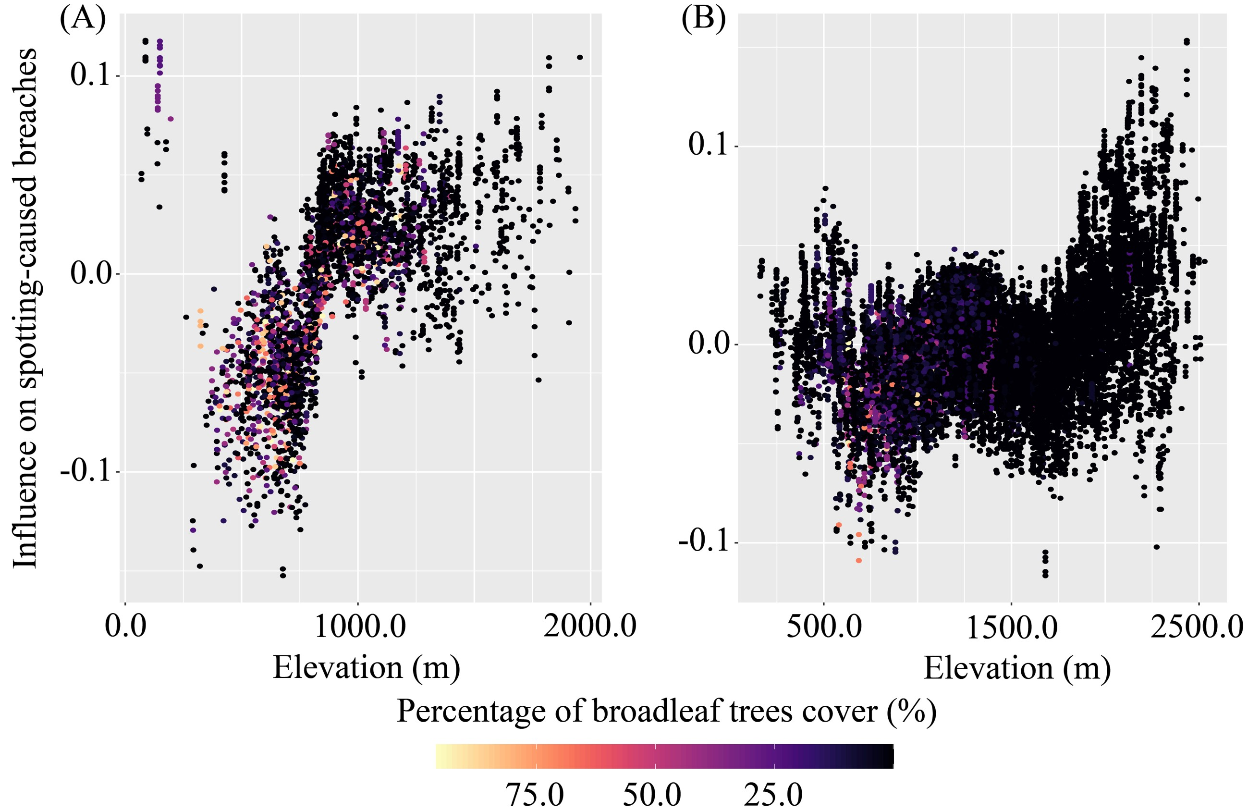
Fig. 7. Influence of mountain conifer forests on firebreak breaches in the Boreal Cordillera (A) and Montane Cordillera (B).
Scatterplots show the influence of elevation on breaches, with point colors indicating broadleaf tree cover. Firebreak breaches were rare in broadleaf-dominated forests (>50% cover), whereas fires in mountain conifer forests were more likely to breach firebreaks.
Table 5 Variables used in building models and analysis
Attribute | Variables | Sources
Weather and fire weather | 24-hr precipitation (mm) | Hourly ERA5 reanalysis data
Weather and fire weather | daily temperature (℃) | Hourly ERA5 reanalysis data
Weather and fire weather | Noon wind speed at 10 m elevation (km/h) | Hourly ERA5 reanalysis data
Weather and fire weather | Noon relative humidity (%) | Hourly ERA5 reanalysis data
Weather and fire weather | Fine fuel moisture code | Calculated based on daily temperature, wind speed, relative humidity, and 24-hr precipitation using ‘cffdrs’ R Package
Weather and fire weather | Duff moisture code
Weather and fire weather | Drought code
Weather and fire weather | Buildup index
Weather and fire weather | Initial spread index
Weather and fire weather | Fire weather index
Fuel characteristics | Percentage of pixel covered by the tree canopy (%) | Extracted from the Spatialized Canadian National Forest Inventory data product (SCANFI)
Fuel characteristics | Broadleaf tree cover in percentage (%)
Fuel characteristics | Aboveground tree biomass (tons/ha)
Fuel characteristics | Vegetation height (m)
Firebreak features | Firebreaks width (m) | Obtained from the geographical features for Canada
Firebreak features | Regional firebreak density (m/km²) | Obtained from the geographical features for Canada
Firebreak features | Firebreak areas (ha) | Obtained from the geographical features for Canada
Firebreak features | Firebreak parameters (m) | Obtained from the geographical features for Canada
Firebreak features | Firebreak types | Obtained from the geographical features for Canada
Topography | Elevation (m) | Calculated based on DEM data
Topography | Slope (°) | Calculated based on DEM data
Topography | Topographic wetness index | Calculated based on DEM data
Topography | Aspect (°) | Calculated based on DEM data

Table 6 Model performance (F1-score) in predicting spotting-driven breaches and overall firebreak effectiveness
Ecozones | Prediction of spotting-driven breaches |  |  |  | Evaluation of overall firebreak effectiveness
Ecozones | Accuracy | Precision | Recall | F1 score | Accuracy | Precision | Recall | F1 score
Boreal Cordillera (BC) | 0.69 | 0.82 | 0.70 | 0.76 | 0.69 | 0.82 | 0.70 | 0.76
Boreal Plains (BP) | 0.72 | 0.84 | 0.69 | 0.75 | 0.72 | 0.84 | 0.69 | 0.75
Boreal Shield East (BSE) | 0.81 | 0.98 | 0.80 | 0.88 | 0.81 | 0.98 | 0.80 | 0.88
Boreal Shield West (BSW) | 0.69 | 0.85 | 0.69 | 0.76 | 0.69 | 0.85 | 0.69 | 0.76
Hudson Plains (HP) | 0.84 | 0.98 | 0.84 | 0.90 | 0.84 | 0.98 | 0.84 | 0.90
Montane Cordillera (MC) | 0.67 | 0.76 | 0.64 | 0.70 | 0.67 | 0.76 | 0.64 | 0.70
Taiga Cordillera (TC) | 0.70 | 0.83 | 0.73 | 0.77 | 0.70 | 0.83 | 0.73 | 0.77
Taiga Plains (TP) | 0.74 | 0.91 | 0.76 | 0.83 | 0.74 | 0.91 | 0.76 | 0.83
Taiga Shield East (TSE) | 0.76 | 0.91 | 0.76 | 0.83 | 0.76 | 0.91 | 0.76 | 0.83
Taiga Shield West (TSW) | 0.72 | 0.75 | 0.73 | 0.74 | 0.72 | 0.75 | 0.73 | 0.74

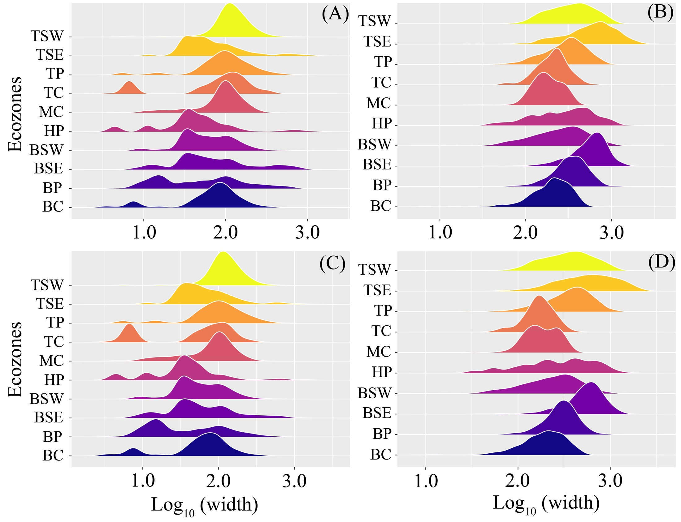
Fig. 8 Distributions of observed breached firebreak widths and predicted minimum effective firebreak widths across Canadian ecozones.
(A) Widths of firebreaks that were actually breached by wildfires regardless of breaching pathways. (B) Predicted minimum effective firebreak widths required to prevent the observed breaches. (C) Widths of firebreaks that were breached specifically by spotting. (D) Predicted minimum effective firebreak widths required to prevent the spotting-caused breaches. Distributions are shown for each ecozone using ridge-density plots, with widths displayed on a log₁₀ scale.

Table 7 Examples of firebreak breaches and model-estimated minimum widths
Fire ID | Affected communities | Breached firebreak widths (m) | Model-estimated minimum widths
106_2011 | Fort MacKay | 1246.6 | 2077.1
145_2006 | Stony Rapids | 529.3 | 851.5
172_2019 | High Level | 59.5 | 397.7
172_2019 | Paddle Prairie | 60.9 | 425.7
1811_2021 | Spences Bridge | 99.9 | 385.0
1888_2021 | Prince Albert | 6.7 | 855.33
194_2002 | Turnor Lake | 16.6 | 402.9
194_2002 | Birch Narrows | 1332.1 | 1740.2
1941_2014 | Rouyn-Noranda | 25.5 | 923.7
255_2016 | Fort McMurray | 1220.9 | 1542.9
354_2023 | Rainbow Lake | 59.5 | 399.4
364_2023 | East Prairie Metis Settlement | 39.8 | 1209.6
366_2023 | Edson | 83.8 | 1678.9
465_2003 | Timber Bay | 11.7 | 527.1
523_2002 | Wahpeton Dakota | 49.2 | 860.6
708_2023 | Evansburg | 29.4 | 1970.4
709_2023 | Drayton Valley | 514.1 | 1111.5
714_2023 | Sturgeon Lake Cree | 54 | 897.2
721_2023 | Riverview Pines Subdivision | 107.1 | 2199.4
753_2019 | Pickle Lake | 8.3 | 818.8
775_2012 | Kirkland Lake | 224.1 | 1444.7
834_2023 | Kelowna | 3111.3 | 5322.1
981_2023 | La Loche | 8.4 | 438.9
989_2009 | 70 Mile House | 15.2 | 661.7

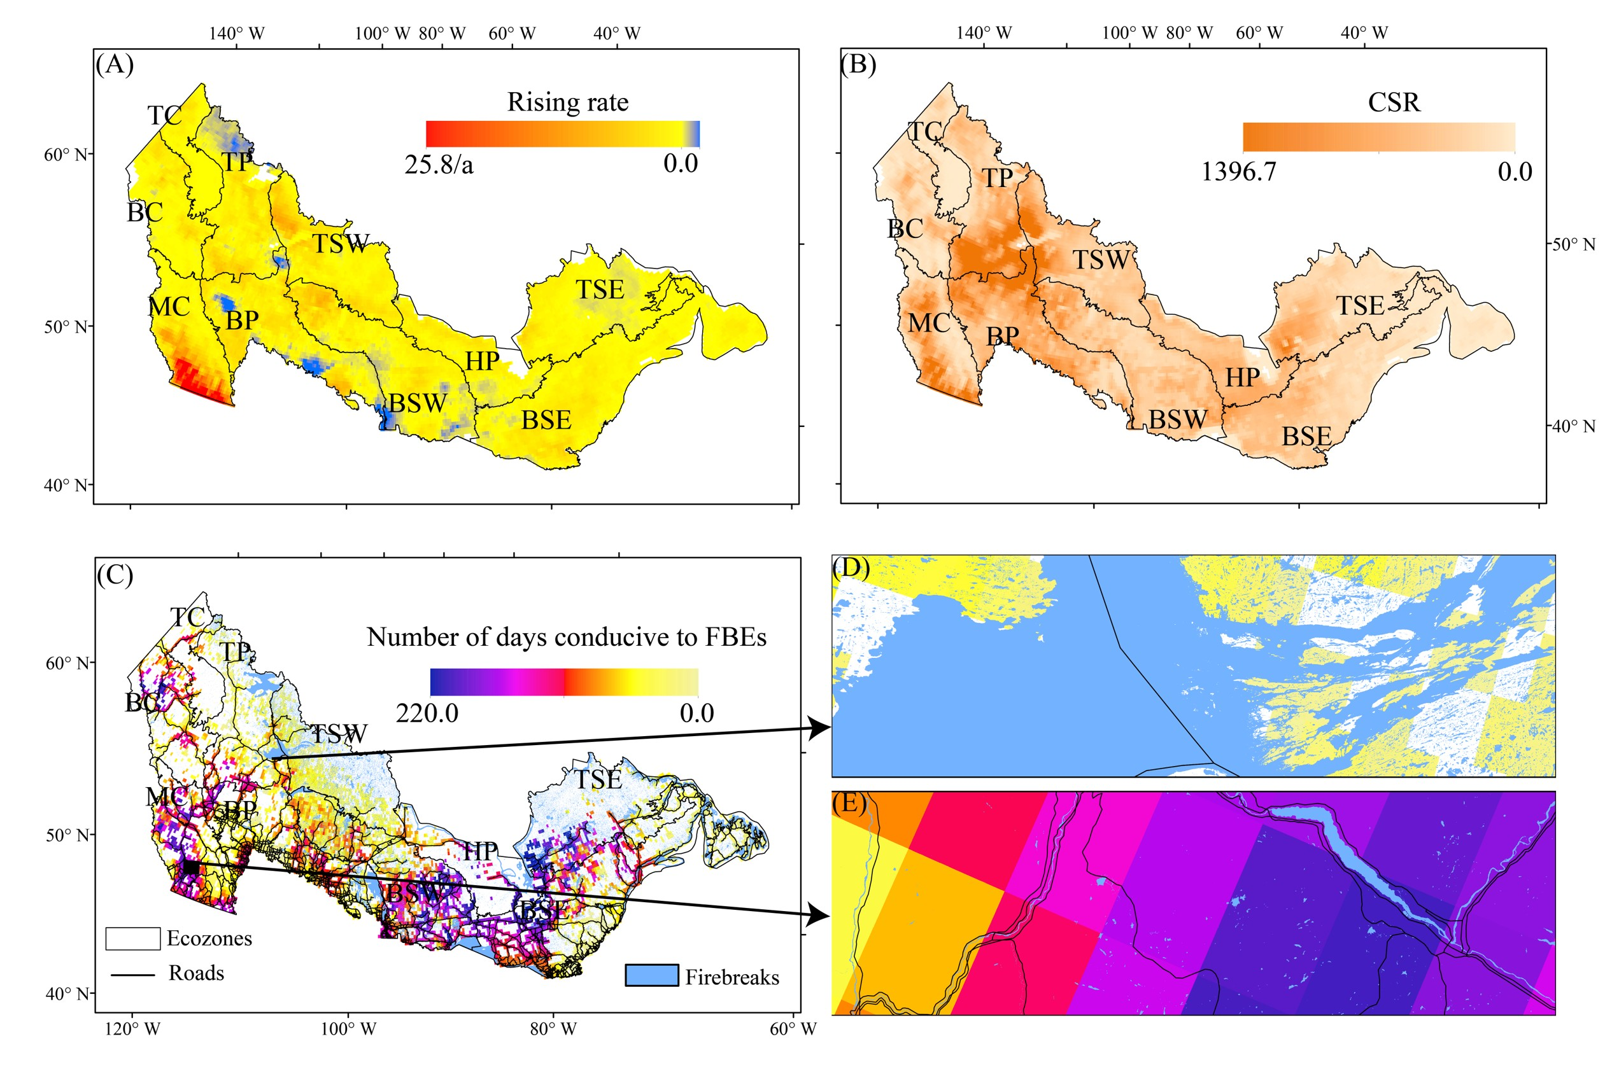
Fig. 9. Intensifying fire weather increases the frequency of annual FBEs days from 1980 to 2023.
(A) Spatial distribution of the increasing rate in seasonal Cumulative Severity Rating (CSR) between 1980 and 2023. The CSR represents seasonal fire control difficulty and is calculated as the sum of daily severity ratings (DSR) during each fire season. DSR is a power function of the Fire Weather Index (FWI; exponent = 1.77). (B) Spatial distribution of CSR during the 2023 wildfire season. (C) Distribution of FBE days during 2023, with maximum and minimum values observed in the (D) southeastern and (E) northern regions of Canadian forests, corresponding to regional differences in firebreak characteristics.

Table 8 The number of days conducive to FBEs and spotting-caused FBEs during the record-breaking 2023 fire season
Ecozones | Overall FBEs |  |  | Spotting-caused FBEs
Ecozones | Spring | Summer | Autumn | Spring | Summer | Autumn
Boreal Cordillera (BC) | 28 | 112 | 16 | 26 | 108 | 15
Boreal Plains (BP) | 40 | 93 | 37 | 39 | 89 | 34
Boreal Shield East (BSE) | 47 | 132 | 35 | 45 | 131 | 31
Boreal Shield West (BSW) | 21 | 101 | 30 | 19 | 89 | 26
Hudson Plains (HP) | 31 | 133 | 33 | 28 | 132 | 31
Montane Cordillera (MC) | 39 | 98 | 30 | 38 | 86 | 26
Taiga Cordillera (TC) | 2 | 100 | 6 | 2 | 93 | 5
Taiga Plains (TP) | 18 | 65 | 7 | 18 | 62 | 6
Taiga Shield East (TSE) | 22 | 142 | 33 | 19 | 141 | 33
Taiga Shield West (TSW) | 4 | 59 | 6 | 4 | 56 | 6

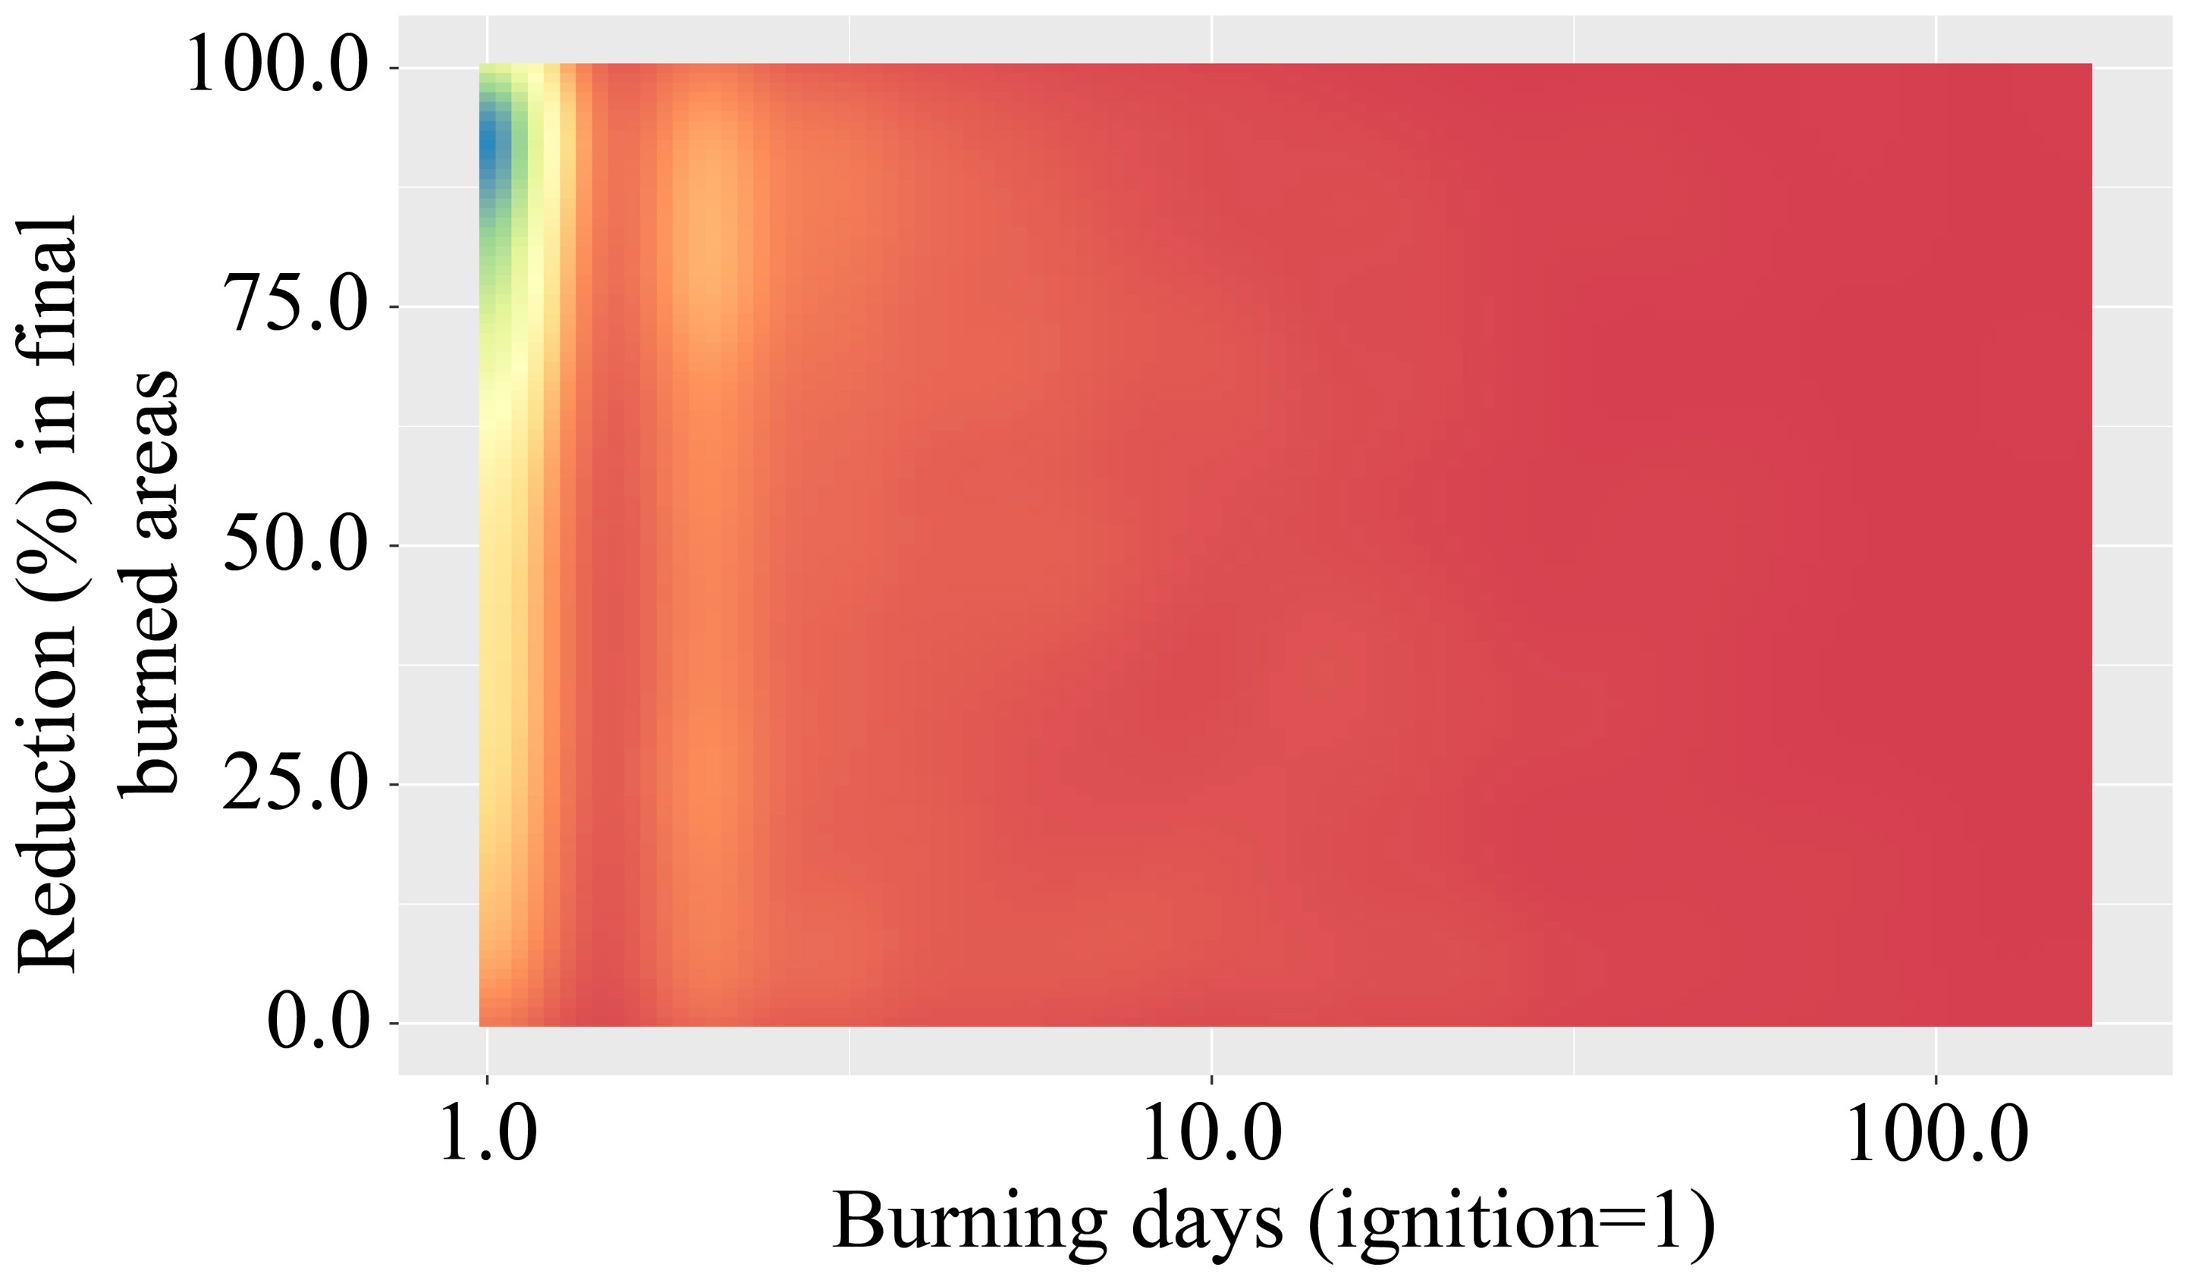
Fig. 10. Effectiveness of stopping fires on final burned areas.
Early containment of wildfire spread substantially reduces the total burned area.

Table 9 Ensemble F1-scores for predicting firebreak breaches across ten ecozones based on multiple environmental and fire behavior variables
Ecozones | Considering fire behavior variables | Excluding fire behavior variables
Boreal Cordillera (BC) | 0.76 | 0.73
Boreal Plains (BP) | 0.75 | 0.65
Boreal Shield East (BSE) | 0.88 | 0.82
Boreal Shield West (BSW) | 0.76 | 0.68
Hudson Plains (HP) | 0.9 | 0.76
Montane Cordillera (MC) | 0.7 | 0.63
Taiga Cordillera (TC) | 0.77 | 0.67
Taiga Plains (TP) | 0.83 | 0.75
Taiga Shield East (TSE) | 0.83 | 0.77
Taiga Shield West (TSW) | 0.74 | 0.64

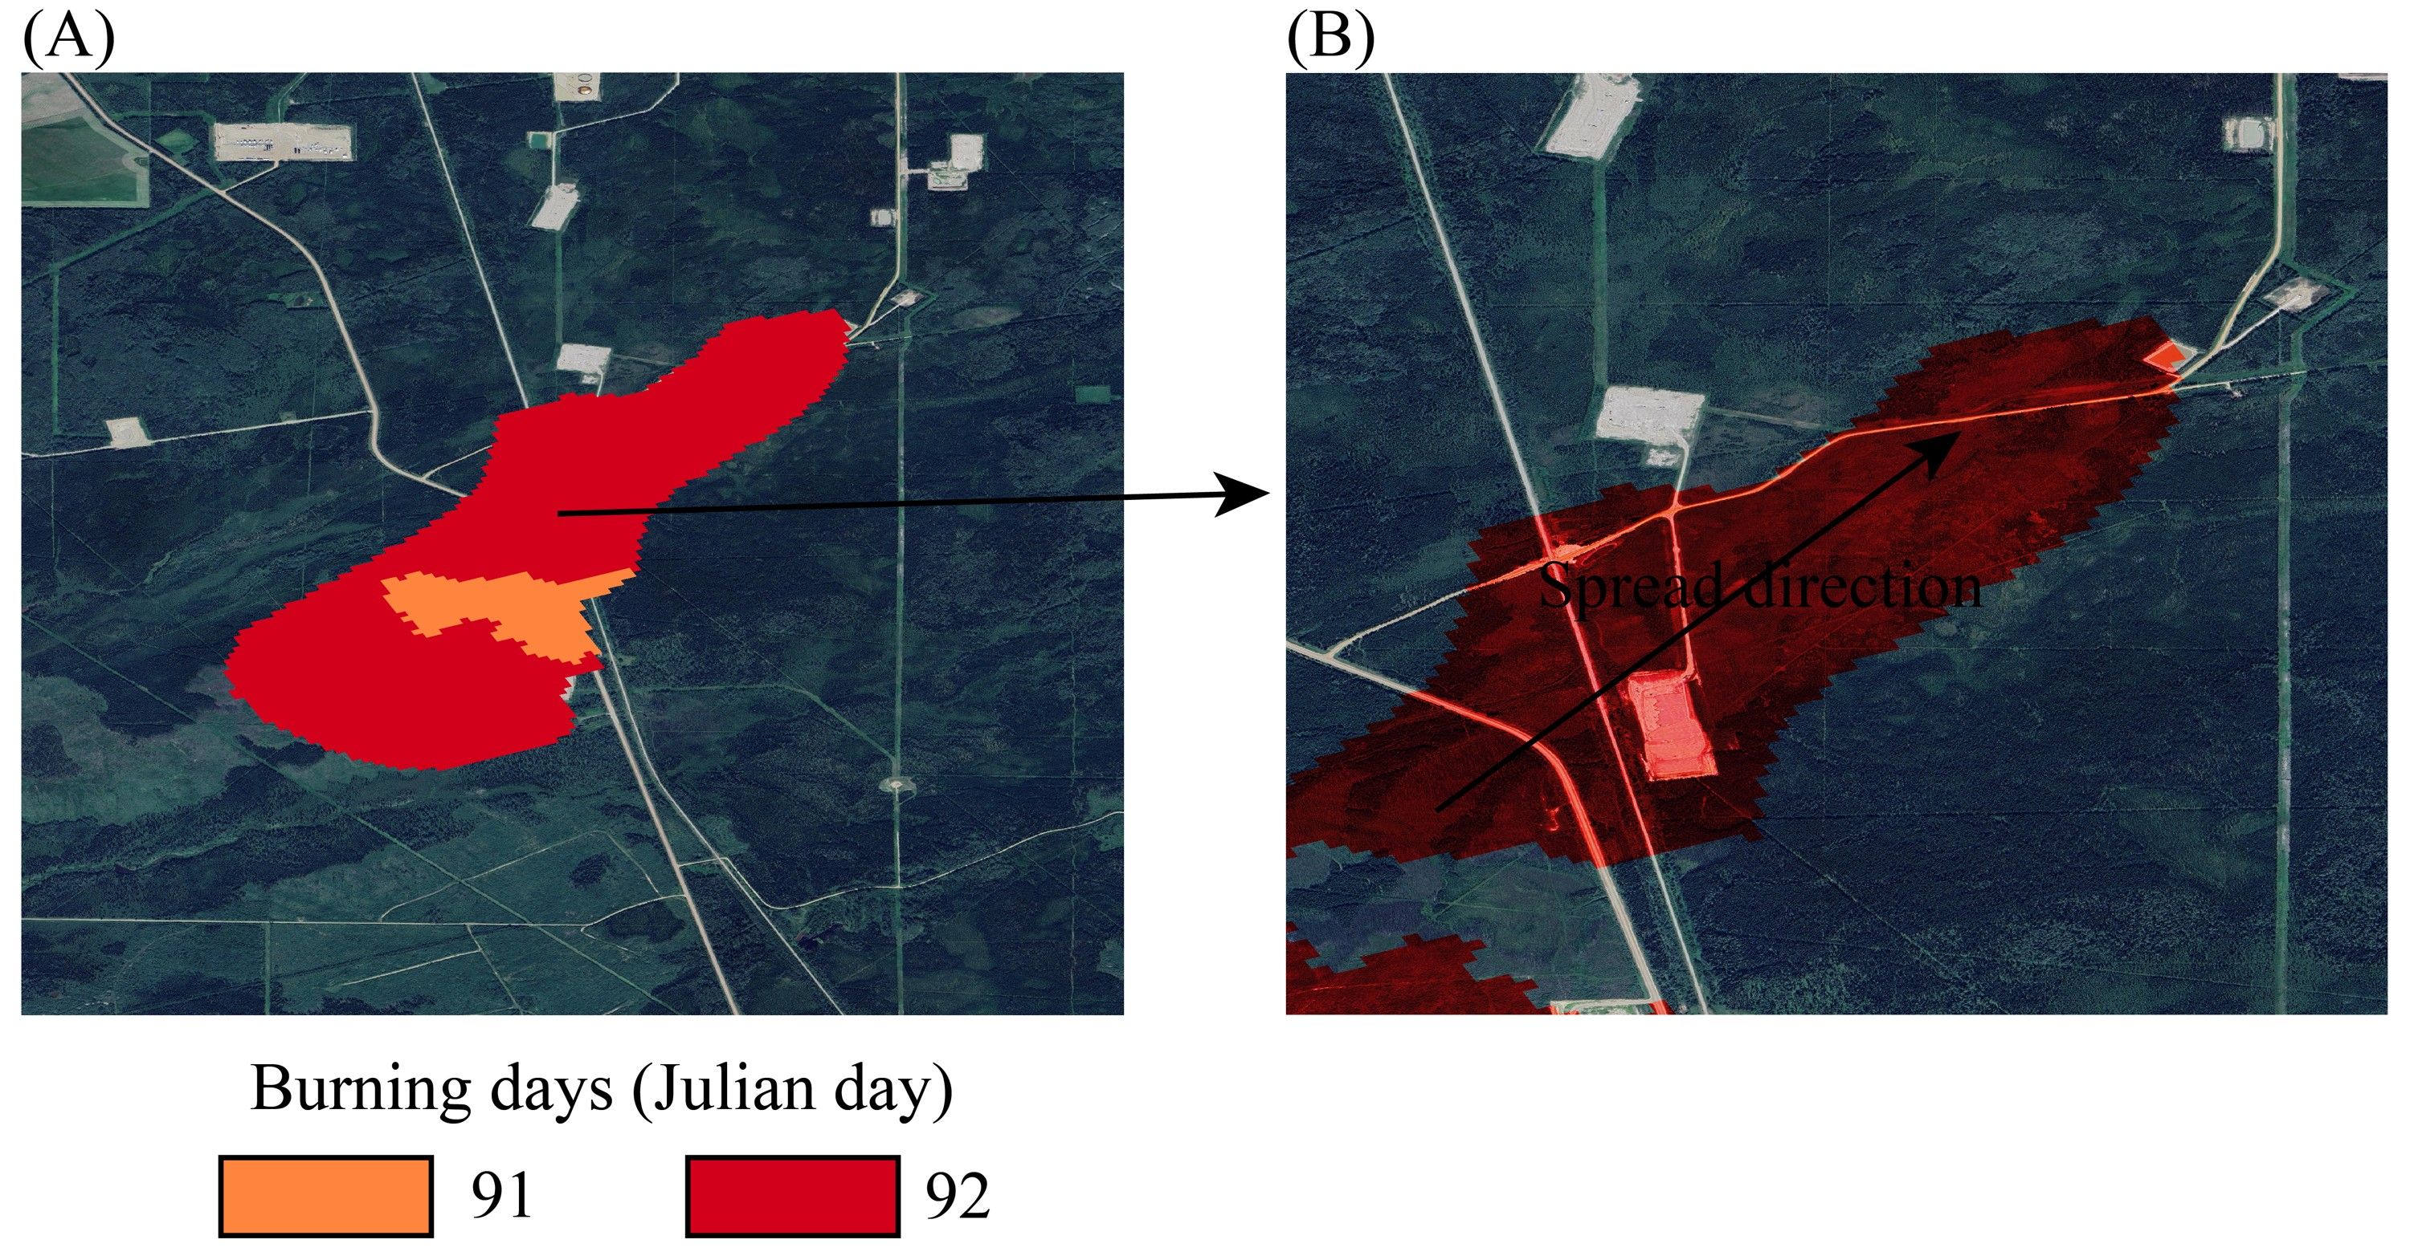
Fig. 11. Example of a fire breaching multiple firebreaks within a single burning day.
(A) Spatial distribution of fire ID 972_2016. (B) Spatial extent of the same fire on Julian day 92.

Table 10 Geographical features for Canada
Themes | Geographical features classes
Transport Features | Nautical facilities, track segments, track junctions, railway stations, track crossings, track marker posts, track structures, rail ferry segments, road segments, road ferry segments, road junctions, blocked passages, toll points, aerial cableway features, footbridges, trails, navigational aids, marinas and runways.
Administrative Features | Geopolitical regions (international, territorial and provincial) and populated place names
Hydro Features | Watercourses, water linear flow segments, hydrographic obstacles (falls, rapids, etc.), waterbodies (lakes, watercourses, etc.), permanent snow and ice features, water wells and springs
Land Features | Islands, shoreline delineation, wooded areas, saturated soil features, landform features (esker, sand, etc.)
Manmade Features | Dams, protection structures (breakwater, dike/levees), liquid storage facilities (basin, swimming pool, etc.), tanks, buildings, delimiting structures (fence, walls, etc.), landmark features (cross, radar, crane, forts, etc.), chimneys, towers, sewage pipelines, conduit bridges, waste, leisure areas, residential areas, commercial and institutional areas and ritual cultural areas (shrine, cemeteries, etc.)
Elevation Features | Elevation contours and elevation points
Resource Management Features | Power lines, communication lines, pipelines, valves, petroleum wells, wind-operated devices, transformer stations, ore extraction sites, aggregate extraction sites, peat extraction sites and oil and gas sites.
Toponymic Features | Proper nouns designating places and representations of the territory

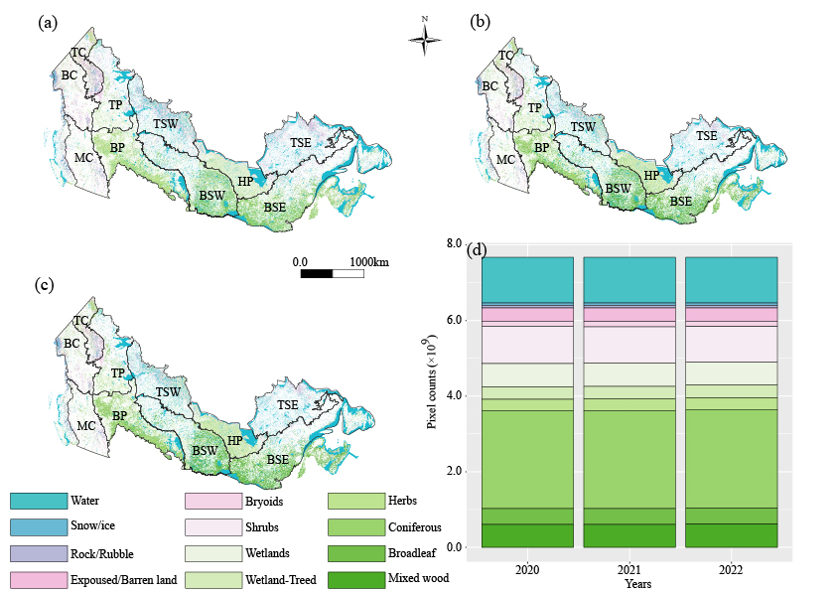
Fig. 12. Distribution of vegetation types over 2020-2022. Where (a)-(c) are land cover maps at 2020, 2021, and 2022, respectively. (d) is the stacked barchart of land cover counts for 2020-2022. Boreal Cordillera (BC), Boreal Plains (BP), Boreal Shield East (BSE), Boreal Shield West (BSW), Hudson Plains (HP), Montane Cordillera (MC), Taiga Cordillera (TC), Taiga Plains (TP), Taiga Shield East (TSE), and Taiga Shield West (TSW).

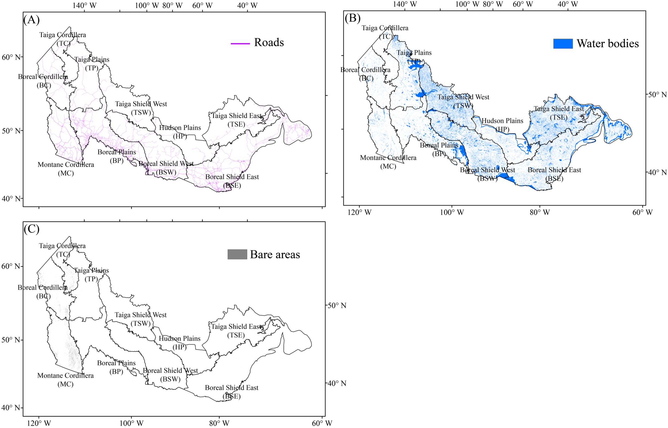
Fig. 13. Distribution of firebreak types across Canadian forests.
Three types were identified from geographical data: (A) roads, (B) water bodies, and (C) bare areas.

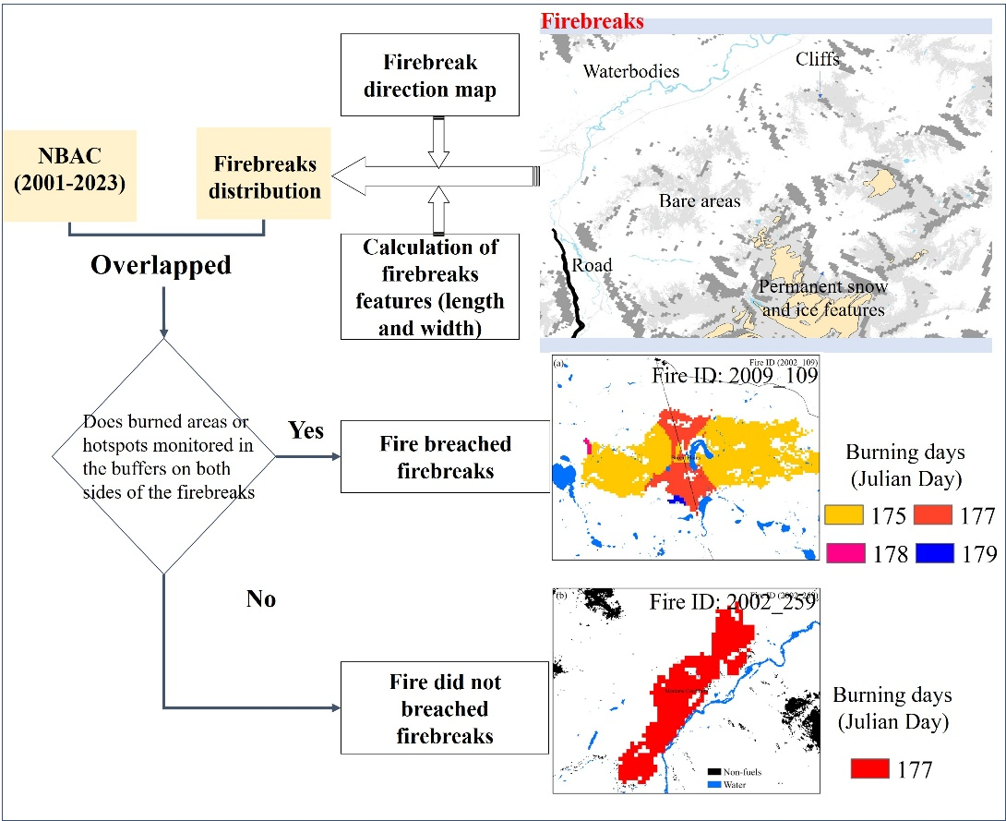
Fig. 14. Framework for identifying firebreak breaching events.
A conceptual workflow illustrating the process of identifying whether wildfires breached firebreaks. The framework integrates daily fire spread data, firebreak distribution, and spatial analysis (st_join function) to identify FBEs.

Table 11 Sampling points for modelling overall effectiveness of firebreaks and spotting-caused breaches across ecozones.
Ecozones | Non-breaching | Firebreak breaches | Spotting-caused breaches
Boreal Cordillera (BC) | 585 | 585 | 585
Boreal Plains (BP) | 1131 | 1131 | 1131
Boreal Shield East (BSE) | 498 | 498 | 498
Boreal Shield West (BSW) | 2766 | 2766 | 2766
Hudson Plains (HP) | 151 | 151 | 151
Montane Cordillera (MC) | 3258 | 3258 | 3258
Taiga Cordillera (TC) | 583 | 583 | 583
Taiga Plains (TP) | 1650 | 1650 | 1650
Taiga Shield East (TSE) | 357 | 357 | 357
Taiga Shield West (TSW) | 4583 | 4583 | 4583

Table 12 Difference in average model performance (F1-score) between logistic regression (LR) and generalized additive models (GAM) across 100 predictive models of firebreak breaches
Ecozones | LR model | GAM model
Boreal Cordillera (BC) | 0.74 | 0.70
Boreal Plains (BP) | 0.68 | 0.68
Boreal Shield East (BSE) | 0.83 | 0.80
Boreal Shield West (BSW) | 0.68 | 0.68
Hudson Plains (HP) | 0.83 | 0.82
Montane Cordillera (MC) | 0.67 | 0.65
Taiga Cordillera (TC) | 0.69 | 0.69
Taiga Plains (TP) | 0.78 | 0.75
Taiga Shield East (TSE) | 0.77 | 0.76
Taiga Shield West (TSW) | 0.69 | 0.68

Table 13 Mean F1-scores of ensemble models (n = 100) predicting firebreak breaches in ten ecozones, comparing the Youden-index-derived threshold and the conventional 0.5 threshold
Ecozones | Youden-index-derived threshold | conventional 0.5 threshold
Boreal Cordillera (BC) | 0.74 | 0.68
Boreal Plains (BP) | 0.68 | 0.62
Boreal Shield East (BSE) | 0.83 | 0.77
Boreal Shield West (BSW) | 0.68 | 0.62
Hudson Plains (HP) | 0.83 | 0.77
Montane Cordillera (MC) | 0.67 | 0.60
Taiga Cordillera (TC) | 0.69 | 0.62
Taiga Plains (TP) | 0.78 | 0.71
Taiga Shield East (TSE) | 0.77 | 0.72
Taiga Shield West (TSW) | 0.69 | 0.64

Table 14 Ensemble F1-scores for predicting firebreak breaches across ten ecozones using different numbers of top-ranked models
Ecozones | Single best model | Top 10 models | Top 20 models | Top 30 models | Top 40 models | Top 50 models | Top 60 models | Top 70 models | Top 80 models | Top 90 models | All 100 models
Boreal Cordillera (BC) | 0.74 | 0.75 | 0.76 | 0.74 | 0.73 | 0.74 | 0.73 | 0.74 | 0.74 | 0.74 | 0.74
Boreal Plains (BP) | 0.68 | 0.68 | 0.75 | 0.69 | 0.70 | 0.72 | 0.69 | 0.72 | 0.69 | 0.69 | 0.68
Boreal Shield East (BSE) | 0.79 | 0.82 | 0.88 | 0.79 | 0.80 | 0.84 | 0.79 | 0.79 | 0.79 | 0.79 | 0.83
Boreal Shield West (BSW) | 0.69 | 0.71 | 0.76 | 0.73 | 0.68 | 0.69 | 0.73 | 0.69 | 0.68 | 0.68 | 0.68
Hudson Plains (HP) | 0.82 | 0.86 | 0.90 | 0.84 | 0.82 | 0.84 | 0.86 | 0.83 | 0.82 | 0.84 | 0.83
Montane Cordillera (MC) | 0.66 | 0.66 | 0.70 | 0.65 | 0.67 | 0.64 | 0.64 | 0.63 | 0.65 | 0.66 | 0.67
Taiga Cordillera (TC) | 0.70 | 0.74 | 0.77 | 0.73 | 0.72 | 0.74 | 0.70 | 0.70 | 0.69 | 0.73 | 0.69
Taiga Plains (TP) | 0.76 | 0.75 | 0.83 | 0.78 | 0.75 | 0.76 | 0.77 | 0.78 | 0.76 | 0.78 | 0.78
Taiga Shield East (TSE) | 0.79 | 0.78 | 0.83 | 0.78 | 0.74 | 0.78 | 0.76 | 0.76 | 0.77 | 0.79 | 0.77
Taiga Shield West (TSW) | 0.70 | 0.68 | 0.74 | 0.67 | 0.68 | 0.70 | 0.70 | 0.68 | 0.68 | 0.69 | 0.69

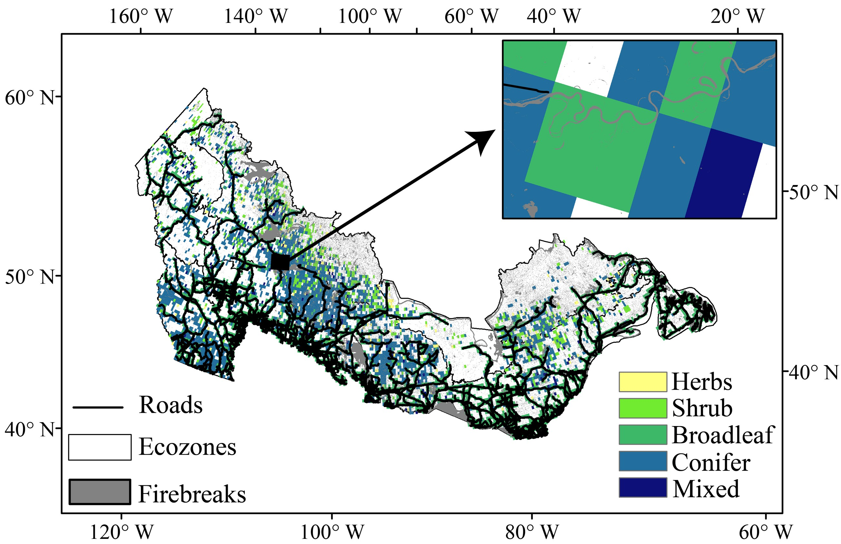
Fig. 15. Spatial distribution of firebreaks and their neighboring vegetated pixels across Canadian forests. Firebreaks include non-fuel areas, water bodies, and roads that potentially constrain wildfire spread. Adjacent vegetated pixels (0.25° resolution) were identified based on their spatial proximity to firebreaks and were used to predict FBEs days.
References
1 Natural Resources Conservation Service. Conservation Practice Standard: Firebreak (Code 394). Retrieved from https://efotg.sc.egov.usda.gov/api/CPSFile/15954/394_OK_CPS_Firebreak_2012. (2021).
2 Partners in Protection. FireSmart: Protecting Your Community from Wildfire, 2nd ed.; Partners in Protection: Edmonton, AB, Canada. (2003).
3 Shire of Augusta Margaret River. Requirements and Bushfire Information 2023–24 (https://www.amrshire.wa.gov.au/getmedia/4268e5f0-b5c1-4f24-8dd9-475dd99019b0/Firebreak-Notice-Requirements-and-Bushfire-Information-2023-24.pdf). (2023).
4 National Forestry and Grassland Administration. National Forest Fire Prevention Plan (2016) for 2016–2025. https://www.gov.cn/xinwen/2016-12/29/content_5154054.htm. (accessed 20 April 2025). (2016).
5 European fire protection associations. Forest Fire (CFPA-E Guideline No 6:2016 N) (https://cfpa-e.eu/app/uploads/2022/05/CFPA_E_Guideline_No_6_2016_N.pdf). (2016).
6 Sardoy, N., Consalvi, J.-L., Porterie, B. & Fernandez-Pello, A. C. Modeling transport and combustion of firebrands from burning trees. Combustion and Flame 150, 151-169, doi:https://doi.org/10.1016/j.combustflame.2007.04.008 (2007).
7 Albini, F. A., Alexander, M. E. & Cruz, M. G. A mathematical model for predicting the maximum potential spotting distance from a crown fire. International Journal of Wildland Fire 21, 609–627 (2012).
8 Pereira, J. C. et al. Calculation of spotting particles maximum distance in idealised forest fire scenarios. Journal of Combustion 2015, 513576 (2015).
9 Martin, J. & Hillen, T. The spotting distribution of wildfires. Applied Sciences 6, 177 (2016).
10 Mendez, A. & Farazmand, M. Quantifying rare events in spotting: How far do wildfires spread? Fire Safety Journal 132, 103630 (2022).
11 Tymstra, C., Bryce, R. W., Wotton, B. M., Taylor, S. W. & Armitage, O. B. Development and Structure of Prometheus: The Canadian Wildland Fire Growth Simulation Model Natural Resources Canada, Canadian Forest Service, Northern Forestry Centre, Information Report NOR-X-417, Edmonton, AB (2010). (2010).
12 Syphard, A. D., Keeley, J. E. & Brennan, T. J. Comparing the role of fuel breaks across southern California national forests. Forest Ecology and Management 261, 2038–2048 (2011).
13 Gannon, B. et al. A quantitative analysis of fuel break effectiveness drivers in Southern California National Forests. Fire 6, 104 (2023).
14 Weise, C. L. et al. A retrospective assessment of fuel break effectiveness for containing rangeland wildfires in the sagebrush biome. Journal of Environmental Management 341, 117903 (2023).
15 Ortega, M., Silva, F. R. Y. & Molina, J. R. Modeling fuel break effectiveness in southern Spain wildfires. Fire Ecology 20, 40 (2024).
16 Yu, Y. et al. Machine learning–based observation-constrained projections reveal elevated global socioeconomic risks from wildfire. Nature Communications 13, 1250 (2022).
17 Kuhn, M. Building predictive models in R using the caret package. Journal of Statistical Software 28, 1–26 (2008).

