Microaggression Simulation Debrief for Year 3 Curriculum

At this point, participants should be familiar with microaggression key concepts. They have also been exposed to a vast array of different themes of microaggressions. Participants should also be familiar with the OTFD framework. The goals of the year 3 curriculum are to 1) continue practicing using the OTFD framework to become proficient in responding to microaggressions, 2) start thinking about how microaggressions contribute to the larger context of health inequities, and 3) start applying systems thinking to identify solutions to make healthcare more inclusive for both patients and healthcare workers.

“Open the Front Door” (OTFD) Framework

OTFD: “Open the front door”

Principles:
Observe: concrete, factual, observable
Think: thoughts based on observation
Feel: emotions
Desire: request or inquire about desired outcome

Example:
“I noticed that you interrupted me when I was talking to the patient [observation of microaggression], which made me think that you didn’t believe what I had to say was important [thoughts based on observation]. I am frustrated [emotion] by this and hope that we can listen to each other more moving forward [desired outcome].”

Next Steps: Introduction to Systems Thinking

Ask: How do you think the microaggression in this case could contribute to health inequities for this patient? Allow learners to brainstorm about this a while (2 minutes).

Introduce the Systems Thinking Iceberg worksheet (print these out so each learner has one to work on, see separate document).

Introduce the iceberg and what each of the parts mean using the following:

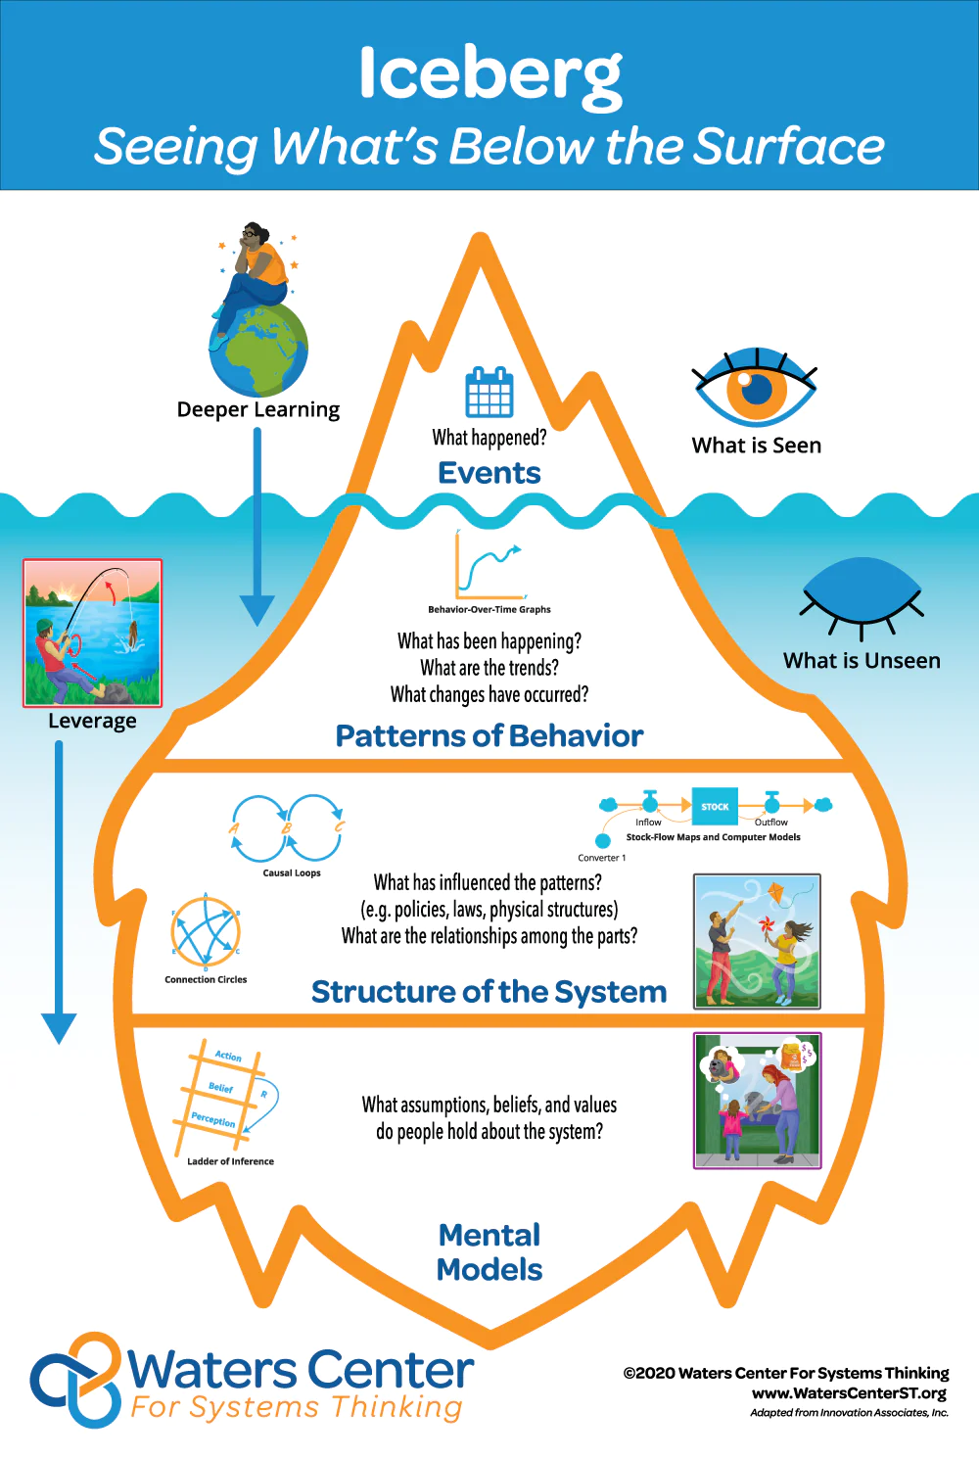

Have the learners work through the iceberg worksheet together using the microaggression and patient from today’s case.

Provide the learners with an example of how to apply the microaggression to this case and/or another one.

Have the learners come up with solutions to the gaps between where we are and where we would ideally like to be using the domains of Health Systems Science below.

