Obstetrical Trauma Includes Microaggression From Embedded Nurse to the Patient’s Wife
Adapted from EM Sim Cases & Case Written by Dr. Malia Moore, Indiana University SOM
Microaggression Content Developed by Dr. Nicole Novotny, Ochsner Medical Center and Dr. Andreia Alexander, Indiana University SOM

Case Description:
Patient is a 32-year-old G1P0 female at 34 weeks EGA brought in by EMS after a rollover MVC. Patient intubated by EMS prior to arrival and transported with cervical collar on a backboard. On arrival, the patient with be hemodynamically unstable. Bedside US will show a positive FAST with blood in Morrison’s pouch as well as a fetus measuring 34 weeks gestational age with decreased fetal movement and low fetal heart rate. Learners should recognize hemorrhagic shock as well as fetal distress and give blood products and consult surgery and obstetrics emergently for operative intervention.

Additionally, both the patient’s wife and brother will arrive, and the learners will be expected to update the family. The learners will also have to recognize and respond to a microaggression from the embedded nurse regarding the patient’s next of kin which is her wife (see microaggression script).

Supplies:
- High fidelity adult mannequin
- Moulage – female, appears gravid, bruises to lower abdomen, intubated and bagged by BVM, backboard, cervical collar
- Monitor
- PIV supplies
- Code cart with medications
- Airway equipment – nasal cannula, non-rebreather, bag-valve-mask, suction, laryngoscope (Mac 3 and 4), size 7.0 or 7.5 cuffed ET tube, stylet, bougie
- Ultrasound
- Blood for transfusion (if not available, can verbalize blood products and use IV fluid bags)
- Additional actors needed – patient’s wife and brother and embedded nurse

Supporting Files:
- Normal CXR
- Normal pelvis XR
- US clips (OB US clip not included but findings will be verbalized to learners when prompted)
- CT imaging (if ordered, radiology will call with results)
- Labs

Initial Presentation:
Patient is a 32-year-old G1P0 female at 34 weeks EGA brought in by EMS after a rollover MVC at 65 mph. Patient was restrained and unconscious on EMS arrival. After 20-minute extrication, patient intubated on scene for low GCS. Cervical collar was placed, and she was transported on a backboard. EMS has placed 1 large bore 18-gauge PIV and has given 500 cc NS en route. Upon arrival, the patient will be hemodynamically unstable and is being bagged by EMS.

ROS: Unable to obtain due to clinical condition (patient intubated)

PMH – no significant PMH, no prenatal complications
Meds – prenatal vitamin
PSH – appendectomy (age 14)
Family Hx – non-contributory
Social Hx – no alcohol, tobacco or illicit drug use
Allergies - NKDA
[Responses to history questions will only be provided if the learners specifically ask the patient’s wife. If the brother is asked, he will respond with “I don’t know. You would have to ask her wife.”]

PE
General – intubated and sedated
HENT – normocephalic, atraumatic
Eyes – pupils 3 mm bilaterally, PERRL
Spine – cervical collar in place, no step offs or deformities
Cardiovascular – tachycardic, regular rhythm, intact distal pulses in all extremities
Respiratory – breath sounds equal bilaterally
Abdomen – gravid, fundus palpated above the umbilicus
Genitourinary – normal external genitalia, no blood in the vaginal vault, os closed
Integumentary – scattered bruising to across the low abdomen
Neuro – normal rectal tone, sedated and paralyzed following RSI, GCS 3T

Branch Point Vitals:

- Initial vitals – HR 140, BP 70/40, RR per BVM, O2 sat 98%, temp 97F
- After IVF bolus given – HR 130, BP 80/60, RR per BVM/vent, O2 sat 98%
- After at least 2 units of blood given – HR 100, BP 110/80, RR per BVM/vent, O2 sat 100% (learners should ask for O negative blood to be emergently released but will not be available for approximately 2 minutes after initially ordering it)
- Vitals if not given blood transfusion – HR 160, BP 60/palp, RR per BVM/vent, O2 sat 93%

MICROAGGRESSION SCRIPT & BRANCH POINTS:

Microaggression Script [starts once the patient’s wife enters the room; the patient’s brother will enter 30 seconds into the case followed by the patient’s wife 1 minute into the case]

Nurse to patient’s wife: “Excuse me, but only immediately family members can be in here right now.”

Patient’s wife to nurse: “I’m her wife.”

Embedded nurse to patient’s wife: “Do you have papers to prove it? If not, you need to leave.

Patient’s wife to nurse: “No, I don’t have papers, but she is my wife.”

Embedded nurse to patient’s wife: Friends of patients always say this as an excuse so they can stay in the room.”

Patient’s brother to nurse: “This is her wife. She should be able to be here.”

[Nurse will go back to nursing tasks and both the patient’s wife and brother will stay in the room.]

The learner should respond to the microaggression using the “OTFD” framework. An example of a possible response using the “OTFD” framework that will be taught in the debrief is below.

Example Response from the Resident Learner to the Embedded Nurse: “I heard you tell the patient’s wife that she needed to leave if she could not provide proof that they were married [observation]. I think this statement assumes that they cannot be married because they are a same sex couple [thoughts]. I am disappointed [emotion] by this assumption, and I would like you to apologize to the patient’s wife and let her stay in the room [desired outcome].”

Microaggression Branch Points

- Proceed to #1 if the learner responds to the microaggression in a timely, appropriate and professional manner (i.e. does not use accusatory language or attacking statements, exhibits positive and open non-verbal responses)
- Nurse to patient’s wife: “I’m sorry that I assumed that you weren’t married. I should not make these assumptions. You are more than welcome to stay in the room with her.”

- Proceed to #2 if the learner does not respond to the initial microaggression OR the learner responds but gives a subpar response (i.e. uses accusatory language or attacking statements, exhibits negative and closed off non-verbal responses)
- Nurse to patient’s brother: “How far along is your she? Does she have any medical problems?
- Patient’s brother to nurse: “I don’t know. You need to ask her wife.”
- Patient’s wife to nurse: “She is 34 weeks today and doesn’t have any medical problems.”
- Nurse to resident learners: “Her “friend” said she is 34 weeks and doesn’t have any medical problems. [Nurse will use air quotes while saying the phrase friend]

- Proceed to #3 if the learner continues to not respond to the microaggressions or continues to provide a subpar response
- Nurse to resident learners: “I need to kick the “lady friend” out of the room. It’s too distracting with all these people in here.”
- Nurse to patient’s wife: “Excuse me, but you need to leave. We only allow next of kin to be in the room.”
- Patient’s wife to nurse: “Well I am her next of kin because she is my wife, and I’m not leaving her or our child.” [Wife will be upset and will be loud enough for the room the hear]

DISCUSSION:
In addition to managing a pregnant trauma patient, this case will also focus on responding to microaggressions in the clinical learning environment. Residents will be expected to quickly recognize the microaggression within the case and respond to the microaggression in an appropriate and professional manner. The resident must demonstrate the skill to handle this difficult situation.

The primary objectives of this case are the following:
- Perform a trauma resuscitation on a pregnant patient and review physiologic changes in pregnancy and trauma implications
- Review ATLS
- Respond to the microaggression in an appropriate and professional manner
- Discuss barriers to addressing microaggressions and review the OTFD framework

CRITICAL ACTIONS:
- Demonstrates a tailored approach to resuscitation in the pregnant trauma patient
- Recognize hemorrhagic shock and give blood products
- Recognize fetal distress and consult obstetrics
- Recognize and respond to the microaggression using the “OTFD” framework

ENDPOINT: The case will end after the resident has responded to the microaggression and has appropriately cared for the patient in this scenario or at the discretion of the faculty. The resident will be debriefed on both the medical aspects of the case as well as the microaggression curriculum content.

Supporting Files:

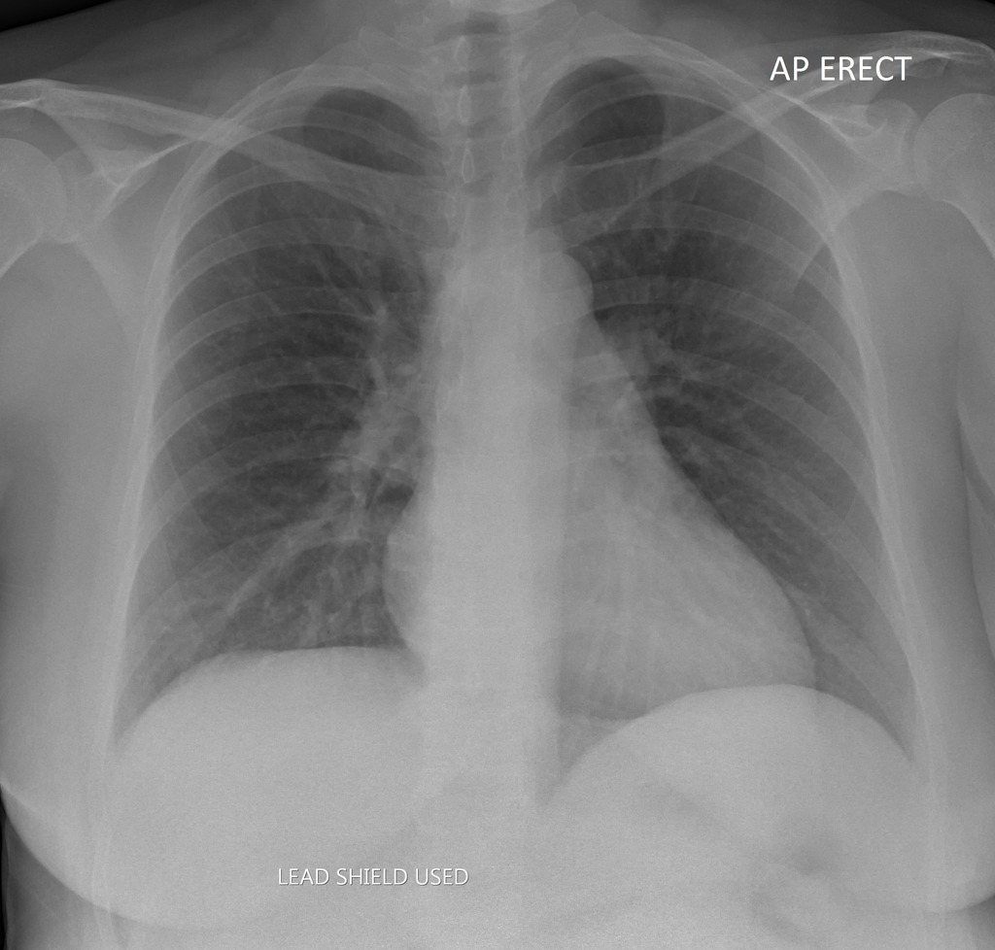

CXR with prominence of the vascular markings which can be normal in late pregnancy due to increased blood volume and cardiac output. Normal acute cardiopulmonary findings.
https://radiopaedia.org/cases/chest-x-ray-in-normal-pregnancy

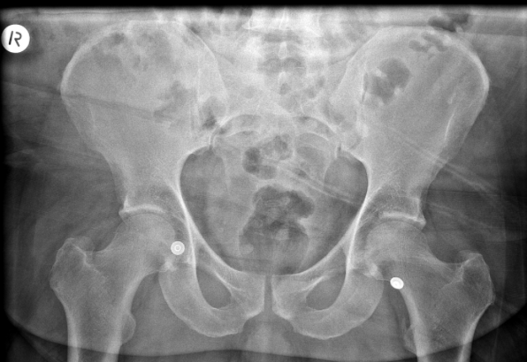

Normal pelvis XR (note that it does not include a fetus but should for the purposes of this case)
https://radiopaedia.org/cases/normal-trauma-chest-and-pelvis-x-rays?lang=us

US Clips for FAST Exam
- Normal lung sliding on US (play link)
https://www.youtube.com/watch?v=YGxYjpaudXc
- Normal subxiphoid pericardial US (see picture below)
https://www.saem.org/about-saem/academies-interest-groups-affiliates2/cdem/for-students/online-education/m3-curriculum/bedside-ultrasonagraphy/fast-exam
- RUQ US positive for free fluid (see picture below)
https://emsimcases.com/2016/08/30/obstetrical-trauma/
- Normal LUQ US (see picture below)
https://www.saem.org/about-saem/academies-interest-groups-affiliates2/cdem/for-students/online-education/m3-curriculum/bedside-ultrasonagraphy/fast-exam
- Does not include OB US which will show 34-week fetus with minimal movement and HR 90 (which will be verbalized)
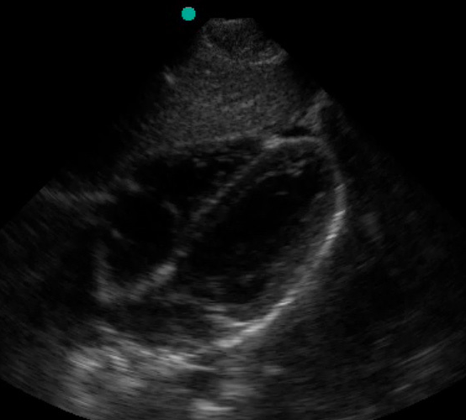

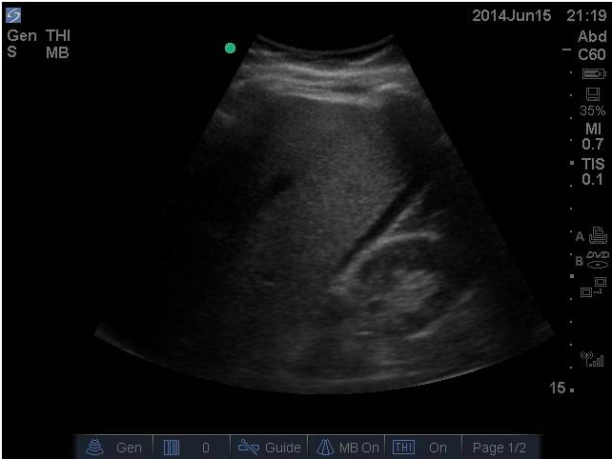

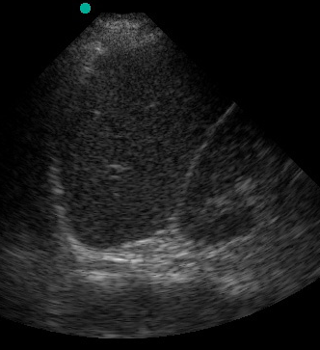

Patient will not be stable enough for CT, however, if ordered, radiology will call with the following results:
- CT Head: No acute intracranial process
- CT C-spine: No acute injury
- CT Chest/Abdomen/Pelvis: Bilateral pulmonary contusions, moderate free fluid in abdomen, grade IV liver laceration, left ribs 3,4, 8-10 fractures, pregnant with fetus in the 3rd trimester

Lab Values & Reference Ranges

POC Glucose 100

Sodium 140 (136-145)
Potassium 4.0 (3.5 – 5.1)
Chloride 105 (98 – 107)
CO2 20 (22-30)
BUN 12 (6-20)
Creatinine 0.8 (0.6-1.4)
Glucose 100 (70-100)
Calcium 9.5 (8.7-10.5)
Total protein 7.1 (6.0-8.4)
Albumin 4.1 (3.5-5.2)
Total Bili 0.4 (0.1-1.0)
Alk phos 75 (55-135)
AST 30 (10-40)
ALT 35 (10-44)

WBC 11,000 (4-11,000)
HGB 10 (12-15)
HCT 30 (36-45)
PLT 210 (100-250)

PT 10 (10-14 sec)
PTT 20 (20-40 sec)
INR 1.0

Lactate 1.2 (0-1.5)

pH 7.38 (7.35-7.45)
pCO2 38 (35-45)
pO2 80 (80-100)
HCO3 25 (24-28)

Type & screen - O pos

ETOH < 10

UDS negative

UA negative

