Septic Shock from Fournier’s Gangrene Includes Microaggression From Embedded Nurse
Adapted from Case Written by Simulation Faculty at Indiana University SOM
Microaggression Content Developed by Dr. Nicole Novotny, Ochsner Medical Center and Dr. Andreia Alexander, Indiana University SOM

Case Description:
The patient is a 75-year-old male brought in from a nursing home (NH) by EMS for altered mental status (AMS). EMS was in a hurry and left behind a pile of paperwork from the NH that must be reviewed. The paperwork does not include a code status, but it will have all the patient’s medical history. Upon arrival, the patient will be in septic shock from Fournier’s gangrene with impending respiratory failure. The learners are expected to call the nursing home to confirm the patient’s code status which is FULL CODE. The patient will not improve without airway management, IV fluid resuscitation and antibiotics, and treatment of hypoglycemia. The patient will ultimately require pressors and surgical consultation for source control.

Additionally, the learners will also have to recognized and respond to a microaggression from the embedded nurse regarding the patient’s code status and age (see microaggression script).

Supplies:
- High fidelity adult sim mannequin
- Monitor
- PIV supplies
- Code cart
- Airway equipment – nasal cannula, non-rebreather, bag-valve-mask, suction, laryngoscope (Mac 3 and 4), size 7.0 or 7.5 cuffed ET tube, stylet, bougie
- Moulage – mannequin should be dressed in a hospital gown and pants and should have moulage to look like skin changes consistent with Fournier’s gangrene in the perineum/genital region, nursing home paperwork should also be present at bedside

Supporting files:
- EKG (sinus tachycardia)
https://litfl.com/sinus-tachycardia-ecg-library/
- Initial CXR (normal)
https://radiopaedia.org/cases/normal-cxr-and-lateral?lang=us
- Post-intubation CXR
https://emcow.files.wordpress.com/2012/11/normal-intubation2.jpg
- Head CT (normal) – pull up on computer in room for learner to interpret
https://radiopaedia.org/cases/normal-ct-head-2?lang=us
- If POCUS used to perform RUSH exam – verbalize results as normal except hyperdynamic left ventricle and collapsible IVC
- Labs: POC glucose, ISTAT, VBG, lactate, CBC, CMP, urinalysis, troponin, BNP, TSH
- Nursing home paperwork (separate file)

Initial Presentation:
The patient was brought in by EMS from a nursing home for altered mental status. Per EMS report, patient is normally able to ambulate with a walker and is oriented to person at baseline due to dementia. Over the last two days, the patient has seemed more confused than usual. On rounds this morning, the patient was found in bed minimally responsive. He seemed globally weak, and nursing staff was concerned about his elevated heart rate, so they called EMS.

ROS: Unable to obtain

History below only obtained from NH paperwork or call to NH
PMH – dementia, HTN, DMII, hyperlipidemia, hypothyroidism, osteoarthritis
Meds – memantine, lisinopril, amlodipine, metformin, atorvastatin, levothyroxine, hydrocodone
PSH – inguinal hernia repair, appendectomy, left hip replacement
Allergies – penicillin (rash)

PE
General – Elderly male, occasionally moans, smells of urine
HENT – Normocephalic, atraumatic, membranes dry, nares patent
Eyes – Pupils 3 mm bilaterally and equal, round, and reactive to light
Neck – No JVD, trachea midline, no lymphadenopathy, no nuchal rigidity
Lungs – Tachypneic, clear breath sounds bilaterally, no retractions, nasal flaring, or accessory muscle usage
Cardiovascular – Tachycardic, regular rhythm, decreased capillary refill, thready pulses, no M/R/G
Abdomen – Soft, non-distended, no response to palpation, normal bowel sounds
Neurological – GCS 8 (E2/V2/M4) – opens eyes to pain only, making incomprehensible sounds, flexion withdraw from pain, no unilateral weakness noted, does not follow commands, no facial droop
Skin – Warm, dry, no skin breakdown over the sacrum, rash/crepitus over the perineum and groin area consistent with Fournier’s gangrene

Branch Point Vitals:

- Initial vitals – HR 135, BP 65/40, RR 28, sats 87% on RA, temp 98F axillary but 101.5F rectally (by request only), wt. 70 kg
  - IV, O2, monitor, FSG
  - Review history and communicate with EMS and NH for clues to AMS
  - Obtain code status (FULL CODE)
  - Expose and roll patient
  - Administer D50 for hypoglycemia
  - Administer rectal acetaminophen for fever
  - Treat septic shock with IV fluid boluses (30 cc/kg x 70 kg = 2,100 cc)
  - Order broad spectrum antibiotics (avoiding PCN due to allergy!)
  - Intubate for airway protection
  - Discuss differential diagnoses and order diagnostic workup

- Vital sign changes after intubation and initial IV fluid resuscitation (at least 2L IV fluid) –
HR 130, BP 75/45, RR per vent, sats 98% on the vent, repeat glucose 140 if D50 given
          - Start pressors for hypotension refractory to IV fluid resuscitation
          - Review labs and imaging
          - Repeat FSG assuming D50 appropriately given
          - Consult ICU for septic shock
          - Consult general surgery for source control for Fournier’s gangrene

- Vitals after pressors initiated – HR 110, BP 100/60, RR per vent, sats 98% on the vent, temp 99F rectally (if antipyretic given)

- Vitals sign changes with inappropriate interventions –
- Patient will have continued hypotension with BP 60/35 until he is fluid resuscitated and pressors are initiated
- Patient will have worsening respiratory failure with RR 30 and sats 82% despite other methods of oxygenation until intubated

Additional Cues/Prompts:
- If BiPAP attempted, the nurse will alert the learners that the patient has vomited in the mask.
- If PCN given, the nurse will notice diffuse hives on the patient and notify the learners.
- If Fournier’s gangrene is not discovered and patient not fully exposed by the time ICU is called for admission, the nurse will state, “I was getting a cath urine specimen, and the patient’s perineum looks worrisome.”

MICROAGGRESSION SCRIPT & BRANCH POINTS:

Microaggression Script [starts when the learner mentions obtaining the patient’s code status or prompted by the nurse if the learner attempts to intubate the patient without obtaining the code status]

Nurse to learner (if the learner mentions obtaining the code status): “This patient looks like they should be a DNR.”

OR

Nurse to learner (if the learner attempts to intubate the patient without obtaining the code status): “I think you should probably obtain a code status before you intubate this patient because they look like they should be a DNR.”

The learner should respond to the microaggression and encourage the nurse to be respectful of the wishes of the patient and his or her family members. An example of a possible response using the “OTFD” framework that will be taught in the debrief is below.

Example Response from the Learner to the Nurse: “I heard you say that the patient looked like they should be a DNR [observation]. I think that statement stereotypes the elderly and assumes that their lives are less valuable [thoughts based on the observation]. I am upset [emotion] by this assumption, and I hope that you will treat your patient with respect [desired outcome].”

Microaggression Branch Points

- Proceed to #1 if the learner responds to the microaggression in a timely, appropriate and professional manner (i.e. does not use accusatory language or attacking statements, exhibits positive and open non-verbal responses)
- Nurse to learner: “I’m sorry if I upset you. The patient deserves more respect than that.”

- Proceed to #2 if the learner responds to the initial microaggression but gives a subpar response (i.e. uses accusatory language or attacking statements, exhibits negative and closed off non-verbal responses)
- Nurse to learner: “I’m sorry, but this patient looks ancient and should be a DNR.”

- Proceed to #3 if the learner does not respond to the initial microaggression or continues to provide a subpar response
- Nurse to learner [if code status not obtained] “I can’t believe you are going to intubate this patient. I guess the family will get to keep getting their disability checks.”
- Nurse to learner: [if code status is obtained]: “I can’t believe this patient is full code. I guess the family just wants to keep getting their disability checks.”

DISCUSSION:
This case will focus on responding to microaggressions in the clinical learning environment. Residents will be expected to quickly recognize the microaggression within the case and respond to the microaggression in an appropriate and professional manner. The resident must demonstrate the skill to handle this difficult situation.

The primary objectives of this case are the following:
- Recognize the microaggression
- Respond to the microaggression in an appropriate and professional manner
- Review the “OTFD” framework for responding to microaggressions

CRITICAL ACTIONS:
- Recognize Fournier’s gangrene and treat septic shock, consult general surgery and admit to the ICU
- Communicate with nursing home and define the patient’s code status
- Recognize the microaggression
- Respond to the microaggression using the “OTFD” framework

ENDPOINT: The case will end after the resident has responded to the microaggression and has appropriately cared for the patient in this scenario or at the discretion of the simulation faculty. The resident will be debriefed on recognizing and responding to microaggressions using the “OTFD” framework.

Supporting Files:

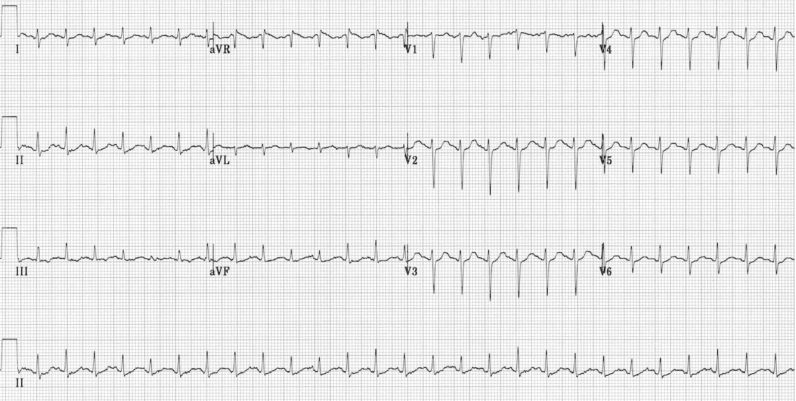

EKG with sinus tachycardia - https://litfl.com/sinus-tachycardia-ecg-library/

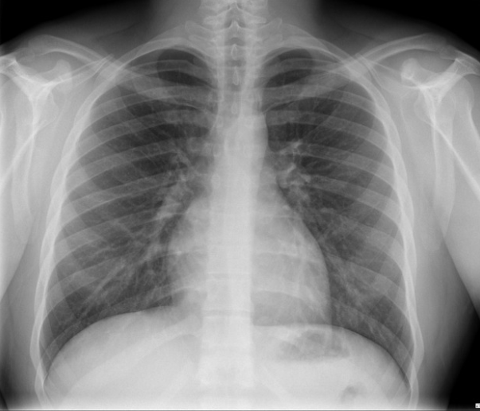

Normal initial chest XR - https://radiopaedia.org/cases/normal-cxr-and-lateral?lang=us

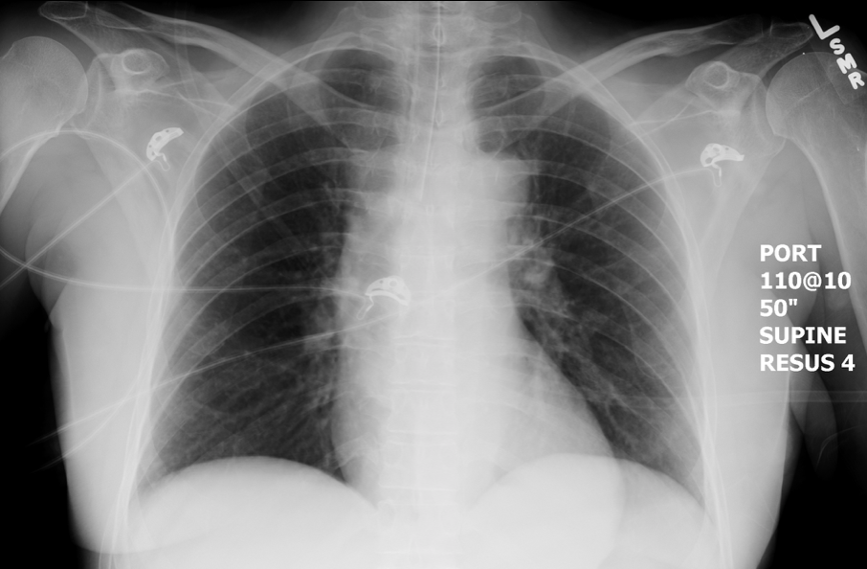

Normal post-intubation chest XR - https://emcow.files.wordpress.com/2012/11/normal-intubation2.jpg

Lab Values

POC Glucose 61

ISTAT Chem8+
Na 132
K 4.9
Cl 108
iCa 1.1
CO2 11
BUN 46
Cr 2.1
Hct 33

VBG
pH 7.2
pCO2 35
Bicarb 11
BE -16
pO2 35

POC Lactate 4

CBC
WBC 26,000
HGB 11
HCT 33
PLT 480,000

CMP
Sodium 132
Potassium 4.9
Chloride 108
CO2 11
Glucose 61
BUN 46
Cr 2.1
Calcium 10.1
GFR 35
Bilirubin 0.9
Albumin 3.1
AST 42
ALT 61

Troponin < 0.06

BNP 110

TSH 3.1

UA
Color Straw colored
Specific gravity 1.01 (1.003-1.030)
pH 7.0 (4.5-8)
Leukocyte esterase Small
Nitrites Negative
Protein Negative
Glucose Negative
Ketones Positive
Urobilinogen 0.3 (0.1-1.0)
Bilirubin Negative
Hemoglobin Negative
WBC 3 (0-5 per hpf)
RBC 1 (0-1 per hpf)
Bacteria Negative

