Infant Hyponatremic Seizure Includes Microaggression From Embedded Medical Student
Adapted from Case Written by Dr. Malia Moore, Indiana University SOM
Microaggression Content Developed by Dr. Nicole Novotny, Ochsner Medical Center and Dr. Andreia Alexander, Indiana University SOM

Case Description:
The patient is a premature infant with a viral prodrome who will be found to have hyponatremic seizures from formula dilution. The learners should have immediate concern for an ill infant and evaluate for potential causes of seizure. Important points will be the patient’s lack of return to baseline and current afebrile status.

Additionally, the learners will also have to recognize and respond to a microaggression from the embedded medical student that is directed towards the parents of the patient (see microaggression script).

Supplies:
- Sim baby mannequin (with seizure capability)
- Monitor
- PIV supplies
- Code cart
- Airway equipment
- Broselow tape
- Dextrose (D10, 25, 50)
- 3% saline
- Ativan, fosphenytoin, phenobarbital, keppra
- Infant LP trainer

Supporting files:
- EKG with sinus tachycardia
- Normal infant chest XR
- Labs: POC glucose, CBC, BMP, VBG, lactate, urinalysis

Initial Presentation:
The patient is a 3-month-old infant brought in for an episode of shaking at home. Currently appears post-ictal. EMS gave 2 mg of diazepam rectally, and the seizure activity seemed to stop, but the child has not returned to normal mental status.

Further history from parent: The patient was born slightly premature and had a 10-day NICU stay but has been well since. She has had diarrhea over the last few days and rhinorrhea without fever. She vomited twice yesterday and once this morning but still fed an additional bottle after.

ROS: positive for seizure-like activity, diarrhea, vomiting, rhinorrhea; otherwise, all other ROS negative

PMH – born preterm at 35 weeks otherwise normal birth history, no infections, formula fed 4 ounces q4h
Meds – none
PSH – none
Allergies – NKDA

PE
General – Lethargic infant with poor tone and occasional grunting
HEENT – Normocephalic, atraumatic, normal fontanelle, normal TMs bilaterally, nares patient, MMM
Lungs – Occasional grunting, no pooling of secretions, lungs clear
Cardiovascular – Tachycardic, no M/R/G
Abdomen – Soft, non-distended, no HSM
Genitourinary – Normal
Neurological – Hypotonic, depressed mental status
Skin – Warm, dry, no rash

Branch Point Vitals:

- Initial vitals – HR 170, BP 70/50, RR 30, Temp 97F, SpO2 95% on room air
- If given IV fluid bolus – HR 150, BP 85/62
- If placed on supplemental oxygen – SpO2 100%

MICROAGGRESSION SCRIPT & BRANCH POINTS:

This case is different from our previous microaggression simulated encounters in that the resident will have a medical student with them for the encounter. The medical student will play the role of microaggressor in the scenario. Prior to the case, the learners should be pre-briefed that they will have a medical student that will be participating in the case with them today.

Microaggression Script [starts either when the learner recognizes hyponatremia and asks the parent about how the formula is being given to the patient OR when the learner goes to admit the patient if never asks about formula; the case should not conclude until one of these occur so that the microaggression can take placer; if labs are not ordered initially by the learner, the nurse in the room can prompt them to obtain labs]

Once the parent is asked about the formula by the resident learner:

Parent to resident: “I have been diluting the formula and giving extra water” (he or she does not explicitly state why)

Implanted medical student: ”Oh, so you don’t have enough money to buy formula?”

Parent response: “No, it’s because I’m trying to prevent him/her (the patient) from being dehydrated” (parent will seem annoyed)

The learner should respond to the microaggression and encourage the medical student to treat the patient’s family with respect. An example of a possible response using the “OTFD” framework that will be taught in the debrief is below.

Example Response from the Resident Learner to the Medical Student: “I heard you say that the patient’s mom does not have enough money to buy formula [observation]. I think that statement assumes that they are of a low socioeconomic status without actually knowing their situation [thoughts based on the observation]. I am disappointed [emotion] by this assumption, and I hope that you will seek to understand your patients’ situations before making assumptions in the future [desired outcome].”

Microaggression Branch Points

- Proceed to #1 if the learner responds to the microaggression in a timely, appropriate and professional manner (i.e. does not use accusatory language or attacking statements, exhibits positive and open non-verbal responses)
- Medical Student: “I’m sorry if I upset you. I should not make assumptions and will make sure to try to understand the situation better in the future.”

- Proceed to #2 if the learner does not respond to the initial microaggression OR the learner responds but gives a subpar response (i.e. uses accusatory language or attacking statements, exhibits negative and closed off non-verbal responses)
- Medical Student: “I know sometimes you people will dilute the formula to save money. Is that what’s going on here?”

- Proceed to #3 if the learner continues to not respond to the microaggressions or continues to provide a subpar response
- Medical Student to Resident: “Do you think they can even take care of this child if they won’t pay for formula? They are probably buying cigarettes instead.”
OR

If the resident learner does not ask about formula even after recognition of hyponatremia, proceed to the script below. The medical student should state the microaggression prior to admission for timing purposes.

Medical Student to Parent: “I know sometimes you people will dilute the formula to save money. Is that what’s going on here?”

[The parent will then have the same response as above]

DISCUSSION:
This case will focus on responding to microaggressions in the clinical learning environment. Residents will be expected to quickly recognize the microaggression within the case and respond to the microaggression in an appropriate and professional manner. The resident must demonstrate the skill to handle this difficult situation.

The primary objectives of this case are the following:
- Recognize the microaggression
- Respond to the microaggression in an appropriate and professional manner
- Review the “OTFD” framework for responding to microaggressions

CRITICAL ACTIONS:
- Recognize and appropriately treat hyponatremia induced seizures in an infant
- Develop a broad differential for hyponatremia in pediatric patients including formula dilution
- Recognize the microaggression
- Respond to the microaggression using the “OTFD” framework

ENDPOINT: The case will end after the resident has responded to the microaggression and has appropriately cared for the patient in this scenario or at the discretion of the simulation faculty. The resident will be debriefed on recognizing and responding to microaggressions using the “OTFD” framework.

Supporting Files:

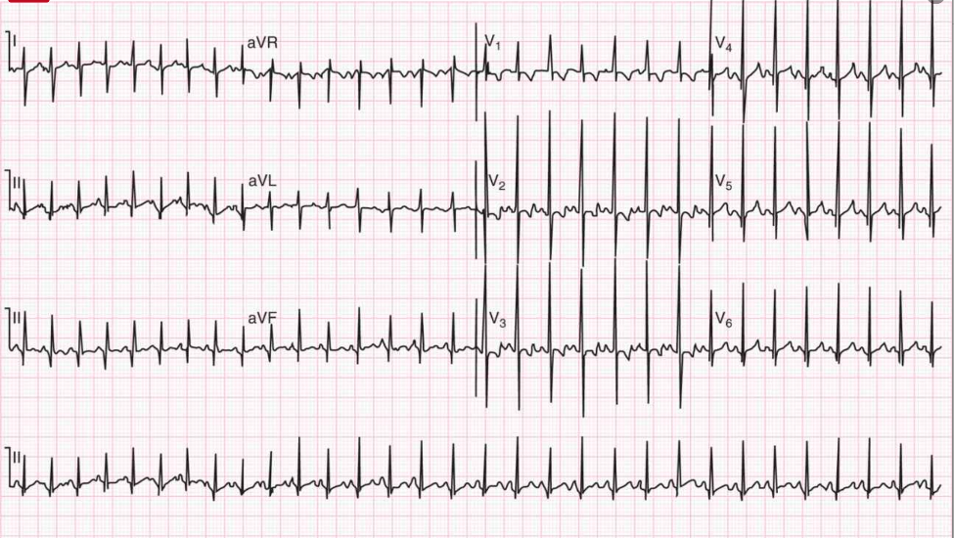

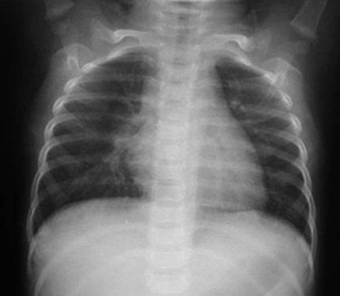
Normal infant chest XR - https://radiopaedia.org/?lang=us

Lab Values

POC glucose 112

CBC
WBC 7,000
HGB 16
HCT 40
PLT 350,000

BMP
Sodium 117
Potassium 5.0
Chloride 104
CO2 16
BUN 6
Glucose 110

VBG
pH 7.32
pCO2 36
Bicarb 16

Lactate 4.0

Urinalysis: Normal

