Supplementary material
Figure S1. Survey participation
Baseline | 14-day follow-up
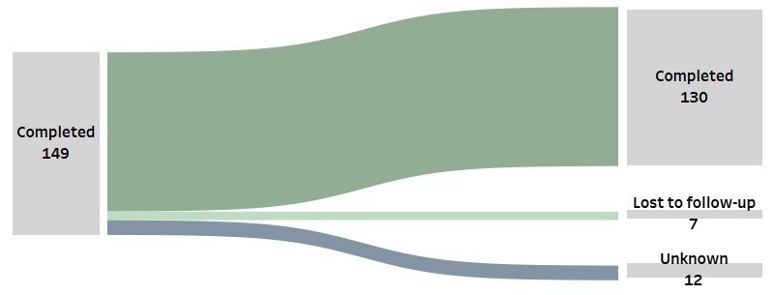

Figure S2. Adjusted Spearman’s correlation of EDI measurements and anchors
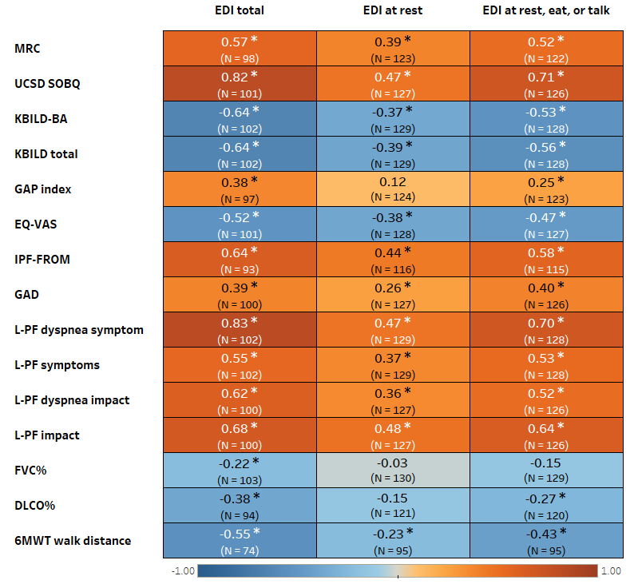
* represents statistically significant.

Table S1. Change in baseline Total EDI score in patients with varying self-reported dyspnea severity
Variable* |  | N | EDI total | Mean difference | p Value†
PGI-S | Normal | 23 | 6.0 ± 6.1 | (ref.)
 | Mild | 61 | 18.9 ± 11.8 | 12.9 (4.1, 21.6) | 0.0009
 | Moderate | 30 | 29.6 ± 13.8 | 23.6 (13.3, 33.9) | <.0001
 | Severe | 16 | 37.5 ± 14.5 | 31.5 (19.2, 43.9) | <.0001
 | Missing | 19 | 20.7 ± 11.5 | 14.7 (2.4, 27.1) | 0.0108
*Normal = normal; mild = borderline or mildly; moderate = moderate; severe = markedly severe or very severe.
†Tukey pairwise comparisons for mean differences to adjust for multiple comparisons.

Figure S3. Unadjusted and adjusted Spearman’s correlation of changes in EDI measurements and anchor change scores
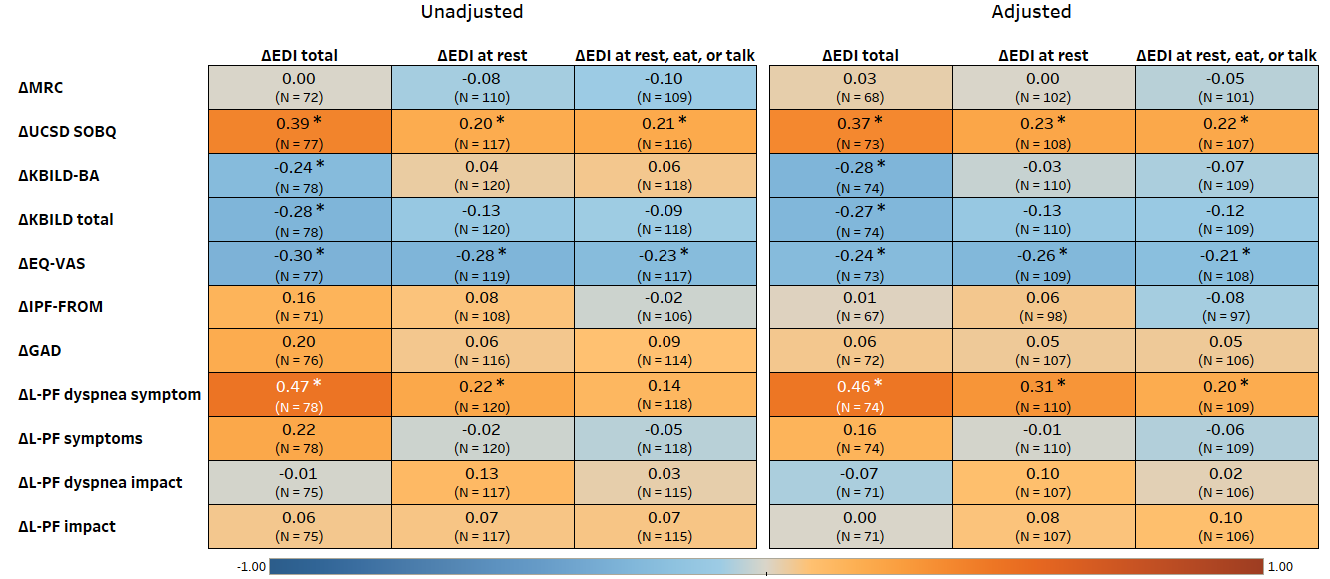
Adjusted: Adjusted for age, sex, BMI, education level, anxiety or depression symptom, and white ethnicity.
L-PF impact 2: impacts Total Score (dyspnea + cough + fatigue+ global) / 4.
* represents statistically significant.

Table S2. EDI measurements and anchors at baseline and 14-day follow-up
Variable | Baseline | 14-day follow-up
EDI total | 20.7 ± 14.6, 18 (9-31) | 18.3 ± 15.9, 13 (6-29)
EDI at rest | 1.0 ± 1.5, 0 (0-2) | 1.0 ± 1.6, 0 (0-1)
EDI at rest, eat, or talking | 4.4 ± 4.5, 3 (0-7) | 4.2 ± 4.8, 3 (0-7)
MRC | 2.7 ± 1.1, 2 (2-4) | 2.6 ± 1.1, 2 (2-3)
UCSD SOBQ | 39.7 ± 25.6, 34 (20-57) | 38.1 ± 26.6, 33 (16-60)
KBILD-BA | 42.3 ± 18.0, 42 (33-50) | 43.4 ± 20.4, 42 (33-53)
KBILD total | 56.4 ± 13.1, 55 (50-64) | 57.4 ± 14.8, 56 (50-65)
EQ-VAS | 62.5 ± 21.6, 64 (50-80) | 63.5 ± 19.6, 65 (50-80)
IPF-PROM | 24.7 ± 7.8, 24 (19-30) | 24.4 ± 8.3, 23 (19-31)
GAD | 4.0 ± 4.6, 3 (0-6) | 3.9 ± 4.3, 3 (0-6)
L-PF dyspnea symptom | 21.5 ± 19.1, 17 (4-38) | 20.7 ± 19.6, 16 (4-33)
L-PF symptom | 33.4 ± 13.3, 31 (23-43) | 31.7 ± 13.4, 30 (22-40)
L-PF dyspnea impact | 44.1 ± 22.2, 42 (25-63) | 43.1 ± 20.1, 38 (29-54)
L-PF impactª | 40.9 ± 17.2, 38 (26-53) | 39.4 ± 16.1, 37 (27-52)
* Generalized Estimating Equations (GEE) model testing for mean difference.
ª L-PF impact: impacts Total Score (dyspnea + cough + fatigue+ global) / 4.

