Table A1. Descriptive statistics
variable | N | Mean | SD | Min | P25 | Median | P75 | Max
Network spillover centrality (Net_sd_centrality) | 1436 | 0.69 | 0.32 | 0.32 | 0.46 | 0.61 | 0.78 | 1.73
Inward spillover exposure (SpilloverIN) | 1436 | 0.64 | 0.21 | 0.11 | 0.48 | 0.68 | 0.82 | 1.00
Industrial production growth (d_ip) | 1436 | 0.05 | 1.37 | -14.14 | -0.28 | 0.10 | 0.49 | 6.35
Oil price change (d_oil) | 1436 | -0.22 | 10.64 | -55.09 | -5.30 | 0.94 | 5.34 | 53.67
Policy rate change (d_rate) | 1436 | 0.02 | 0.15 | -0.93 | 0.00 | 0.00 | 0.02 | 0.70
Unemployment-rate change (d_unrate) | 1436 | -0.03 | 0.83 | -2.20 | -0.10 | 0.00 | 0.10 | 10.40
Temperature anomaly (temp_anom) | 1436 | 0.92 | 0.22 | 0.47 | 0.78 | 0.88 | 1.07 | 1.48
Temperature change (temp_change) | 1436 | 0.09 | 0.07 | 0.00 | 0.04 | 0.08 | 0.13 | 0.29
Climate index (temp_index) | 1436 | 0.34 | 0.15 | 0.09 | 0.22 | 0.31 | 0.42 | 0.85
Temperature level (temp_level) | 1436 | 0.92 | 0.22 | 0.47 | 0.78 | 0.88 | 1.07 | 1.48
Temperature surprise (temp_surprise) | 1436 | 0.10 | 0.08 | 0.00 | 0.03 | 0.07 | 0.14 | 0.45
12-month temperature volatility (temp_vol12) | 1436 | 0.11 | 0.04 | 0.05 | 0.09 | 0.11 | 0.12 | 0.23
Standardized 12-month temperature volatility (temp_vol12_z) | 1436 | 0.08 | 1.03 | -1.58 | -0.63 | -0.07 | 0.42 | 3.37
3-month temperature volatility (temp_vol3) | 1436 | 0.08 | 0.04 | 0.01 | 0.05 | 0.07 | 0.11 | 0.20
CBOE Volatility Index (VIX) | 1436 | 18.10 | 6.29 | 10.13 | 13.98 | 16.38 | 20.24 | 57.74
Note: Descriptive statistics are reported for the common complete-case panel used in the main state-level GARCH ODL model; all variables therefore share the same 𝑁. Net_sd_centrality is the cross-sectional standard deviation of node-level net directional spillovers. SpilloverIN is inward spillover exposure. d_ip, d_oil, d_rate, and d_unrate denote industrial production growth, oil-price change, policy-rate change, and unemployment-rate change, respectively. temp_anom, temp_change, temp_level, temp_surprise, temp_vol12, temp_vol12_z, and temp_vol3 denote the temperature anomaly, its monthly change, its level, the short-horizon surprise measure, the 12-month volatility, the standardized 12-month volatility, and the 3-month volatility, respectively; temp_index is the entropy-weighted climate index. VIX is the CBOE Volatility Index. P25 and P75 denote the 25th and 75th percentiles.

Table A2. Correlation matrix
Variable | 1 | 2 | 3 | 4 | 5 | 6 | 7 | 8 | 9 | 10 | 11 | 12 | 13
1. SpilloverIN | 1.00
2. Net_sd_centrality | 0.68 | 0.04 | 1.00
3. temp_index | -0.02 | 0.06 | -0.10 | 1.00
4. temp_vol12 | -0.11 | 0.00 | -0.31 | 0.38 | 1.00
5. temp_surprise | -0.04 | 0.02 | -0.09 | 0.40 | 0.54 | 1.00
6. temp_anom | -0.31 | -0.01 | -0.13 | 0.30 | 0.35 | 0.30 | 1.00
7. temp_change | 0.08 | -0.00 | -0.03 | 0.88 | 0.20 | 0.24 | 0.01 | 1.00
8. temp_vol3 | 0.04 | 0.12 | -0.09 | 0.82 | 0.33 | 0.36 | 0.01 | 0.59 | 1.00
9. d_rate | 0.07 | 0.05 | 0.20 | 0.05 | -0.14 | 0.01 | -0.15 | 0.07 | 0.11 | 1.00
10. d_unrate | 0.04 | 0.05 | 0.11 | 0.02 | 0.03 | -0.02 | 0.10 | -0.01 | -0.02 | -0.31 | 1.00
11. d_ip | 0.00 | -0.07 | -0.10 | 0.04 | -0.05 | -0.03 | -0.10 | 0.06 | 0.07 | 0.33 | -0.84 | 1.00
12. VIX | 0.44 | -0.07 | 0.54 | -0.08 | -0.17 | -0.03 | 0.01 | -0.05 | -0.11 | -0.13 | 0.21 | -0.21 | 1.00
Note: Reported coefficients are Pearson pairwise correlations computed on the common complete-case panel used in the main state-level GARCH ODL model $\left(N = 1,436\right)$. SpilloverIN denotes inward spillover exposure, and Net_sd_centrality is the cross-sectional standard deviation of node-level net directional spillovers. temp_index, temp_vol12, temp_surprise, temp_anom, temp_change, and temp_vol3 denote, respectively, the entropy-weighted climate index, 12-month temperature volatility, temperature-surprise measure, temperature anomaly, monthly change in the anomaly, and 3-month temperature volatility. d_rate, d_unrate, and d_ip are the policy-rate change, unemployment-rate change, and industrial production growth, respectively. VIX is the CBOE Volatility Index. Correlations are shown in lower-triangular form.

Table A3. Node-level spillover and network-position measures
(GARCH FEVD network; last window)
Node | IN | OUT | NET | |NET| | OUT/IN | IN rank | OUT rank | |NET| rank
NA_ENERGY | 0.18 | 1.18 | 1.01 | 1.01 | 6.72 | 8 | 1 | 1
EU_INSURANCE | 0.47 | 0.88 | 0.42 | 0.42 | 1.90 | 5 | 2 | 4
NA_UTILITIES | 0.61 | 0.49 | -0.13 | 0.13 | 0.79 | 2 | 3 | 6
EU_ENERGY | 0.88 | 0.43 | -0.45 | 0.45 | 0.48 | 1 | 4 | 3
NA_BANKING | 0.39 | 0.34 | -0.05 | 0.05 | 0.86 | 6 | 5 | 7
EU_BANKING | 0.37 | 0.32 | -0.04 | 0.04 | 0.89 | 7 | 6 | 8
NA_INSURANCE | 0.53 | 0.27 | -0.26 | 0.26 | 0.51 | 4 | 7 | 5
EU_UTILITIES | 0.59 | 0.09 | -0.49 | 0.49 | 0.16 | 3 | 8 | 2
Note: This table reports node-level spillover and network-position measures from the final rolling GARCH FEVD window. IN denotes inward spillover exposure received from all other nodes, OUT denotes outward spillover transmitted to all other nodes, and NET = OUT − IN is the net directional spillover position; positive values indicate net transmitters and negative values indicate net receivers. |NET| is the absolute net position and measures the strength of a node’s directional role regardless of sign. OUT/IN is the outward-to-inward spillover ratio. Ranks are reported in descending order, with higher IN indicating greater incoming vulnerability, higher OUT indicating stronger outward transmission, and higher |NET| indicating a more pronounced directional position in the network. Results are based on the last available 36-month rolling window using a VAR(1) and a 10-step forecast-error variance decomposition.
Table A4. Strongest directional spillover links
(Top 10 links in the GARCH FEVD network; last window)
Rank | Source node | Target node | Edge weight
1 | EU_ENERGY | NA_ENERGY | 0.58
2 | NA_UTILITIES | EU_INSURANCE | 0.30
3 | EU_UTILITIES | EU_INSURANCE | 0.18
4 | EU_BANKING | NA_ENERGY | 0.18
5 | NA_BANKING | NA_UTILITIES | 0.17
6 | NA_INSURANCE | EU_INSURANCE | 0.15
7 | NA_UTILITIES | NA_ENERGY | 0.14
8 | EU_INSURANCE | NA_INSURANCE | 0.12
9 | NA_INSURANCE | NA_BANKING | 0.11
10 | EU_INSURANCE | EU_BANKING | 0.11
Note: This table reports the 10 strongest directional spillover links in the final rolling GARCH FEVD network. Source node and target node refer to the transmitting and receiving sector-region nodes in the network. Edge weight is the directional forecast-error variance decomposition share from the source ETF to the target ETF; larger values indicate stronger bilateral spillover transmission. Results are based on the last available 36-month rolling window using a VAR(1) and a 10-step forecast-error variance decomposition.

Table A5. Full directional spillover links: GARCH FEVD network
Rank | Source node | Target node | Edge weight
1 | EU_ENERGY | NA_ENERGY | 0.58
2 | NA_UTILITIES | EU_INSURANCE | 0.30
3 | EU_UTILITIES | EU_INSURANCE | 0.18
4 | EU_BANKING | NA_ENERGY | 0.18
5 | NA_BANKING | NA_UTILITIES | 0.17
6 | NA_INSURANCE | EU_INSURANCE | 0.15
7 | NA_UTILITIES | NA_ENERGY | 0.14
8 | EU_INSURANCE | NA_INSURANCE | 0.12
9 | NA_INSURANCE | NA_BANKING | 0.11
10 | EU_INSURANCE | EU_BANKING | 0.11
11 | EU_ENERGY | NA_BANKING | 0.10
12 | EU_UTILITIES | NA_INSURANCE | 0.10
13 | NA_UTILITIES | EU_ENERGY | 0.10
14 | NA_BANKING | EU_INSURANCE | 0.10
15 | NA_INSURANCE | NA_UTILITIES | 0.09
16 | EU_INSURANCE | NA_ENERGY | 0.09
17 | NA_INSURANCE | NA_ENERGY | 0.08
18 | EU_INSURANCE | EU_ENERGY | 0.08
19 | EU_UTILITIES | NA_UTILITIES | 0.08
20 | NA_ENERGY | EU_INSURANCE | 0.08
21 | EU_ENERGY | EU_BANKING | 0.08
22 | NA_BANKING | EU_ENERGY | 0.07
23 | EU_UTILITIES | NA_ENERGY | 0.07
24 | EU_ENERGY | NA_UTILITIES | 0.07
25 | EU_UTILITIES | EU_ENERGY | 0.07
26 | EU_BANKING | EU_INSURANCE | 0.05
27 | NA_UTILITIES | EU_BANKING | 0.04
28 | EU_INSURANCE | NA_BANKING | 0.04
29 | EU_BANKING | EU_ENERGY | 0.04
30 | NA_ENERGY | EU_BANKING | 0.04
31 | NA_INSURANCE | EU_ENERGY | 0.04
32 | EU_UTILITIES | EU_BANKING | 0.04
33 | NA_INSURANCE | EU_UTILITIES | 0.04
34 | EU_UTILITIES | NA_BANKING | 0.04
35 | EU_BANKING | NA_BANKING | 0.03
36 | EU_BANKING | NA_INSURANCE | 0.03
37 | NA_BANKING | NA_ENERGY | 0.03
38 | EU_BANKING | NA_UTILITIES | 0.03
39 | EU_ENERGY | EU_INSURANCE | 0.03
40 | NA_ENERGY | NA_UTILITIES | 0.03
41 | EU_INSURANCE | NA_UTILITIES | 0.02
42 | EU_ENERGY | EU_UTILITIES | 0.02
43 | NA_ENERGY | EU_ENERGY | 0.02
44 | NA_UTILITIES | EU_UTILITIES | 0.01
45 | NA_BANKING | NA_INSURANCE | 0.01
46 | NA_UTILITIES | NA_INSURANCE | 0.01
47 | NA_INSURANCE | EU_BANKING | 0.01
48 | NA_BANKING | EU_UTILITIES | 0.01
49 | NA_UTILITIES | NA_BANKING | 0.01
50 | EU_BANKING | EU_UTILITIES | 0.01
51 | EU_INSURANCE | EU_UTILITIES | 0.01
52 | NA_ENERGY | NA_BANKING | 0.00
53 | NA_ENERGY | EU_UTILITIES | 0.00
54 | NA_BANKING | EU_BANKING | 0.00
55 | NA_ENERGY | NA_INSURANCE | 0.00
56 | EU_ENERGY | NA_INSURANCE | 0.00
Note: This table reports the full set of directional spillover links in the final rolling GARCH FEVD network. Source node and target node denote the transmitting and receiving sectoral ETFs used to represent the sector-region nodes in the network. Edge weight is the directional forecast-error variance decomposition share from the source ETF to the target ETF; larger values indicate stronger bilateral spillover transmission. Links are ranked in descending order by edge weight. Results are based on the last available 36-month rolling window using a VAR(1) and a 10-step forecast-error variance decomposition.
Table A6. Full directional spillover links: Realized FEVD network
Rank | Source node | Target node | Edge weight
1 | EU_ENERGY | NA_ENERGY | 0.33
2 | EU_UTILITIES | NA_UTILITIES | 0.33
3 | NA_BANKING | NA_ENERGY | 0.28
4 | NA_UTILITIES | EU_INSURANCE | 0.25
5 | EU_ENERGY | NA_INSURANCE | 0.22
6 | NA_INSURANCE | NA_ENERGY | 0.20
7 | EU_INSURANCE | NA_INSURANCE | 0.17
8 | EU_BANKING | NA_ENERGY | 0.17
9 | EU_INSURANCE | EU_BANKING | 0.14
10 | EU_INSURANCE | NA_UTILITIES | 0.14
11 | EU_ENERGY | EU_INSURANCE | 0.13
12 | NA_INSURANCE | EU_INSURANCE | 0.12
13 | NA_ENERGY | EU_INSURANCE | 0.11
14 | EU_UTILITIES | EU_INSURANCE | 0.11
15 | NA_ENERGY | NA_INSURANCE | 0.10
16 | EU_BANKING | NA_UTILITIES | 0.09
17 | EU_ENERGY | EU_BANKING | 0.08
18 | NA_BANKING | EU_INSURANCE | 0.07
19 | NA_INSURANCE | NA_UTILITIES | 0.06
20 | NA_INSURANCE | EU_UTILITIES | 0.06
21 | NA_UTILITIES | NA_INSURANCE | 0.06
22 | NA_BANKING | NA_UTILITIES | 0.06
23 | EU_BANKING | EU_INSURANCE | 0.05
24 | EU_BANKING | NA_INSURANCE | 0.05
25 | NA_ENERGY | EU_BANKING | 0.05
26 | NA_UTILITIES | NA_ENERGY | 0.05
27 | NA_INSURANCE | NA_BANKING | 0.05
28 | NA_ENERGY | EU_ENERGY | 0.04
29 | NA_BANKING | EU_BANKING | 0.04
30 | EU_UTILITIES | NA_INSURANCE | 0.04
31 | NA_BANKING | NA_INSURANCE | 0.04
32 | EU_INSURANCE | NA_ENERGY | 0.03
33 | NA_INSURANCE | EU_BANKING | 0.03
34 | EU_UTILITIES | EU_BANKING | 0.03
35 | EU_ENERGY | NA_BANKING | 0.03
36 | EU_UTILITIES | NA_ENERGY | 0.02
37 | NA_ENERGY | EU_UTILITIES | 0.02
38 | EU_ENERGY | NA_UTILITIES | 0.02
39 | NA_BANKING | EU_UTILITIES | 0.02
40 | EU_BANKING | EU_ENERGY | 0.02
41 | EU_BANKING | NA_BANKING | 0.02
42 | EU_INSURANCE | EU_ENERGY | 0.01
43 | NA_ENERGY | NA_BANKING | 0.01
44 | NA_UTILITIES | EU_BANKING | 0.01
45 | NA_UTILITIES | EU_UTILITIES | 0.01
46 | NA_ENERGY | NA_UTILITIES | 0.01
47 | EU_UTILITIES | NA_BANKING | 0.01
48 | NA_INSURANCE | EU_ENERGY | 0.01
49 | NA_BANKING | EU_ENERGY | 0.01
50 | NA_UTILITIES | NA_BANKING | 0.01
51 | EU_UTILITIES | EU_ENERGY | 0.01
52 | NA_UTILITIES | EU_ENERGY | 0.01
53 | EU_INSURANCE | EU_UTILITIES | 0.00
54 | EU_BANKING | EU_UTILITIES | 0.00
55 | EU_ENERGY | EU_UTILITIES | 0.00
56 | EU_INSURANCE | NA_BANKING | 0.00
Note: This table reports the full set of directional spillover links in the final rolling realized-return FEVD network. Source node and target node denote the transmitting and receiving sectoral ETFs used to represent the sector-region nodes in the network. Edge weight is the directional forecast-error variance decomposition share from the source ETF to the target ETF; larger values indicate stronger bilateral spillover transmission in realized returns. Links are ranked in descending order by edge weight. Results are based on the last available 36-month rolling window using a VAR(1) and a 10-step forecast-error variance decomposition.

Table A7. Model diagnostics
Panel B Diagnostics
Diagnostic | Statistic | p-value | Interpretation
Breusch–Pagan test | 42.82 | <0.01 | Reject homoskedasticity
Pesaran CD test | 7.52 | <0.01 | Cross-sectional dependence present
Wooldridge serial-correlation test | 4273.20 | <0.01 | Serial correlation present
Maximum VIF | 3.67 | — | No serious multicollinearity
Note: This table reports diagnostic tests for the benchmark state-level GARCH ODL specification. The Breusch–Pagan test evaluates heteroskedasticity, the Pesaran CD test evaluates cross-sectional dependence, and the Wooldridge test evaluates first-order serial correlation in the panel residuals. The maximum VIF reports the largest variance inflation factor across regressors and is used to assess multicollinearity. The results indicate heteroskedasticity, cross-sectional dependence, and serial correlation, which motivate the use of Driscoll–Kraay standard errors in the main analysis; the reported VIF suggests that severe multicollinearity is unlikely to be a major concern.
Panel B. Variance inflation factors
Variable | VIF
temp_vol12_z_L1 | 1.16
Net_sd_centrality | 1.78
d_rate | 1.29
d_unrate | 3.57
d_ip | 3.67
VIX | 1.65
d_oil | 1.49
Note: This panel reports variance inflation factors (VIFs) for the regressors in the benchmark state-level GARCH ODL specification. VIFs are used to assess multicollinearity among explanatory variables; higher values indicate greater collinearity. The reported values are uniformly low, with a maximum of 3.67, suggesting that multicollinearity is not severe and is unlikely to materially affect coefficient estimation or inference.

Table A8. XGBoost persistence model
(Pooled date-level benchmark with lagged SpilloverIN; feature importance and performance)
Panel A. Feature importance
Feature | Gain | Cover | Frequency
SpilloverIN_L1 | 0.689 | 0.199 | 0.157
Net_sd_centrality | 0.178 | 0.073 | 0.055
temp_vol12_z_L2 | 0.031 | 0.052 | 0.079
temp_vol12_z_L1 | 0.022 | 0.063 | 0.073
Vix | 0.017 | 0.069 | 0.062
d_oil | 0.014 | 0.115 | 0.097
temp_vol12_z_L3 | 0.010 | 0.035 | 0.046
temp_vol12_z_L4 | 0.009 | 0.034 | 0.046
d_ip | 0.005 | 0.053 | 0.059
temp_vol12_z_L12 | 0.004 | 0.054 | 0.052
temp_vol12_z_L6 | 0.004 | 0.022 | 0.026
temp_vol12_z_L5 | 0.004 | 0.041 | 0.046
temp_vol12_z_L11 | 0.003 | 0.033 | 0.042
d_rate | 0.002 | 0.032 | 0.033
temp_vol12_z_L9 | 0.002 | 0.020 | 0.021
temp_vol12_z_L7 | 0.002 | 0.029 | 0.032
temp_vol12_z_L10 | 0.001 | 0.028 | 0.029
d_unrate | 0.001 | 0.022 | 0.020
temp_vol12_z_L8 | 0.001 | 0.026 | 0.026
Notes. Gain measures the contribution of a feature to loss reduction across boosting splits; Cover measures the relative share of observations affected by those splits; Frequency measures how often the feature is used. The XGBoost model is estimated as a persistence-augmented nonlinear benchmark. The comparison to the linear model uses the reported metrics for the main DK state-level specification supplied in the analysis outputs.
Panel B. Performance
Sample | N | RMSE | MAE | R-squared | Best iteration
Train | 135 | 0.005 | 0.004 | 0.997 | 196
Test | 34 | 0.024 | 0.020 | 0.719 | 196
Note: Model estimation uses a standard gradient-boosted tree setup for continuous outcomes. The objective function is specified as squared-error regression (reg:squarederror), and predictive performance during training is monitored using root mean squared error (RMSE). The learning rate is set to $η=0.05$, so that each successive tree makes only a modest adjustment to the existing ensemble; this slows learning but improves stability and reduces the risk of overfitting. Tree depth is limited to three splits (max_depth = 3), which constrains the learner to relatively shallow trees and prevents the model from fitting excessively complex local patterns. The minimum child weight is set to 1 (min_child_weight = 1), allowing the algorithm to split even relatively small nodes when doing so improves fit. To introduce additional regularization, each tree is fitted on a random 80% subsample of observations (subsample = 0.8) and a random 80% subsample of features (colsample_bytree = 0.8). These settings reduce tree-to-tree correlation and improve out-of-sample generalization.
The boosting process is allowed to run for up to 500 rounds (nrounds = 500), but training is controlled by early stopping with a patience of 25 rounds (early_stopping_rounds = 25). Accordingly, estimation terminates once the validation RMSE fails to improve for 25 consecutive boosting iterations, and the retained model corresponds to the best iteration identified by this stopping rule. This combination of a moderate learning rate, shallow trees, subsampling, and early stopping is intended to produce a conservative nonlinear benchmark that captures persistent nonlinear structure without overfitting a relatively small pooled time-series sample.
The estimation sample is divided chronologically into 80% training observations and 20% test observations, preserving time order rather than randomly shuffling the data. This is important because the objective is predictive robustness in a time-dependent setting rather than purely cross-sectional classification accuracy.

Figure A1 – Time Series
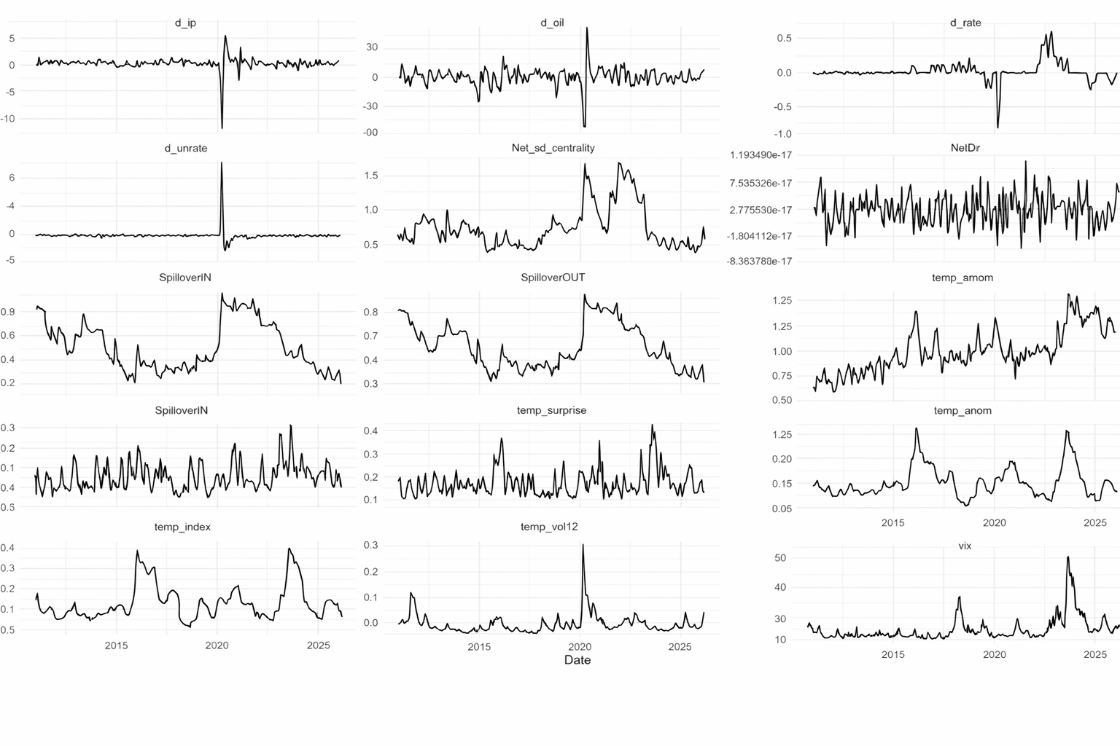
Note: This figure plots the pooled time series of the main variables used in the empirical analysis. The series include the macro-financial controls (d_ip, d_oil, d_rate, d_unrate, and VIX), the network measures (Net_sd_centrality, NetDir, SpilloverIN, and SpilloverOUT), and the climate variables (temp_anom, temp_index, temp_surprise, temp_vol12, and temp_vol12_z). Each line shows the cross-node pooled value at each monthly observation date. The figure is intended to provide a visual summary of time variation, common trends, and major spikes in the variables over the sample period.

Figure A2: GARCH FEVD network
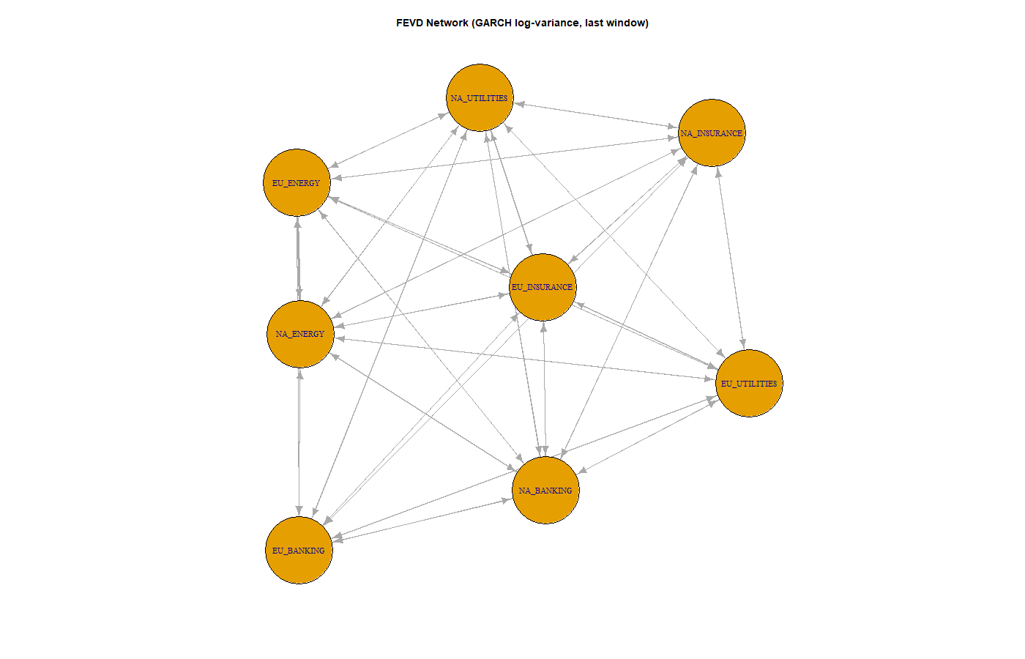
Note: This figure visualizes the final rolling GARCH FEVD spillover network. Each node represents a sectoral ETF corresponding to a sector-region unit in the sample, and each directed edge represents a bilateral spillover link based on the forecast-error variance decomposition of log conditional variance. Arrows indicate the direction of spillover transmission from the source ETF to the receiving ETF. The network is shown for the last available 36-month rolling window, estimated using a VAR(1) and a 10-step forecast-error variance decomposition.

Figure A3: Orthogonal distributed lag model 12 lag profile : temp_vol12_z
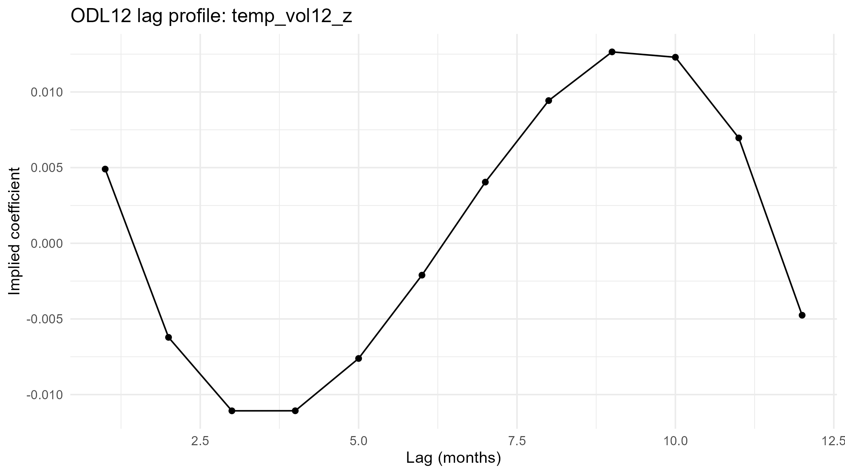
Note: This figure plots the reconstructed 12-month lag profile for the standardized 12-month temperature-volatility measure (temp_vol12_z) from the orthogonalized distributed-lag (ODL) model. The vertical axis shows the implied lag-specific coefficients recovered from the estimated polynomial basis, and the horizontal axis shows the lag horizon in months. Positive values indicate that higher climate volatility is associated with higher inward spillover exposure at that lag, while negative values indicate the opposite. The profile summarizes the dynamic pattern of the climate-volatility association over the full one-year horizon.
Figure A4 Orthogonalized distributed-lag specification profile : temp_surprise
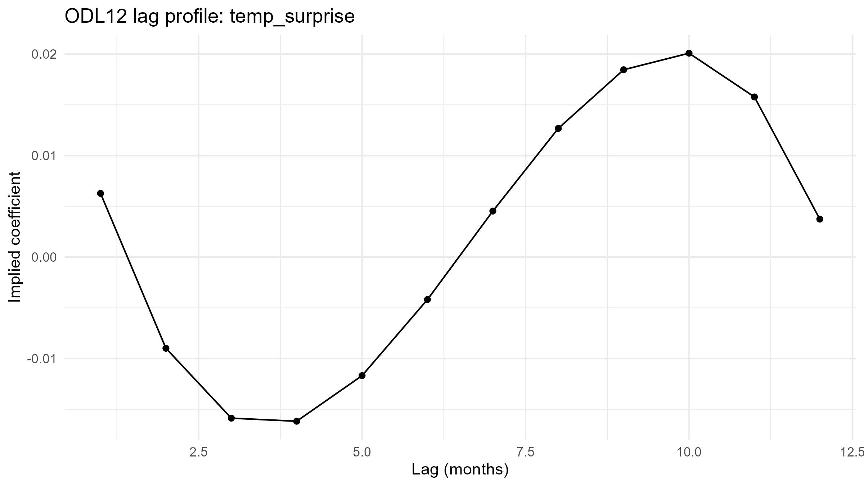
Note: This figure plots the reconstructed 12-month lag profile for the temperature-surprise measure (temp_surprise) from the orthogonalized distributed-lag (ODL) model. The vertical axis shows the implied lag-specific coefficients recovered from the estimated polynomial basis, and the horizontal axis shows the lag horizon in months. Positive values indicate that larger temperature surprises are associated with higher inward spillover exposure at that lag, while negative values indicate the opposite. The profile summarizes the dynamic pattern of the temperature-surprise association over the full one-year horizon.
Figure A5 Orthogonalized distributed-lag specification profile : temp_index
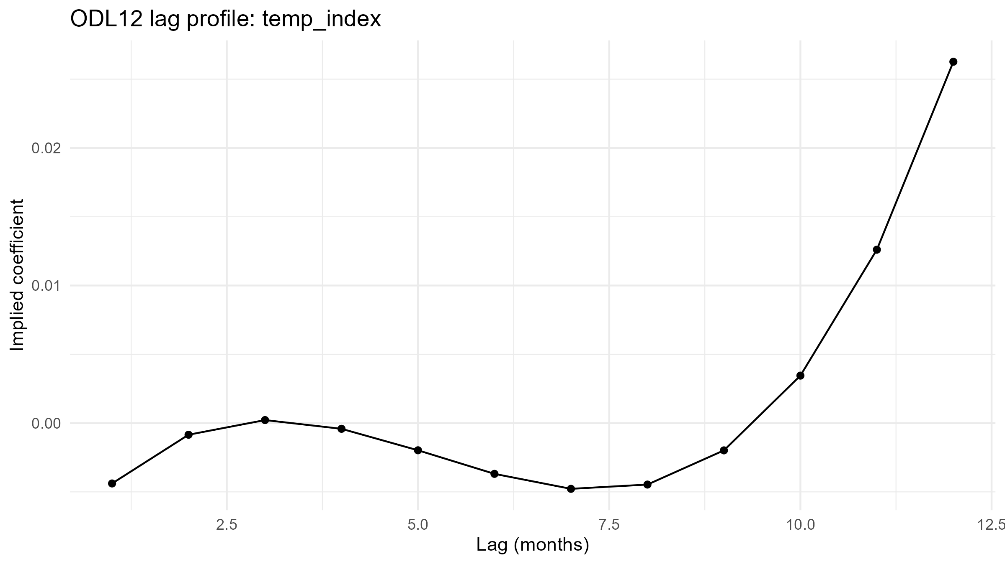
Note: This figure plots the reconstructed 12-month lag profile for the climate index (temp_index) from the orthogonalized distributed-lag (ODL) model. The vertical axis shows the implied lag-specific coefficients recovered from the estimated polynomial basis, and the horizontal axis shows the lag horizon in months. Positive values indicate that a higher climate index is associated with higher inward spillover exposure at that lag, while negative values indicate the opposite. The profile summarizes the dynamic pattern of the climate-index association over the full one-year horizon.
Figure A6: Climate volatility vs spilloverIN
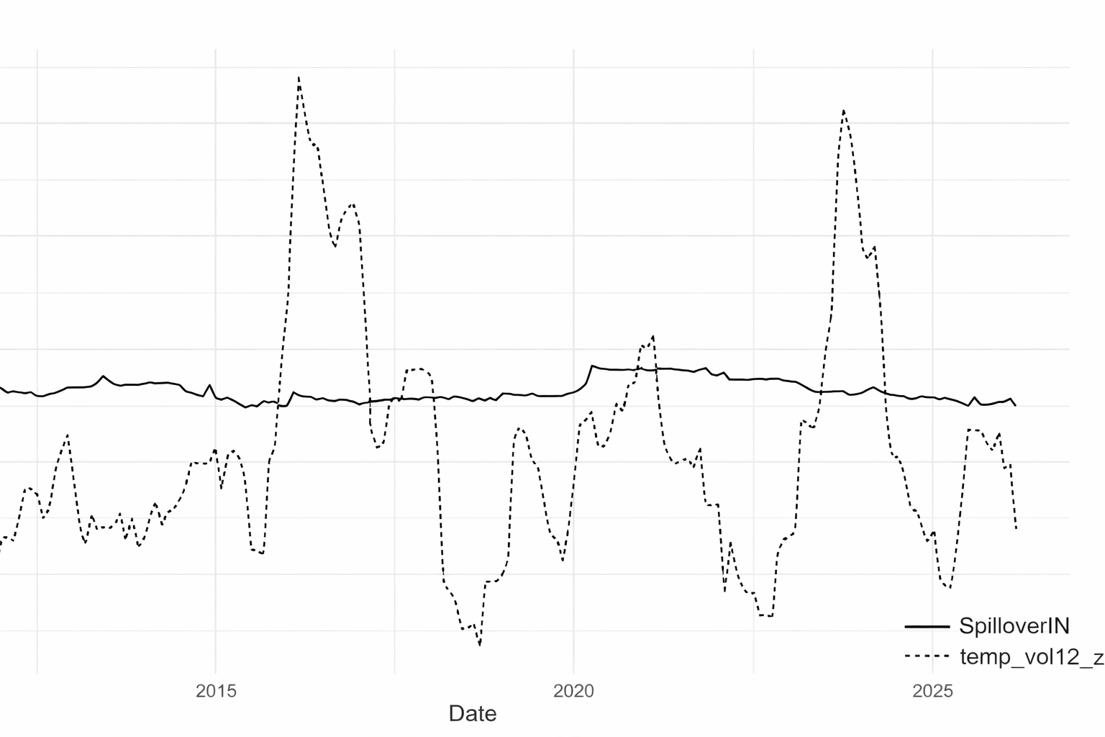
Note: This figure plots the pooled time series of inward spillover exposure (SpilloverIN) and the main climate regressor, the standardized 12-month temperature-volatility measure (temp_vol12_z). The solid line shows SpilloverIN, while the dashed line shows temp_vol12_z. The figure is intended to provide a visual comparison of their co-movement over time and to illustrate that the climate-volatility series is considerably more variable than the spillover-exposure series.

