Colonoscopy Quality Performance: Evaluations of the Early Introduction of FIT-based Population Screening for Colorectal Cancer in Romania and Lessons Learned
Cristian Gheorghe^{1,2}, Bogdan Cotruta¹, Stefania Bunduc^{1,2}, Razvan Iacob^{1,2}, Adrian Ionut Saizu^{1,2}, Anca Dimitriu^{1,2}, Dan Pitigoi¹, Cosmin Ciora^{1,2}, Bancila Ion¹, Mircea Diculescu^{1,2}, Gabriel Becheanu^{1,2}, Mona Dumbrava¹, Silvia Sanduleanu³, Mircea Manuc^{1,2}
- Digestive Diseases and Liver Transplantation Center, Fundeni Clinical Institute, Bucharest 022328, Romania
- Faculty of Medicine, Carol Davila University of Medicine and Pharmacy, Bucharest 020021, Romania
- Division of Gastroenterology and Hepatology Maastricht University Medical Center Maastricht the Netherlands

Corresponding author: Stefania Bunduc
Email: stefania.bunduc@drd.umfcd.ro
Adress:
Fundeni Clinical Insitute
Fundeni Street no 258, Bucharest, Romania, Sector 2, postcode 022328
Gastroenterology and Hepatology Department
Building B, First Floor, Room 7
Phone: +40 21 2750500
Supplementary material

Annex 1. Definitions
Inclusion criteria:
- age between 50-74 years
- residency in the South Muntenia region
The location of the target group was interpreted exclusively from the perspective of the legal residency of the person who benefited from the actual screening. Exception: People who do not have identity documents, but live in this territory, fall into the group vulnerable were included based on a written personal declaration
C. at least 50% of the beneficiaries of the screening procedures have to be part of a "disadvantaged socioeconomic group"
Definition of disadvantaged socioeconomic group:
- Residency: rural
- Socioeconomic factors:
- Employed but the average income per family member is lower than the minimum wage
- Unemployed (registered in the records of the Public Employment Service)
- Inactive - they do not have a job and are not registered in the records of the Public Employment Service
- Uninsured
- Beneficiaries of the guaranteed minimum income or family support allowance (social aid)
- self-employed in agriculture
- Persons from or who have previously been in foster care
- Persons who have left the child protection system
- Homeless persons
- Persons of Roma ethnicity
- people suffering from addiction to alcohol, drugs, and other toxic substances
- Victims of domestic violence
- Victims of human traffic
- People with disabilities or with complex needs (handicap certificate)
- People who have disabled children (disability certificate)
- Persons deprived of liberty or under judicial control
- Persons in probation services
- Ethnicity: Roma

Exclusion criteria:
- ineligible age;
- residence outside South Muntenia Region;
- people who fall into the high-risk groups of colorectal cancer (directly referred to colonoscopy)

Risk assessment questionnaire
Question | Yes | No | N/A | Remarks
HISTORY OF COLON CANCER OR COLONIC POLYPS
adenomatous polyps, sessile serrated, serrated adenoma
FAMILY HISTORY OF COLORECTAL CANCER
one or more first-degree relatives
HISTORY OF INFLAMMATORY BOWEL DISEASE
Crohn's Disease or Ulcerative Colitis with at least 8 years from diagnosis/symptom onset and who has not had a colonoscopy during this period
COLONIC POLYPOSIS SYNDROMES
Familial Adenomatous Polyposis, Peutz-Jeghers syndrome, juvenile polyposis, hereditary polyposis, etc.)
LYNCH SYNDROME
3 or more relatives with a history of cancer (colorectal, genital, intestines, ureter, renal)
2 or more successive generations affected
1 or more relatives with a cancer diagnosis before age 50
1 person must be a first-degree relative of the other two
*the cancer must be confirmed by a histopathologist

COLORECTAL CANCER ALARM SIGNS
Blood in the stool, Abnormal digital rectal examination with palpable mass
Risk assessment: High/ average; Does the individual accept FIT/colonoscopy: yes/no;
Risk group | Definition
Average | 50-75 years old  No family/personal history of cancer  No previous colorectal polyps
High | Familial adenomatous polyposis syndrome  Family history of Lynch syndrome (Hereditary Non-polyposis Colorectal Cancer)  Diagnosis of Inflammatory bowel disease (Crohns’ Disease, Ulcerative Colitis)  Personal/Family history of colorectal cancer/adenomatous polyps  Alarm symptoms (blood loss, palpable mass)
Colonoscopy | Definition
Cecal intubation rate | Total number of colonoscopies where cecum was reached among all the performed procedures
Adenoma detection rate | Total number of adenomas among the total number of colonoscopies
Adenoma per colonoscopy | The ratio between total number of detected adenomas and number of performed colonoscopies
Multiple adenoma detection rate | The proportion of colonscopies where more than one adenoma was detected
Adequate preparation | BBPS ≥6, and BBPS ≥2 per each segment
Withdrawal time | Calculated only for colonoscopies without subsequent interventions
Adequate withdrawal time | ≥6 minutes

Screening outcomes calculation ¹
Indicator | Numerator# | Denominator#
Rate of indication for colonoscopy | Recommended FU colonoscopy | Recommended + not recommended FU colonoscopy
Follow up colonoscopy participation rate | Participated in FU colonoscopy | Participated + did not participate in FU colonoscopy
Completion rate of FU colonoscopy | Completed FU colonoscopy | Completed + did not completed FU colonoscopy
Detection rate advanced adenomas | Advanced adenoma  (≥10 mm and/or vilous/ tubulo-vilous component and/or high drade dysplasia) | Screened
Detection rate of CRC | CRC | Screened
Positive predictive value advanced adenomas | Advanced adenoma (≥10 mm and/or vilous/ tubulo-vilous component and/or high drade dysplasia) | Performed colonoscopy
Positive predictive value colorectal cancer | CRC | Performed colonoscopy

The calculations were performed by dividing the numerator to the denominator; #number of; abbreviations: CRC – colorectal cancer; FU – follow-up;
Sesile serrated lesions were defined according to the 2019 WHO criteria ²

Supplementary Figures and Tables
Supplementary table 1. Colonoscopy uptake among the 50 000 invited screenees
Participants | 50000
Invalid FIT | 982 (2%)
Positive rate of FIT (cut off 20) | 2576 (5%)
Colonoscopy uptake - FIT positive | 1038 (40%)

Supplementary figure 1. Age and sex distribution among the 50 000 screenees invited to perform FIT
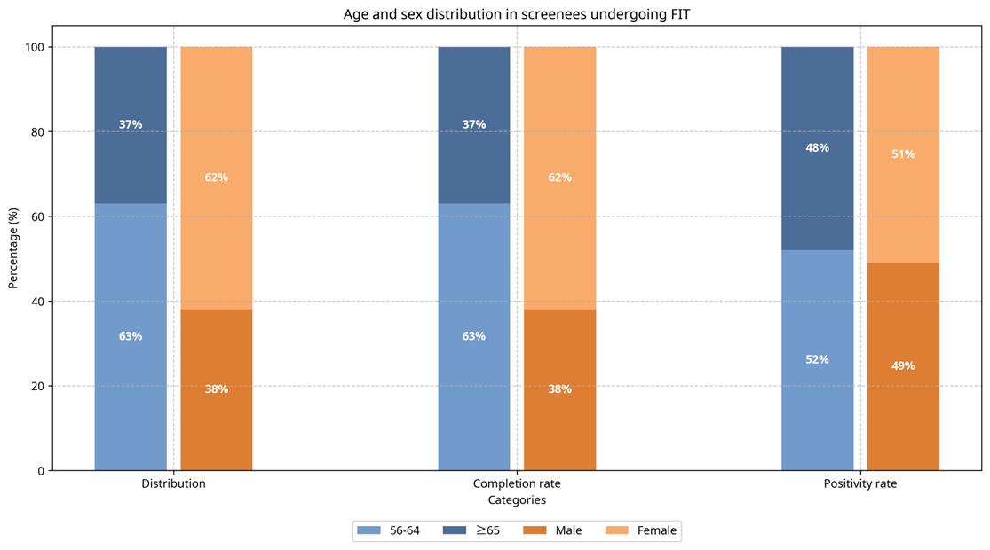
Legends: FIT: fecal immunochemical test

Supplementary Figure 2. Characteristics of patients undergoing colonoscopy (1038 cases)
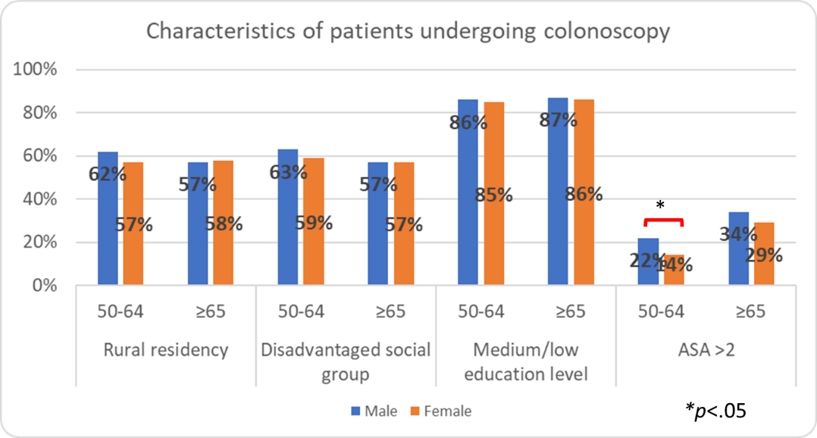
Legends: ASA - American Society of Anesthesiologists score

Supplementary Table 2. Rate of detected lesions across the various categories of screened individuals (1038 cases)
Categorical variables
Characteristic | Categories | Adenoma | Advanced adenoma | Right-sided SSL
Sex | Male | 67%* | 36%* | 4%
 | Female | 43% | 22% | 5%
Age group | 50–64 yrs | 52% | 31% | 5%
 | ≥65 yrs | 58% | 27% | 5%
ASA score | ≥3 | 56% | 30% | 2%
 | <3 | 55% | 19% | 6%
Residency | Urban | 57% | 33%* | 5%
 | Rural | 53% | 27% | 5%
Education | College degree | 55% | 32% | 5%
 | No higher education | 52% | 29% | 5%
Socioeconomic status | Disadvantaged | 53% | 23% | 5%
 | Not disadvantaged | 57% | 33%* | 5%
Colonoscopy waiting time | >6 months | 50% | 29% | 0%
 | ≤6 months | 55% | 28% | 5%
Bowel preparation (BBPS) | Adequate (≥6, all ≥2) | 56% | 29% | 5%
 | Inadequate  (<6 or any <2) | 53% | 29% | 4%
Continuous variables
Characteristic | Adenoma | Advanced adenoma | Right-sided SSL
Age, mean ± SD | 63 ± 7# | 63 ± 6 | 62 ± 7
Colonoscopy waiting time, median (IQR) | 61 (43–77) | 60 (42–76) | 59 (39–81)
FIT test value, median (IQR) | 57.9 (32.8–186) | 69.2 (36.8–259.8)## | 58.1 (30.6–144.5)
BBPS score, median (IQR) | 7 (6–8) | 7 (6–8) | 7 (6–8)

Legends: *p<.05; #vs. 62±6 in screenees without adenoma, p<.05; ##vs. 48.2; IQR: 29.5-152.9, p<.05, in screenes without advanced adenoma

Supplementary Table 3. Independent predictors of colorectal lesions detection among 1038 average-risk screenees undergoing colonoscopy within the South Muntenia ROCCAS pilot
Variable | Adenoma | p | Advanced adenoma | p | Right-sided SSL | p
Age ≥65 | 1.30 (1.01–1.68) | .045 | 1.20 (0.91–1.58) | .2 | 1.04 (0.48–2.26) | .93
Male Sex | 2.72 (2.11–3.51) | <.001 | 1.85 (1.41–2.44) | <.001 | 0.34 (0.14–0.81) | .015
Vulnerable group | 0.84 (0.65–1.08) | .19 | 0.69 (0.53-0.92) | .011 | 0.94 (0.44–2.02) | .87
FIT (log) | 0.99 (0.90–1.09) | .86 | 1.13 (1.02–1.25) | .023 | 0.92 (0.67–1.27) | .6
ASA≥2 | 1.14 (0.63–2.03) | .67 | 1.33 (0.73–2.43) | .35 | 2.47 (0.70–8.74) | .16
Adequate bowel preparation | 0.85 (0.63–1.14) | .28 | 0.97 (0.70–1.34) | .86 | 0.59 (0.20–1.72) | .33
Results are expressed as odds ratio and 95% confidence interval and the corresponding P value

Supplementary figure 3. Lesions detection rate during colonoscopy among the FIT positives (1038 cases)

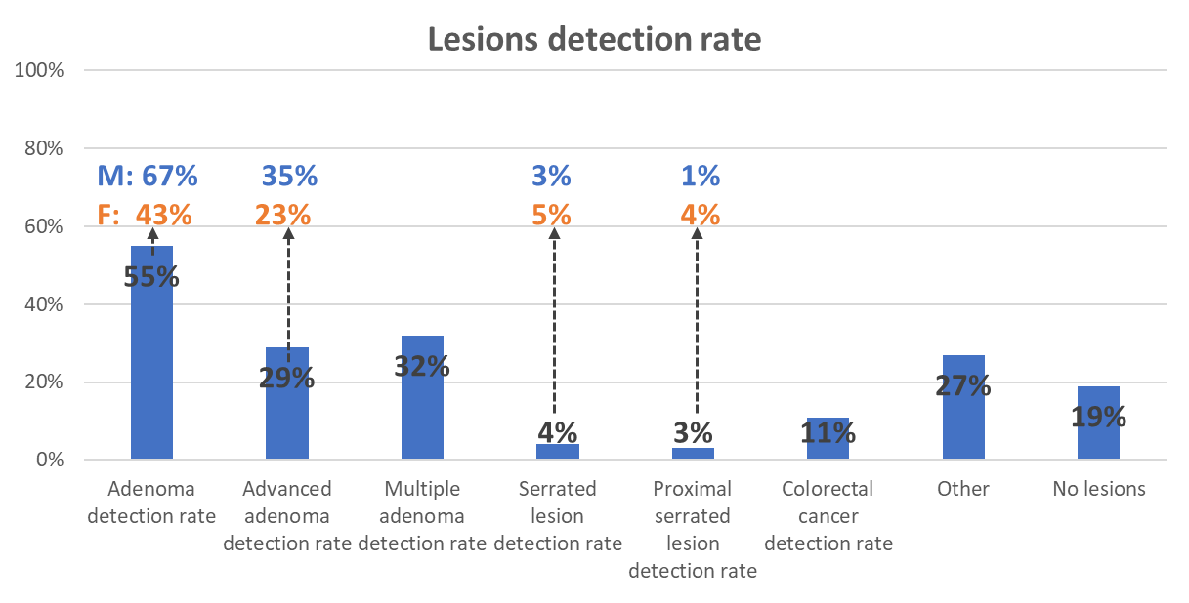

Legends: M: males; F: females; the additional numbers on the figures illustrate the case where positivity rate was significantly different between males and females. The positivity rates did not differ by sex in the other cases

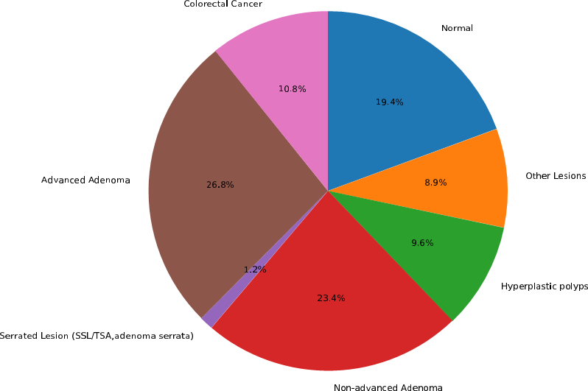
Supplementary figure 4. The distribution of lesions by severity in the scoped population (1038 cases)

Non-malingant

Supplementary figure 5. Violin plots of FIT value by most severe lesion detected during colonoscopy
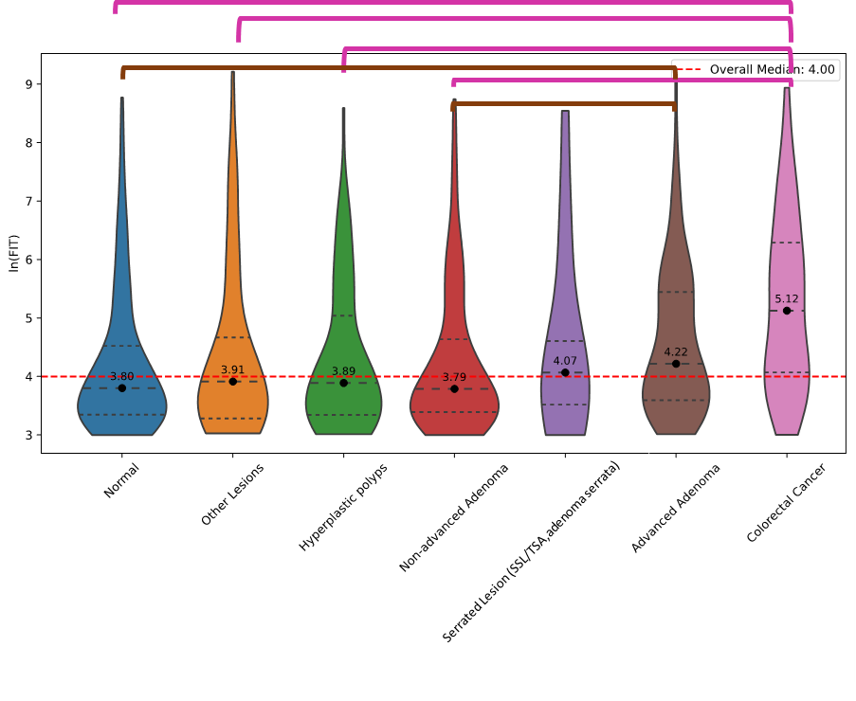Supplementary table 4. FIT values
Variable | Result (µg Hb/g)
Value | 54.5(30.8-184.6)
Female vs Male patients | -104.76 (-.209.71, .18)
Normal vs abnormal colonoscopy | -115.13(-244.49, 14.22)
No polyp vs polyp detection | -46.55 (-163.14, 70.02)
No adenoma vs adenoma detection | 68.15 (-39.54-175.83)
Advanced adenoma vs no advanced adenoma | 12.54 (-101.67, 126.76)
CRC vs no CRC | 339.76 (105.87, 573.64)*
Legends: result reported as median, (inter quartile range); mean differences and 95% confidence intervals; CRC – colorectal cancer; *P<0.05

Supplementary figure 6. Characteristics of the colorectal cancer cases detected during colonoscopy among the FIT positive patients in ROCCAS South Muntenia pilot (114 patients)
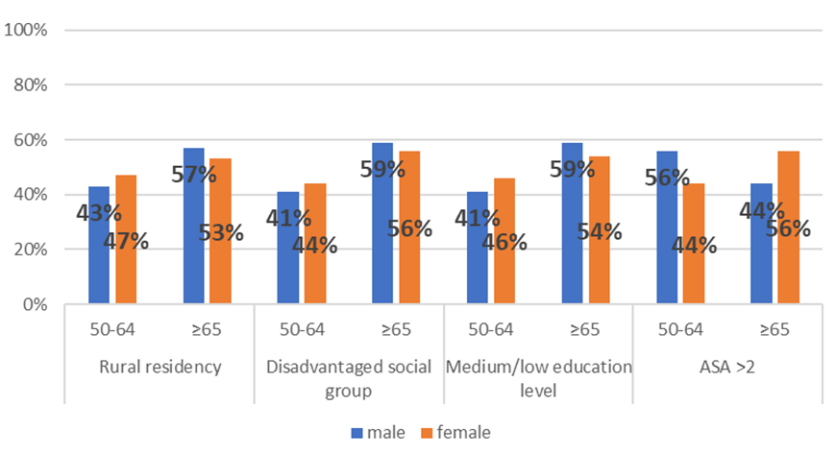
Supplementary Table 5. Comparison of ROCCAS South Muntenia pilot KPIs with European benchmarks

Indicator | EU / ESGE benchmark | ROCCAS South Muntenia | Comment
FIT positivity rate | Typically 5–10% (cut-off 20 µg/g Hb) | 6% | Within target range
Colonoscopy uptake after positive FIT | ≥85% (EU guideline) | 40% | Well below benchmark; major limitation
Time from positive FIT to colonoscopy | ≤31 days recommended | Median 60 days (IQR 42–77) | Above limit; needs improvement
Cecal intubation rate | ≥90% (ESGE) | 96% | Exceeds benchmark
Adenoma detection rate (ADR) | ≥45% in men, ≥35% in women (ESGE) | Overall 55% (67% men, 43% women) | Meets/exceeds benchmark
Proximal adenoma detection rate | No strict benchmark, but ~25–30% expected | 29% | In line
Advanced adenoma detection rate | Variable (10–20% typical in FIT+ populations) | 29% | High yield
Sessile serrated lesion detection rate | 4–9% overall, right-sided SSL ≥4% desirable | 13% overall, 4.8% right-sided | Overall high SSL yield; right-sided rate at threshold
Withdrawal time | ≥6 minutes | Median 8 min (80% ≥6 min) | Meets benchmark
Adequate bowel prep | ≥90% (Boston score ≥6 or equivalent) | 81% | Slightly below benchmark
Adverse events | <2% significant complications | <2% (bleeding, sedation incidents, suspension) | Within safe range

References
1 Report on the implementation of the Council Recommendation on cancer screening. Cancer Screening in the European Union. 2017.
2 Pai RK, Bettington M, Srivastava A, Rosty C. An update on the morphology and molecular pathology of serrated colorectal polyps and associated carcinomas. Modern Pathology 2019; 32: 1390–415.

