Supplementary Figures
sFigure 1: Proteomic analysis of the embryonic chick heart. A) Coefficients of variation distribution for protein sample groups from Figure 1. B) Principal component analysis of all sample groups. One SAN sample pool varied significantly from the remainder of the dataset along PC1. This sample was not used for downstream quantitative analysis. C) Comparison of previously published RNA sequencing data(Henley et al., 2023) to current proteomic data. For this analysis, factors that were differentially expressed between SAN vs both atria and ventricle (Log2FC >1.0) were compared. D) GO terms (Biological Process) that were enriched in proteins upregulated in the SAN vs atria and ventricle. E) GO terms (Cellular Component) that were enriched for proteins upregulated in the SAN vs atria and ventricle. F) Schematic representation of GO terms calculated using ShinyGO 2.0 (Ge et al., 2020). G) Volcano plot of differentially expressed proteins between SAN and atria/ventricles. Red points indicate RhoGaps/RhoGefs from Figure 2E.

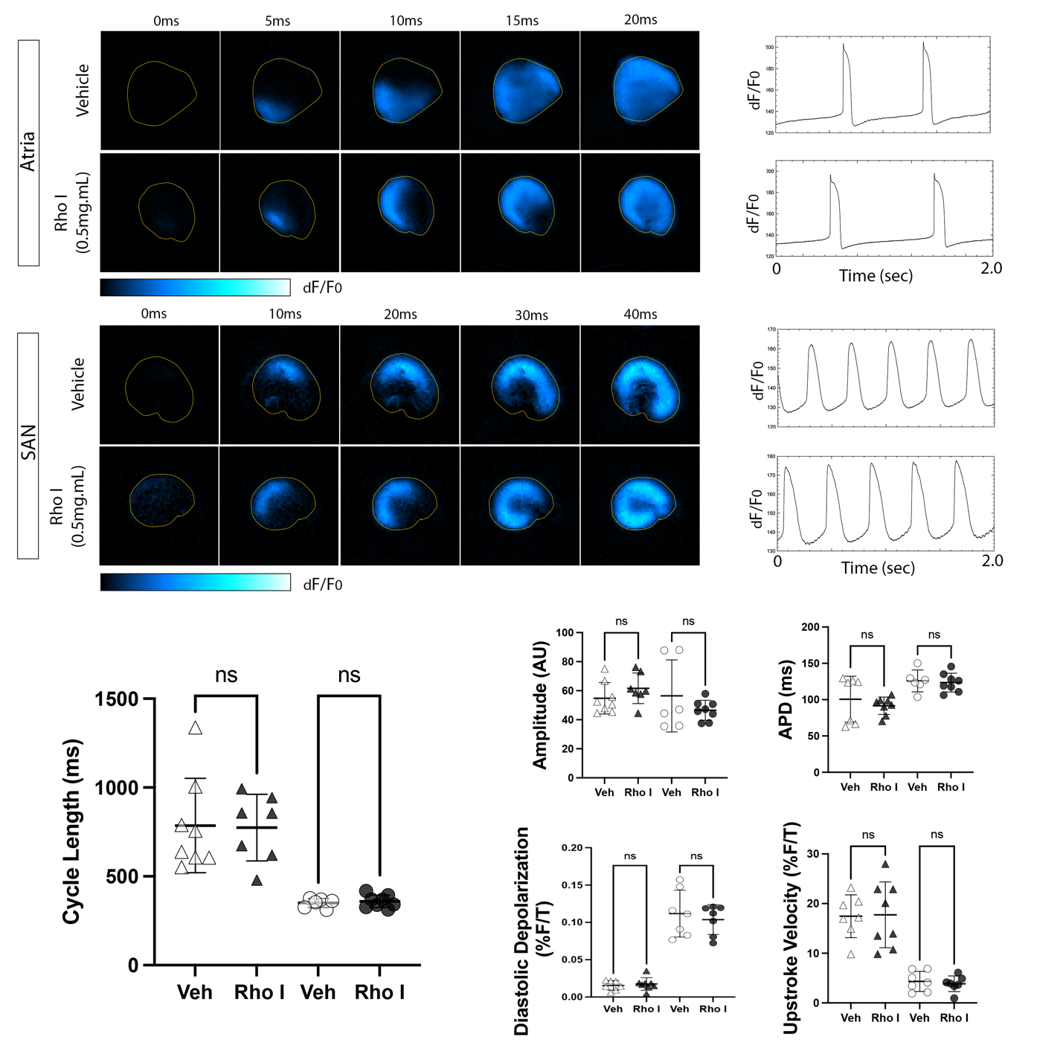

sFigure 2: Inhibition of RhoA signaling does not influence SAN or atrial conduction characteristics. A) Time series of voltage imaging of atrial tissue preparations following 14hrs of treatment with vehicle or 1.0 ug/ml of the RhoA inhibitor CT04. B) Optically recorded action potential traces from atrial tissue preparations treated with vehicle or CT04. C) Time series of voltage imaging of SAN tissue preparations following 14hrs of treatment with vehicle or 1.0 ug/ml of the RhoA inhibitor CT04. D) Optically recorded action potential traces from SAN tissue preparations treated with vehicle or CT04. E) Quantification of Cycle length between vehicle and CT04 tissue preparations. F) Quantification of signal amplitude, action potential duration, slope of diastolic depolarization, and upstroke velocity between vehicle and CT04 tissue preparations. For all analysis atrial vehicle n=7, atrial CT04 n=8, SAN vehicle n=6, SAN CT04 n=7). Statistical significance was calculated using Welch’s t-tests.

sFigure 3: RNA sequencing analysis of CN03-treated SAN and atrial tissue preparations. A) Cluster dendrogram demonstrating the bioinformatically determined similarity between sample groups. B) Relative contribution of the four highest principal components to sample variance based on RNA sequencing results. C) Volcano plot of differentially expressed genes between vehicle and CN03-treated atrial preparations. CN03 downregulated genes are indicated in blue, CN03 upregulated genes are indicated in red (Log2FC >1.0, pvalue <0.05). D) Volcano plot of differentially expressed genes between vehicle and CN03-treated SAN preparations. CN03 downregulated genes are indicated in blue, CN03 upregulated genes are indicated in red (Log2FC >1.0, pvalue <0.05). E) Top 200 genes differentially expressed between freshly isolated atria and SAN based on Log2FC. Top inset shows the response of atrial-enriched genes to CN03 treatment in the SAN. Bottom inset shows the response of SAN-enriched genes to CN03 treatment in the SAN. F) Alteration to transcription factor expression in the SAN following CN03 treatment. For this analysis, all of the differentially expressed transcription factors between freshly isolated atria and SAN were examined. G) Alteration to transcription factor expression in the atria following CN03 treatment.

sFigure 4: RhoA alters critical SAN ion channel expression. A) Response of a manually annotated group of ion channels to CN03 treatment in atrial tissue preparations. B) Response of a manually annotated group of ion channels to CN03 treatment in SAN tissue preparations. C) Comparison of selected ion channel expression changes between CN03 treatment and freshly isolated SAN, and CN03 and vehicle-treated SAN. D) Diagram of the ion currents that participate in the cardiac pacemaker cell action potential. Color coding denotes relative expression change between CN03 treatment vs freshly isolated SAN. E) RNA scope quantification for HCN4 in vehicle-treated (n=19 ROIs) vs CN03-treated (n=20 ROIs) SAN tissue preparations. F) RNA scope quantification for GJA1 in vehicle-treated (n=23 ROIs) vs CN03-treated (n=20 ROIs) SAN tissue preparations. All RNAscope quantification was performed across 5 biological replicates. Statistical significance was calculated using Welch’s t-tests, p-values **** < 0.0001.

Table S1: Proteomic Analysis of Embryonic SAN, Atria, And Ventricle. Data table contains five tabs. These include all Proteins identified by mass spectrometry, differentially regulated proteins between SAN and ventricle, differentially regulated proteins between SAN and atria, differentially regulated proteins between atria and ventricle, and a comparison of differentially regulated transcripts and proteins between SAN and atria.
Table S2: GO Term Analysis for Differentially Regulated Proteins. Data Table contains four tabs. These include GO terms related to proteins enriched in the SAN over both atria and ventricle and GO terms related to proteins that were enriched in the atria and ventricle over the SAN. GO terms are categorized based on Biological Process (BP) and Cellular Component (CC).
Table S3: Pathway Analysis of Differentially Regulated Proteins: Data table has two tabs. These include pathway enrichment analysis, highlighting upstream signaling pathways predicted to be differentially active between SAN and both atria and ventricle. Differentially expressed factors related to Rho cycling have been isolated in the second tab.

Table S4: RNA Sequencing of SAN and Atrial Tissue Preparations. Data table has three tabs. These include all differentially expressed genes between freshly isolated SAN and atrial tissue preparations, a subset of these data including only differentially expressed ion channels between SAN and atria, and raw data for selected ion channels and gap junctions in atria and SAN (comparing freshly isolated samples (t=0), vehicle treatment, and CN03 treatment).

Table S5: Predicted Transcription Factor Activation: Data table has two tabs. These include predicted transcription factor activation following RhoA stimulation in the SAN and atria.
Video S1: Voltage Imaging of Atrial Tissue Preparations following 14hrs of Treatment with Vehicle, CN03, or CN02.
Video S2: Voltage Imaging of SAN Tissue Preparations following 14hrs of Treatment with Vehicle, CN03, or CN02.
Video S3: Voltage Imaging of Atrial Tissue Preparations following 14hrs of Treatment with Vehicle CT04.
Video S4: Voltage Imaging of SAN Tissue Preparations following 14hrs of Treatment with Vehicle CT04.

